Terraform-03
Set environmental variables
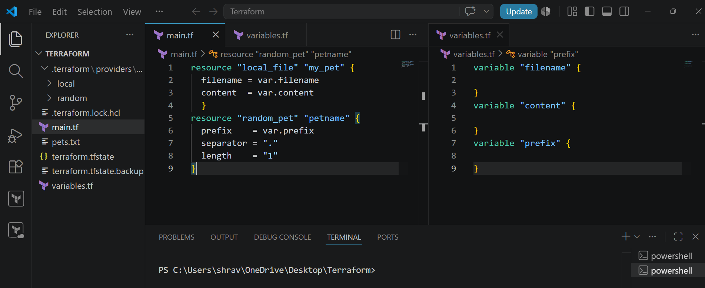
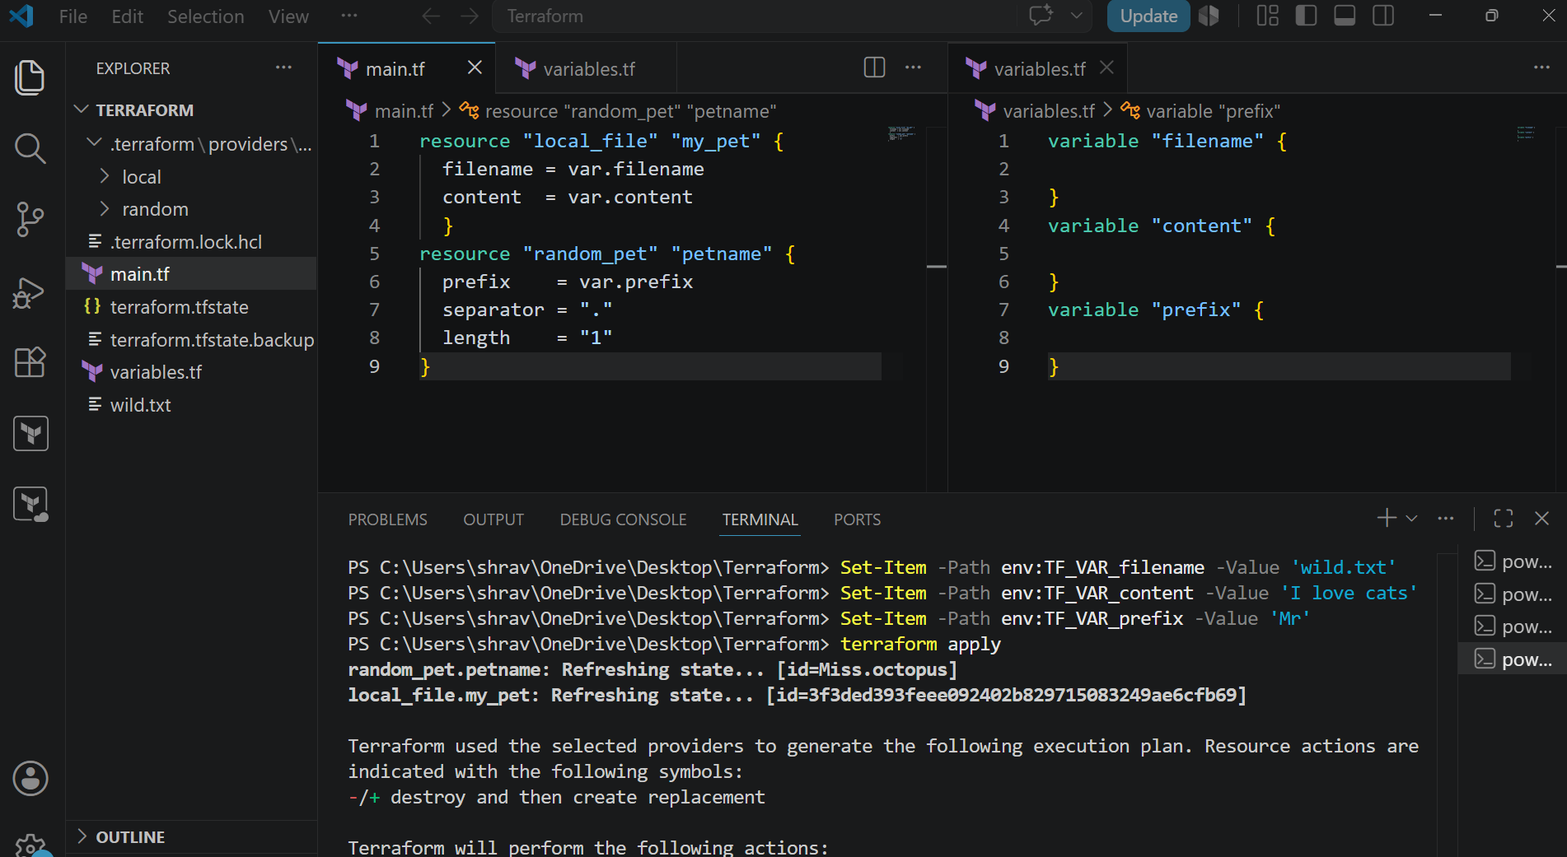
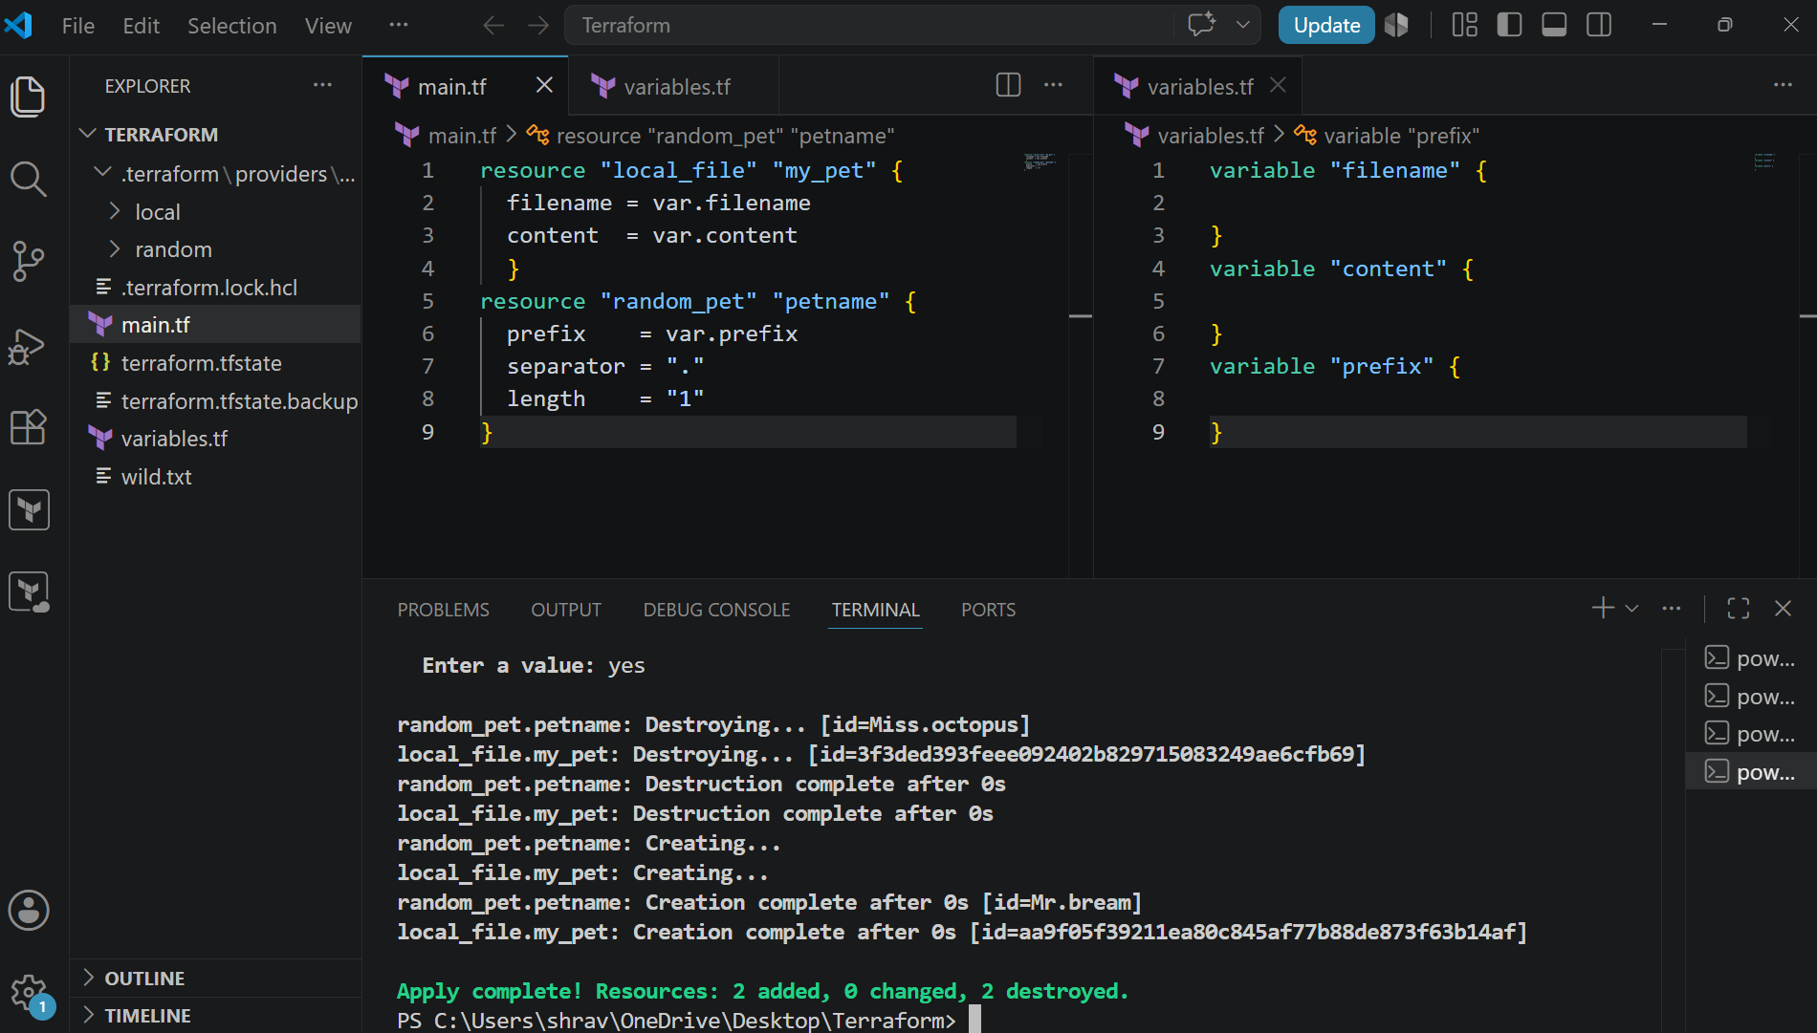
Resource dependency
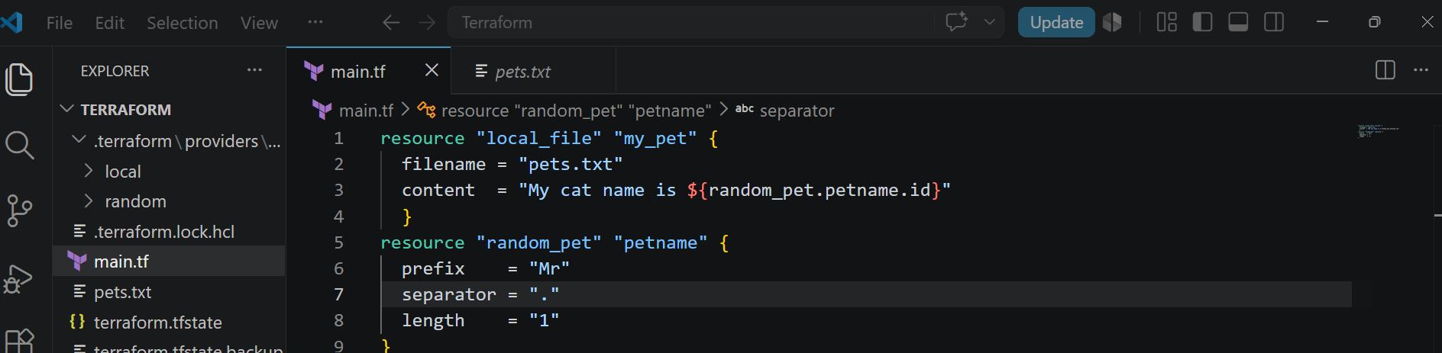
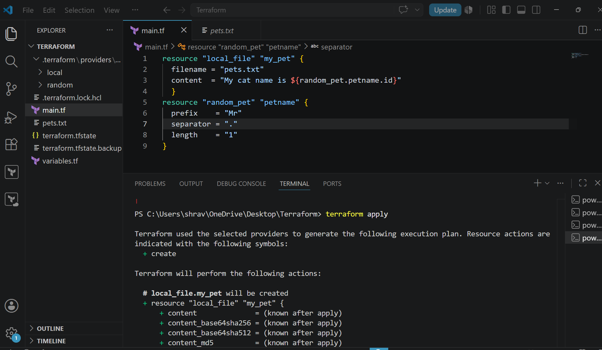
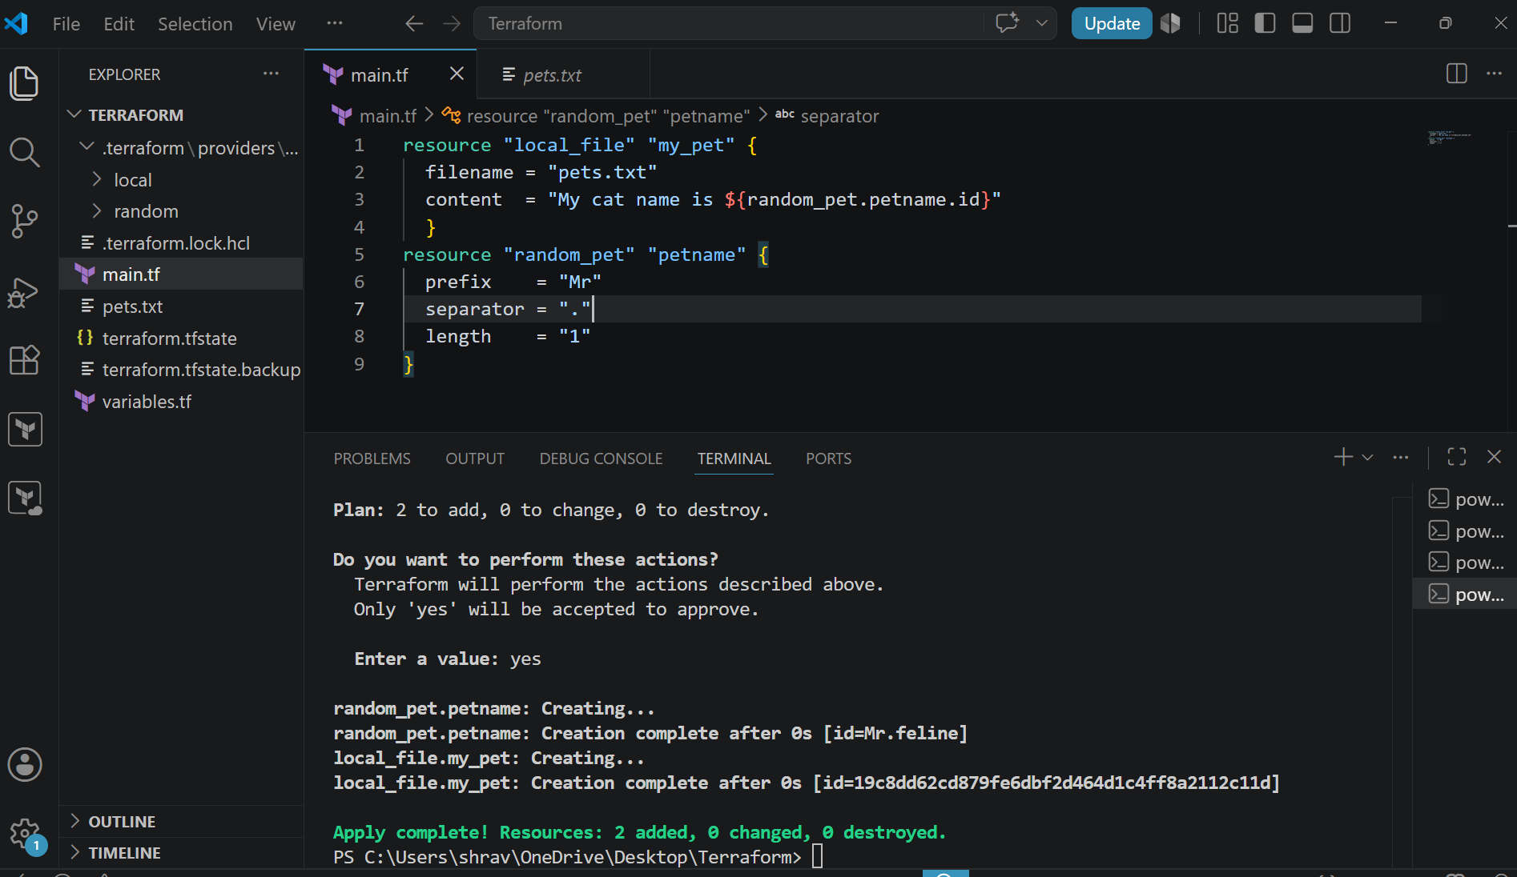
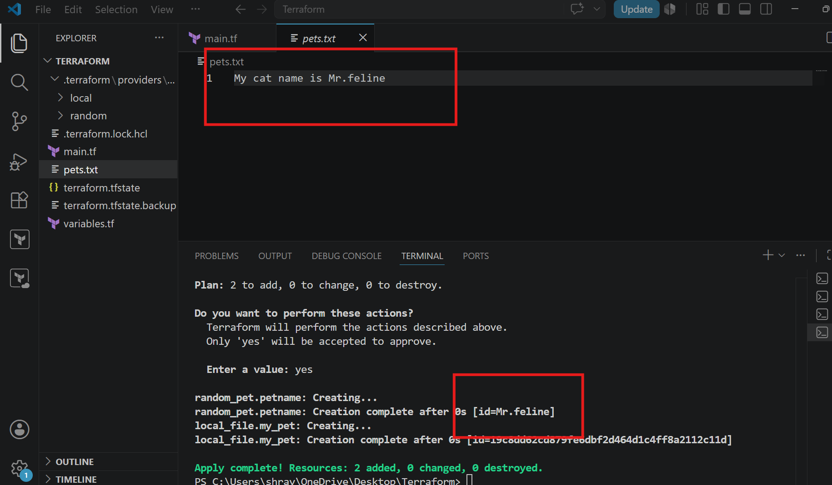
Output variables:
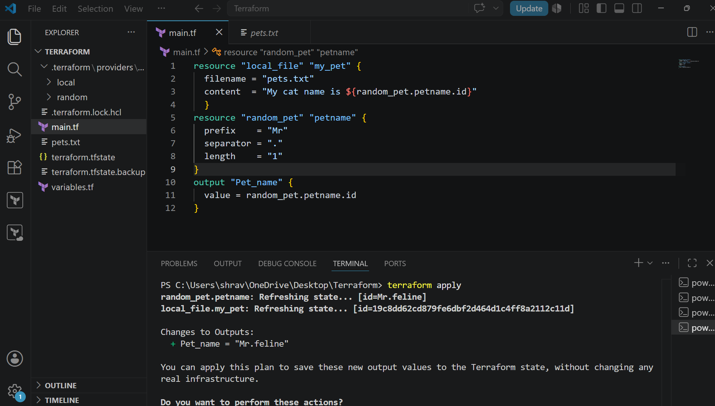
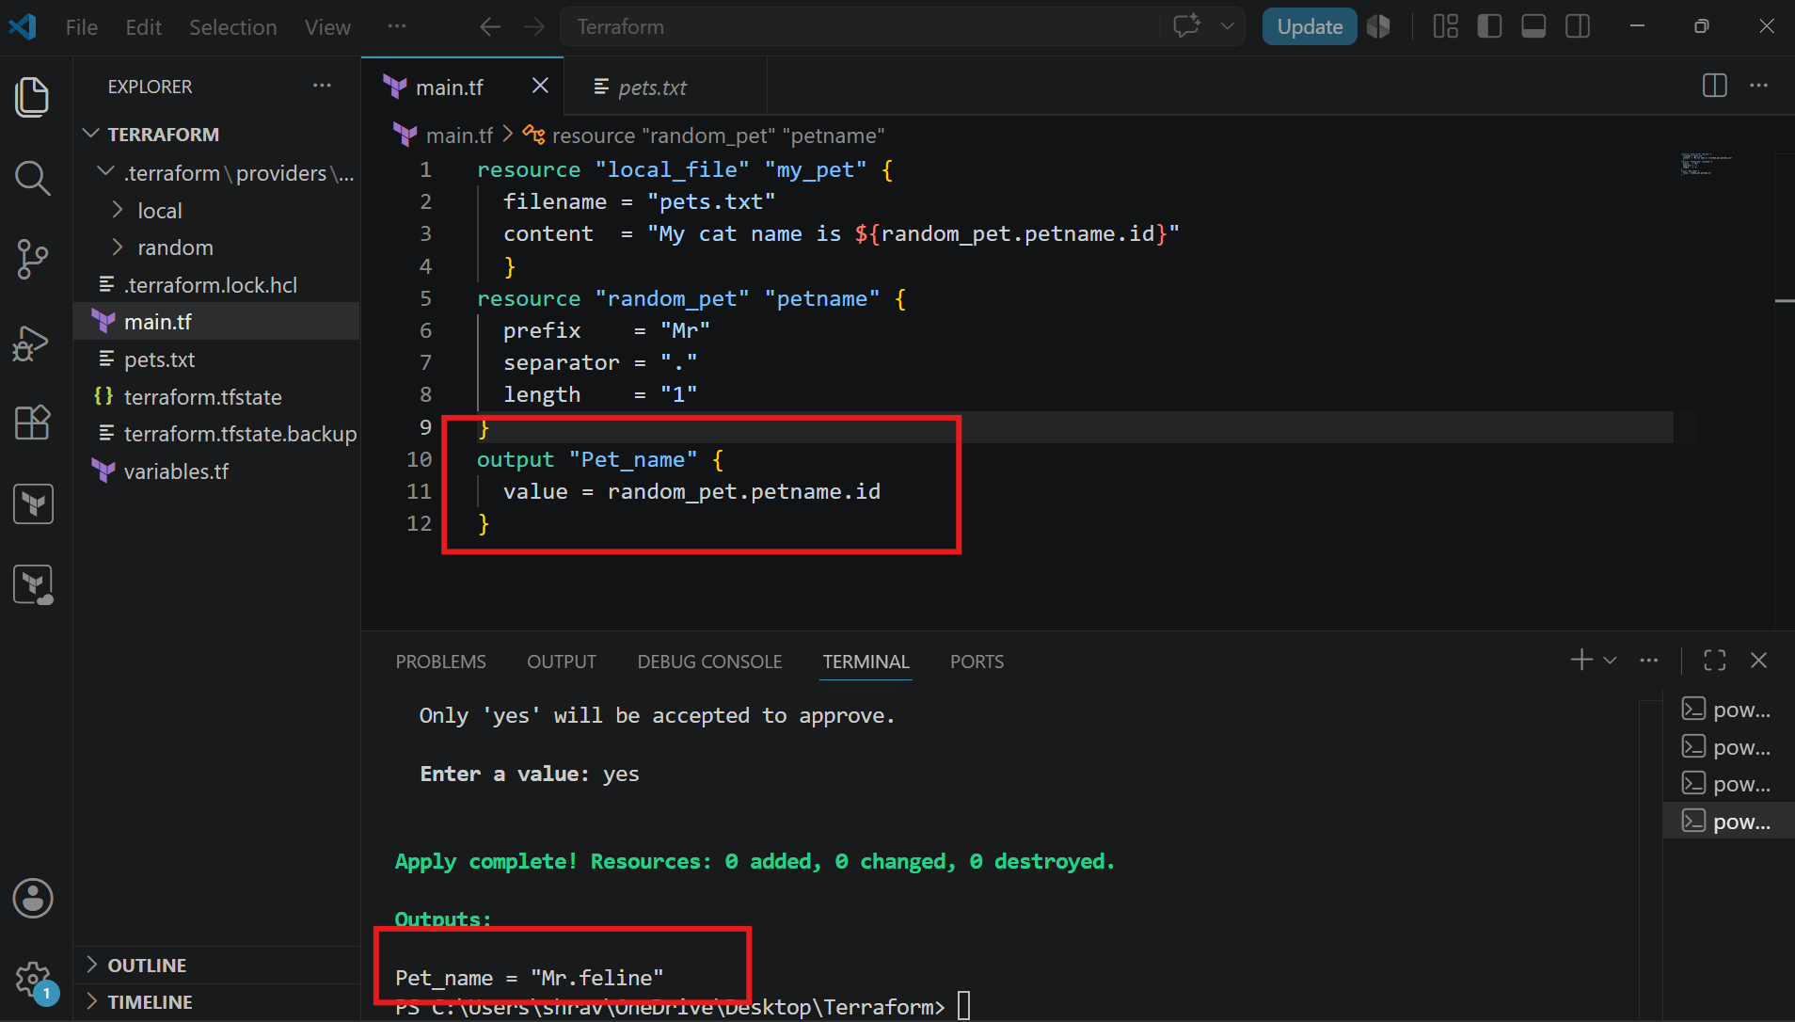
We can use also like
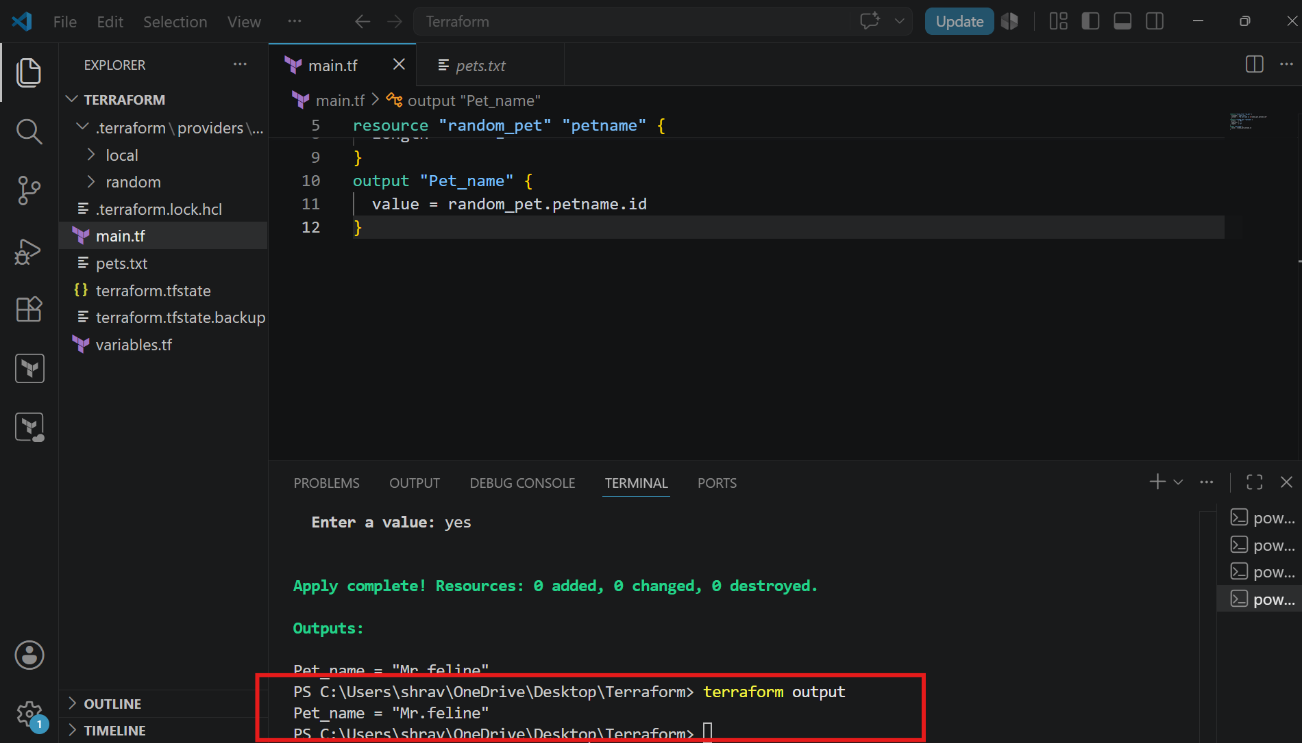
State files
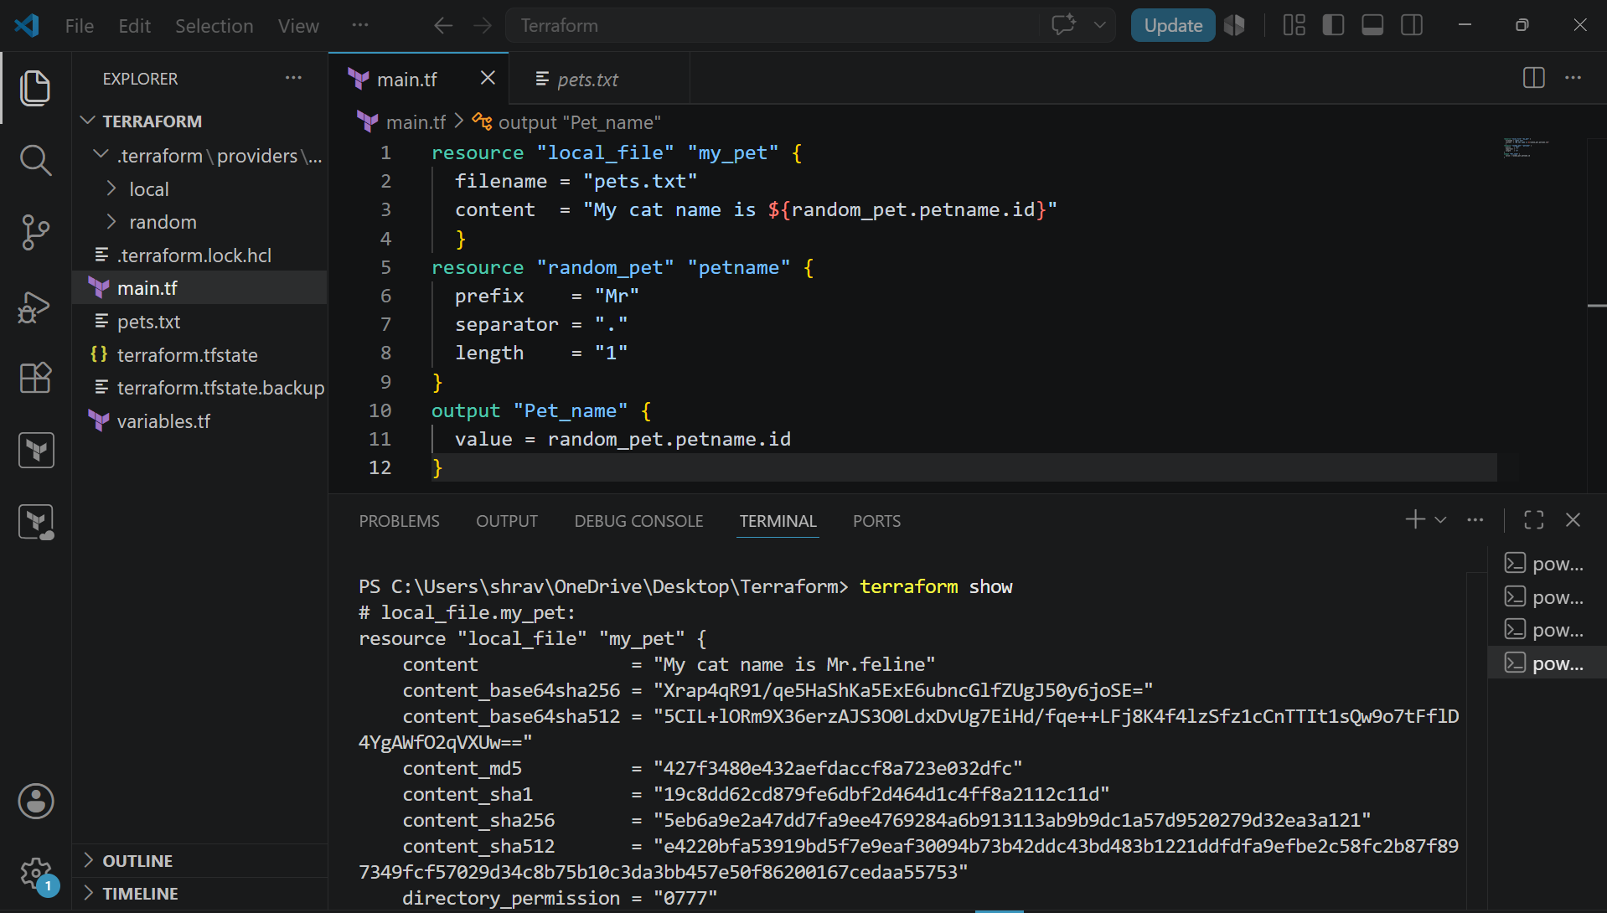
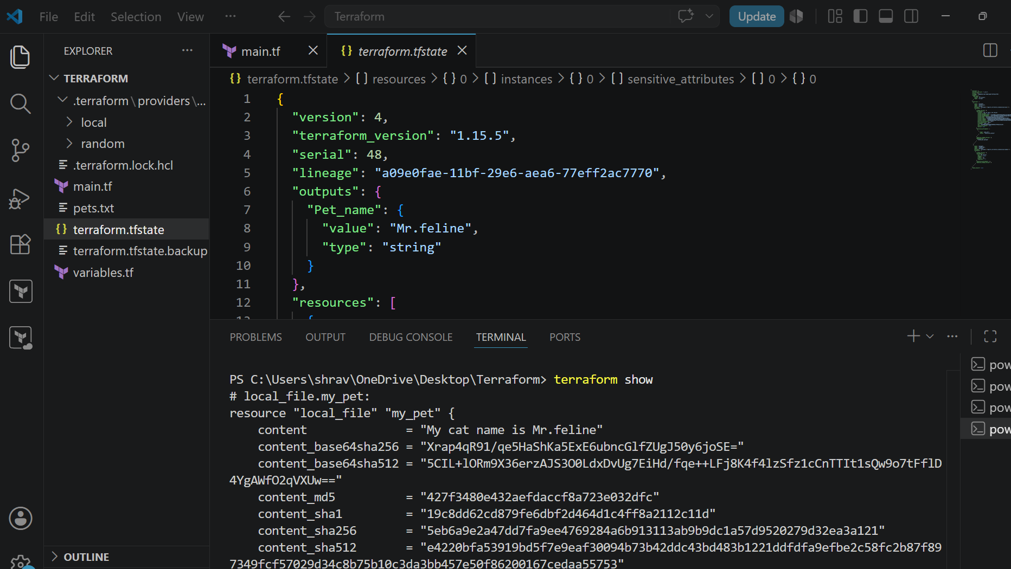
Integrate Terraform in Jenkins using the Terraform plugin.
Go to cd /var/lib/Jenkins/workspace/terraform-jenkins-pipe
Vi main.tf
terraform {
required_providers {
local = {
source = "hashicorp/local"
}
}
}

resource "local_file" "demo" {
filename = "shravan.txt"
content = "Hi Shravan, Welcome to Jenkins Terraform"
}
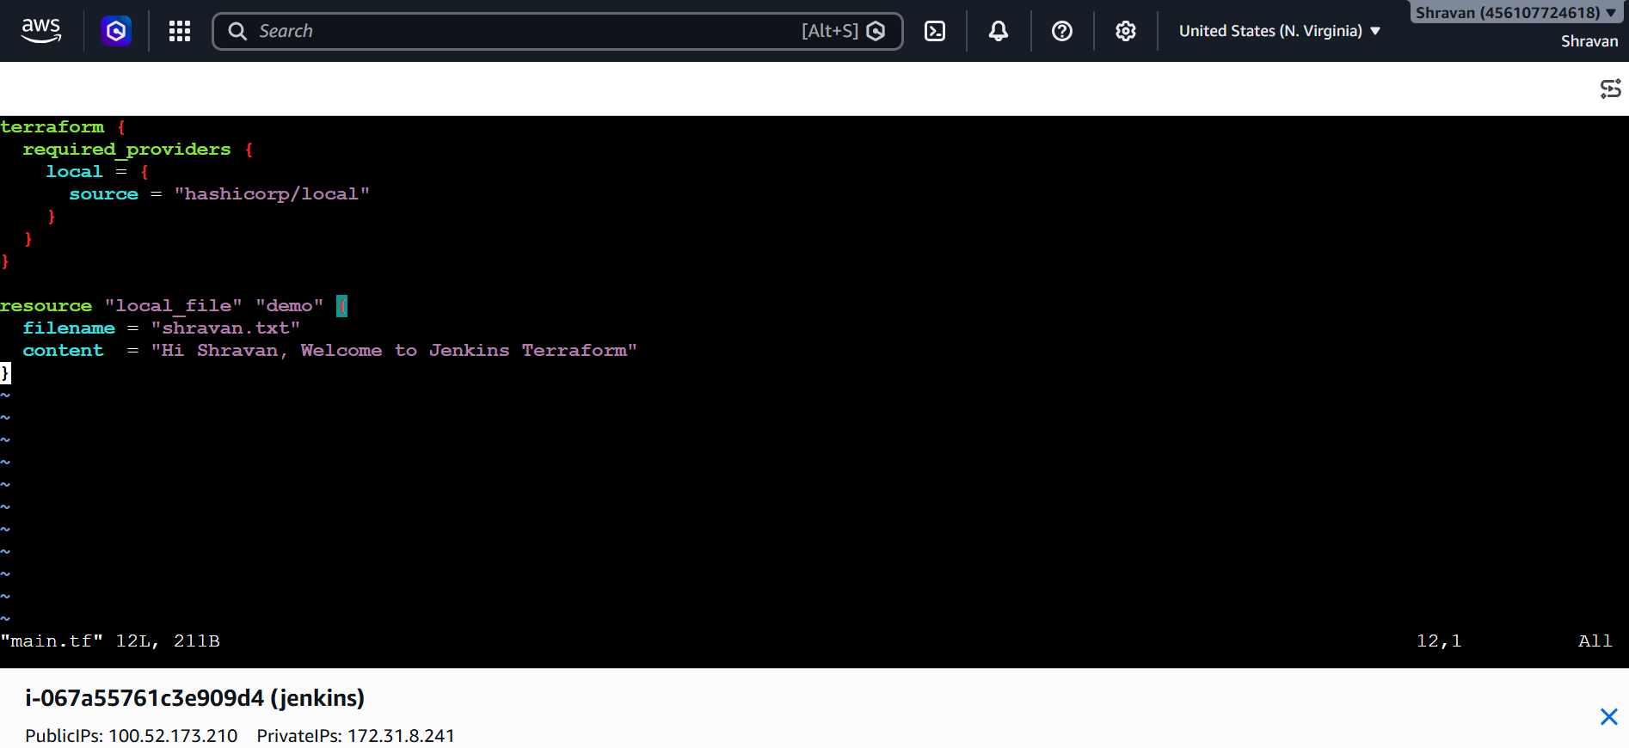
Now write a pipeline script
pipeline {
agent any

tools {
terraform 'terraform'
}

stages {

stage('Check Terraform Version') {
steps {
sh 'terraform version'
}
}

stage('Terraform Init') {
steps {
sh 'terraform init'
}
}

stage('Terraform Validate') {
steps {
sh 'terraform validate'
}
}

stage('Terraform Plan') {
steps {
sh 'terraform plan -out=tfplan'
}
}

stage('Terraform Apply') {
steps {
sh 'terraform apply -auto-approve tfplan'
}
}
}

post {
success {
echo 'Terraform deployment completed successfully.'
}
failure {
echo 'Terraform deployment failed.'
}
}
}
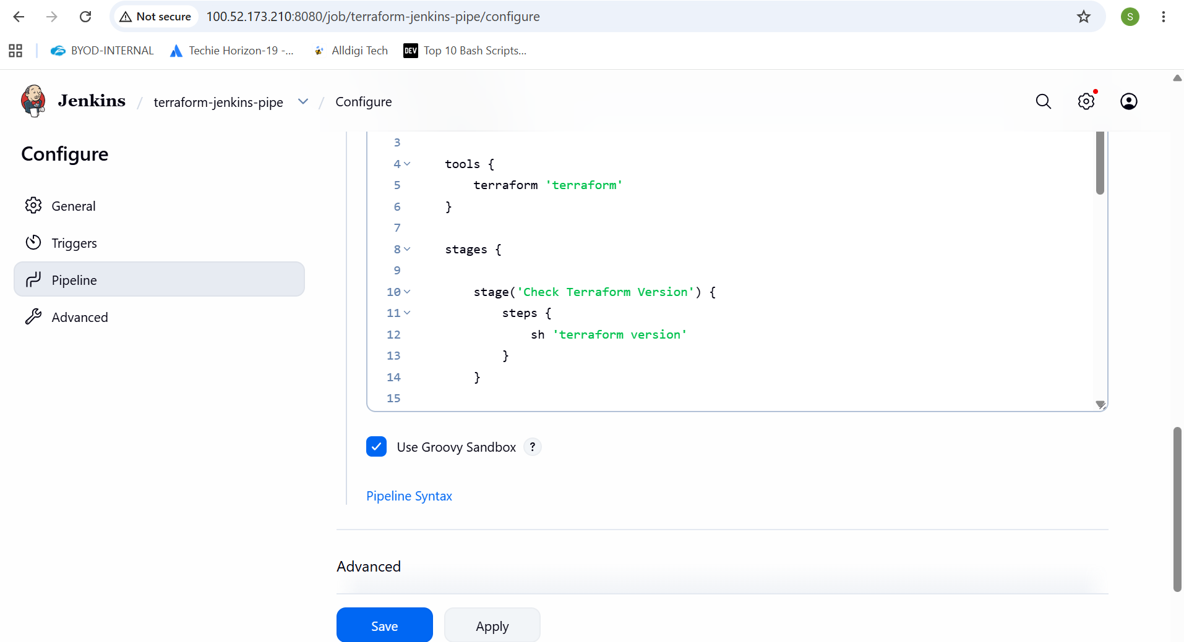
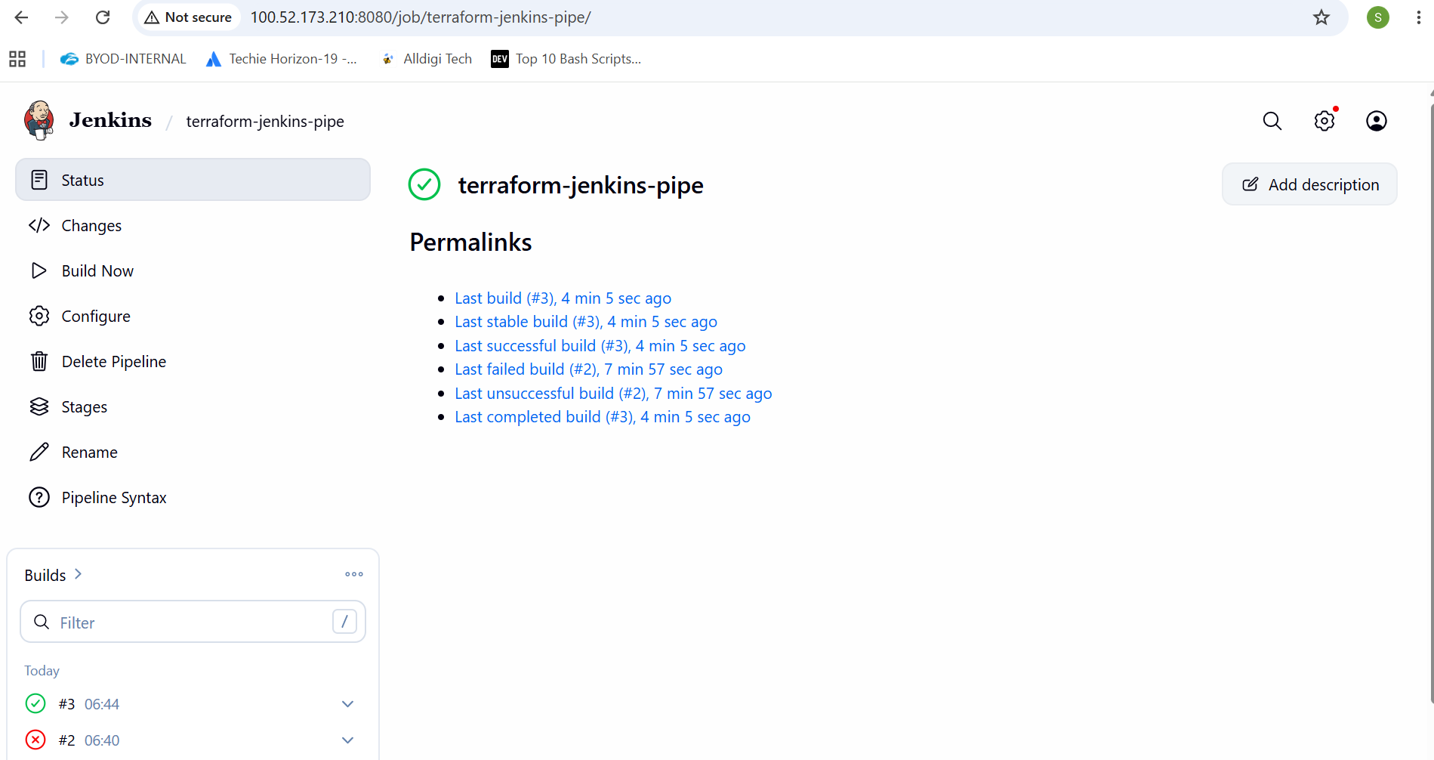
4.Create one Jenkins job using Maven Project for the code below with two stages:
  - Stage 1:Git clone
  - Stage 2:Maven CompilationCode:https://github.com/betawins/java-Working-app.git
Install maven integration plugin
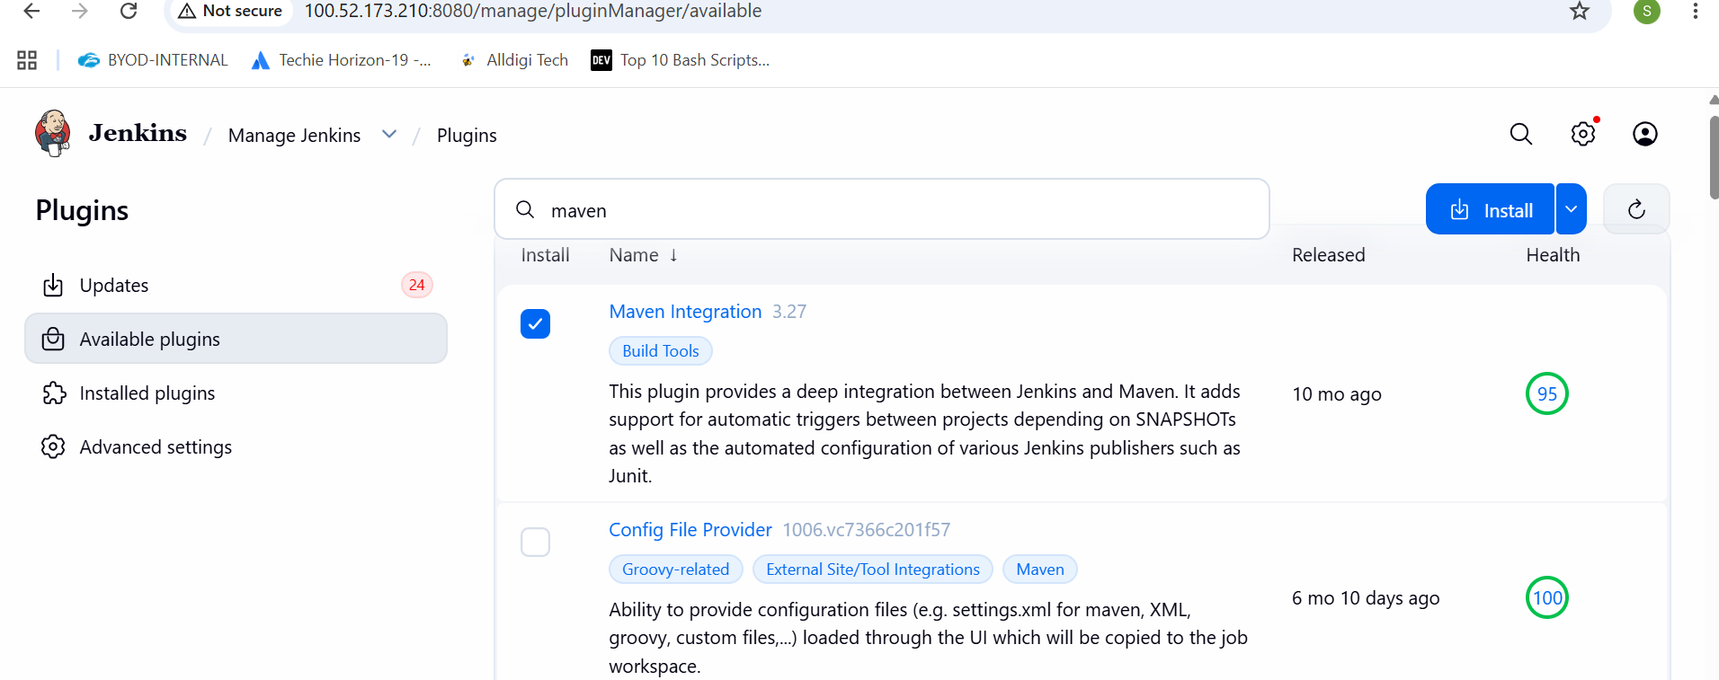
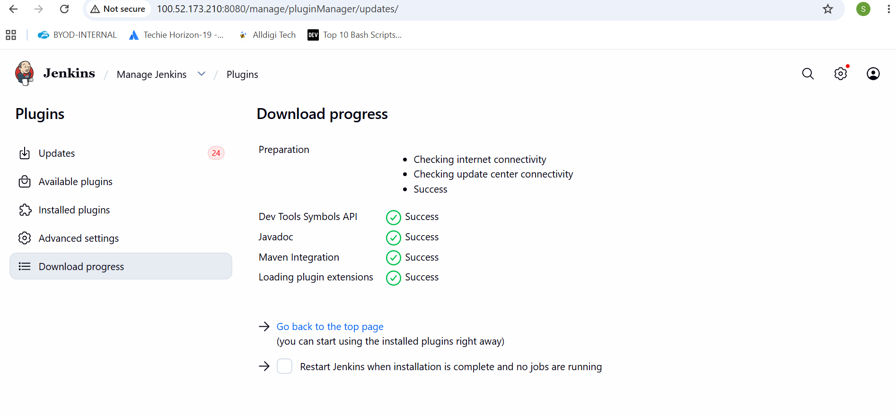
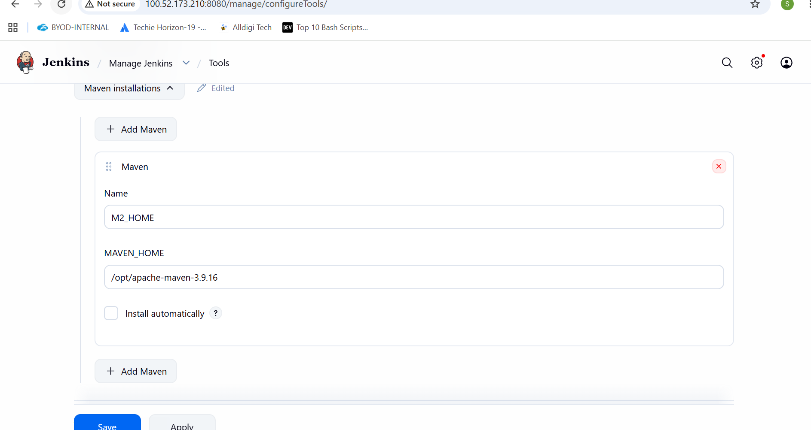
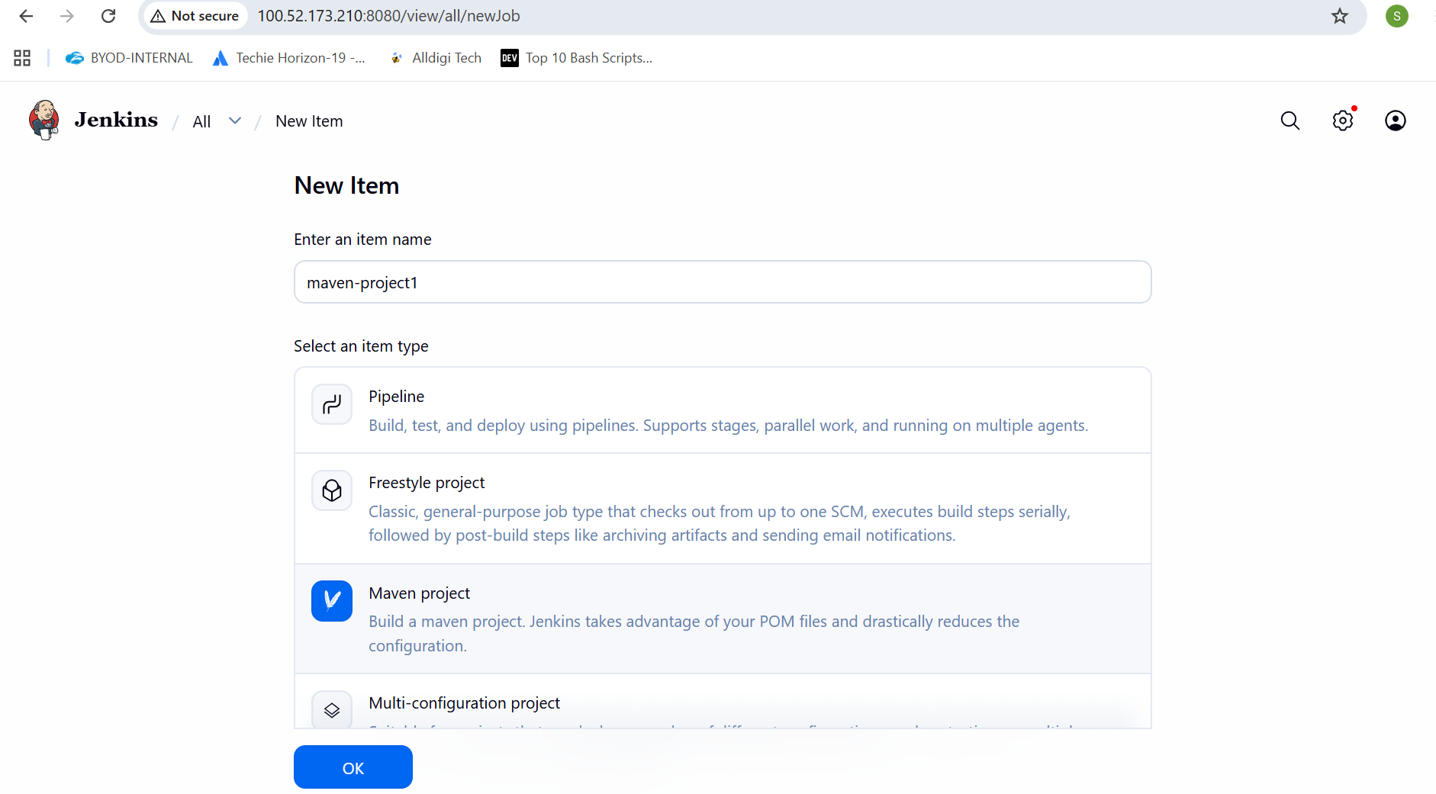

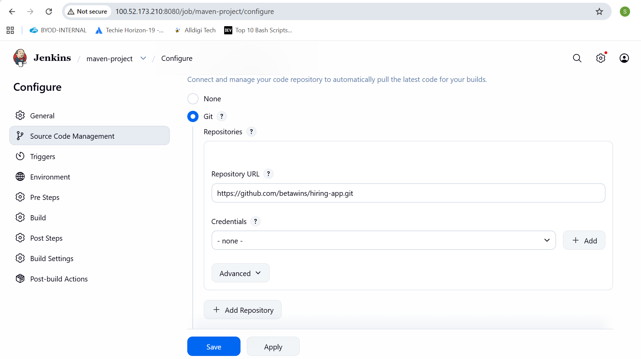
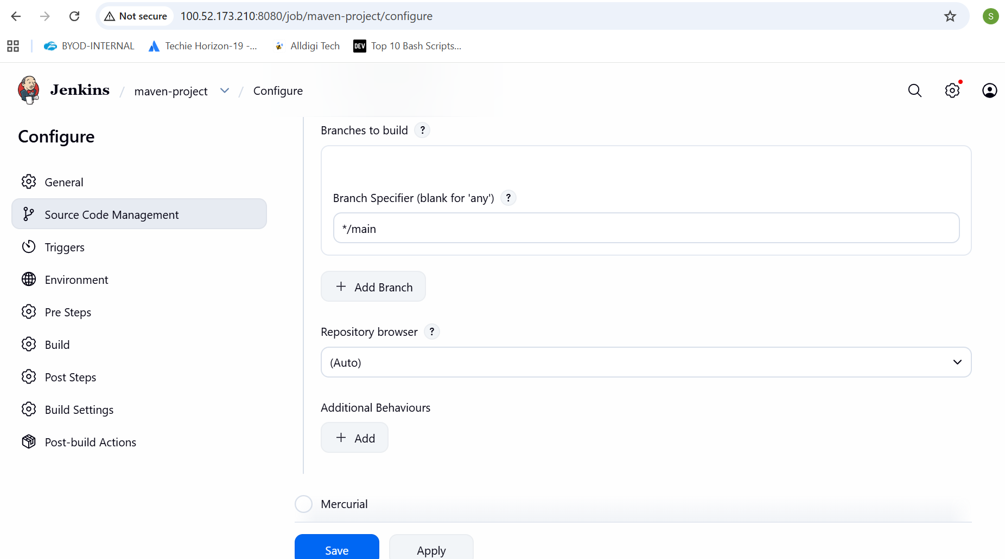
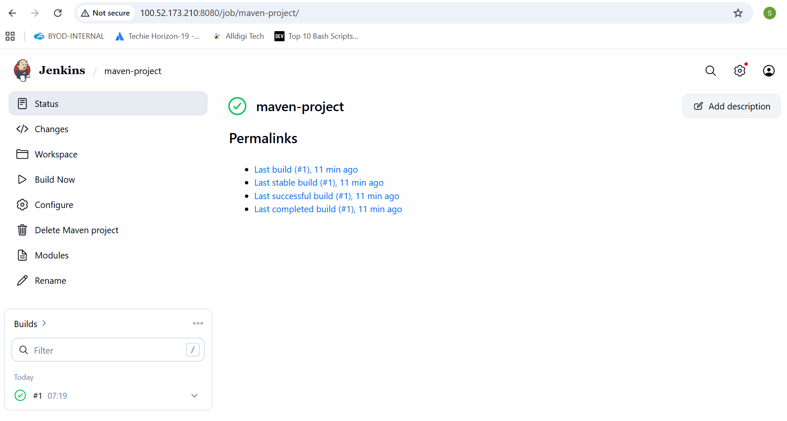
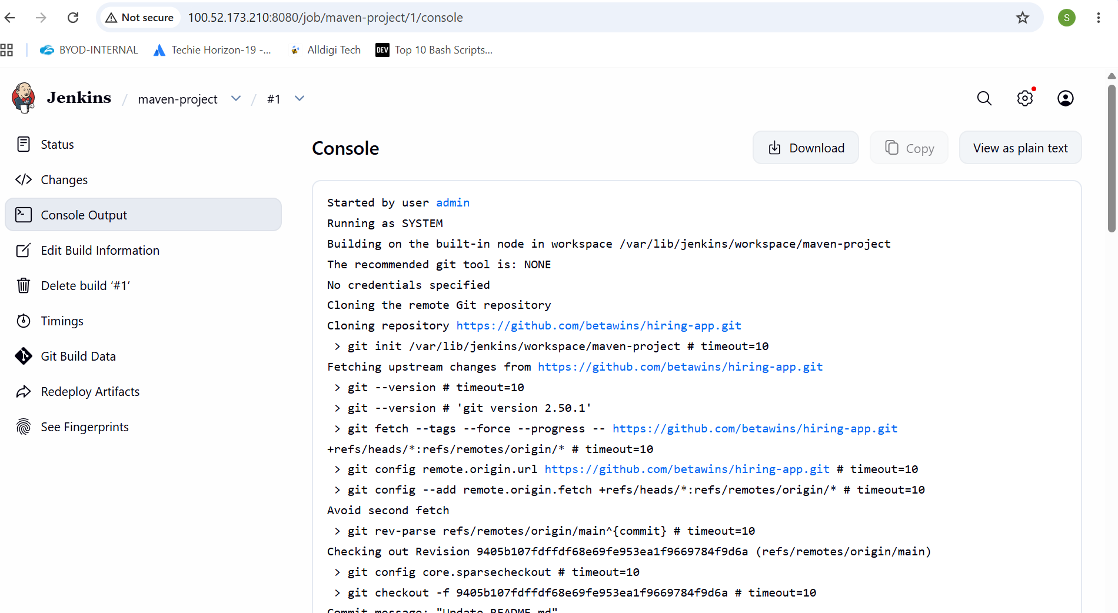
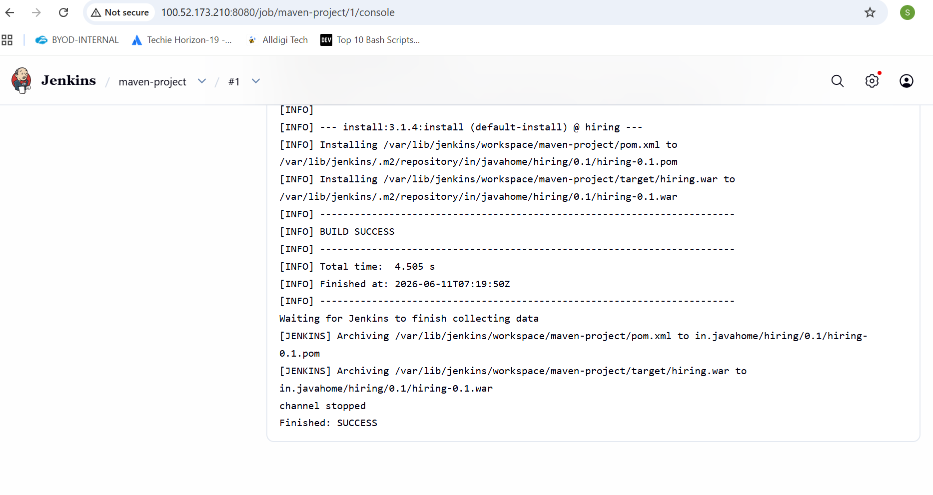
6.Use the same code and create a parameterized job in Jenkins with:
  - Stage 1:Git clone
  - Stage 2:Maven CompilationCode:https://github.com/betawins/java-Working-app.git
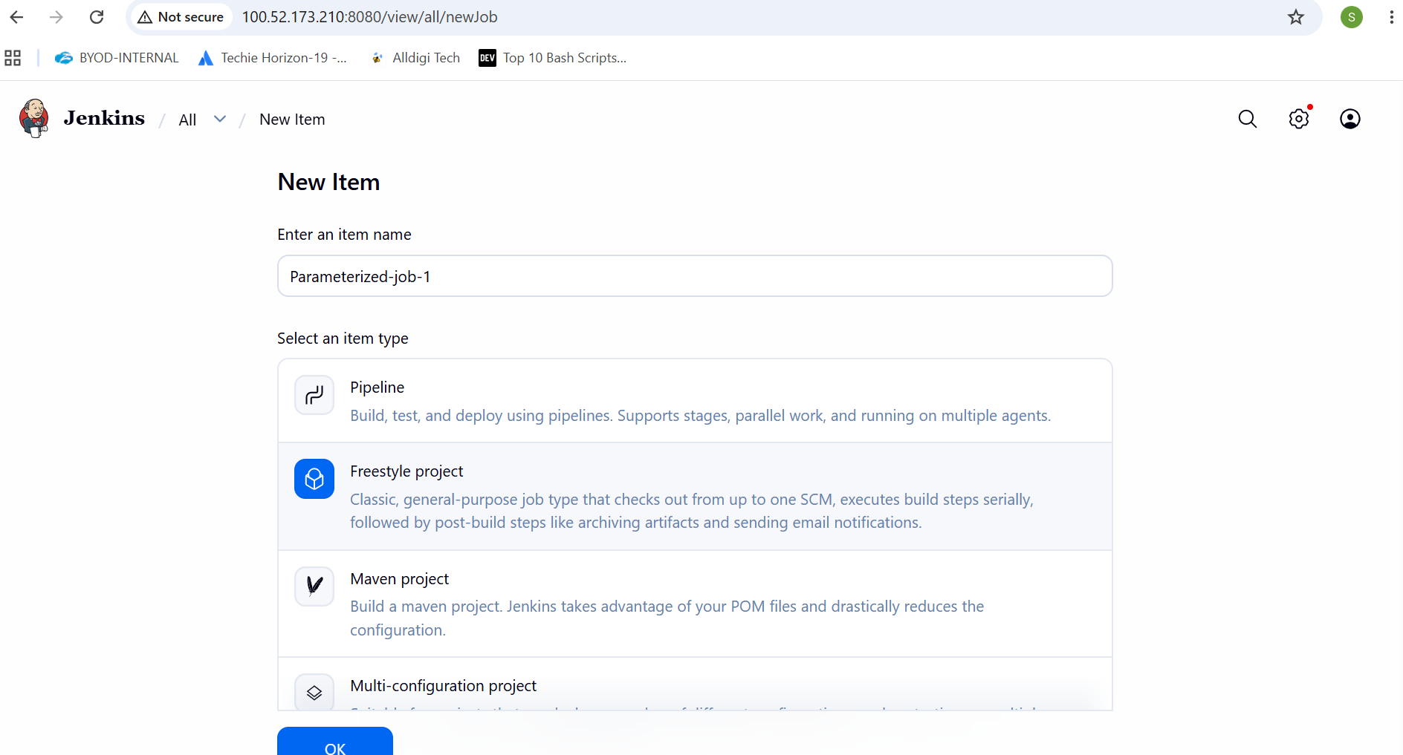
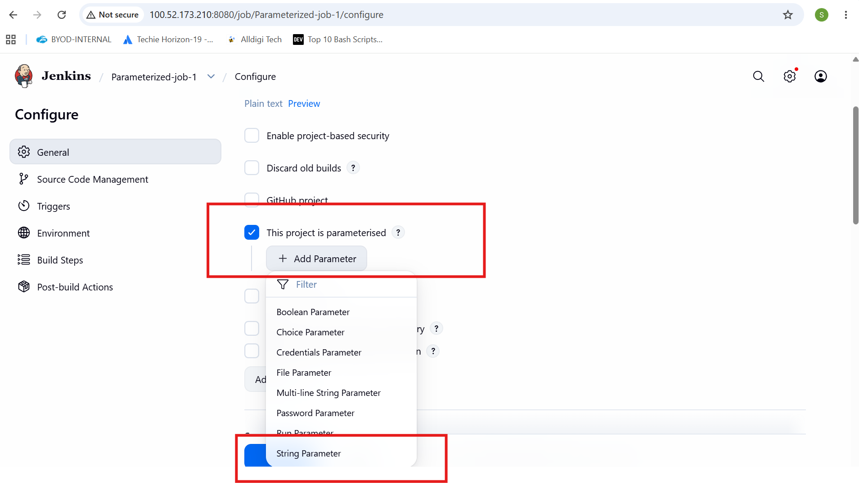
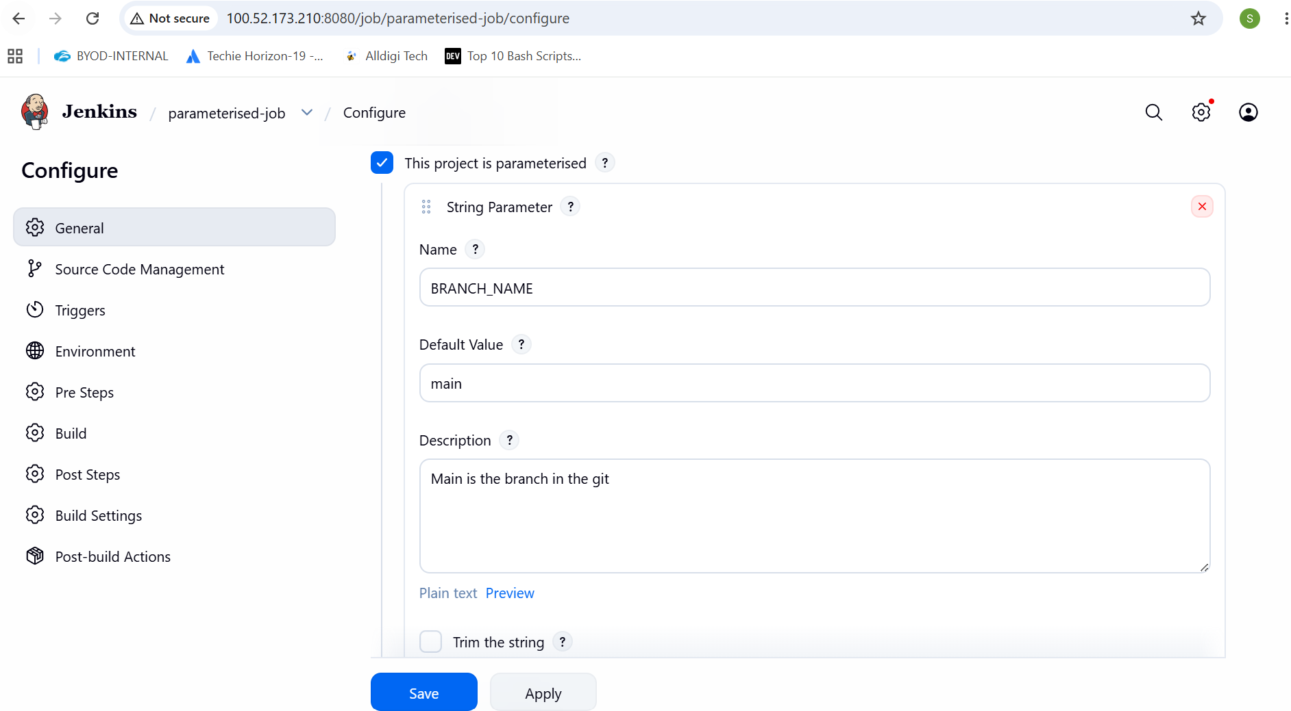
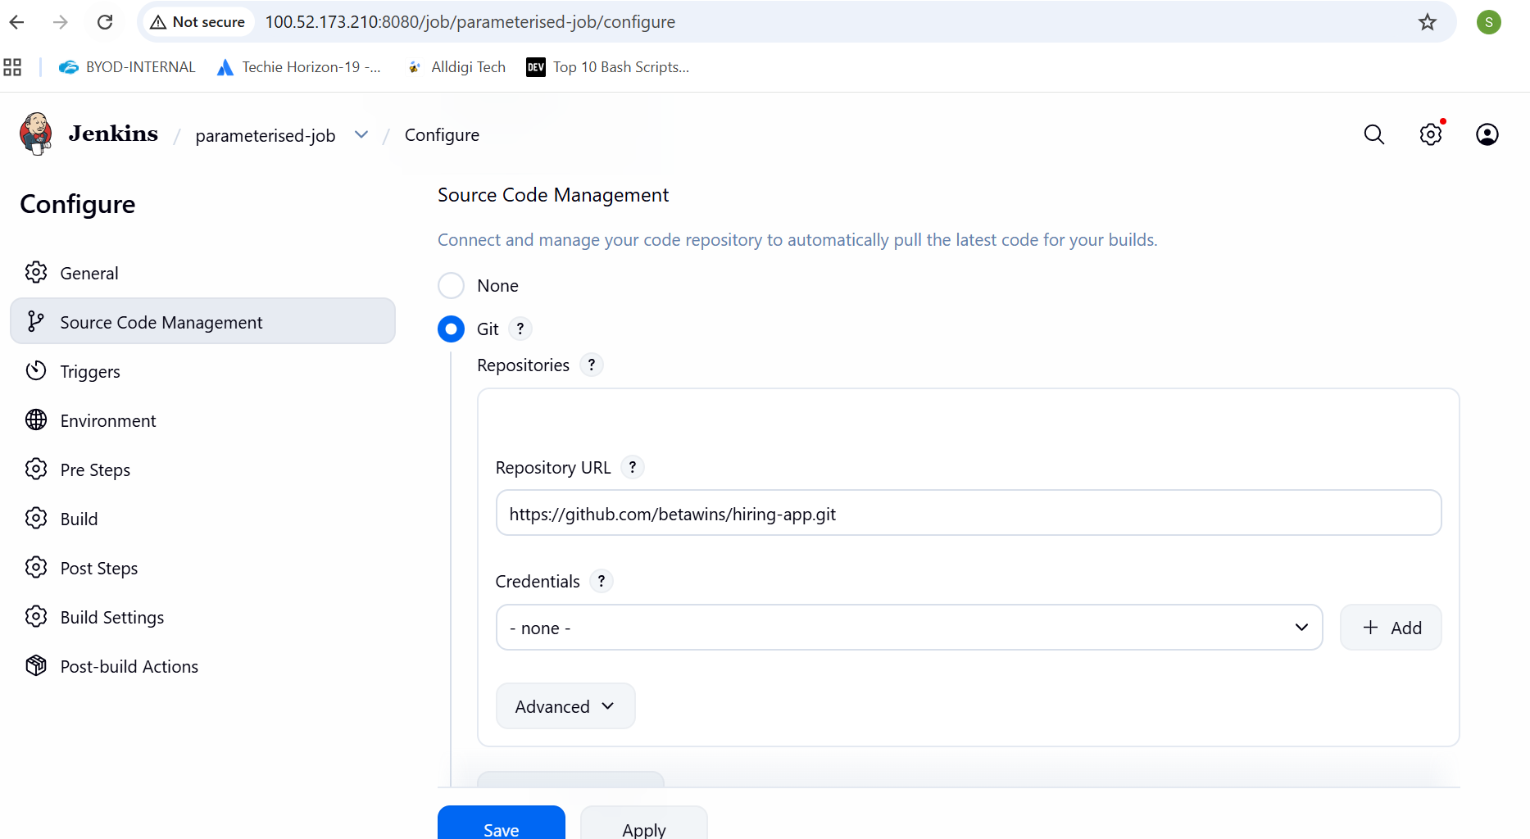
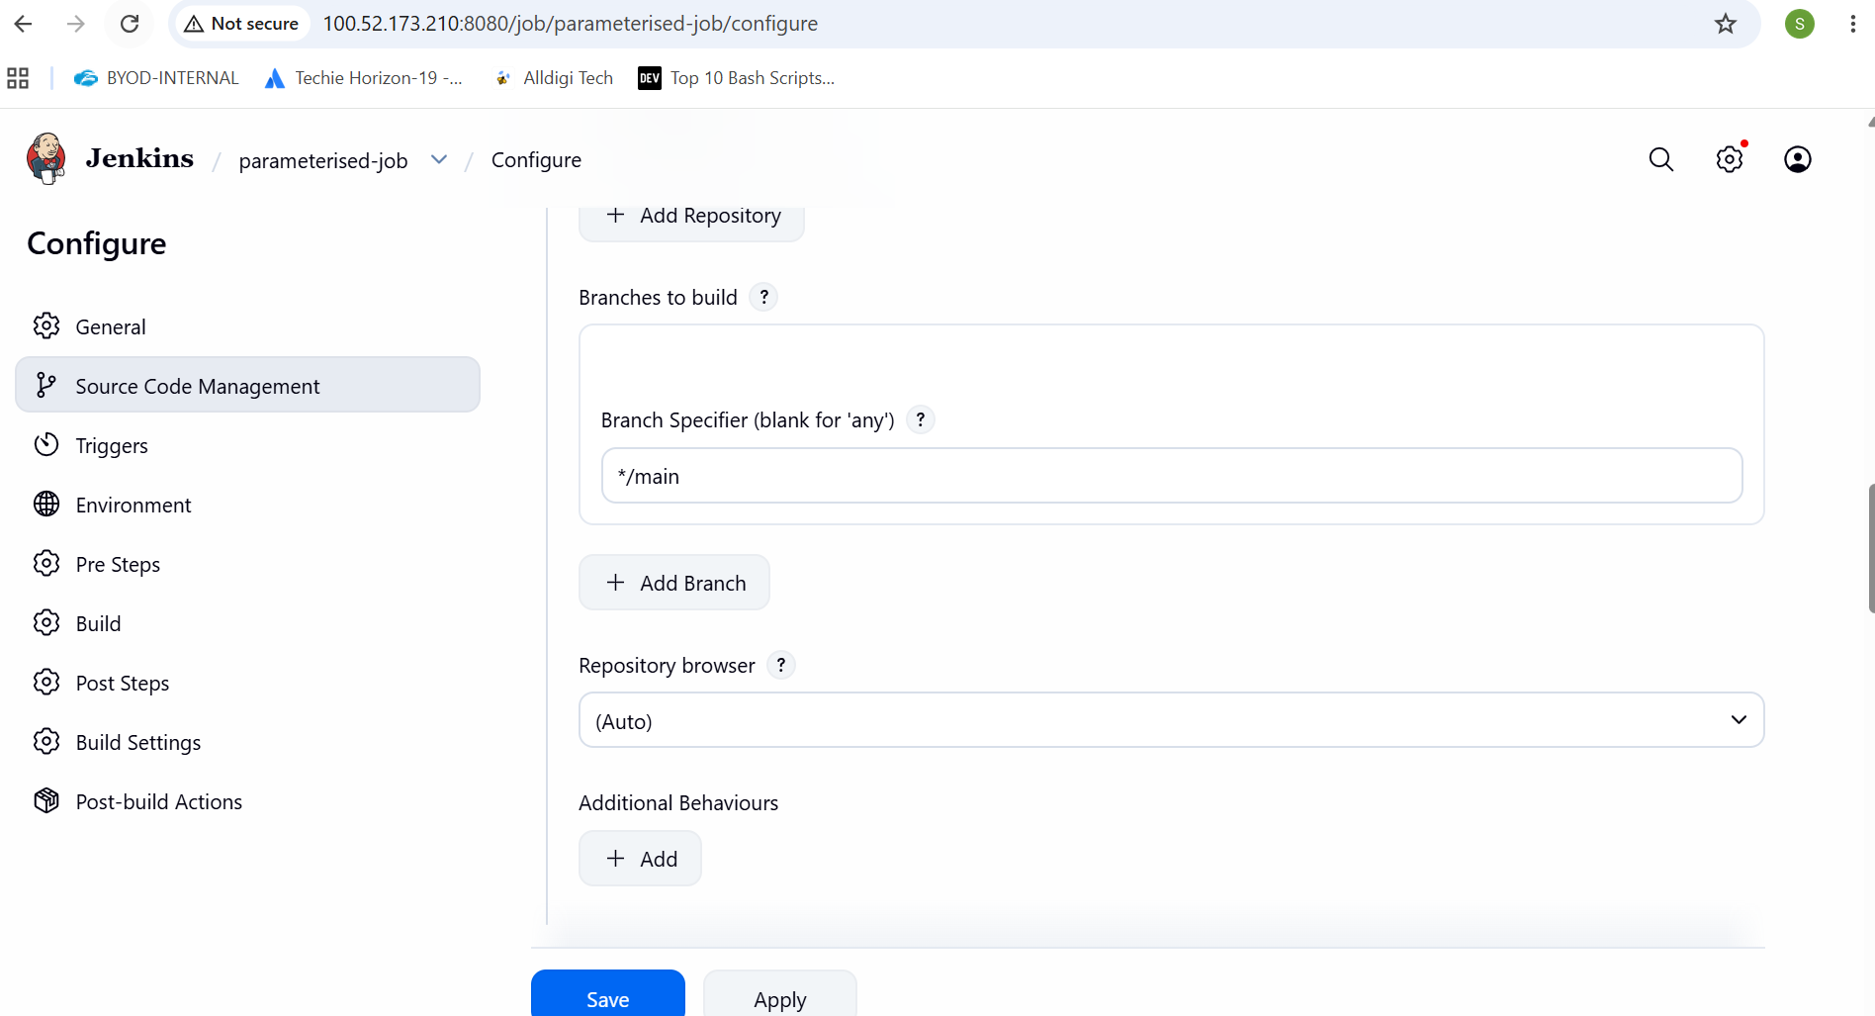
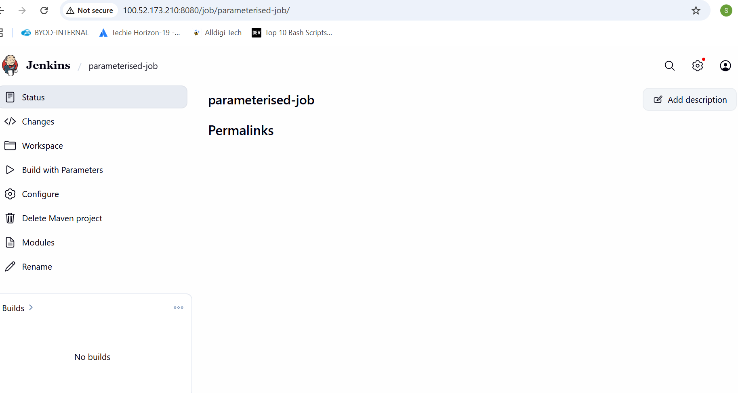
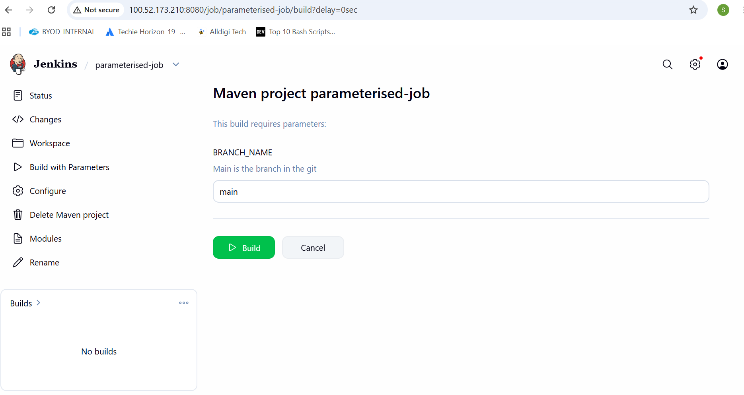
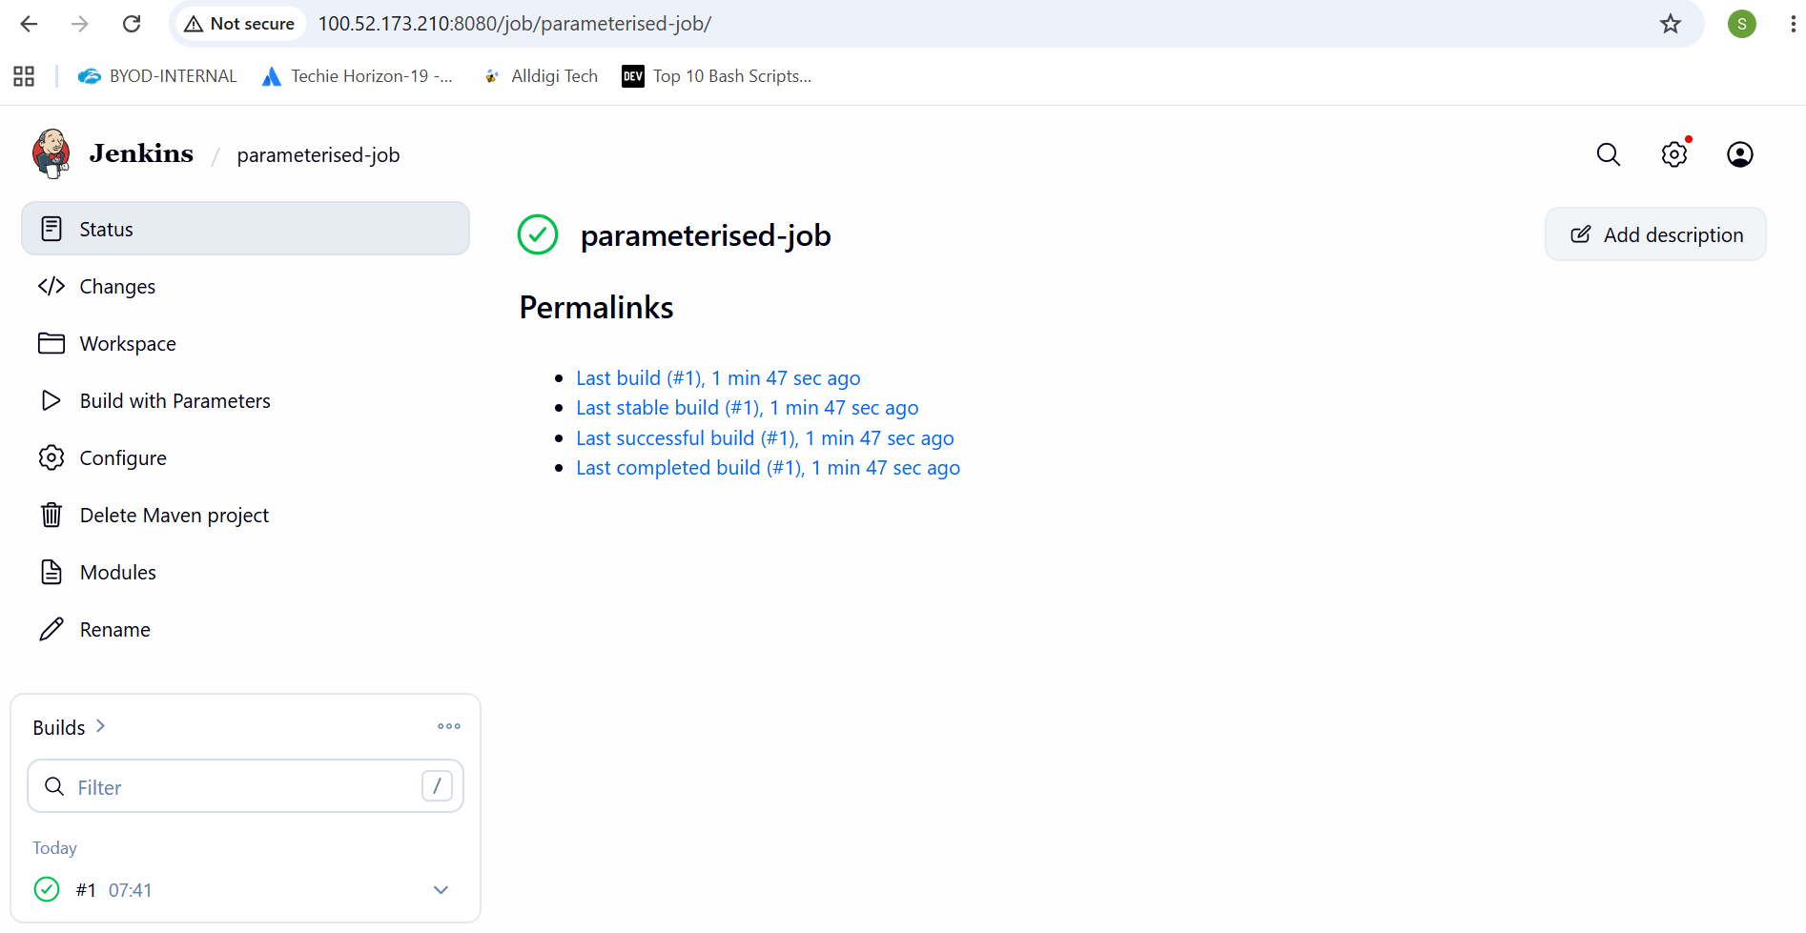
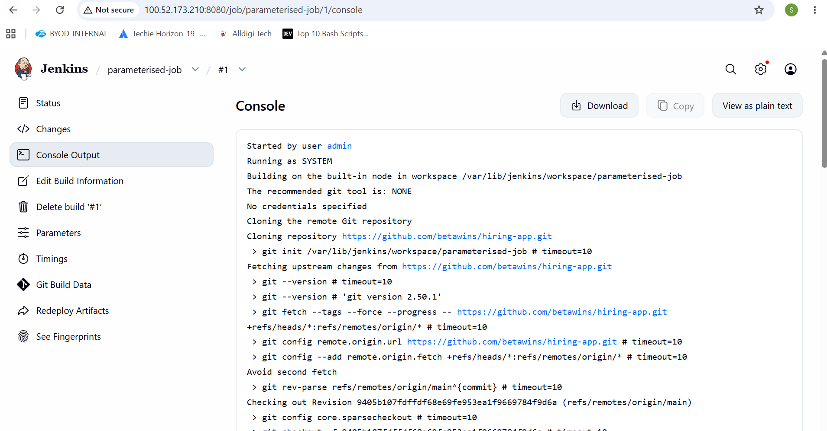
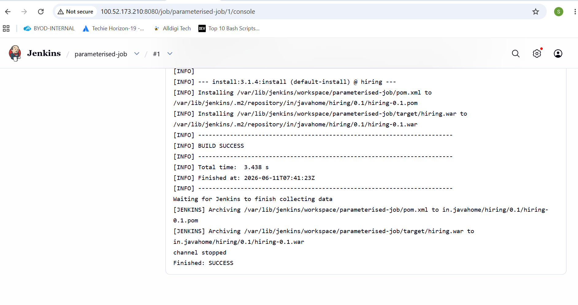
6. What are the global variables in Jenkins?
Global variables in Jenkins are predefined environment variables accessible across jobs and pipelines. They provide build-related information such as build number, workspace path, job name, Git branch, and Jenkins home directory.
Some commonly used global variables include
BUILD_NUMBER, which stores the current build number,
JOB_NAME, which contains the name of the Jenkins job, and
WORKSPACE, which defines the location where Jenkins clones the source code and executes builds.
Variables like GIT_COMMIT and GIT_BRANCH help identify the exact Git commit and branch used during the build process.
These global variables are useful in automation, scripting, and CI/CD pipelines to make Jenkins jobs more dynamic and reusable.

