Terraform-04
1). Watch Terraform-04 video.
2). Execute the script shown in the video.
Version Constraints:
===================
Changing in terraform providers version may get us into incompatability issues.
By default terraform will always try to downlaod the latest version of provider available from registry.
To make sure to use the specific version provider we can add the provider block in configuration.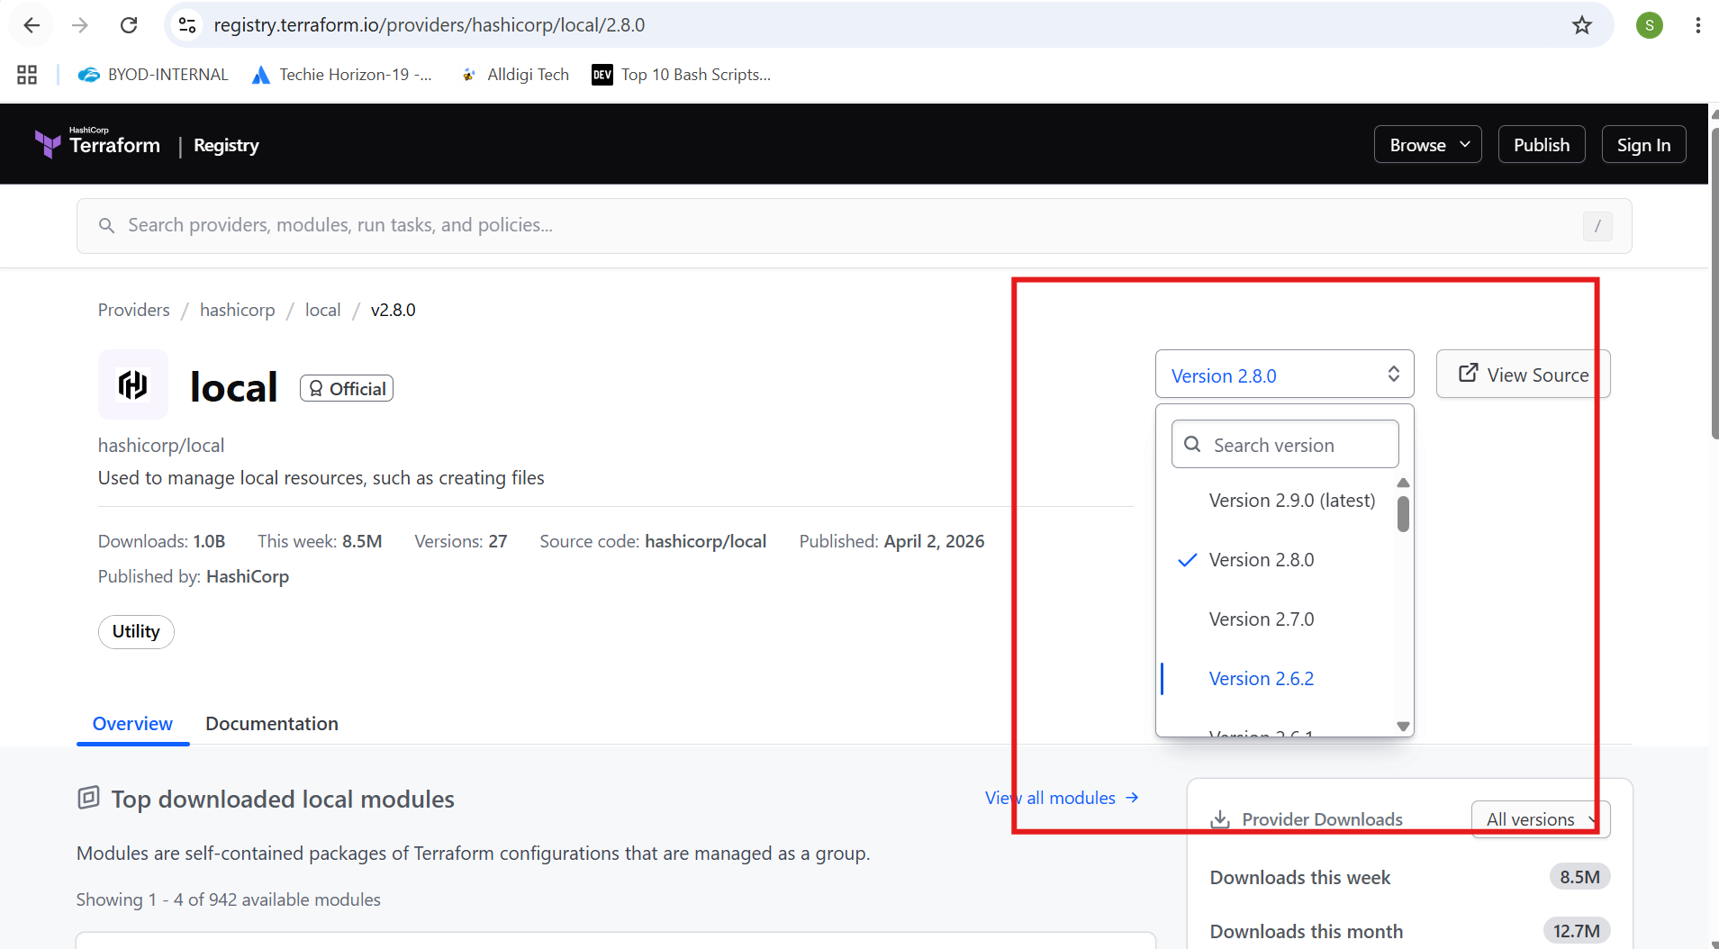
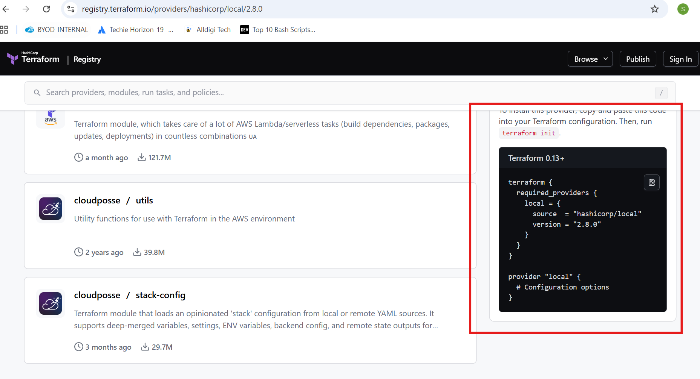
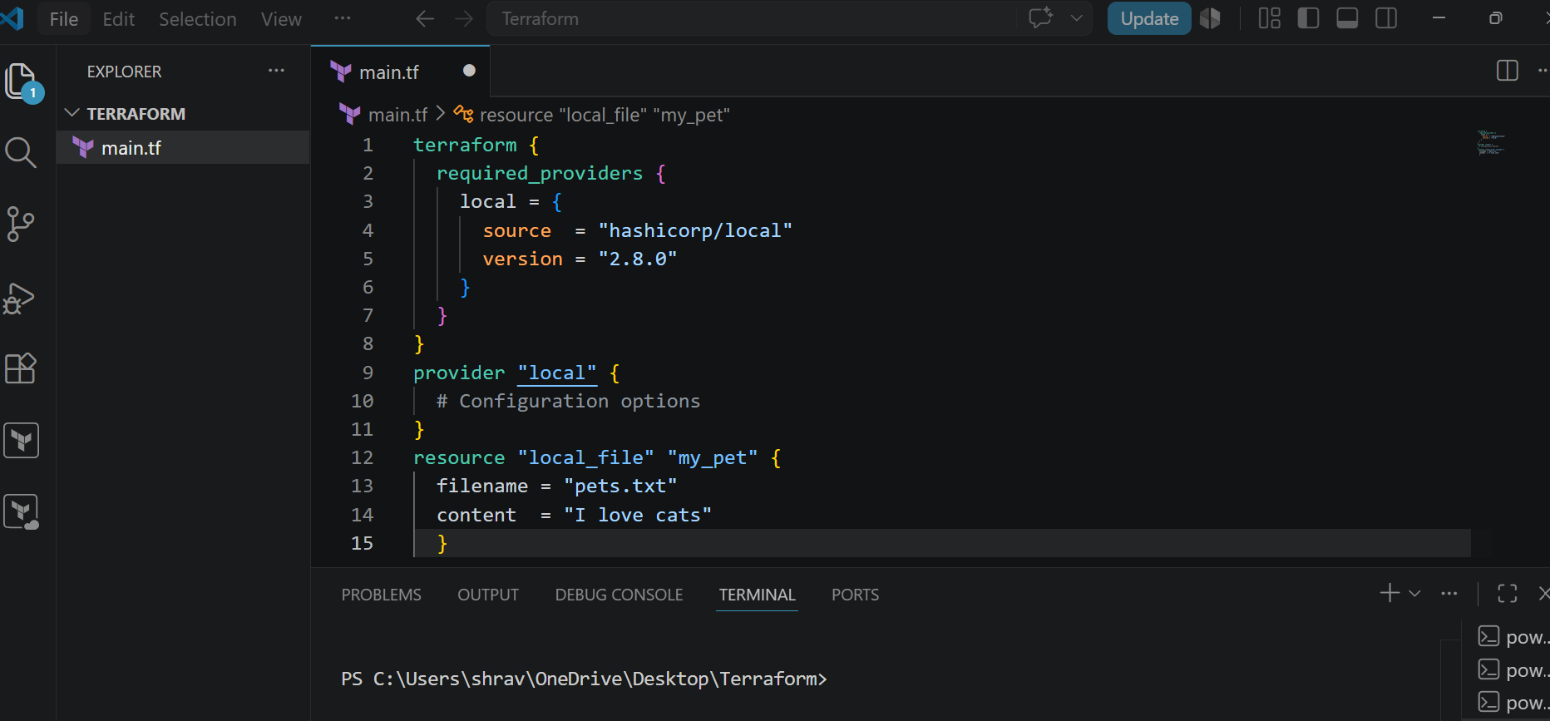
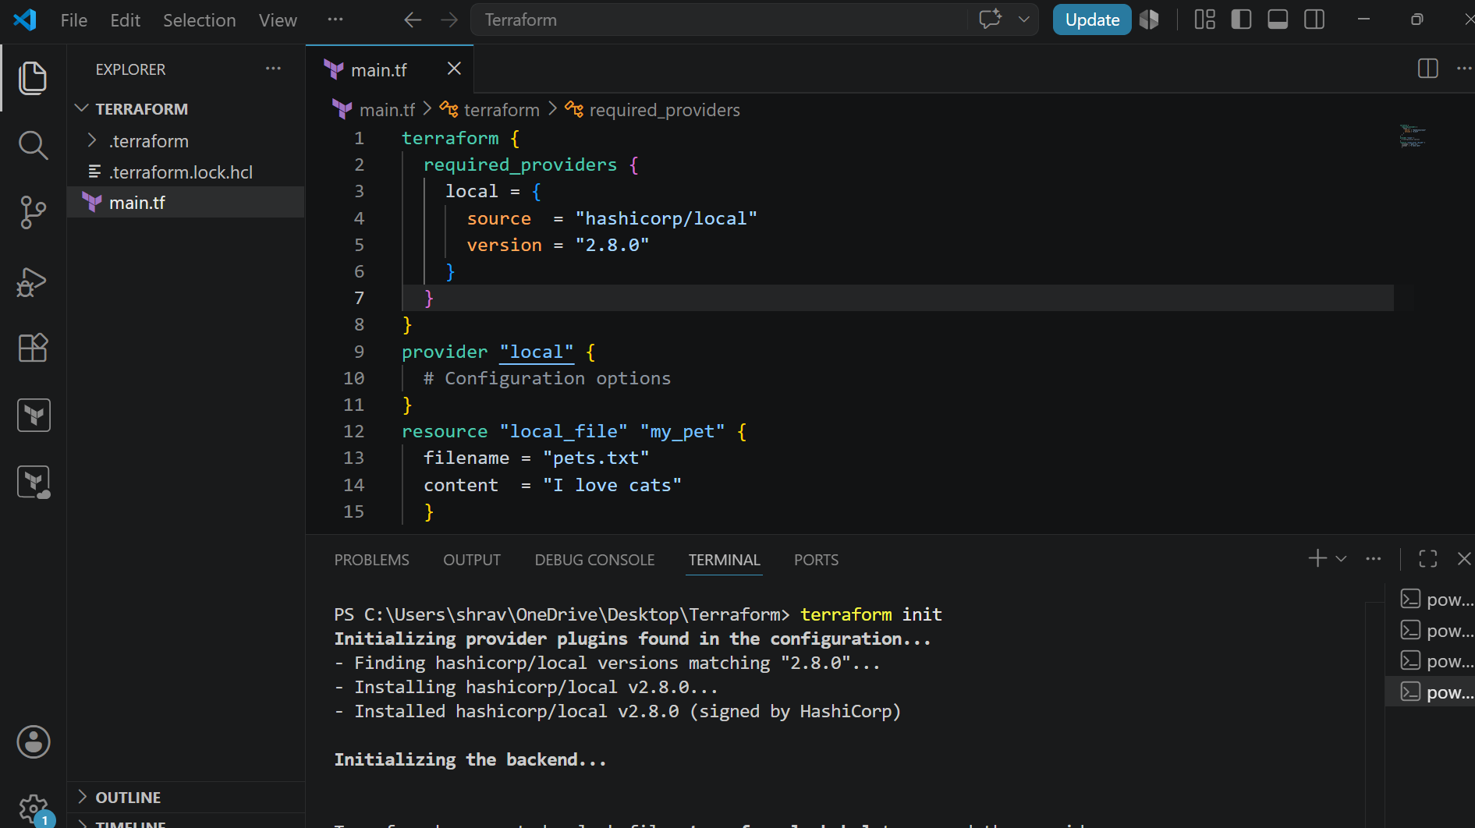
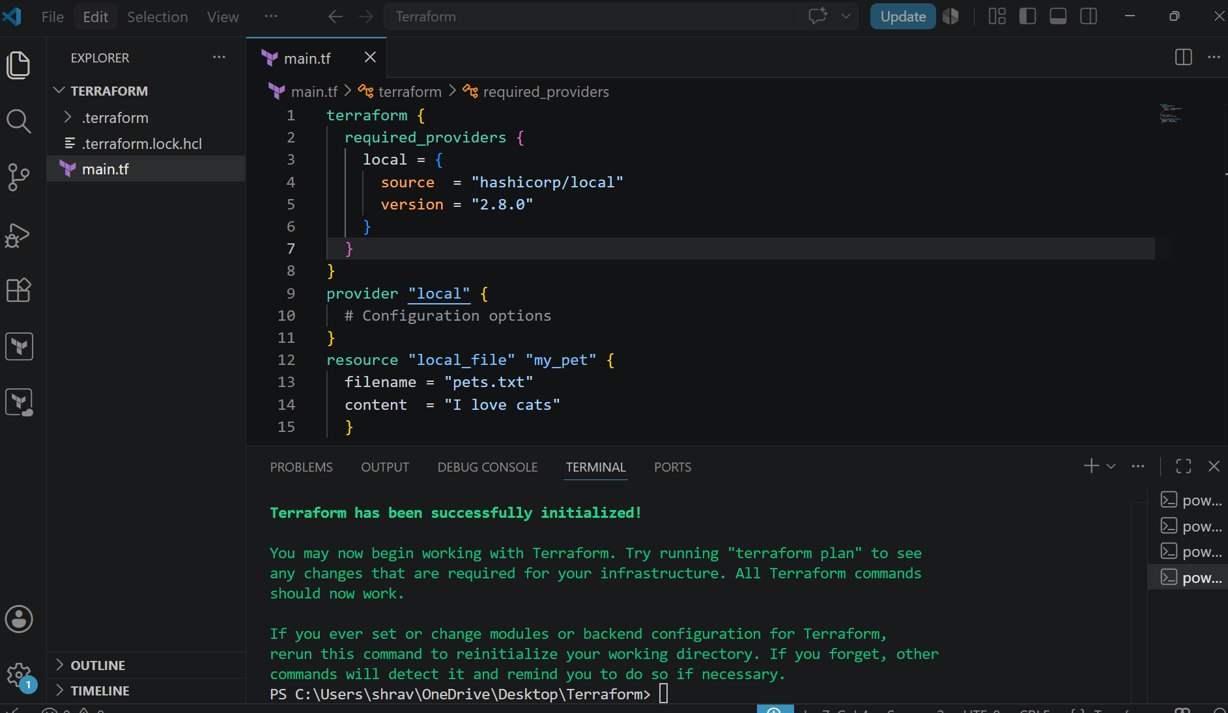
Upgrading from 2.8 to 2.7
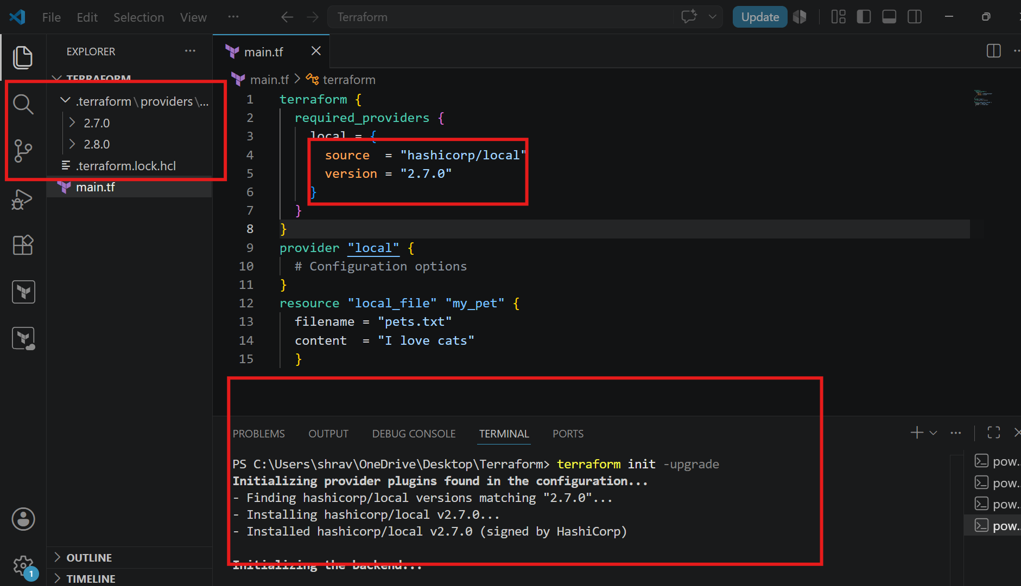
version = "!=2.6.2"
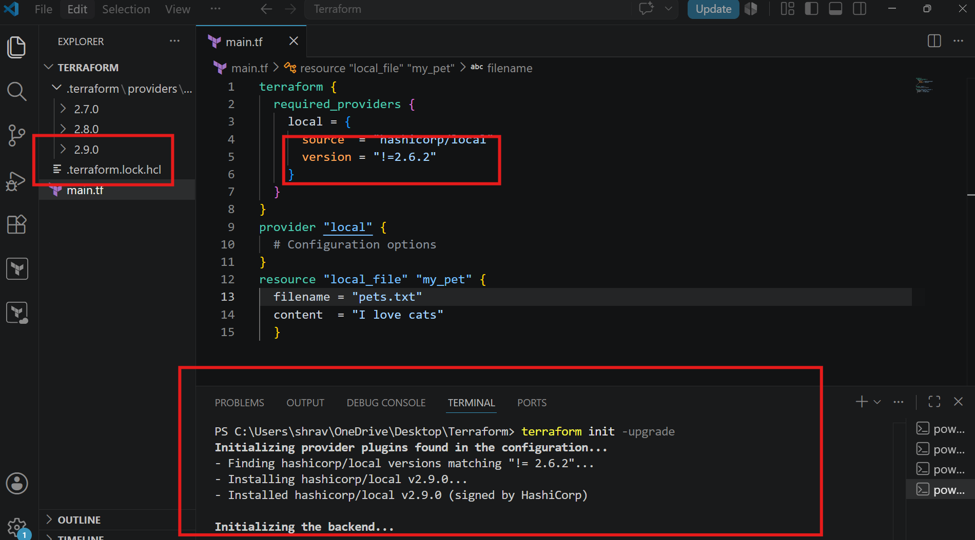
Passing 2 parameters
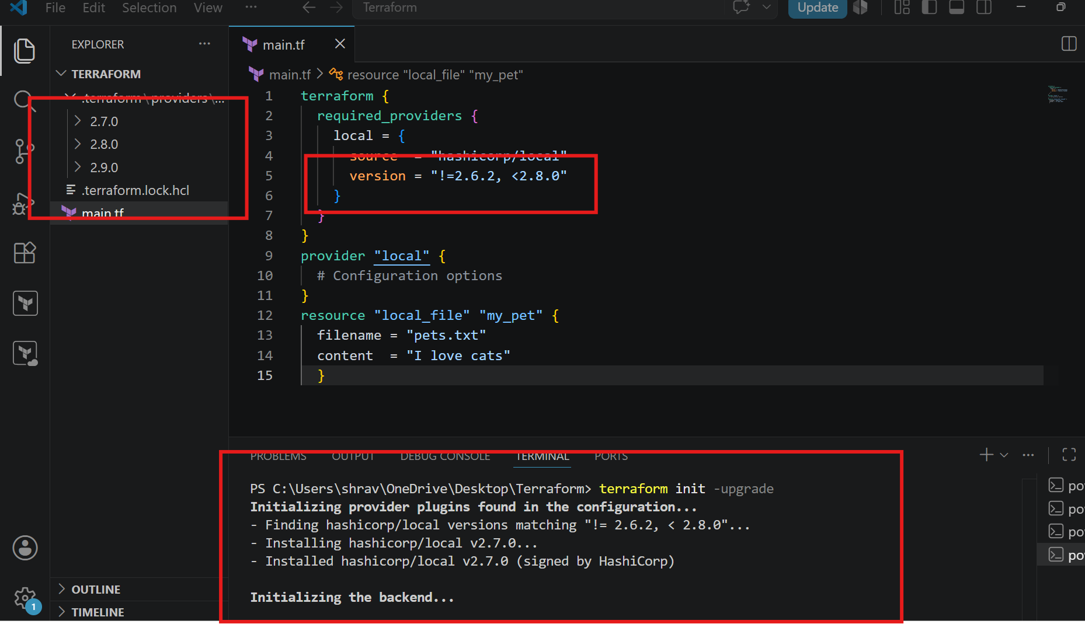
Data variables
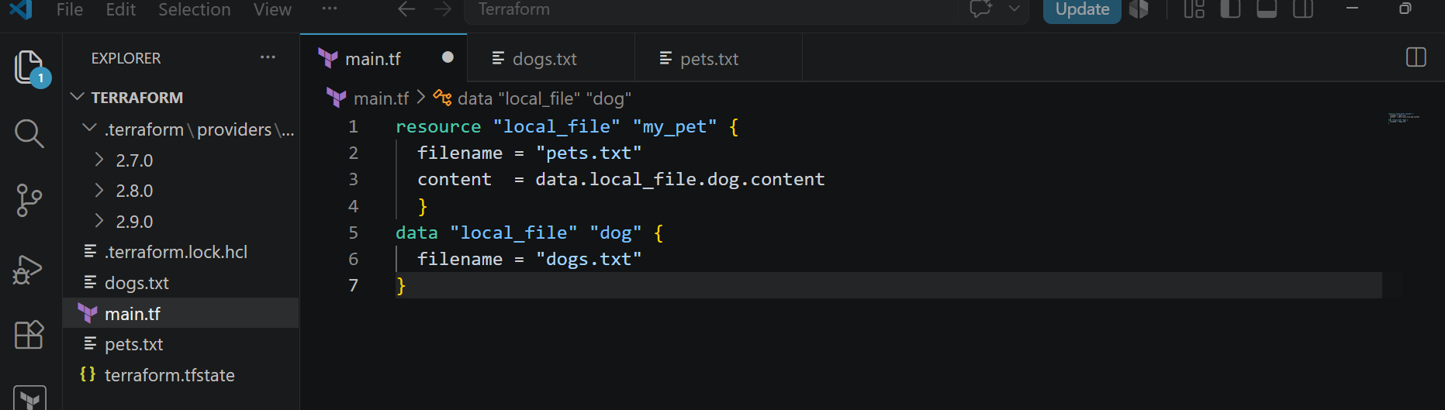
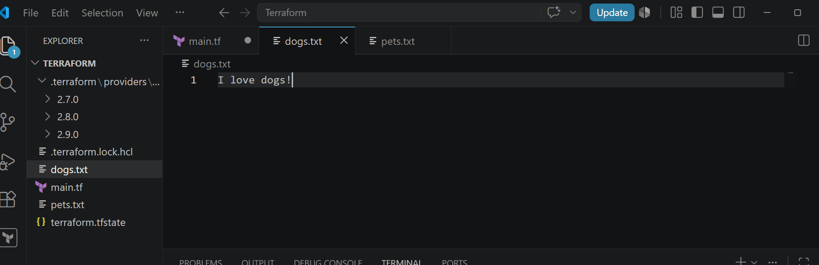
Now you can check in pets.txt
It is read from the main.tf and dogs.txt and then output will get in pets.txt
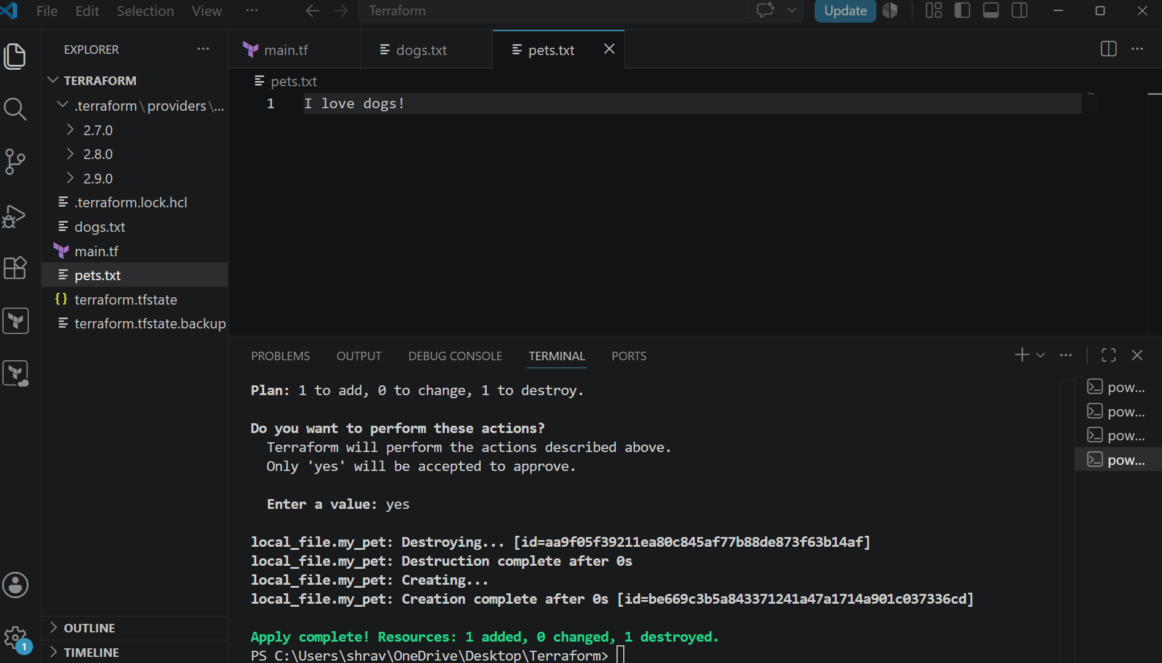
Meta arguments
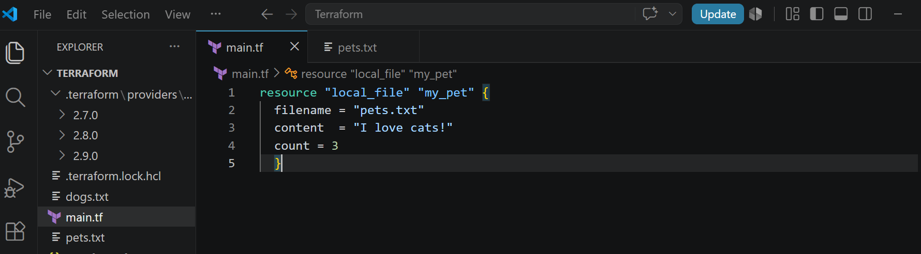
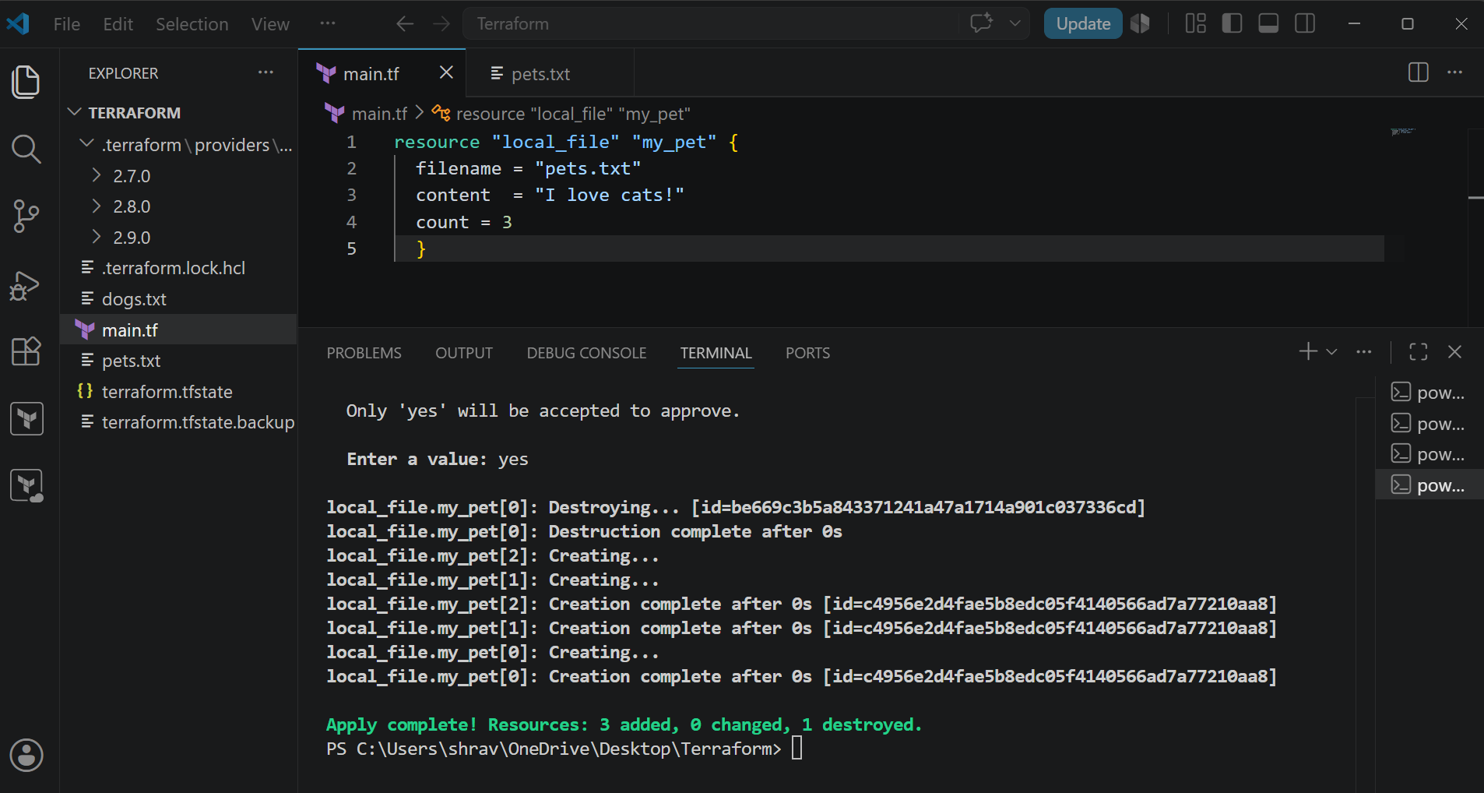
It is overriding
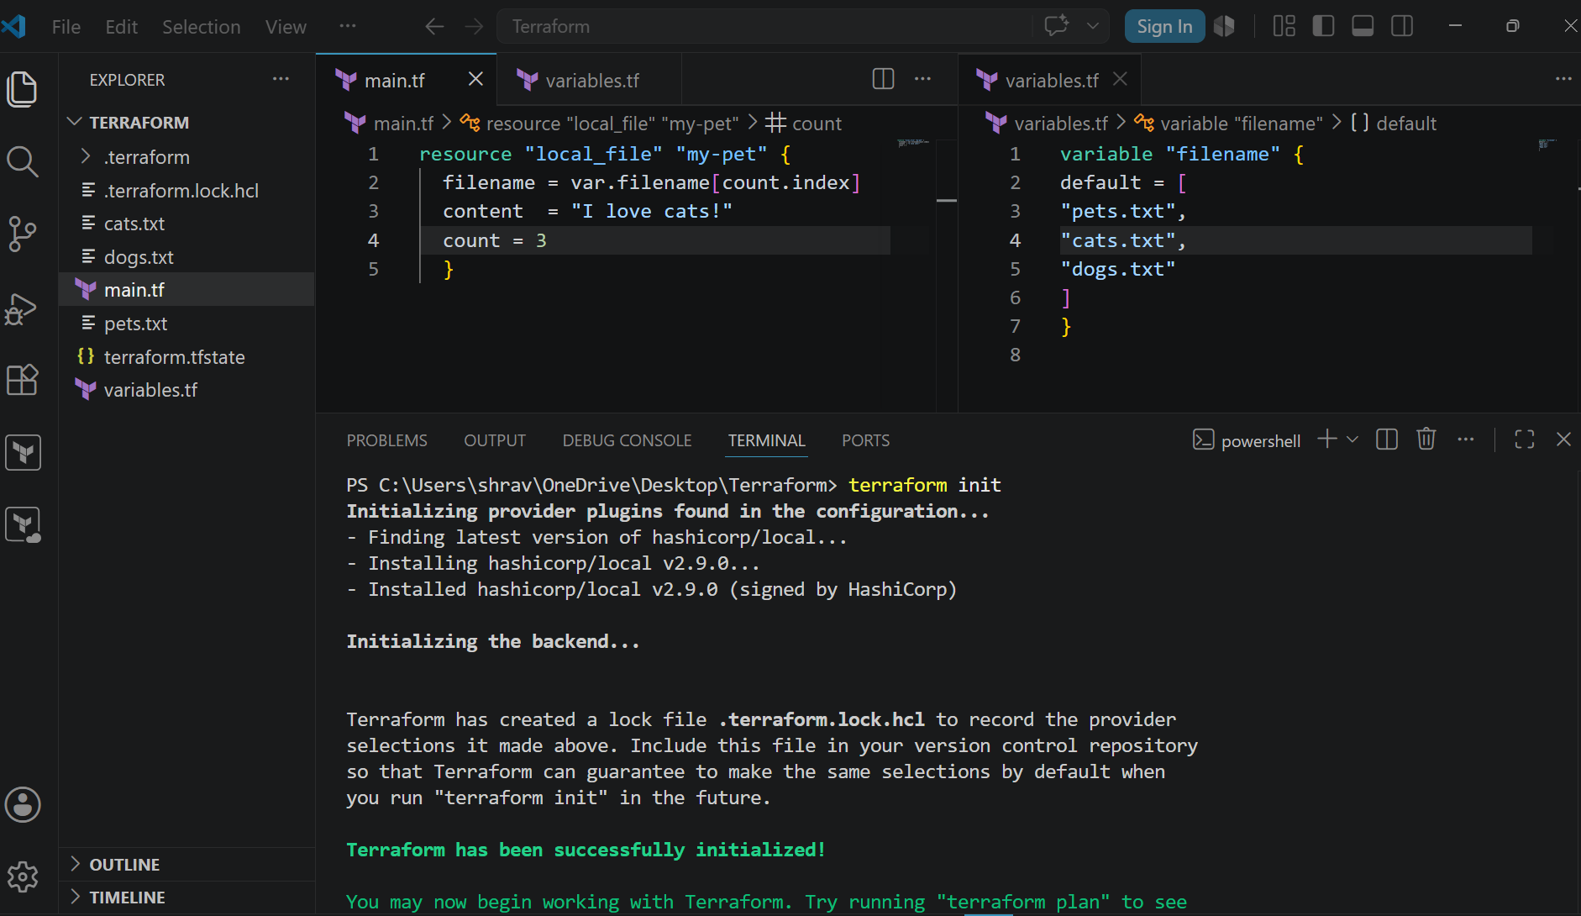

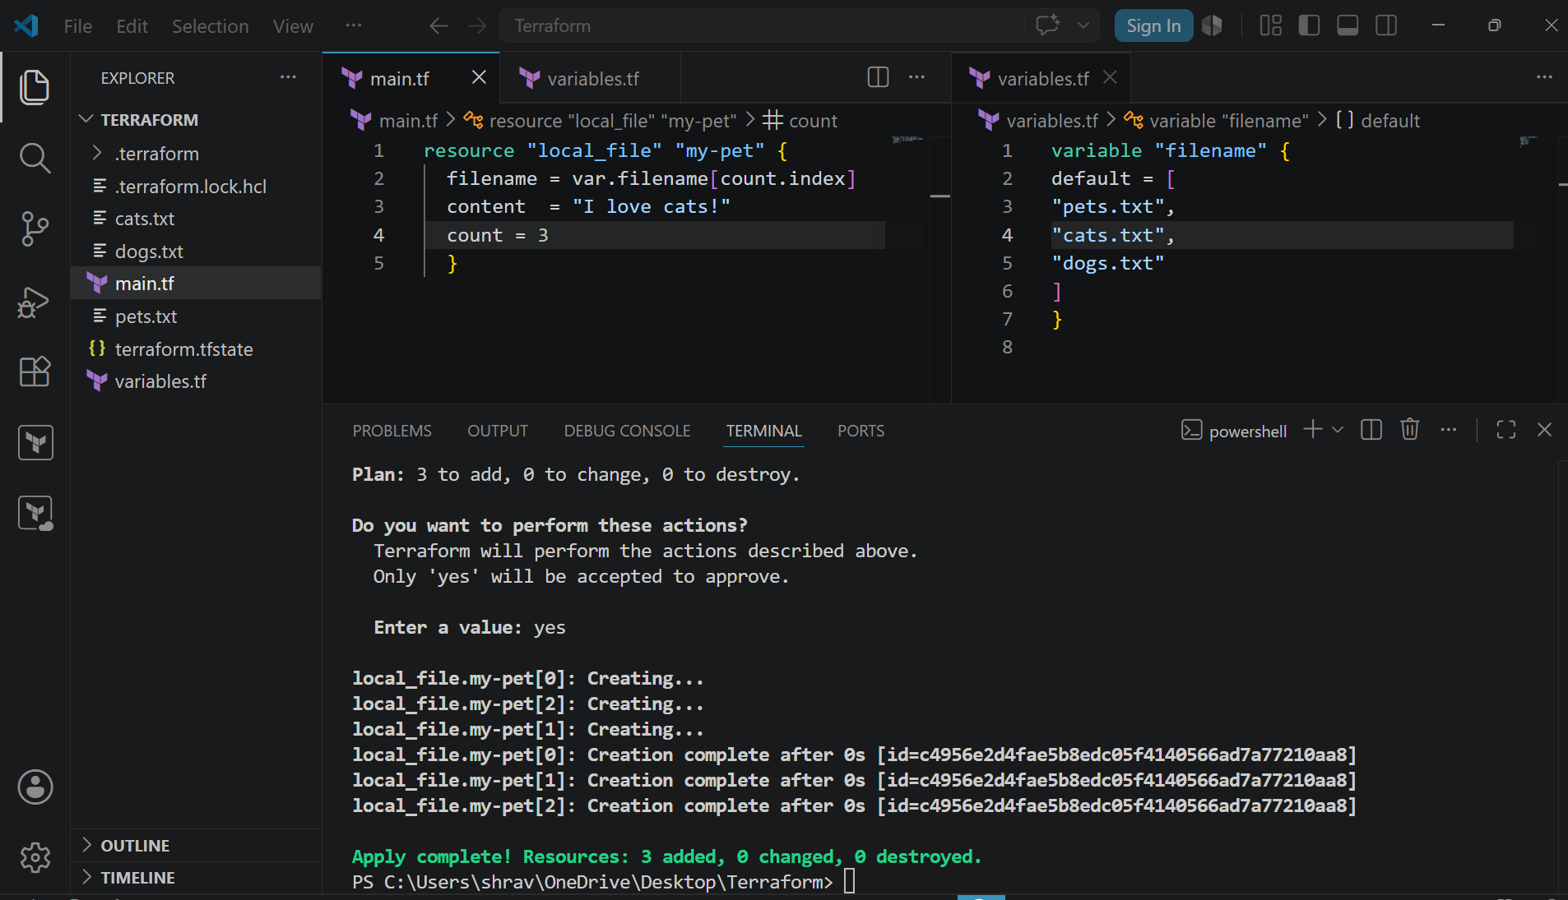
count = lenght(var.filename)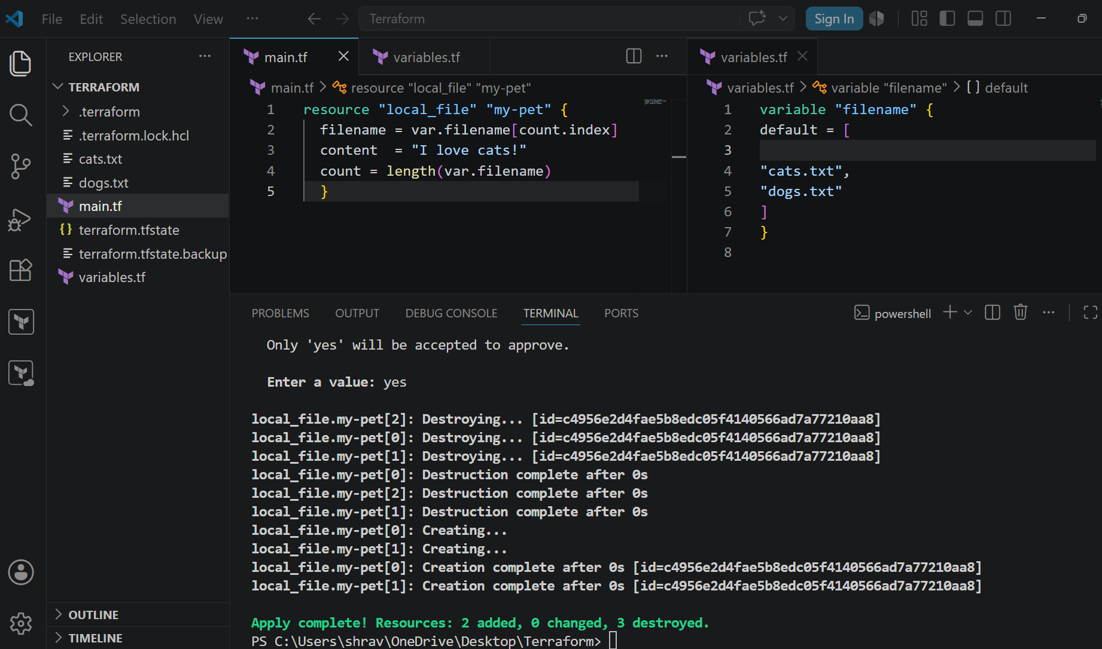
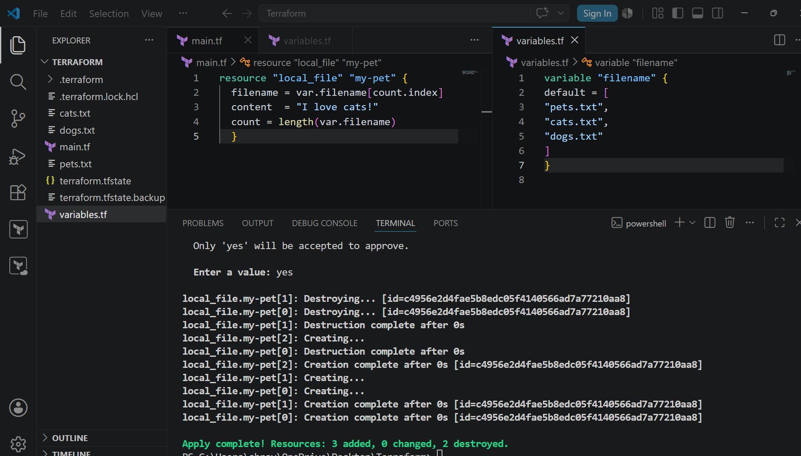
Using for each
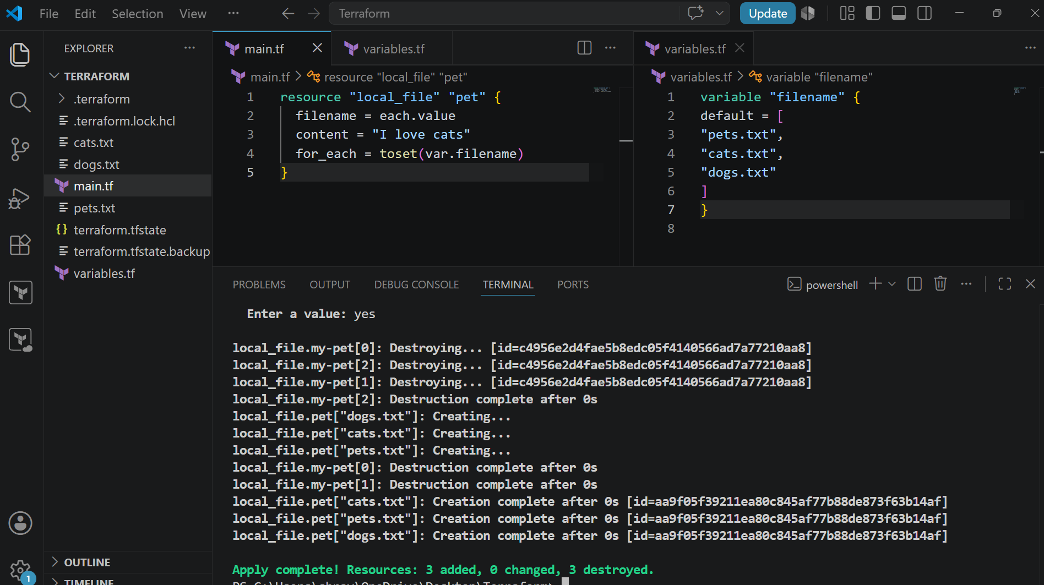
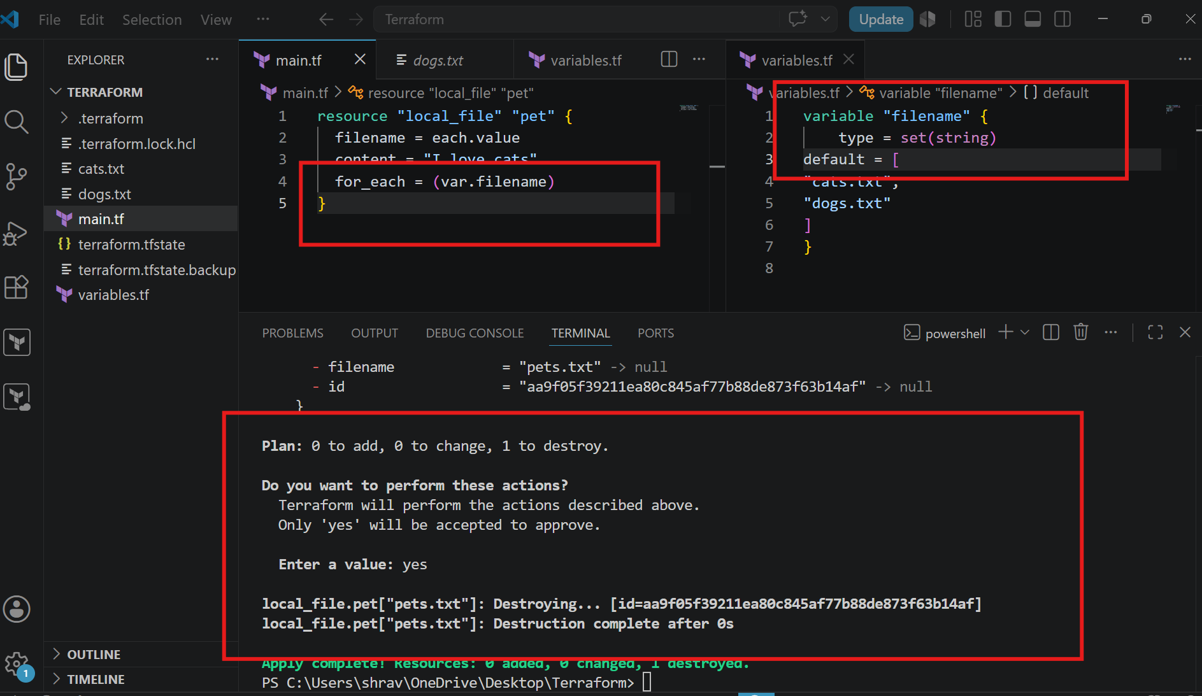
Creating I am user in EC2 by using Terraform
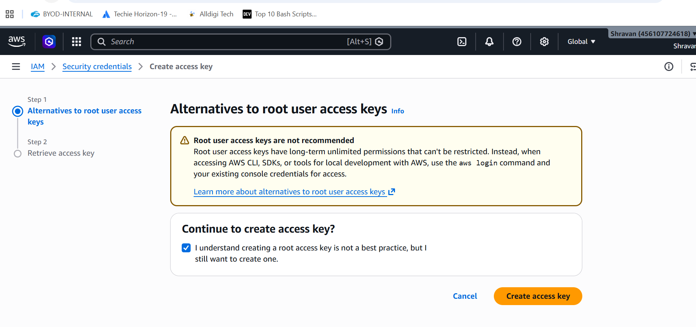
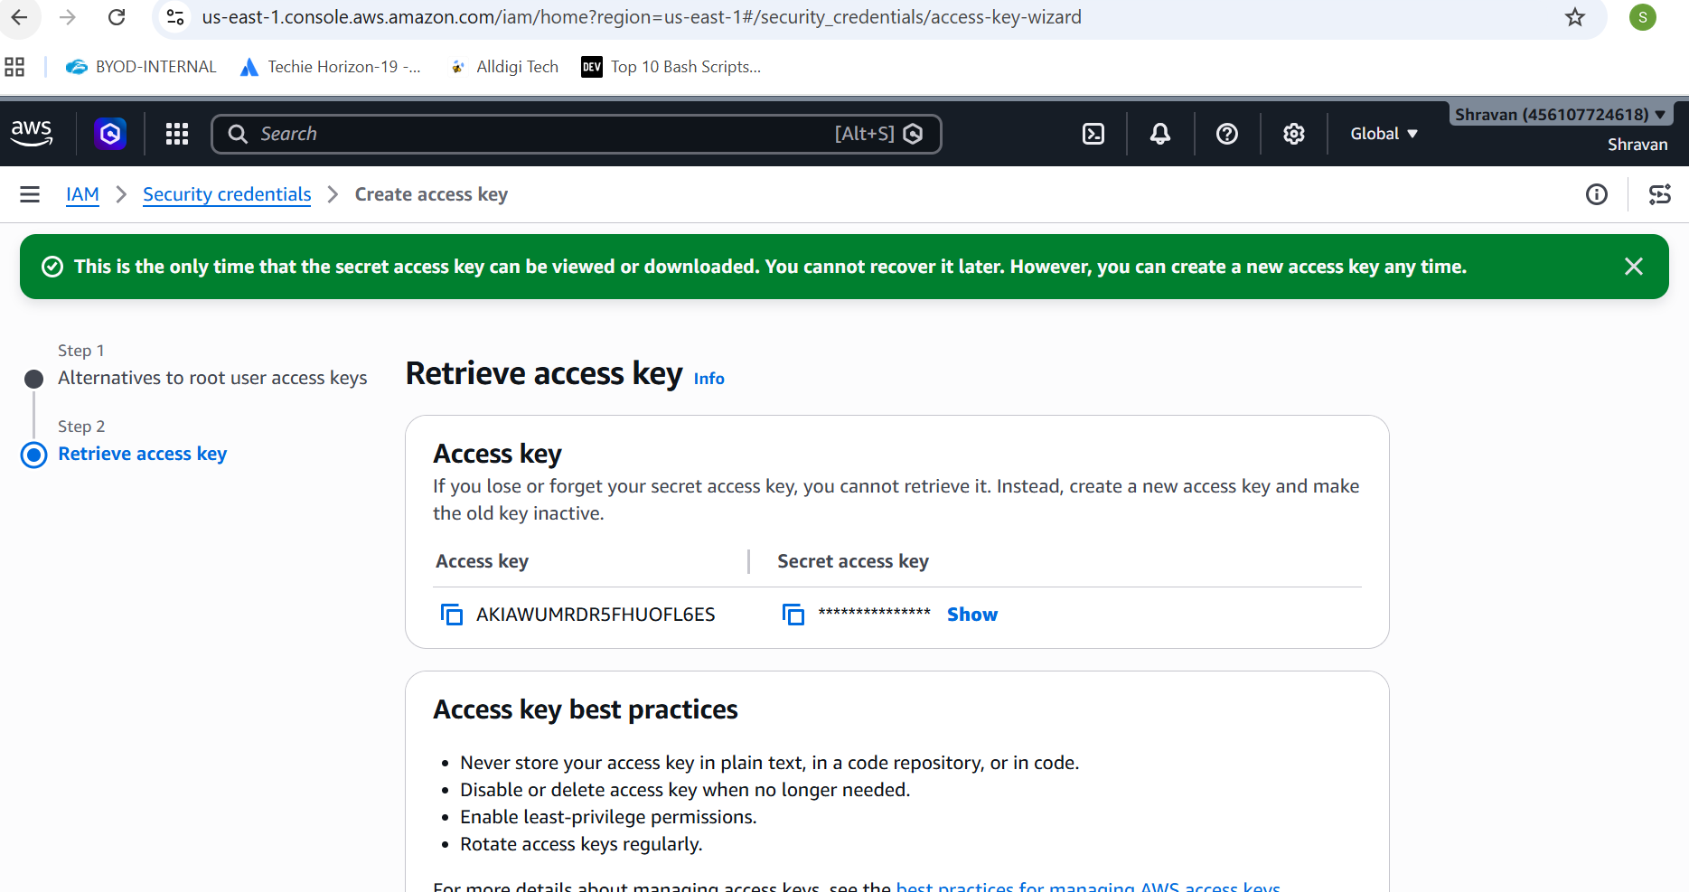
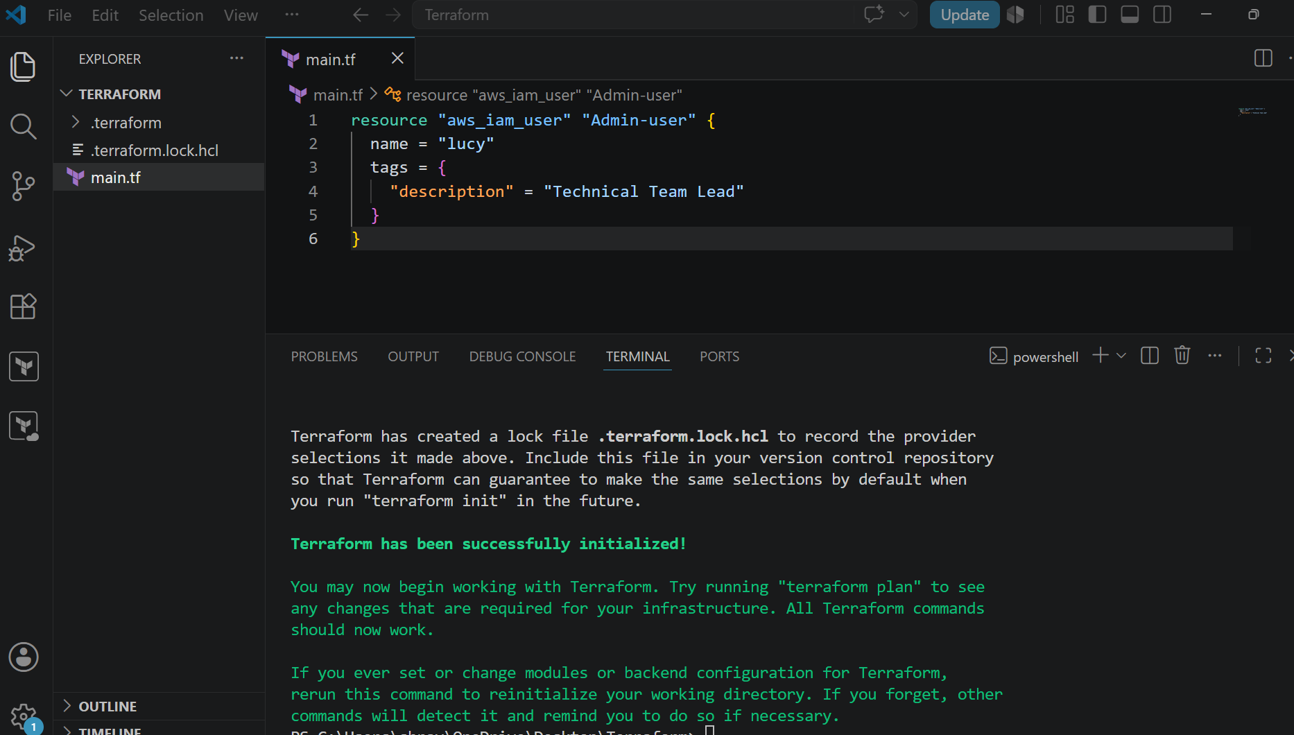
Terraform apply , if you do without aws configure then it will show an error
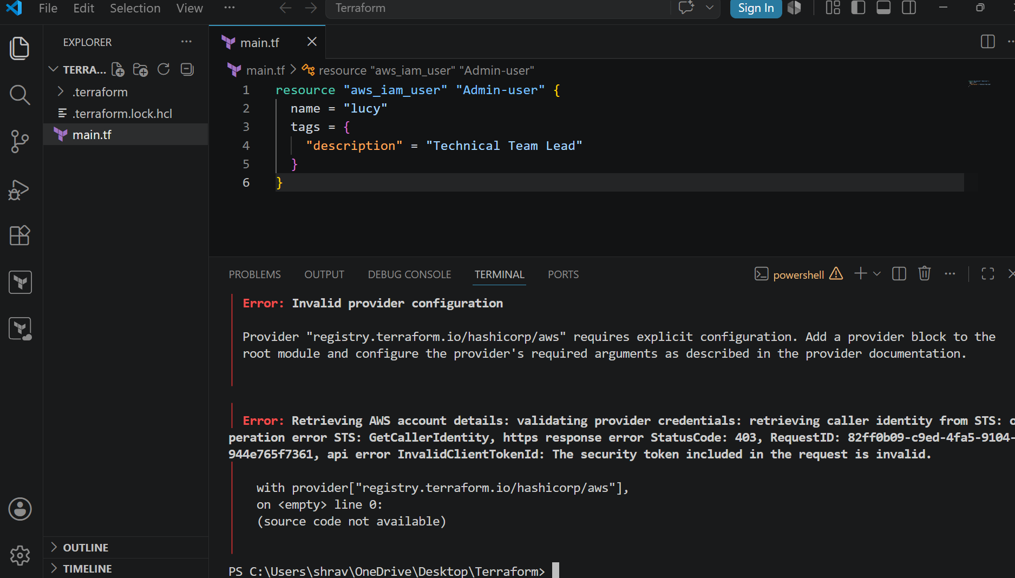
So first do AWS Configure
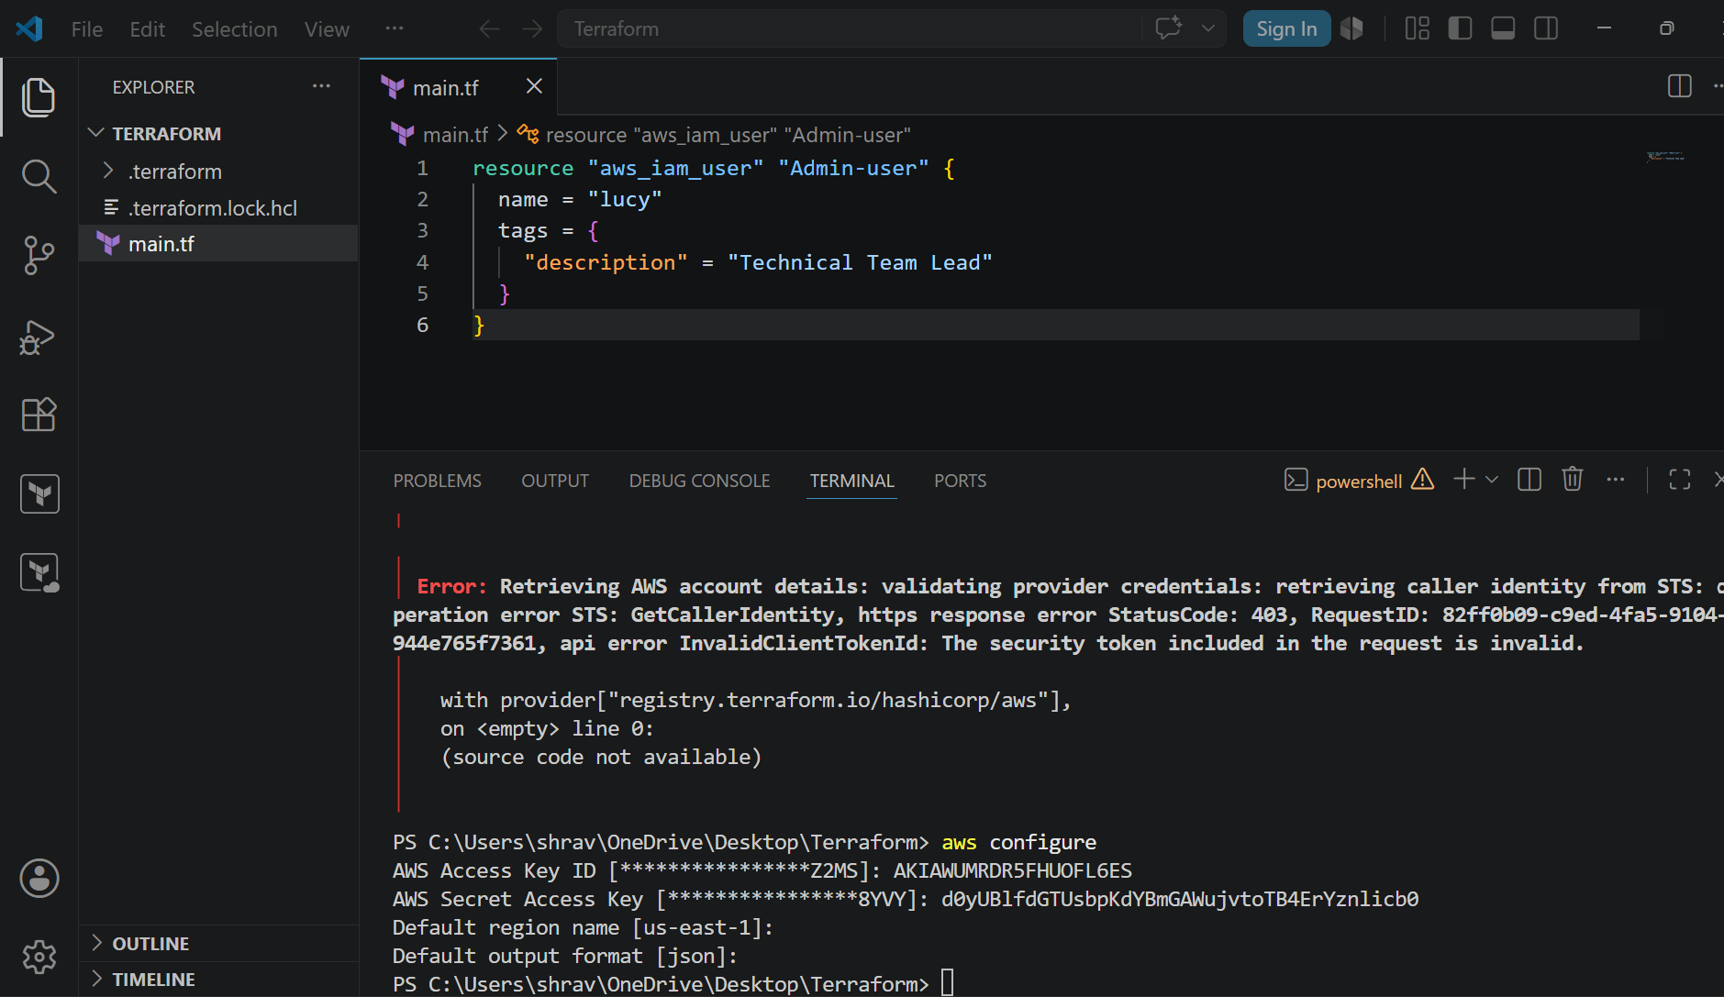
Terraform apply
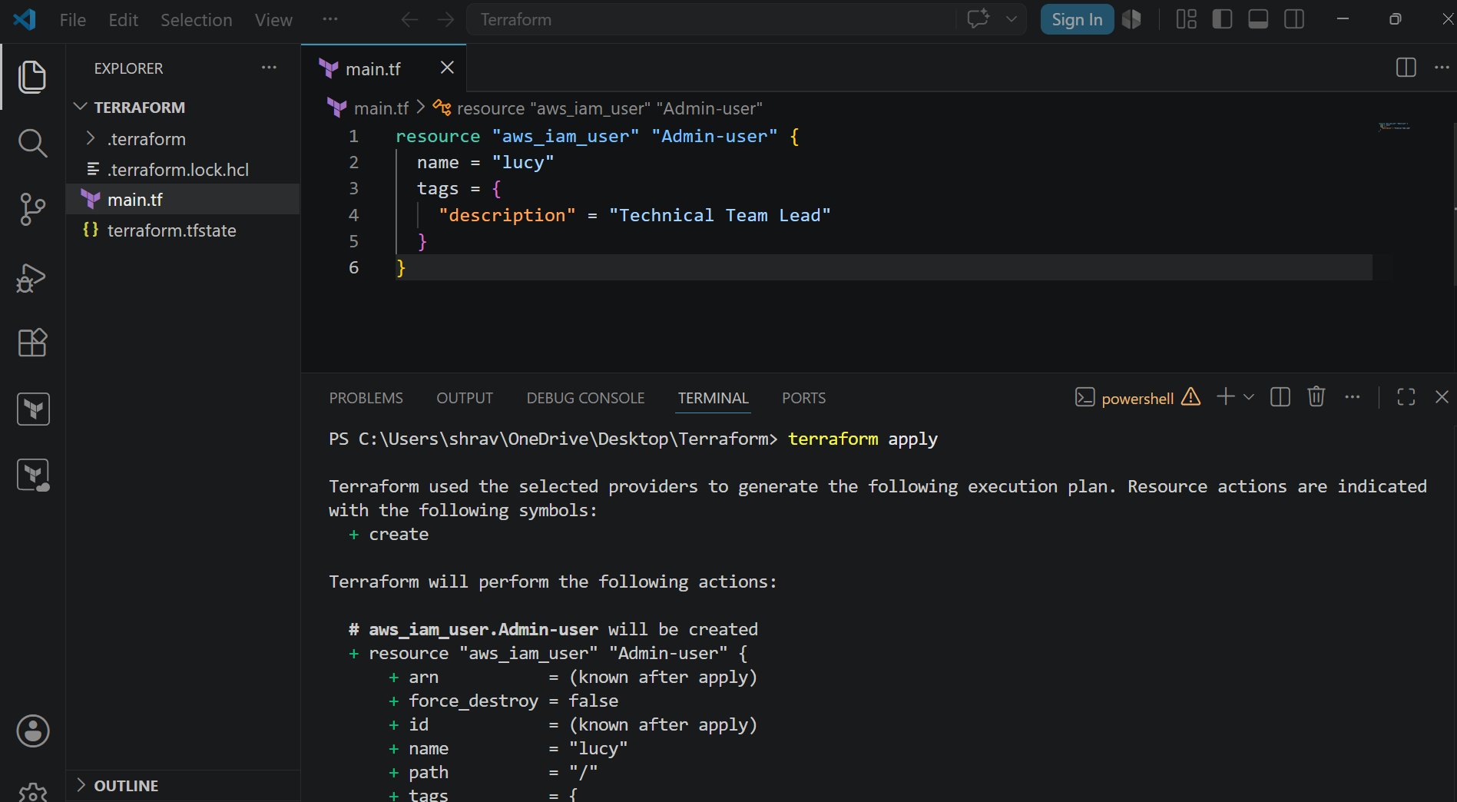
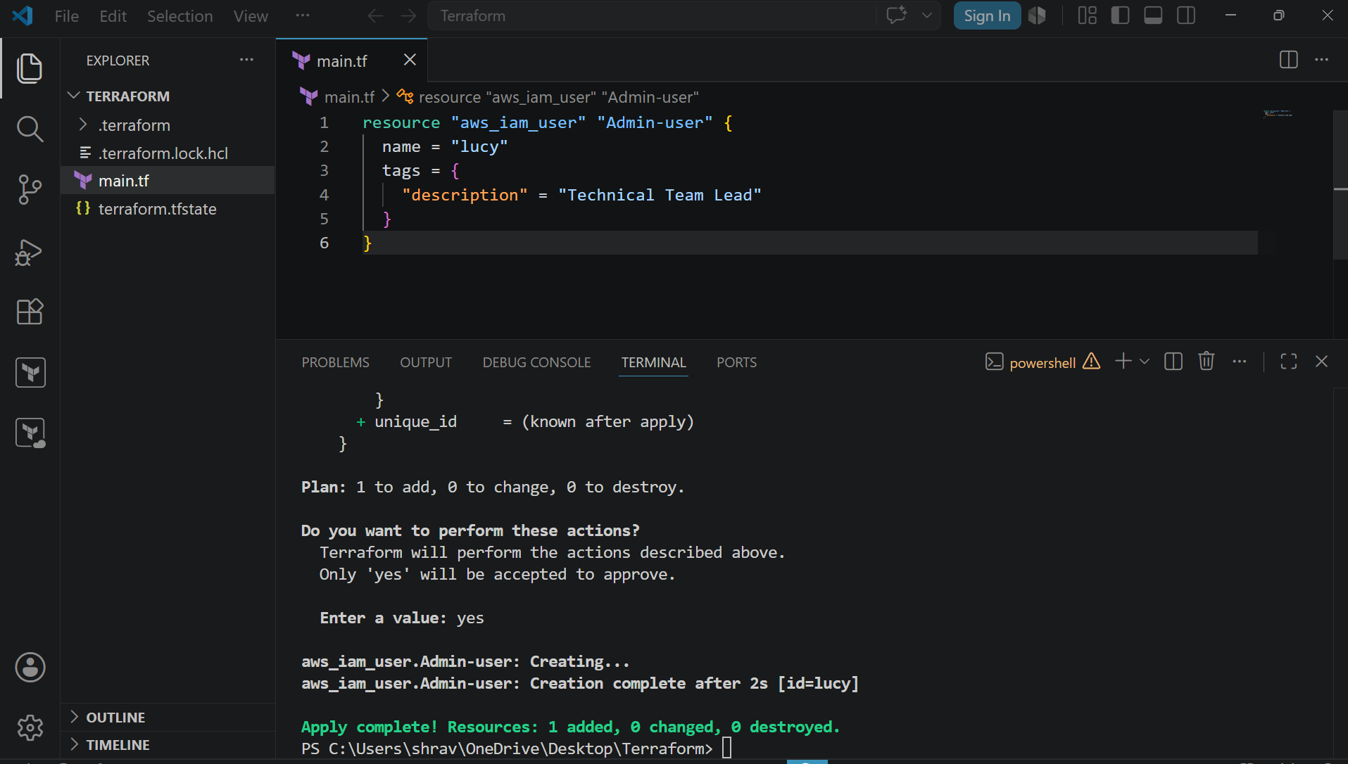
It has been created
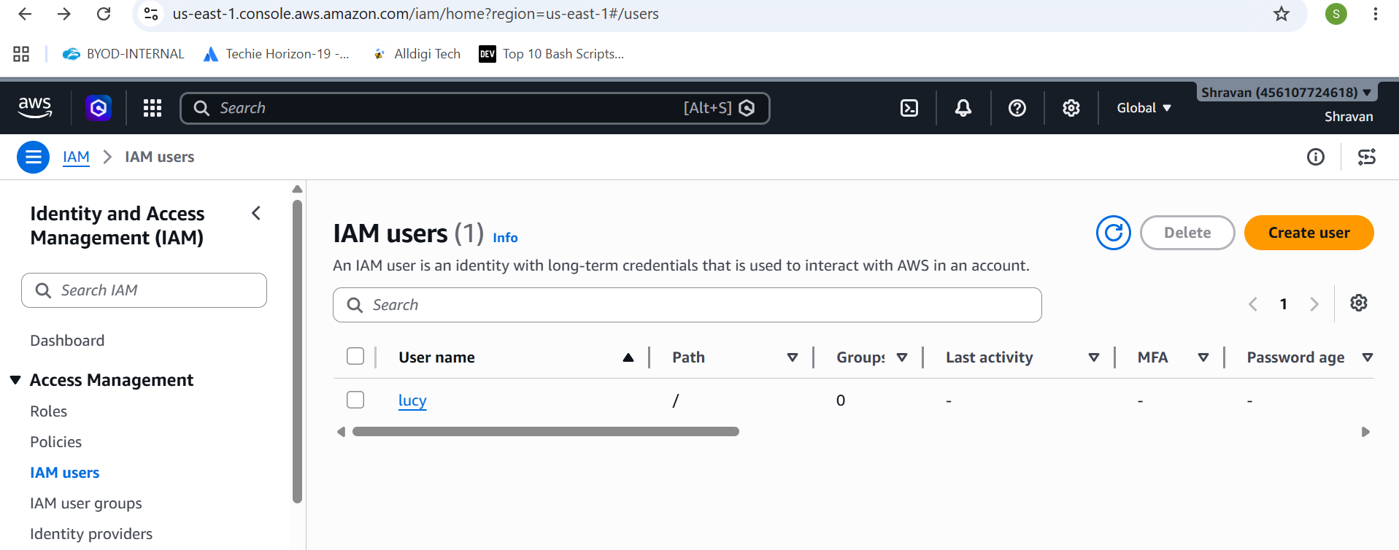
Now adding the policy to user
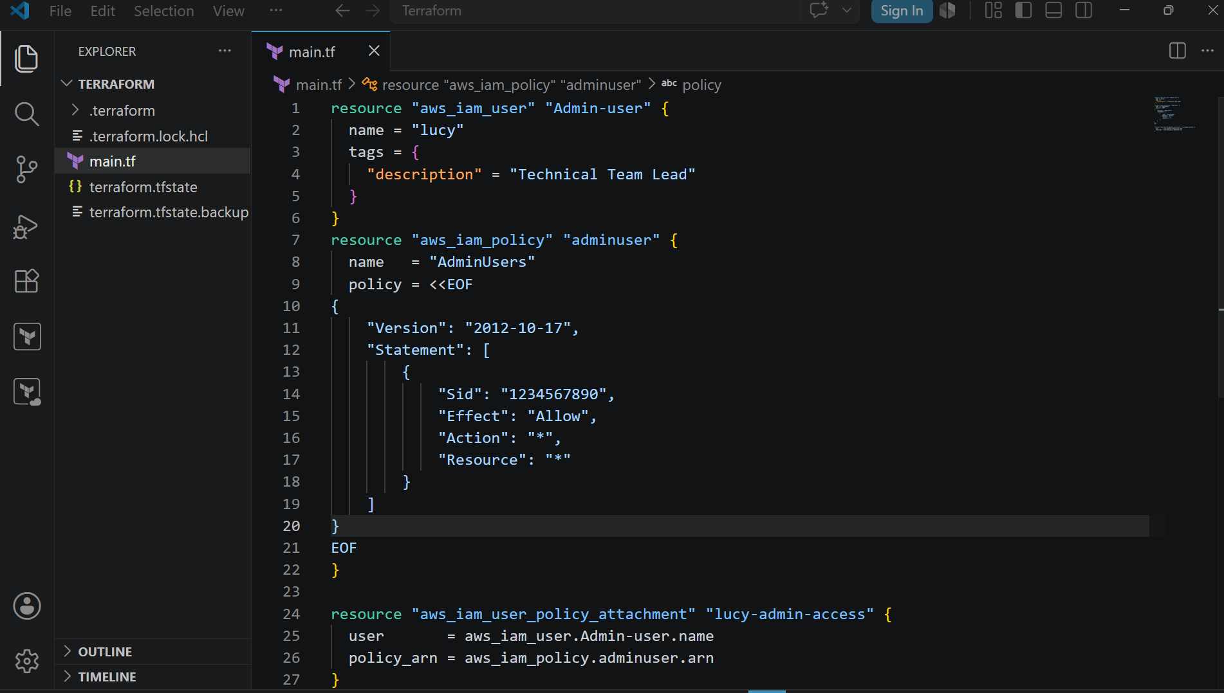
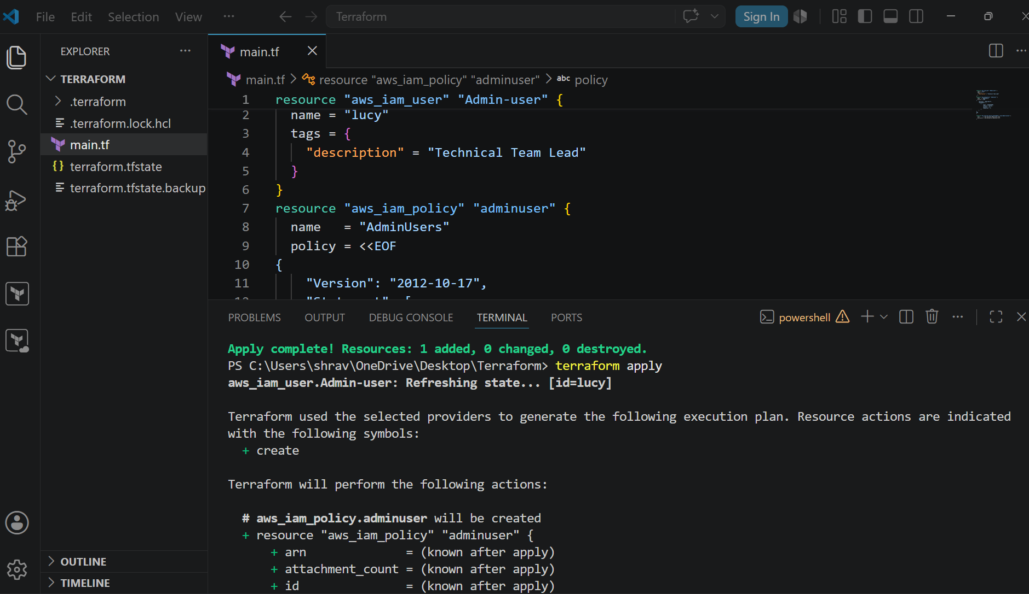
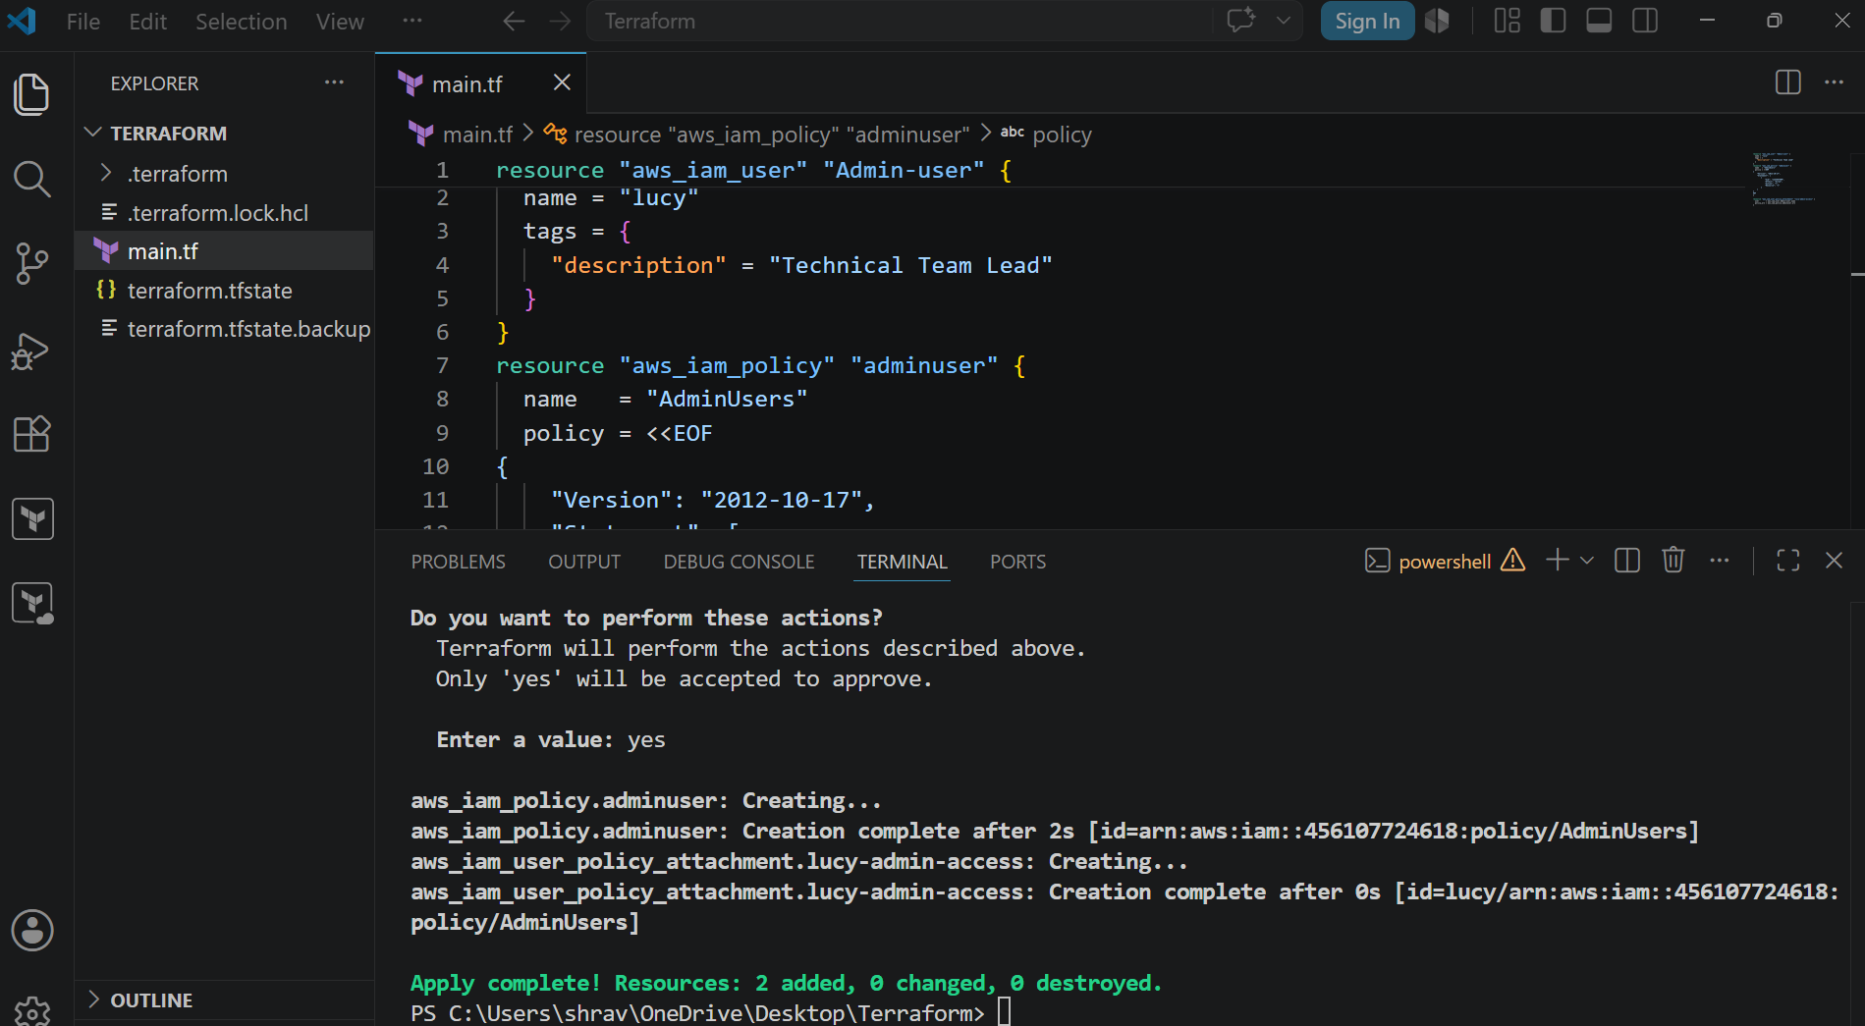
3). Integrate Terraform in Jenkins using the Terraform plugin.
Go to cd /var/lib/Jenkins/workspace/terraform-jenkins-pipe
Vi main.tf
terraform {
required_providers {
local = {
source = "hashicorp/local"
}
}
}

resource "local_file" "demo" {
filename = "shravan.txt"
content = "Hi Shravan, Welcome to Jenkins Terraform"
}
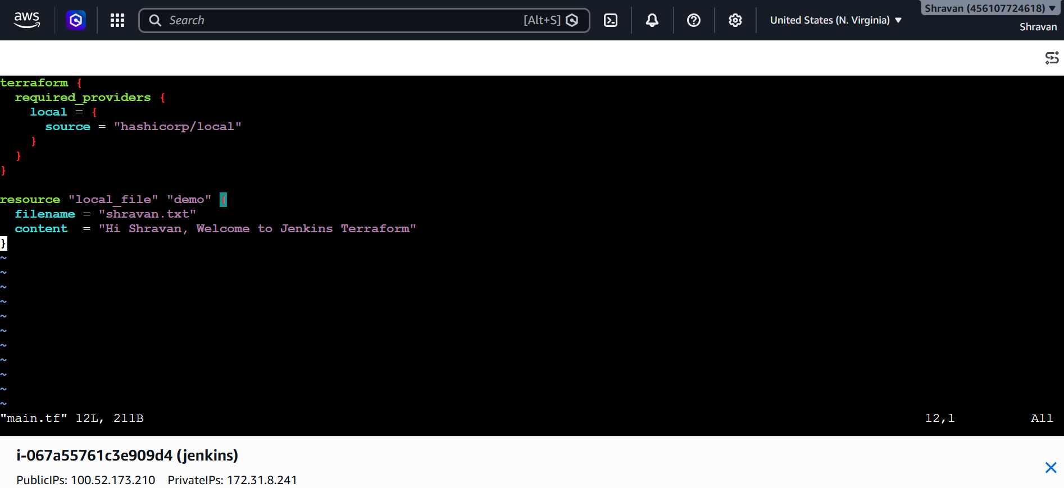
Now write a pipeline script
pipeline {
agent any

tools {
terraform 'terraform'
}

stages {

stage('Check Terraform Version') {
steps {
sh 'terraform version'
}
}

stage('Terraform Init') {
steps {
sh 'terraform init'
}
}

stage('Terraform Validate') {
steps {
sh 'terraform validate'
}
}

stage('Terraform Plan') {
steps {
sh 'terraform plan -out=tfplan'
}
}

stage('Terraform Apply') {
steps {
sh 'terraform apply -auto-approve tfplan'
}
}
}

post {
success {
echo 'Terraform deployment completed successfully.'
}
failure {
echo 'Terraform deployment failed.'
}
}
}
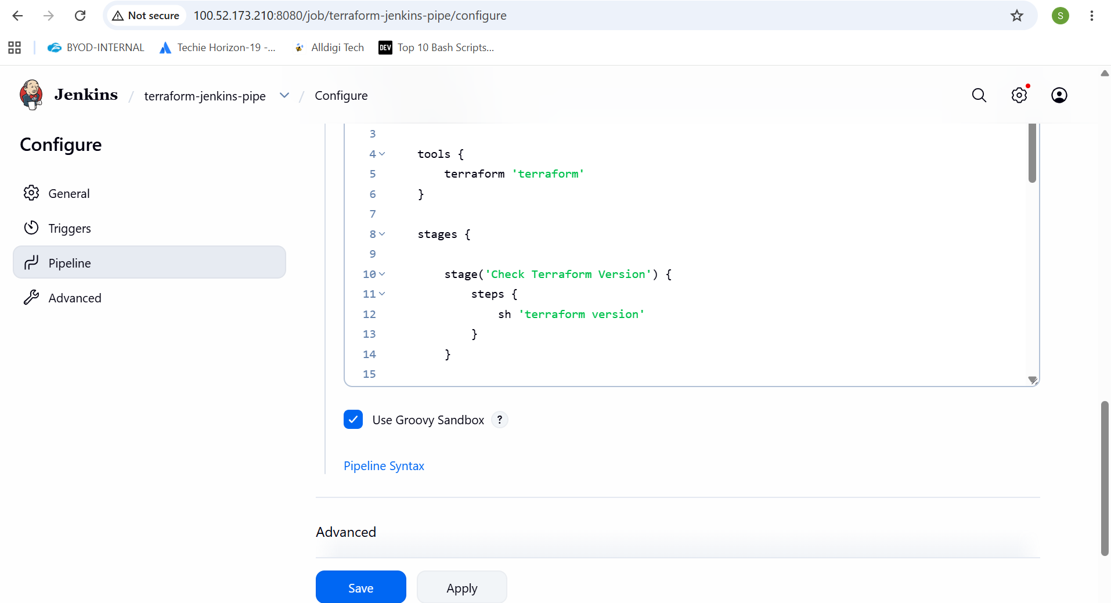
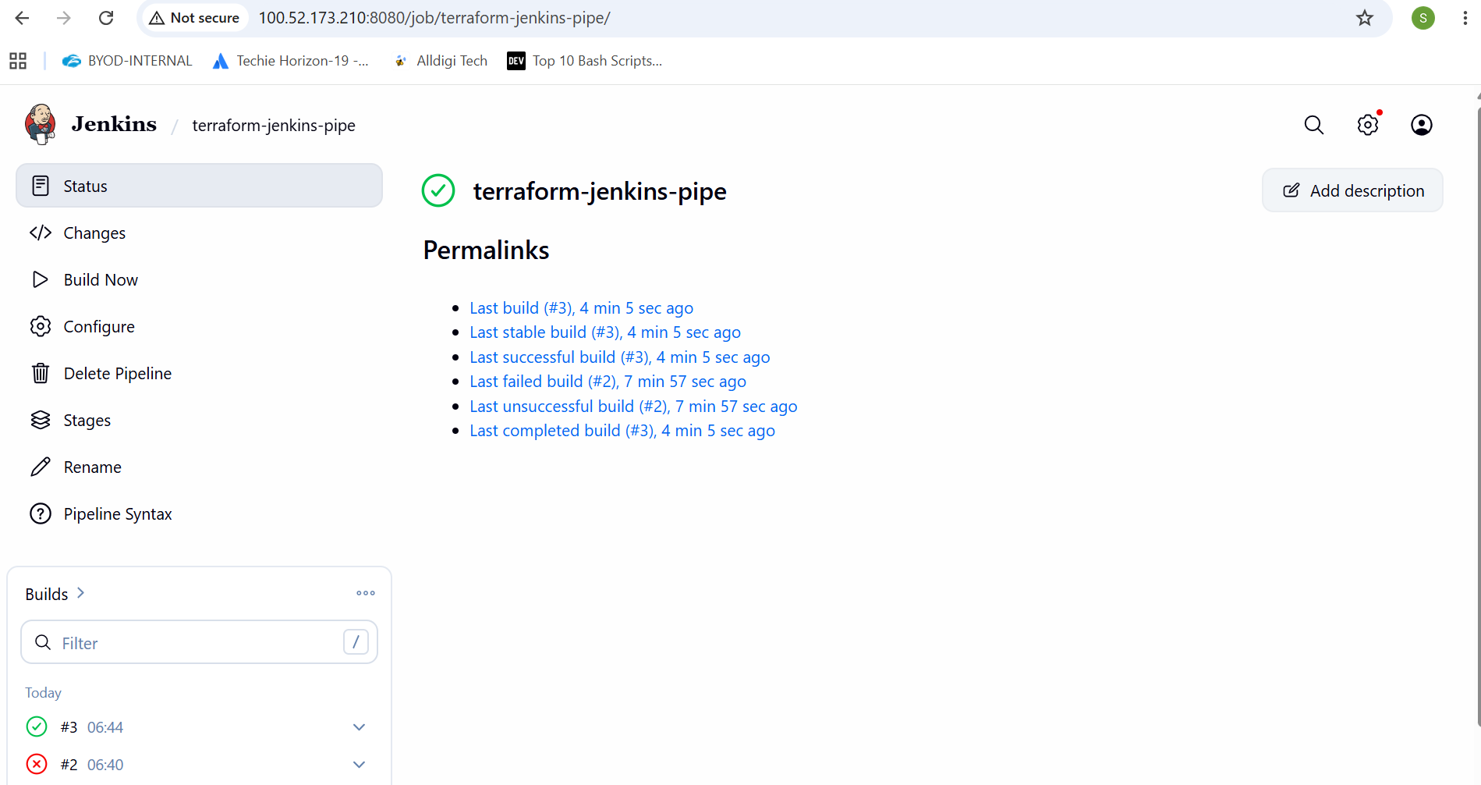
4). Create a CI/CD pipeline for a Nodejs Application: https://github.com/betawins/Trading-UI.git
Install nodejs
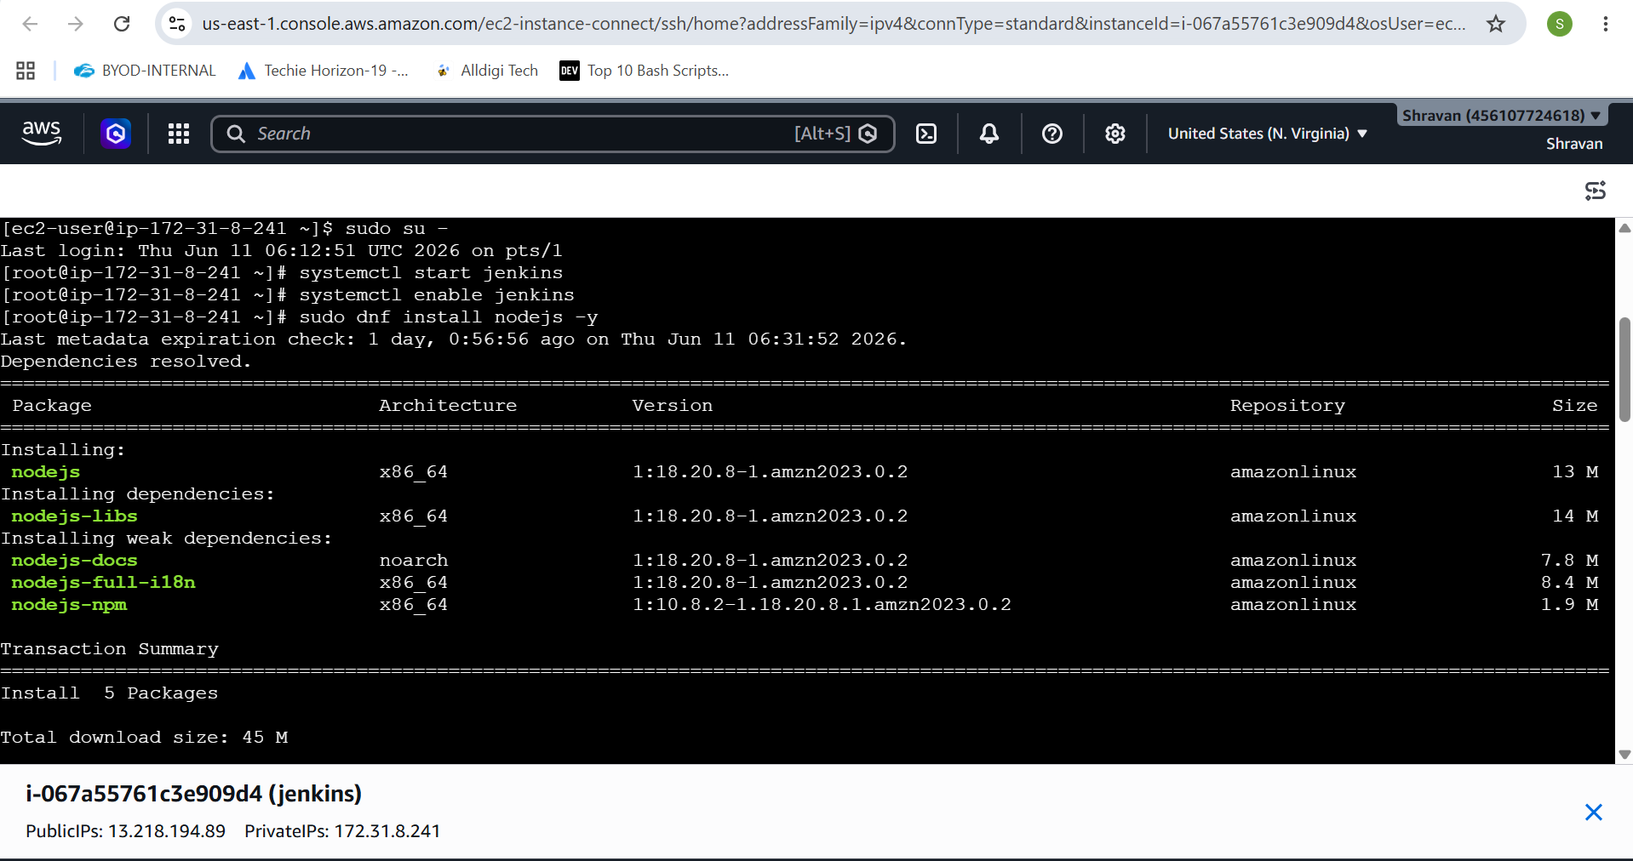
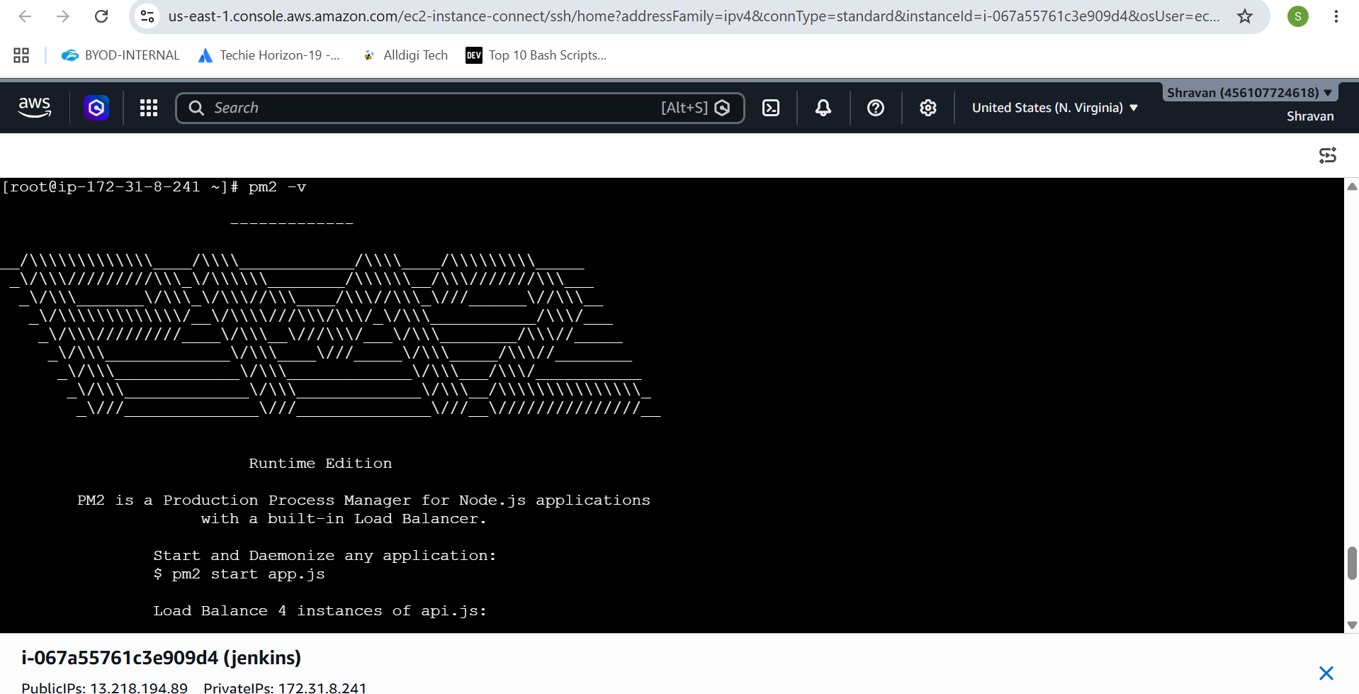
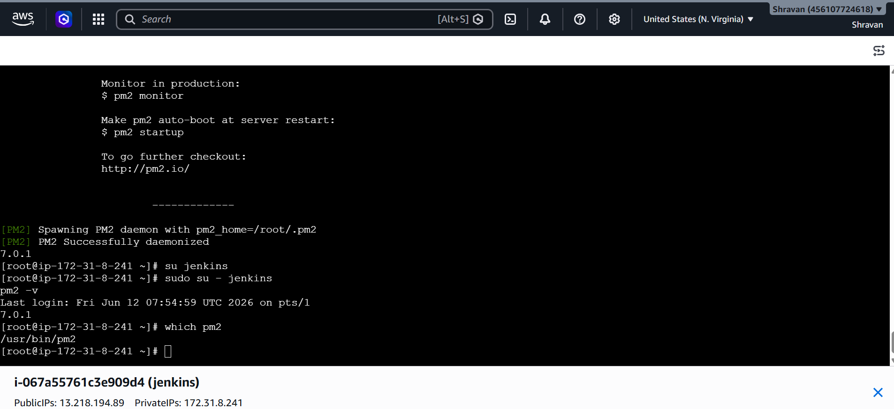
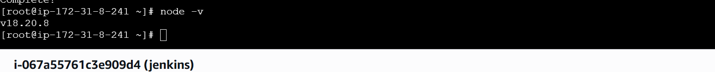
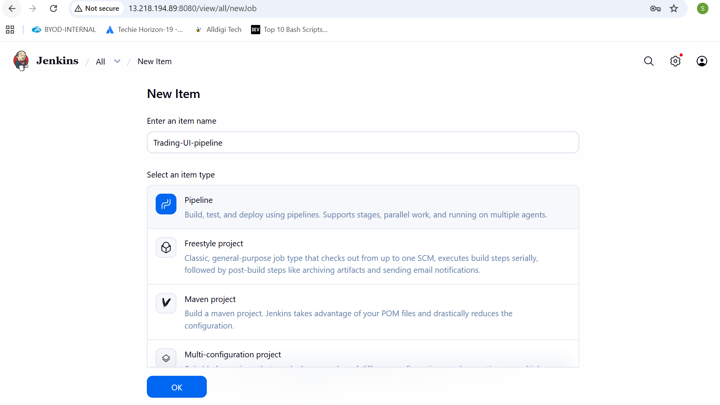
Add the pipeline
pipeline {
agent any

environment {
NODE_OPTIONS = "--openssl-legacy-provider"
CI = "false"
}

stages {

stage('Checkout') {
steps {
git 'https://github.com/betawins/Trading-UI.git'
}
}

stage('Install & Build') {
steps {
sh '''
npm install
npm run build
'''
}
}

stage('Deploy') {
steps {
sh '''
pm2 restart Trading-UI || pm2 start npm --name Trading-UI -- start
'''
}
}
}
}
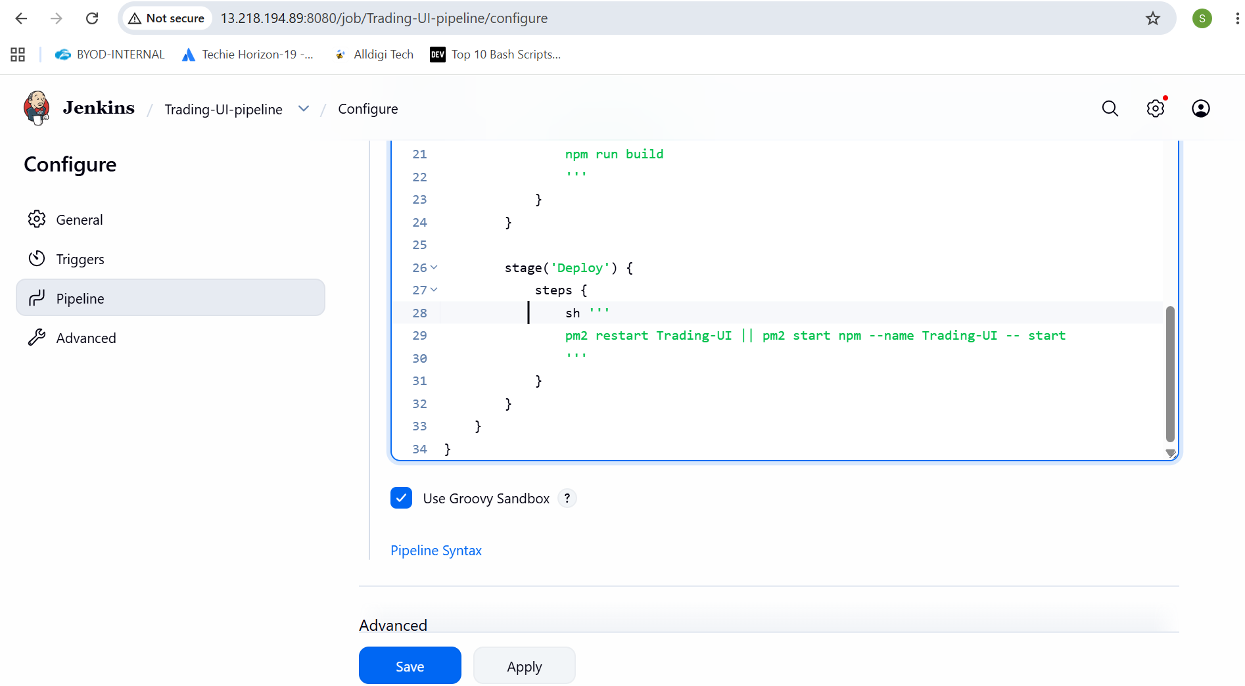
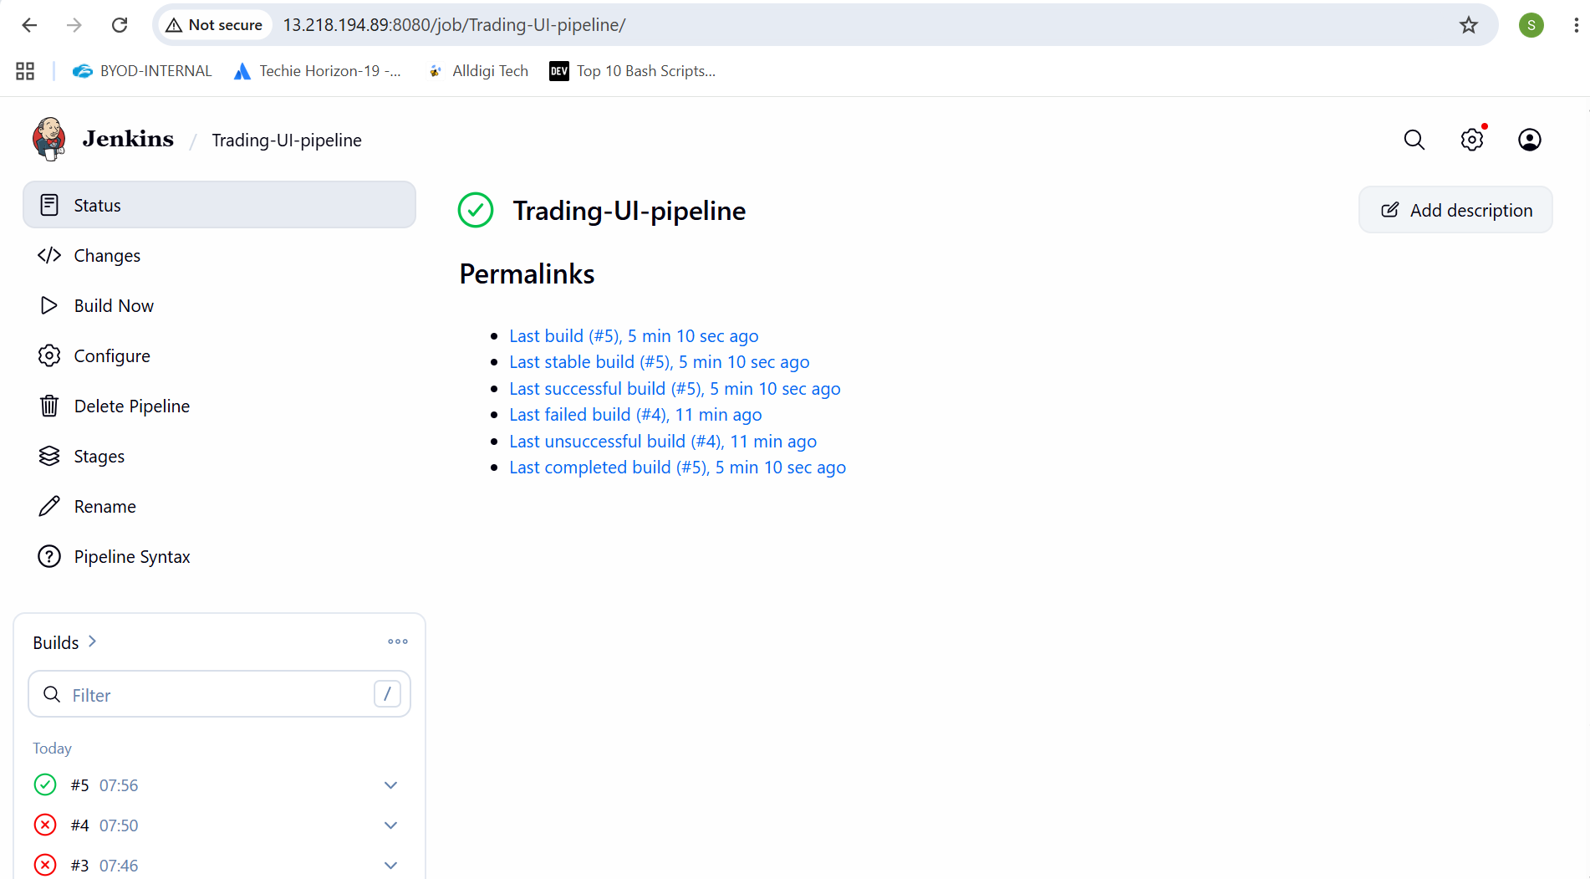
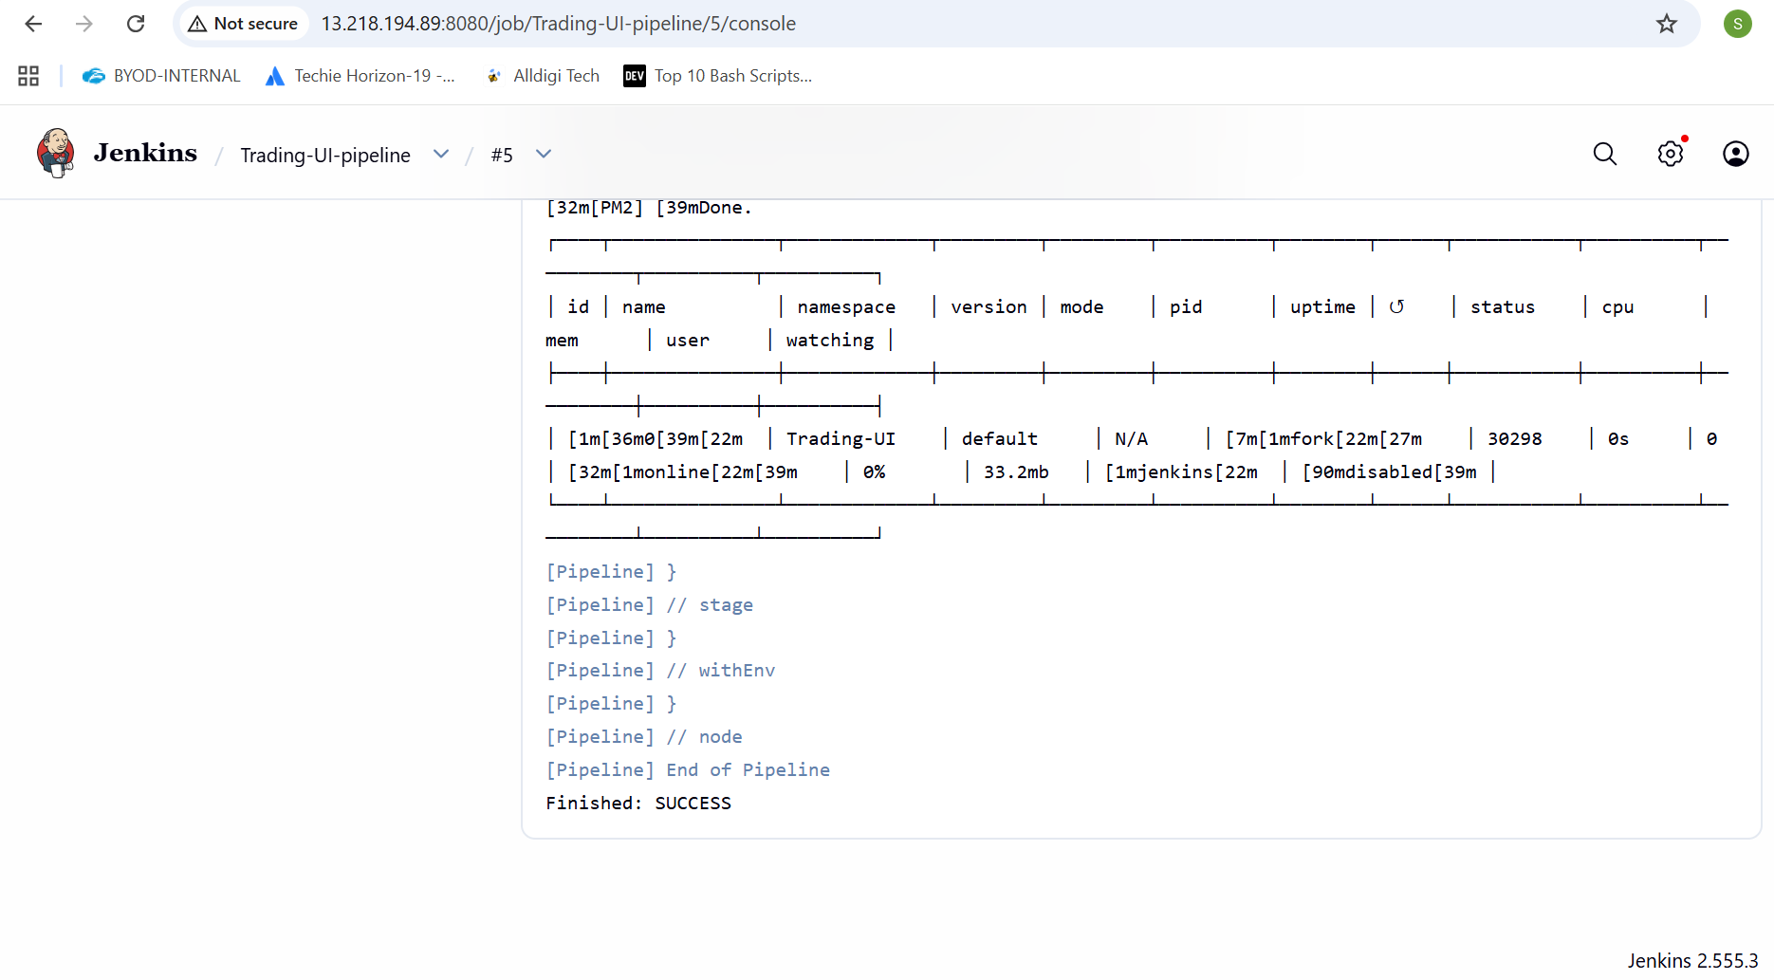
5). Explain 10 Maven commands.
Apache Maven is a popular Java build and dependency management tool. Its commands are run through the mvn CLI. Here are 10 important Maven commands and what they do:
1. mvn clean
Removes the target/ directory where compiled files and build outputs are stored. Useful to ensure a fresh build without old artifacts interfering.
2. mvn compile
Compiles the source code of your project (src/main/java). It does not run tests or package the application—only checks and compiles code.
3. mvn test
Runs unit tests defined in src/test/java using testing frameworks like JUnit. It compiles both main code and test code before execution.
4. mvn package
Takes compiled code and packages it into a distributable format like a JAR or WAR file inside the target/ directory.
5. mvn install
Installs the packaged artifact into your local Maven repository (~/.m2/repository) so it can be used as a dependency in other local projects.
6. mvn deploy
Copies the final package to a remote repository (like Nexus or Artifactory), making it available for other developers or CI/CD pipelines.
7. mvn validate
Checks whether the project structure and configuration are correct before the build starts. It ensures the project is ready to build.
8. mvn verify
Runs additional checks on the package after tests, such as integration tests or quality checks, to ensure the build is valid.
9. mvn dependency:tree
Displays the full dependency hierarchy of the project. Helpful for debugging version conflicts or unwanted transitive dependencies.
10. mvn archetype:generate
Creates a new Maven project from a template (archetype). It helps quickly scaffold standard project structures

3). Integrate Terraform in Jenkins using the Terraform plugin.
4). Create a CI/CD pipeline for a Nodejs Application: https://github.com/betawins/Trading-UI.git
5). Explain 10 Maven commands.

