Terraform-05
1). Watch the Terraform-05 video
2). Execute the script shown in the video.
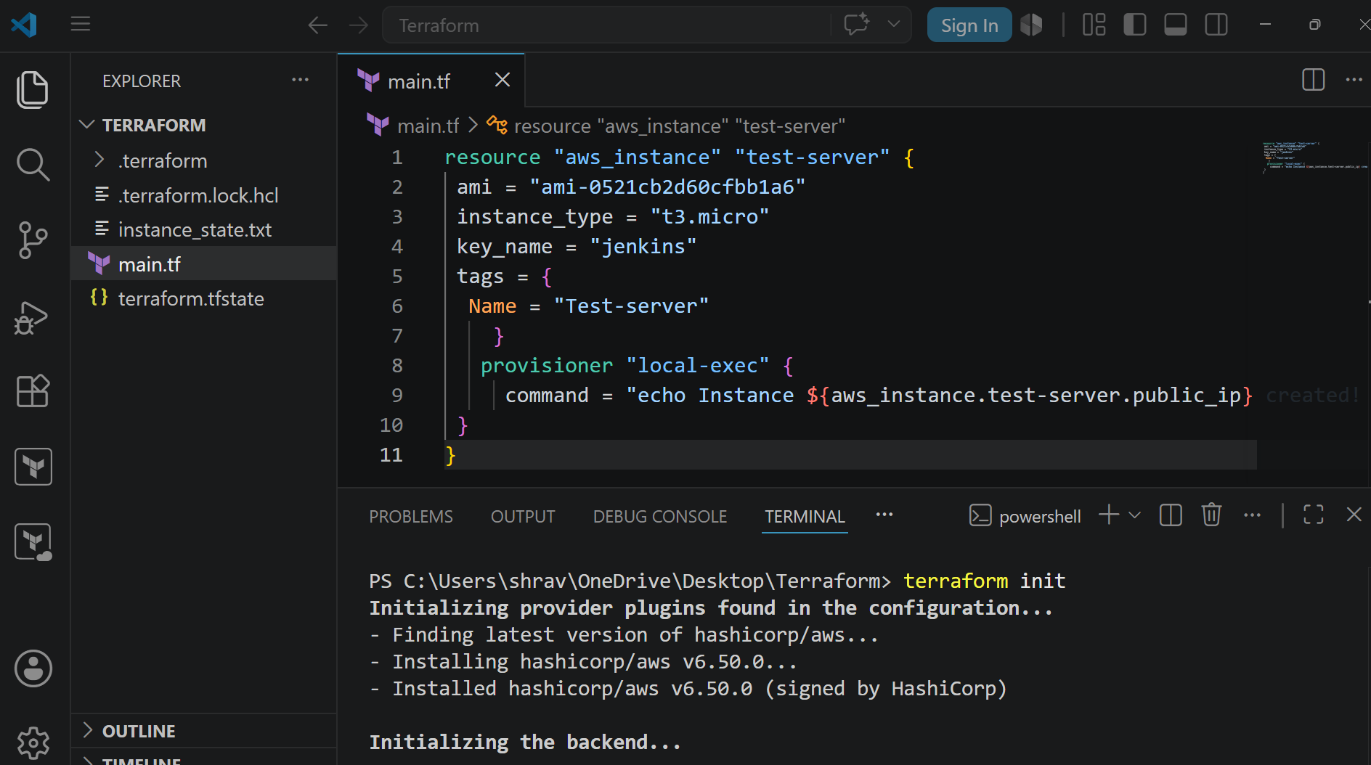
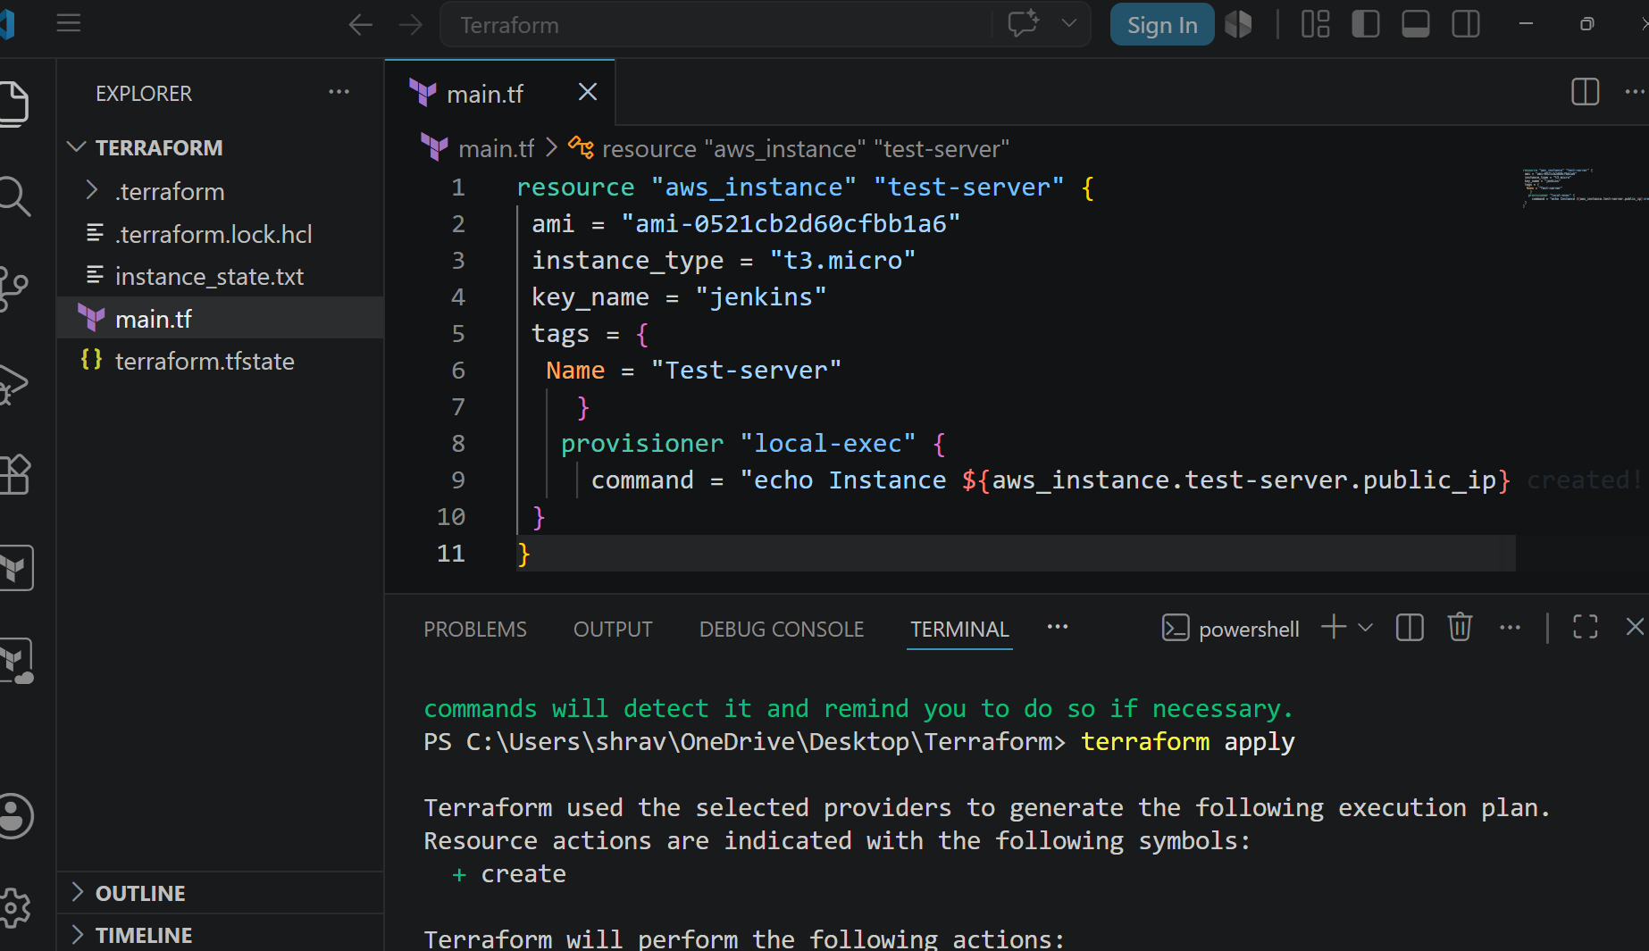
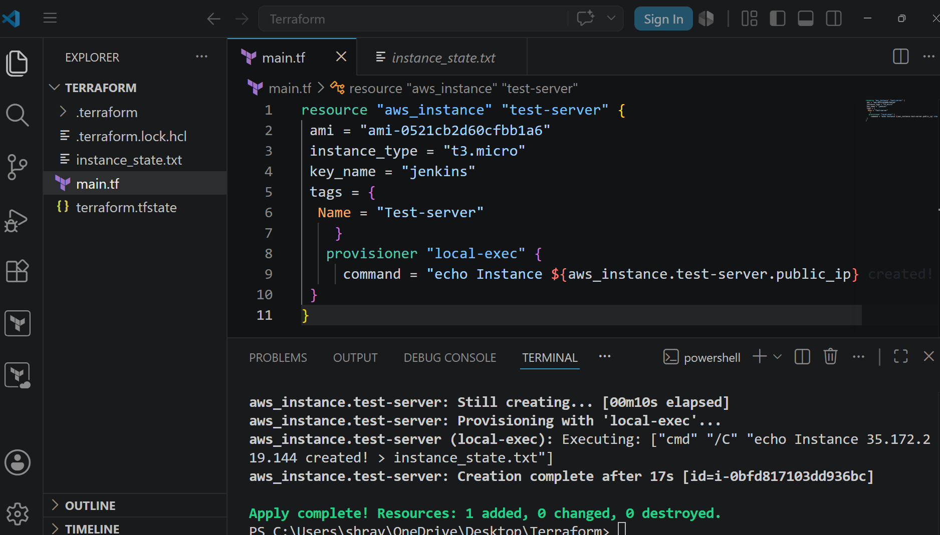
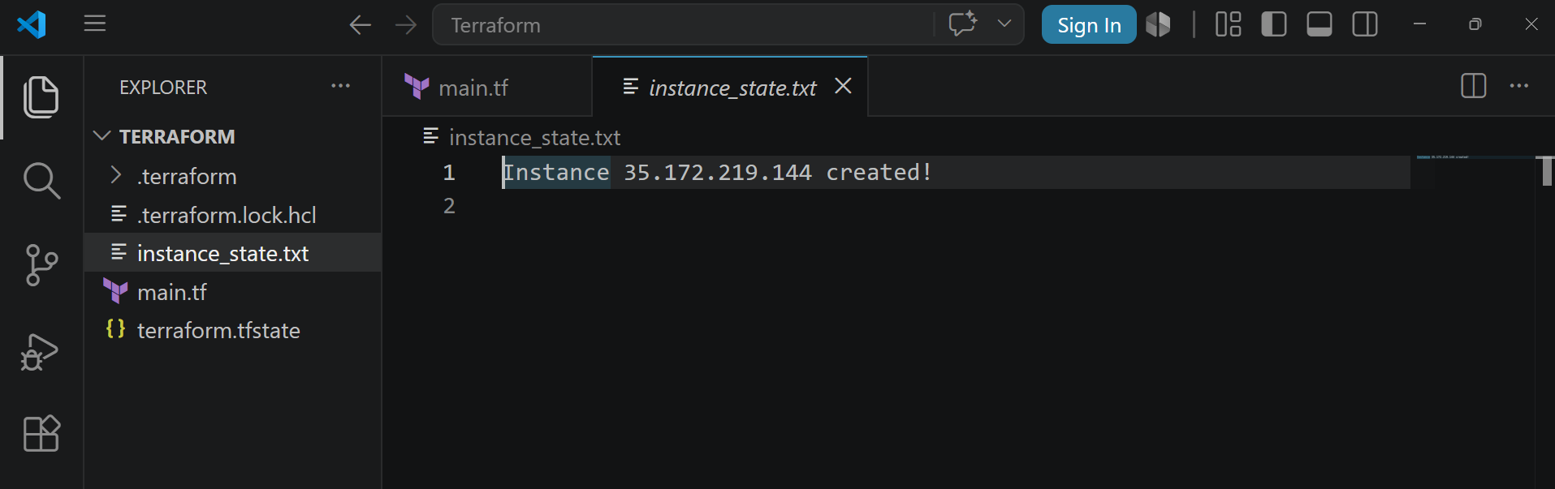
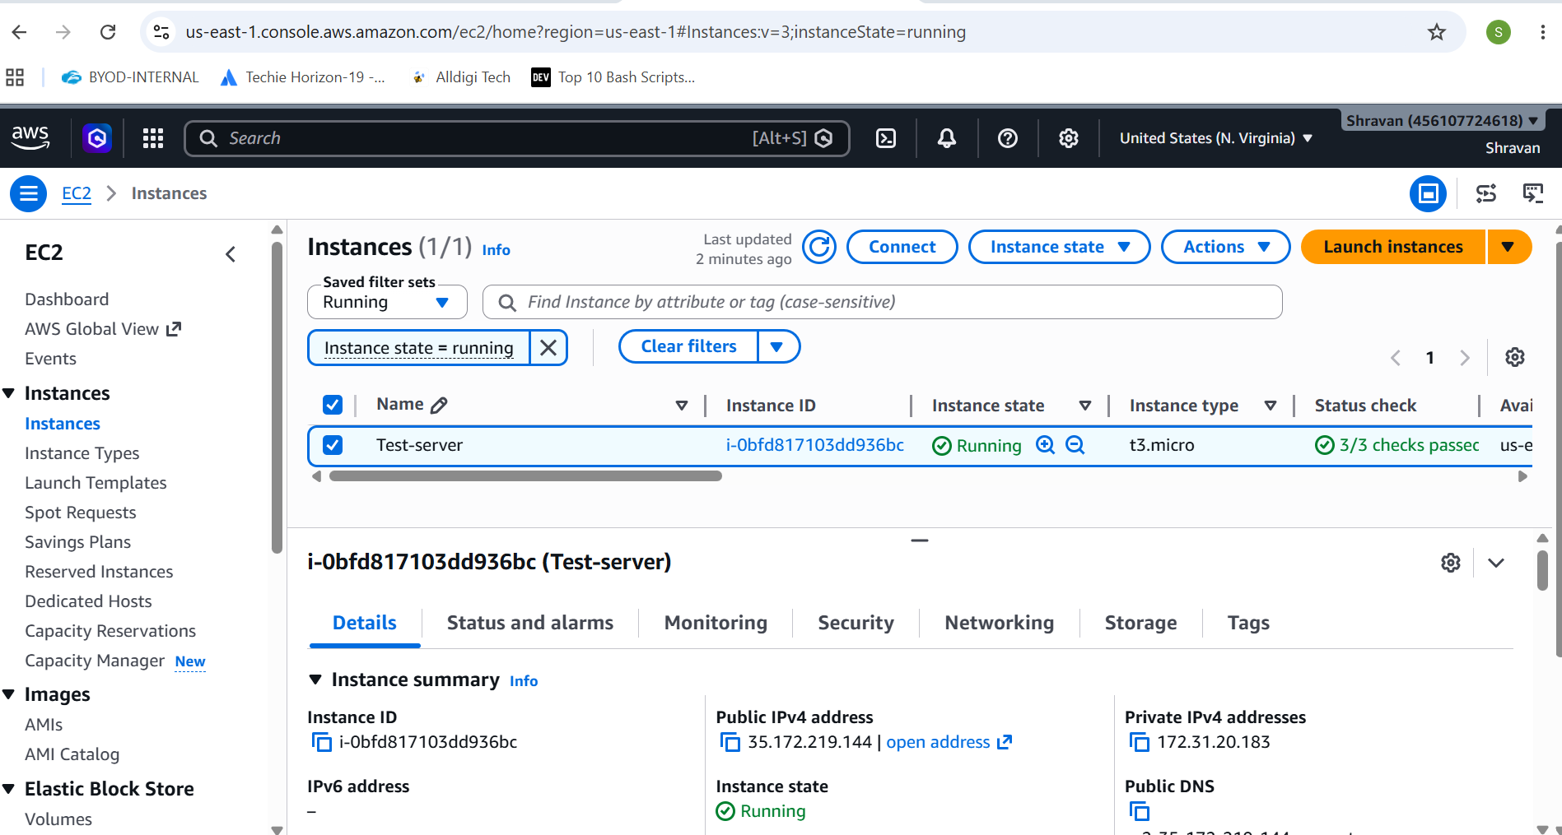
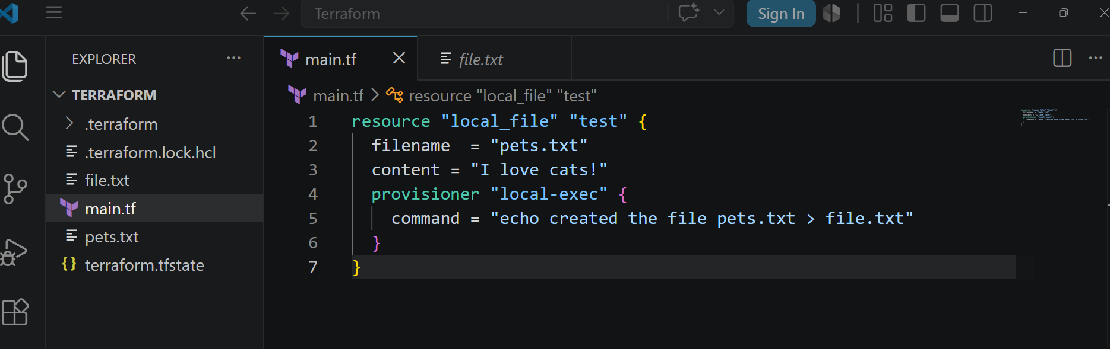
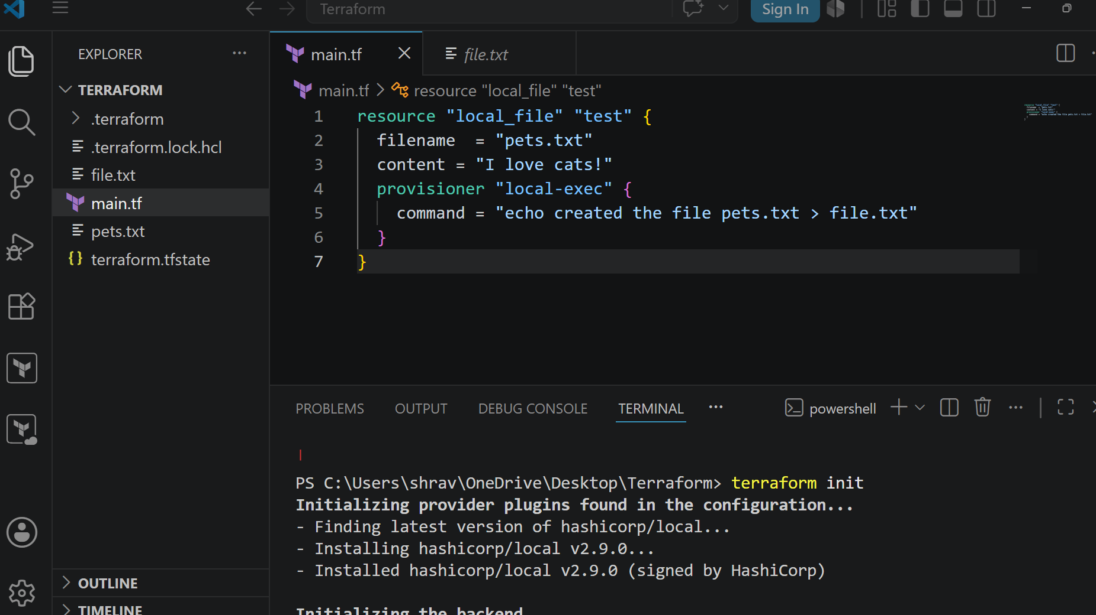
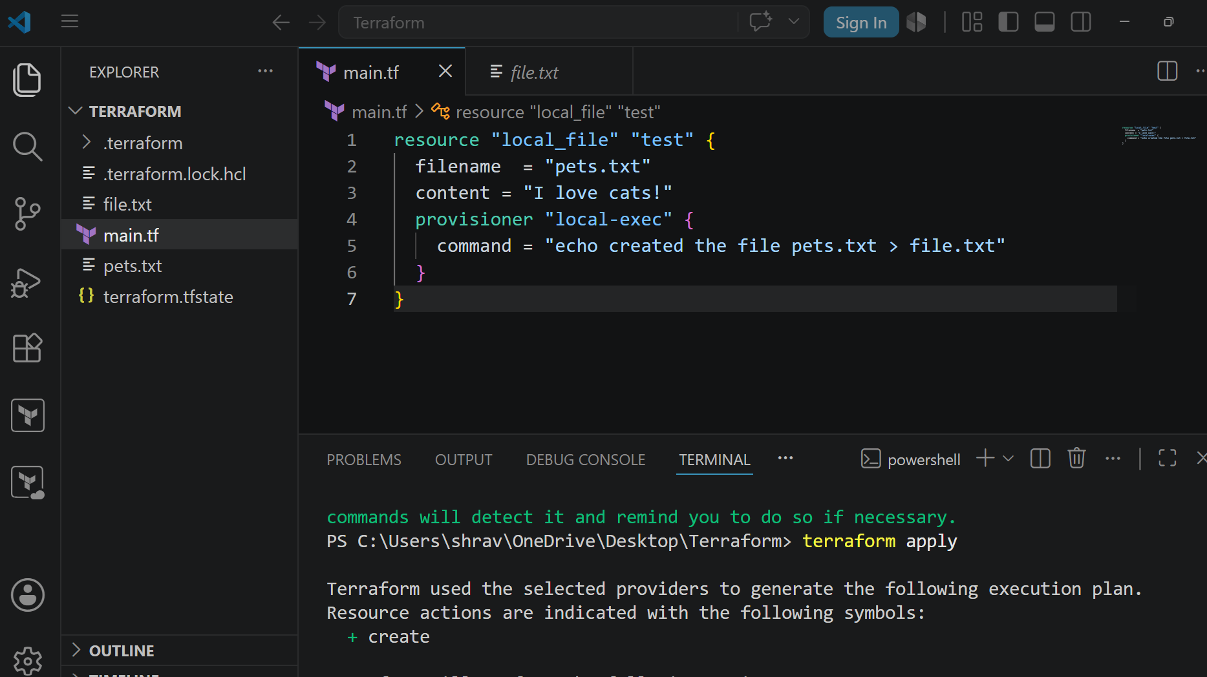
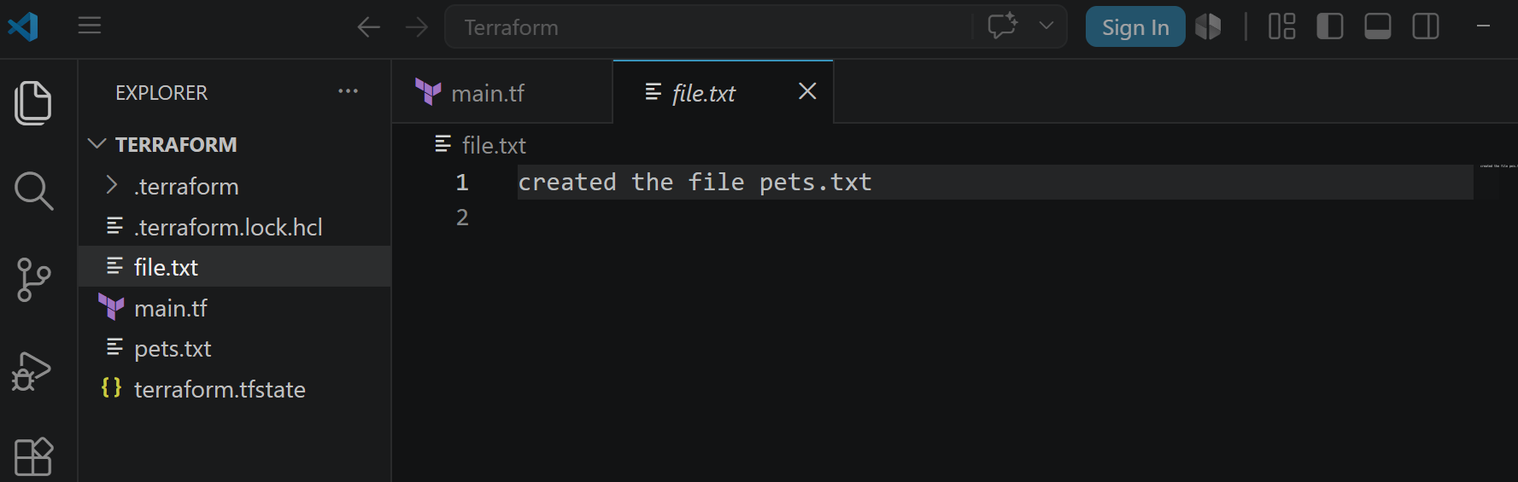
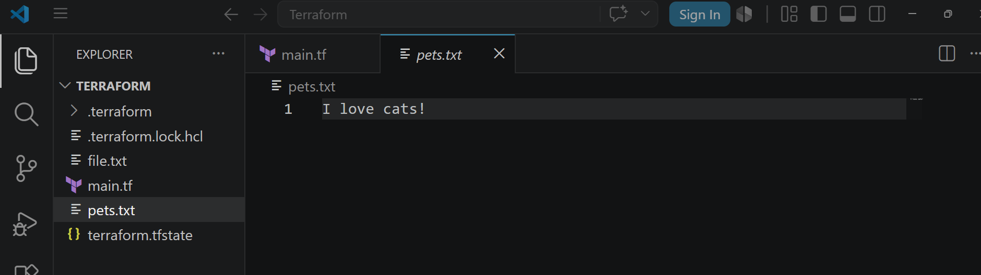
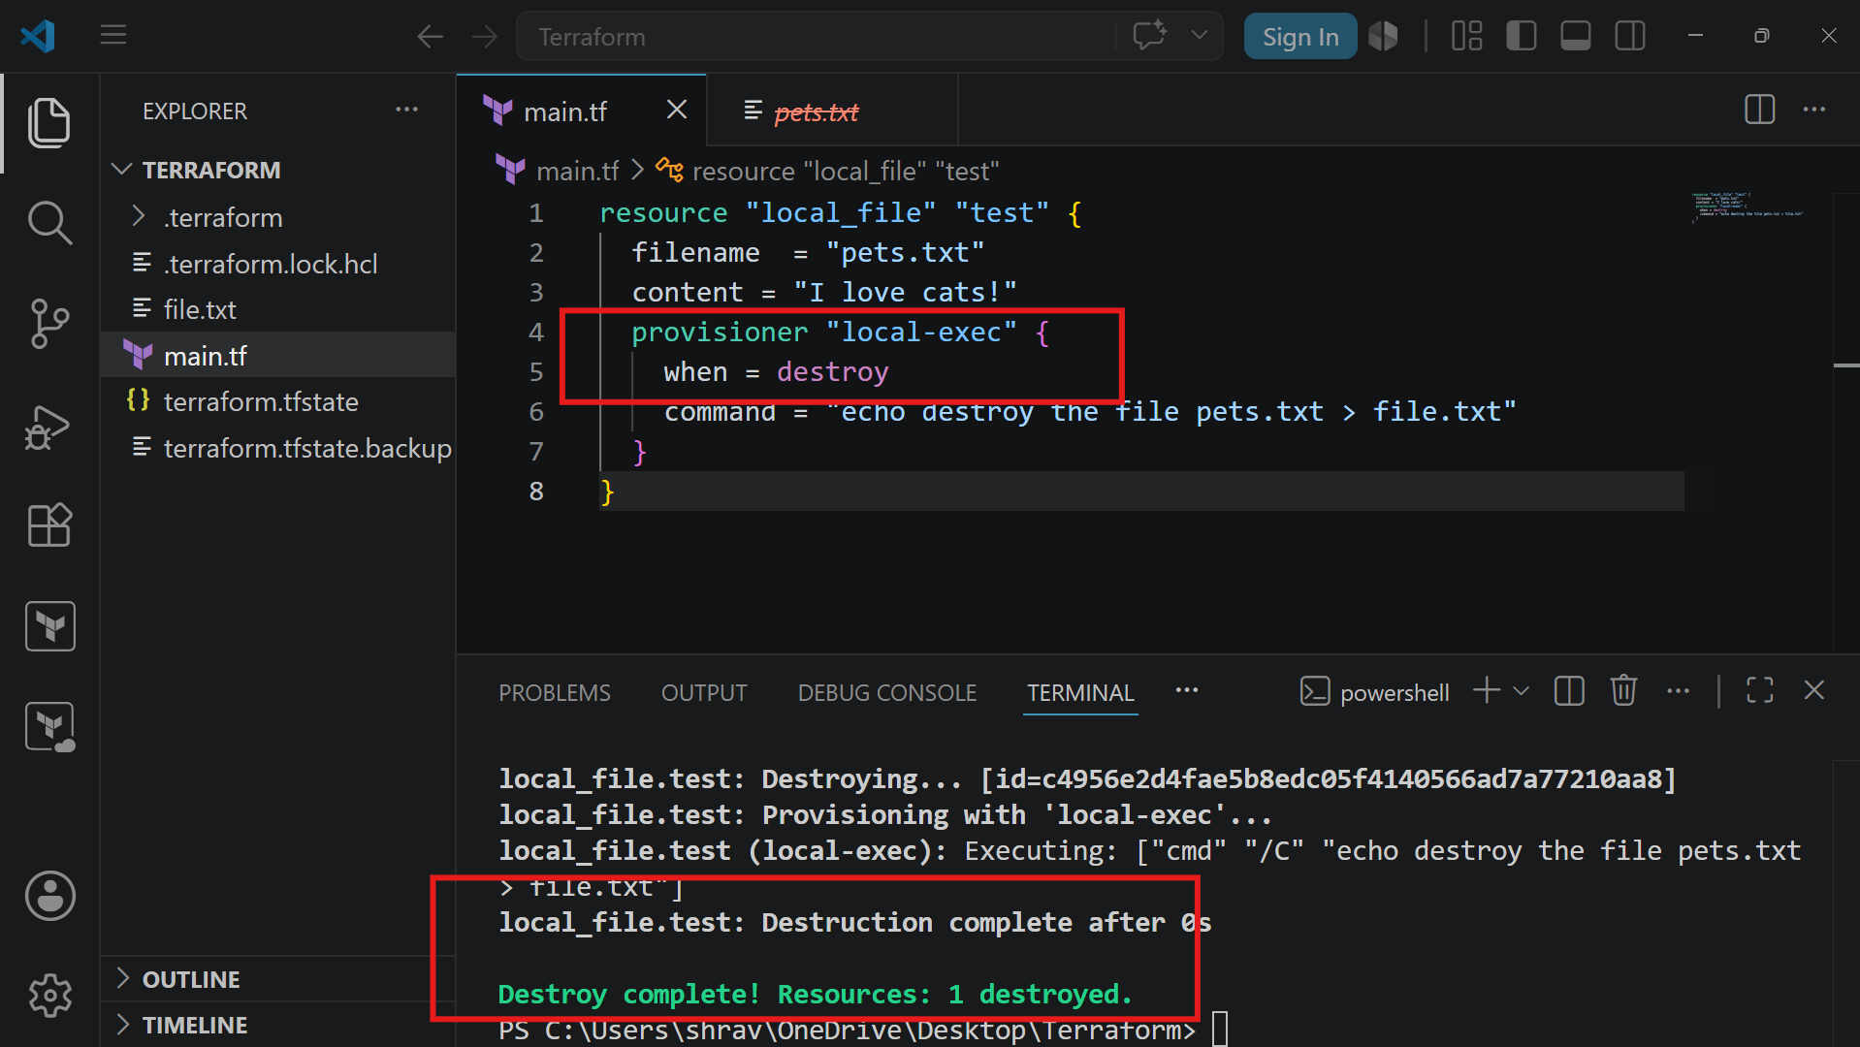
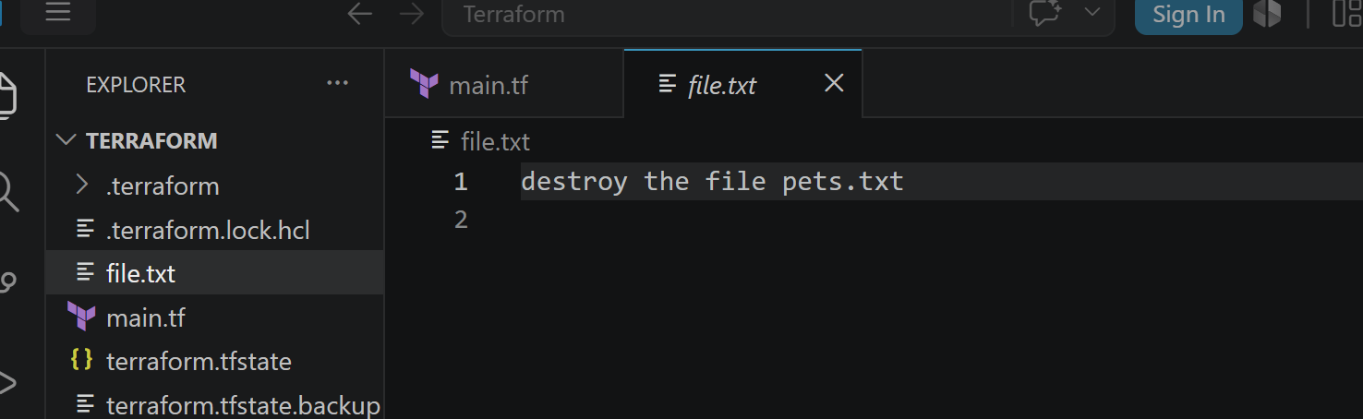
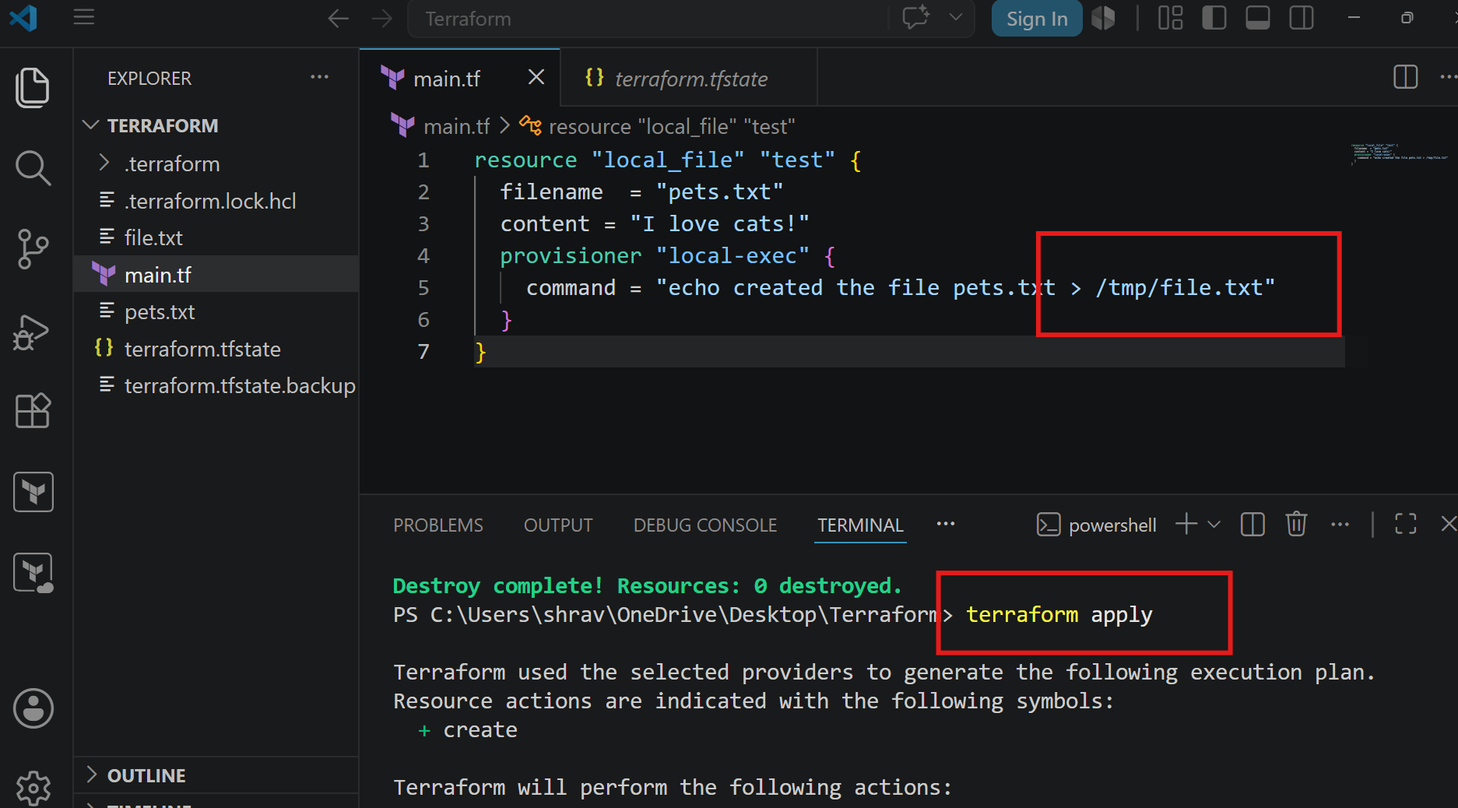
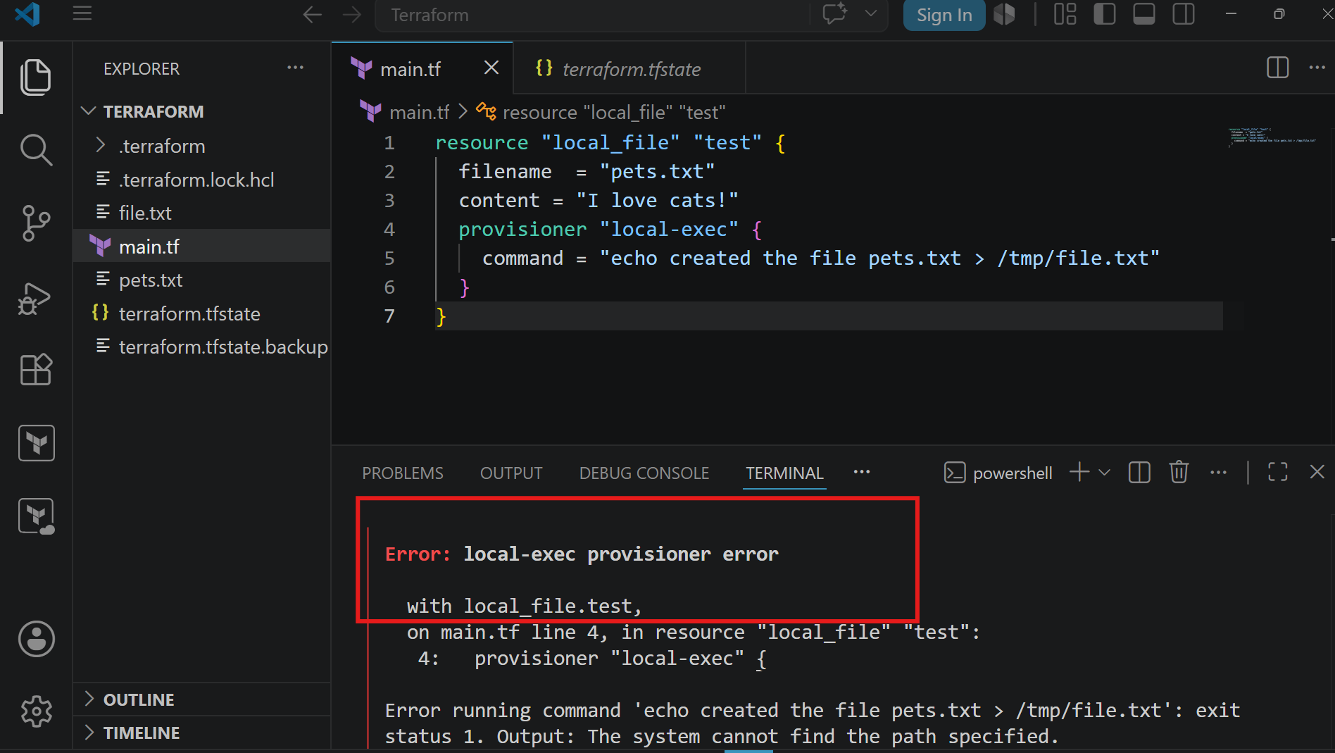
If we give any wrong path and do terraform apply then in the state file you can see as status as tainted by default
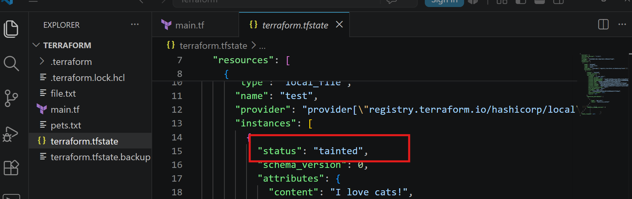
taint
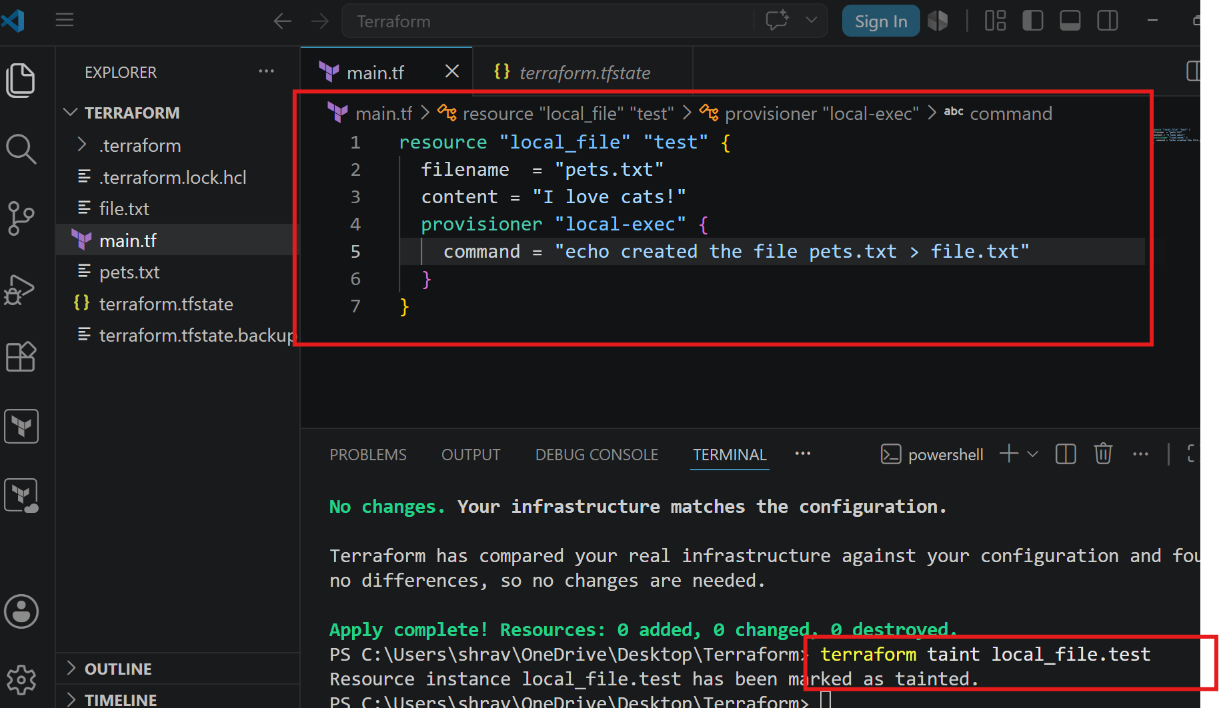
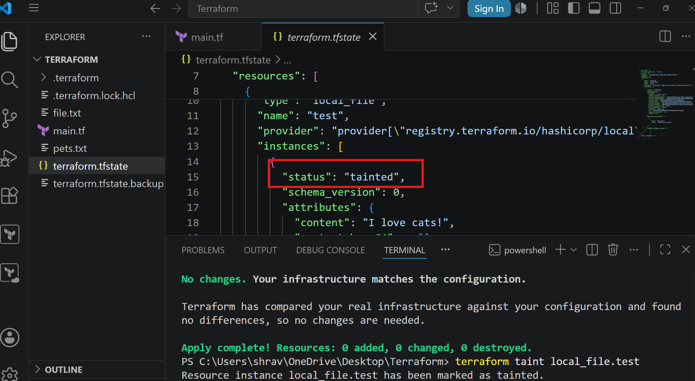
Now do terraform apply
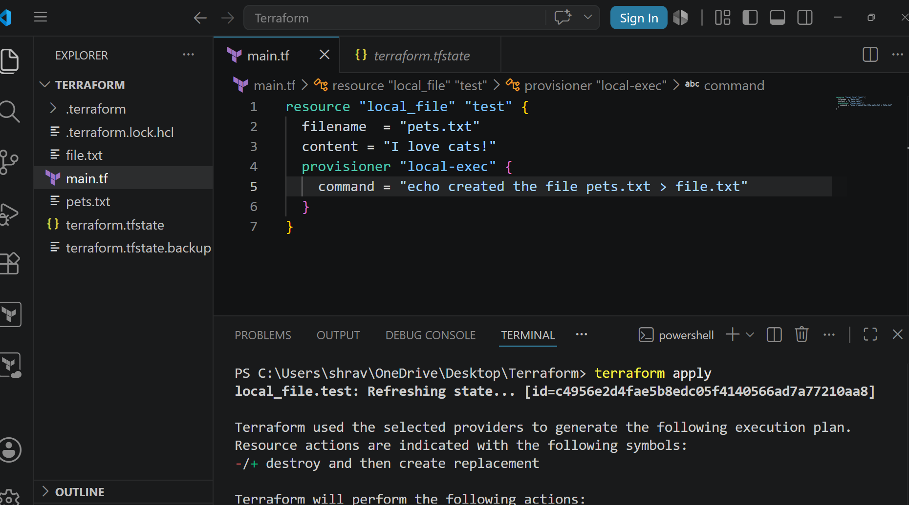
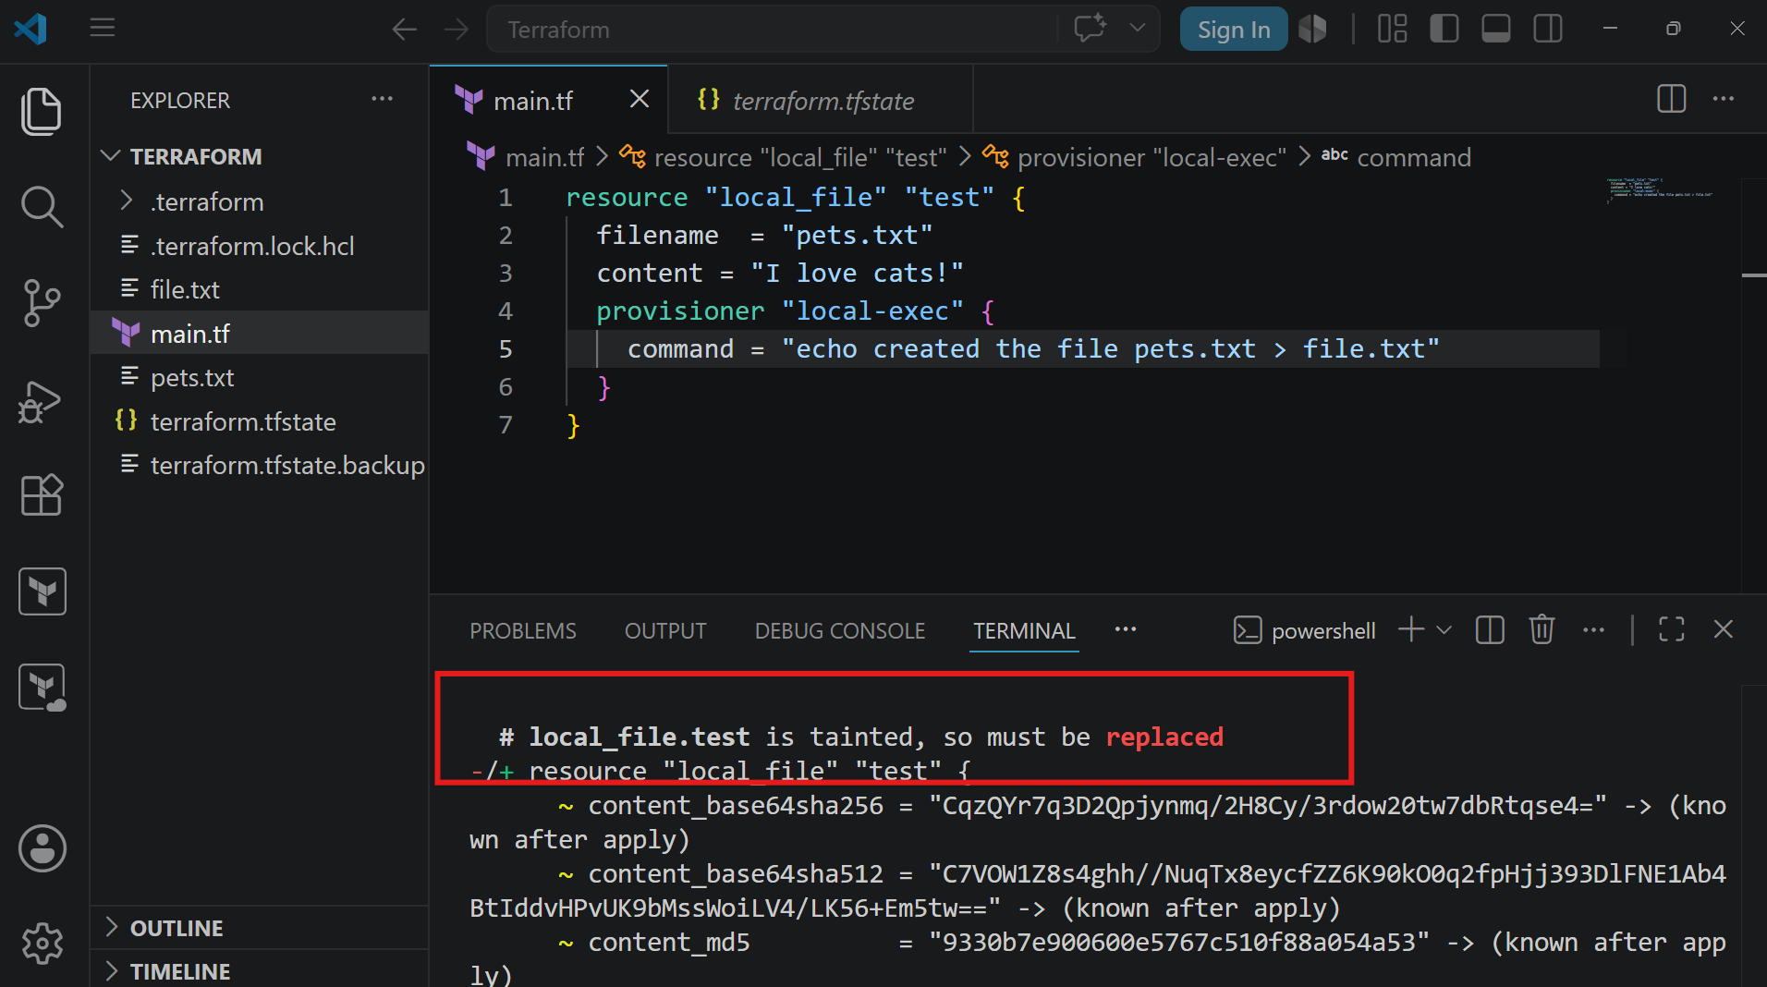
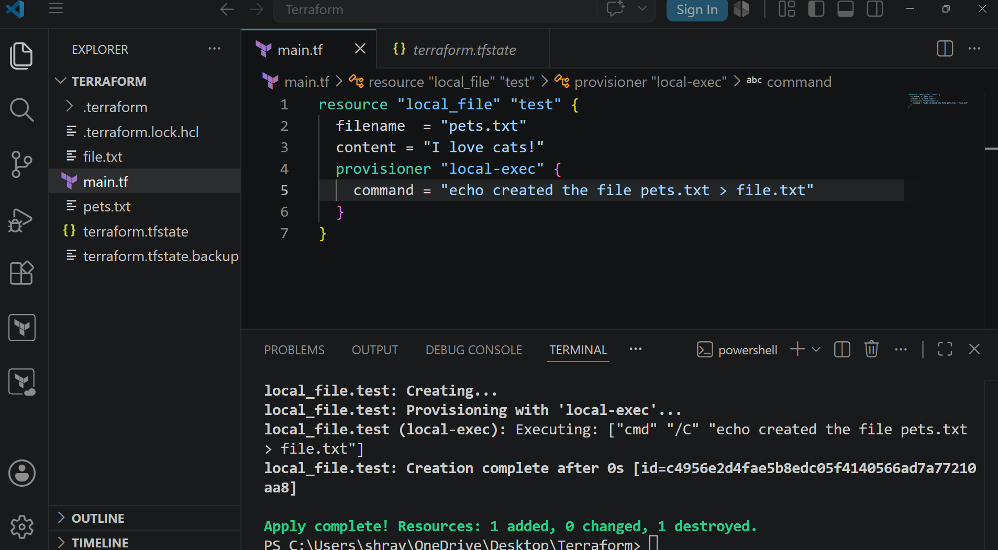
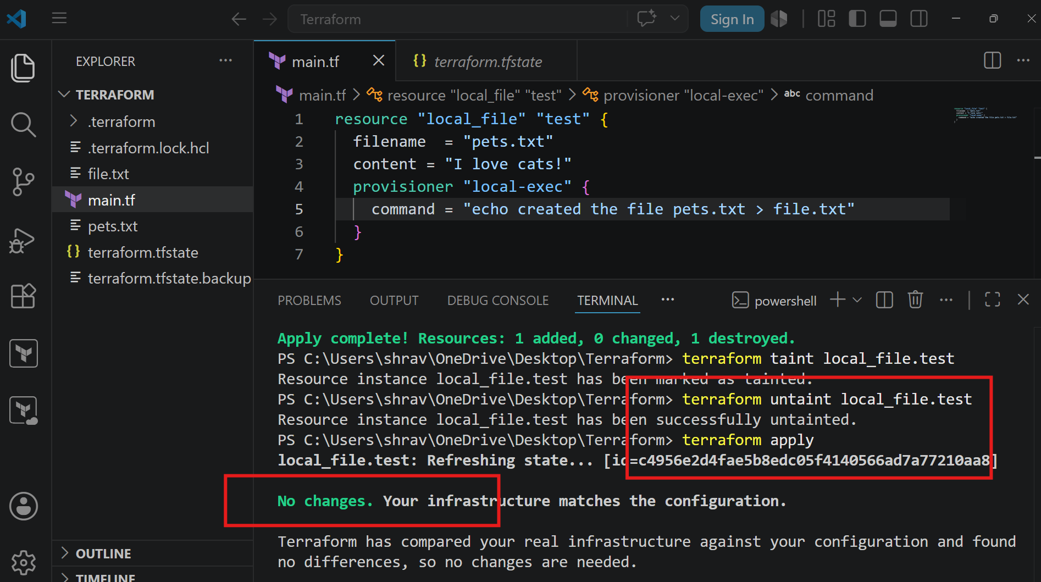
Debugging
Trace
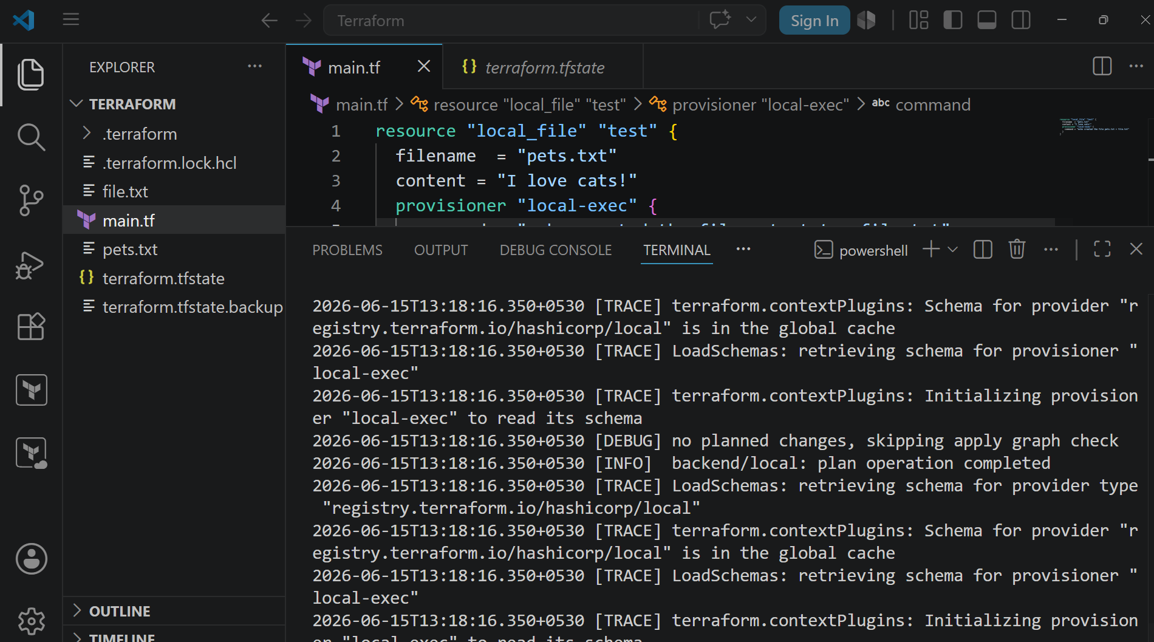
ERROR
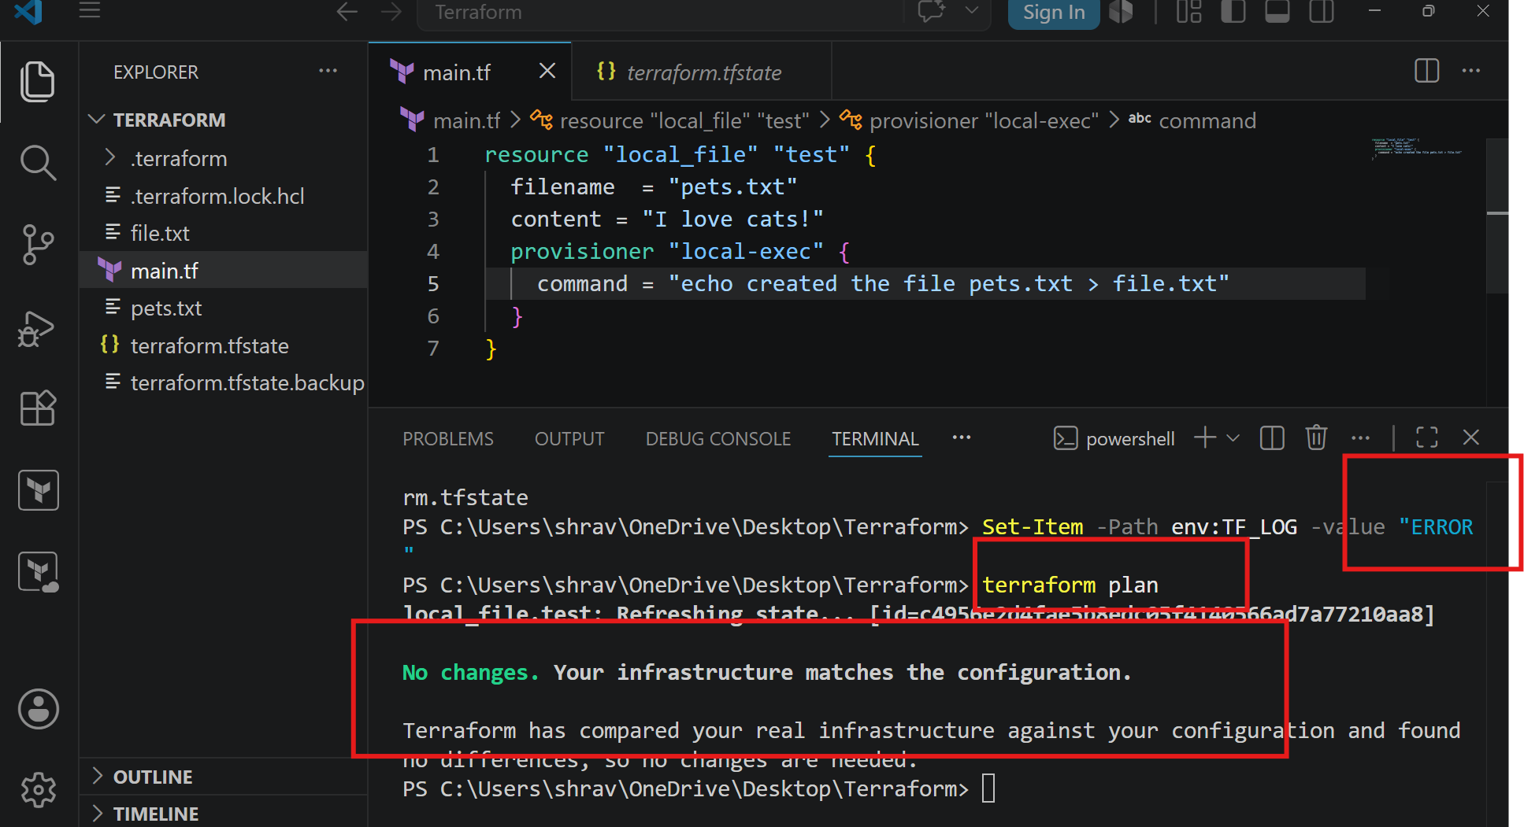
Import
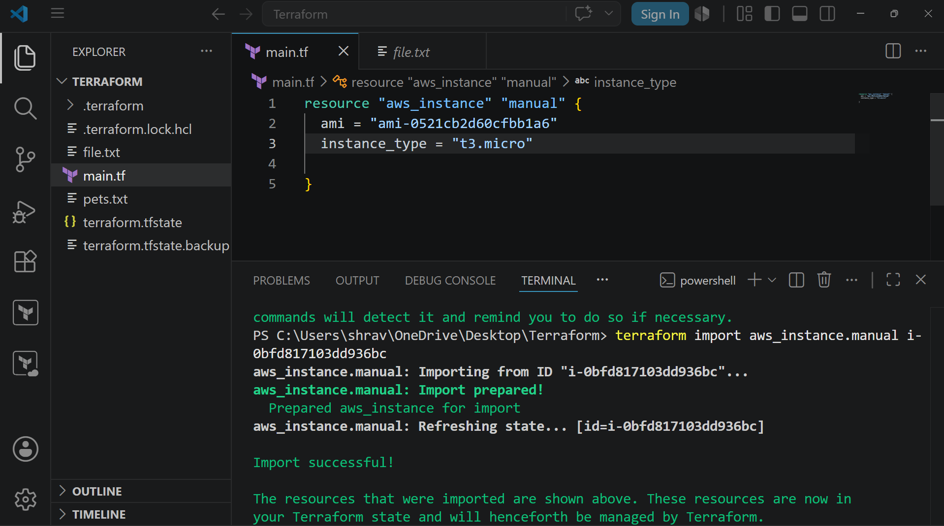
Destroy
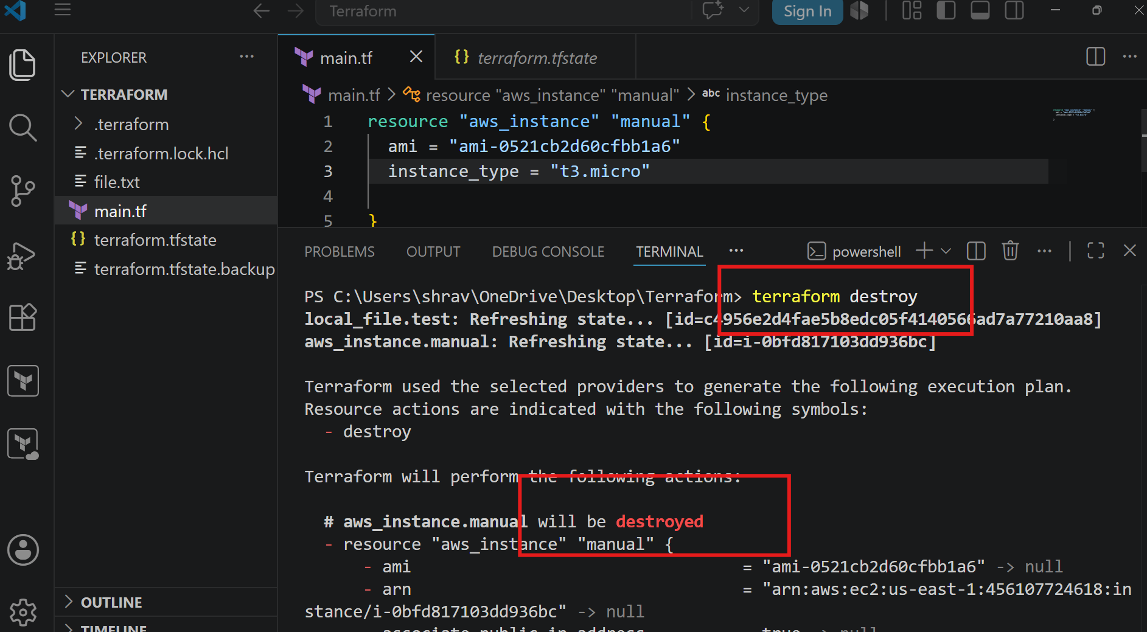
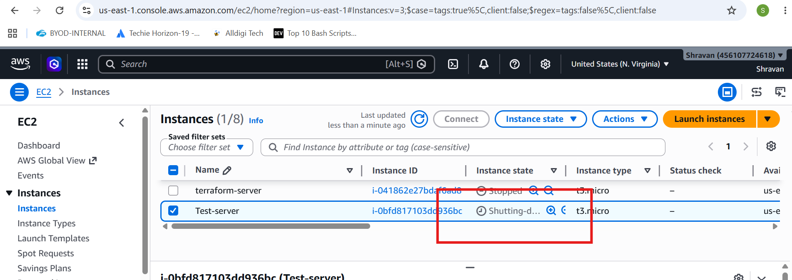
3). Create one EC2 instance with httpd installed using a Terraform script
Lets create an instance by using ami id,t3.micro, key name and user data,
Rest all will downloaded by default
In userdata write about to install httpd
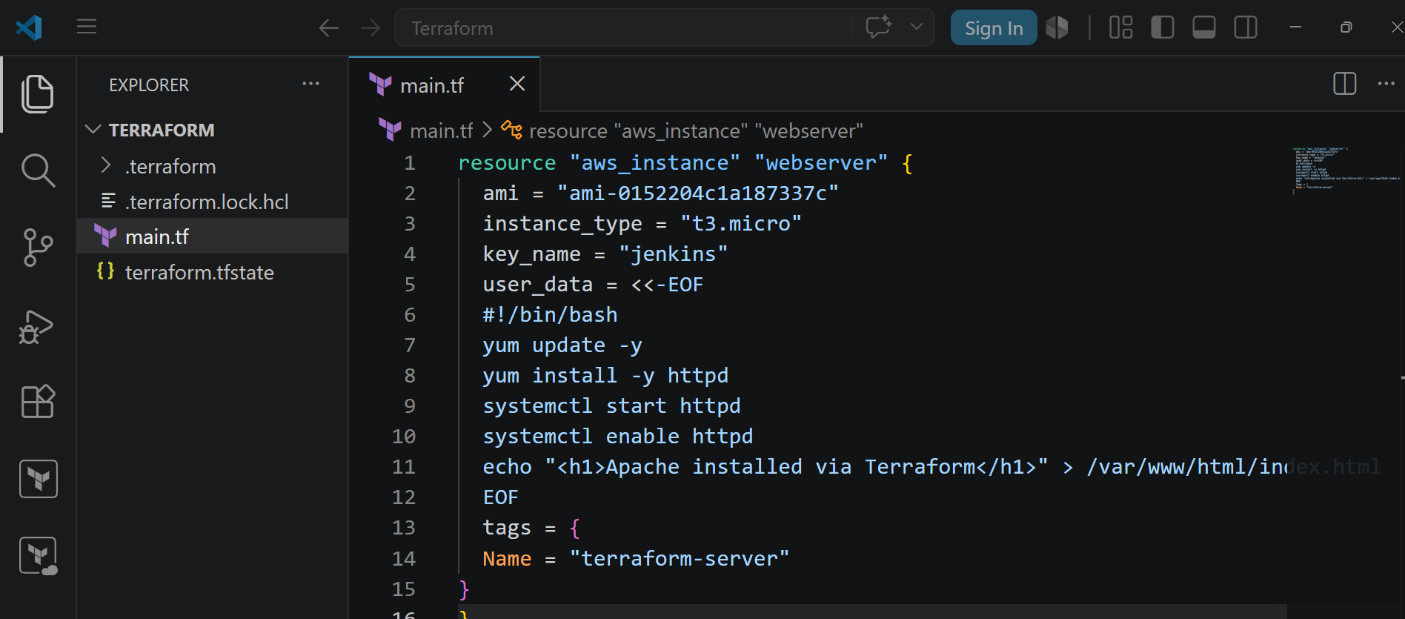
Terraform init
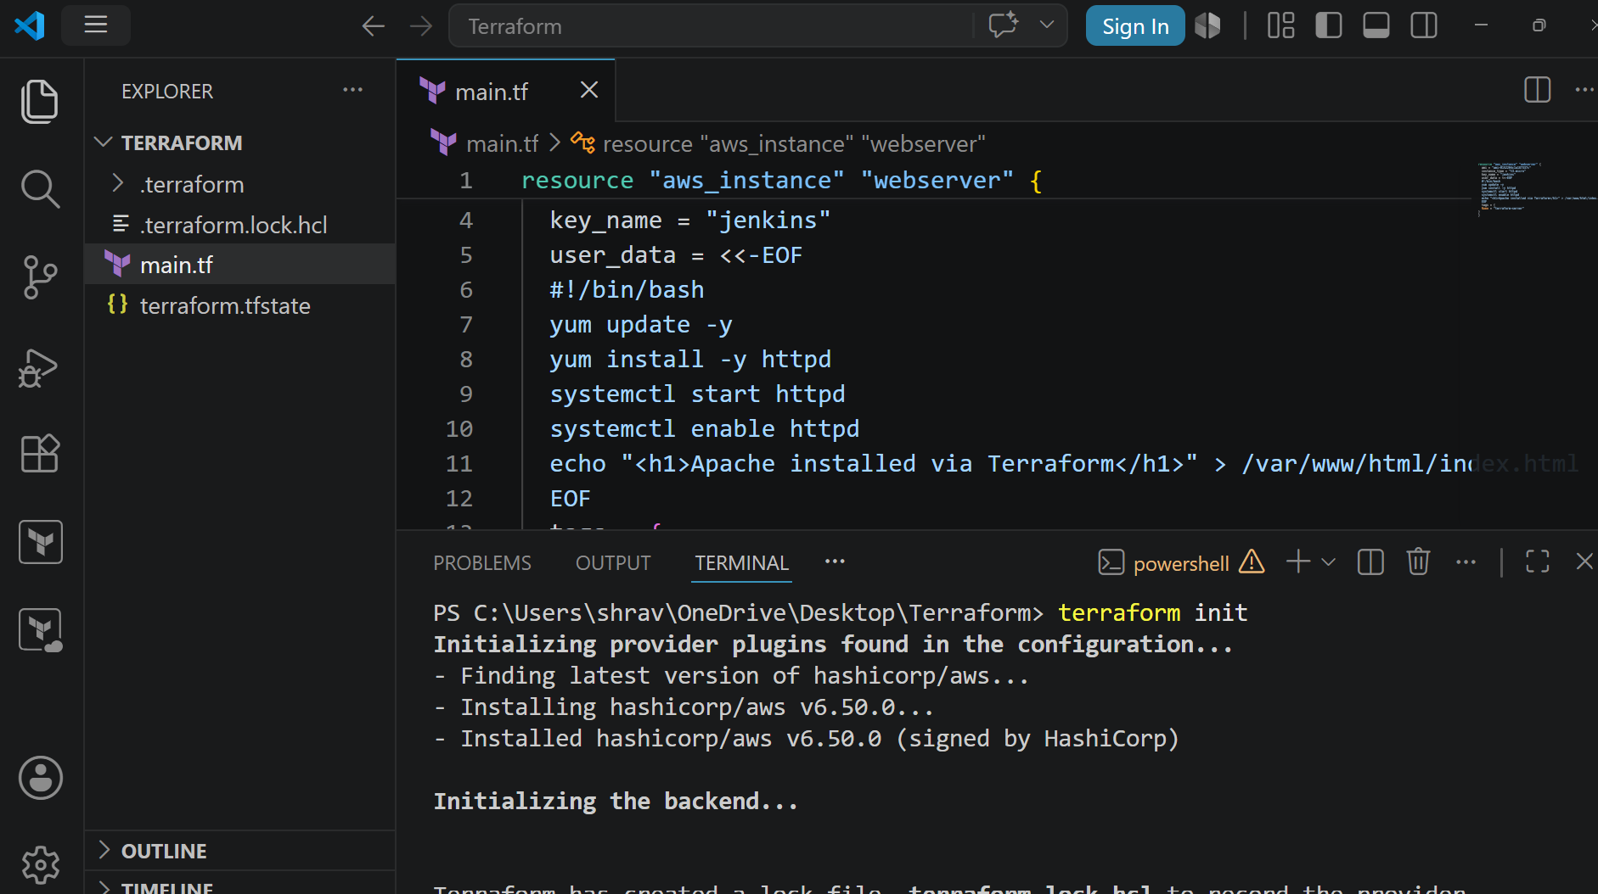
Terraform plan
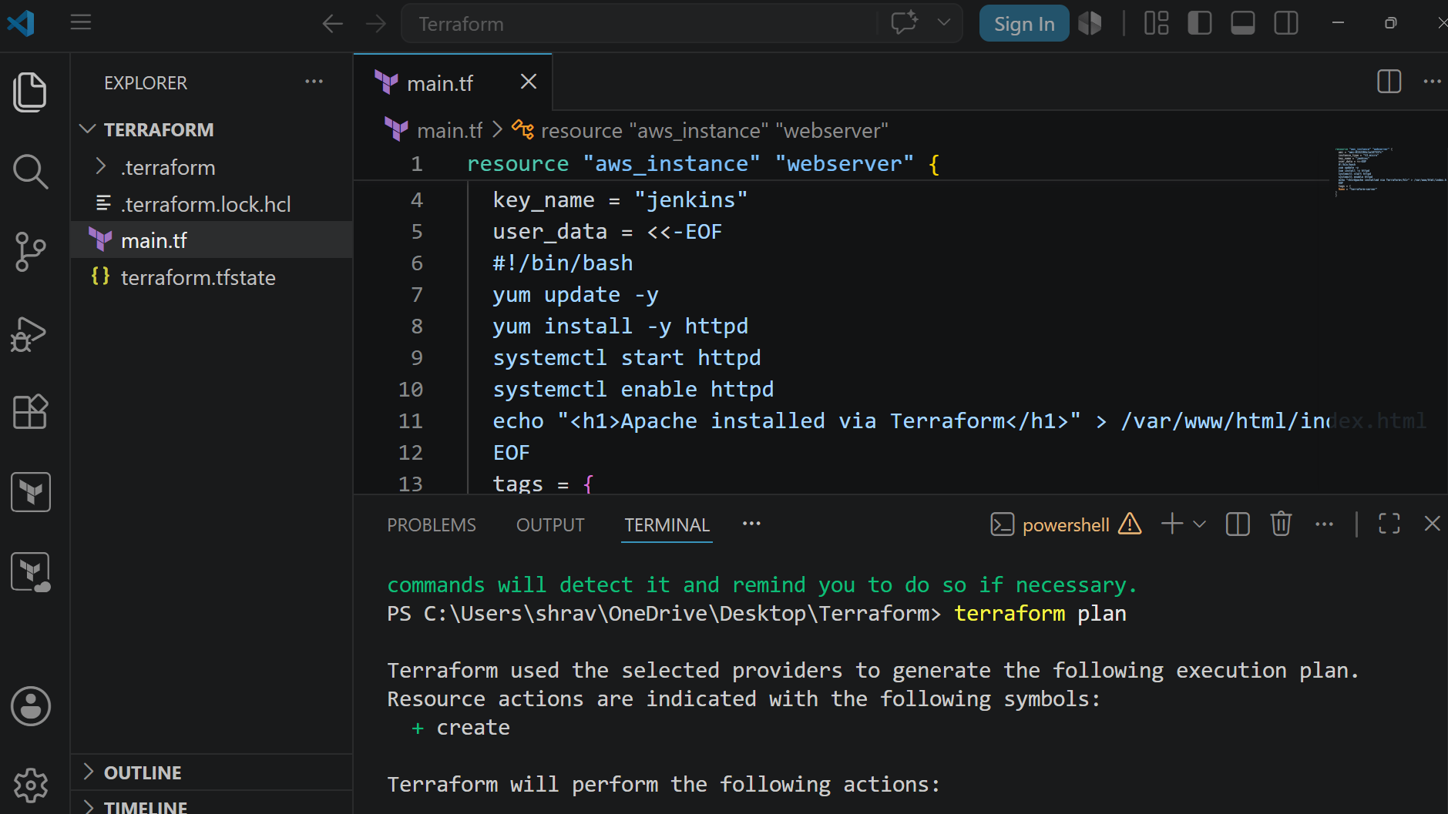
Terraform plan
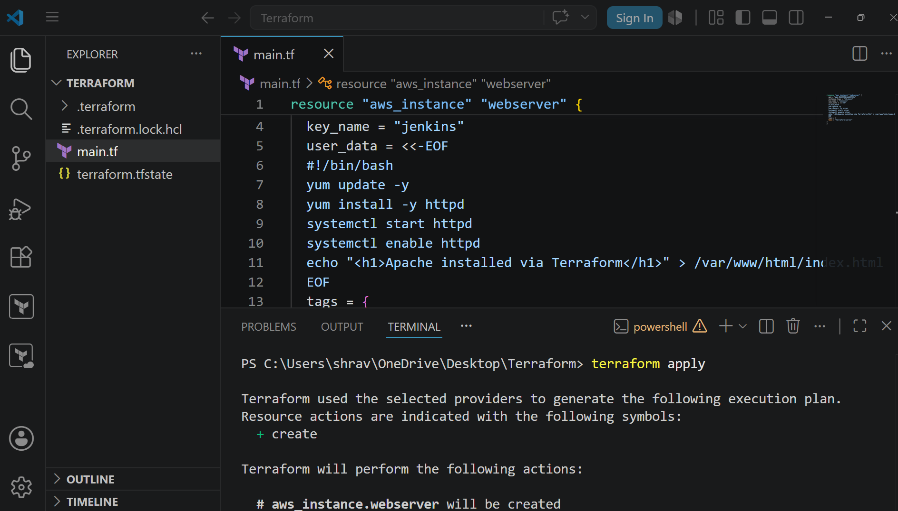
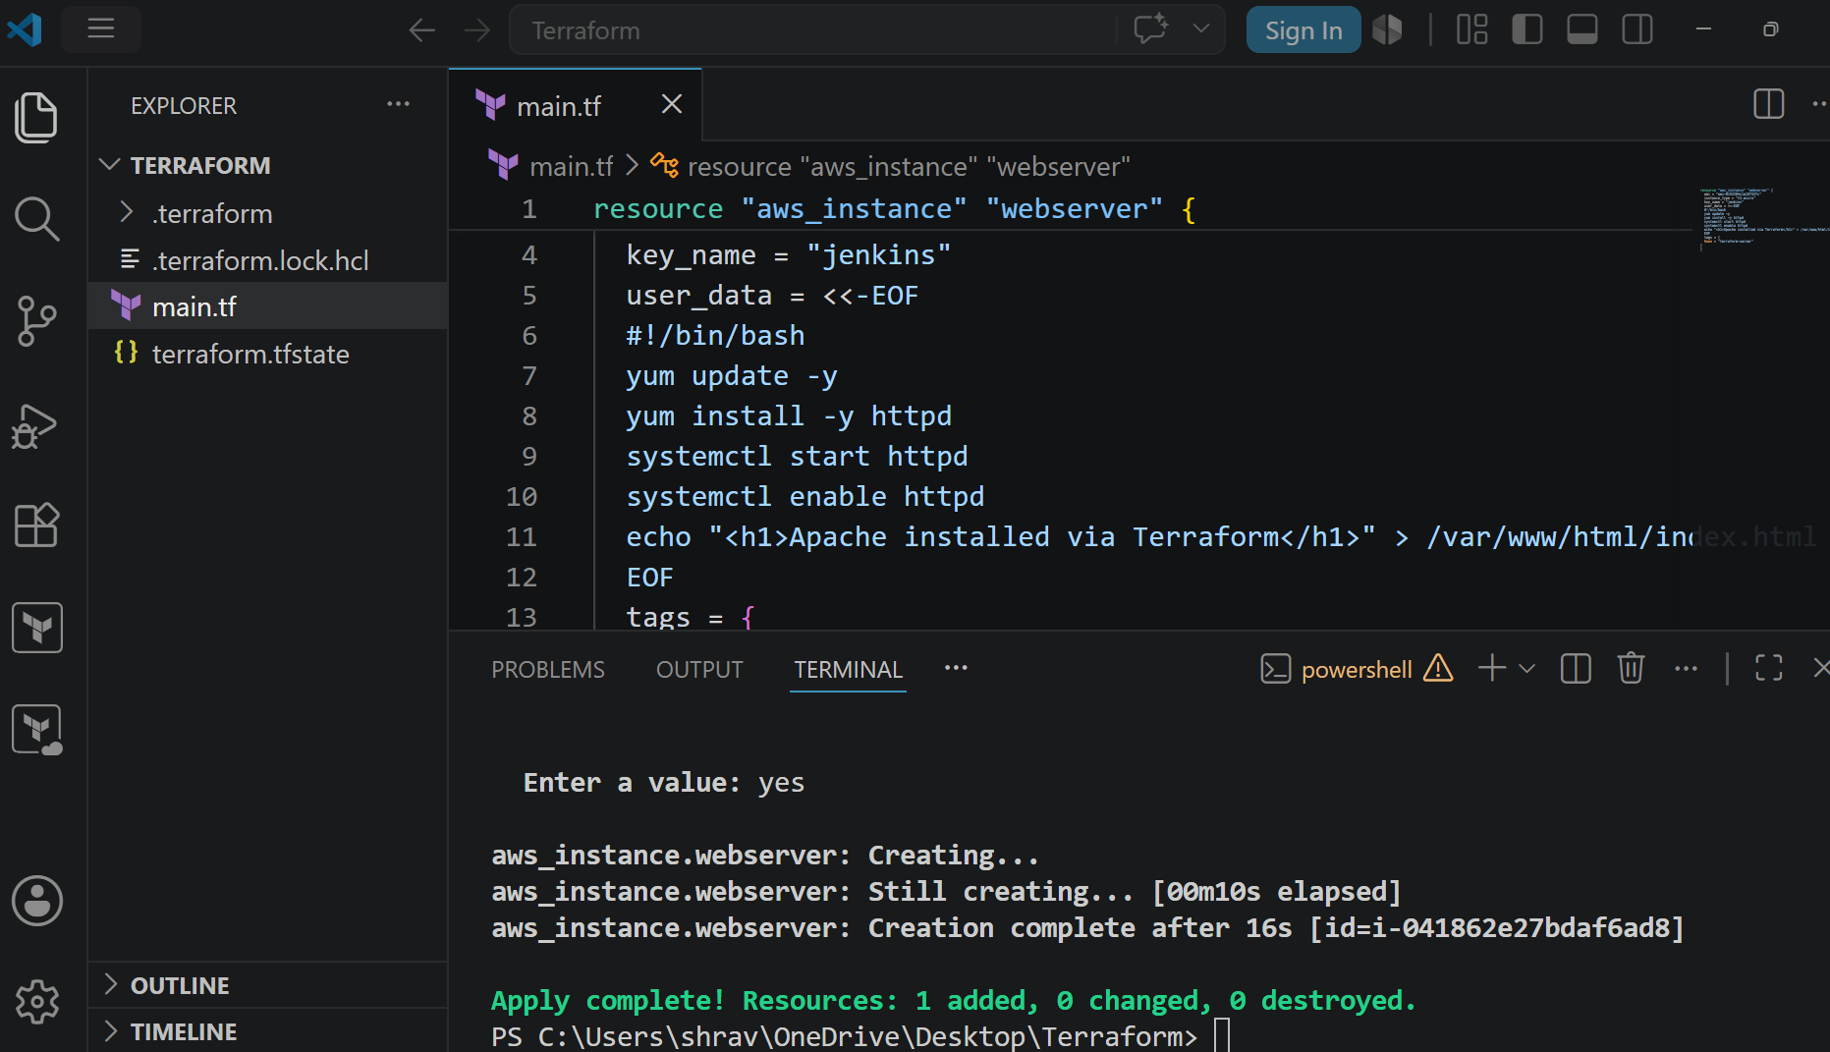

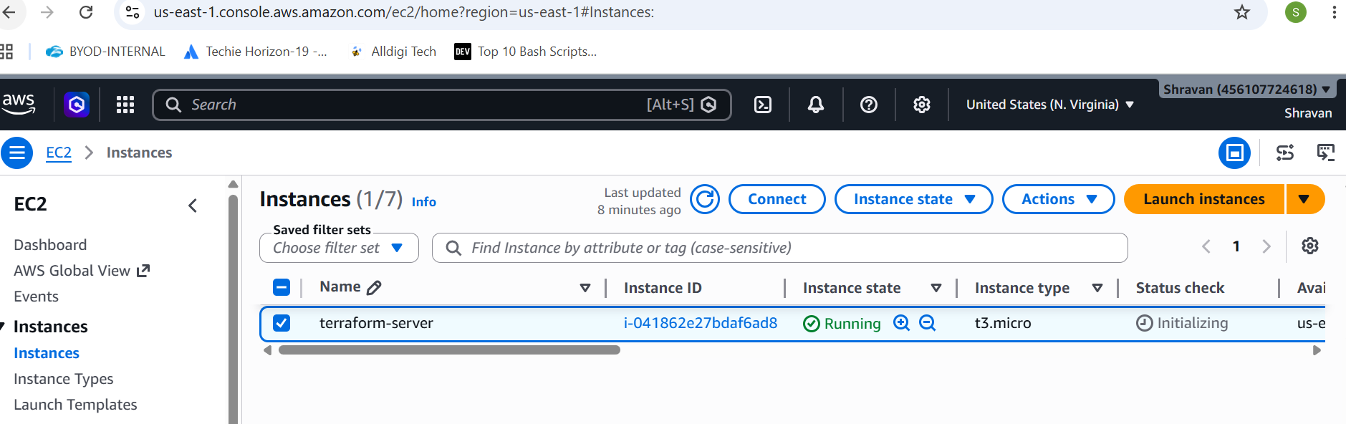
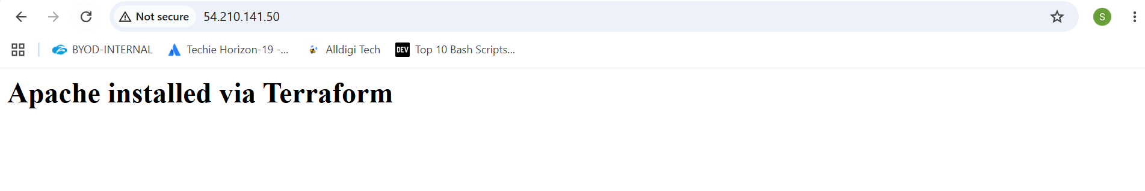
4). Set up S3 as backend for task 3.
5). Set up DynamoDB locking for task 3.
resource "aws_s3_bucket" "s3_bucket" {
bucket = "my-terraform-state-bucket-4618"
}
resource "aws_dynamodb_table" "terraform_locks" {
name = "terraform-locks"
billing_mode = "PAY_PER_REQUEST"
hash_key = "LockID"

attribute {
name = "LockID"
type = "S"
}
}

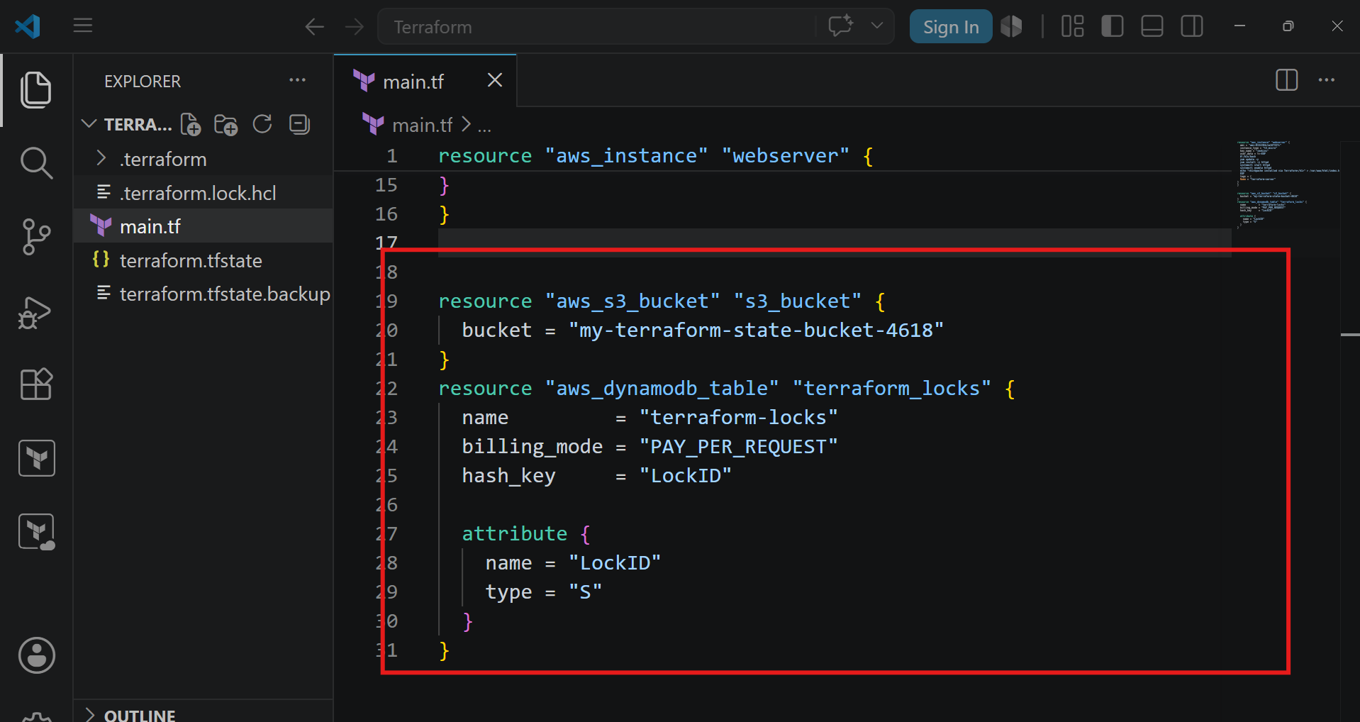
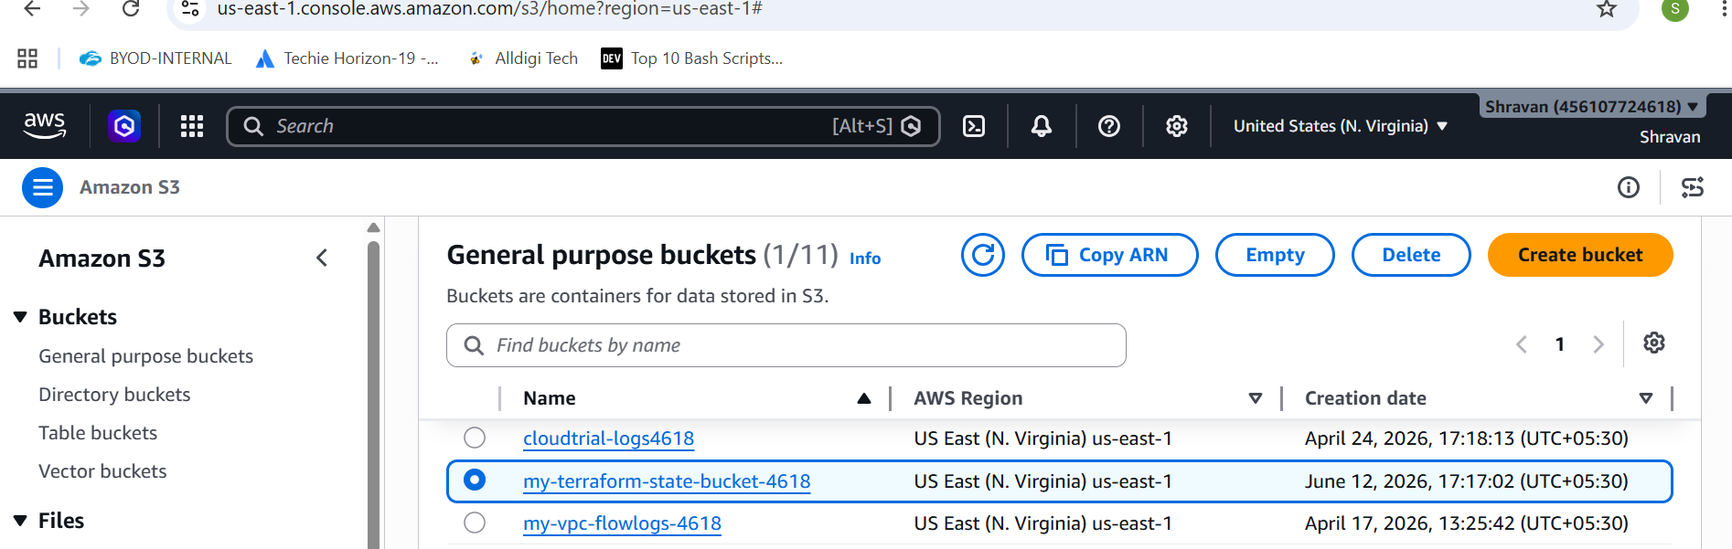
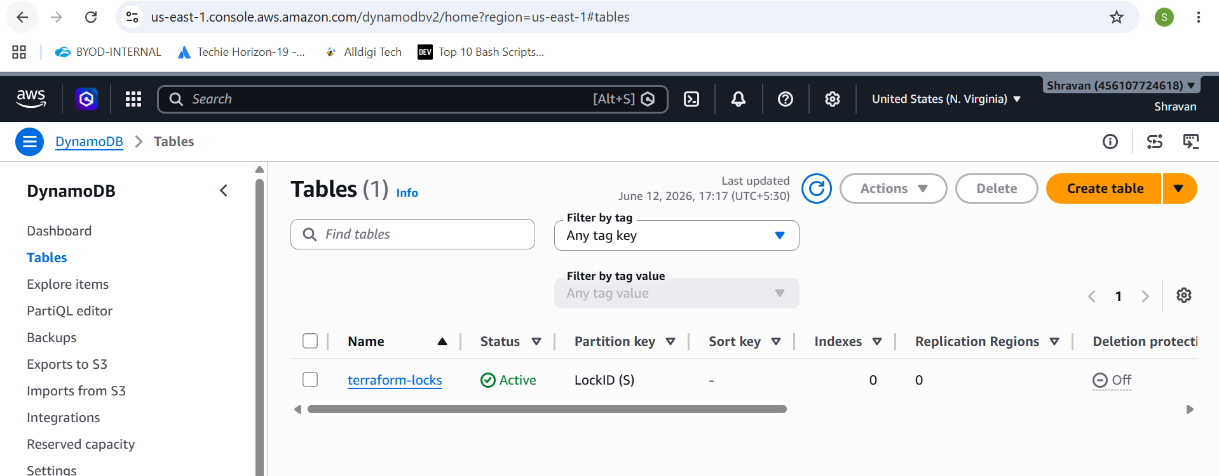
terraform {
backend "s3" {
bucket = "my-terraform-state-bucket-4618"
key = "ec2/terraform.tfstate"
region = "us-east-1"
dynamodb_table = "terraform-locks"
encrypt = true
}
}
Do terraform init
