Terraform Final Challenge
Start working on final `Terraform` Final Task.
1) Create VPC
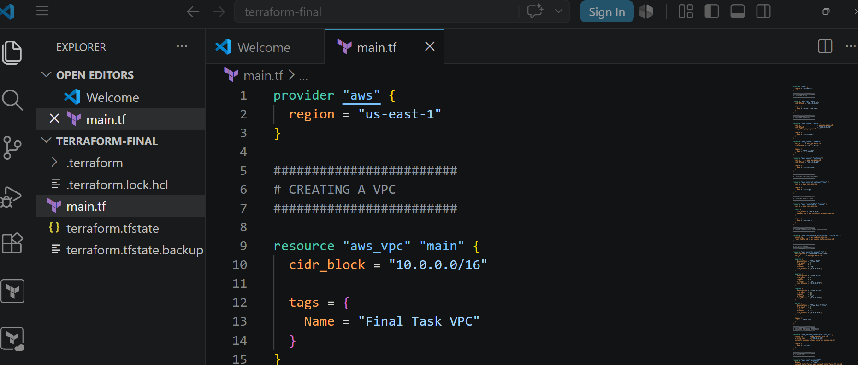
2) Create Internet gateway
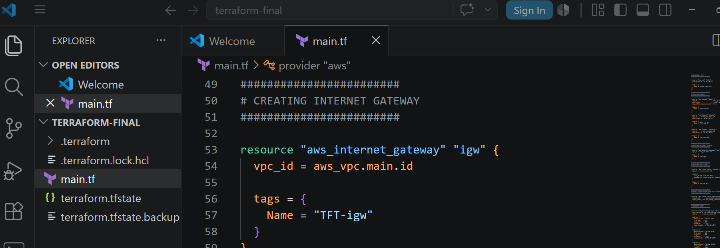
3) Create Custom Route Table
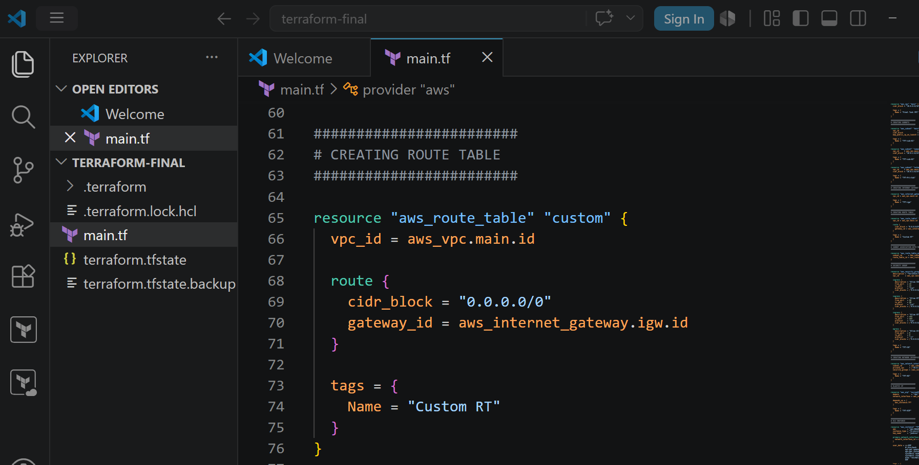
4) Create Subnet
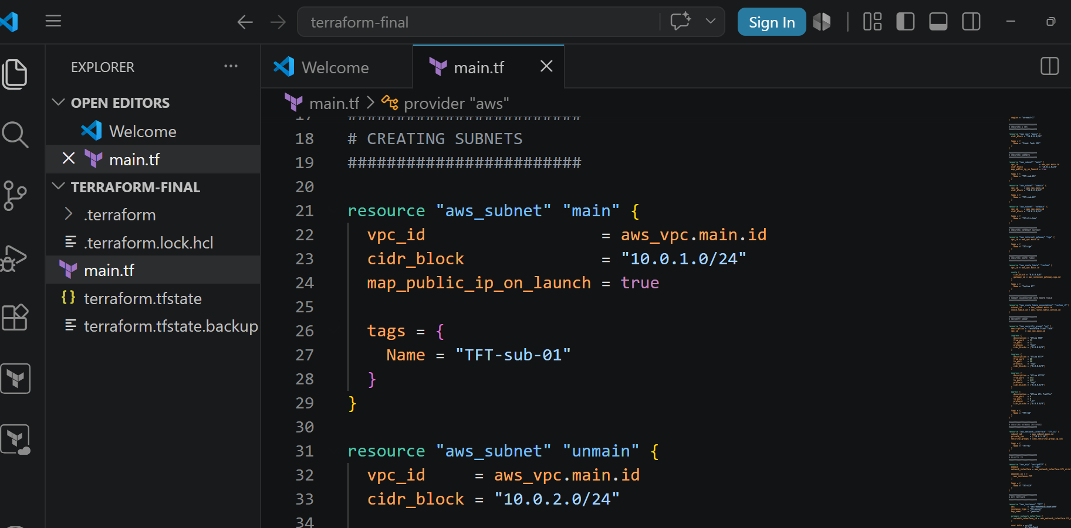
5) Associate subnet with Route Table
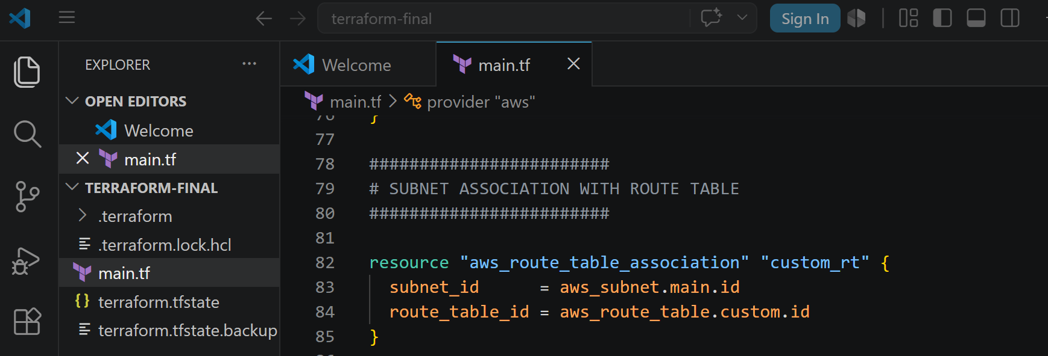
6) Create Security Group to allow port 22.80,443
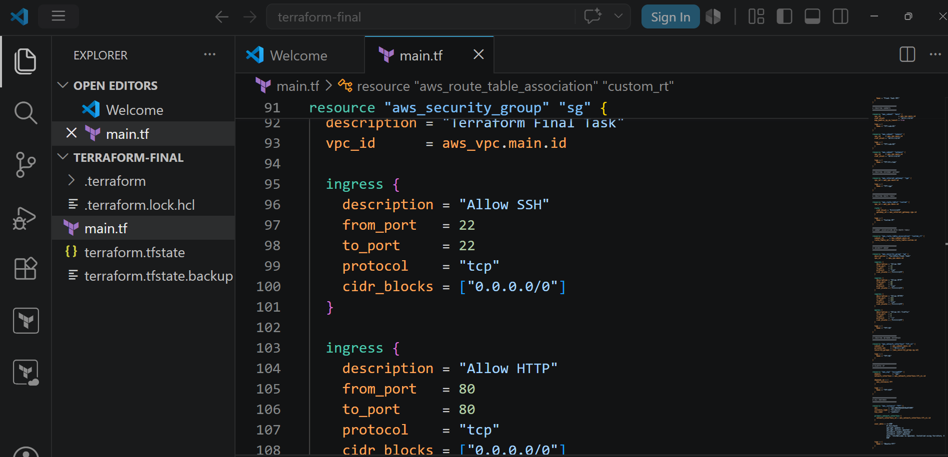
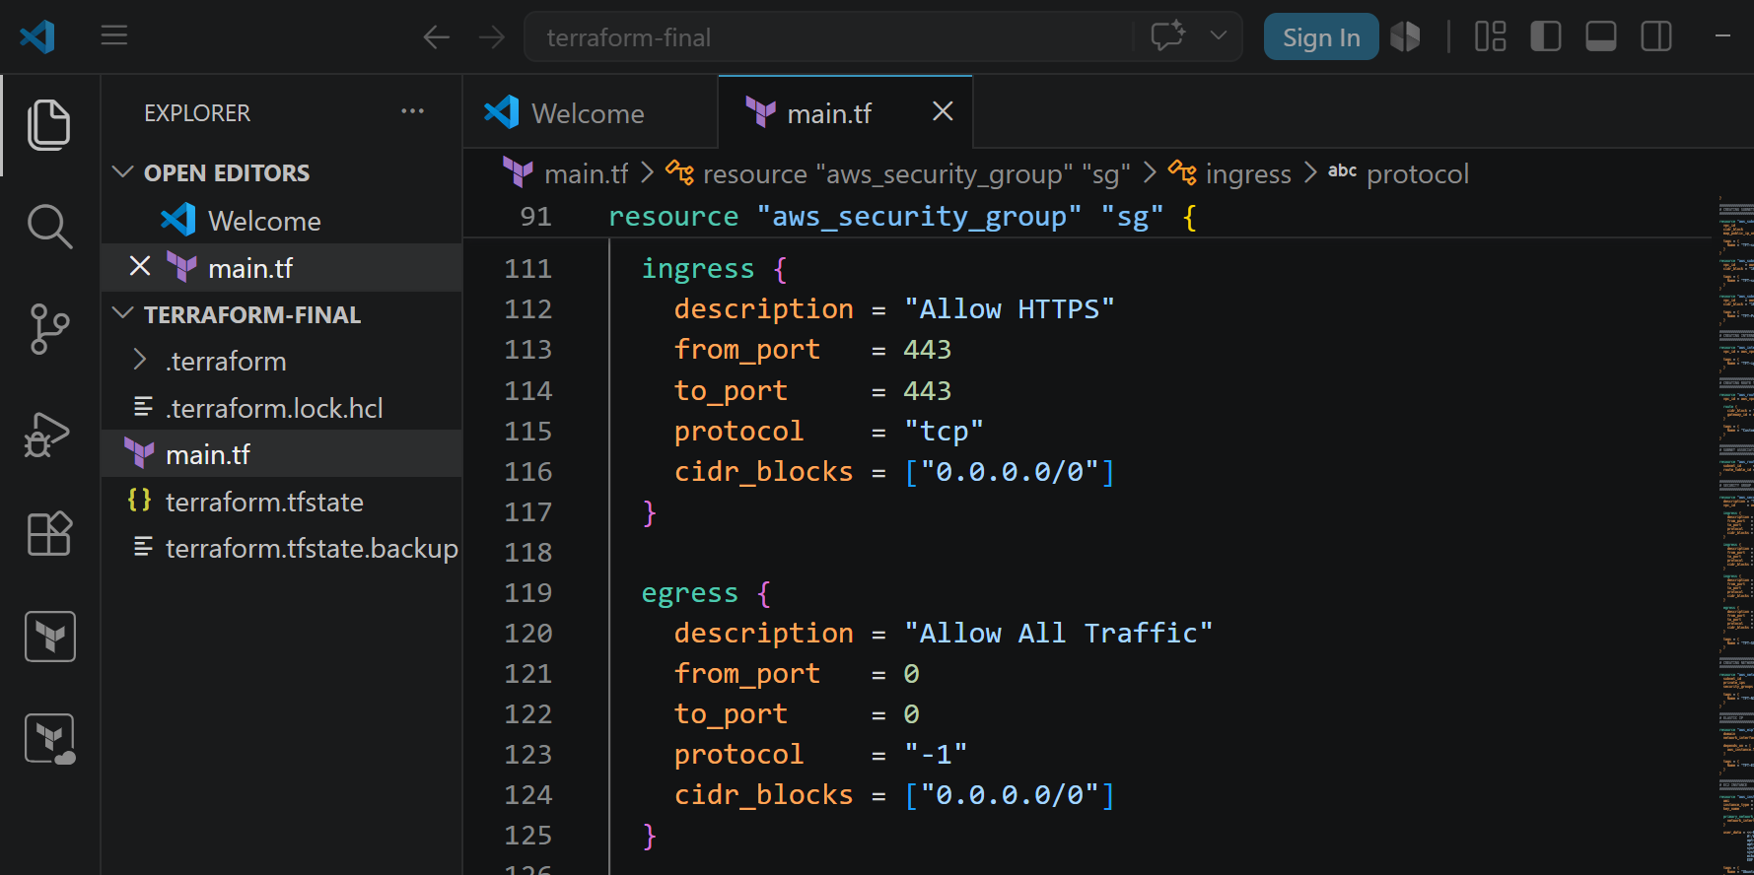
7) Create a network interface with an ip in the subnet that was created in step 4
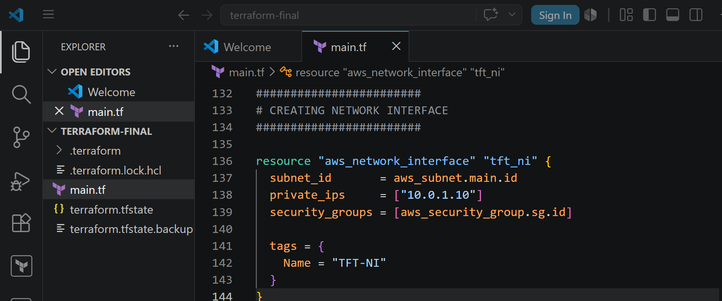
8) Assign an elastic IP to the network interface created in step 7
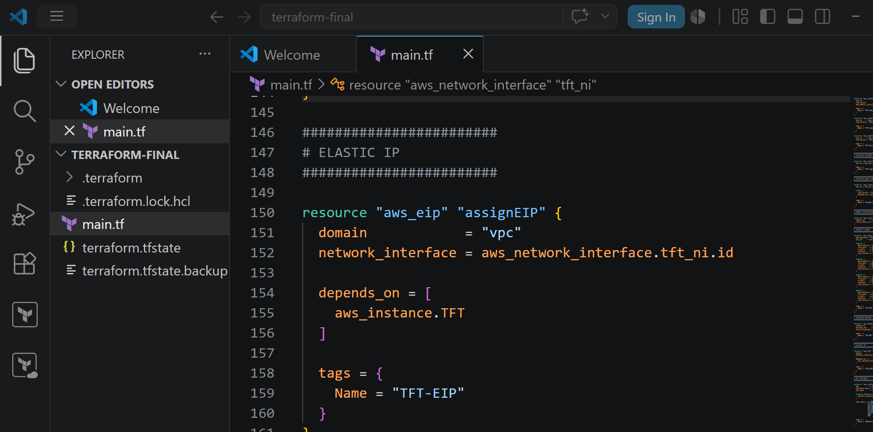
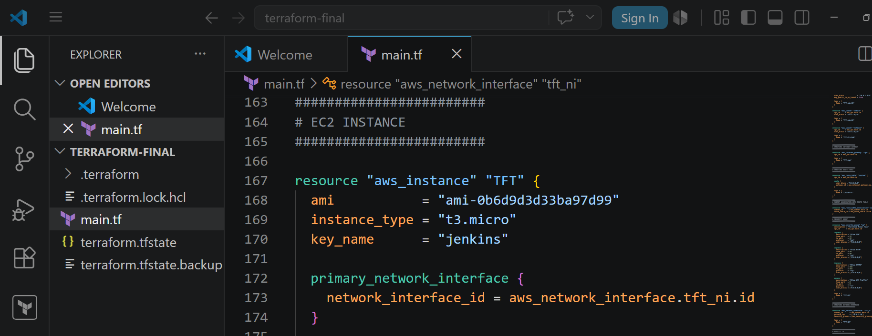
9) Create Ubuntu server and install/enable apache2
