Jenkins Challenge
Use the below code and implement our CICD stages.
- Source Code:https://github.com/betawins/hiring-app.git
  - Repository contains the application code for the hiring app.
- Create one Declarative pipeline job
- Create one Scripted pipeline job
- Create one multi stage pipeline job
- Create one parallel stage pipeline job
Create or open all the instance and make them start the instances like Jenkins, sonarqube, Nexus and tomcat servers
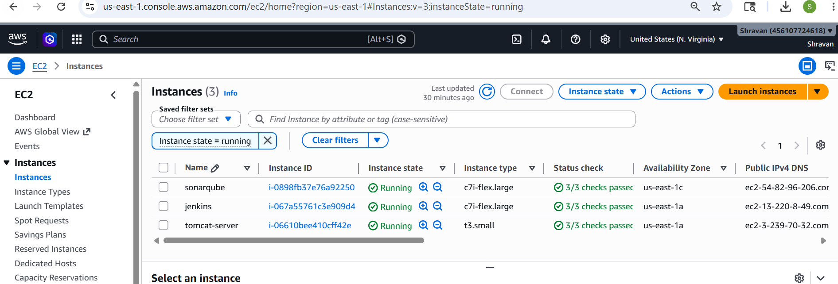
Configure sonarqube servers
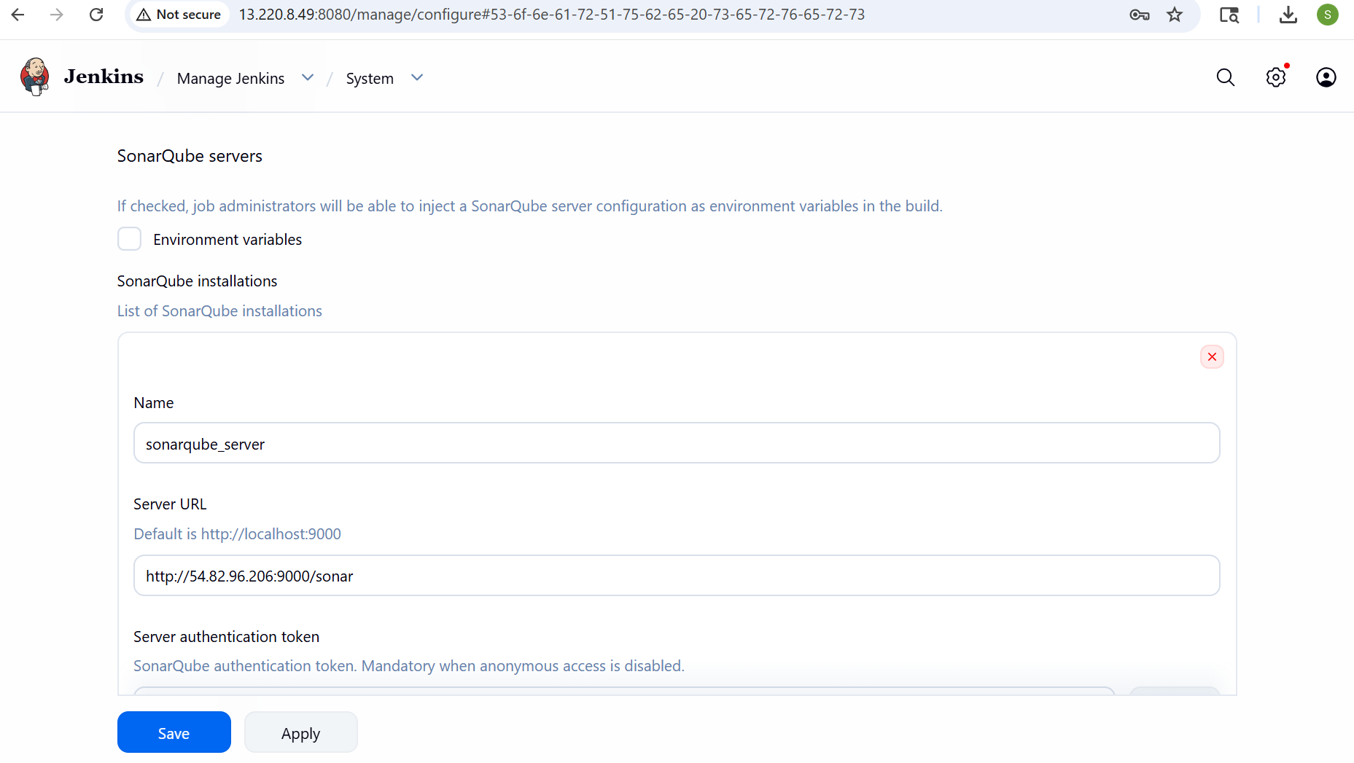
Integrate sonarqube scanner
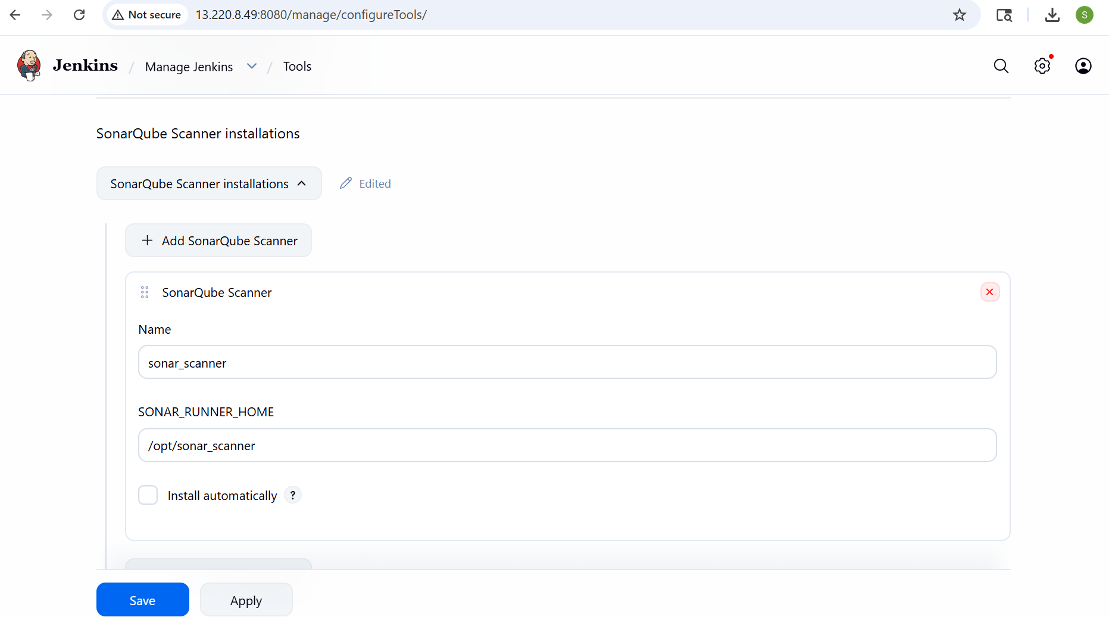
Integrate maven
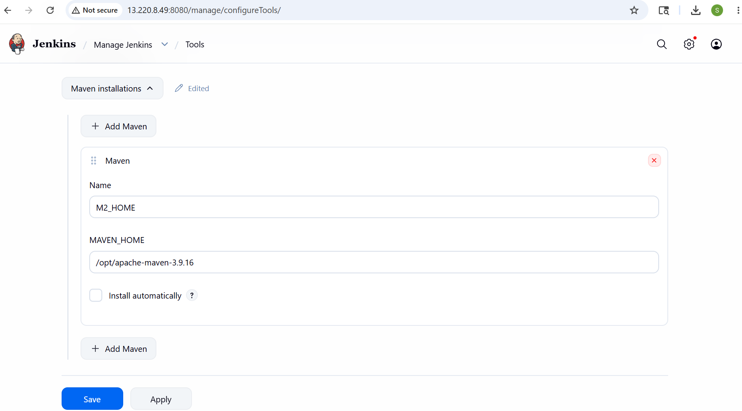
Configure email notification
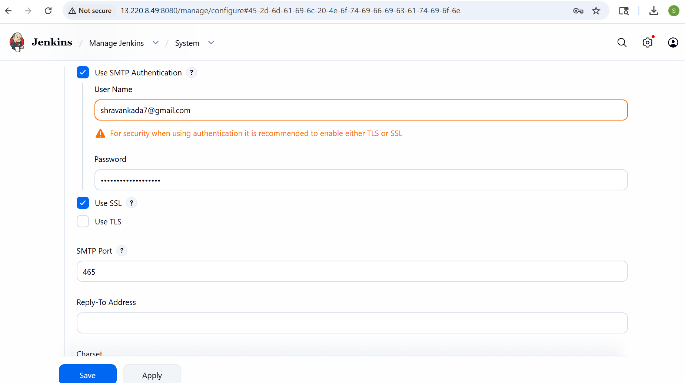
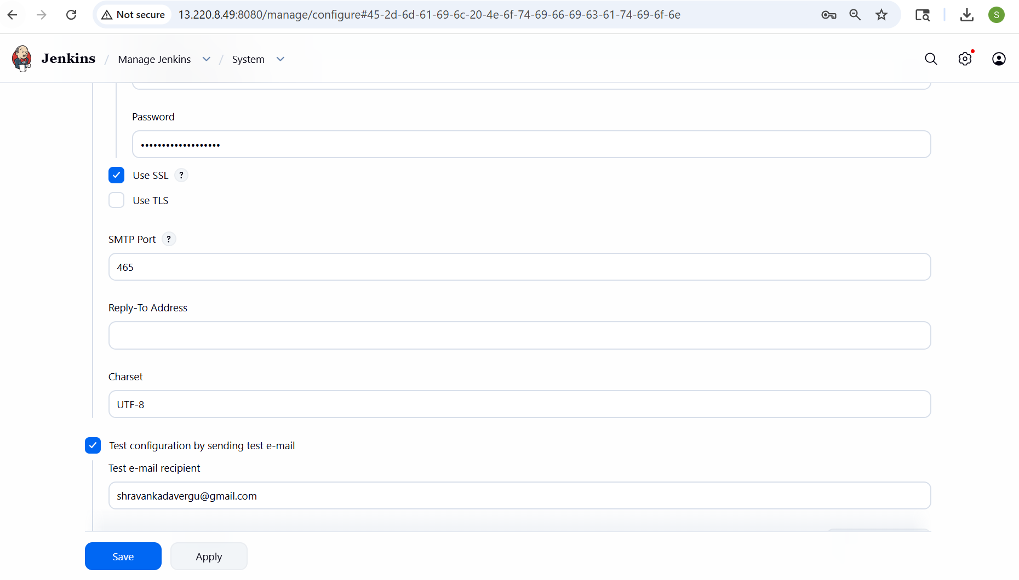
Create one Declarative pipeline job
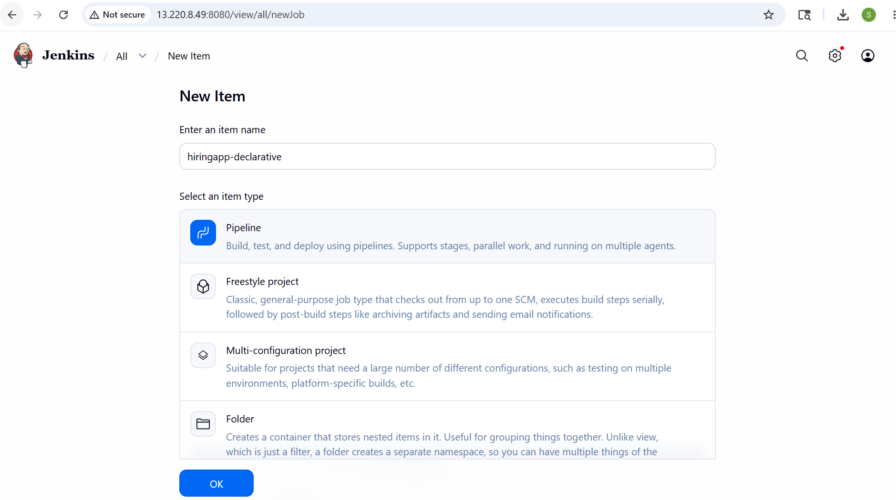
pipeline {
agent any

tools {
maven "M2_HOME"
}

environment {
SCANNER_HOME = tool 'sonar_scanner'
}

stages {

stage('Clone Code') {
steps {
git branch: 'main',
url: 'https://github.com/shravank7/hiring-app.git'
}
}

stage('Build') {
steps {
sh 'mvn clean install'
}
}

stage('SonarQube Analysis') {
steps {
withSonarQubeEnv('sonarqube_server') {

sh """
mkdir -p target/classes

${SCANNER_HOME}/bin/sonar-scanner \
-Dsonar.projectKey=Test \
-Dsonar.projectName=Test \
-Dsonar.sources=src \
-Dsonar.java.binaries=target/classes
"""
}
}
}

stage('Upload Artifact to Nexus') {
steps {

nexusArtifactUploader(
nexusVersion: 'nexus3',
protocol: 'http',
nexusUrl: '3.239.70.32:8081',
repository: 'hiring',
credentialsId: 'f8aec3dd-80dd-4369-8a7f-7b3971777fe2',
groupId: 'in.javahome',
version: "${BUILD_NUMBER}-SNAPSHOT",

artifacts: [
[
artifactId: 'hiring',
classifier: '',
file: 'target/hiring.war',
type: 'war'
]
]
)
}
}
}
post {

success {

emailext(
subject: "SUCCESS: Job '${JOB_NAME} [${BUILD_NUMBER}]'",

body: """
<h2 style="color:green;">Build Successful</h2>

<p><b>Job Name:</b> ${JOB_NAME}</p>
<p><b>Build Number:</b> ${BUILD_NUMBER}</p>
<p><b>Build URL:</b> ${BUILD_URL}</p>
""",

mimeType: 'text/html',

to: 'shravankada7@gmail.com'
)
}

failure {

emailext(
subject: "FAILED: Job '${JOB_NAME} [${BUILD_NUMBER}]'",

body: """
<h2 style="color:red;">Build Failed</h2>

<p><b>Job Name:</b> ${JOB_NAME}</p>
<p><b>Build Number:</b> ${BUILD_NUMBER}</p>
<p><b>Build URL:</b> ${BUILD_URL}</p>

<p>Check Jenkins console logs.</p>
""",

mimeType: 'text/html',

to: 'shravankada7@gmail.com'
)
}
}
}
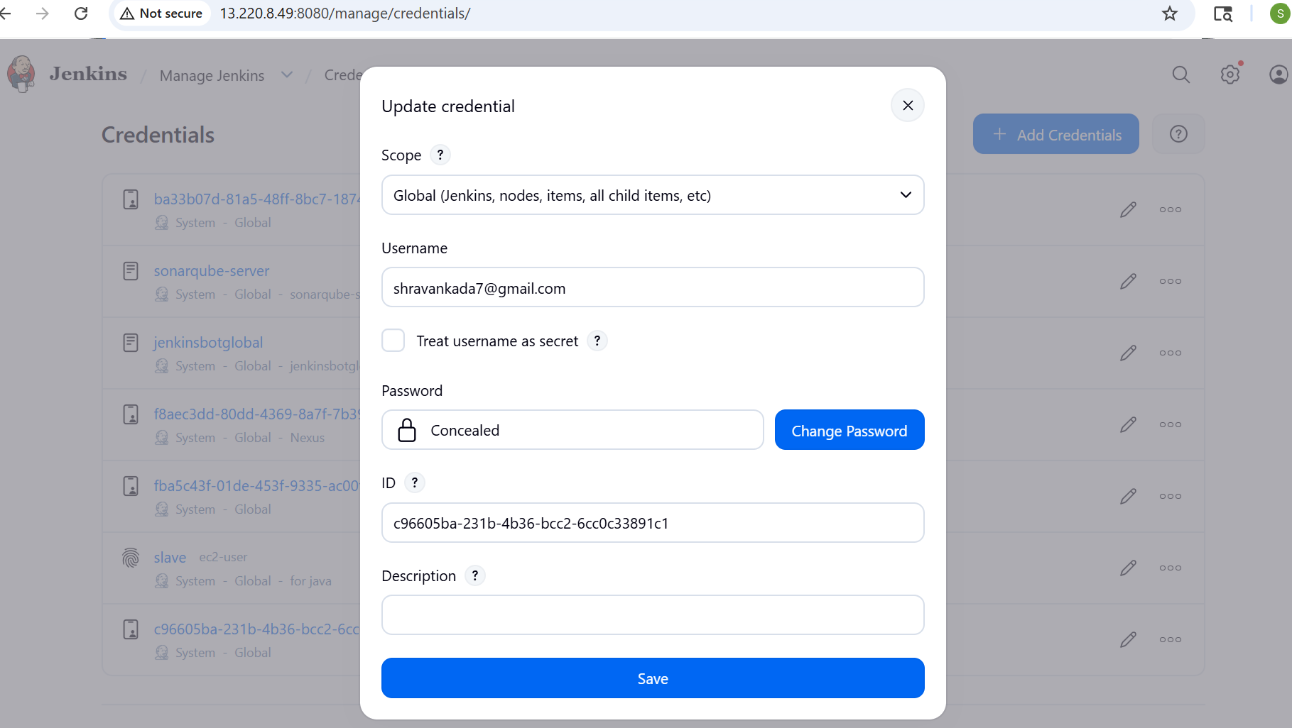
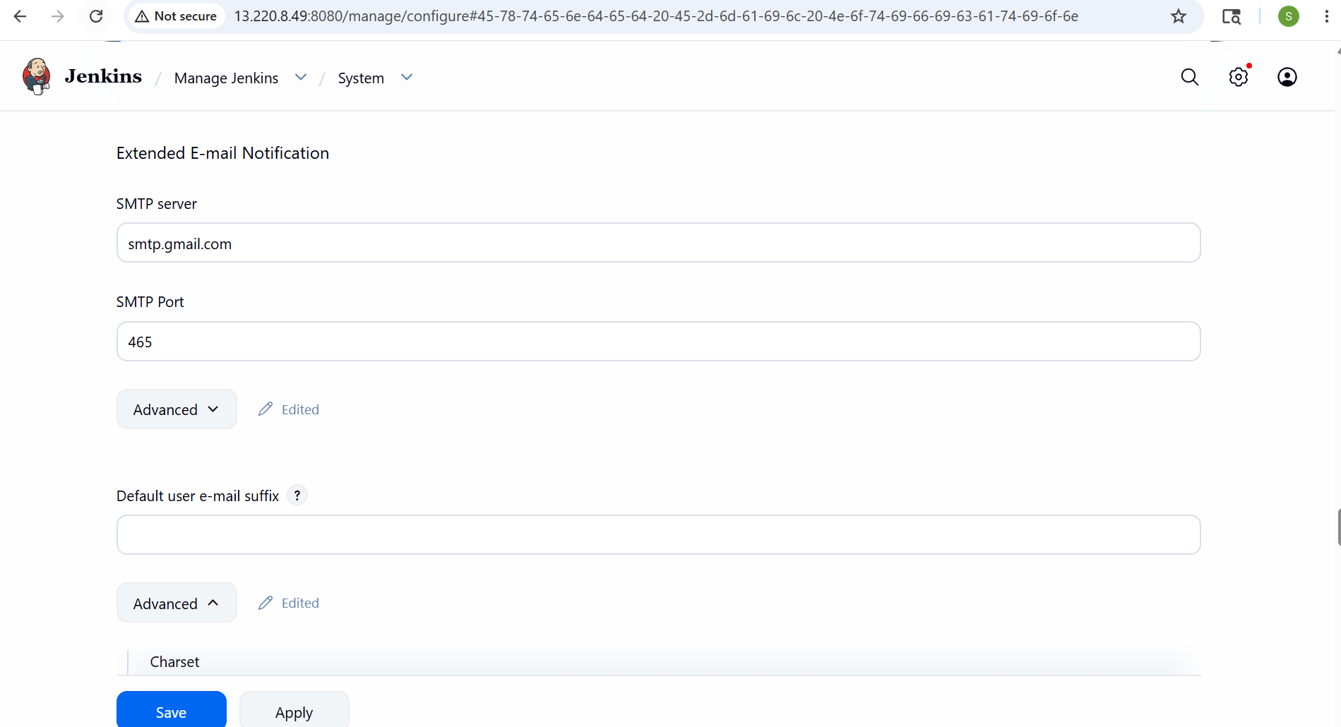
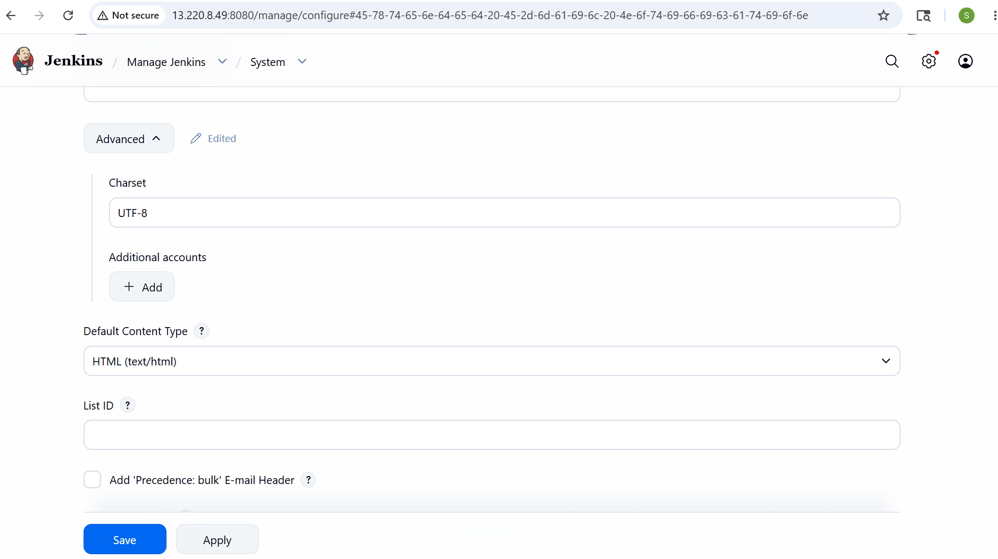
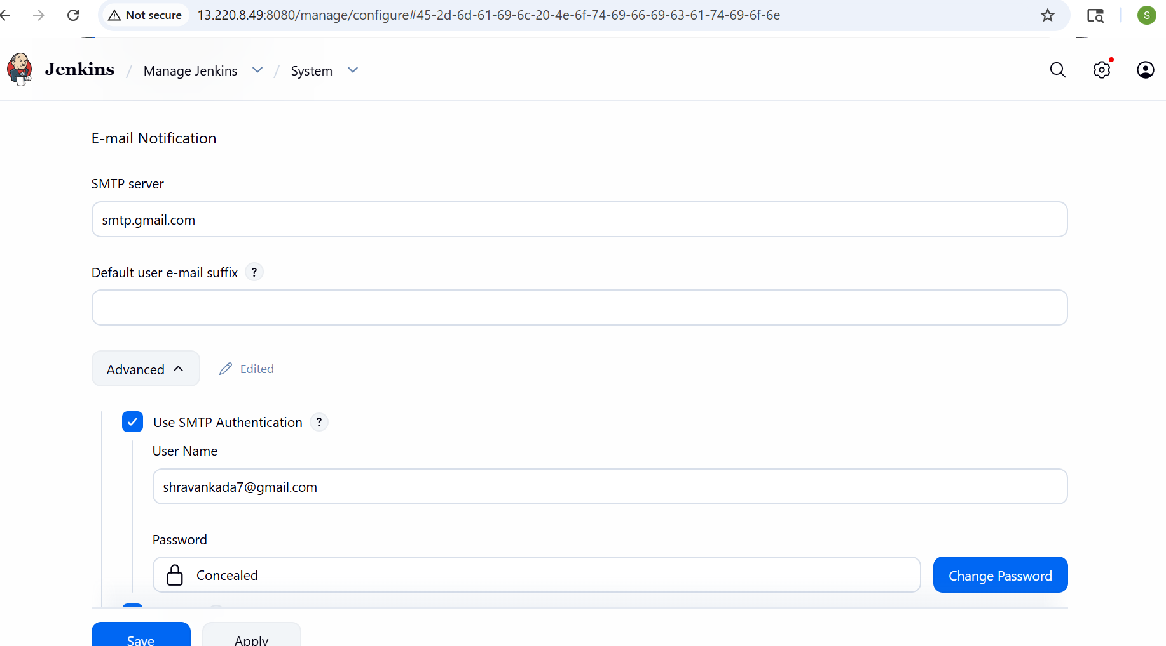
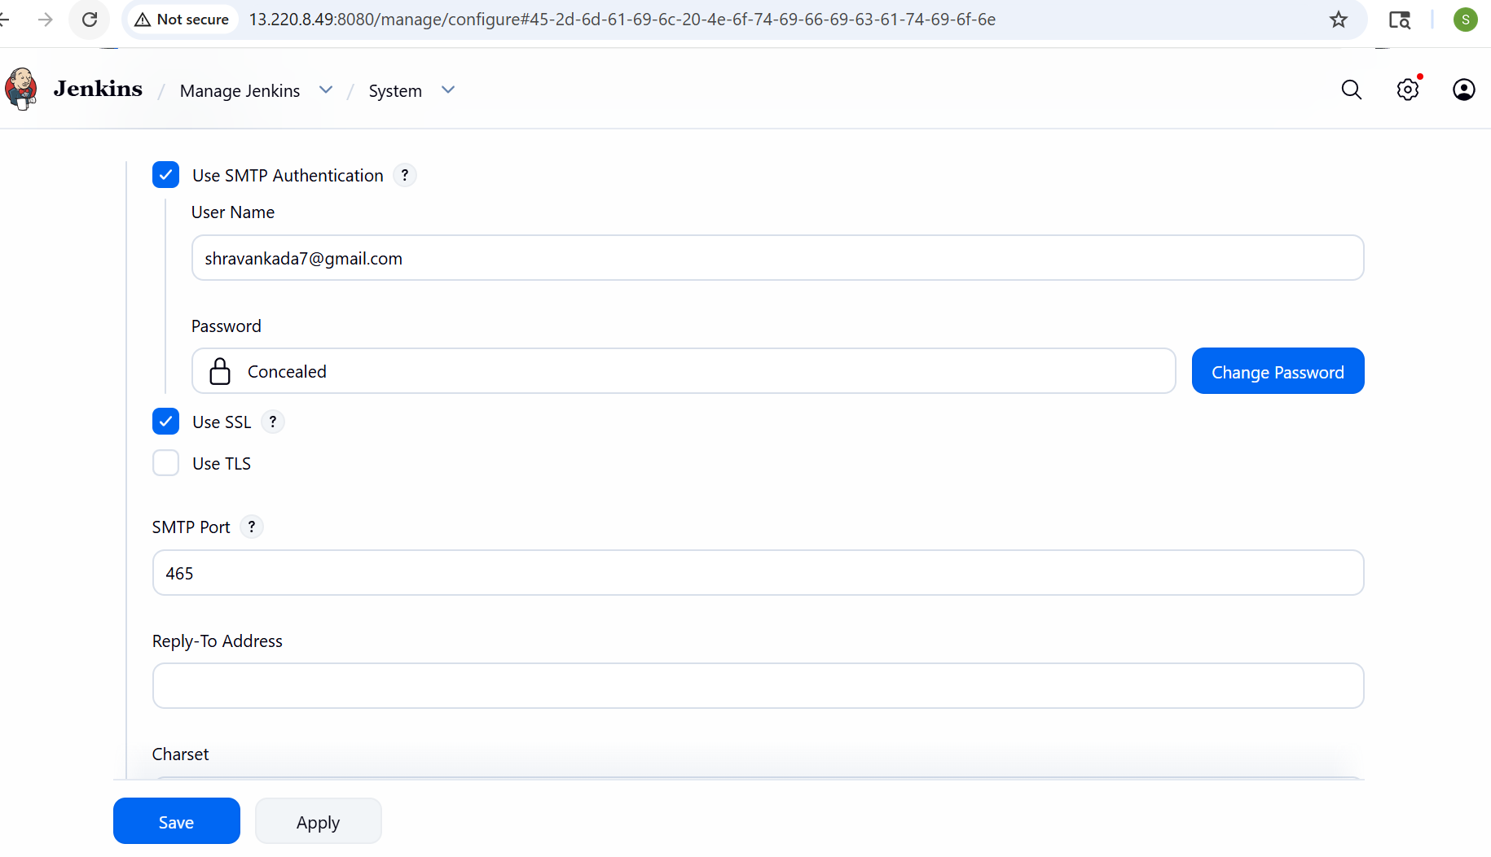
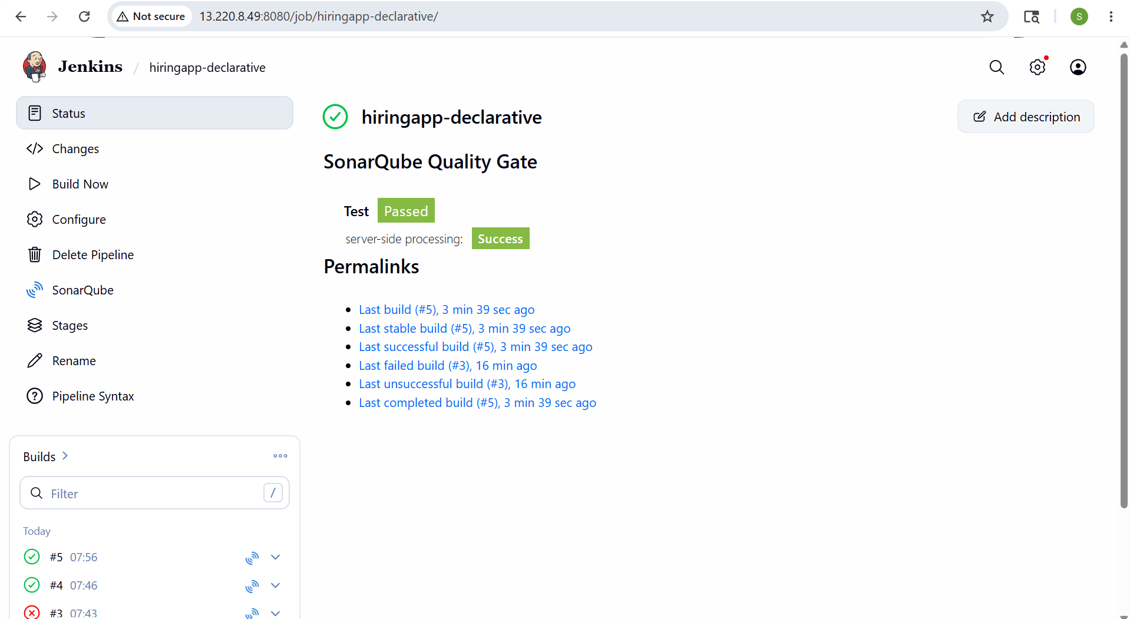
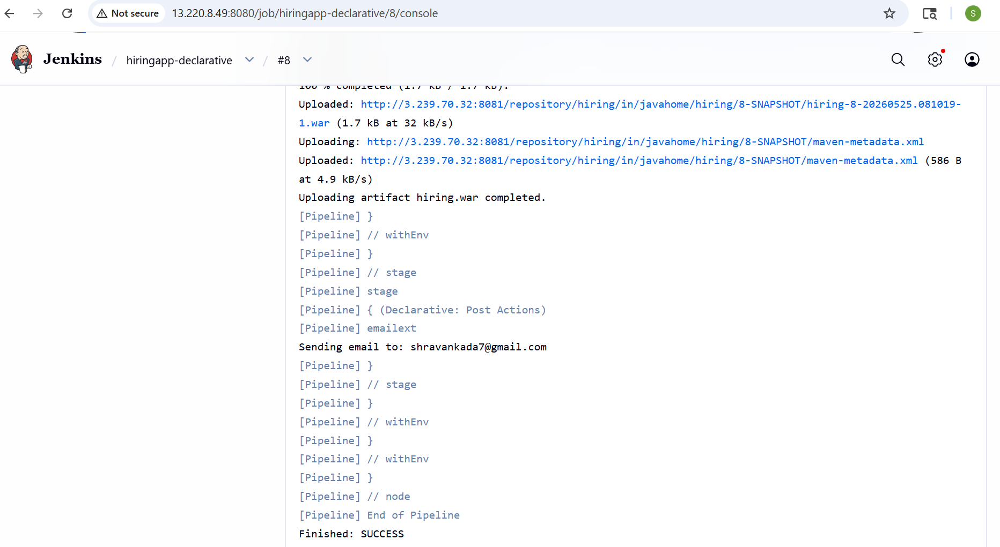
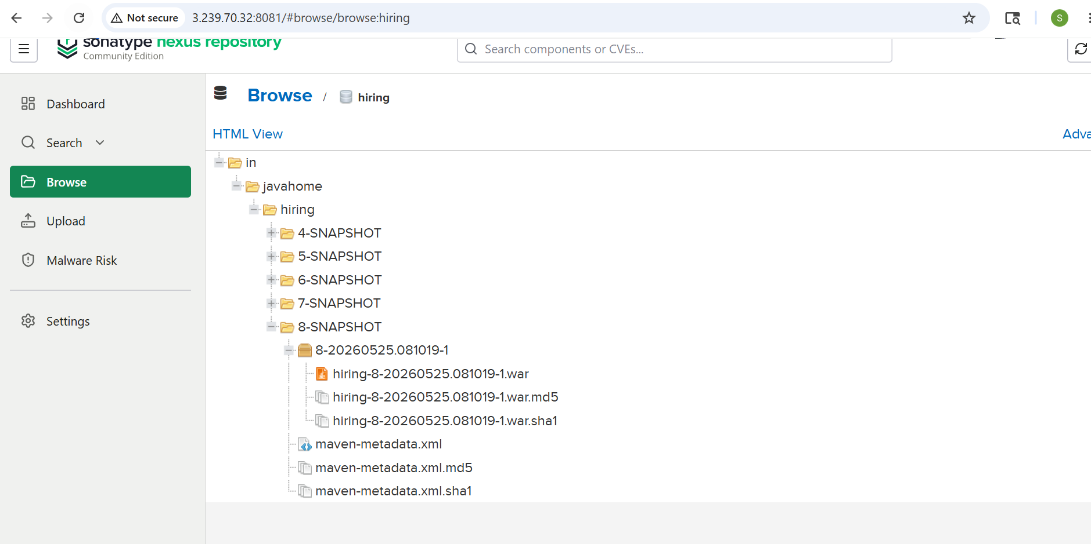
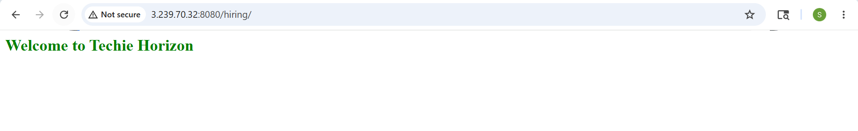
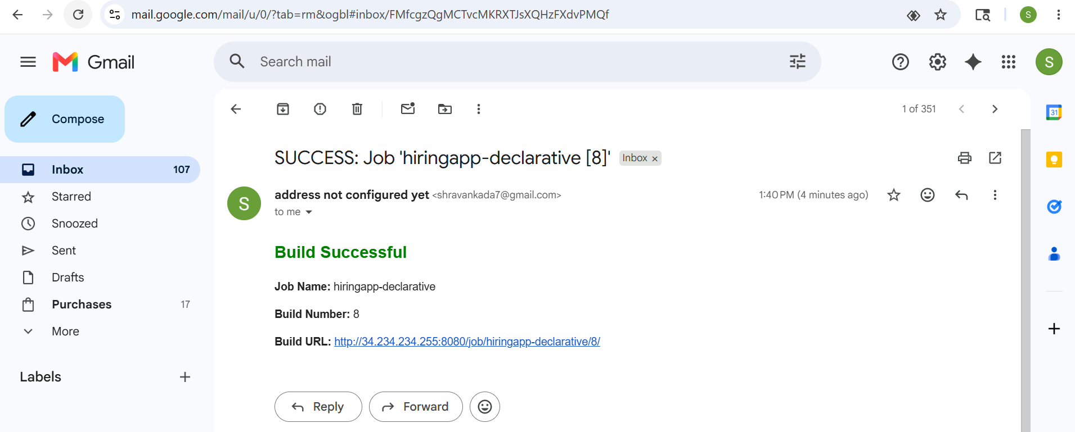
Create one Scripted pipeline job
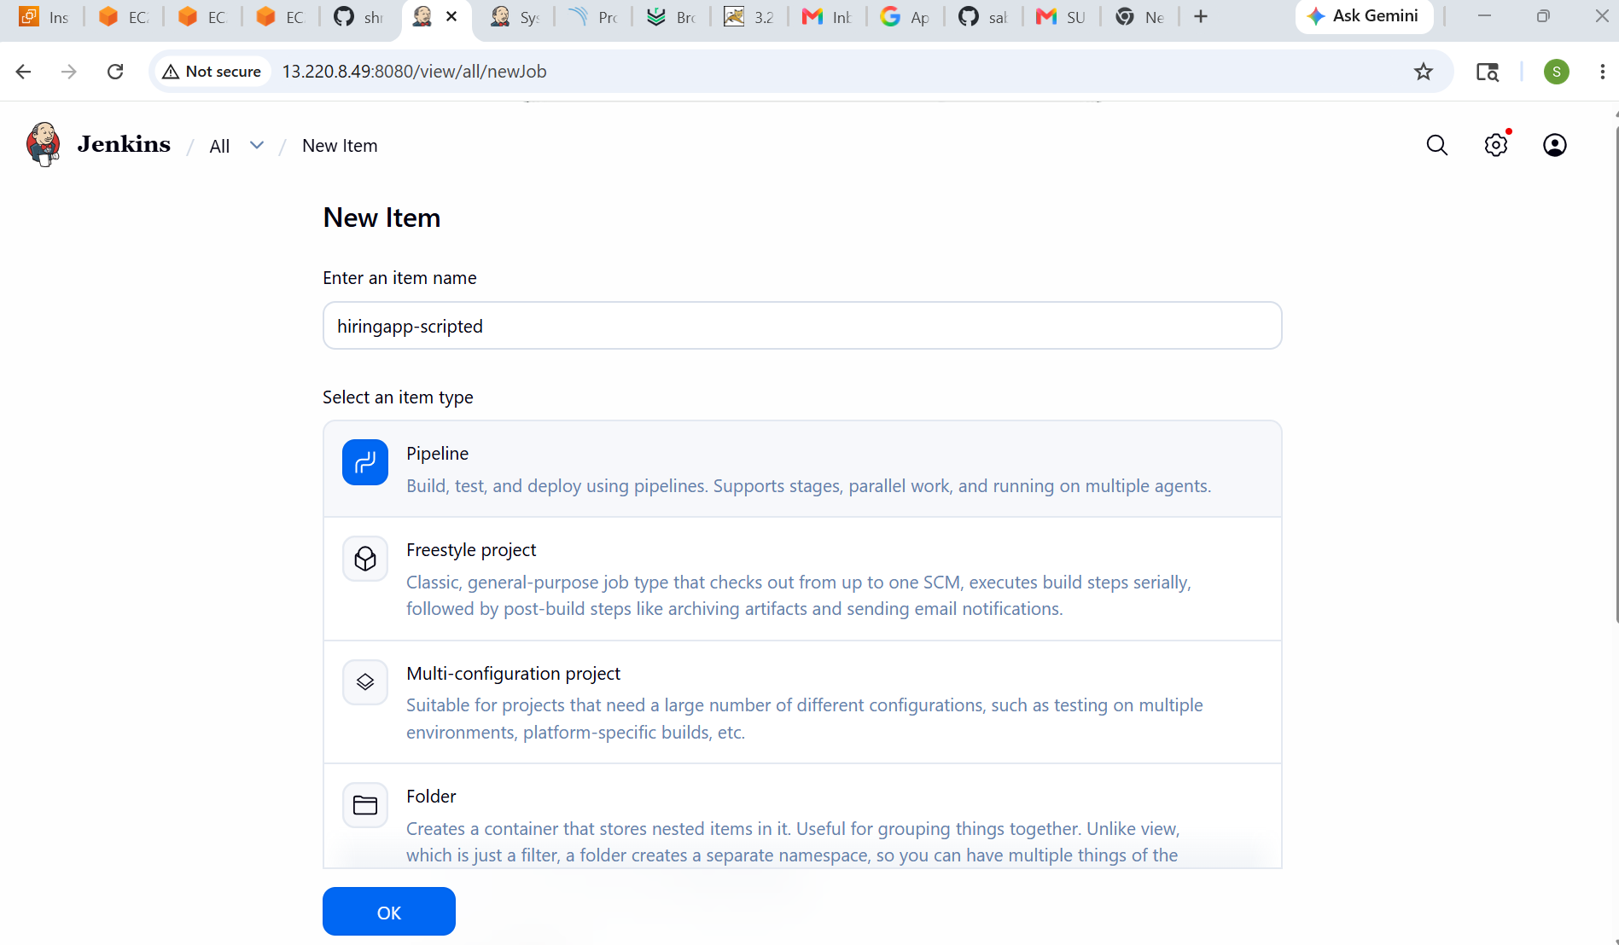
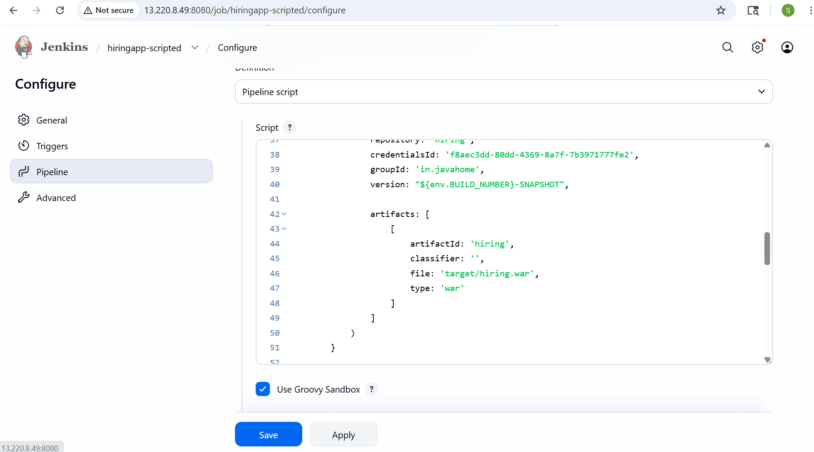
node {

def mvnHome = tool 'M2_HOME'
def scannerHome = tool 'sonar_scanner'

try {

stage('Clone Code') {
git branch: 'main',
url: 'https://github.com/shravank7/hiring-app.git'
}

stage('Build') {
sh "${mvnHome}/bin/mvn clean install"
}

stage('SonarQube Analysis') {
withSonarQubeEnv('sonarqube_server') {

sh """
mkdir -p target/classes

${scannerHome}/bin/sonar-scanner \
-Dsonar.projectKey=Test \
-Dsonar.projectName=Test \
-Dsonar.sources=src \
-Dsonar.java.binaries=target/classes
"""
}
}

stage('Upload Artifact to Nexus') {
nexusArtifactUploader(
nexusVersion: 'nexus3',
protocol: 'http',
nexusUrl: '3.239.70.32:8081',
repository: 'hiring',
credentialsId: 'f8aec3dd-80dd-4369-8a7f-7b3971777fe2',
groupId: 'in.javahome',
version: "${env.BUILD_NUMBER}-SNAPSHOT",

artifacts: [
[
artifactId: 'hiring',
classifier: '',
file: 'target/hiring.war',
type: 'war'
]
]
)
}

currentBuild.result = 'SUCCESS'

} catch (e) {
currentBuild.result = 'FAILURE'
throw e

} finally {

if (currentBuild.result == 'SUCCESS') {
emailext(
subject: "SUCCESS: Job '${env.JOB_NAME} [${env.BUILD_NUMBER}]'",
body: """
<h2 style="color:green;">Build Successful</h2>

<p><b>Job Name:</b> ${env.JOB_NAME}</p>
<p><b>Build Number:</b> ${env.BUILD_NUMBER}</p>
<p><b>Build URL:</b> ${env.BUILD_URL}</p>
""",
mimeType: 'text/html',
to: 'shravankada7@gmail.com'
)
} else {
emailext(
subject: "FAILED: Job '${env.JOB_NAME} [${env.BUILD_NUMBER}]'",
body: """
<h2 style="color:red;">Build Failed</h2>

<p><b>Job Name:</b> ${env.JOB_NAME}</p>
<p><b>Build Number:</b> ${env.BUILD_NUMBER}</p>
<p><b>Build URL:</b> ${env.BUILD_URL}</p>

<p>Check Jenkins console logs.</p>
""",
mimeType: 'text/html',
to: 'shravankada7@gmail.com'
)
}
}
}
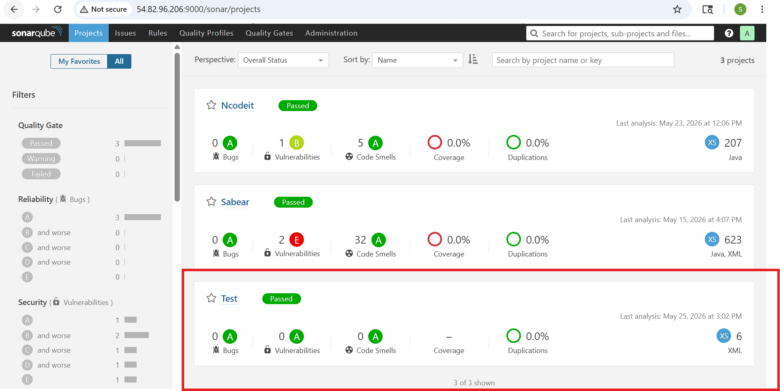
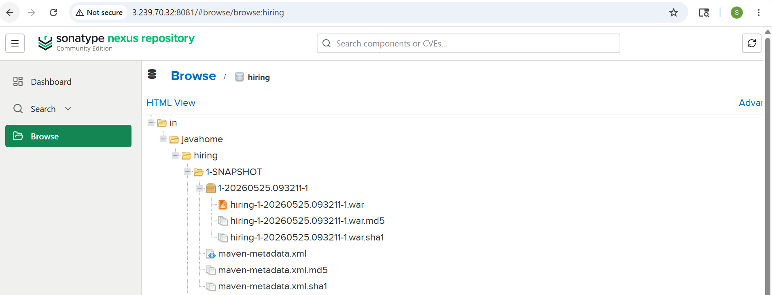
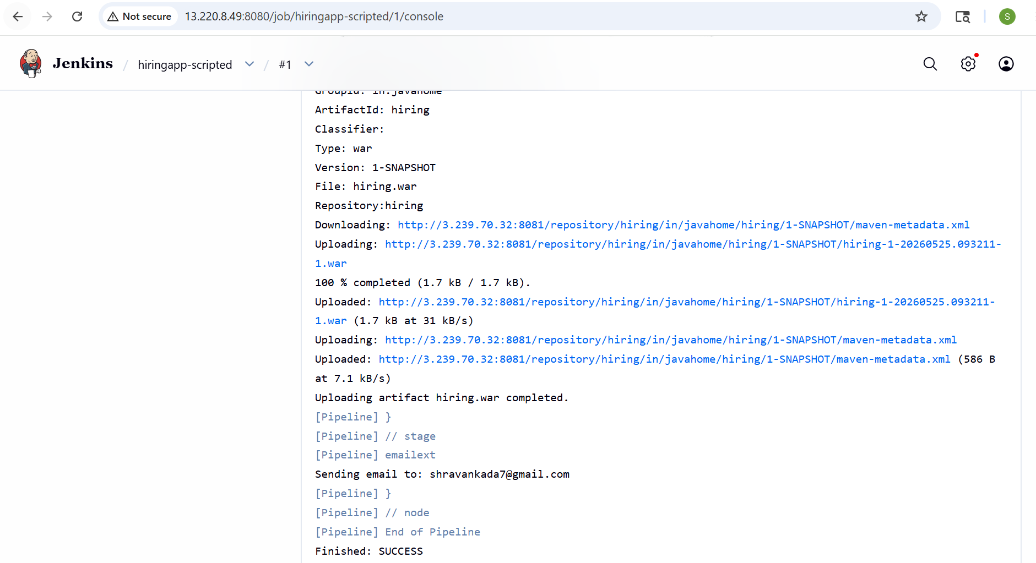
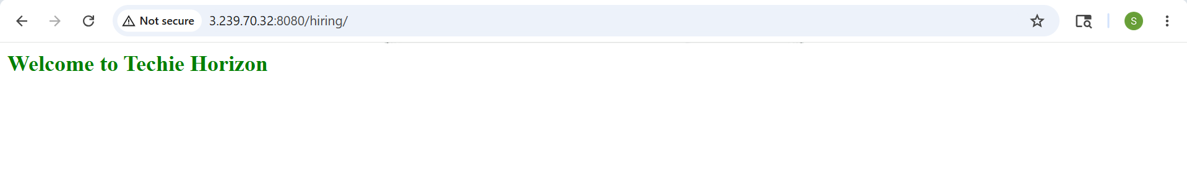
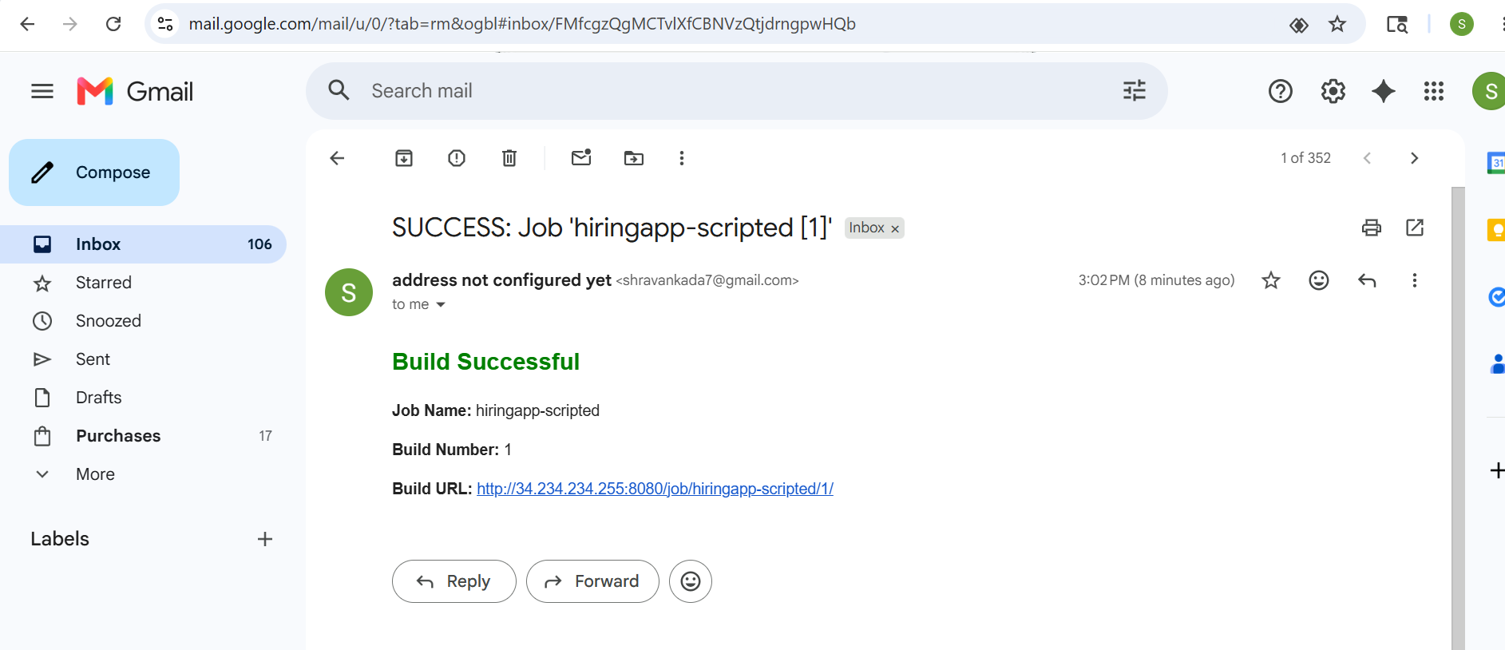
Create one multi stage pipeline job
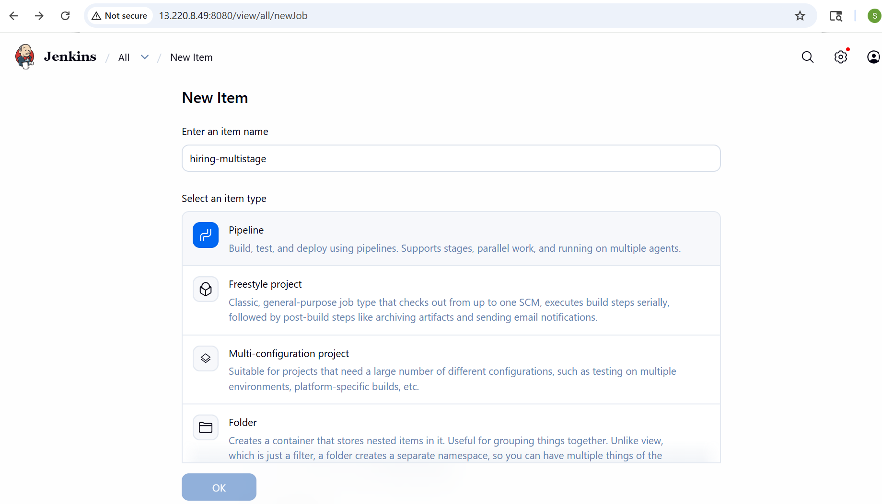
node {

def mvnHome = tool 'M2_HOME'
def scannerHome = tool 'sonar_scanner'
def buildStatus = 'SUCCESS'

// Closures (NOT methods)
def cloneCode = {
stage('Clone Code') {
git branch: 'main',
url: 'https://github.com/shravank7/hiring-app.git'
}
}

def buildApp = {
stage('Build') {
sh "${mvnHome}/bin/mvn clean install"
}
}

def sonarAnalysis = {
stage('SonarQube Analysis') {
withSonarQubeEnv('sonarqube_server') {
sh """
mkdir -p target/classes

${scannerHome}/bin/sonar-scanner \
-Dsonar.projectKey=Test \
-Dsonar.projectName=Test \
-Dsonar.sources=src \
-Dsonar.java.binaries=target/classes
"""
}
}
}

def uploadToNexus = {
stage('Upload Artifact to Nexus') {
nexusArtifactUploader(
nexusVersion: 'nexus3',
protocol: 'http',
nexusUrl: '3.239.70.32:8081',
repository: 'hiring',
credentialsId: 'f8aec3dd-80dd-4369-8a7f-7b3971777fe2',
groupId: 'in.javahome',
version: "${env.BUILD_NUMBER}-SNAPSHOT",
artifacts: [[
artifactId: 'hiring',
classifier: '',
file: 'target/hiring.war',
type: 'war'
]]
)
}
}

try {

cloneCode()
buildApp()
sonarAnalysis()
uploadToNexus()

} catch (e) {
buildStatus = 'FAILURE'
throw e

} finally {

stage('Notification') {

if (buildStatus == 'SUCCESS') {
emailext(
subject: "SUCCESS: Job '${env.JOB_NAME} [${env.BUILD_NUMBER}]'",
body: """
<h2 style="color:green;">Build Successful</h2>
<p><b>Job Name:</b> ${env.JOB_NAME}</p>
<p><b>Build Number:</b> ${env.BUILD_NUMBER}</p>
<p><b>Build URL:</b> ${env.BUILD_URL}</p>
""",
mimeType: 'text/html',
to: 'shravankada7@gmail.com'
)
} else {
emailext(
subject: "FAILED: Job '${env.JOB_NAME} [${env.BUILD_NUMBER}]'",
body: """
<h2 style="color:red;">Build Failed</h2>
<p><b>Job Name:</b> ${env.JOB_NAME}</p>
<p><b>Build Number:</b> ${env.BUILD_NUMBER}</p>
<p><b>Build URL:</b> ${env.BUILD_URL}</p>
<p>Check Jenkins console logs.</p>
""",
mimeType: 'text/html',
to: 'shravankada7@gmail.com'
)
}
}
}
}
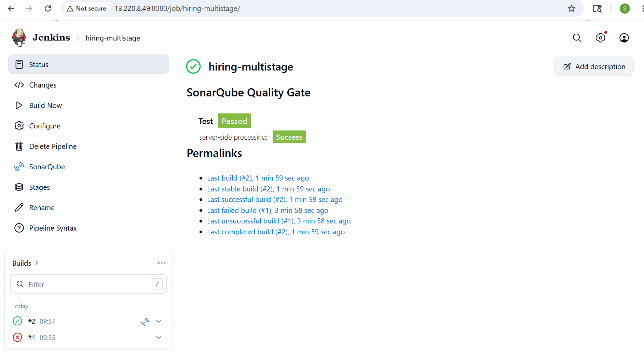
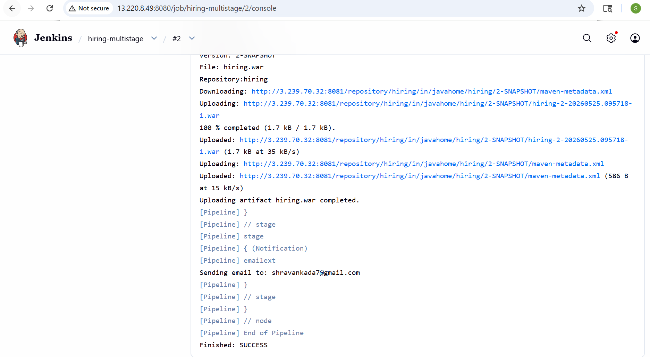
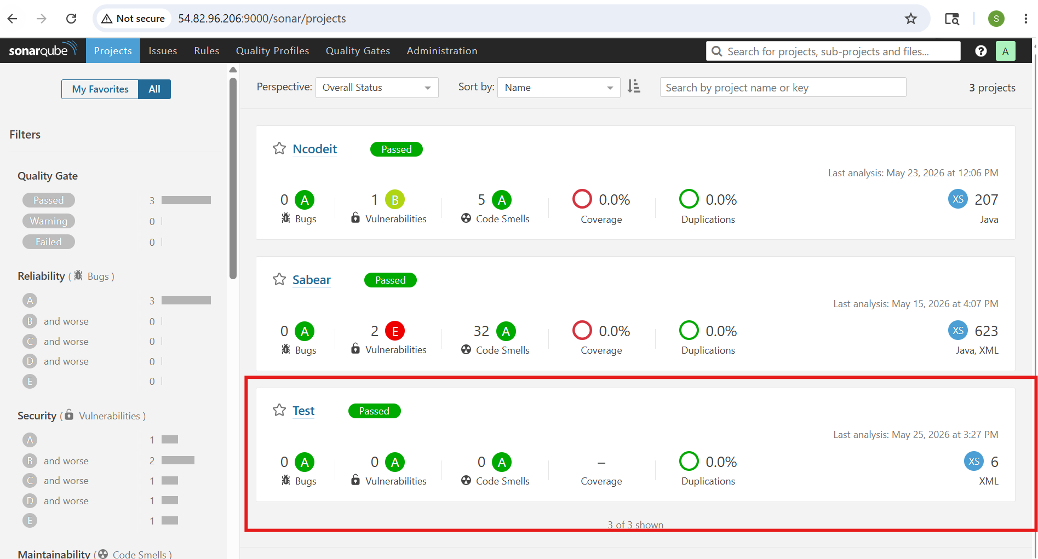
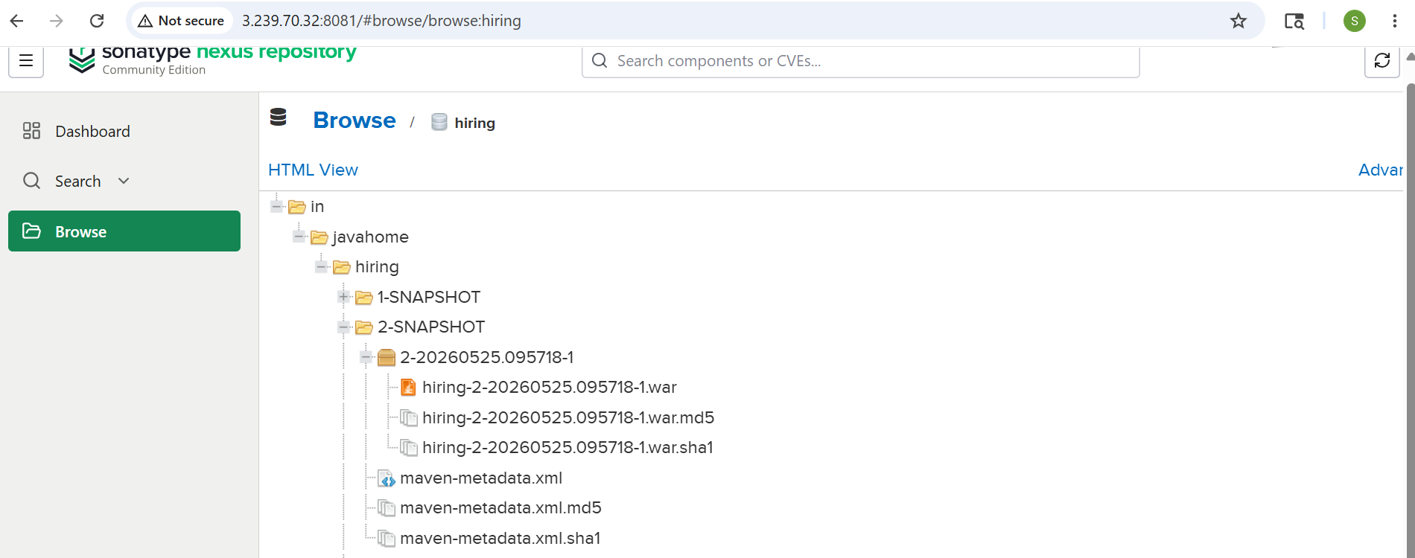
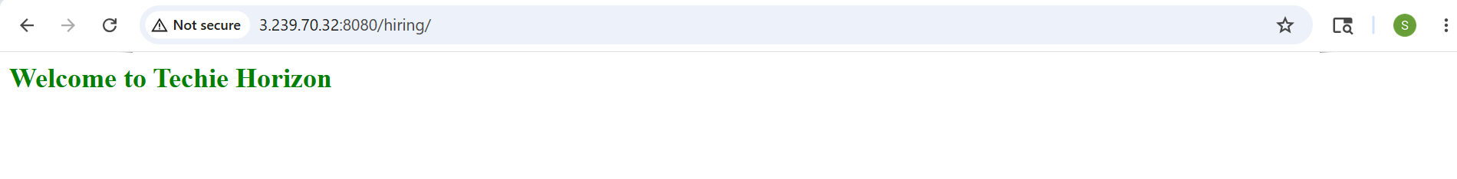
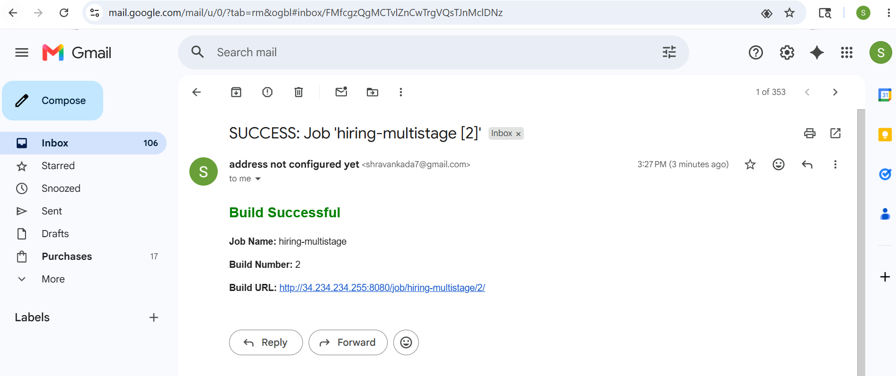
Create one parallel stage pipeline job
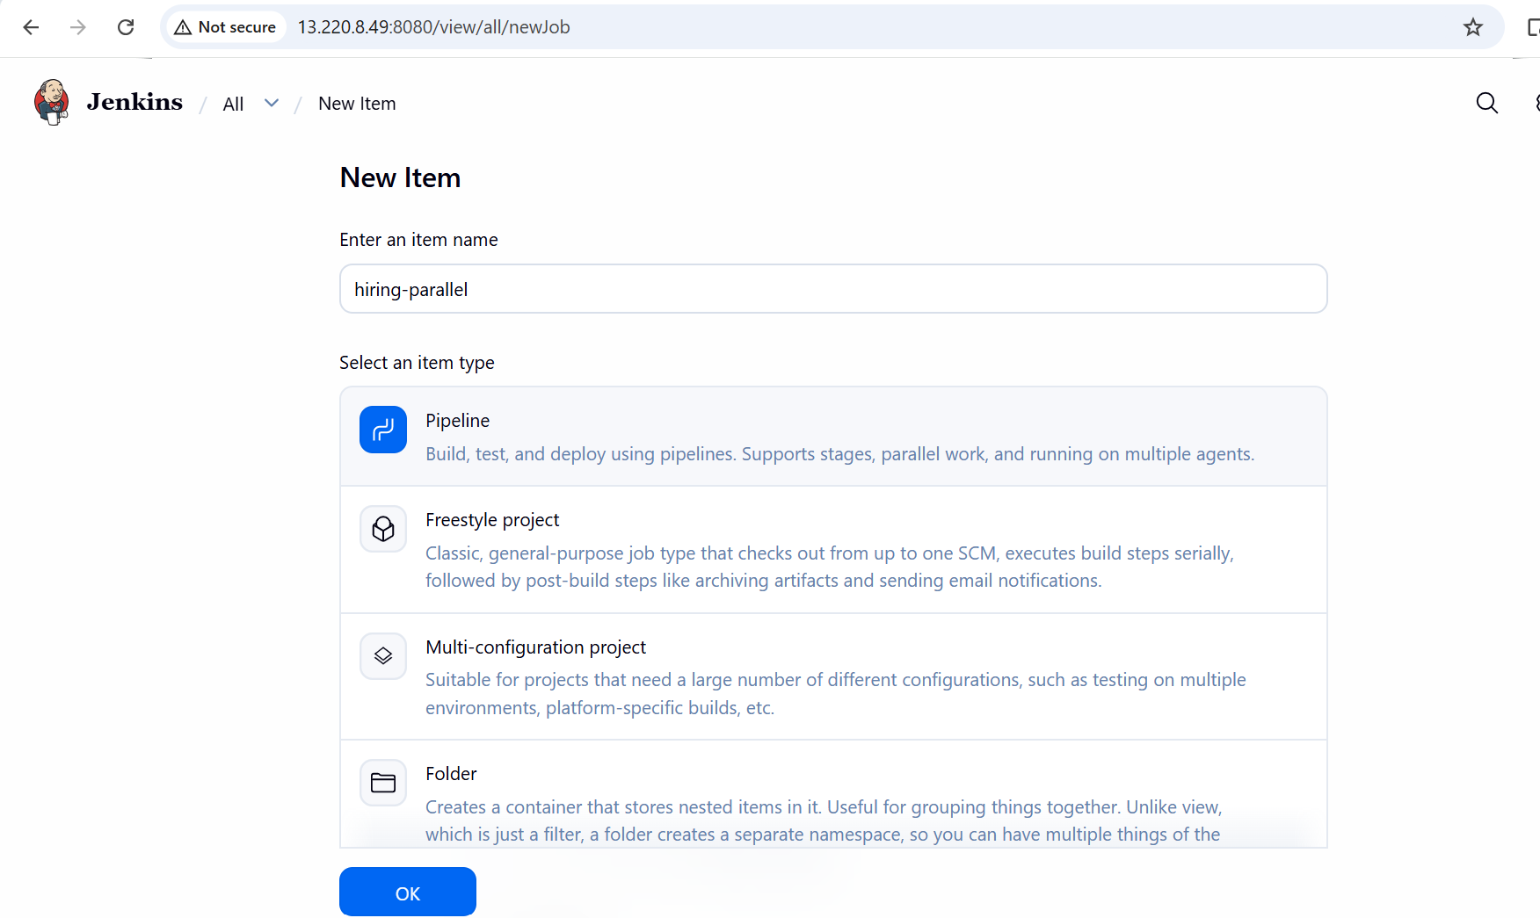
pipeline {
agent any

tools {
maven "M2_HOME"
}

environment {
SCANNER_HOME = tool 'sonar_scanner'
}

stages {

stage('Clone Code') {
steps {
git branch: 'main',
url: 'https://github.com/shravank7/hiring-app.git'
}
}

stage('Build + Parallel Analysis') {
parallel {

stage('Build') {
steps {
sh 'mvn clean install'
}
}

stage('SonarQube Analysis') {
steps {
withSonarQubeEnv('sonarqube_server') {
sh """
${SCANNER_HOME}/bin/sonar-scanner \
-Dsonar.projectKey=Test \
-Dsonar.projectName=Test \
-Dsonar.sources=src \
-Dsonar.java.binaries=target/classes
"""
}
}
}
}
}

stage('Upload Artifact to Nexus') {
steps {

nexusArtifactUploader(
nexusVersion: 'nexus3',
protocol: 'http',
nexusUrl: '3.239.70.32:8081',
repository: 'hiring',
credentialsId: 'f8aec3dd-80dd-4369-8a7f-7b3971777fe2',
groupId: 'in.javahome',
version: "${BUILD_NUMBER}-SNAPSHOT",

artifacts: [
[
artifactId: 'hiring',
classifier: '',
file: 'target/hiring.war',
type: 'war'
]
]
)
}
}
}

post {
success {
emailext(
subject: "SUCCESS: Job '${JOB_NAME} [${BUILD_NUMBER}]'",
body: """
<h2 style="color:green;">Build Successful</h2>
<p><b>Job Name:</b> ${JOB_NAME}</p>
<p><b>Build Number:</b> ${BUILD_NUMBER}</p>
<p><b>Build URL:</b> ${BUILD_URL}</p>
""",
mimeType: 'text/html',
to: 'shravankada7@gmail.com'
)
}

failure {
emailext(
subject: "FAILED: Job '${JOB_NAME} [${BUILD_NUMBER}]'",
body: """
<h2 style="color:red;">Build Failed</h2>
<p><b>Job Name:</b> ${JOB_NAME}</p>
<p><b>Build Number:</b> ${BUILD_NUMBER}</p>
<p><b>Build URL:</b> ${BUILD_URL}</p>
<p>Check Jenkins console logs.</p>
""",
mimeType: 'text/html',
to: 'shravankada7@gmail.com'
)
}
}
}
