Docker-03
Create a image from running container
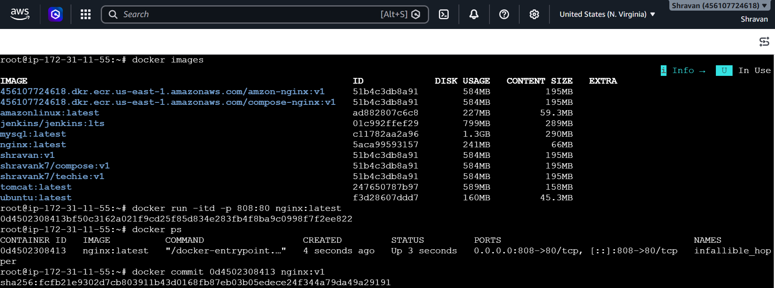
docker commit 0d4502308413 nginx:v1
and check in images now the new images is created
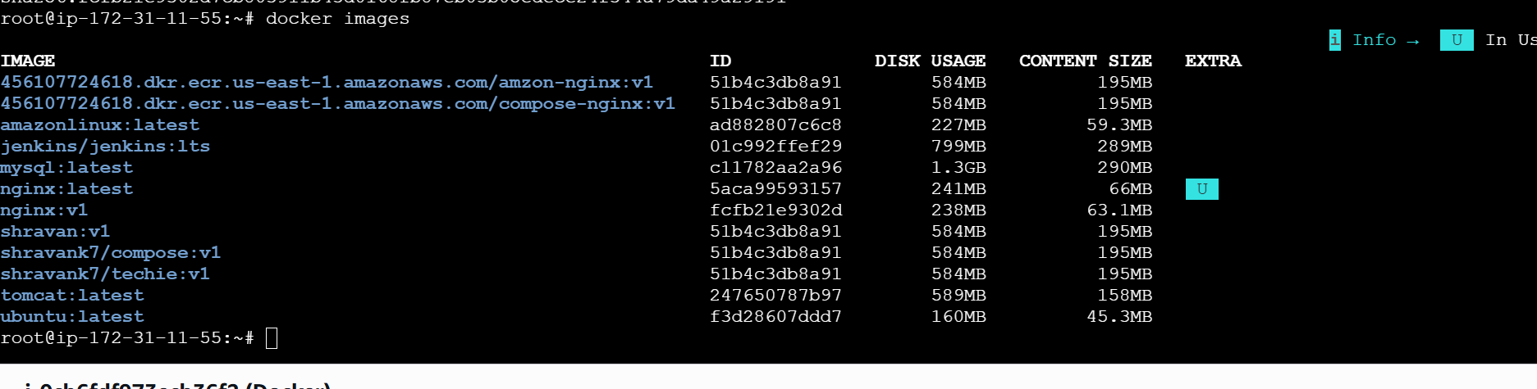
Copy image from local machine to docker server and load the image.
Downloaded tomcat in the local machine
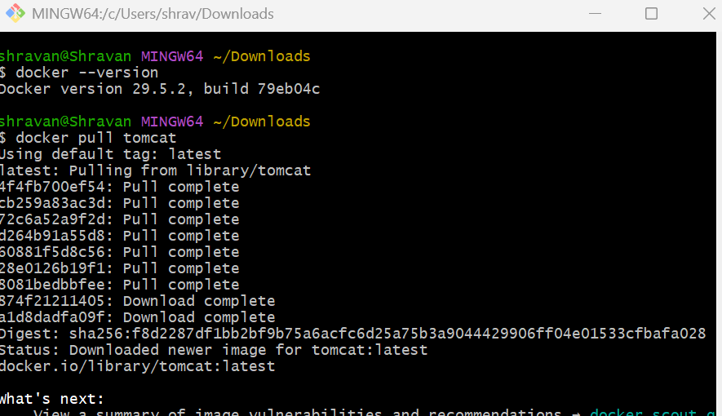
It is changed and saved to test.tar
docker save -o test.tar tomcat:latest
scp -i /c/Users/shrav/Downloads/jenkins.pem test.tar ubuntu@32.198.24.42:/tmp
and copied from local to server
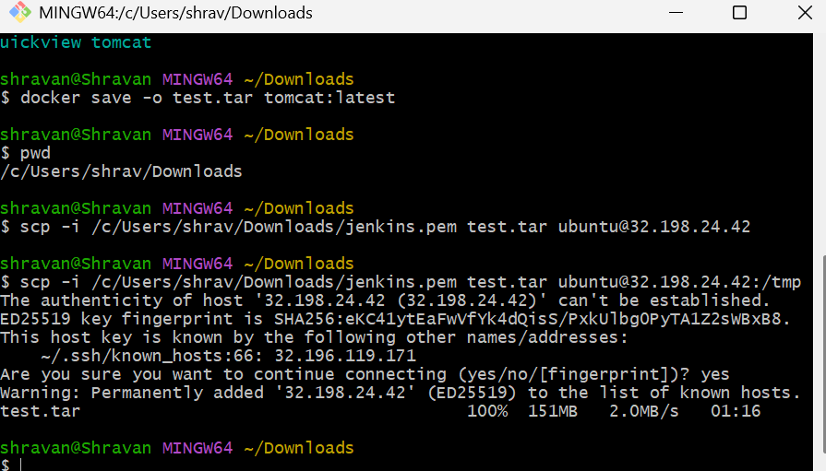
Now check in server
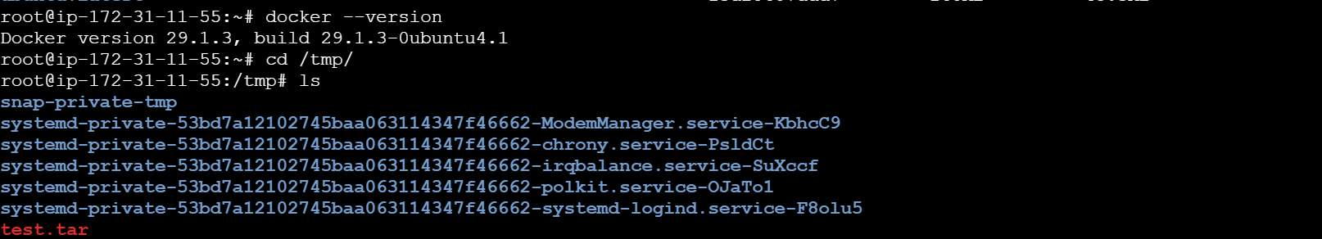
Now changed to image
docker load -i test.tar
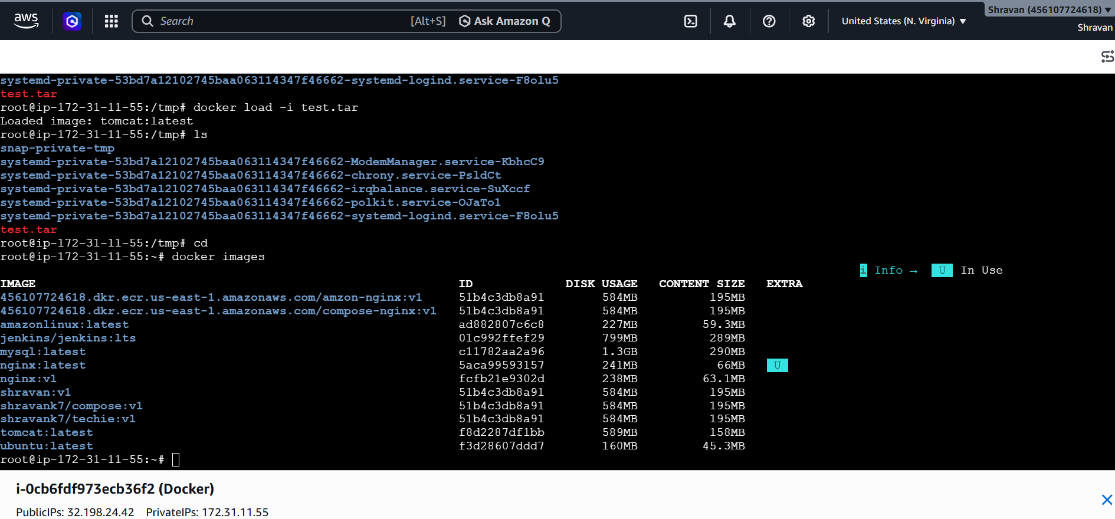
Create Docker image using alpine and customize with tomcat
In vi Dockerfile
FROM alpine:3.10
MAINTAINER Techie_Horizon
RUN mkdir /usr/local/tomcat/
WORKDIR /usr/local/tomcat
RUN apk --no-cache add curl && \
apk add --update curl && \
https://dlcdn.apache.org/tomcat/tomcat-11/v11.0.22/bin/apache-tomcat-11.0.22.tar.gz
RUN tar -xvf apache*.tar.gz
RUN mv apache-tomcat-11.0.22/* /usr/local/tomcat/.
RUN rm -rf apache-*
COPY sample.war /usr/local/tomcat/webapps
RUN apk update && apk add openjdk8
WORKDIR /usr/local/tomcat
EXPOSE 8080
CMD ["/usr/local/tomcat/bin/catalina.sh", "run"]
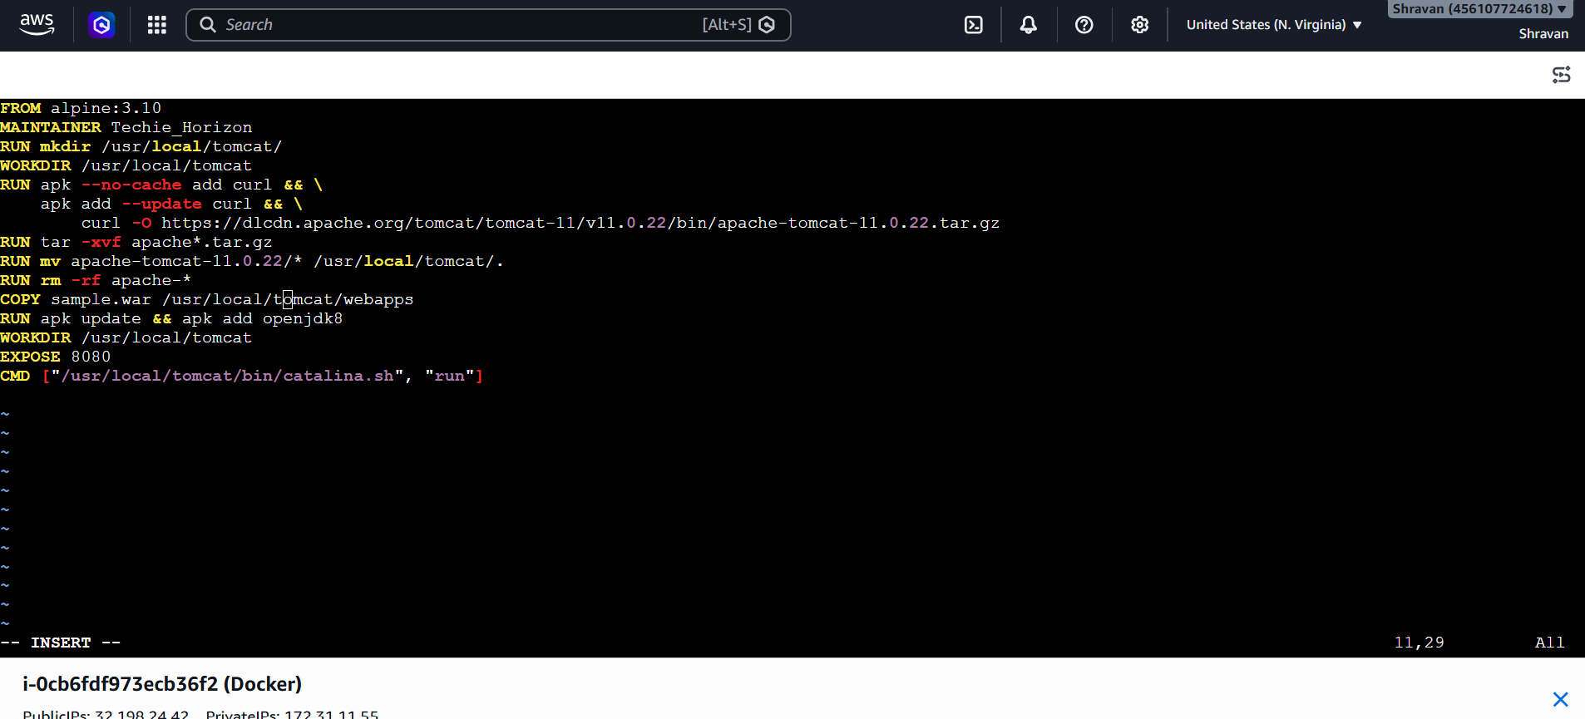
Now create a image
docker build -t tomcat:works .
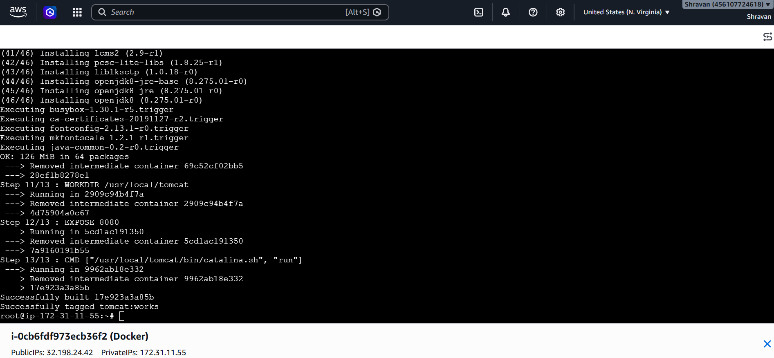
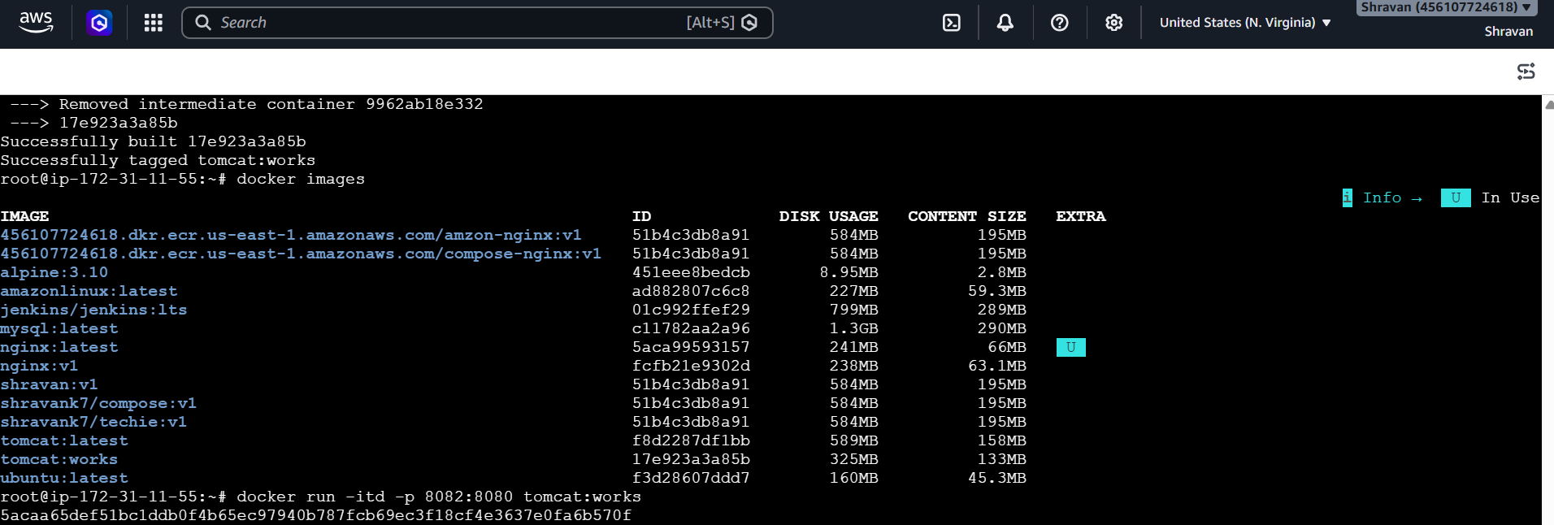
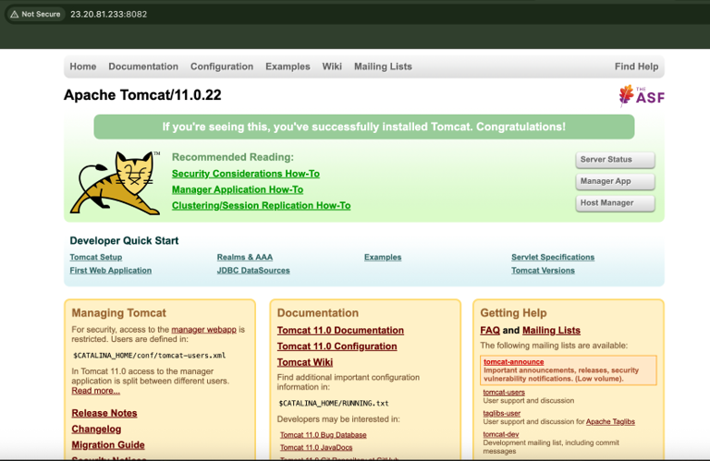
Create single stage and multi stage docker file using this source code:https://github.com/betawins/multi-stage-example.git
Git clone
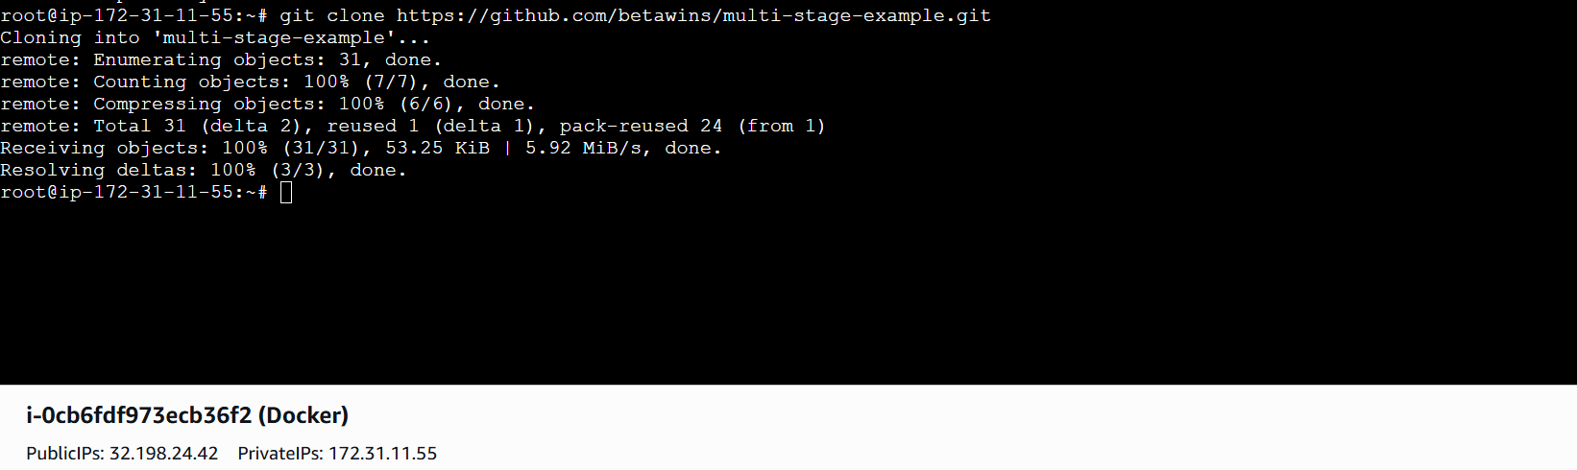
FROM maven:3.8.5-openjdk-11
WORKDIR /app

COPY . .

RUN mvn clean package -DskipTests

EXPOSE 8080

CMD [“sh”, “-c”, "java -jar target/*.jar"]
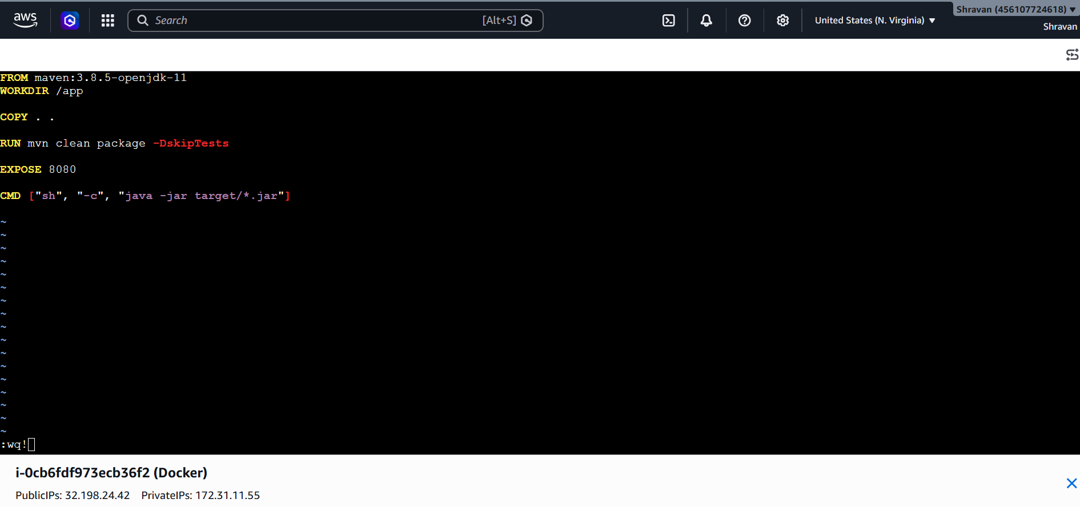
docker build -t single-stage:v1
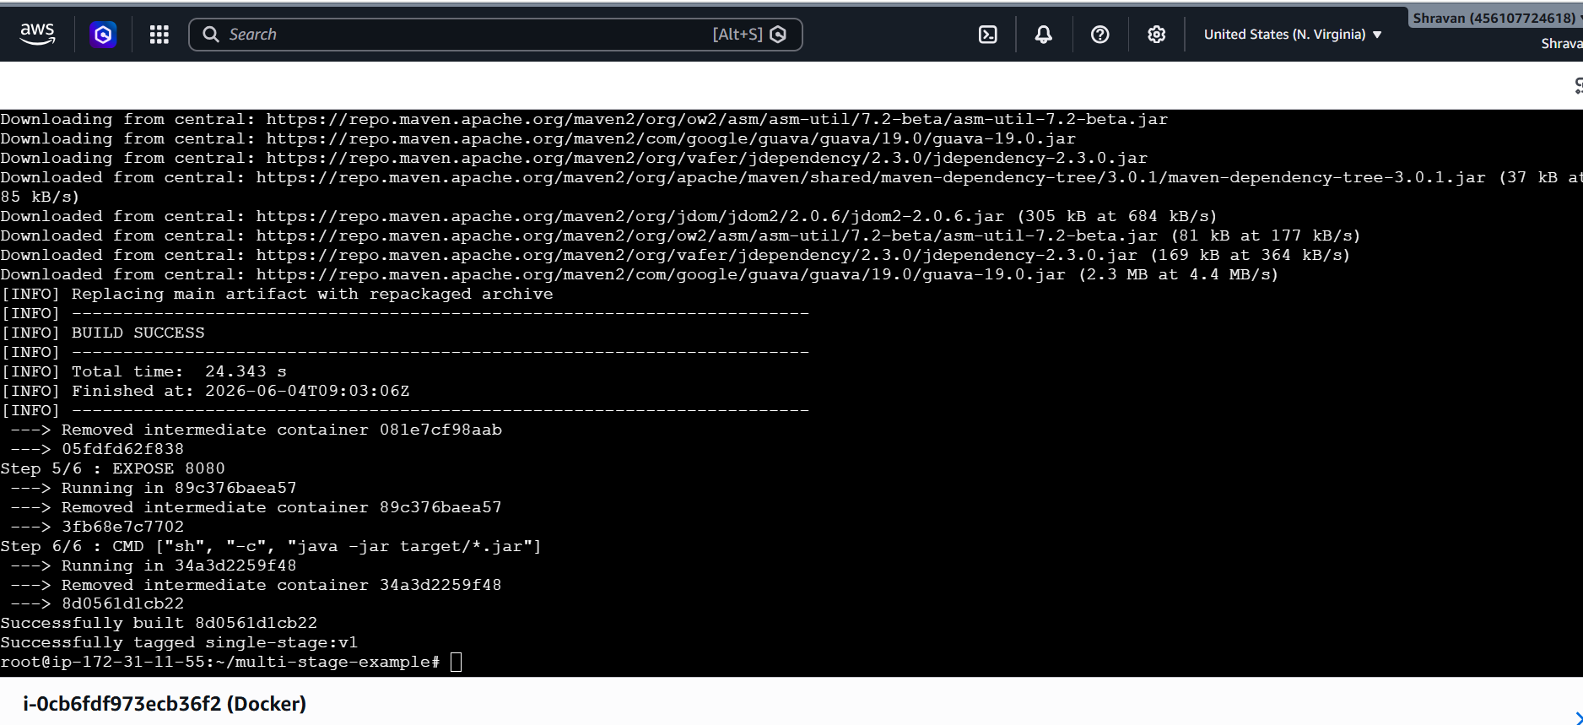
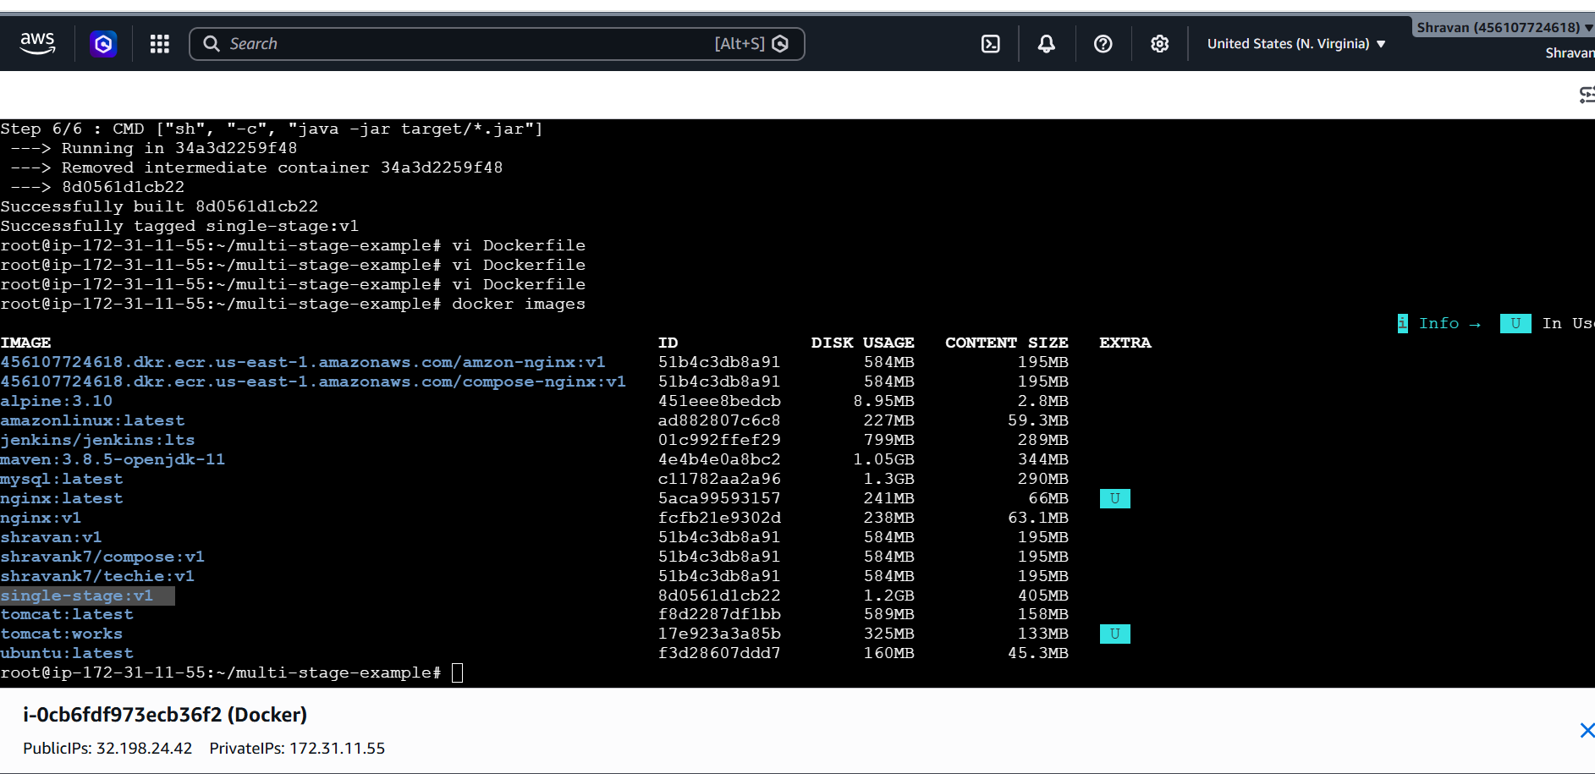
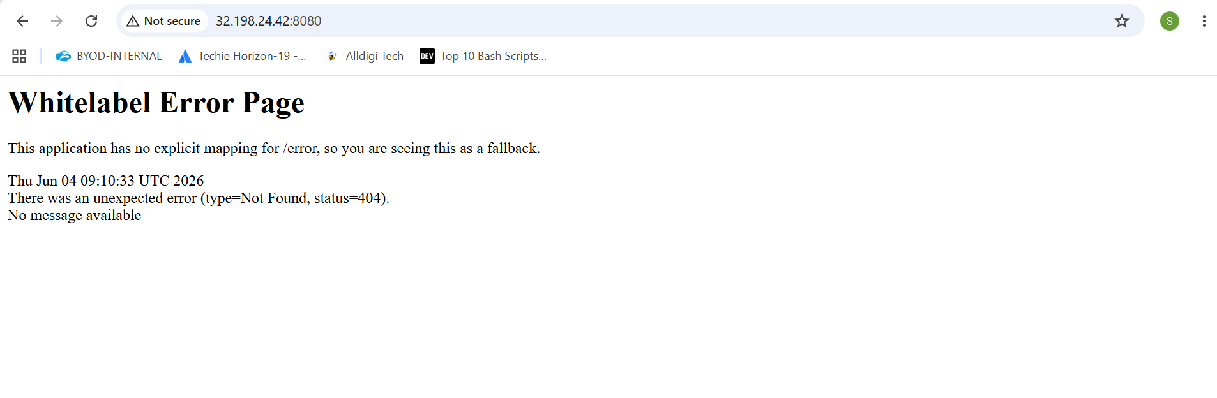
In Dockerfile of multi-stage
# Stage 1 - Build
FROM maven:3.8.5-openjdk-11 AS build

WORKDIR /app

COPY . .

RUN mvn clean package

# Stage 2 - Runtime
FROM eclipse-temurin:11-jre

WORKDIR /app

COPY --from=build /app/target/*.jar app.jar

EXPOSE 8080

CMD ["java","-jar","app.jar"]
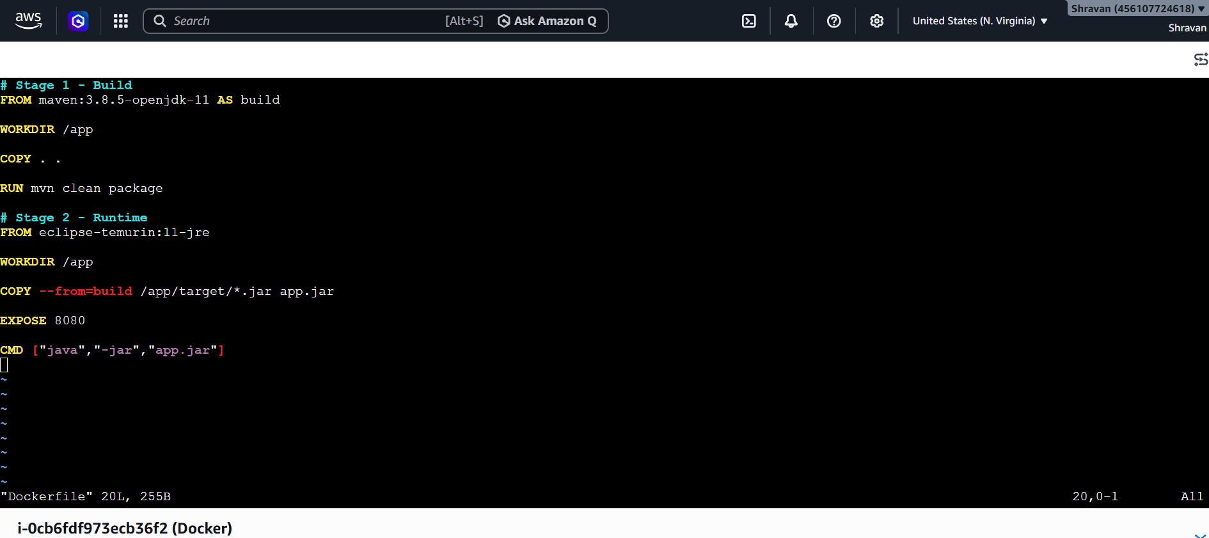
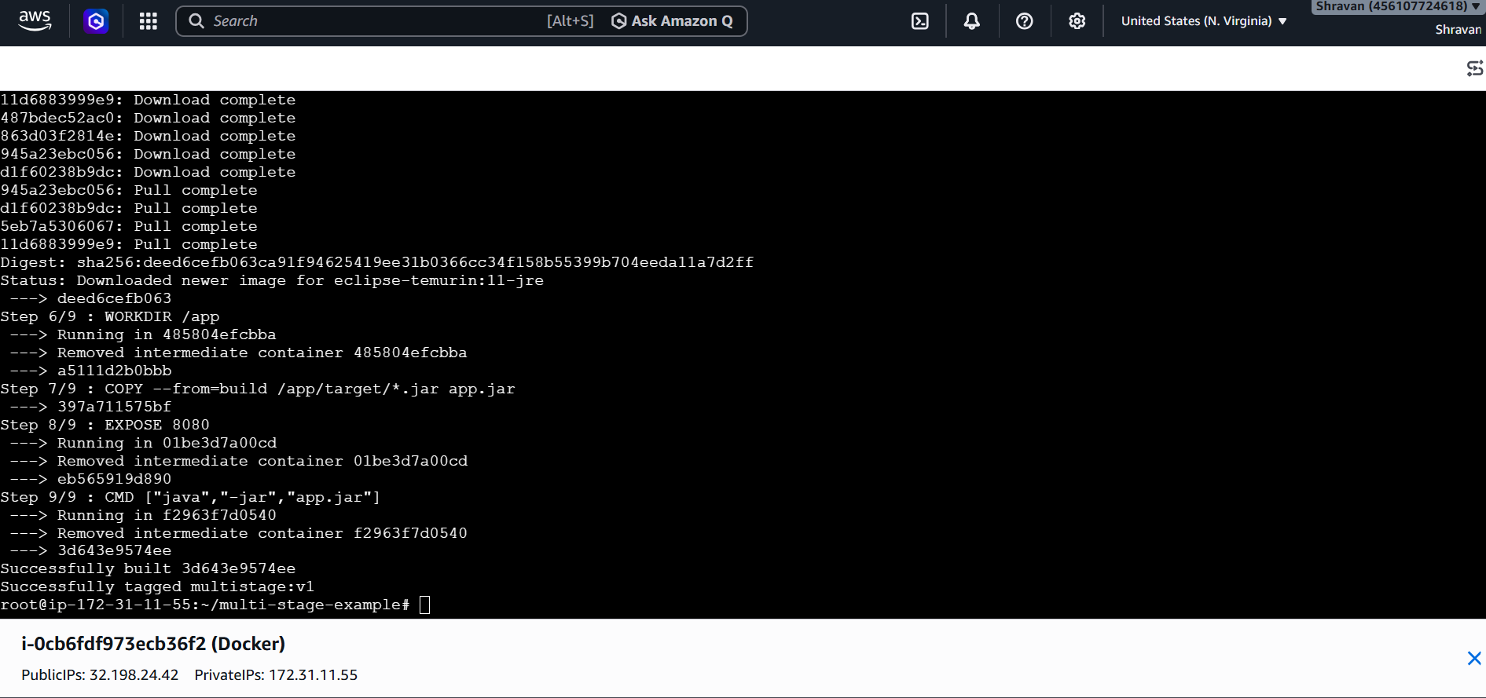
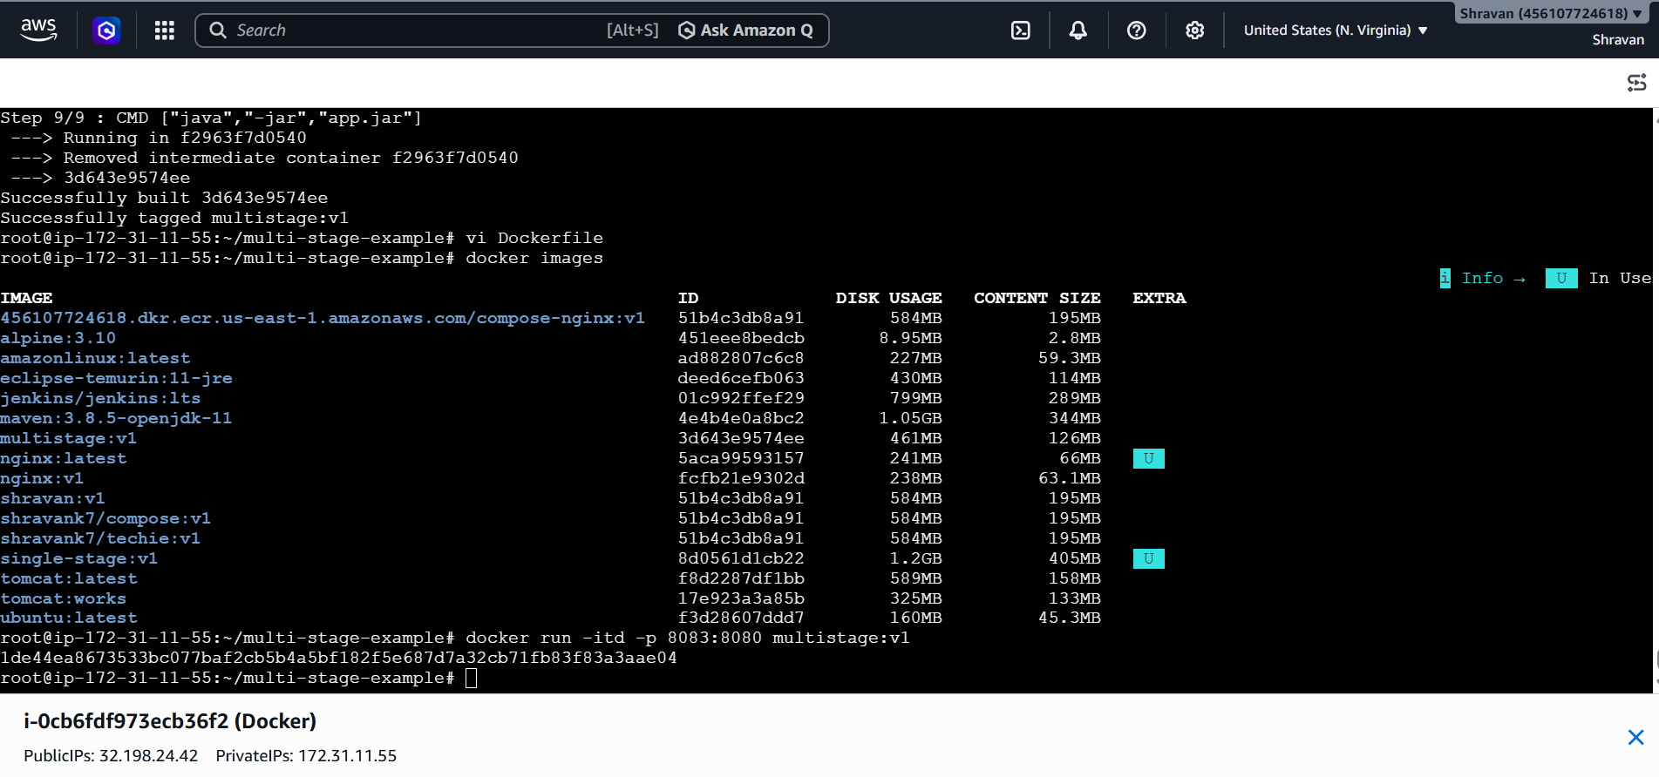
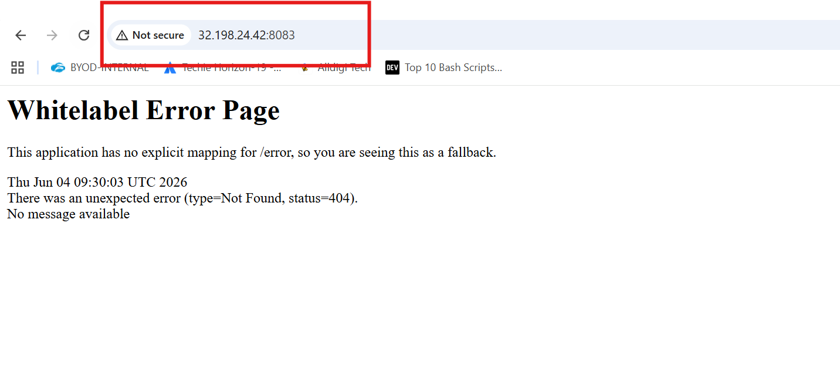
Install docker compose and execute sample application
Install docker compose
sudo curl -L https://github.com/docker/compose/releases/download/1.21.0/docker-compose-`uname -s`-`uname -m` | sudo tee /usr/local/bin/docker-compose > /dev/null
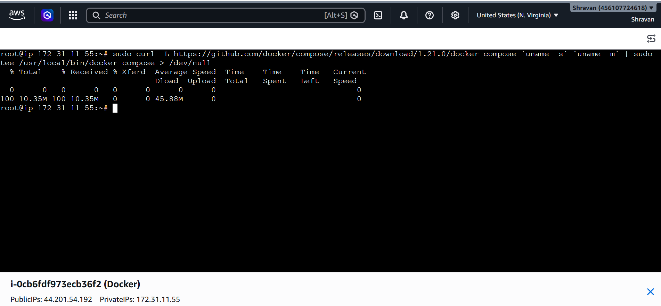
Give permissions
sudo chmod +x /usr/local/bin/docker-compose
create symbolic link
ln -s /usr/local/bin/docker-compose /usr/bin/docker-compose
docker version
docker-compose –version
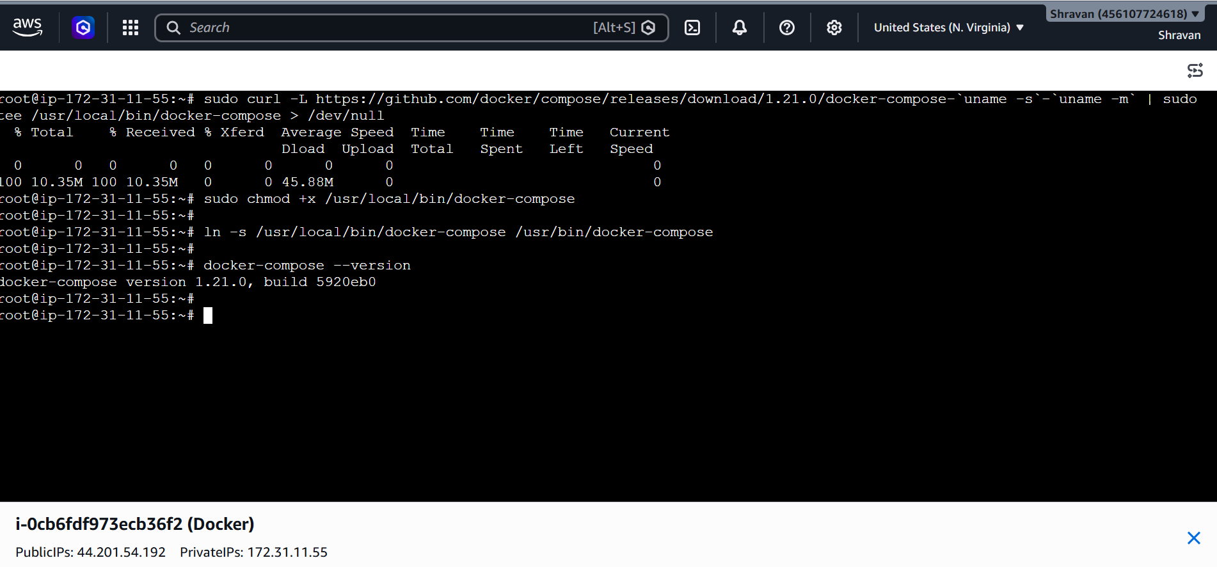
Sample application
version: '3'

services:
web:
image: nginx
ports:
- "8080:80"

db:
image: mysql
environment:
MYSQL_ROOT_PASSWORD: root123
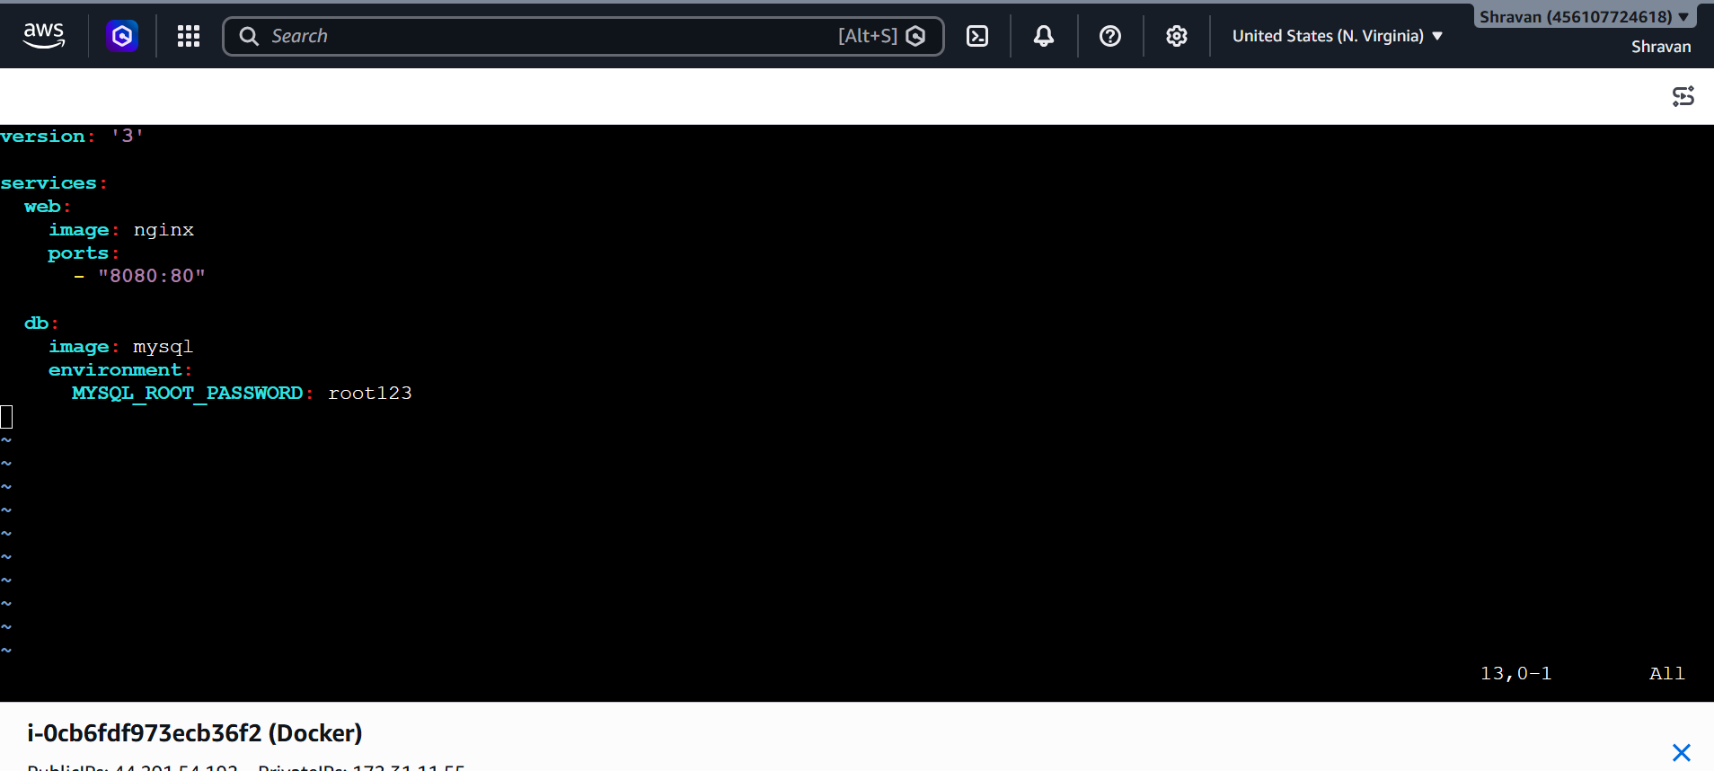
docker-compose up
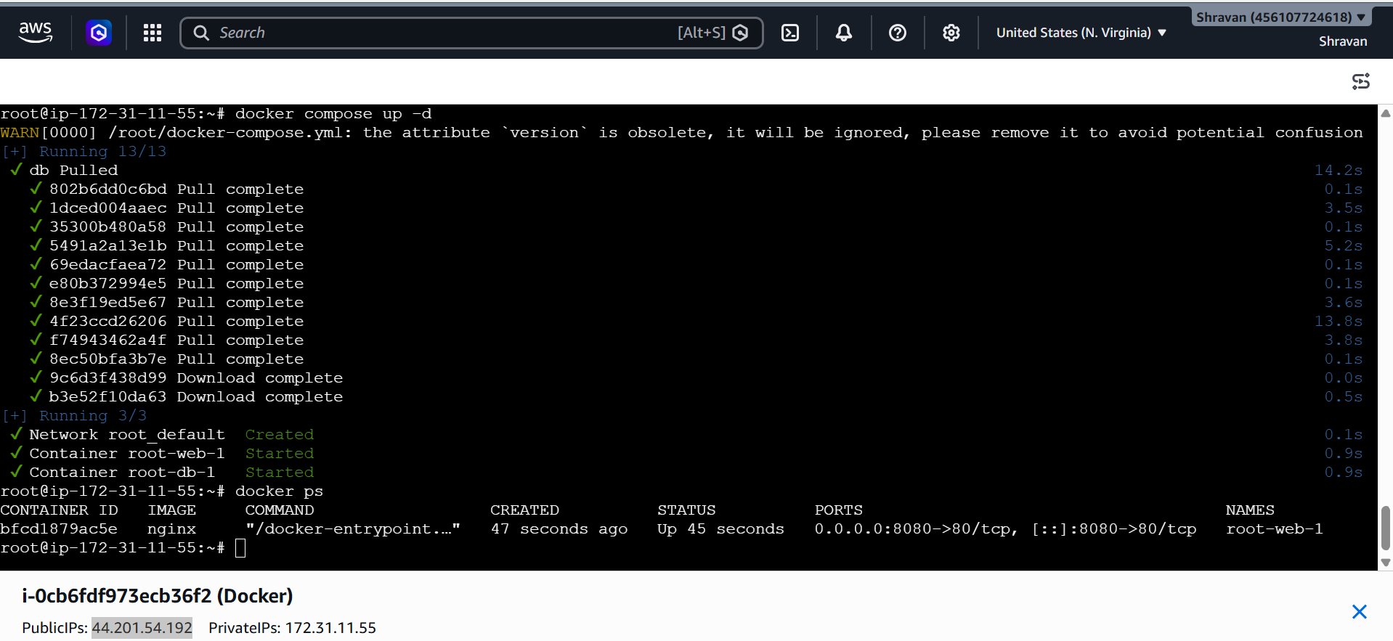
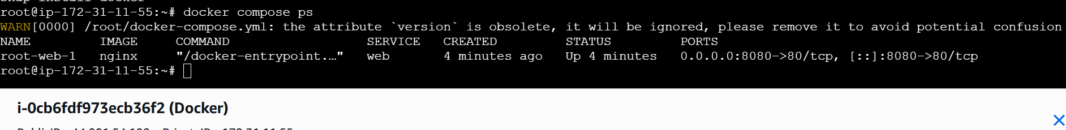
Now it is completed and check in docker ps
And also check in url
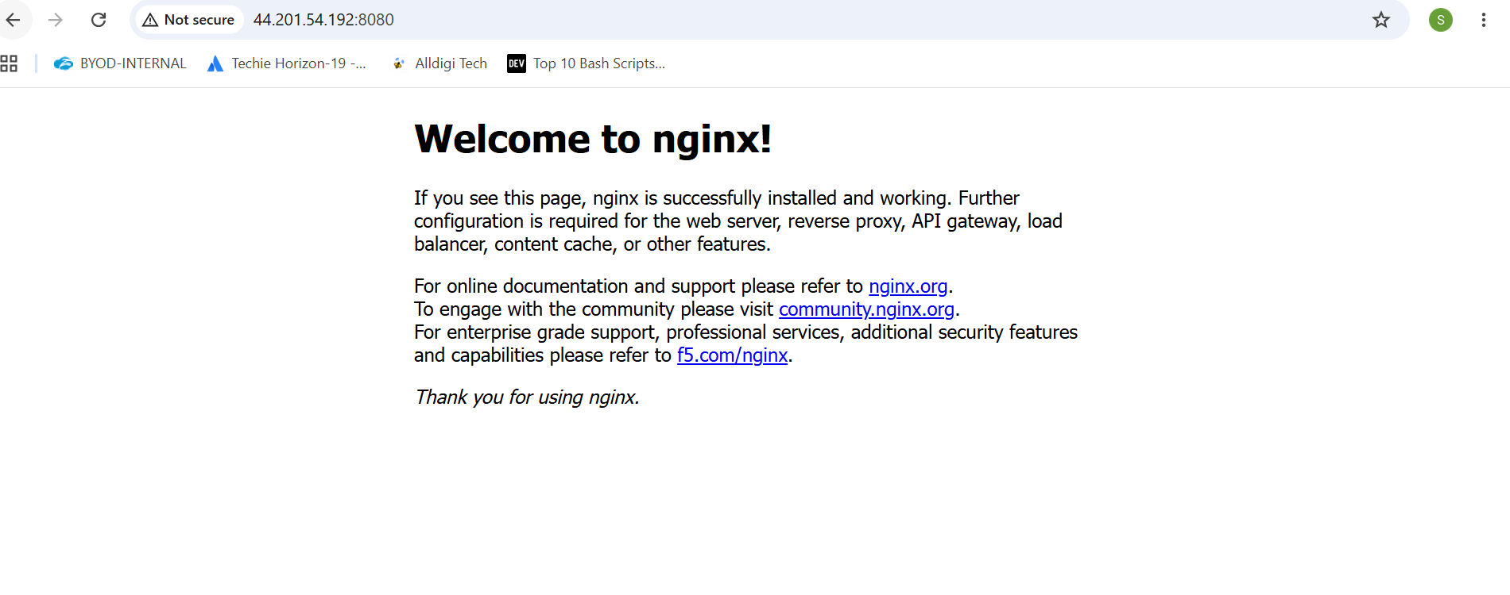Implement solution to scan images when pushed to docker registry.
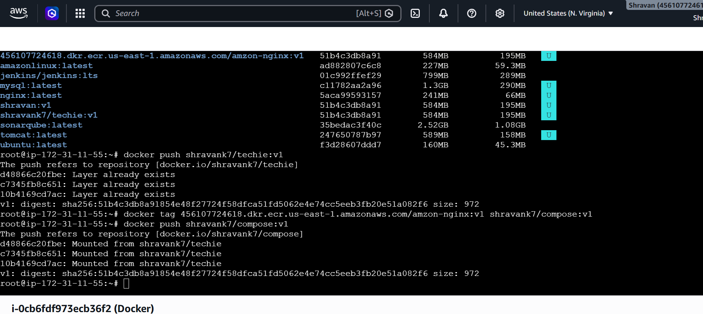

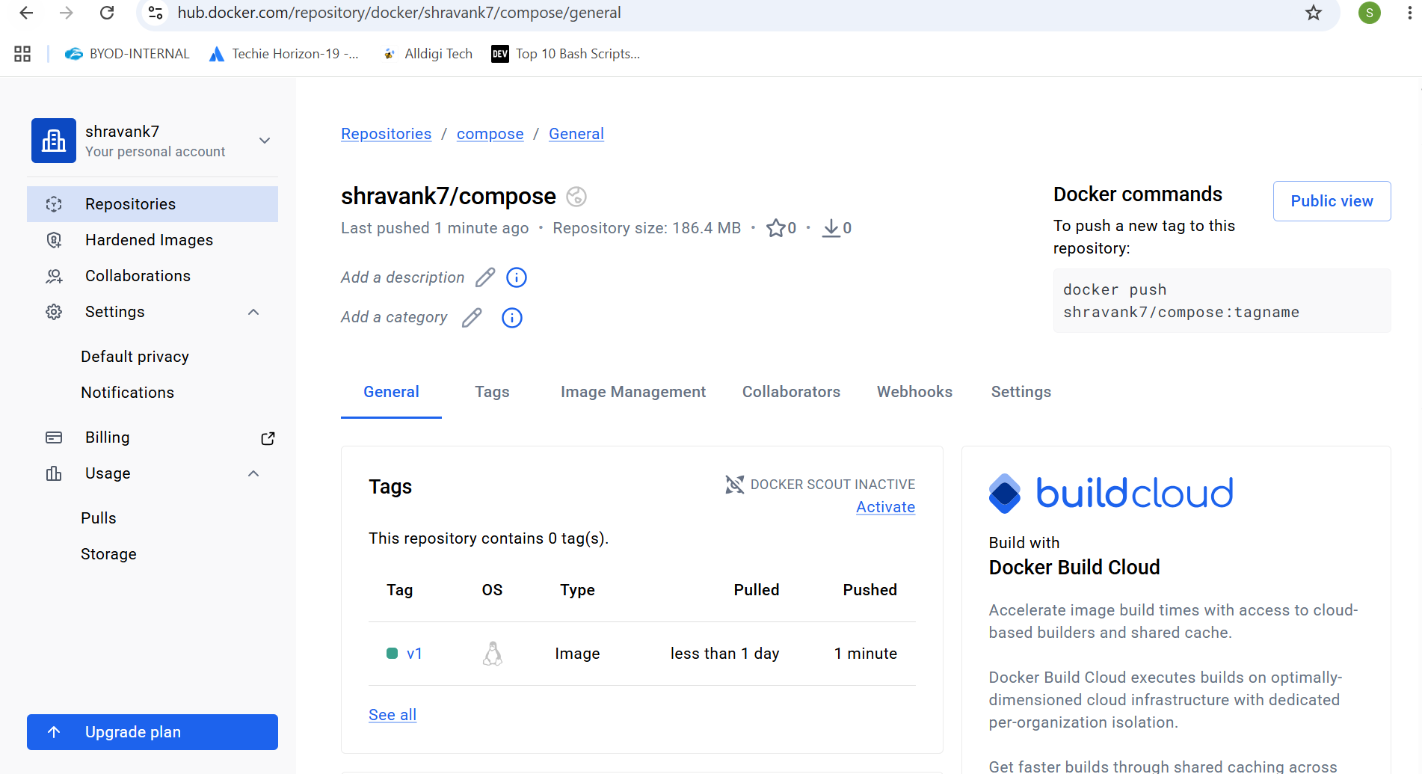

Implement solution to scan images when pushed to AWS ECR.
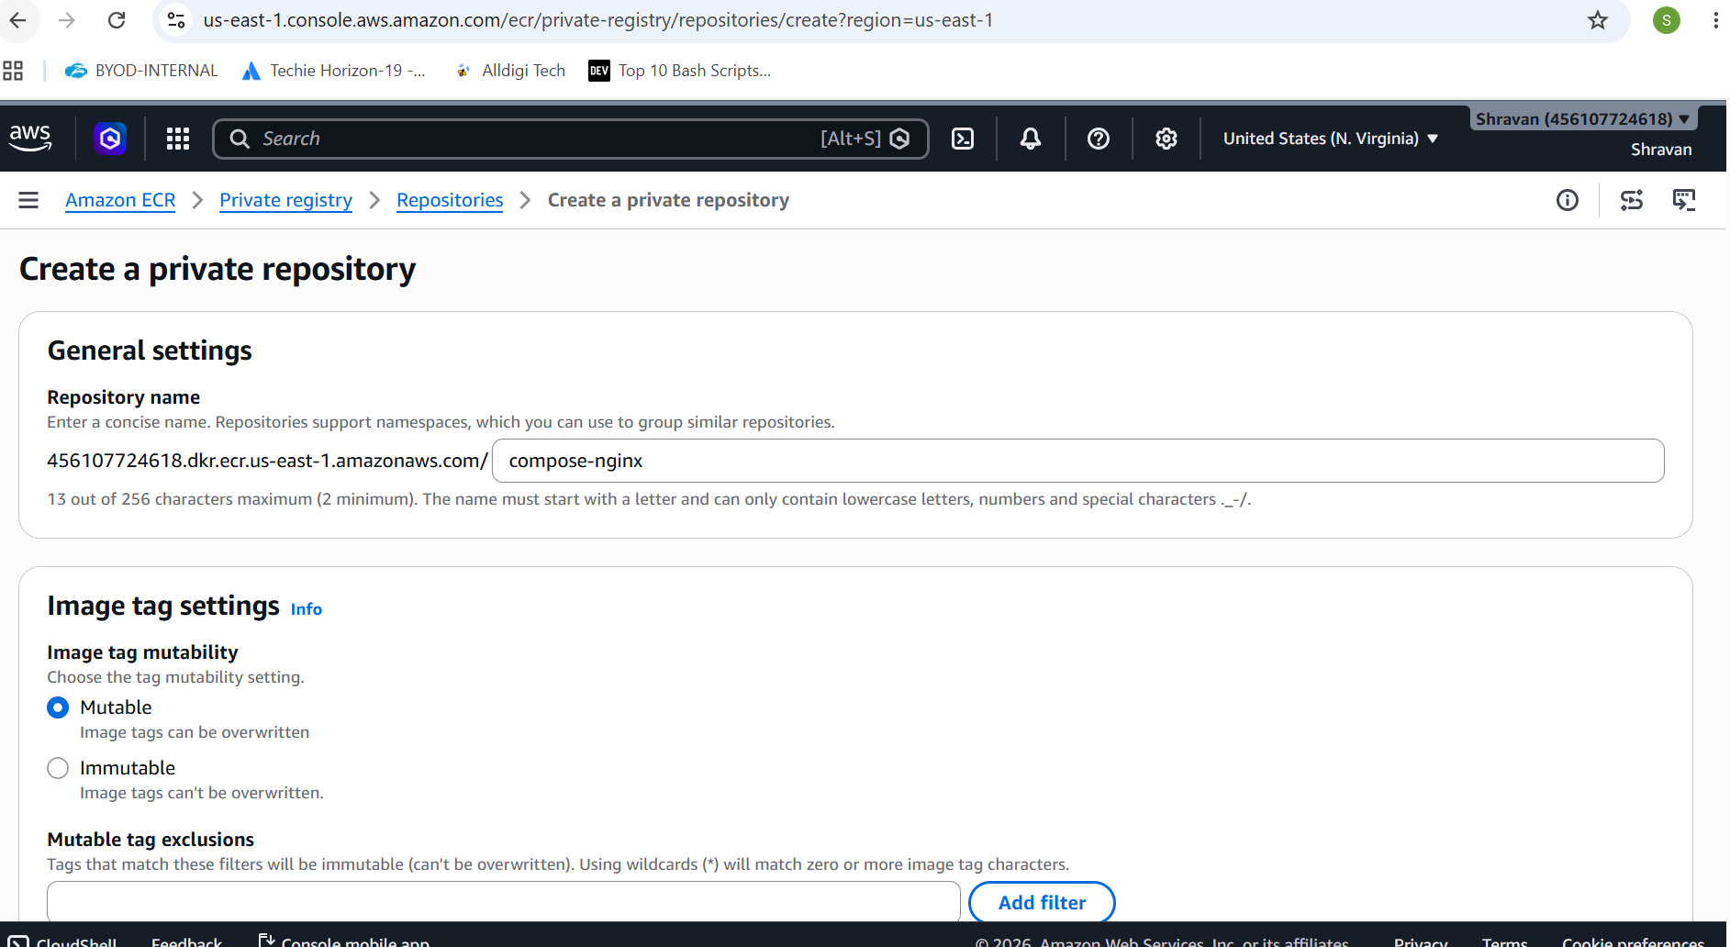
aws ecr get-login-password --region us-east-1 | \
docker login --username AWS \
--password-stdin 456107724618.dkr.ecr.us-east-1.amazonaws.com/compose-nginx
Docker tag and then docker push to ecr
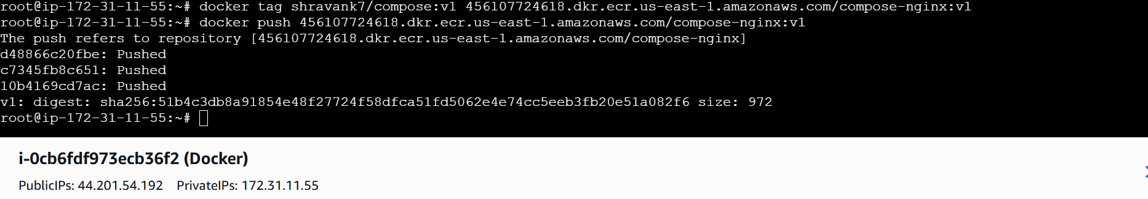
Create a Jenkins pipeline to create a docker image and push the image to Docker hub.
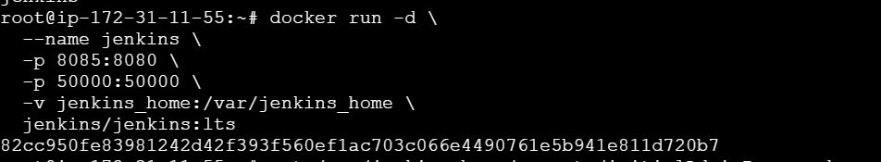
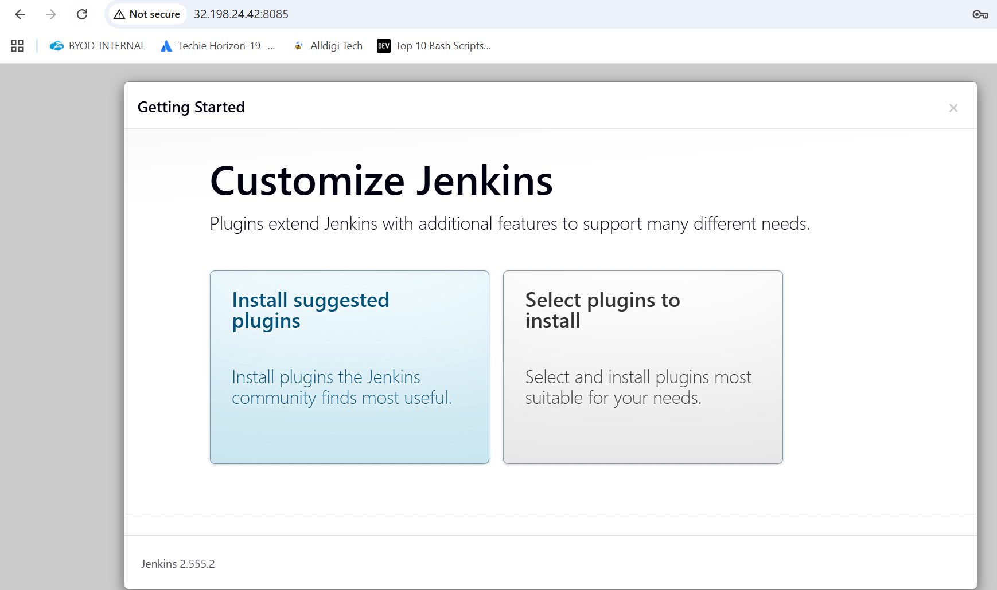
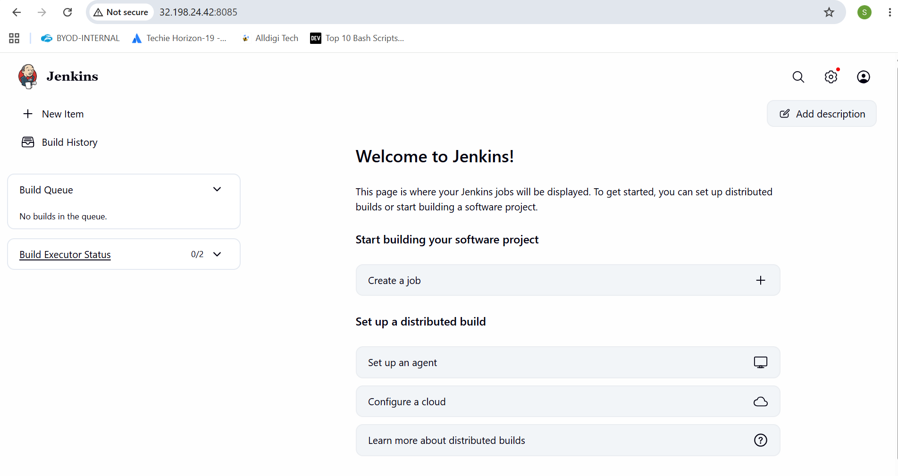
Now to docker personal access token and generate then after copy
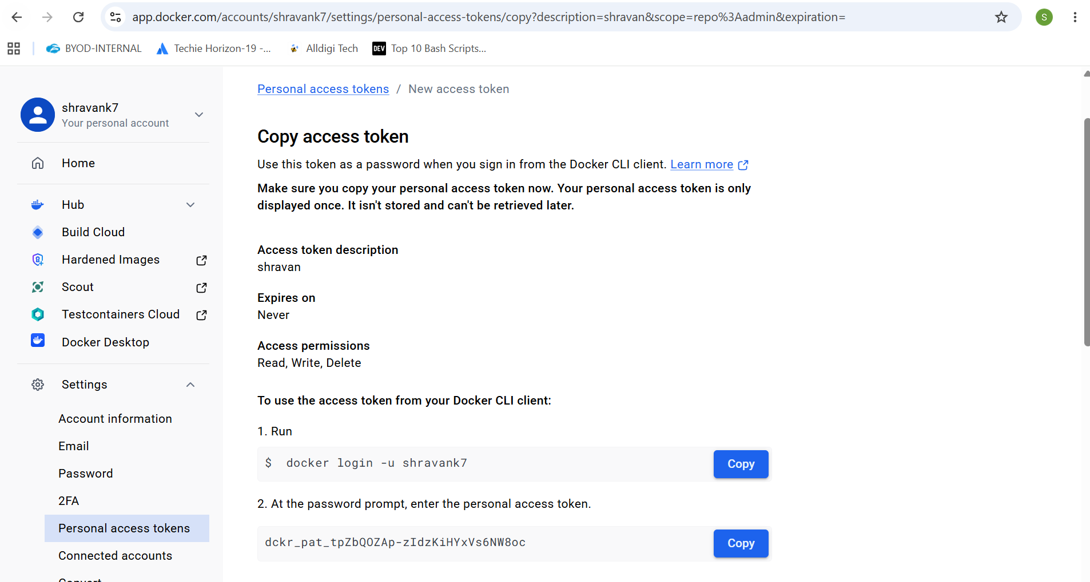
Now go to Jenkins url manage Jenkins credentials
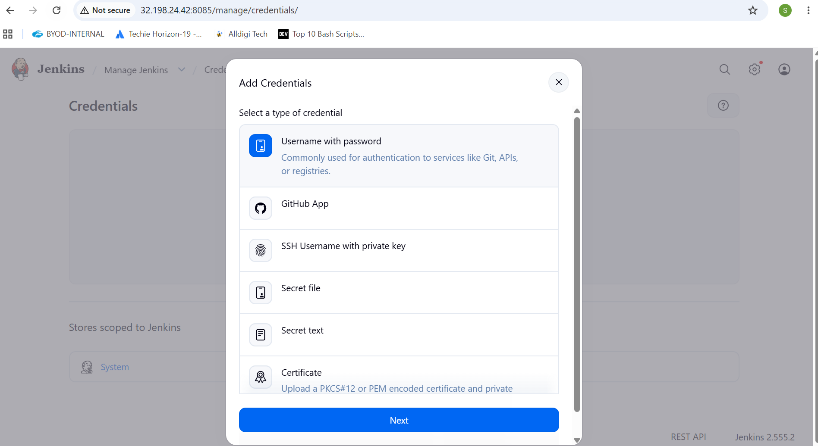
Now change into multistage repo docker file
FROM maven:3.8.6-openjdk-8 AS builder

RUN mkdir -p /app/source

COPY . /app/source

WORKDIR /app/source

RUN mvn clean package

# Stage 2 - Runtime
FROM eclipse-temurin:8-jre

COPY --from=builder /app/source/target/*.jar /app/app.jar

EXPOSE 8080

ENTRYPOINT ["java","-Djava.security.egd=file:/dev/./urandom","-jar","/app/app.jar"]
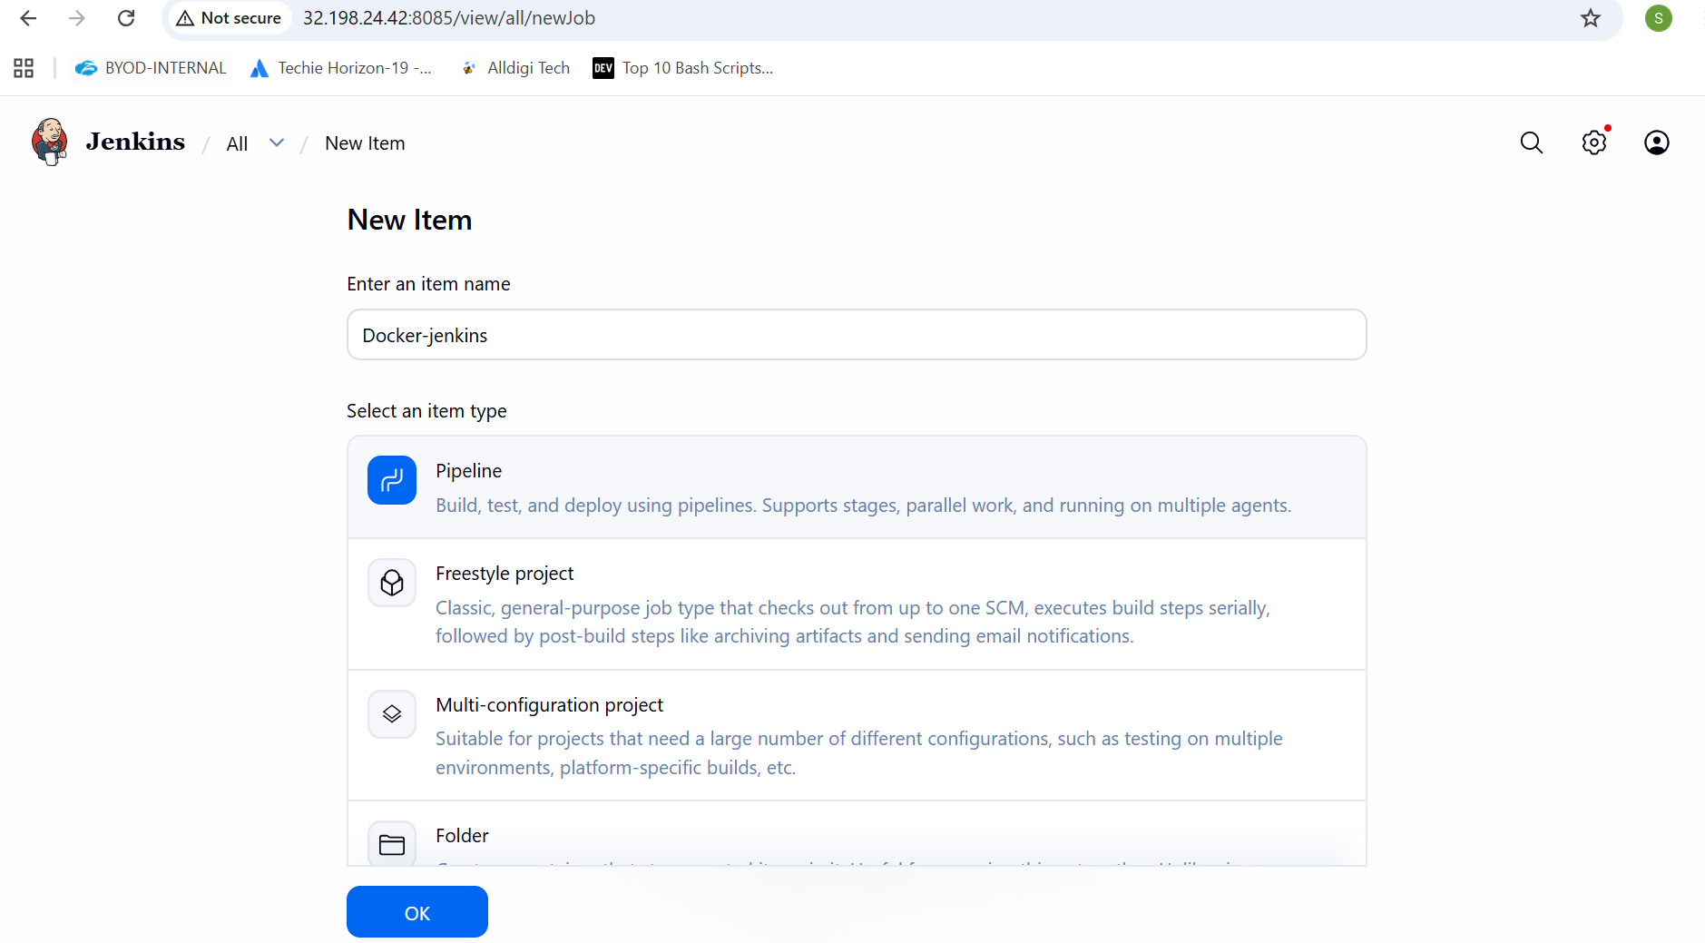
pipeline {
agent any

environment {
IMAGE_NAME = "shravank7/techie"
IMAGE_TAG = "v1"
}

stages {

stage('Clone Code') {
steps {
git 'https://github.com/shravank7/multi-stage-example.git'
}
}

stage('Build Docker Image') {
steps {
sh 'docker build -t $IMAGE_NAME:$IMAGE_TAG .'
}
}

stage('Login DockerHub') {
steps {
withCredentials([
usernamePassword(
credentialsId: 'dockerhub-creds',
usernameVariable: 'DOCKER_USER',
passwordVariable: 'DOCKER_PASS'
)
]) {
sh '''
echo $DOCKER_PASS | docker login \
-u $DOCKER_USER \
--password-stdin
'''
}
}
}

stage('Push Image') {
steps {
sh 'docker push $IMAGE_NAME:$IMAGE_TAG'
}
}
}

post {
success {
echo 'Docker image pushed successfully!'
}

failure {
echo 'Pipeline failed!'
}
}
}
