Kubernets-01
- Setup Minikube in your local machine.
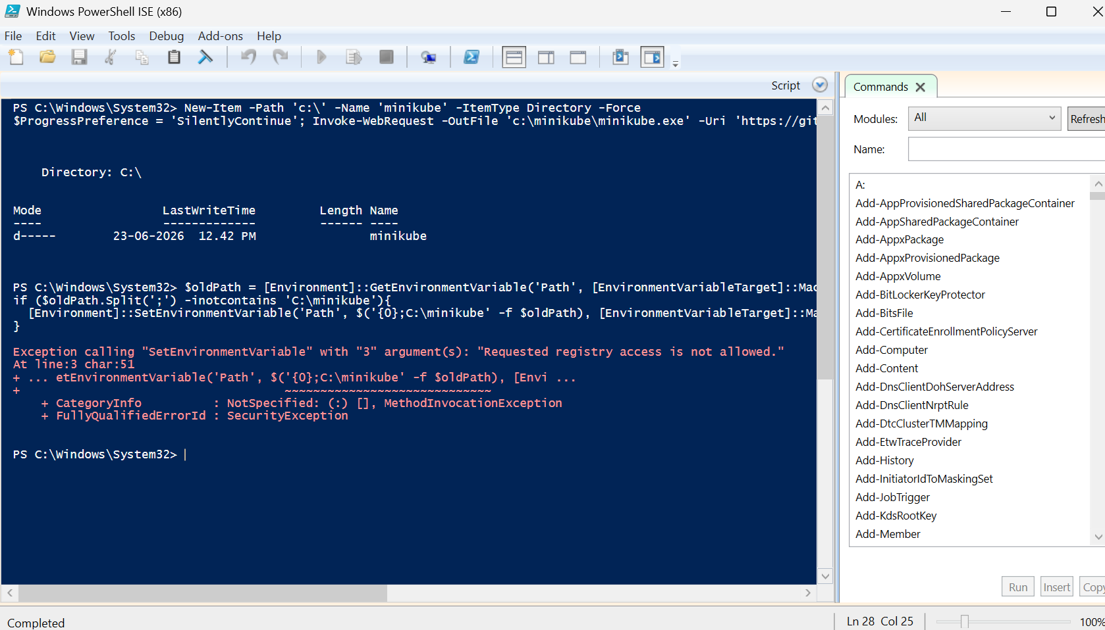
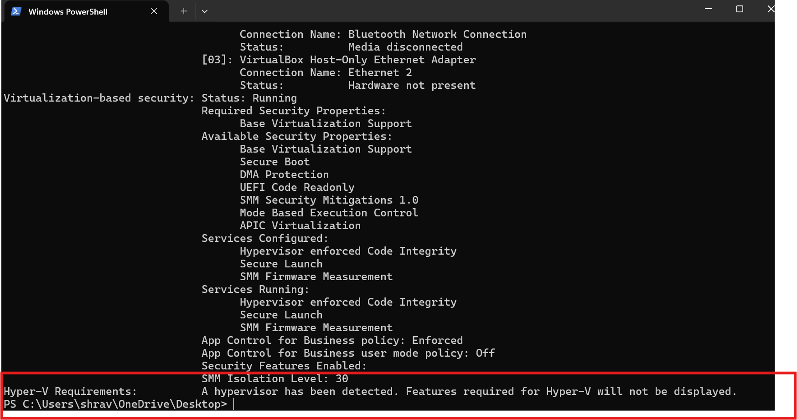
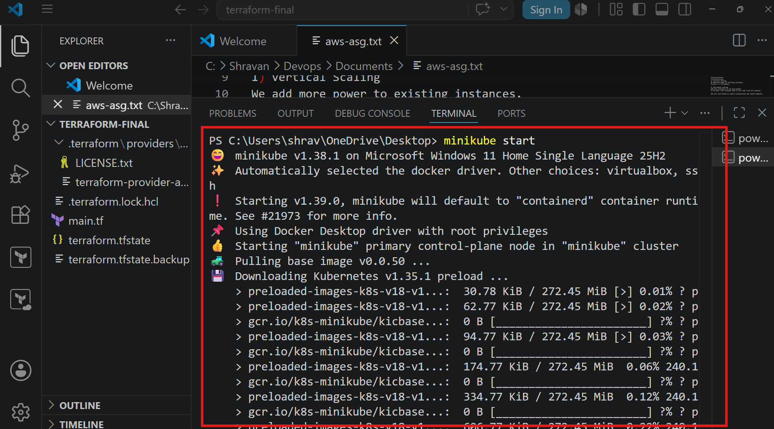
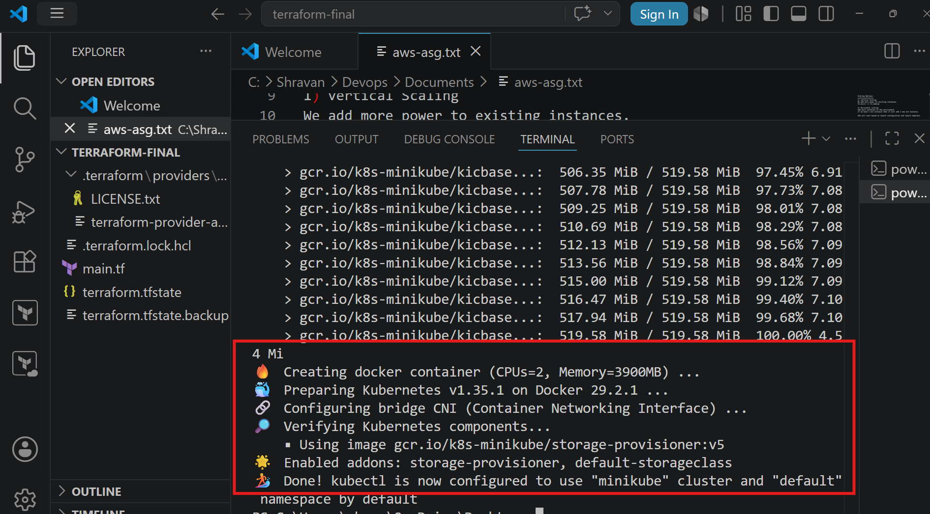
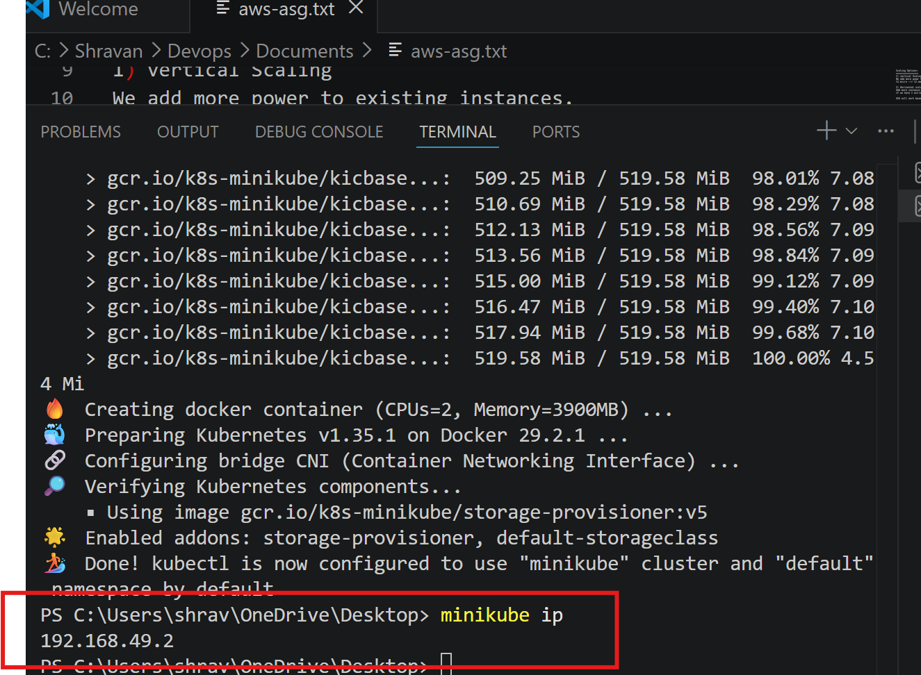
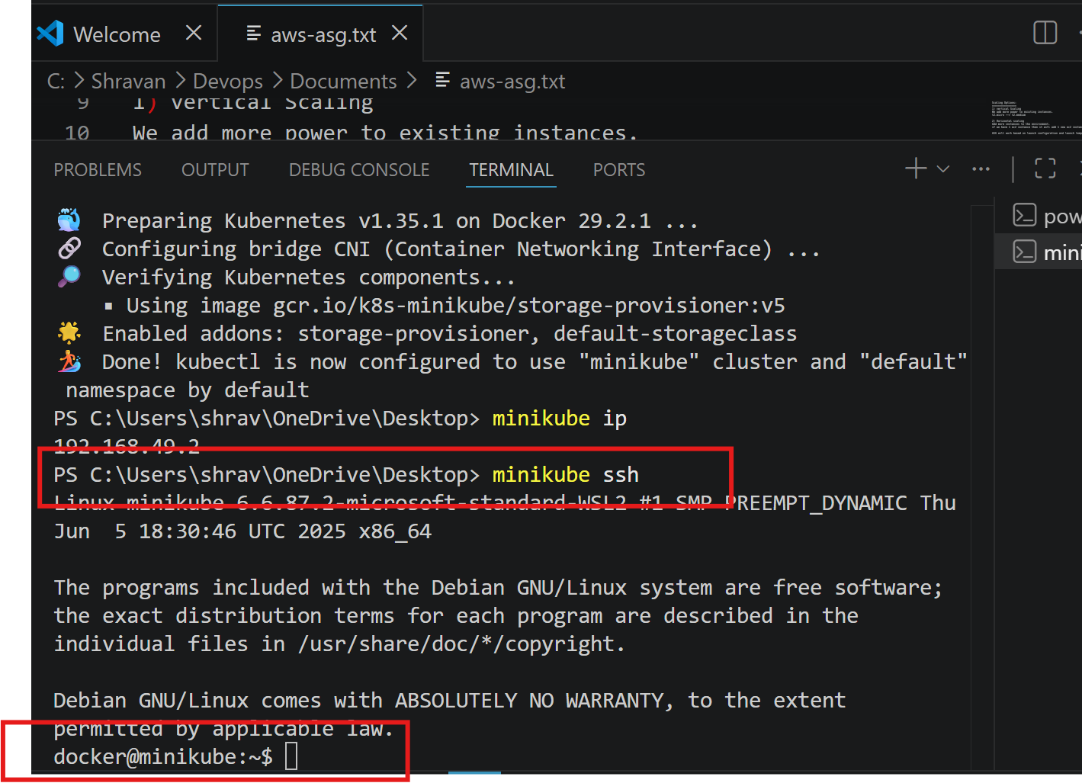
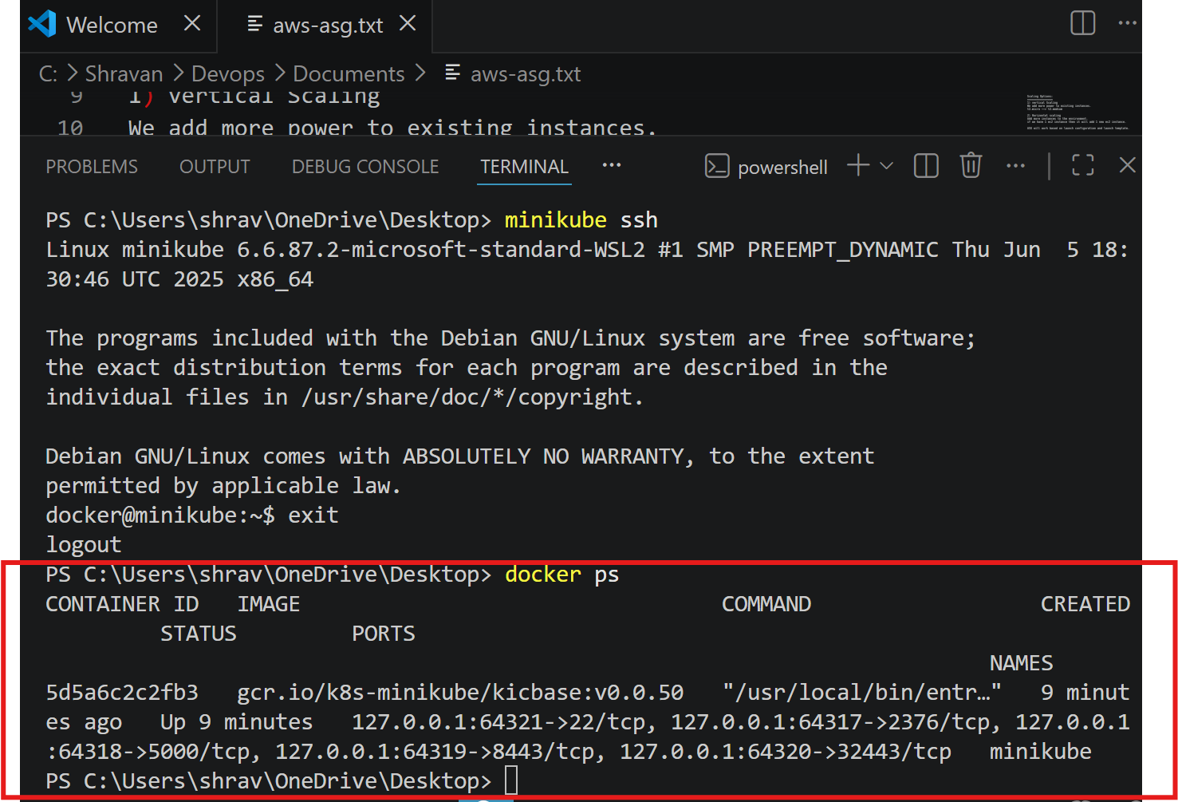
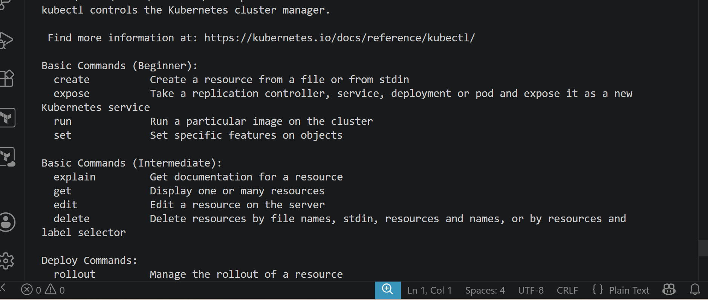

- Setup k8s master and two worker nodes on ubuntu.
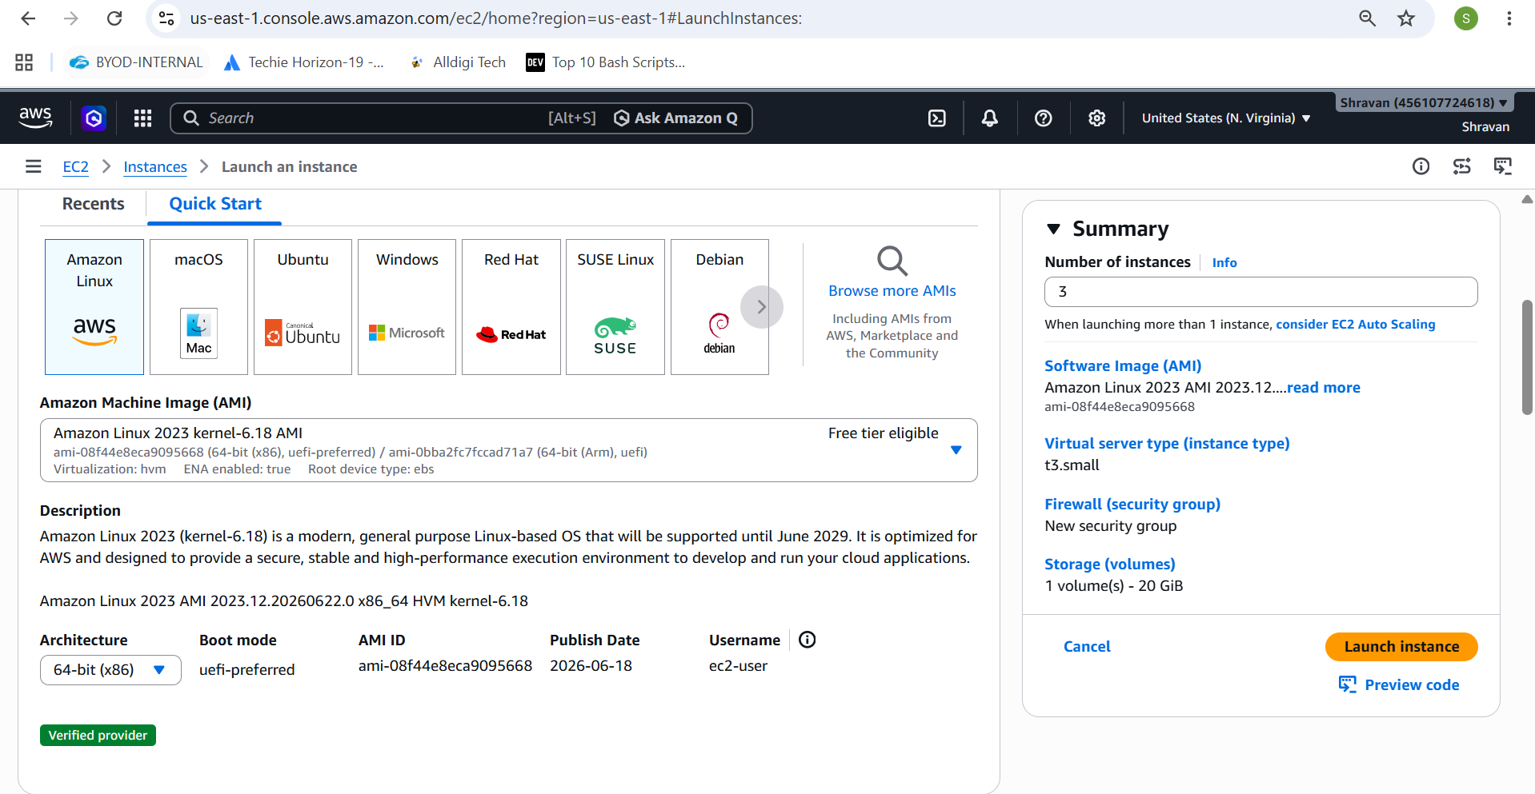
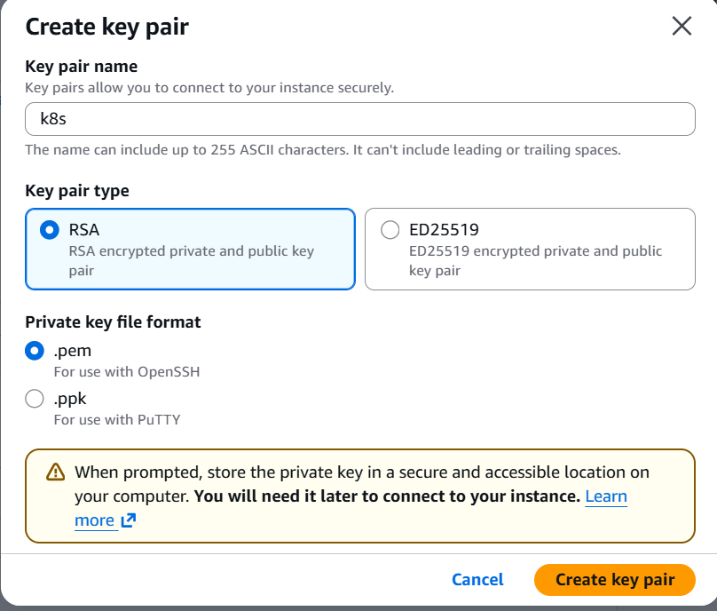
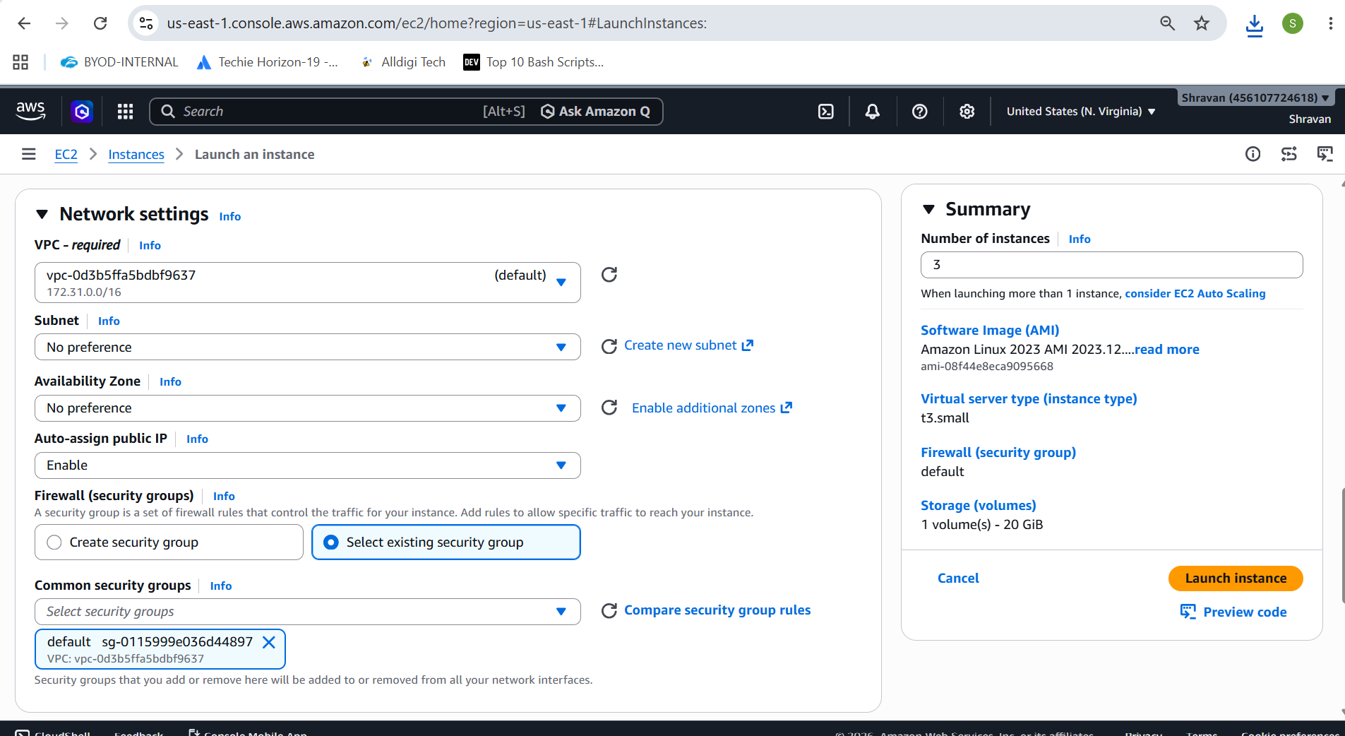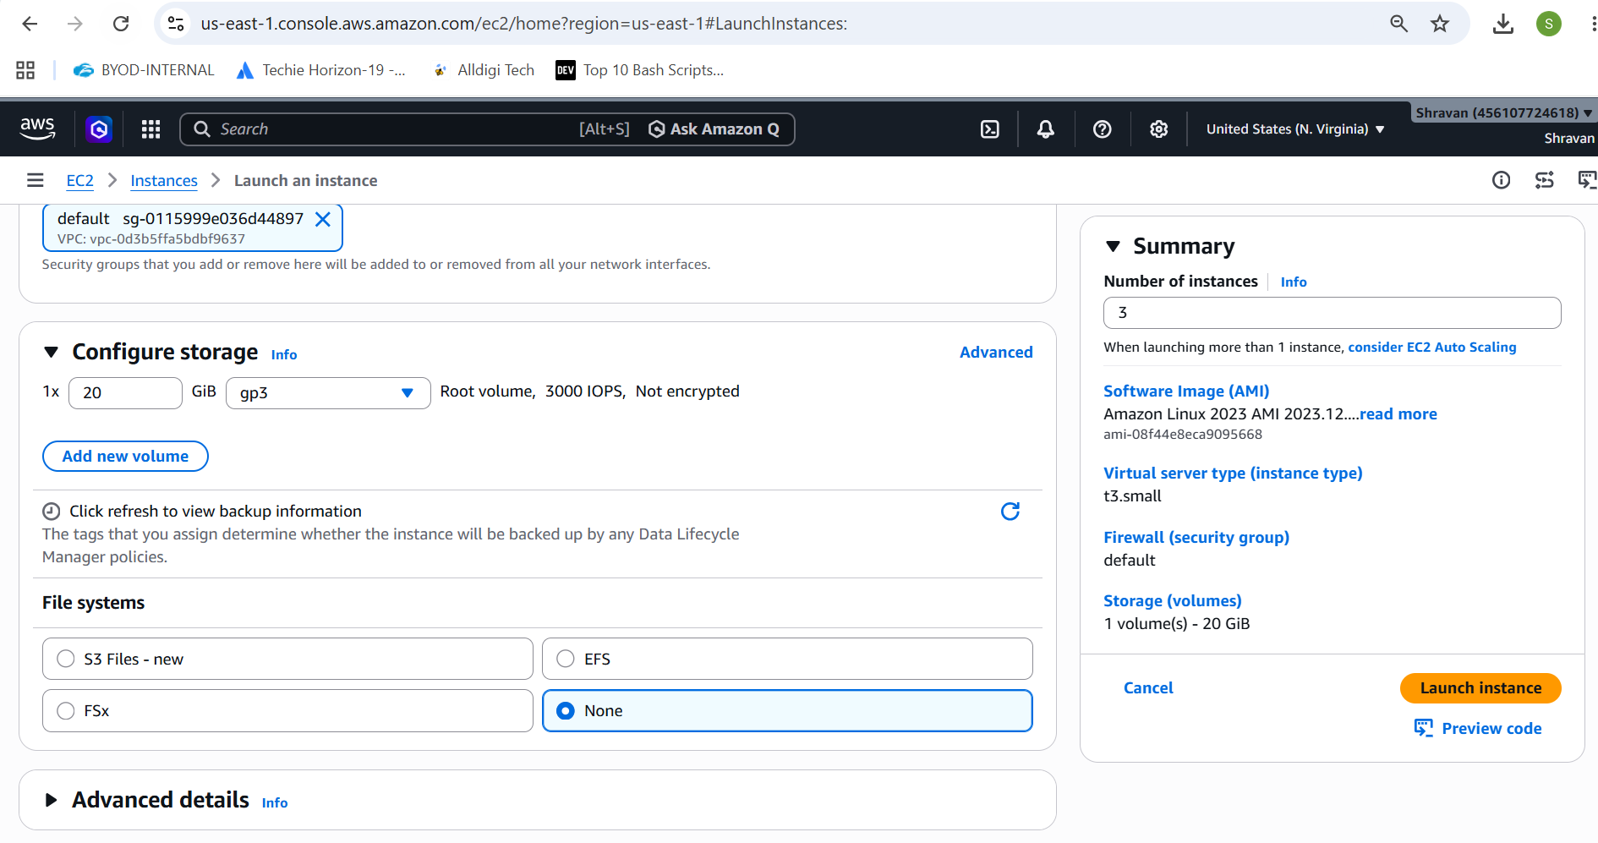
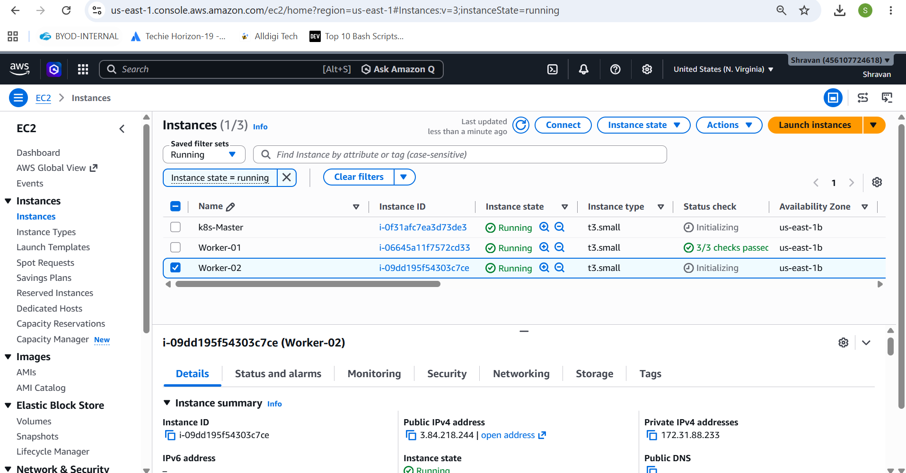
Now log into k8s-master
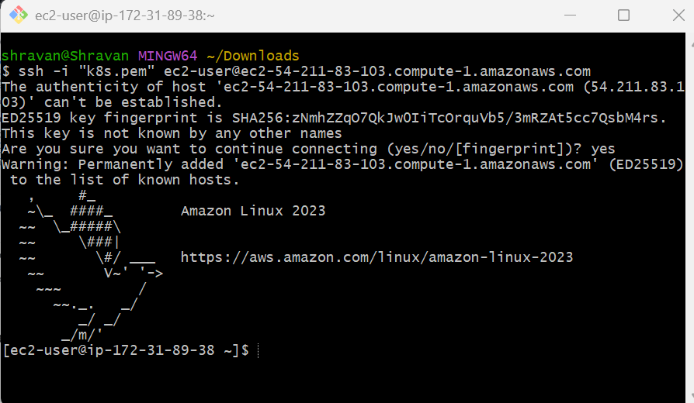
Change the root name to the master
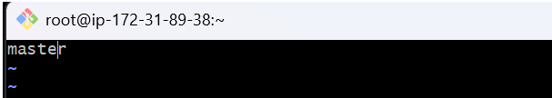
Do hostname master
Then check in ssh master, do restart and check
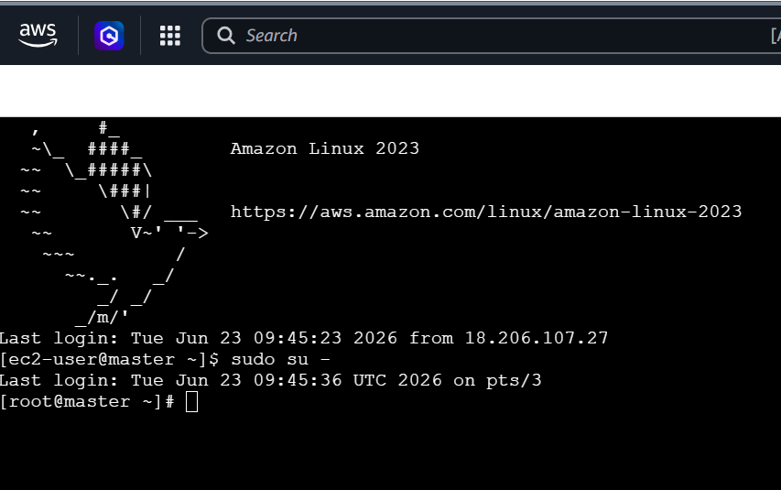
Now connect to worker-01and change the name
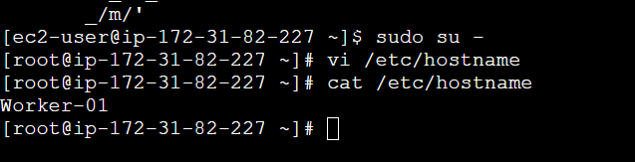
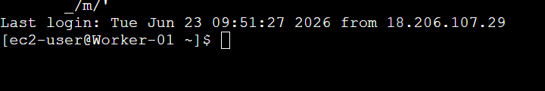
Now connect to Worker-02 and change the name
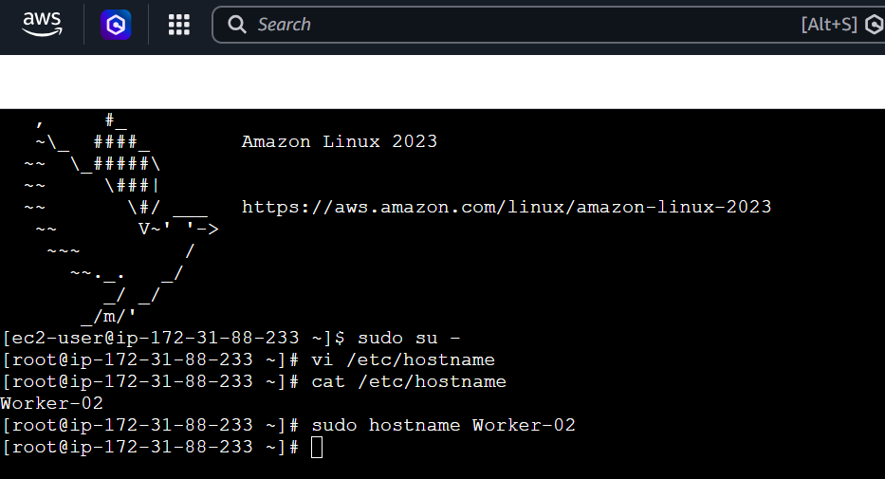
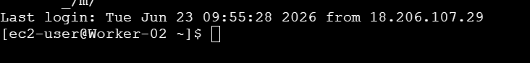
Install docker in all the 3 instances like master, worker-01 & Worker-02
yum -y install docker
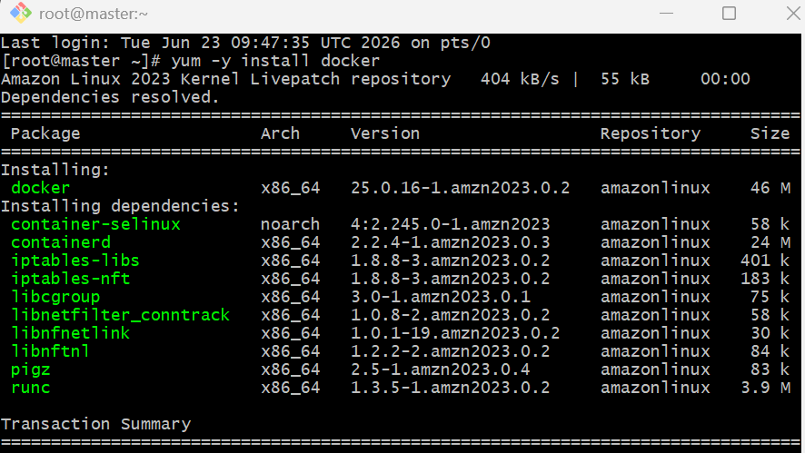
Download then start and enable the docker
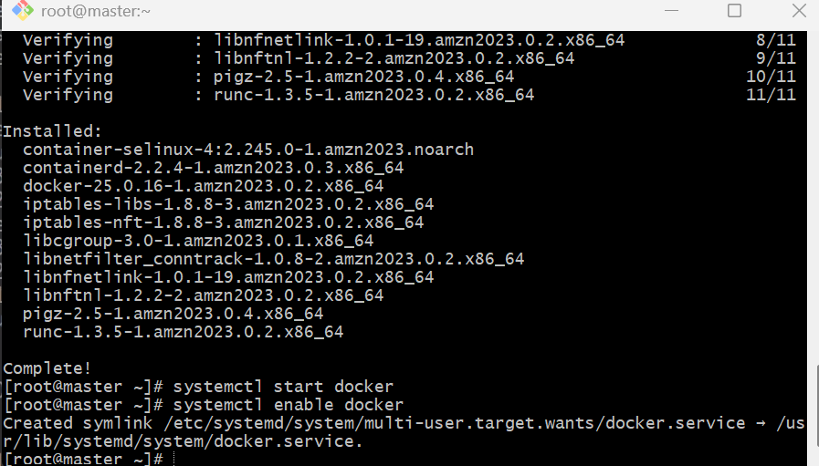
Now to install kubeadm
From the official document link
https://kubernetes.io/docs/setup/production-environment/tools/kubeadm/install-kubeadm/
Inside the document as by step-1
sudo setenforce 0
sudo sed -i 's/^SELINUX=enforcing$/SELINUX=permissive/' /etc/selinux/config
In Step 2
cat <<EOF | sudo tee /etc/yum.repos.d/kubernetes.repo
[kubernetes]
name=Kubernetes
baseurl=https://pkgs.k8s.io/core:/stable:/v1.36/rpm/
enabled=1
gpgcheck=1
gpgkey=https://pkgs.k8s.io/core:/stable:/v1.36/rpm/repodata/repomd.xml.key
exclude=kubelet kubeadm kubectl cri-tools kubernetes-cni
EOF
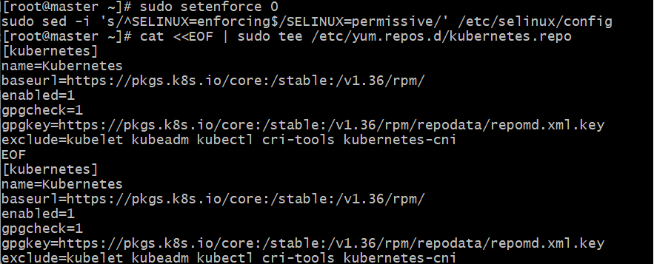
Install kubelet, kubeadm and kubectl
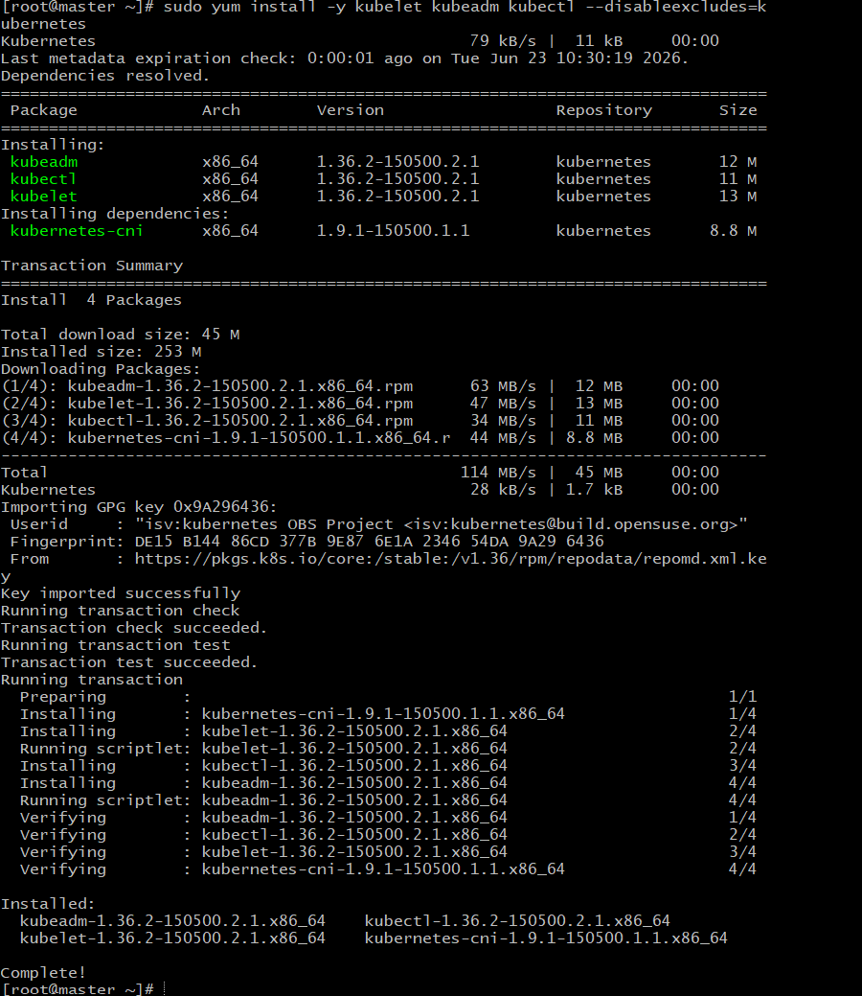
Enable the kubelet service before running kubeadm:
sudo systemctl enable --now kubelet
To configure master we need to initialize with CIDR
kubeadm init --pod-network-cidr=10.244.0.0/16
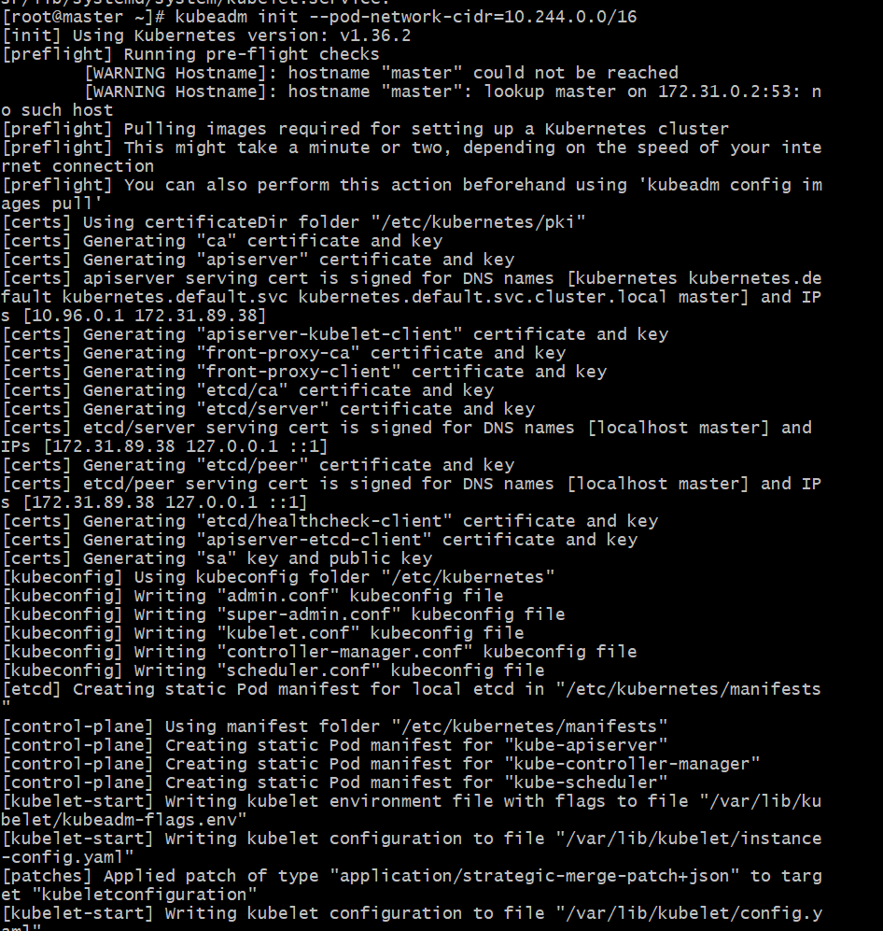
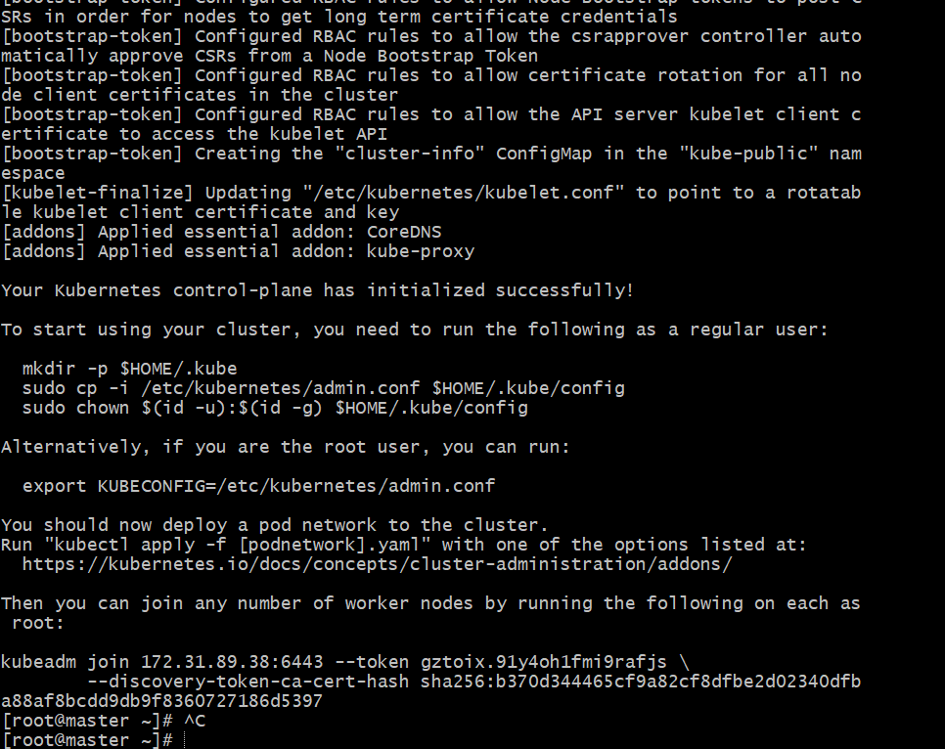
Now copy and paste
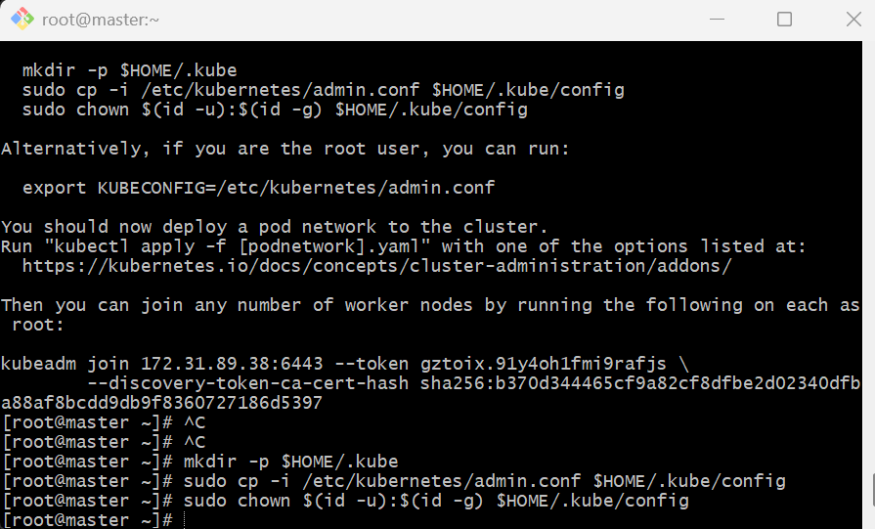
To check the pods use
kubectl get pods
Now paste the
kubeadm join 172.31.89.38:6443 --token gztoix.91y4oh1fmi9rafjs \
--discovery-token-ca-cert-hash sha256:b370d344465cf9a82cf8dfbe2d02340dfba88af8bcdd9db9f8360727186d5397
In Worker-01 and Worker-02
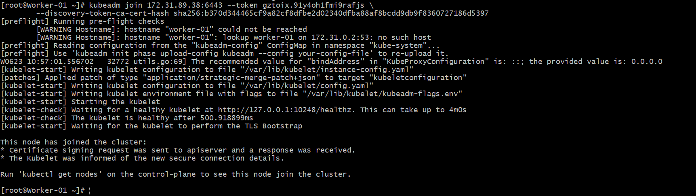
Now check in master to verify
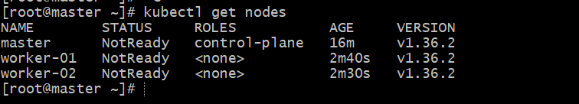
It is not ready , to get it ready use this
Install flannel network
kubectl apply -f https://github.com/flannel-io/flannel/releases/latest/download/kube-flannel.yml
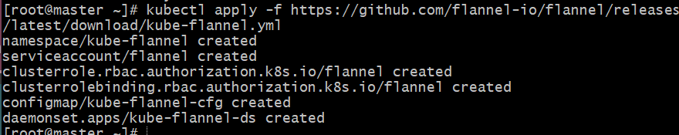
Now check the nodes, it will be ready
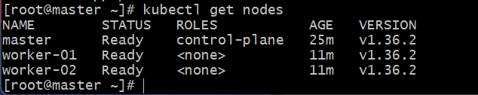
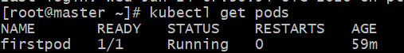

- Run one nginx pod.
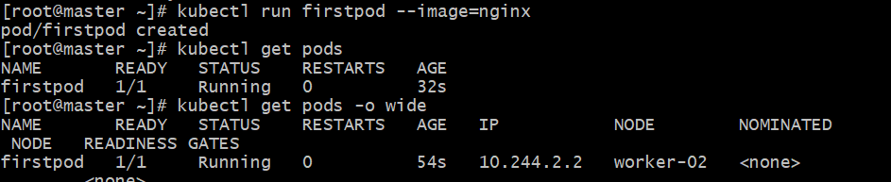
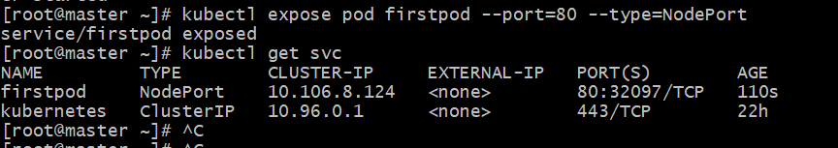
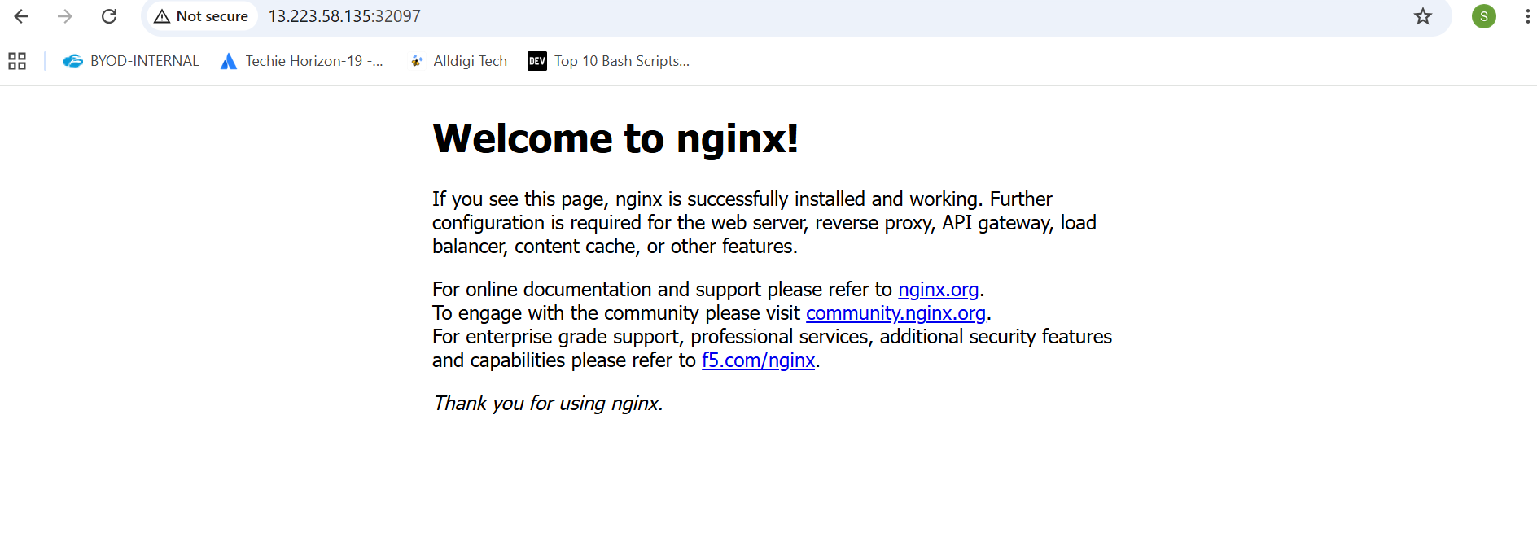
- Mugup Master and slave components on k8s.

