Docker-01
Setup a virtual machine using Ubuntu image
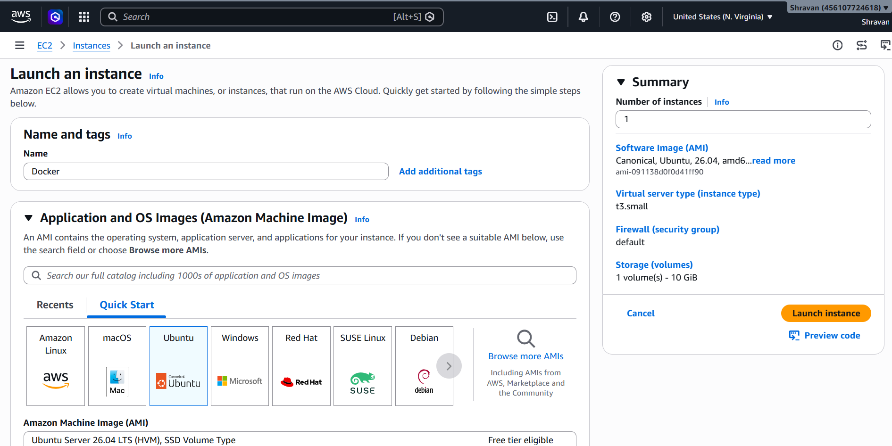
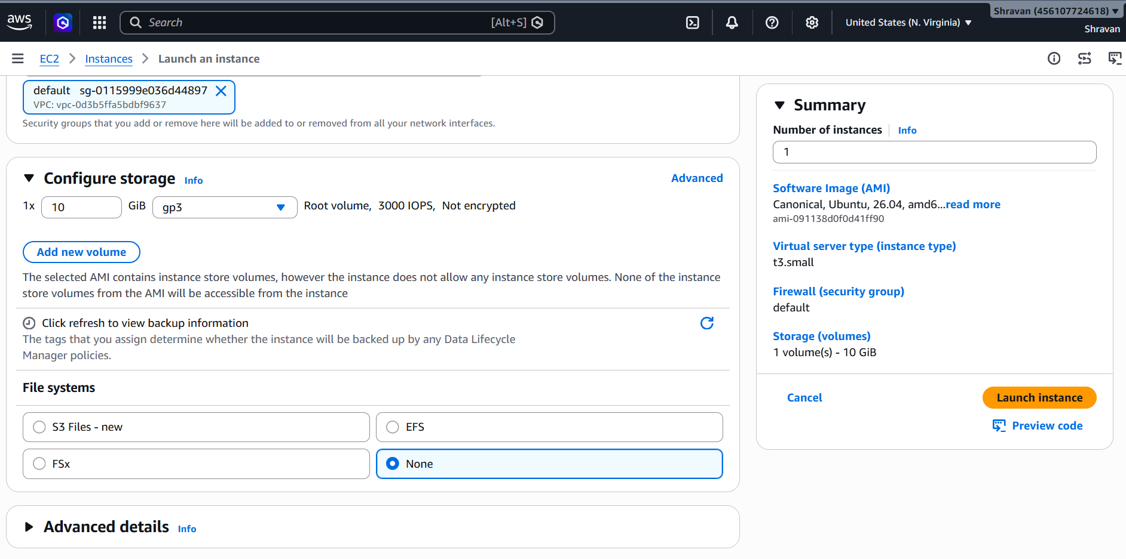
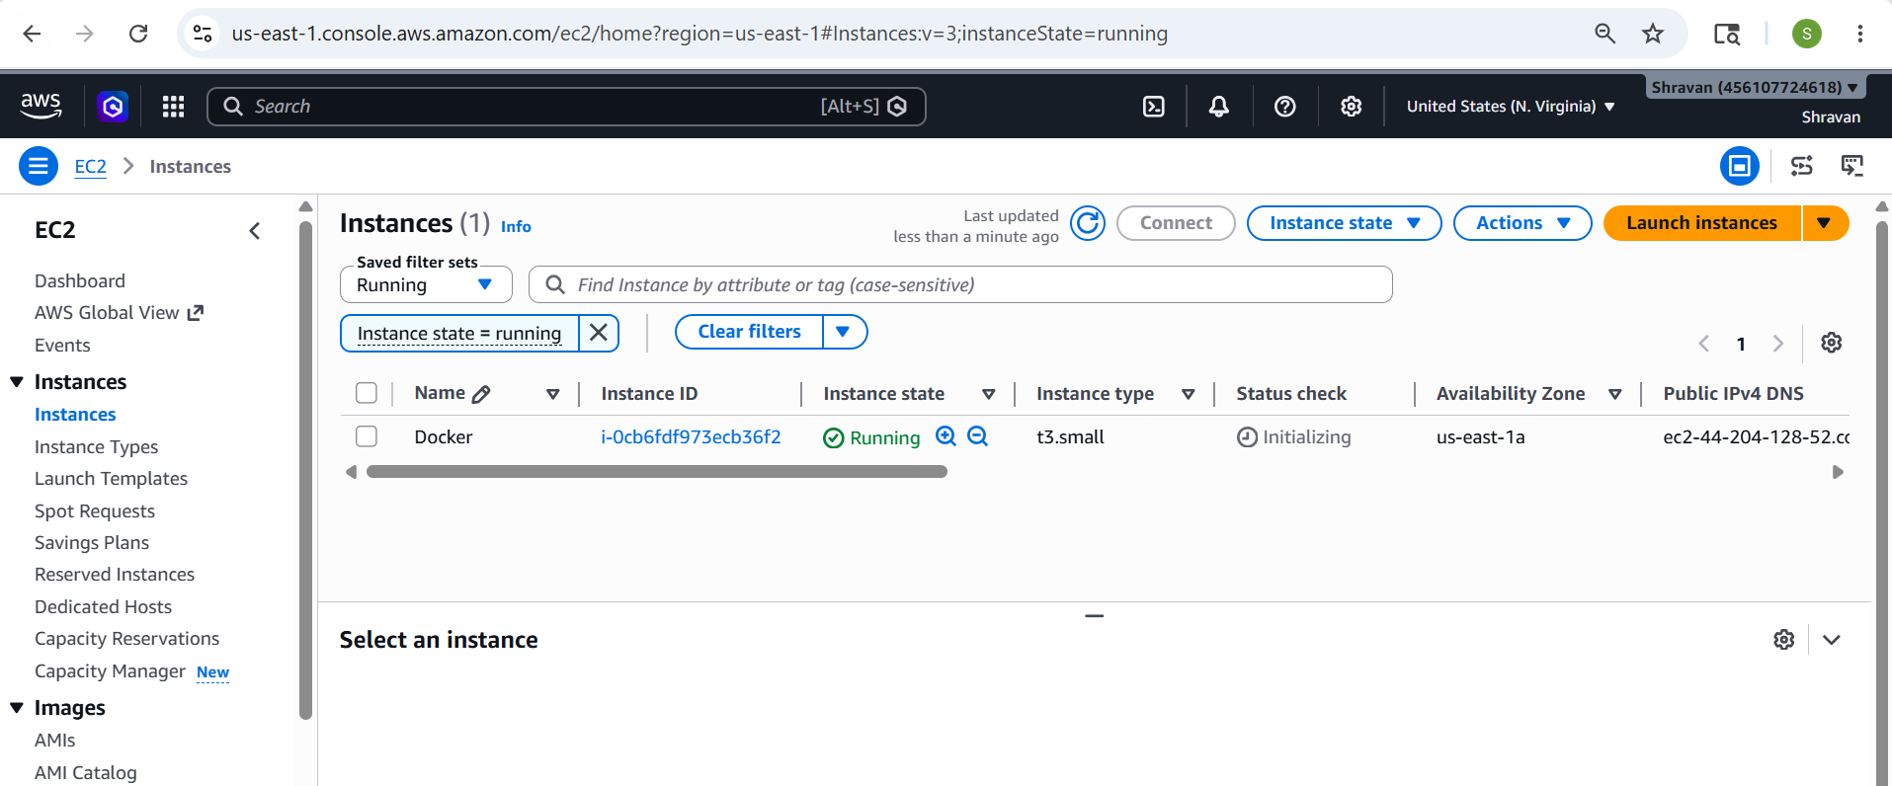
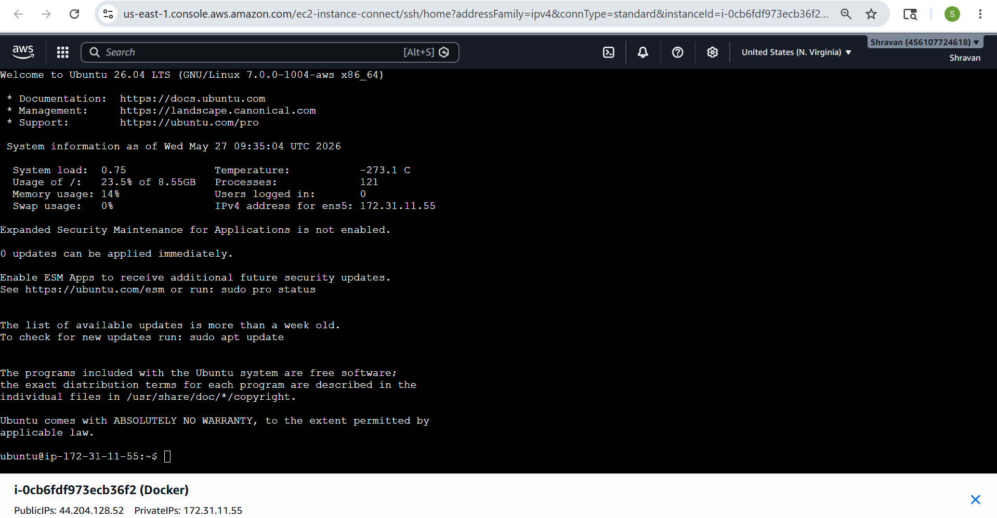
Install docker on ec2.
apt update— to update the packages
apt install docker.io -y
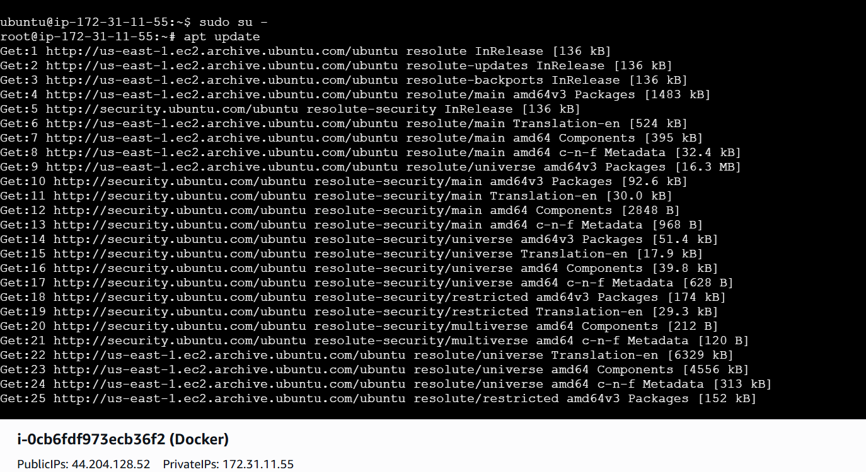
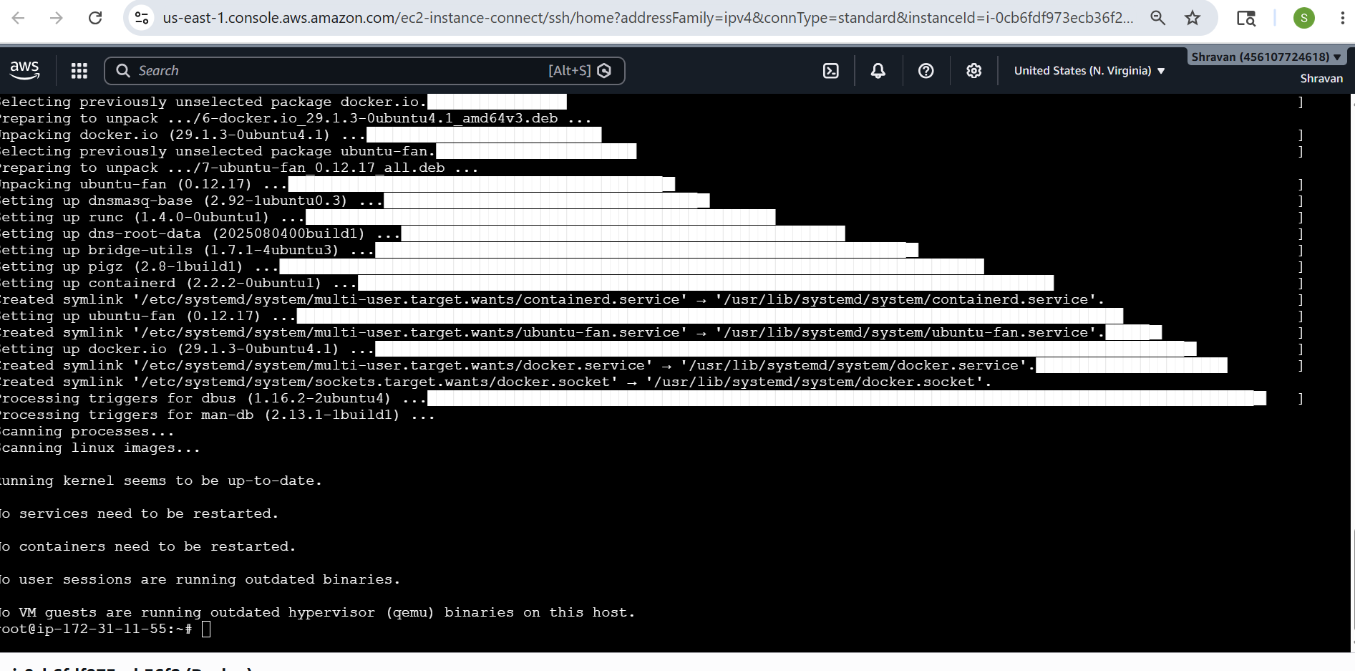
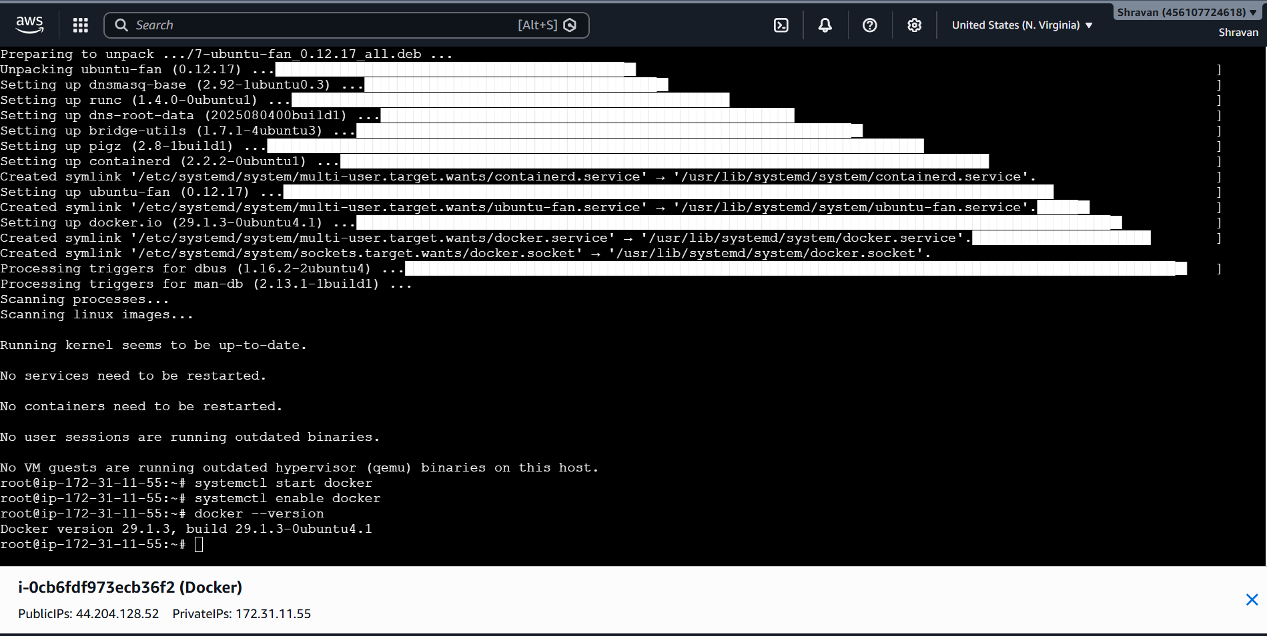
Pull 5 docker images. (nginx, Apache tomcat, ubuntu, Jenkins, SonarQube)
Installed nginx
docker pull nginx
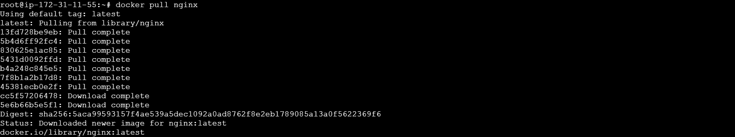
Installed apache tomcat
docker pull tomcat
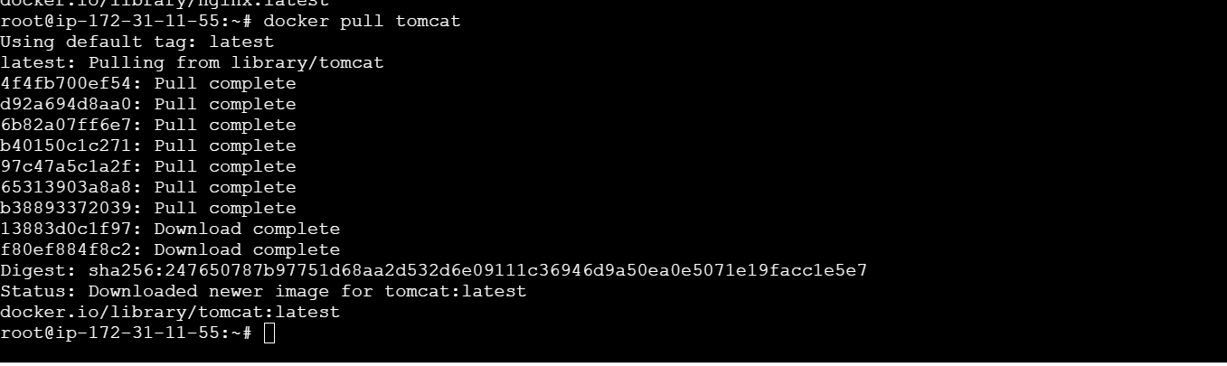
Installed ubuntu
docker pull ubuntu
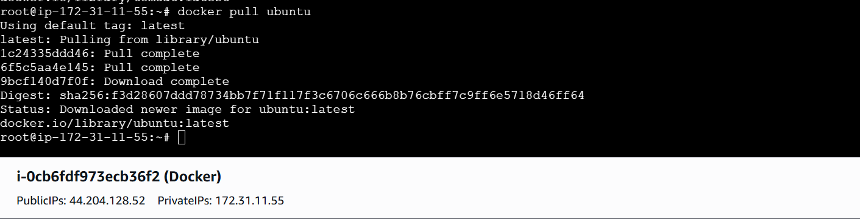
Installed jenkins
docker pull jenkins/jenkins:lts
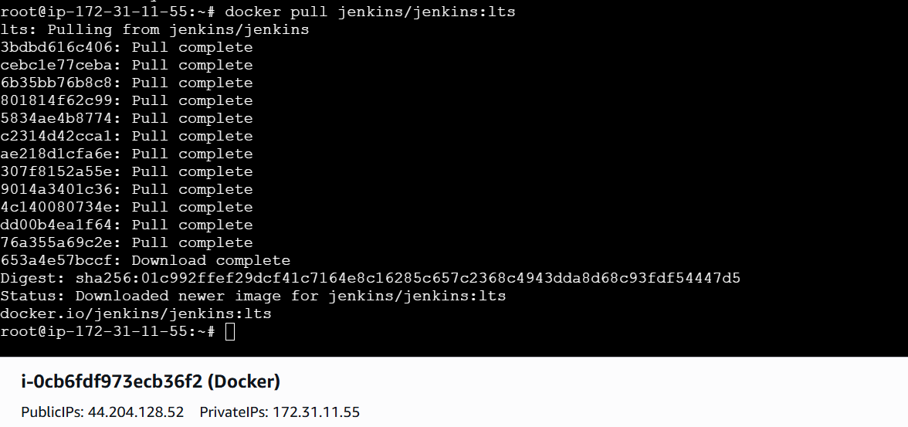
Installed sonarqube
docker pull sonarqube
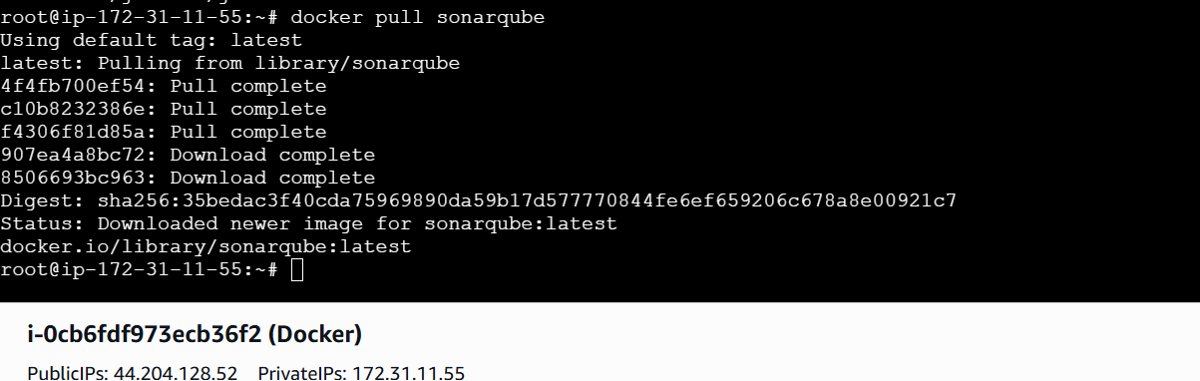

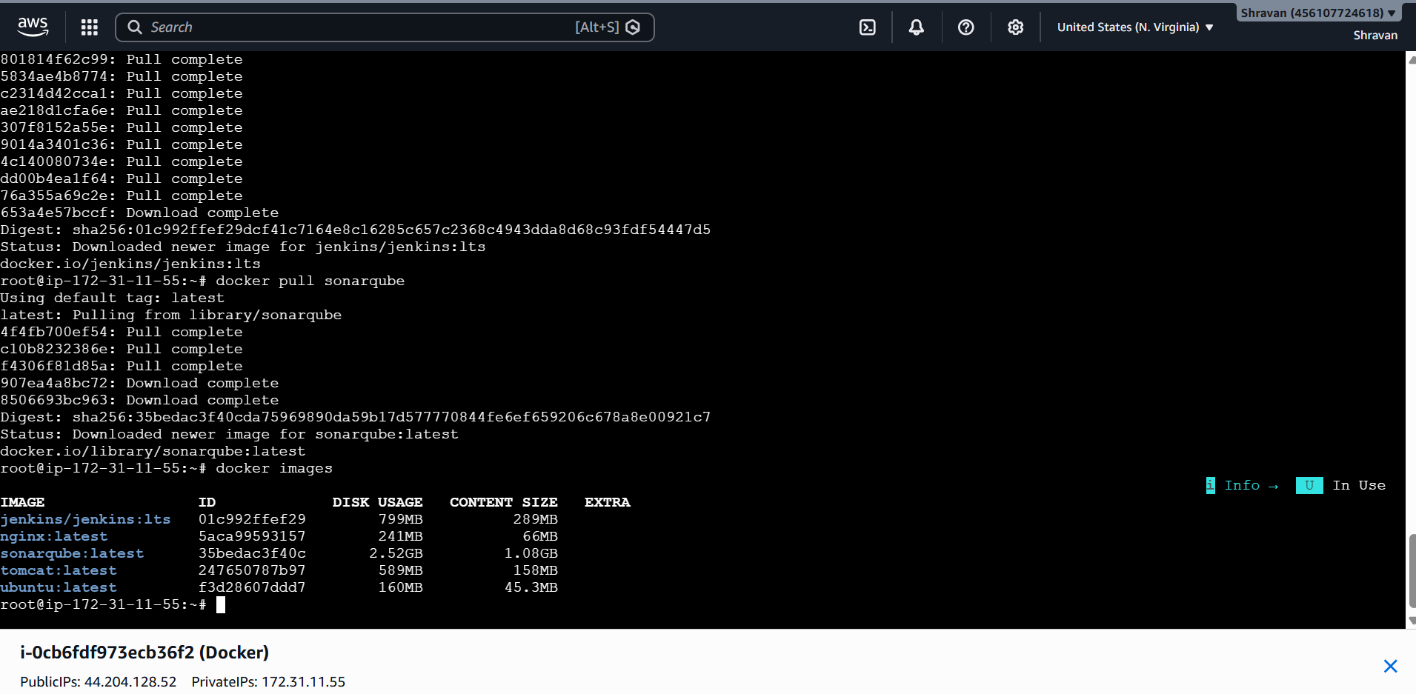
Run nginx container and expose on port 81.
Changing the default port number 80 to 81
docker run -d --name nginx-container -p 81:80 nginx
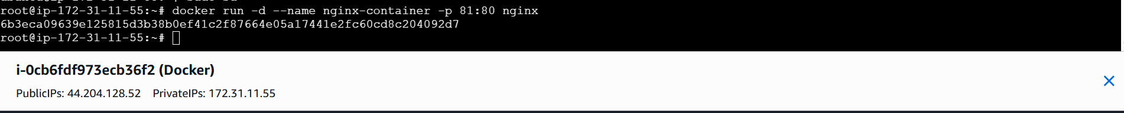
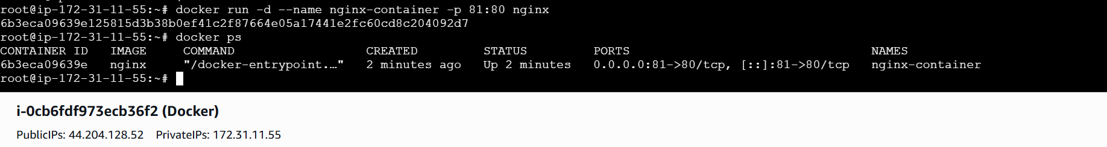
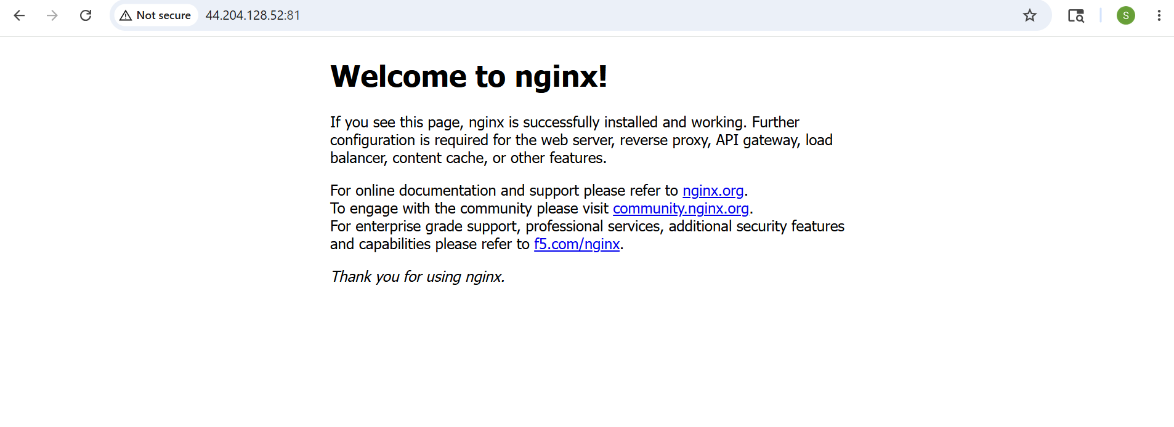
Delete the Apache tomcat image from local.
docker rmi tomcat
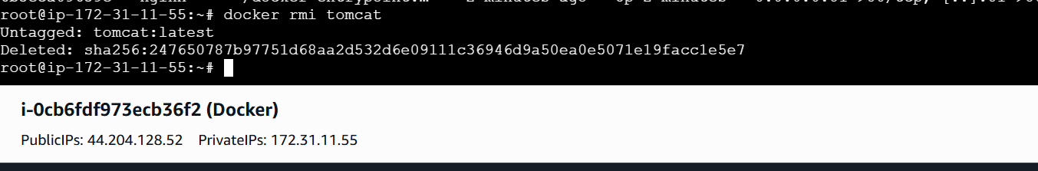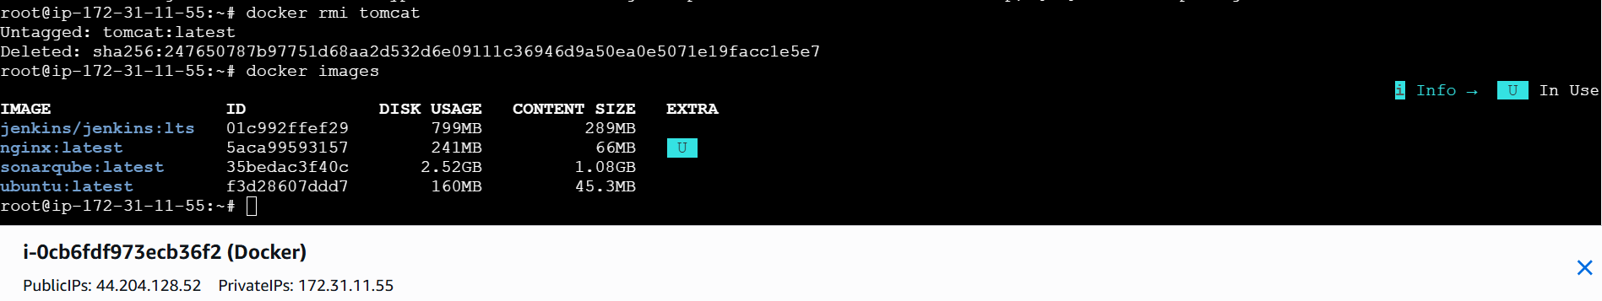
Inspect the Jenkins image, SonarQube image.
docker inspect jenkins/jenkins:lts
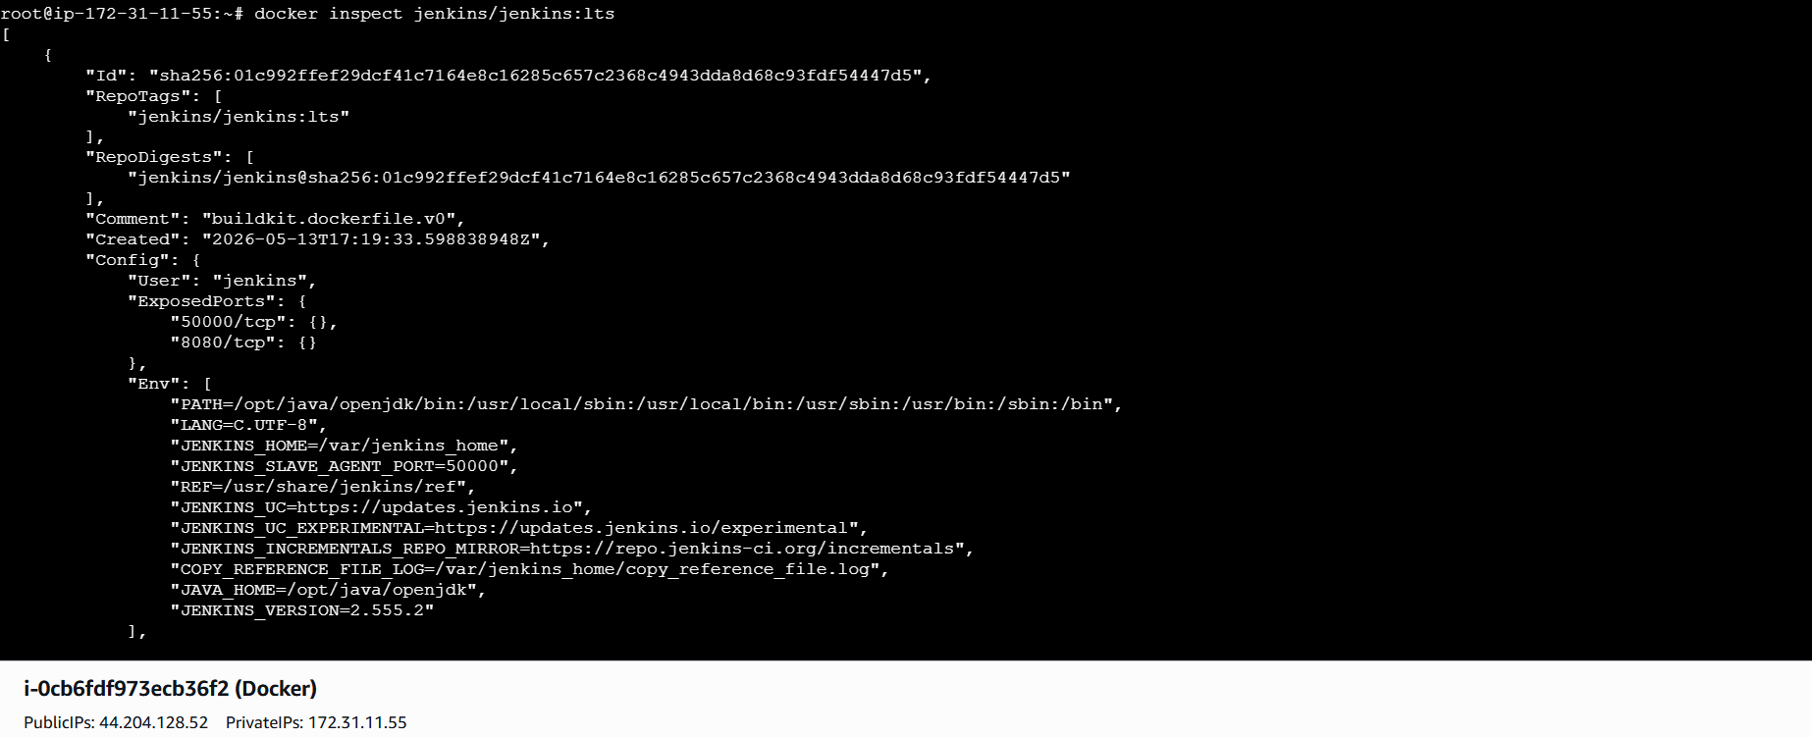
docker inspect sonarqube
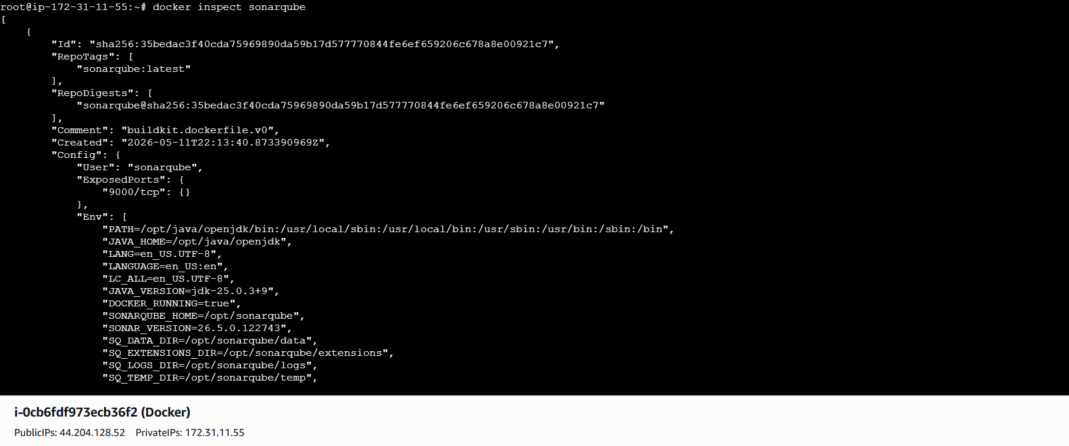
Run Jenkins container and run one sample job
docker run -d \
--name jenkins-container \
-p 8080:8080 \
-p 50000:50000 \
jenkins/jenkins:lts
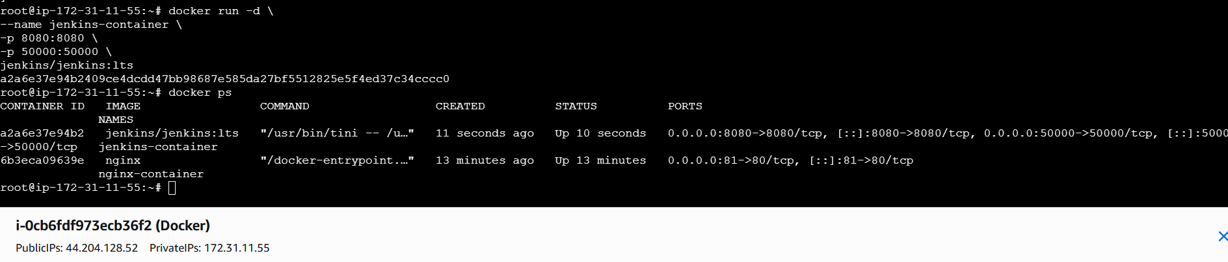
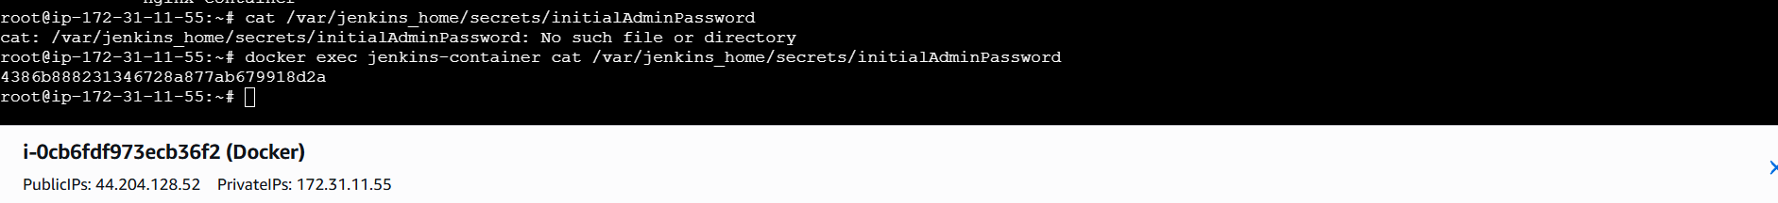
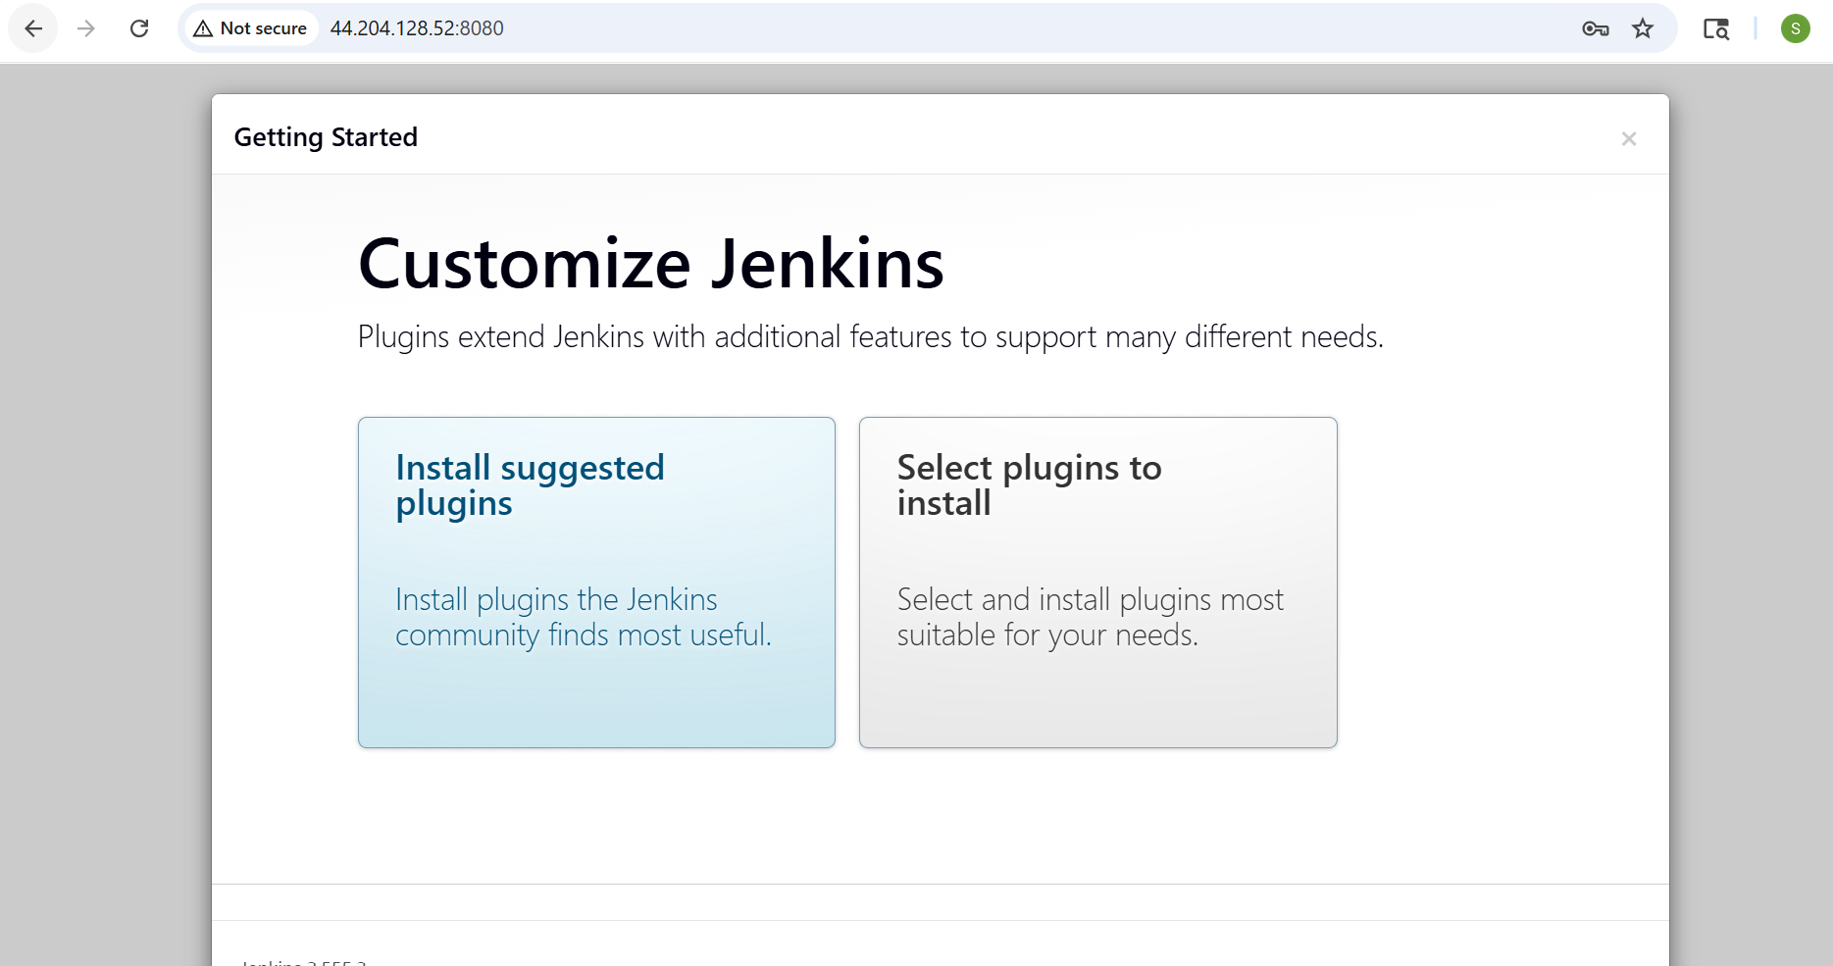
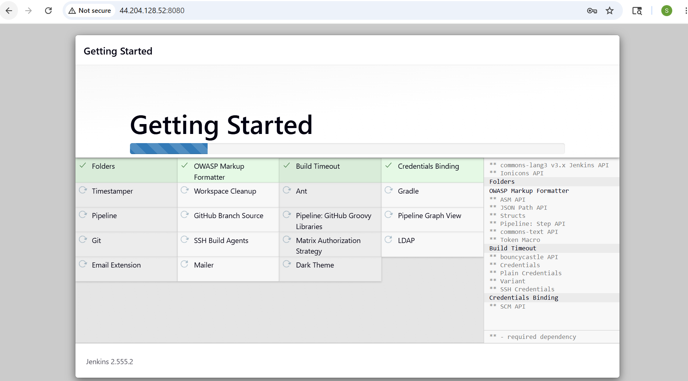
Now the Jenkins is created
