Docker-02
Create a tomcat container on 8080 and deploy sample application in tomcat
Create an instance and login to it
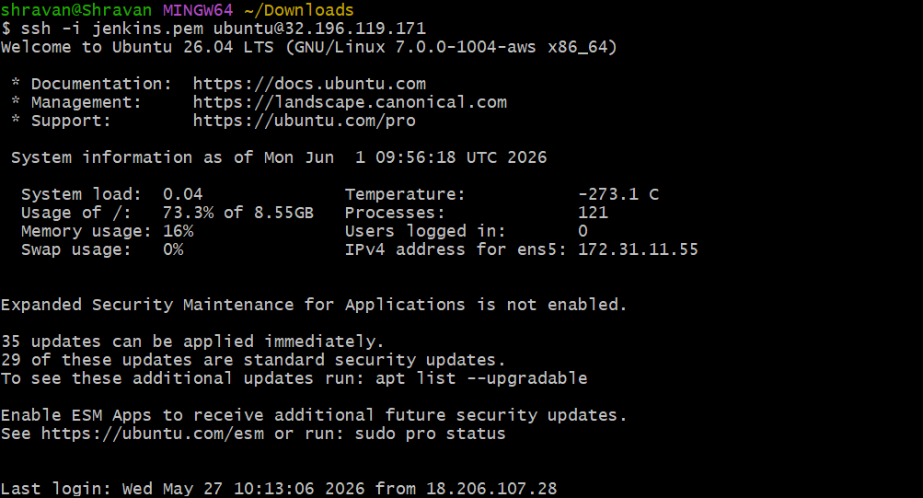
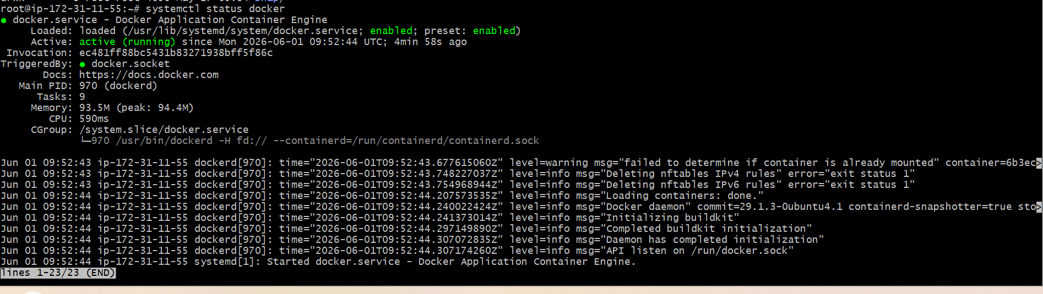
docker pull tomcat
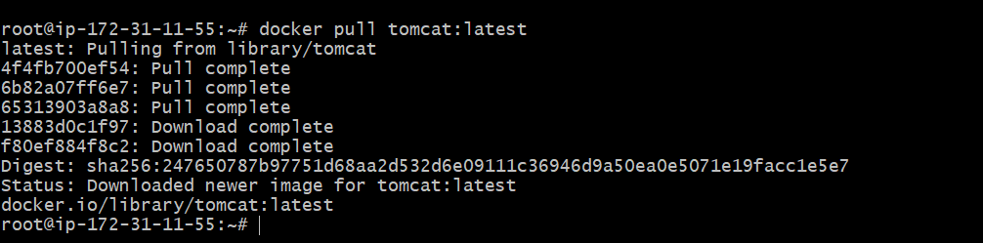
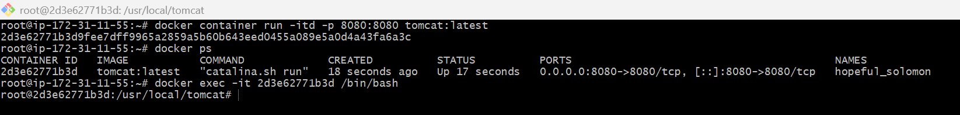
apt-get update
apt-get install -y wget
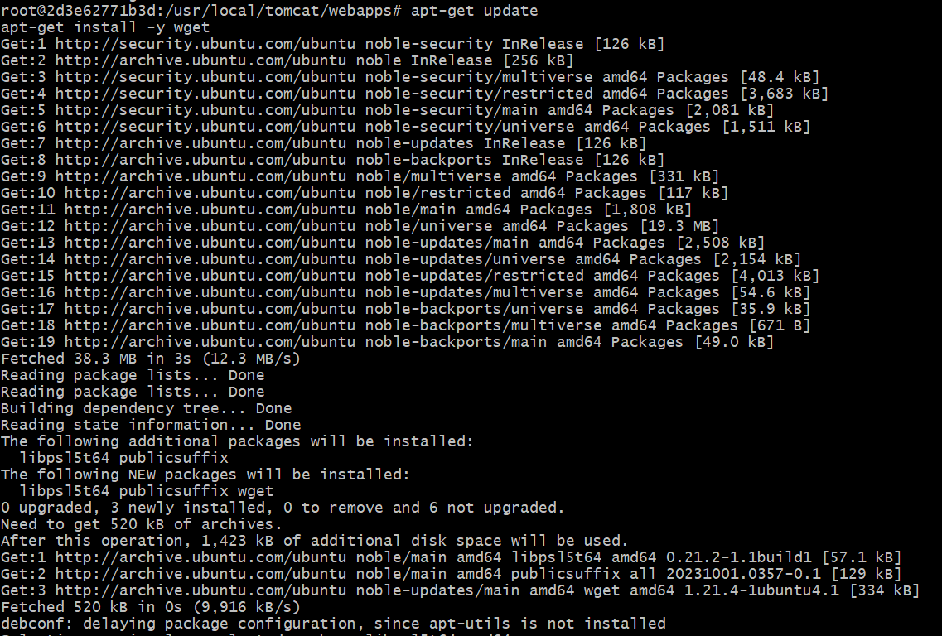
wget https://tomcat.apache.org/tomcat-6.0-doc/appdev/sample/sample.war
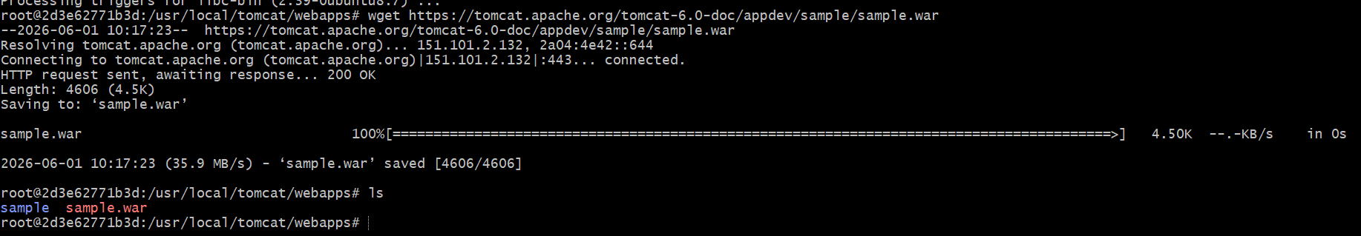
Now check the url
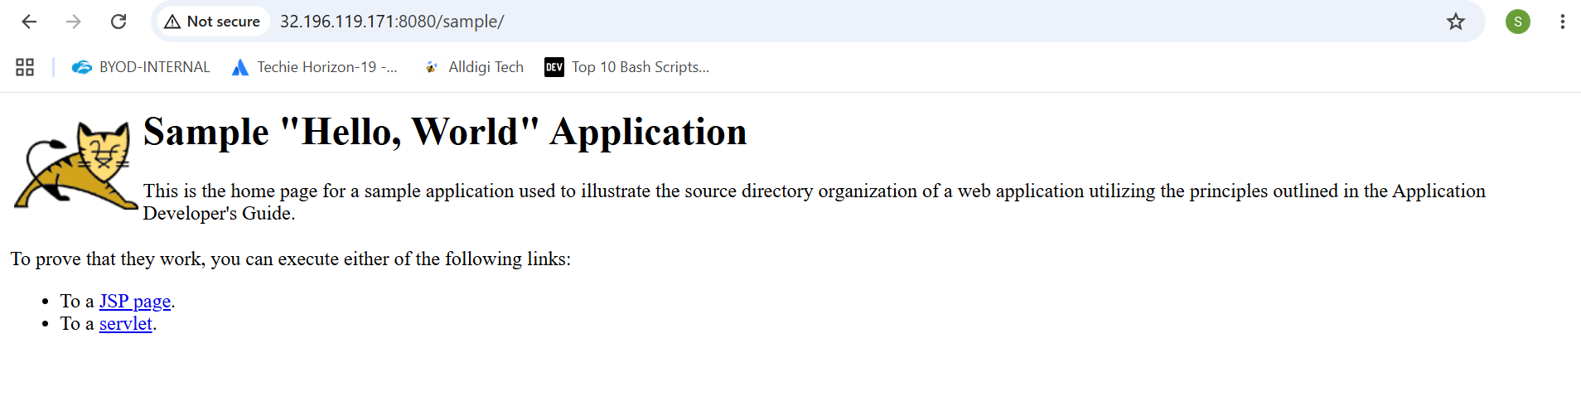
Create volume and deploy tomcat container on port 8081
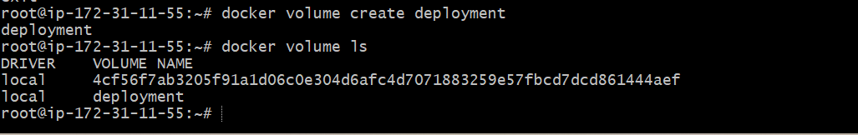
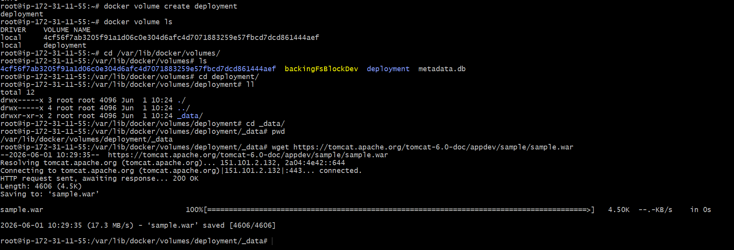
Now the port number is changed to 8081 and the volume is mapped to tomcat container
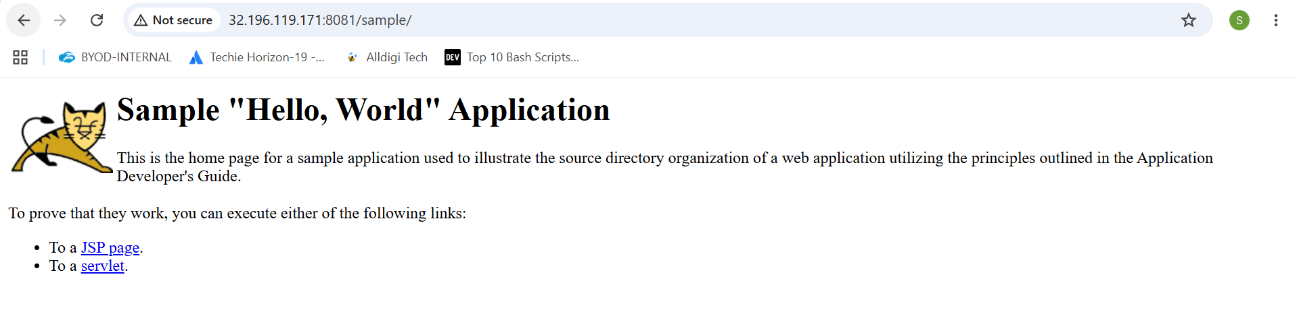
Limit the nginx container to 500 MB
docker container run -itd -p 80:80 –memory=500m nginx
changed the limit of nginx to 500mb
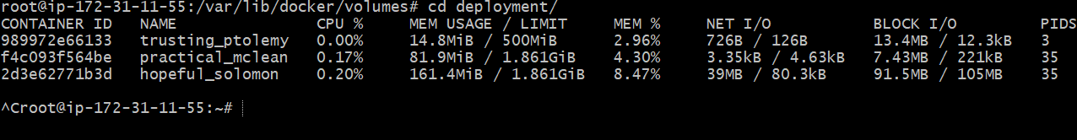
Create a sample docker file using below instructions
Create a index.html file
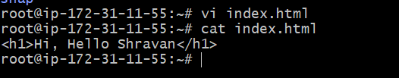
  - Base module as amazonlinux:latest
  - Maintainer you name
  - Install nginx
  - COPY one index.html file to image
  - Expose on port 80
  - Command to start the nginx container
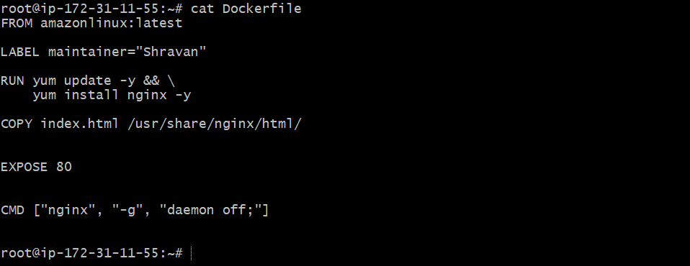
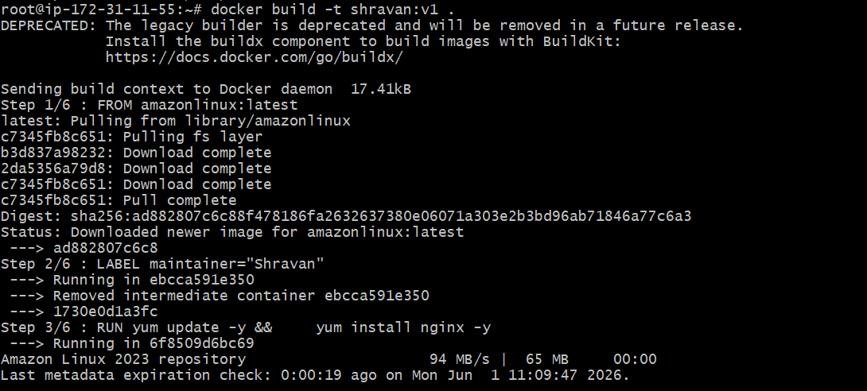
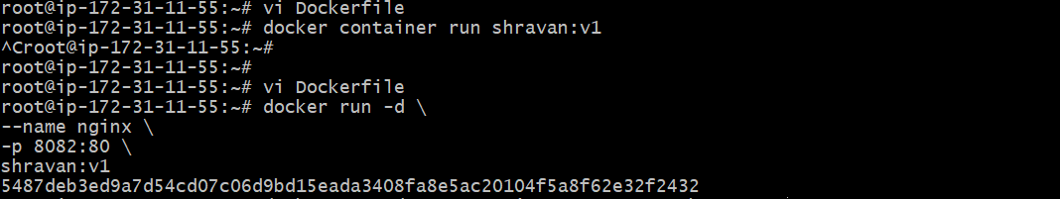
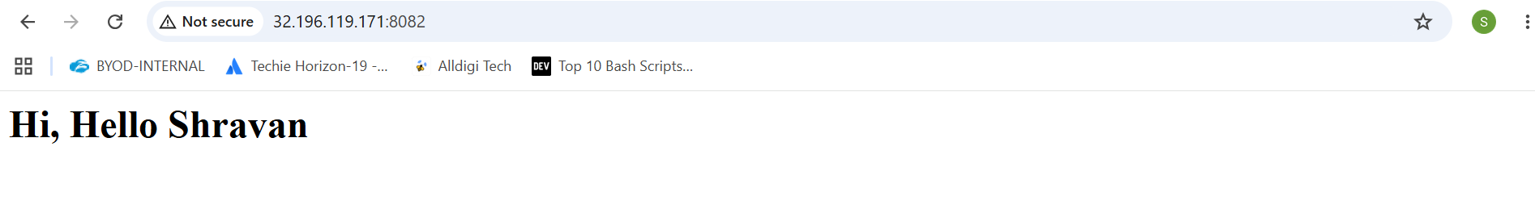
Push image to Docker hub
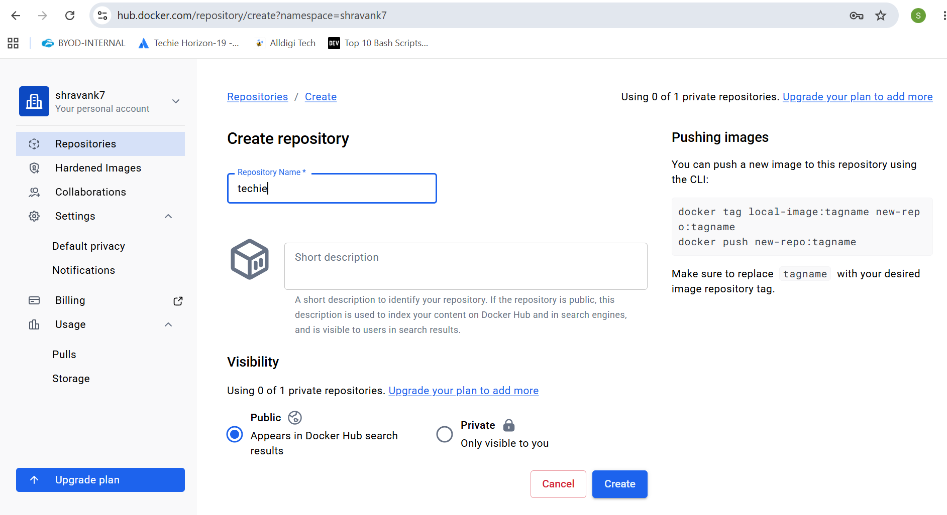
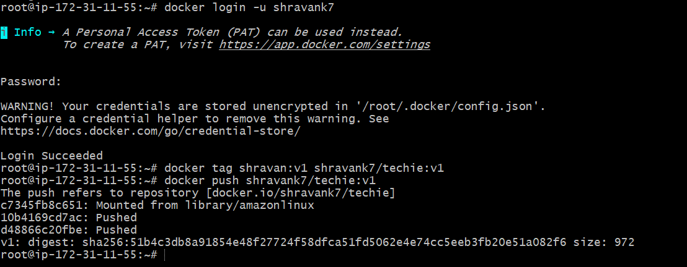
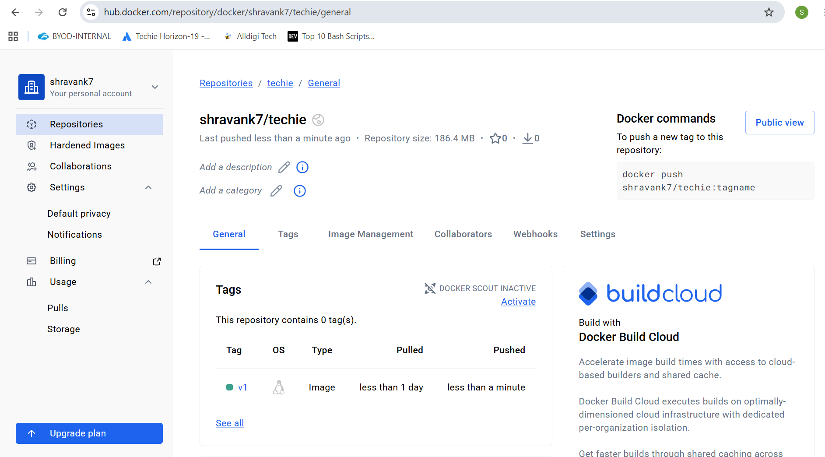
push image to AWS ECR
create a repository in AWS ECR
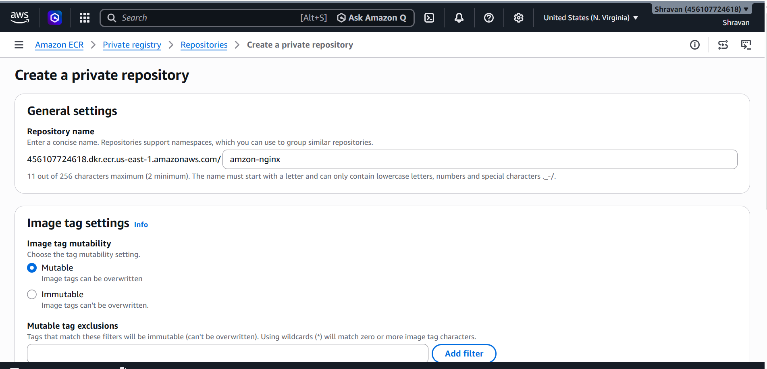
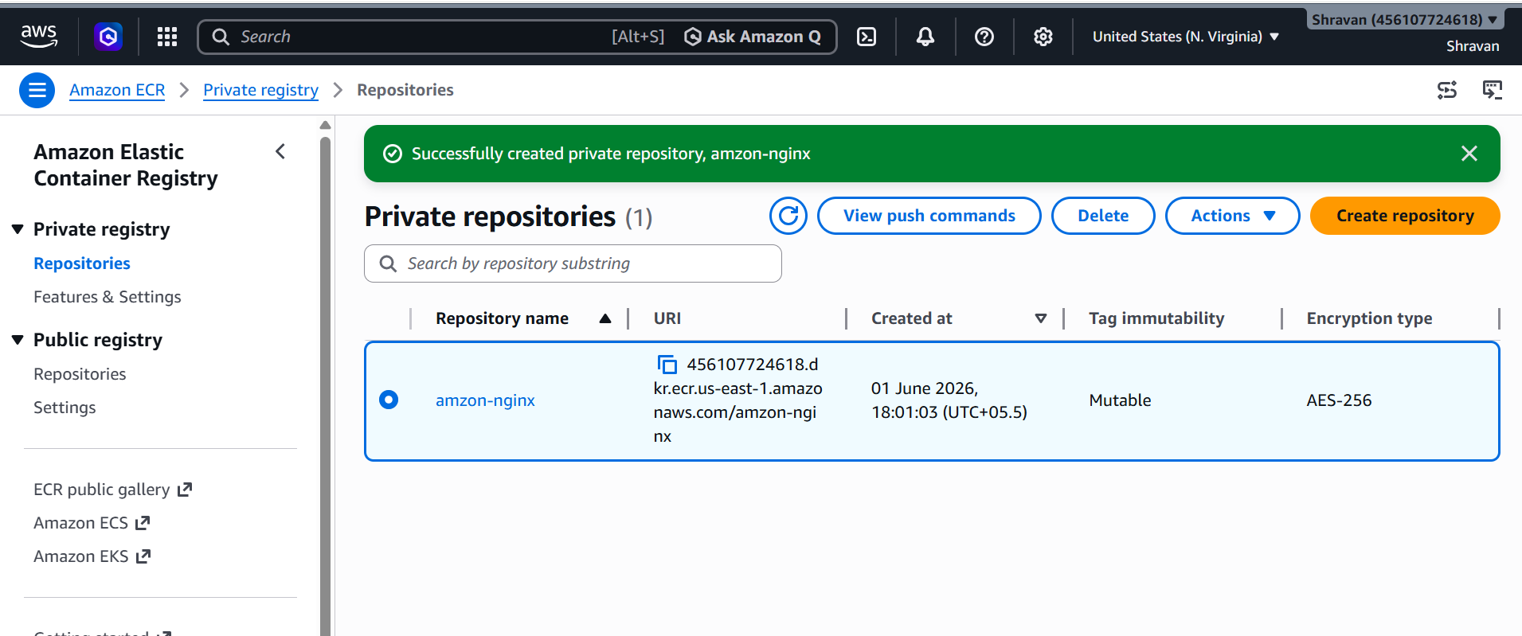
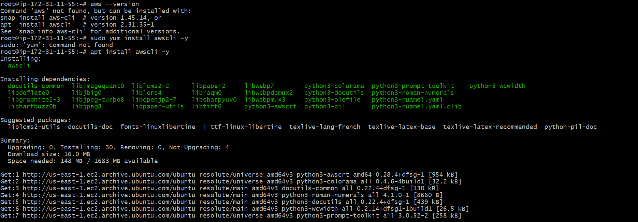
Now aws configure and login cli in aws
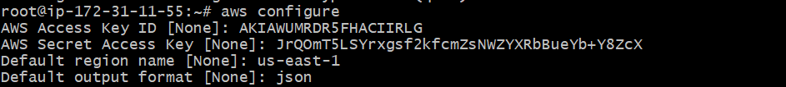
Now login to docker using aws cli
aws ecr get-login-password --region us-east-1 | \
docker login \
--username AWS \
--password-stdin 456107724618.dkr.ecr.us-east-1.amazonaws.com/amzon-nginx
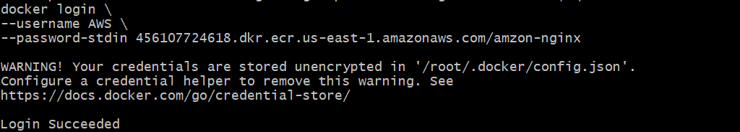
Now docker tag and push to ECR
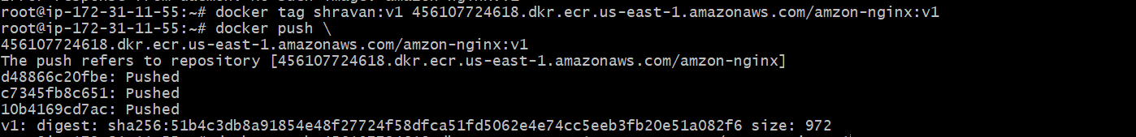
Check in amazon ecr
