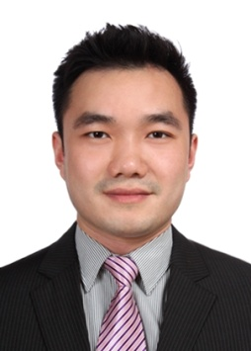

**Alan Wang (王亚闻)**

Add: Room 1703, Building One, 268 Baoshan Road

Jingan District, Shanghai

Tel: (86) 187 2162 0167

Email: [*wangyawen@ccig.com*](mailto:wangyawen@ccig.com)*; alan.wyw@hotmail.com*

**Professional Experience**

**China Capital Investment Group Shanghai, China**

*Senior Investment Manager (Buy-side) May 2015 – Mar 2017*

* Successfully completed investment on ECLA student housing project in France (10 million Euro)
* Executed convertible debt investment for Healdsburg project in the US (10 million USD)
* Executed equity investment for Fusion Resort project in Vietnam (50 million USD)
* Participated in acquisition of Vati nursing home project in Japan (1.2 billion JPY)
* Participated in equity investments on Klook and Lamei Tour vacation and travel related investments
* Responsible for post investment management of Daydream Island Resort in Australia

**Satori Investments Shanghai, China**

*Associate (Sell-side) May 2013 – May 2015*

* Worked on a number of M&A transactions with a combined value of over $5 billion Australian dollars:
  + $1.4 billion joint takeover of Aquila Resources by Baosteel Resources International and Aurizon Holdings
  + Advised ASX listed Sundance Resources on its $4 billion African Iron Ore project
* Performed research and analysis into various industries including mining, infrastructure and Consumer sectors
* Developed and maintained financial models; performed valuations and financial analysis

**Copal Partners Beijing, China**

*Analyst Jun 2011 – Apr 2013*

* Conducted in-depth research and analysis of TMT, real estate, consumer sectors
* Built and updated financial models; performed financial statement analysis
* Undertook industry research and data analysis to determine current and long-term sector trend

**CK Locke & Partners Perth, Australia**

*Research Assistant Nov 2008 – Jun 2011*

**Education**

|  |  |  |
| --- | --- | --- |
| Master of Commerce (Finance & Economics) | **Curtin University, Australia** | *2006 - 2008* |
| Bachelor of Business Administration (Finance) | **Curtin University, Australia** | *2002 - 2006* |

**Additional**

Excellent written and verbal communication skills in Chinese and English

Detailed oriented and highly organized; proven ability to work in a high pressure environment