Approach : Linear Regression

1)Capture the linear relationship between the features and predict the CurrentRPO

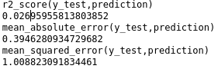

Upon validation, R2 score is low (Closer to 1 is good), mean_squared_error is very high and mean_absolute_error is moderate. Hence the approach is not viable.

2) predict k1 using other feature values k2...km, time t, we can use data from (t - (n-1) to t), n= 1
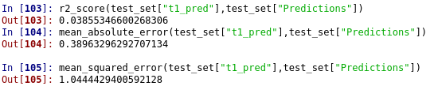

3)
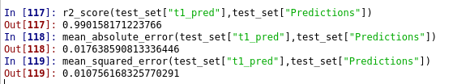

Approach : Support Vector Machines for classification

Use RBF kernel of SVM to classify Anomaly (deviation >0)
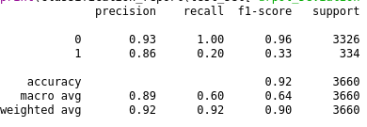

Though accuracy is good, recall is bad. This could be because of imbalance of DataSet. Could try resampling approaches like SMOTE.

Approach : Support Vector Machines for Regression

1)original featuers
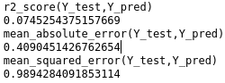

Upon validation, R2 score is low (Closer to 1 is good), mean_squared_error is very high and mean_absolute_error is moderate. Hence the approach is not viable.

2nd approach
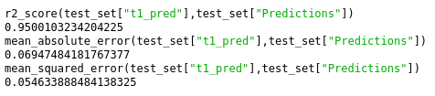

3rd approach

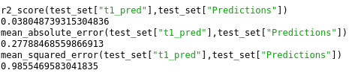

Approach : Random Forest

1) original features
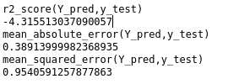

2) Approach 2
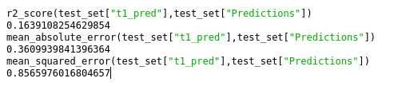

3) Approach 3

