

Foundations of Programming

Assignment No.: 22
Name: Shravasti Ganvir
PRN:1262252031
Division 11
PROBLEM STATEMENT: Write a menu driven program in C to perform various string operations using in-built functions.

OBJECTIVE:

- To understand the concept of strings in the C programming language.
- To learn how to use built-in string functions for string manipulation.
- To perform operations such as length calculation, copying, concatenation, comparison, and reversal using menu options.
.

THEORY:
In the C programming language, a string is a sequence of characters terminated by a null character ('\0'). Strings are stored in character arrays and manipulated using functions available in the string.h header file.
Common built-in string functions include strlen() for finding the length of a string, strcpy() for copying one string to another, strcat() for concatenating two strings, and strcmp() for comparing two strings.
A menu driven program allows the user to select different operations from a list of options. Based on the user’s choice, the corresponding string function is executed. This approach makes the program interactive and easy to use.

PLATFORM: Linux

INPUT:
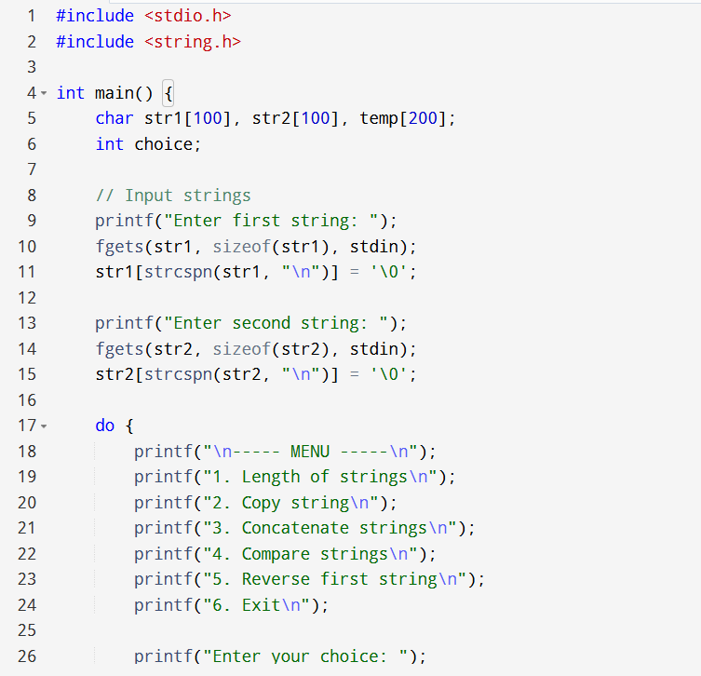
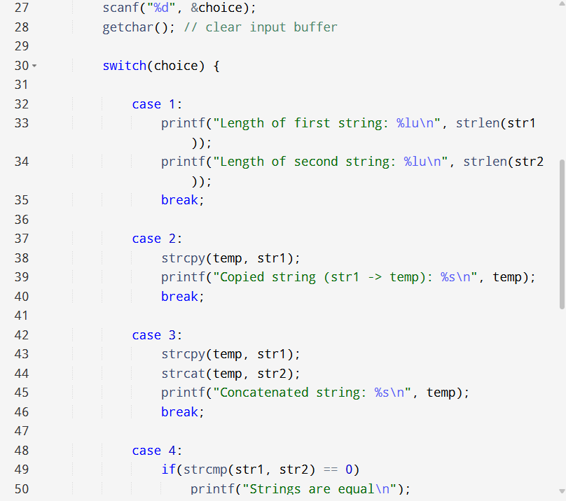
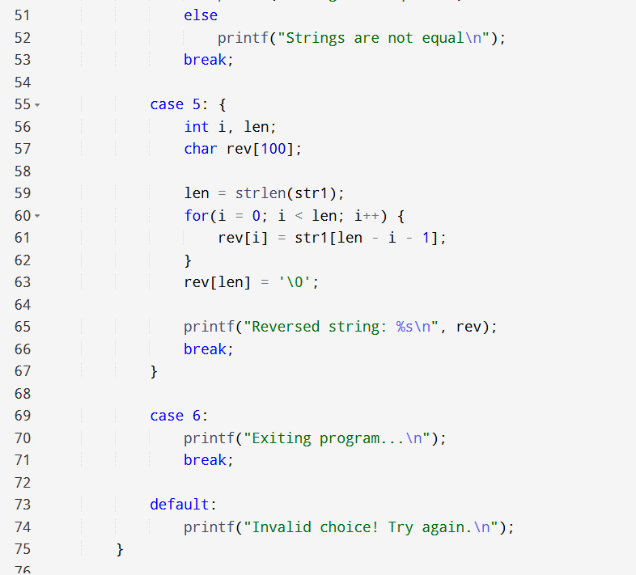
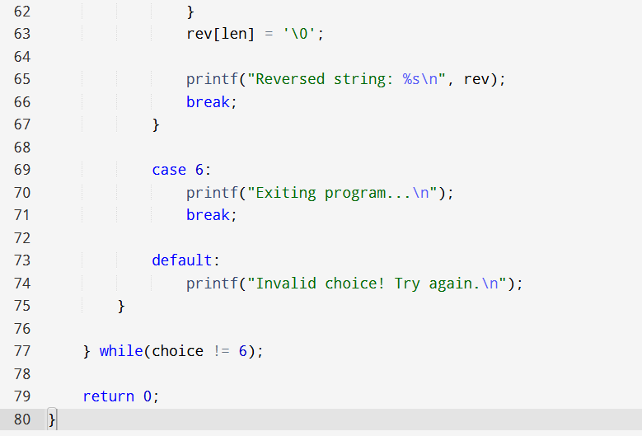

OUTPUT:
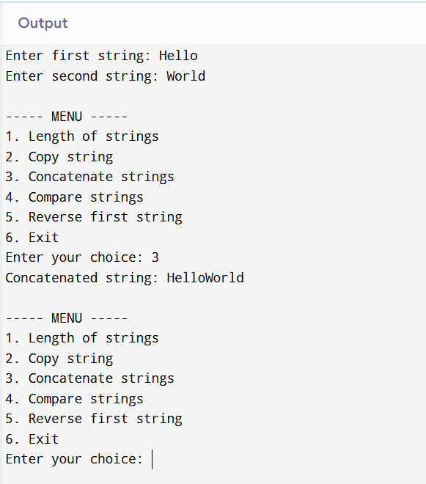

SAMPLE INPUT:
Enter first string: Hello
Enter second string: World
Choice: 3

SAMPLE OUTPUT:
Concatenated string: HelloWorld
CONCLUSION: Thus, the C program successfully demonstrates different string operations using built-in functions through a menu driven approach, making the program interactive and easy to use.

FAQs:
- What are built-in string functions in C and why are they used?
- What is the purpose of the string.h header file in C programs?
- How does a menu driven program improve user interaction in programming?

