

# **DEPARTMENT OF COMPUTER SCIENCE ANDENGINEERING**

**KU/CST/MP/ 2021**

**Light Monitoring for Plants using Bolt**

***A mini project report submitted by***

**KOTA SHRAVAN KUMAR (URK18CS204)**

***in partial fulfillment for the award of the degree of***

**BACHELOR OF TECHNOLOGY**

***in***

**COMPUTER SCIENCE AND ENGINEERING**

***under the supervision of***

**IWIN THANAKUMAR JOSEPH. S, Assistant Professor**



**DEPARTMENT OF COPUTER SCIENCE AND ENGINEERING**

**KARUNYA INSTITUTE OFTECHNOLOGY AND SCIENCE**

(Declared as Deemed to be University -under Sec-3 of the UGC Act, 1956)

**Karunya Nagar, Coimbatore - 641 114. INDIA**

**March 2021**



**DEPARTMENT OF COMPUTER SCIENCE AND ENGINEERING**

**BONAFIDE CERTIFICATE**

This is to certify that the project report entitled, “**Light Monitoring for Plants using Bolt**

”is a bonafide record of Mini Project work done during the even semester of the academic year 2020-2021 by

**KOTA SHRAVAN KUMAR (Reg. No: URK18CS204)**

in partial fulfillment of the requirements for the award of the degree of Bachelor of Technology in Computer Science and Engineering of KarunyaInstitute of Technology and Sciences.

Submitted for the Viva Voce held on _________________

**Project Coordinator Signature of the Guide**

**ACKNOWLEDGEMENT**

First and foremost, I praise and thank ALMIGTHY GOD whose blessings have bestowed in me the will power and confidence to carry out my project.

I am grateful to our beloved founders Late**.Dr. D.G.S. Dhinakaran, C.A.I.I.B, Ph.D** and **Dr. Paul Dhinakaran, M.B.A, Ph.D**, for their love and always remembering us in their prayers.

I extend my thanks to our Vice Chancellor **Dr.P. Mannar Jawahar, Ph.D**and our Registrar **Dr. Elijah Blessing, M.E., Ph.D,**for giving me this opportunity to do the project.

I would like to thank **Dr. Prince Arulraj, M.E., Ph.D.,**Dean, School of Engineering and Technology for his direction and invaluable support to complete the same.

I would like to place my heart-felt thanks and gratitude to**Dr. J. Immanuel John Raja, M.E., Ph.D.,**Head of the Department,Computer Science andEngineering for his encouragement and guidance.

I feel it is a pleasure to be indebted to, **Mr. J. Andrew, M.E, (Ph.D.),** AssistantProfessor, Department of Computer Science and Engineering and **Mr. IWIN THANAKUAMR JOSEPH (guide)** for their invaluable support, advice and encouragement.

I also thank all the staff members of the Department for extending their helping hands to make this project a successful one.

I would also like to thank all my friends and my parents who have prayed and helped me during the project work.

**CONTENTS**

Acknowledgement i

Abstract ii

**1. Introduction 6**

1.1 Introduction

1.2 Objectives

1.3 Motivation

1.4 Overview of the Project

1.5 Chapter wise Summary

**2. Analysis and Design 7**

2.1 Functional Requirements

2.2 Non-Functional Requirements

2.3 Architecture

2.4 Use case diagram

2.5. Sequence Diagram

**3. Implementation** . **10**

3.1. Modules Description 3.2. Implementation Details

3.3. Tools used 3.4. …

**4. Test results/experiments/verification**. **11**

4.1. Testing

4.2. Verification

4.3. Results

**5. Conclusions and Further Scope 19**

**References 20**

.

**ABSTRACT**

**TITLE: Light Monitoring for Plants using Bolt**

> Light Monitoring for Plants using bolt iot.

>keeping the data of values indicating intensity of the light from the garden plants .

>By the data reading ,The garden owner can know the light intensity and can correct the mistakes.

> we will build a system so that we could monitor the light our plants get and send the data to Bolt Cloud. In fact, this product is commercially available

**About :**

* This project is based on the principle that whenever the light falling on the sensor changes, the resistance of sensor changes which is then converted into a change in voltage. The ADC pin on Bolt WiFi Module converted this analog voltage level into digital values which are shown on the graphs.
* We connect the LDR between 5v pin and the analog input pin (A0), so that when light intensity increases, the resistance of LDR decreases so the voltage across the LDR decreases and as a result, the voltage on the analog input pin increases.
* This means that as the **light intensity increases, the voltage on the analog input pin also increases**. The Bolt then converts that the voltage a 10 bit (10 places in binary number system) digital value that varies from 0-1024 (0 to 2 raised to 10).
* Image in pg.10 showes briefly….

**CHAPTER 1**

**INTRODUCTION**

* 1. **Introduction:**
* Light Monitoring for Plants using bolt iot.
* we will build a system so that we could monitor the light our plants get and send the data to Bolt Cloud. In fact, this product is commercially available
* we will be able to collect the values indicating intensity the of the light and plot them over a line graph.

**Objectives:**

>Our objective is to read the data of the light required of monitoring plant by using sensor.

>To control the parameter based on the data by using bolt Iot bolt wifi Module.

>Ensure that the minimum amount of light that required for plant from environment .

* 1. **Motivation:**
* Due to insufficient sunlight the plant cannot make sufficient food ,

So there will problems in the growth of plant.

* 1. **Overview of the Project:**

**>**We all know that plants require sunlight for their healthy growth. However, at times we may not be able to keep a track of it or maybe we are not sure if our plants are getting enough sunlight.

**>**If the plant get’s the insufficient light ,there will be problem in photosysthesis reaction

**>**we will build a system so that we could monitor the light our plants get and send the data to Bolt Cloud.

**>**we will be able to collect the values indicating intensity the of the light

**CHAPTER 2**

**ANALYSIS AND DESIGN**

**2.1 Functional Requirements:**

* Hardware Components
* Bolt IoT Bolt WiFi Module
* Light Dependent Resistor
* Resistor 10k ohm
* Bolt IoT Bolt Cloud(online service)

.

**2.2 Non-Functional Requirements:**

.

* BOLT IOT cloud (online services)

**2.3 Architecture:**

* Bolt module is taken
* LDR (Light Dependent Resistor) is connected to the bolt module.
* Resistor 10kohm is added to the same module.
* Connected to bolt online server
* Perform according to the algorithm in the bolt sever .
* Data has been collected .
* Graph’s has been displayed .

**2.4 Diagram:**

**BOLT MODEL:**

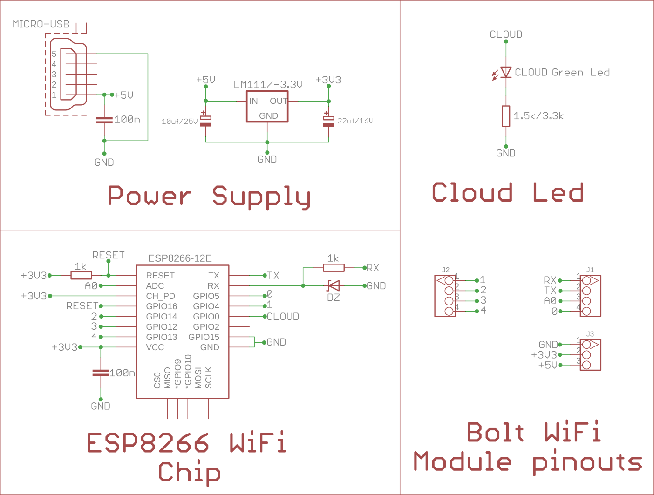

**2.5 Sequence Diagram:**

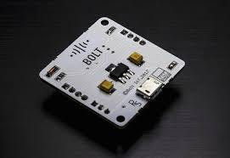

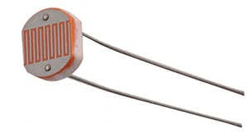 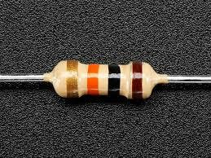

**CHAPTER 3**

**IMPLEMENTATION**

**3.1 Modules Description:**

* **Input : Make sure you have not powered on your Bolt Module while connecting the circuit. This will ensure that in case we make any mistake, it will not short circuit your device. Switch off the power if it is connected.**
* **Connect one end of the LDR to the A0 (analog) pin of the Bolt device and other ends of the LDR to the 5V pin of the Bolt as shown in the image below.**
* **Connect the 10K ohm resistor between the GND and A0 pin of the Bolt so that LDR and the resistor form a series connection. To see the image for this, click on the > arrow on the image below.**

**Output:**

* The data collected by the sensor of the bolt cloud has shown in graph.

**3.2 Implementation Details:**

* This project is based on the principle that whenever the light falling on the sensor changes, the resistance of sensor changes which is then converted into a change in voltage. The ADC pin on Bolt WiFi Module converted this analog voltage level into digital values which are shown on the graphs.
* We connect the LDR between 5v pin and the analog input pin (A0), so that when light intensity increases, the resistance of LDR decreases so the voltage across the LDR decreases and as a result, the voltage on the analog input pin increases.
* This means that as the **light intensity increases, the voltage on the analog input pin also increases**. The Bolt then converts that the voltage a 10 bit (10 places in binary number system) digital value that varies from 0-1024 (0 to 2 raised to 10).

**3.3 Tools Used:**

* Bolt cloud
* LDR
* JavaScript
* Resistor 10k

**CHAPTER 4**

**TEST RESULTS/VERIFICATION/RESULTS**

**4.1 Verification:**

* User can verify his garden plat data were the plant data has sufficient sunlight.
* He can also verify his output light intensity to the environment.

**4.3 Results:**

**Input:** 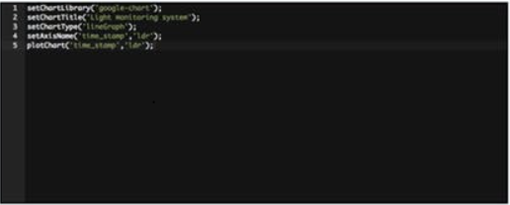

**Output :**

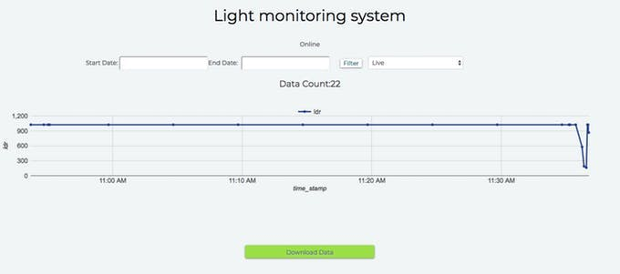

**ABOUT INDUSTRY:**

Karunya Institute of Technology and Sciences, was founded with the noble vision to raise professionals and leaders of high academic calibre and unblemished character, nurtured with a strong motivation and commitment to serve humanity. The institution is the fulfillment of the vision of its founders Late Dr. D. G. S. Dhinakaran and the present Chancellor Dr. Paul Dhinakaran. Established in 1986 as an Engineering College, it was granted an autonomous status in 2000 and declared Deemed-to-be University by the University Grants Commission (UGC) in recognition of its academic excellence by the Ministry of Human Resources Development under section 3 of the UGC Act, 1956 vide notification no 9-3-2000-U3 dated 23.6.2004 of the Government of India. Accredited by NAAC, the institution offers a wide array of Bachelors, Masters and Doctoral Degree programmes in various branches of Engineering, Biotechnology, Food processing and Agricultural Sciences. From a humble beginning of 180 students, the institution has rapidly grown to 8491 students and 452 faculty representing 18 academic departments.

The Karunya Emblem has a human face to indicate that the well-being of humanity is central to our entire endeavors and that we shall never forget them in the midst of our equations and diagrams. The symbol has a gear wheel as the human eye, in appreciation of the importance of technology in today’s world. The lighted torch stands for the light of knowledge, the light that promises moral, social and economic well-being; The hand holding the torch depicts Karunya’s contribution towards enlightening the young minds by spreading knowledge through education. The motto ‘ARISE AND SHINE’ is a motivation to the youth to shine in their respective fields of study. To sum up, Karunya’s emblem reflects the institution's mission in creation and dissemination of knowledge, value addition to men and materials and optimization of human potential for national development in all its ramifications for a bright future.

The university library is stocked with 78191 books, 221 international and national journals and online access to several journals through Science Direct, IEEE Journals, J-Gate and Ebsco, 3300 CDs. The campus also has auditoria, extracurricular clubs, book store, gymnasiums, water recycling plant, restaurant and canteens. The other campus amenities include bank counter, post office, BSNL Telephone Exchange, hospital, police station, guest house, music club, guest house, indoor sports hall and extensive playgrounds. There is also the Karunya Residential International School and Karunya Matriculation Higher Secondary School within the campus. The university computer centre houses 1757 computers and offers 100 Mbps LAN with exhaustive software support provided with 15 kms of fibre optic backbone, there are internet centres in hostels enabled through 100 Mbps connectivity and 1 Gbps, 700 phone connections, five mobile phone towers and power backup using diesel-bio-diesel generators (1450 KVA).

Karunya University is accredited by the NAAC with Grade A and all technical programmes conform to prescribed norms of the AICTE (Govt. of India). Karunya University boasts 72 MoUs with reputed institutions across the globe with focus on fields relating to thermal management, nanotechnology, and renewable energy. The research projects are funded by the government.

**VISION:**

True to its name Karunya which means Compassion, it shall be a university with a social concern which will address the problems of humanity through teaching, research and extension in socially relevant areas.

The students and faculty of Karunya University will be imbibed with spiritual discernment and a zeal to serve humanity and to eventually become leaders of society.

**MISSION:**

To raise undergraduate and post graduate students and research scholars to serve humanity by attaining high levels of academic excellence, professional competence, exemplary values and spiritual empowerment.

To find solutions to human problems in areas relating to Water, Food, Health Care and Energy through scientific, social and technological research as well as policy formulation.

To set up care homes for physically and mentally challenged as well as the elderlyand the terminally ill to enable the students to understand the human needs and pain, by participating in the services rendered to them on campus and thus to dedicate themselves to work towards solving those problems through research, development, policy making at high levels or through providing spiritual care.

**ORGANIZATIONAL CHART:**

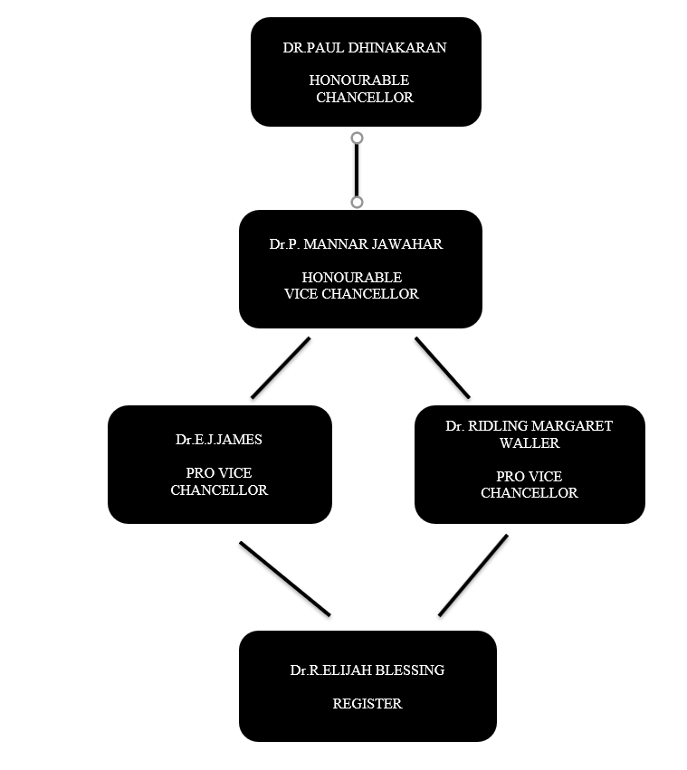

**CHAPTER 5**

**CONCLUSIONS AND FURTHER SCOPE**

**5.1 Conclusions:**

* Bolt cloud ,this tool generated the data from the monitored plant
* By collecting the values indicating intensity by the bolt cloud that plot over a line graph
* The owner of the plant can know the weather the sunlight is sufficient for his the gardening plants.

**5.2 FURTHER SCOPE:**

* Adding a alert system by the online services.
* Building a smart garden and alert system

**REFERENCES:**

**Wikipedia:**

<https://en.everybodywiki.com/BOLT_IOT_Platform>

**Websites:**

[1] <https://www.boltiot.com/>

2]<https://www.w3schools.com/js/DEFAULT.asp>