

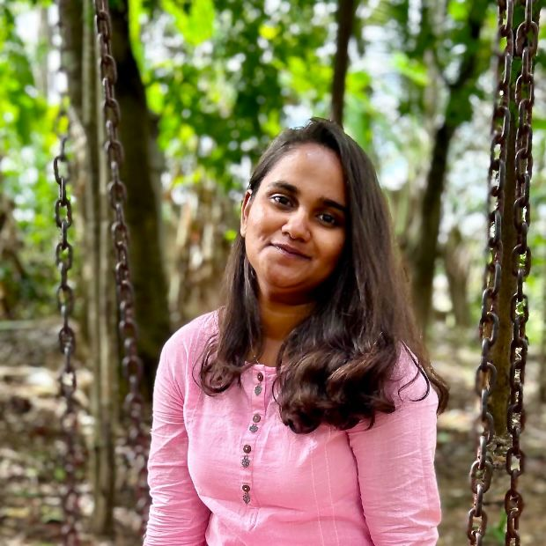

Affix your photo

|  |  |  |
| --- | --- | --- |
| **Name** | **:** | Sinchana Raj G |
| **Phone Number** | **:** | 7411211166 |
| **Email-Id** | **:** | [sinchanaraj18@gmail.com](mailto:sinchanaraj18@gmail.com) |
| **LinkedIn Profile** | **:** |  |
| **GitHub URL** | **:** |  |

# CAREER OBJECTIVE

# EDUCATION

|  |  |  |  |
| --- | --- | --- | --- |
| **Course Studied** | **Name of the Institution / University** | **Percentage/ CGPA** | **Year of Completion** |
| **B.E.** | Malnad College Of Engineering |  |  |
| **Computer Science and Engineering** |
| **12th** | Gnana Jyothi School & PU College | 97,3 | 2022 |
| **10th** | Gnana Jyothi School & PU College | 91 | 2020 |

**CERTIFICATION**

|  |  |  |
| --- | --- | --- |
| **Course Title** | **Certifier** | **Year** |
|  |  |  |
|  |  |  |
|  |  |  |
|  |  |  |
|  |  |  |
|  |  |  |

# INTERNSHIP

|  |  |  |
| --- | --- | --- |
| **Company Name** | **Duration** | **Details** |
|  |  |  |

**PROJECTS**

|  |  |  |
| --- | --- | --- |
| **Title** | **Year** | **Details** |
|  |  |  |
|  |  |  |
|  |  |  |

# TECHNICAL SKILL PROFICIENCY

|  |  |
| --- | --- |
| **Operating Systems** |  |
| **Programming Languages** | Python, C |
| **Application Packages** |  |
| **Others (Tools)** |  |

**ACADEMIC ACHIEVEMENTS**

# VOLUNTARY ACTIVITIES

# EXTRA CURRICULAR ACTIVITIES

# PERSONAL DETAILS

|  |  |  |
| --- | --- | --- |
| **Date of Birth & Age** | **:** | 29.10.2004 (20 yrs) |
| **Gender** | **:** | Female |
| **Father’s Name** | **:** | Rajappa G S |
| **Permanent Address** | **:** | Gangasamudra,Holalkere(Tq),Chitradurga |
| **Languages Known** | **:** | Kannada , English , Hindi |
| **Date of Joining** | **:** |  |

**Date:**

**Signature: Place: Hassan**