Property and Rental Management System
Team Leader:
Bhuvan Kumar Chennoju
Team members:
Shravya Sri Kanchi, Lakshmi Manjusha Namburi, Hemanth Sairam Bandi.
Story of the project:
Apartments are used as a place of residence by a person, family or household. Rooms in apartments can be rented for short-term occupancy by paying owners at any time. It gets challenging for an individual to locate an apartment in his desired location and at his desired price, inquire about the details, and complete the application process. Our system has taken into consideration this issue and resolved it in a timely manner.
Property and rental management systems can help collect all the data to make a digital transition. The increase in digitalization has led to everything moving towards data driven solutions to solve everyday problems.What tasks does this application help with? - Collecting We will help in trouble free user to tenant lease transfers and in managing operations smoothly by tracking and managing property information, providing billing and accounting details to all parties, and listing all vacant units.
Moreover, the data collected by this application could be used to develop a machine learning model that will suggest the apartments based on the user's inputs and searches. Though this is not in the scope of the project, we would like to highlight this as an additional usage.
The Data :
The data required for this application is basically divided in to two categories that are described below:
- Data About Property :
- Price : The data about the value of different kinds of properties.
- Area : The data about the dimensions of the respective properties that are present in the application.
- Bedrooms : The data about the number of bedrooms and bathrooms available in each property.
- Availability : The data about whether or not a certain property is available to rent.
- Safety & Tenant Friendly : The data about neighborhood whether or not it’s safe.
- Location : The data about the location of the property.
2. Data About Tenant :
- Name : The first name and last name of the tenant.
- Age : The age of the tenant.
- Contact : The Mobile number or phone number of the tenant.
- Email Id : The email id of the tenant.
- Address : The current/permanent address of the tenant.
- Rent Details : The leasing and rent details of the property the tenant chooses.

Working screens from project :

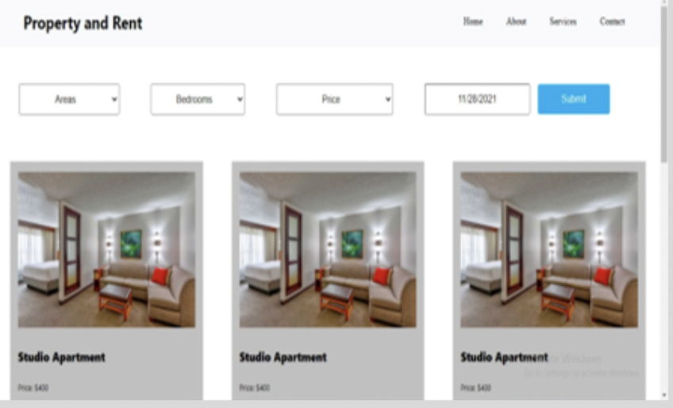
- Home Page :

2. Property description and Interest form :
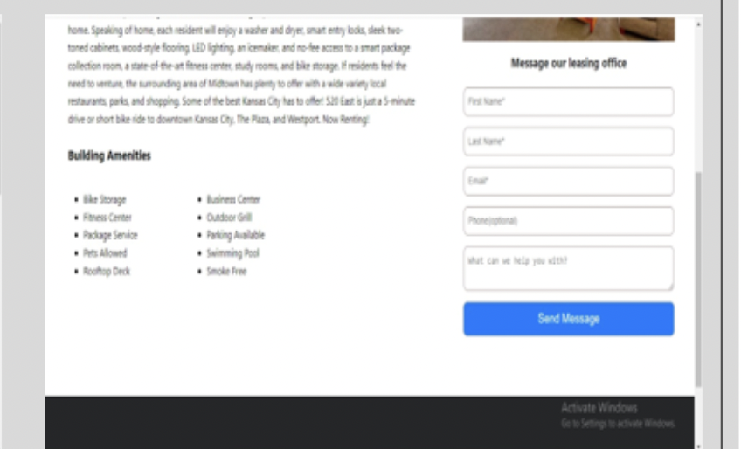

3. Property Details & Contact form :
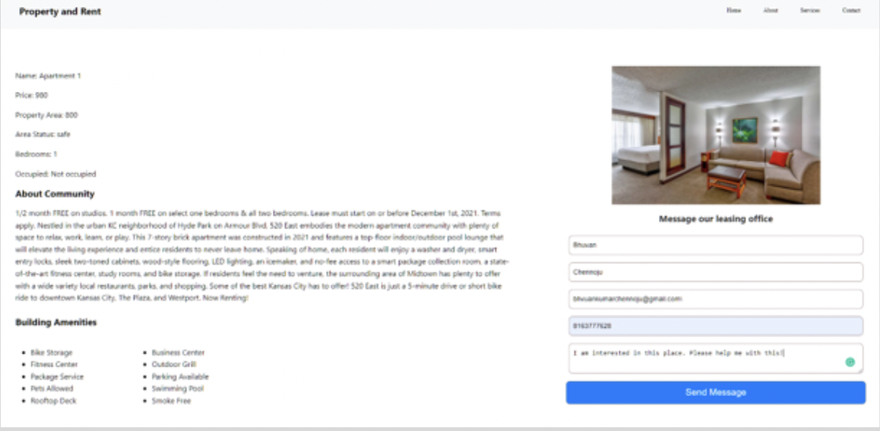

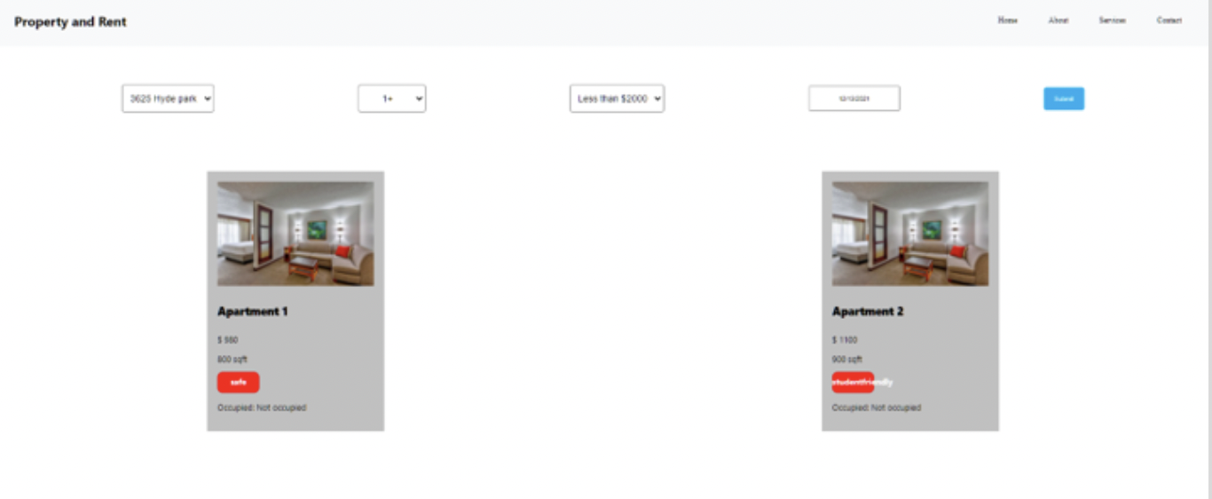
4. Property Listing on Website :

5. User & Admin Accesses :
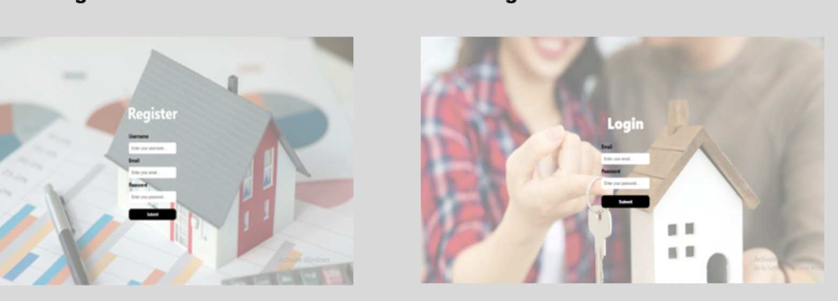

6. Administrative Dashboard :
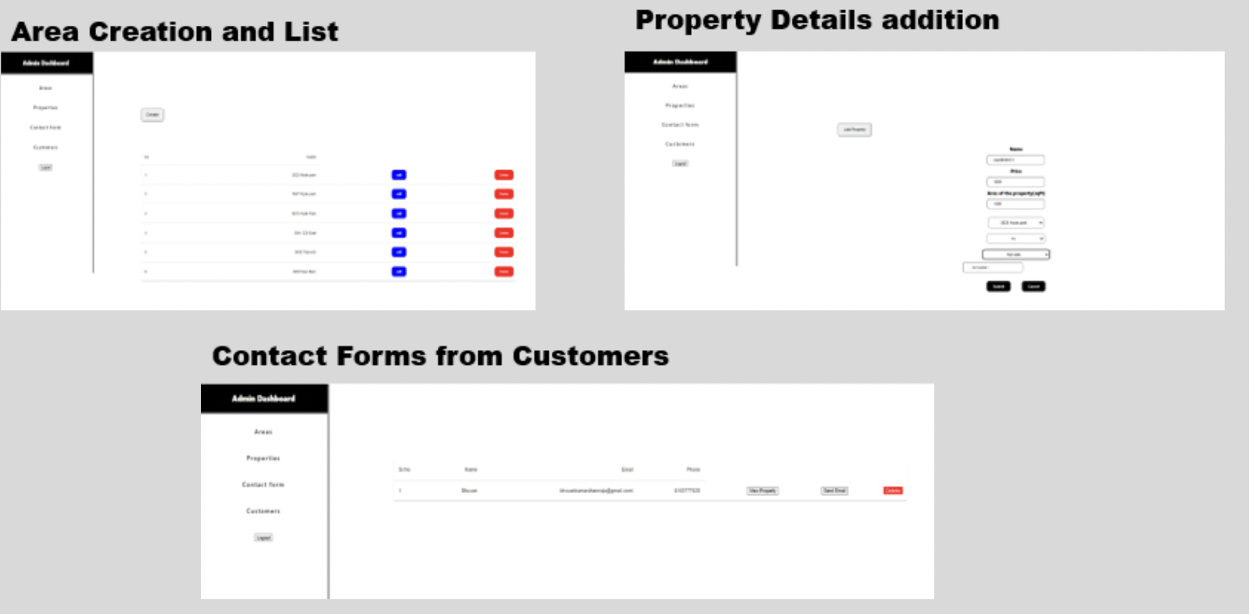

Improvement from the previous increment :

Important code snippets from the project :

Work sharing/Module sharing between teammates :

- Admin Work : Bhuvan Kumar Chennoju
- Front End : Shravya Sri Kanchi
- Integration & Testing : Lakshmi Manjusha Namburi
- Customer login & Data collection : Hemanth Sai Bandi

Any issues, blockages with the project :

    - Attempted to automate the data filling with the API’s but unable to get the accurate data required for the application.
    - Haven’t build different webpages for all the components of the website.

GitHub link for your project :

https://github.com/bhuvan454/Web_and_mobile/edit/master/Project
Video link for your project :

Presentation link for your project :

References :

Mac properties : http://macproperties.com/
Kaggle : https://www.kaggle.com/
Data : https://www.data.gov/
Airbnb : https://www.airbnb.com/

