VITyarthi – Build Your Own Project

PROJECT REPORT
SPAM MESSAGE DETECTOR SYSTEM

Submitted By: Shravya Mishra
Register Number: 26BCE10259
Course: Introduction to Problem Solving and Programming
Subject: CS
Faculty: Dr. J. Manikandan
Academic Year: 2026

Contents
1. Introduction
2. Problem Statement
3. Objectives and Scope
4. Functional Requirements
5. Non-Functional Requirements
6. System Architecture
7. Design Diagrams
8. Design Decisions & Rationale
9. Implementation Details
10. Screenshots / Results
11. Testing Approach
12. Challenges and Implementation Considerations
13. Learnings & Key Takeaways
14. Future Enhancements
15. References
1. Introduction
With the rapid growth of mobile communication and instant messaging, people receive a large number of SMS messages every day. While many of these messages are useful or personal, users also receive unwanted messages such as advertisements, fraudulent offers, fake rewards, suspicious links, and other misleading content. These unwanted messages are generally known as spam messages.
Identifying spam messages manually can be difficult and time-consuming, especially when a person receives a large number of messages. To solve this problem, an automated system can be used to classify messages as either spam or legitimate, helping users identify unwanted messages more quickly.
The Spam Message Detector System is a machine learning-based application designed to classify SMS messages into two categories: Spam and Not Spam (Ham). The system first preprocesses the text messages and then uses TF-IDF (Term Frequency–Inverse Document Frequency) to convert the text into numerical features. These features are then provided to a Multinomial Naive Bayes classification algorithm, which predicts whether a message is spam or not.
For training and testing the system, the SMS Spam Collection dataset was used. It contains 5,574 SMS messages, which were divided into training and testing sets using an 80:20 split. The model achieved an accuracy of 96.86%, precision of 100.00%, recall of 76.51%, and an F1-score of 86.69%. From the confusion matrix, 966 legitimate messages were correctly identified and 114 spam messages were correctly detected. There were 35 spam messages that were classified as legitimate, while none of the legitimate messages were incorrectly classified as spam.
The application was developed using Python and includes a simple Streamlit-based user interface. Users can enter an SMS message and receive a prediction along with a confidence score. For example, during testing, the message “Congratulations! You have won a free prize. Click now to claim.” was classified as SPAM with a confidence of 95.70%.
Overall, this project shows how machine learning and natural language processing can be used to solve a practical problem involving text classification. It also provided practical experience in areas such as dataset preparation, text preprocessing, feature extraction, model training, evaluation, application development, validation, and software testing.

2. Problem Statement
The increasing use of mobile phones and SMS communication means that people receive many messages every day. While some of these messages are useful, others may be unwanted spam messages containing advertisements, promotional offers, fraudulent messages, fake rewards, or suspicious links. Checking each message manually can be time-consuming and may not always give consistent results.
The main problem addressed by this project is the automatic detection and classification of SMS messages as Spam or Not Spam (Ham). An automated system is needed that can analyze the content of a message and identify its category without requiring the user to check every message manually.
To solve this problem, the project develops a machine learning-based Spam Message Detector System using the SMS Spam Collection dataset. The system first preprocesses the text messages and then converts them into numerical features using TF-IDF vectorization. These features are passed to a Multinomial Naive Bayes classification model, which predicts whether a message is spam or not.
The system provides a simple interface where users can enter an SMS message and receive:
- A classification as SPAM or NOT SPAM
- A confidence percentage for the prediction
- A descriptive result explaining the classification
- A temporary history of previous predictions
The performance of the system is measured using accuracy, precision, recall, F1-score, and a confusion matrix. In the current implementation, the model achieved 96.86% accuracy, 100.00% precision, 76.51% recall, and an 86.69% F1-score on the test dataset.
The main objective of the project is to demonstrate a practical and user-friendly way of detecting unwanted SMS messages using machine learning and text-processing techniques.

3. Functional Requirements
Functional requirements describe the main operations and features that the Spam Message Detector System should provide.
FR1. Enter SMS Message
The system shall provide a text input area where the user can enter or paste an SMS message for analysis.
FR2. Validate Input
The system shall check the entered message before processing it. It should identify invalid inputs such as:
- Empty messages
- Messages that are too short
- Messages that exceed the maximum allowed length
- Non-text input
FR3. Preprocess Message
The system shall preprocess the entered message before sending it to the classification model. The preprocessing includes:
- Converting the text to lowercase
- Removing URLs
- Removing email addresses
- Removing special characters
- Removing unnecessary whitespace
FR4. Convert Text into Numerical Features
The system shall use TF-IDF (Term Frequency–Inverse Document Frequency) vectorization to convert the processed text into numerical features that can be used by the machine learning model.
FR5. Classify Message
The system shall use the trained Multinomial Naive Bayes model to classify the message into one of two categories:
- SPAM
- NOT SPAM (HAM)
FR6. Display Prediction
After processing the message, the system shall clearly display the predicted classification to the user.
FR7. Display Confidence Score
The system shall display a confidence percentage associated with the prediction.
FR8. Maintain Prediction History
The system shall temporarily maintain a history of predictions made during the current application session. The history includes:
- Original message
- Prediction
- Confidence score
- Prediction time
FR9. Clear Prediction History
The system shall provide an option for the user to clear the stored prediction history.
FR10. Handle Errors
The system shall display appropriate warning or error messages when invalid input is provided or when an error occurs during prediction.
FR11. Train Machine Learning Model
The system shall support training the classification model using the SMS Spam Collection dataset. The trained model and TF-IDF vectorizer shall be saved so they can be used later for predictions.
FR12. Evaluate Model
The system shall support evaluation of the trained model using the following measures:
- Accuracy
- Precision
- Recall
- F1-score
- Confusion matrix
FR13. Automated Testing
The system shall include automated tests for important components of the application, including text preprocessing, dataset loading, message prediction, and input validation.

4. Non-Functional Requirements
Non-functional requirements describe the quality, performance, and other characteristics that the Spam Message Detector System should provide.
NFR1. Performance
The system should process an SMS message and provide a prediction within a short amount of time so that the application remains responsive.
NFR2. Accuracy
The machine learning model should provide reliable classification results. In the current evaluation, the system achieved 96.86% accuracy on the test dataset.
NFR3. Usability
The application should have a simple and user-friendly interface. Users should be able to enter a message and view the prediction without needing any technical knowledge.
NFR4. Reliability
The system should consistently provide predictions for valid text inputs and handle invalid inputs without causing the application to crash.
NFR5. Maintainability
The project should be organized into separate modules for tasks such as preprocessing, dataset loading, model training, prediction, validation, utilities, history management, and evaluation. This makes the project easier to understand, modify, and maintain.
NFR6. Scalability
The system should allow the dataset and machine learning model to be updated or retrained when additional SMS data becomes available.
NFR7. Security
The system should validate user input before processing it and should not execute user-provided text as code or commands.
NFR8. Portability
The application should be able to run on systems that support Python and the required project dependencies. The Streamlit interface allows users to interact with the application through a web browser.
NFR9. Testability
The system should be testable using automated unit tests. The project includes tests for preprocessing, dataset loading, prediction, and input validation.
NFR10. Documentation
The project should include sufficient documentation explaining its purpose, requirements, system architecture, machine learning approach, implementation, testing, and usage. This documentation should make it easier for users and developers to understand and work with the system.

5. System Architecture
The Spam Message Detector System follows a modular machine learning architecture. The main components of the system include the user interface, input validation, text preprocessing, TF-IDF feature extraction, the trained Multinomial Naive Bayes model, prediction processing, and result display.
The overall process starts when the user enters an SMS message through the Streamlit user interface. The message is first checked by the validation component to make sure that it is suitable for processing. After validation, the message is passed to the preprocessing module, where unnecessary elements such as URLs, email addresses, special characters, and extra whitespace are removed.
The cleaned message is then converted into numerical features using the TF-IDF vectorizer. These features are passed to the trained Multinomial Naive Bayes model, which predicts whether the message is SPAM or NOT SPAM.
Finally, the prediction and its confidence score are displayed through the Streamlit interface. The prediction can also be temporarily stored in the application's history so that the user can view previous predictions during the current session.
The system also contains separate components for dataset loading, model training, evaluation, and automated testing. This modular structure makes the project easier to develop, test, maintain, and update.

The overall architecture of the system is shown below:

5.1 Architecture Components
1. User Interface Layer
The user interacts with the application through a Streamlit web interface. The user can enter an SMS message in the provided text area and click the Check Message button to start the analysis.
2. Validation Layer
The validation module checks whether the entered message is suitable for processing. It prevents inputs such as empty messages, messages that are too short, or messages that exceed the allowed length from being processed.
3. Preprocessing Layer
The preprocessing module prepares the message for classification. It converts the text to lowercase and removes unnecessary elements such as URLs, email addresses, special characters, and extra whitespace.
4. Feature Extraction Layer
After preprocessing, the cleaned message is converted into numerical features using TF-IDF (Term Frequency–Inverse Document Frequency) Vectorization. The trained TF-IDF vectorizer is saved in models/tfidf_vectorizer.pkl and is used to transform new messages before prediction.
5. Machine Learning Layer
The numerical features generated by the TF-IDF vectorizer are passed to the trained Multinomial Naive Bayes classifier. The trained classification model is stored in models/spam_model.pkl.
6. Prediction Layer
The prediction module uses the trained model to determine whether the message is Spam or Not Spam. It also calculates the confidence percentage associated with the prediction.
7. Presentation and History Layer
The prediction result and confidence score are displayed to the user through the Streamlit interface. The application also temporarily stores previous predictions in its history during the current session. This allows the user to review messages that have already been checked and clear the history when required.

5.2 Model Training Architecture
The training process is separate from the prediction process:
This modular architecture separates the user interface, validation, preprocessing, machine learning, prediction, and evaluation components. As a result, individual components can be tested and modified without significantly affecting the other parts of the system.
6. Design Diagrams
The design diagrams provide a visual representation of the structure, workflow, interactions, and components of the Spam Message Detector System. The following diagrams are included in the project documentation.
6.1 Use Case Diagram
The Use Case Diagram represents the interactions between the user and the Spam Message Detector System.
The main user activities include:
- Entering an SMS message
- Checking the message
- Viewing the spam/not-spam prediction
- Viewing the confidence score
- Viewing prediction history
- Clearing prediction history
Figure 6.1: Use Case Diagram
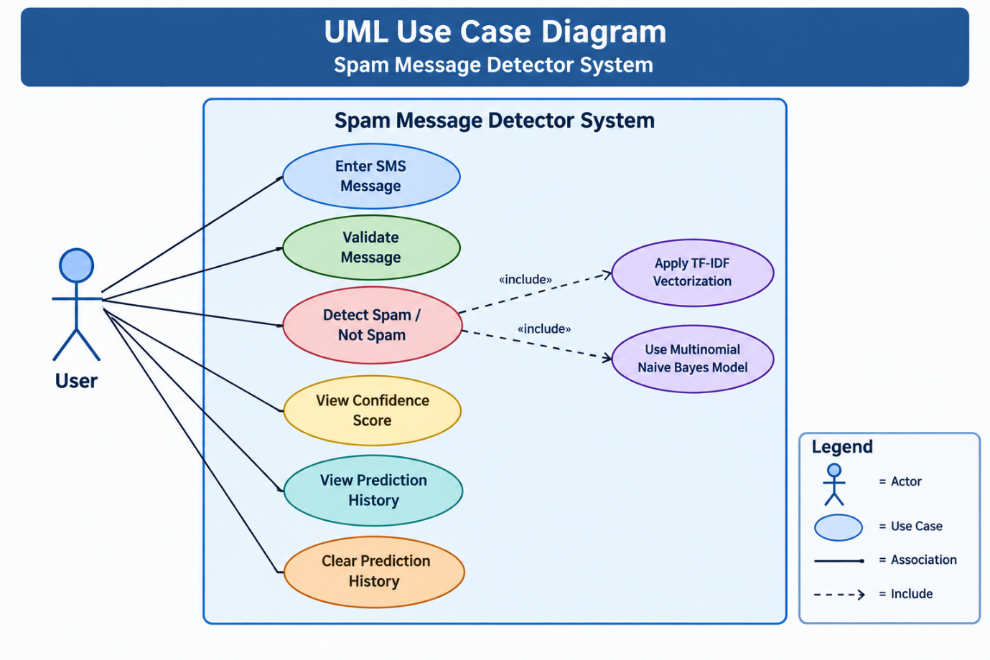

6.2 Workflow Diagram
The Workflow Diagram represents the sequence of processing steps performed by the system from receiving an SMS message to displaying the final prediction.
The workflow is:

Figure 6.2: Workflow / Process Flow Diagram
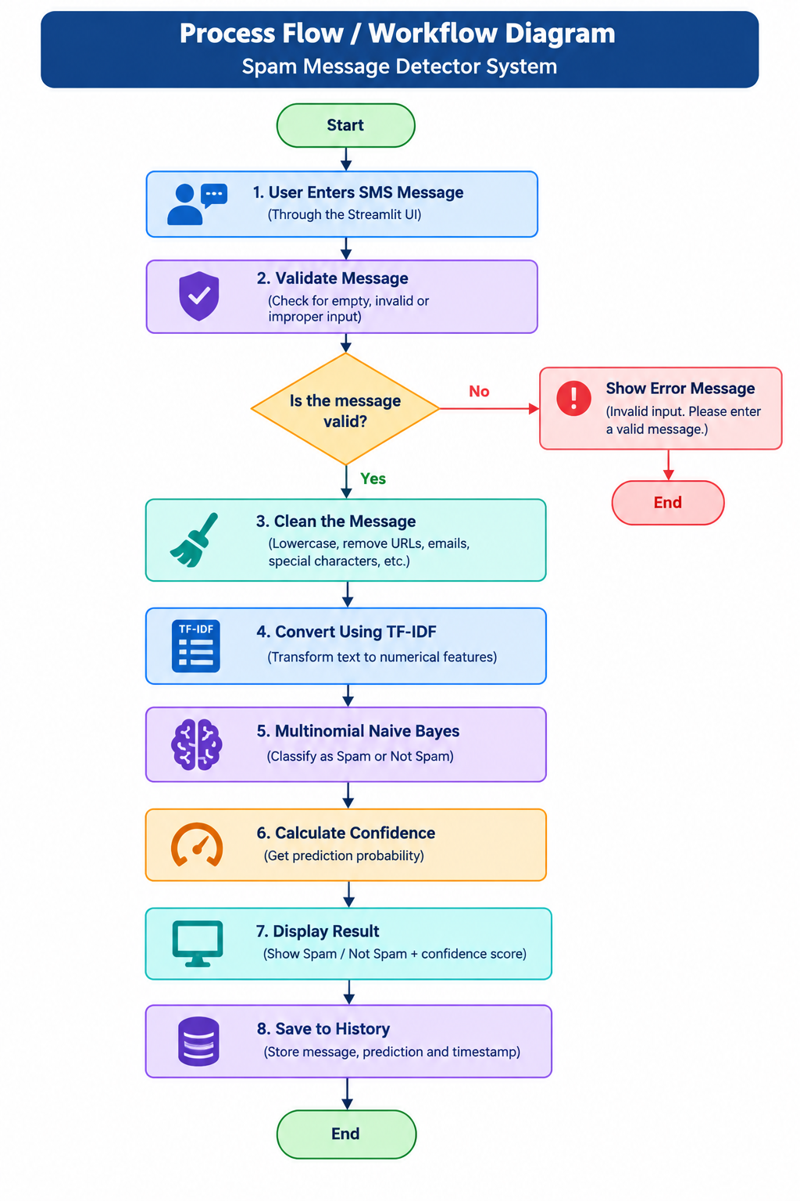
6.3 Sequence Diagram
The Sequence Diagram shows the interaction between the user, Streamlit application, validation module, preprocessing module, prediction module, and machine learning model.
The sequence of operations is:
- The user enters an SMS message.
- The application receives the message.
- The validation module checks the input.
- The message is sent to the preprocessing module.
- The cleaned message is converted into TF-IDF features.
- The trained Multinomial Naive Bayes model performs classification.
- The prediction and confidence score are returned.
- The application displays the result to the user.
- The prediction is added to the temporary history.
Figure 6.3: UML Sequence Diagram
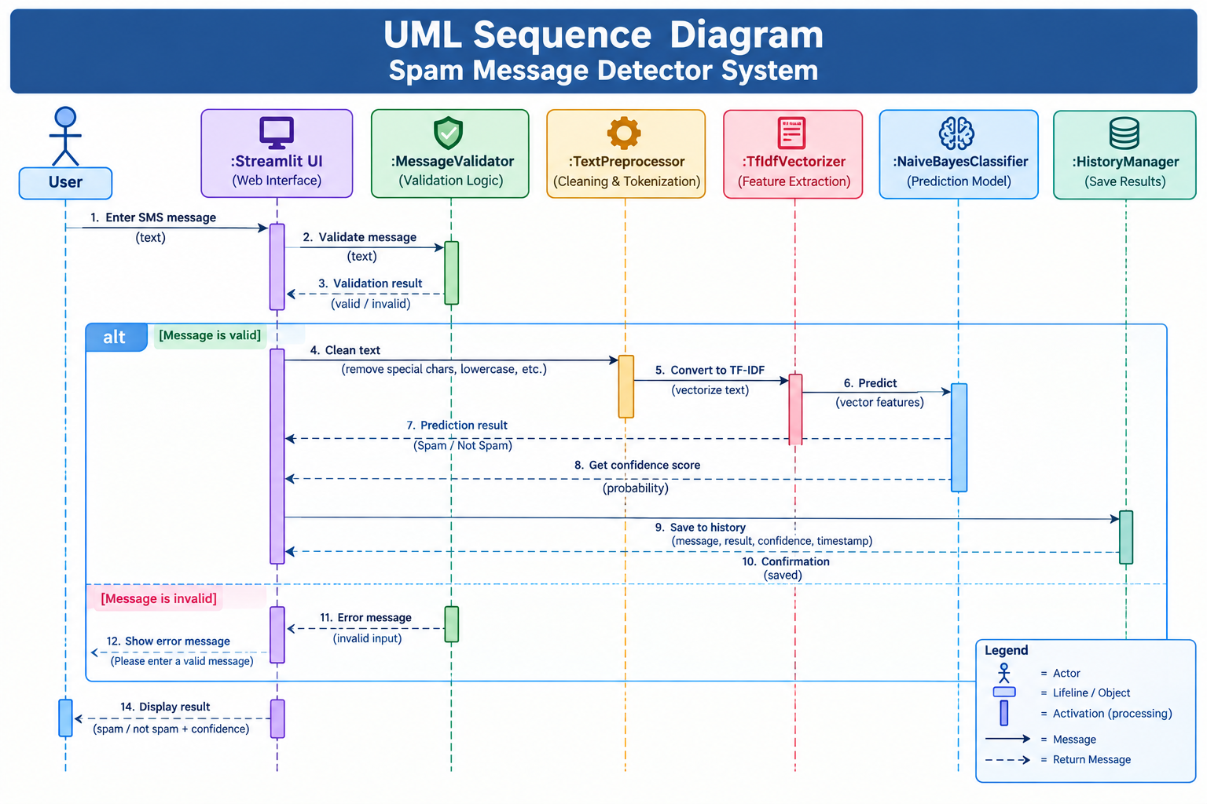

6.4 Class / Component Diagram
The Class/Component Diagram represents the major software modules used in the project and their relationships.
The main components include:
- app.py – Streamlit user interface
- validation.py – Input validation
- preprocessing.py – Text cleaning
- predictor.py – Prediction functionality
- utils.py – Result formatting
- history.py – Prediction history management
- dataset_loader.py – Dataset loading and preparation
- train_model.py – Model training
- evaluation.py – Model evaluation
These components work together to provide the complete spam detection functionality.
Figure 6.4: UML Class / Component Diagram
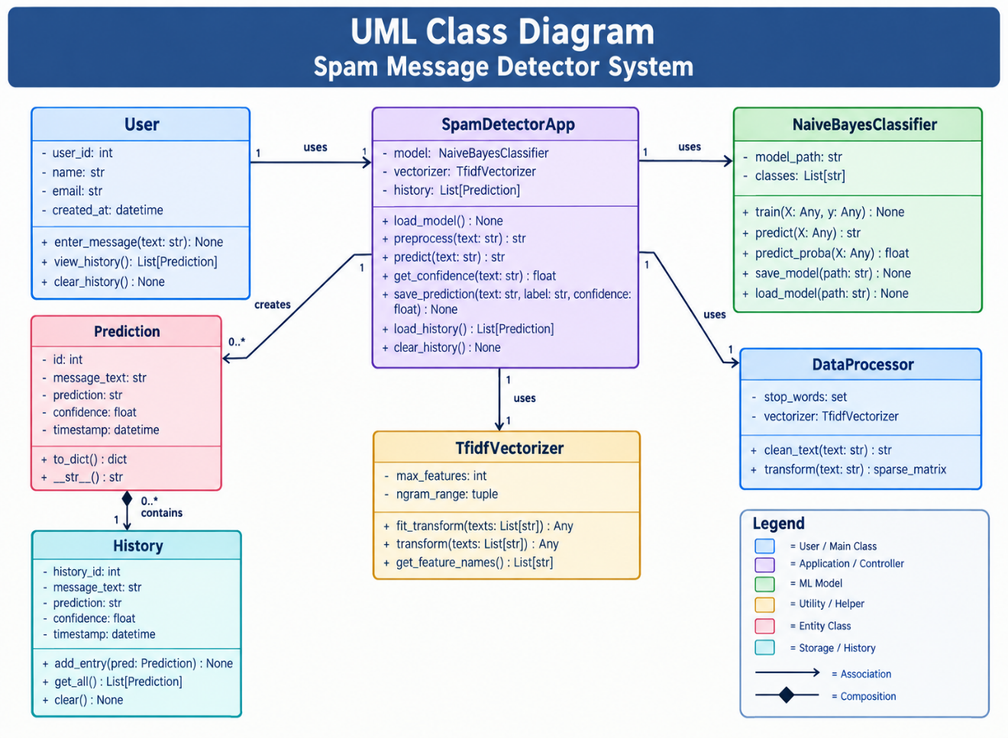
6.5 ER / Storage Design Diagram
The project does not use a relational database such as MySQL. Therefore, a traditional ER diagram with database tables is not applicable.
Instead, the project uses file-based storage for the trained machine learning artifacts:
- models/spam_model.pkl – Stores the trained Multinomial Naive Bayes model.
- models/tfidf_vectorizer.pkl – Stores the trained TF-IDF vectorizer.
- models/confusion_matrix.png – Stores the model evaluation visualization.
- data/SMSSpamCollection – Stores the SMS dataset.
- Prediction history is maintained temporarily in application memory during the current Streamlit session.
Figure 6.5: Database / Storage Design Diagram
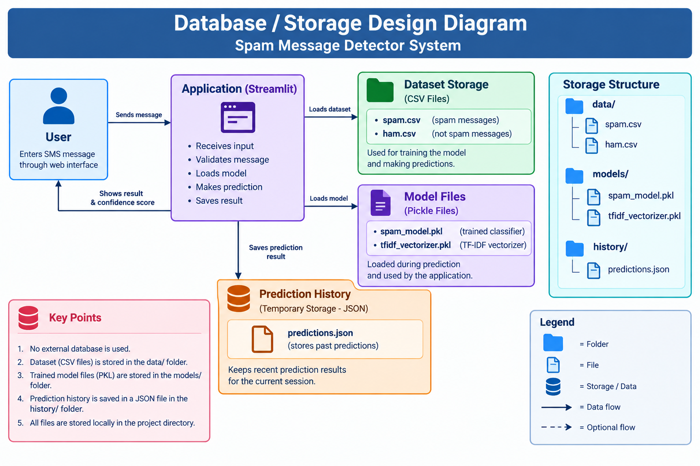This storage approach is suitable for the current project because the application does not require persistent user accounts or a relational database. The trained model and vectorizer can be loaded directly from the saved files whenever predictions are made.
7. Design Decisions & Rationale
During the development of the Spam Message Detector System, several design choices were made to keep the application simple, modular, and suitable for SMS text classification. The main decisions and the reasons behind them are described below.
7.1 Python as the Programming Language
Decision: Python was chosen as the main programming language for the project.
Rationale: Python has many libraries that support machine learning, text processing, data handling, testing, and application development. Libraries such as pandas, scikit-learn, joblib, and Streamlit helped in developing different parts of the system using the same programming language.
7.2 SMS Spam Collection Dataset
Decision: The SMS Spam Collection dataset was used for developing and testing the model.
Rationale: The dataset contains SMS messages that are already labelled as spam or legitimate (ham). This makes it suitable for supervised binary classification and provides real-world text data for training and evaluating the model.
7.3 Text Preprocessing
Decision: SMS messages are cleaned before they are passed to the classification model.
Rationale: SMS messages can contain URLs, email addresses, special characters, different capitalization, and unnecessary spaces. Cleaning these elements makes the text more consistent and prepares it for the next stage of processing.
7.4 TF-IDF Feature Extraction
Decision: TF-IDF was used to convert SMS text into numerical features.
Rationale: Machine learning models work with numerical data rather than raw text. TF-IDF assigns weights to words based on how important they are in the messages. This allows more useful words to have greater influence while common words that provide less information receive lower weights.
7.5 Multinomial Naive Bayes
Decision: The Multinomial Naive Bayes algorithm was selected for message classification.
Rationale: Multinomial Naive Bayes is commonly used for text classification and works well with word-based numerical features such as TF-IDF. It is also relatively simple and efficient to train, making it suitable for this project.
7.6 Modular Project Structure
Decision: The application was divided into separate Python modules.
Rationale: Different tasks, such as preprocessing, validation, prediction, dataset loading, model training, evaluation, utilities, and history management, are handled separately. This makes the code easier to understand, test, maintain, and modify later.
7.7 Streamlit User Interface
Decision: Streamlit was used to develop the user interface.
Rationale: Streamlit makes it possible to create an interactive web interface using Python without having to build a separate frontend. It provides a simple way for users to enter messages and view the prediction results.
7.8 Joblib for Model Storage
Decision: Joblib was used to save and load the trained machine learning model and TF-IDF vectorizer.
Rationale: Saving these objects means that the model does not need to be trained every time the application starts. The application can simply load the previously trained model and vectorizer from the models directory.
7.9 Temporary Prediction History
Decision: Prediction history was stored temporarily in application memory instead of using a database.
Rationale: The current project does not require permanent storage of user messages or user accounts. Keeping the history in memory makes the implementation simpler while still providing users with a way to view their recent predictions during the current session.
7.10 Automated Testing
Decision: Pytest was used for automated testing.
Rationale: Separate tests were created for important parts of the system, including dataset loading, text preprocessing, prediction, and input validation. These tests help check whether individual components are working correctly and make it easier to identify errors.
7.11 Model Evaluation
Decision: Accuracy, precision, recall, F1-score, and a confusion matrix were used to evaluate the model.
Rationale: Accuracy gives an overall view of how many messages were classified correctly. Precision and recall provide more information about the model's performance in identifying spam. The F1-score combines precision and recall into a single measure, while the confusion matrix shows the number of correct and incorrect predictions for each category.
7.12 Result of the Design
The selected design resulted in a working end-to-end spam detection application. On the current test split, the system achieved 96.86% accuracy, 100.00% precision, 76.51% recall, and 86.69% F1-score. The implementation also passed the project's automated test suite with 12 tests passed.

8. Implementation Details
The Spam Message Detector System was developed using Python along with libraries for machine learning, data processing, testing, and application development. The project follows a modular structure, where different tasks are handled by separate files and modules.
The main implementation stages include dataset loading, text preprocessing, feature extraction, model training, prediction, validation, model evaluation, and user interface development. The trained model and TF-IDF vectorizer are saved so that they can be loaded directly when the application is used.
The following sections describe the main parts of the implementation in more detail.

8.1 Development Environment
The project was developed using Python 3.13.5 in Visual Studio Code. A Python virtual environment was used to manage the project dependencies.
The major technologies and libraries used are:
Technology / Library | Purpose
Python | Main programming language
pandas | Dataset loading and data preparation
scikit-learn | Machine learning and evaluation
TF-IDF Vectorizer | Text feature extraction
Multinomial Naive Bayes | Spam classification
joblib | Saving and loading trained model files
Streamlit | Web-based user interface
matplotlib | Confusion matrix visualization
pytest | Automated testing

8.2 Project Modules
The project follows a modular structure:
Spam_Message_Detector/
│
├── data/
│ └── SMSSpamCollection
│
├── docs/
│ ├── system_architecture.png
│ ├── process_flow.png
│ ├── use_case_diagram.png
│ ├── uml_class_diagram.png
│ ├── uml_sequence_diagram.png
│ └── database_storage_design_diagram.png
│
├── models/
│ ├── spam_model.pkl
│ ├── tfidf_vectorizer.pkl
│ └── confusion_matrix.png
│
├── src/
│ ├── dataset_loader.py
│ ├── preprocessing.py
│ ├── train_model.py
│ ├── evaluation.py
│ ├── predictor.py
│ ├── validation.py
│ ├── utils.py
│ └── history.py
│
├── tests/
│ ├── test_dataset_loader.py
│ ├── test_preprocessing.py
│ ├── test_predictor.py
│ └── test_validation.py
│
├── app.py
├── README.md
├── statement.md
├── requirements.txt
└── .gitignore

8.3 Dataset Loading and Preparation
The dataset_loader.py module loads the SMS Spam Collection dataset using pandas. The dataset is tab-separated, with the first column containing the message label and the second column containing the SMS message.
The labels are converted to lowercase and only the spam and ham categories are retained. Missing records are removed before the dataset is used for training.
8.4 Text Preprocessing
The preprocessing.py module contains the clean_text() function.
The preprocessing operations include:
- Converting text to lowercase.
- Removing URLs.
- Removing email addresses.
- Removing special characters.
- Removing unnecessary whitespace.
This ensures that the text supplied to the machine learning model is consistent and cleaner.
8.5 Model Training
The train_model.py module is responsible for training the machine learning model.
The dataset is divided into:
- 80% training data
- 20% testing data
A random_state of 42 and stratified splitting are used so that the class distribution is maintained between the training and testing sets.
The cleaned messages are converted into numerical features using:
TF-IDF Vectorizer
The resulting feature vectors are then provided to the:
Multinomial Naive Bayes classifier
After training, two files are saved:
- models/spam_model.pkl
- models/tfidf_vectorizer.pkl
8.6 Message Prediction
The predictor.py module performs predictions using the saved model and vectorizer.
When a user enters a message:

The model returns either spam or ham. The prediction probability is also used to calculate the displayed confidence percentage.
8.7 Input Validation
The validation.py module checks user input before prediction.
The system rejects:
- Empty messages
- Messages shorter than the minimum allowed length
- Messages longer than 5000 characters
- Non-text input
Appropriate warning messages are displayed to the user when validation fails.
8.8 Streamlit Application
The app.py file provides the main user interface.
The application allows the user to:
- Enter an SMS message.
- Click Check Message.
- View the prediction.
- View the confidence score.
- View a description of the result.
- View previous predictions during the current session.
- Clear prediction history.
The interface displays spam predictions using an error message and legitimate messages using a success message.
8.9 Prediction History
The history.py module maintains temporary prediction history in application memory.
Each record contains:
- Original message
- Prediction
- Confidence score
- Prediction time
The history can be displayed through the Streamlit interface and can be cleared using the Clear History option.

8.10 Model Evaluation
The evaluation.py module evaluates the trained model using the held-out test data.
The following metrics were calculated:
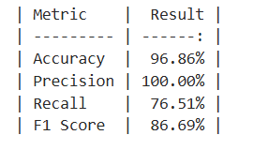

The resulting confusion matrix was:
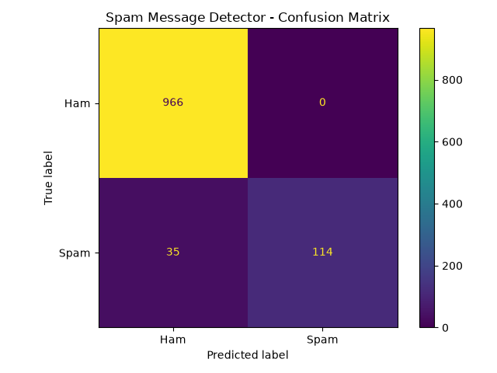

8.11 Example Prediction
During testing, the following message was entered:
"Congratulations! You have won a free prize. Click now to claim."
The system produced:
Prediction: SPAM
Confidence: 95.70%
*This demonstrates the complete workflow from user input through preprocessing, feature extraction, classification, and result display.
8.12 Automated Testing
The project uses pytest for automated testing. Tests were created for:
- Dataset loading
- Text preprocessing
- Message prediction
- Input validation
The complete test suite successfully passed:
12 tests passed
*This confirms that the major functional components of the application were tested successfully.

9. Screenshots / Results
The developed Spam Message Detector System was tested through its Streamlit user interface as well as through automated testing and machine learning evaluation. The following screenshots demonstrate the major features and results of the system.
9.1 Main Application Interface
The main application provides a simple interface where the user can enter an SMS message and click the Check Message button to perform classification.
Figure 9.1: Main Application Interface
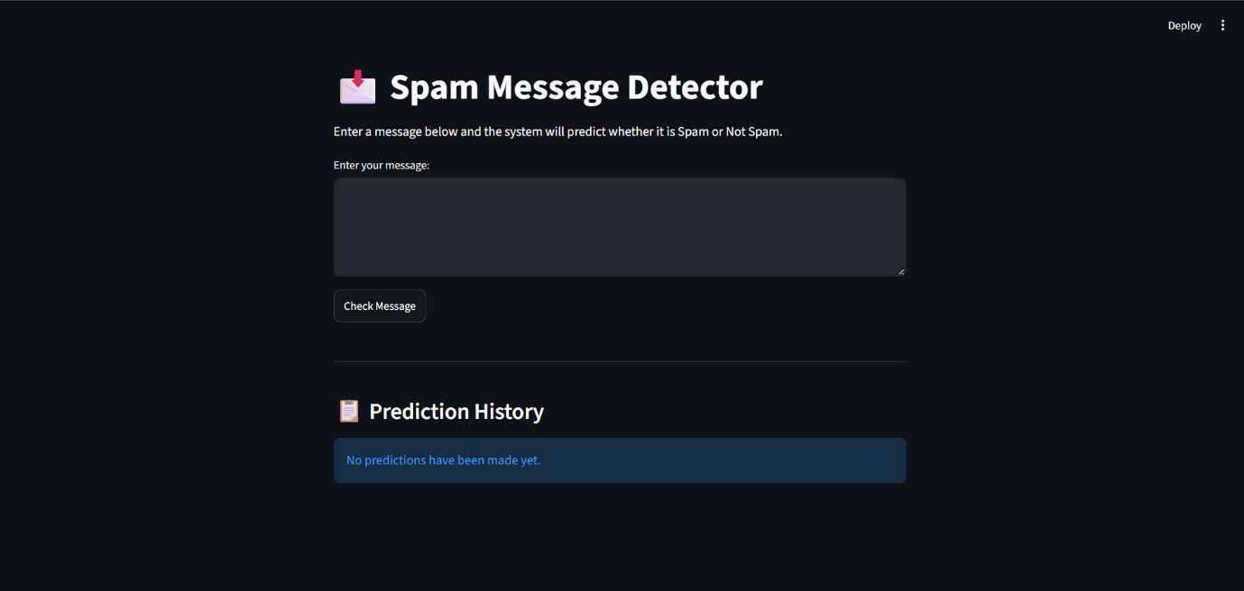

9.2 Spam Message Prediction
A sample spam message was entered into the application:
"Congratulations! You have won a free prize. Click now to claim."
The system classified the message as:
Prediction: SPAM
Confidence: 95.70%
Figure 9.2: Spam Message Prediction
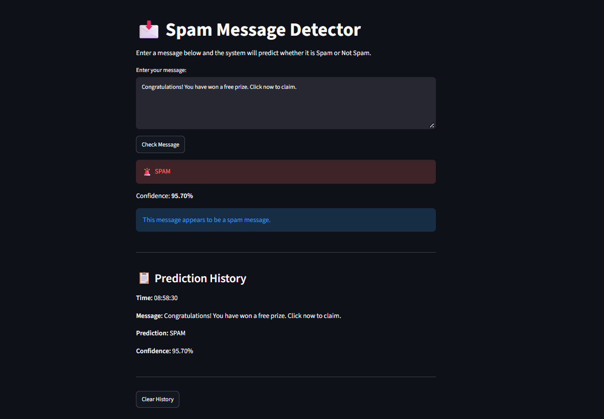

9.3 Legitimate Message Prediction
A legitimate SMS message was also tested to verify that the system could identify messages that were not spam.
The application displayed the classification as NOT SPAM along with the corresponding confidence score.
Figure 9.3: Legitimate Message Prediction
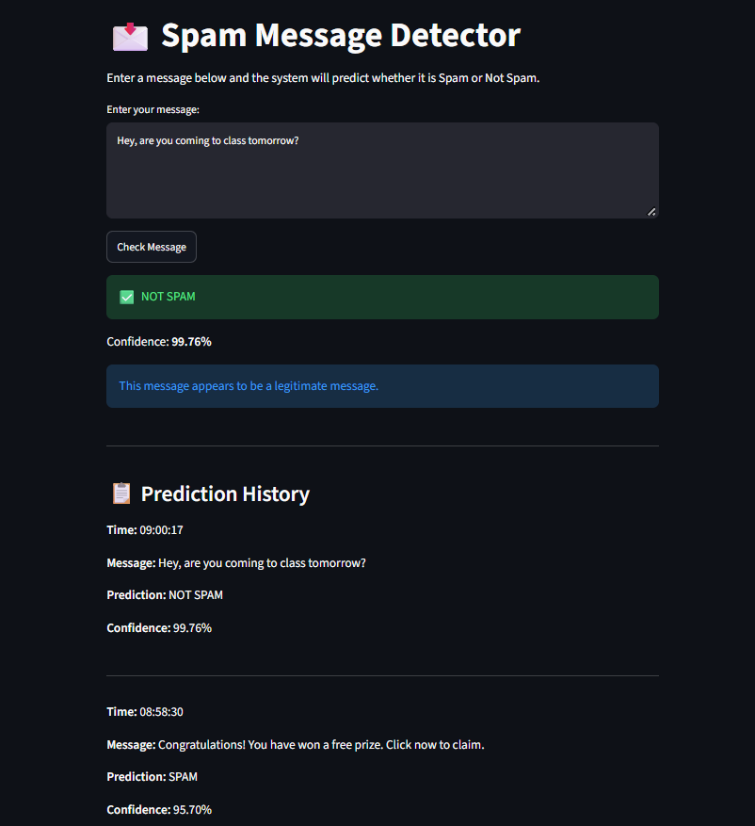

9.4 Input Validation
The application validates the user's input before sending it to the machine learning model. When an invalid input, such as an empty message, is submitted, the system displays an appropriate warning instead of attempting a prediction.
Figure 9.4: Input Validation
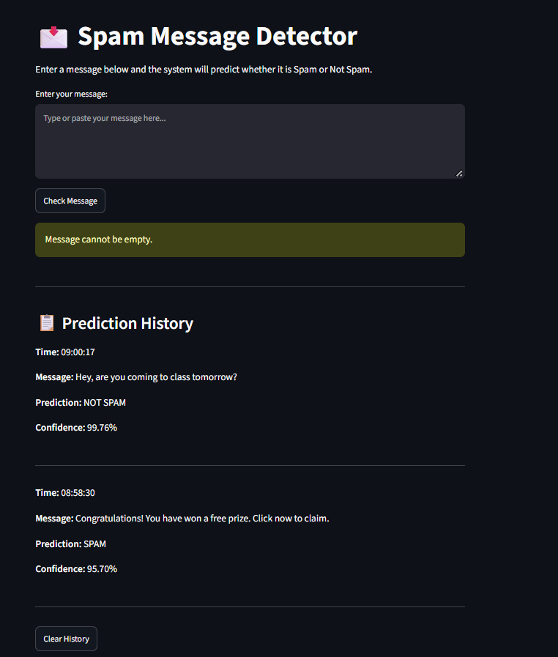

9.5 Prediction History
The application maintains a temporary history of predictions during the current session. Each history record contains the message, prediction, confidence score, and prediction time.
The user can also clear the stored prediction history using the Clear History option.
Figure 9.5: Prediction History
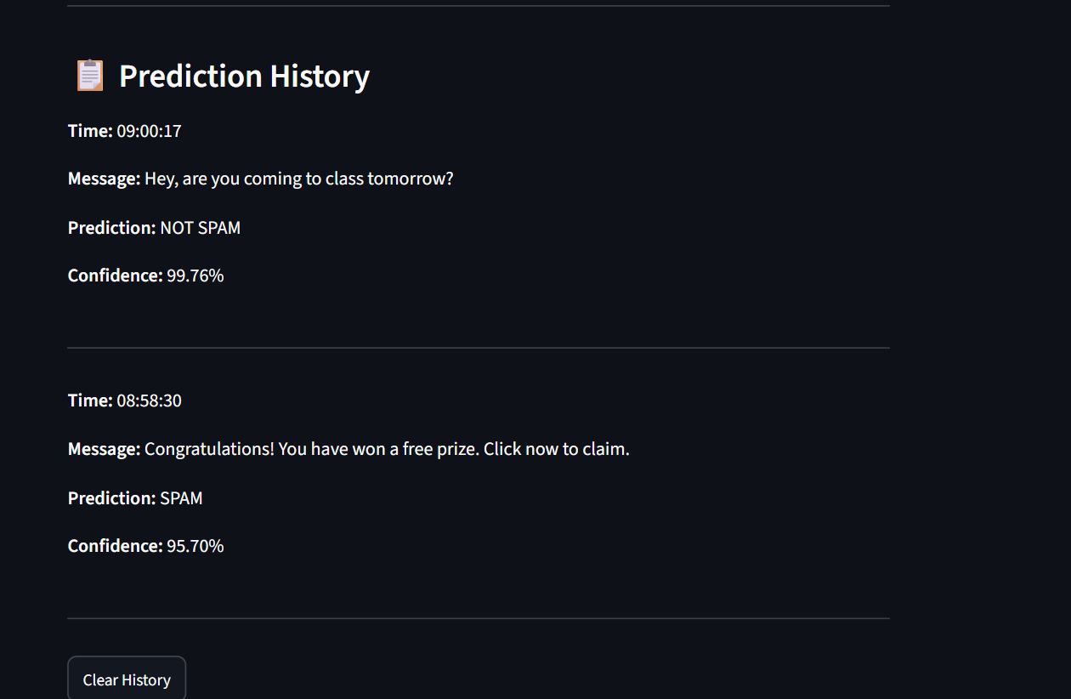

9.6 Model Evaluation Results
The trained Multinomial Naive Bayes model was evaluated using a test set containing 20% of the dataset.
The obtained results were:
Evaluation Metric | Result
Accuracy | 96.86%
Precision | 100.00%
Recall | 76.51%
F1-Score | 86.69%
The confusion matrix was:

This means that 966 legitimate messages and 114 spam messages were correctly classified. There were 35 spam messages classified as legitimate, while no legitimate messages were classified as spam.

Figure 9.6: Model Evaluation Results
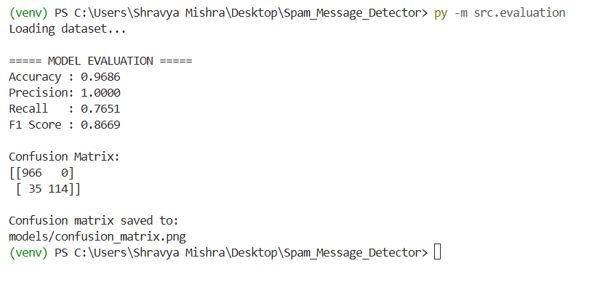
9.7 Confusion Matrix
The confusion matrix generated during model evaluation provides a visual representation of the classification results.
The matrix contains four outcomes:
- 966 – Ham correctly classified as Ham
- 0 – Ham incorrectly classified as Spam
- 35 – Spam incorrectly classified as Ham
- 114 – Spam correctly classified as Spam

8.12 Automated Testing
The project uses pytest for automated testing. Tests were created for:
- Dataset loading
- Text preprocessing
- Message prediction
- Input validation

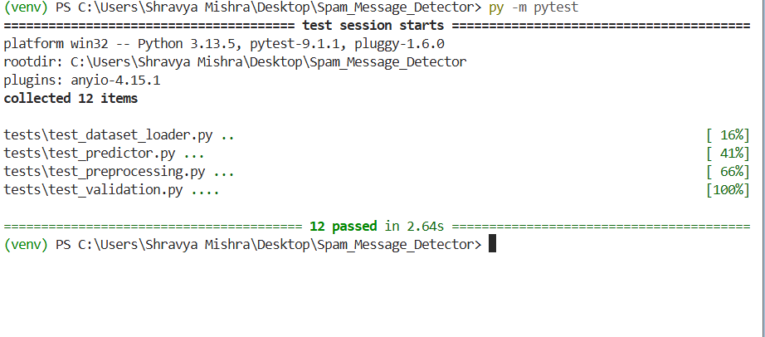
The complete test suite successfully passed:
12 tests passed
This confirms that the major functional components of the application were tested successfully.

10. Testing Approach
Testing was performed to verify the correctness, reliability, and functionality of the Spam Message Detector System. The project used both automated software testing and manual application testing.
10.1 Unit Testing
The project uses pytest to test individual modules independently. Tests were created for:
- Dataset loading
- Text preprocessing
- Message prediction
- Input validation
10.2 Functional Testing
The Streamlit application was manually tested with different types of inputs, including:
- Spam messages
- Legitimate messages
- Empty input
- Invalid or extremely short input
The purpose was to verify that the application responds correctly to valid and invalid user inputs.
10.3 Integration Testing
The complete prediction workflow was tested to ensure that the modules work together correctly:

This verified the interaction between the user interface and the machine learning components.
10.4 Model Testing
The trained model was evaluated using a separate test portion of the dataset. Standard classification metrics and a confusion matrix were used to assess its performance.
10.5 Test Completion
The final automated test suite completed successfully with 12 tests passed. The testing process helped identify errors during development and verify that the major components were functioning correctly.
11. Challenges Faced
During the development of the Spam Message Detector System, a few challenges were encountered while working with the dataset, machine learning model, Python modules, testing, and the user interface. These challenges were solved through debugging, testing, and making improvements to the implementation.
11.1 Dataset Handling
One of the initial challenges was loading the SMS Spam Collection dataset correctly. Since the dataset is stored as a tab-separated file, it had to be read and prepared properly before it could be used for training and testing the machine learning model.
11.2 Text Preprocessing
SMS messages can have different formats and may contain URLs, email addresses, special characters, unnecessary spaces, and different types of capitalization. A preprocessing step was therefore required to clean the messages and make the text more consistent before classification.
11.3 Machine Learning Integration
Another challenge was connecting the TF-IDF feature extraction process with the Multinomial Naive Bayes classifier. The same feature representation used during training had to be applied to new messages during prediction. Handling this correctly was important for obtaining meaningful predictions.
11.4 Python Package and Module Management
Organizing the project into different Python modules required careful management of imports, dependencies, virtual environments, and the project folder structure. Making sure that the modules could communicate correctly was an important part of the development process.
11.5 Input Validation
The application needed to handle invalid user input without causing the program to crash. Validation was added to check the message before it was passed to the prediction model. This helped the application respond appropriately when users entered invalid or incomplete input.
11.6 Testing and Debugging
Different parts of the application had to be tested separately as well as together. Testing helped identify errors in areas such as dataset loading, preprocessing, prediction, and validation. The identified issues were then corrected before completing the application.
11.7 User Interface Development
Another challenge was connecting the machine learning components with the Streamlit interface while keeping the application simple to use. The interface needed to clearly show the prediction, confidence score, validation messages, and prediction history.
Overall, these challenges provided practical experience with machine learning, Python programming, debugging, testing, and application development. They also helped in understanding how different components of a project work together to form a complete application.

14. References
- UCI Machine Learning Repository – SMS Spam Collection Dataset
https://archive.ics.uci.edu/dataset/228/sms+spam+collection
- Scikit-learn Documentation – Machine Learning and TF-IDF
https://scikit-learn.org/
- Streamlit Documentation – Application Development
https://docs.streamlit.io/
- Python Documentation
https://docs.python.org/3/
- pytest Documentation – Software Testing
https://docs.pytest.org/

