UNIT – 1
Algorithm
Algorithm:- An algorithm is a finite set of instruction that, if followed, accomplishes a particular task. In addition all algorithms must satisfy the following criteria.
- Input: Zero or more quantities are externally supplied.
- Output: Atleast one quantity is produced.
- Definiteness: - Each instruction is clear and unambiguous. It must be feasible.
- Finiteness: - If we trace out the instructions of an algorithm then for all cases the algorithm terminates after a finite number of steps
- Effectiveness:- Every instruction must be very basic so that it can be carried out in principle by a person using only pencil & paper
Algorithms that are definite and effective are computational procedures.
To achieve definiteness algorithms are written in a programming language. A program is the expression of an algorithm in a programming language.
The study of algorithms includes many important and active areas of research
They are
- How to devise algorithms.
- How to validate algorithms
- How to analyse algorithms (priori Analysis)
- How to test a program (Posteriori Analysis)

How to devise algorithms: - Creating an algorithm can never be fully automated. The major goal of studying various design techniques, is to yield good algorithms. Some of the design strategies are Divide and conquer, greedy method, Dynamic programming. These strategies are useful in fields other than computer science engineering such as operations research and electrical engineering

How to validate Algorithms: - The process of checking whether an algorithm computer correct answer for all possible legal input is called as algorithm validation This assures that the algorithm works correctly independent of the issues correctly independent of the issues concerning the programming language. One the algorithm is valid, a program can be written and second phase begins.

How to analyse Algorithms :- This refers to the task of determining how much computing time and storage an algorithm requires, This allows us to make quantitative judgements about the value of one algorithm over another. It also allows us to predict whether the software will meet any efficiency constraints that exist.

How to test a Program:- Testing a program consists of two phases that is debugging and profiling. Debugging is the process of executing programs on sample data sets to determine whether faulty results occur and if so to connect them, Debugging can only point to the presence of errors but not their absence.

Profiling as performance measurement is the process of executing a correct program on data sets and measuring the time and space it takes to compute the results. These timing figures are useful in that they may confirm a previously done analysis and point out logical places to perform useful optimization. (Posteriori Analysis)

Algorithm Specification
Algorithms can be described using natural language like English, graphic representations called flow charts or using pseudocode resembling C and Pascal.
Some of the specifications are
- Comments begins with //
- Blocks are indicated using braces { }
- Statements are delimited by ;
- An identifier begins with a letter.
- Datatype of variables are not explicitly declared.They are clear from context global or local variable is also evident from context.
- Compound datatypes are declared as follows.
node = record
{
datatype_1 data_1;
.
.
datatype_ n data _ n;
node * link;
}
- Assignment of values to variables is done using : = operator
<variable>$∶=$<expression> ;
- There are 2 Boolean values true and false
- In order to produce Boolean values logical operators (and, or, not) and relational operators ( <, ≤ , = , ≠ , > , ≥ ) are provided.
- Conditional statements have the following forms
- if <condition> then statement ;
- if <condition> then statement ;
else statement 2 ;
- case
{
:<condition 1> : <statement 1>;
:
:
: <condition n> : <statement n>;
: <else> : <statement n+1> ;
}
- Looping statement are of the following forms.
- while <condition> do
{
< statement 1>;
.
.
<statement n>;
}

- repeat
{
<statement 1>;
:
:
<statement n>;
} until <condition>;

- for variable := value 1 to value 2 step stepvalue do

{
<statement 1>;
<statement 2>;
:
:
<statement n>;
}

- Element of multidimensional arrays are accessed using [ and ]. For example if A is a 2 dimensional array the ( i, j )^{th} element of the array is denoted as A[i, j].

- Input and output operations are done using read and write.
- This is only one type of procedure ie, Algorithm which contains of head and body.
Heading: 1. Algorithm Name (parameter list).
2. {
3. ----------
body -------------
-------------
}

There are 2 types of algorithms. They are
- Iterative Algorithms.
- Recursive Algorithms.

Iterative Algorithm:- Sum of element of an Array
- Algorithm Sum(A, n)
- {
- s $∶=$0;
- for i$∶=$ 1 to n step 1 do
- {
- s $∶=$s + A[i];
- }
- return s;
- }

Recursive Algorithm: Sum of the element of an Array

- Algorithm RSum (A, n)
- {
- if(n=0) then
- return 0;
- else
- return A[n] +RSum(A, n-1);
- }

Performance Analysis
There are many criteria upon which we can judge an algorithm.
- Does it do what we want it to do?
- Does it work correctly according to the original specifications of the task?
- Is there documentation that describes how to use it and how it works?
- Are procedures created in such a way that they perform logical subfunctions?
- Is the code readable?
These criteria are vitally important when it comes to writing software, most especially for large systems.
The other criteria for judging algorithms that have a more direct relationship to performance are computing time and storage requirements i.e. Time complexity and complexity.

Space complexity of an algorithm is the amount of memory it needs to run to completion.Time complexity of an algorithm is the amount of computer time it needs to run an algorithm.
Space Complexity: - Space complexity is the sum of the following components.
- Fixed part that is independent of the characteristics of inputs and outputs. This includes instruction space, space for simple variable and fixed size component variables (aggregate), space for constants and so on.
- Variable part that consists of space needed by component variables whose size is dependent on the particular problem instance being solved, space needed by reference variable and recursion stack space(space for formal parameters, local variables and return address). The space requirement S(P) of any algorithm P may therefore be written as S()=C+Sp, where C is a constant. Hence when analysing space complexity, we concentrate solely on estimating Sp (instance characteristics)
E.g. 1:-
- Algorithm abc(a, b, c)
- {
- return a+b+b*c/(a-b+c)*a+4.0;
- }

Space needed by the algorithms is 3 units of memory i.e. 1 unit for a, b, c and no instance characteristics are present i.e. Sp=0

E.g. 2:-
1.Algorithm Sum(A, n)
2.{
3.S ꞉꞊ 0.0;
4.for i ꞉꞊ 1 to n step 1 do
5.S ꞉꞊ S + A[i];
6.Return s;
7.}
Space required by the above algorithm1 unit of memory each for s, i, n and n units of memory for the array A (instance characteristics). Hence
S_{Sum}(n) ≥ n+3

E.g. :-
- Algorithm RSum(A,n)
- {
- if (n ≤ 0) then
- return 0.0;
- else
- return RSum (A, n-1) + A[n];
- }
Each call to RSum requires at least 3 units of memory (space for n, space for pointer to A, return address). Since the function is called n+1 times the S_{Rum}(n) ≥ 3(n+1)

Time Complexity: - The time complexity T(p) is the sum of compile time and runtime of the algorithm, since compile time does not depend on instance characteristics and compilation is done at most twice or thrice but it must be run several times, compile time is negligible. Hence Time complexity is runtime of the program or algorithm.
If we know the characteristics of the compiler we can proceed to compute time complexity as sum of total number of additions, multiplications, subtractions, divisions, compares, loads, stores and so on.
So tp(n) will be of the form
tp(n) = C_{a} Add(n) + C_{s} Sub(n) + C_{m} Mul(n) +…………..

Where n denotes instance characteristics C_{a}, C_{s}, C_{m},……. Denote the time needed for addition, subtraction, multiplication and Add, Sub, Mul denotes the number of additions subtractions, multiplications, Obtaining such an exact formula is impossible since the operations time depends on the number being operated. Hence we count the program steps for computing time complexity.
A program step is assumed to take one un it of time for completion.A program step is loosely defined as a syntactically and semantically meaningful program segment that has an execution time independent of instance characteristics. The number od steps any program statement is assigned depends on kind of statement.
For example comments count as 0 steps, An assignment that does not involve any call to other programs is counted as 1 step, Iterative stunts such as for , repeat – until, while consider step counts for control part of the stunt.

There are 2 methods for calculating time complexity of a program
- Introducing a global count variable with initial value 0 and incrementing by 1 for each program statement. The change in the value of count at the end of algorithm is timecomplexity.
- Determine step count of algorithm by building a table and list the total number of steps contributed by each number of steps contributed by each statement. This is obtained by determining the number of step per execution of the statement and total number of times each statement is executed (frequency).

Steps per execution is the amount by which count changes as a result of execution of that statement.

Method 1
E.g. 1:-
Algorithm Sum (A, n)
{
S ꞉꞊ 0.0;
Count $∶=$ count+1; // count is global
for i$∶=$ 1 to n step 1 do
{
count $∶=$ count + 1; // for for loop
S $∶=$ S + A[i];
count $∶=$ count + 1; // for assignment
}
count $∶=$ count + 1; //last time of for
return s;
count $∶=$ count +1; // for return
}
The total count value is 2n+3
So each invocation of Sum executes a total of 2n+3 steps

E.g. 2:-
Algorithm RSum(A,n)
{
count $∶=$ count + 1; // for if
if (n ≤ 0 ) then
{
count $∶=$ count +1; // for return
return 0.0;
}
else
{
count $∶=$ count +1: // for addition, function invocation and return
return RSum(A, n-1) +A[n];
}
}

t_{Rsum}(n) =$\left\{\begin{aligned}2 if n=0 \\ 2+tRSum(n-1) if n >0\end{aligned}\right.$
t_{Rsum}(n) = 2 + t_{Rsum}(n-1)
= 2 + 2 + t_{Rsum}(n-2)
= 2(2) + t_{Rsum}(n-2)
=……….
=……….
= n(2) + t_{Rsum}(0)
= 2n + 2 n ≥ 0

E.g. 3:-
Algorithm Add (A, B, C, m, n)
{
for i=1 to m step 1 do
{
count ꞉꞊ count + 1;
for j ꞉꞊ 1 to n step 1 do
{
count ꞉꞊ count + 1;
C[i, j] ꞉꞊ A[i, j] +B[i, j];
count ꞉꞊ count +1;
}
count ꞉꞊ count +1;
}
count ꞉꞊ count +1;
}
Algorithm terminates at 2mn + 2m +1

Method 2:-
E.g 1:-
Statement | s/e | Frequency | Total Steps
- Algorithm Sum(A,n) | 0 | - | 0
- { | 0 | - | 0
- S ꞉꞊ 0.0; | 1 | ! | 1
- for I ꞉꞊ 1 to n step 1 do | 1 | n + 1 | n + 1
- s ꞉꞊ s +A[i]; | 1 | n | n
- return s; | 1 | 1 | 0
- } | 0 | - | 2n + 3

E.g. 2:-
Statement | s/e | Frequency |  | Total Steps
- Algorithm RSum(A, n) | 0 | n = 0 | n > 0 | n = 0 | n > 0
- { | 0 | - | - | 0 | 0
- if (n ≤ 0) then | 1 | 1 | 1 | 1 | 1
- return 0.0; | 1 | 1 | 0 | 1 | 0
- else | 0 | 0 | 0 | 0 | 0
- return RSum (A, n-1)+A[n]; | 1+x | 0 | 1 | 0 | 1 + x
- } | 0 | - | - | 0 | 0
 |  |  |  | 2 | 2 + x

2n + 2

Summary: - We can extricate (escape) ourselves from the difficulties resulting from situations when the chosen parameters are not adequate (enough) to determine the step count uniquelyby defining three kinds of step counts i.e. best case, worst case and average case.
The best-case step count is the minimum number of steps that can be executed for given parameters.
The worst case step count is the maximum number of steps that can be executed for given parameters.
The average case step count is the average number of steps executed on instances with given parameters.

Asymptotic Notations: -These notations introduce some terminology that enables us to make meaningful statements about time and space complexity of an algorithm. Using this we can define nearest upper and lower limit for time and space of an algorithm.
There are five Asymptotic Notations
- Big-Oh(O)Notation:- The function f(n) = O(g(n)) (read as f of n is big Oh of g of n)iffthere exists positive constants c and no such that f(n) ≤ c * g(n) for all n, n ≥ n0
e.g :- f(n) = 3n + 2
=>3n + 2 ≤ = O(n)
⁘ 3n + 2 ≤ 4n V n ≥ 2
- 3n +2 ≤ 4* n

f(n) ≤ c g(n) f(n) = O(n)
E.g. 2 :- 3n+3 = O(n) ⁘ 3n + ≤ 4n V n ≥ 2
E.g. 3 :- 100n+b=O(n) ⁘ 100n+b ≤ 101n V n ≥ 6
E.g. 4 :- 10n²+4n+2 = O(n²) ⁘ 6*2^{n}+n² ≤ 2^{n} * 7 V n ≥ 4

O(1) means computing time is constant
O(n) means computing time is linear
O(n²) means computing time is quadratic
O(n³) means computing time is cubic
O(2^{n}) means computing time isexponential
g(n) is called upper bound of f(n)

2) Omega (Ω) Notation: - The function f(n) = Ω (g(n)) if there exists positive constants c and n₀ such that f(n) ≥ c*g(n) For all n, n ≥ n₀
E.g. 1 :- f(n)= 3n+2
=> 3n+2 = Ω(n)
⁘ 3n+2 ≥ 3n for n ≥ 1
- 3n+2 ≥ 3* n

f(n) ≥ c*g(n) ⁘ f(n)=Ω(n)
E.g. 2:- 3n +3=Ω(n) as 3n+3 ≥ 3n for n ≥ 1
E.g. 3 :- 100n+b = Ω(n) as 100n + 6 ≥ 100n for n ≥ 1
E.g. 4:- 10n²+4n+2 = Ω(n²) as 10n²+4n+2 ≥ n² for n ≥ 1
G(n) is the lower bound of f(n).

3)Theta (θ) Notation: - The function f(n)= θ(g(n)) if there exist +ve constants c1, c2, number such that
C1 g(n) ≤ f(n) ≤ c2 g(n) for all n, n ≥ no

E.g. 1 :- f(n) = 3n+2
=> 3n+2 = θ(n) as
3n+2 ≥ 3n V n ≥ 2 and
3n+2 ≤ 4n V n ≥ 2
So c1 = 3, c2 = 4 and no =2

E.g 2:- 3n+3 = θ(n)
E.g 3:- 10n²+4n+2 = θ(n²)
g(n) is both upper and lower bound of f(n)

4)Little “oh” (0) Notation: - The function
f(n)= 0(g(n)) iff$\lim_{n→∞}{\frac{f(n)}{g(n)}}$=0

E.g. 1 :- 3n+2=0(n²) since
$\lim_{n→∞}{\frac{3n+2}{n2}}$ =0

5)Little “omega^{” (w)} Notation^{: -}
Thefunctionf(n)=w(g(n))if$\underset{n→∞ }{lim⁡}{\frac{g(n)}{f(n)}}$ =0
E.g.: - 3n+2 = w(1)
$\underset{n→∞ }{lim⁡}{\frac{1}{3n+2}}$ =0

RECURRENCES
A recurrence is an equation that describes a function in terms of its value on smaller inputs.
Solving a recurrences relation means obtaining a function defined on natural number that satisfies the recurrences.
For E.g. T(n)=$\left\{\begin{aligned}θ(1) if n=1 \\ 2T(n/2)+ θ(n) if n> 1\end{aligned}\right.$

There are 3 methods for solving this
- Substitution method: - We guess a bound and then use mathematical indication to prove our guess correct.
- Iteration method: - Iteration method converts the recurrence into a summation and then relies on techniques for bounding summations to solve the recurrence.
- Master method: - Provides bounds for recurrences of the form T(n)=aT(n/b)+f(n) where a ≥ 1, b ≥ 1 and f(n) is given function.

Substitution method
This method consists of 2 main steps
- Guess the solution
- Use mathematical induction to find the boundary condition and show that the guess is correct.
E.g. T(n)=2T(n/2)+n

- Step 1:- Guess the solution
T(n)=O(nlog₂^{n})
i.e T(n) ≤ c* _{n}log₂^{n}
checking for n=1
T(1) ≤ c * log₂¹ assuming T(1) =1
1 ≤ c* 0 i.e the guess does not hold for n=1
Now for n=2
T(2) ≤ c.2log₂² log₂²=1
2T(2/2)+2 ≤ c.2
2T(1)+2 ≤ c.2
: T(1)=0 0+2 ≤ c.2 which is true
:T(n) ≤ c.log₂^{n} is true for n=2
Assuming n=n/2
T(n/2) ≤ c. n/2 log₂(n/2)
T(n)=2 T(n/2)+n
=2[c.n/2 log n/2 ] +n
=2cn/2 log n/2 +n
=cn log(n/2)+n
=cnlog₂^{n} - cnlog₂²/1 + n
=cnlog n – cn +n
≤ cnlog₂^{n}
: T(n)=O(nlog₂^{n})

E.g. 2:- T(n)-T([n/2])+1
Let T(n) = O(log₂^{n})
i.e T(n) ≤ c * log₂^{n}
assume n=n/2
T(n) ≤ c log ([n/2])+1
≤ c log (n/2)+1
≤ clog.n-clog₂²+1
≤ clog₂^{n} for c ≥ 1
Thus T(n)=0(log₂^{n})
E.g. 3 :- T(n)= 2T($\sqrt{n}$) thugn
In such cases we algebraic manipulations to make unknown recurrence relation similar to the known one
Suppose m=log₂n => n=2^{m}
n^{1/2} =2^{m/2} =>$\sqrt{n}$ = 2^{m/2}
considering s(m) = T(2^{m})
s(m)=2s$\left({m \atop 2}\right)$+m
Using the recurrence relation, the solution is
S(m)=O(mlog₂m)
Substituting m we get
T(n)=s(m)=O(mlog₂m)
= O(log₂nlog₂log₂n)

Iteration Method:- The basic idea is to expend the recurrence and express it as a summation of term dependent only on n and initial conditions.
E.g. T(n)=3T([$\frac{n}{4}])+n$
= n+3$\left[\frac{n}{4}+3T\left(\frac{n}{16}\right)\right]$
= n+$\frac{3}{4}n$+9T$\left(\frac{n}{16}\right)$
= n+$\frac{3}{4}n$+9$\left[\frac{n}{16}+3T\left(\frac{n}{64}\right)\right]$
= n+$\frac{3}{4}$n+$\frac{9}{16}$n+27 T$\left(\frac{n}{64}\right)$
=n+$\frac{3}{4} + \frac{3^{2}}{4^{2}}n+.........$3^{i}T$\left(\frac{n}{4^{i}}\right)$
SERIES TERMINATES $\frac{n}{4^{i}}$=1 => n= 4^{i}
= >i = log 4^{n}
T(n) $≤$ n+ $\frac{3n}{4}$ + $\frac{9}{ 16}$ n + $\frac{27}{64}n+$……..3^{log}₄^{n} T(1)
$≤$ n+ $\frac{3n}{4}$ + $\frac{9}{ 16}$ n + $\frac{27}{64}n+$……..3^{log}₄³θ (1)
≤ n$\sum_{i=0}^{∞}{\left(\frac{3}{4}\right)}$^{I} + θ(n^{log}₃⁴)since 3^{log}₄^{n}=n
≤ n.$\frac{1 v}{1-\frac{3}{4}}$ + O(n) :^{log}₄³< 1 ^{log}₄³ < 1
= 4n + O(n) θ(n^{log}₃⁴)=O(n)
=O(n)
E.g. 2 :- T(n)=T(n-1) +n⁴
T(n)= T(n-1) + n⁴
=[T(n-2) + (n-1)⁴] + n⁴
=T(n-3) + (n-2)⁴ + (n-1)⁴ + n⁴
:
:
= n⁴ +(n-1)⁴ +……..2⁴ + 1⁴ + T(0)
=$\sum_{i=1}^{n}{i}$⁴ +T(0) => T(n) = θ(n⁴)
Recursion Tree:- It is a pictorial representation of an iteration method, which is in the form of a tree, where at each level nodes are expanded. In general we assume second term in recurrence as root
E.g:- T(n) = 2T($\frac{n}{2}$) + n²

n²

T(n/2) T(n/2)
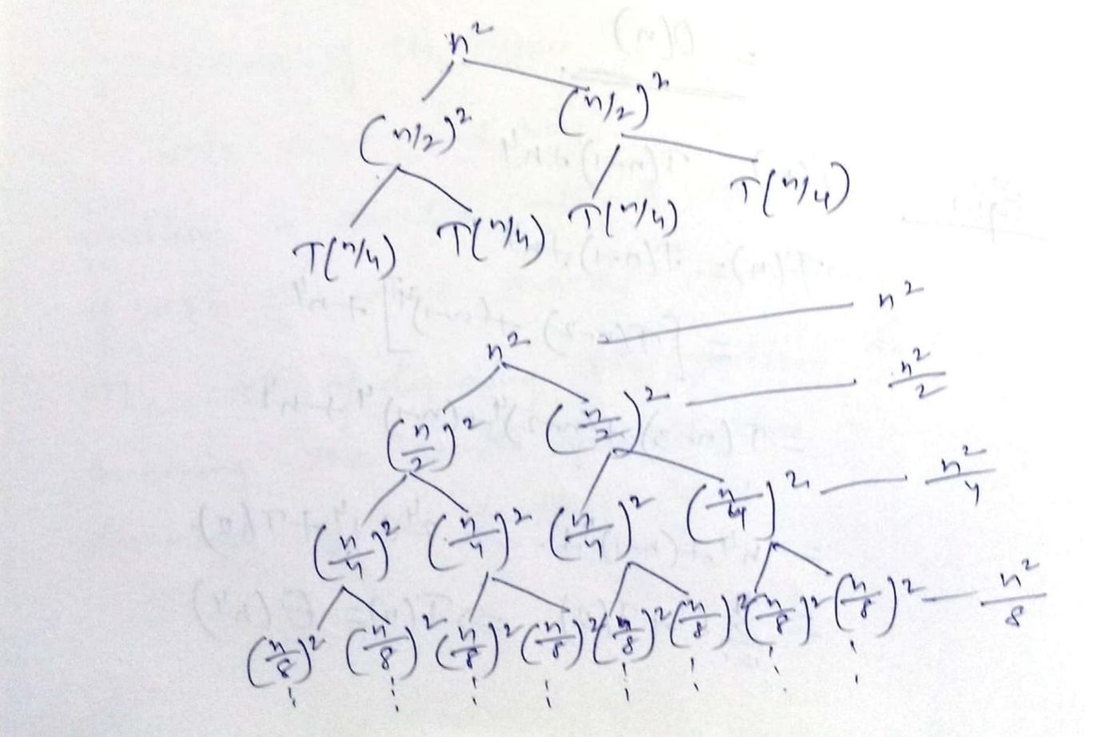

T(n) = n²+$\frac{n^{2}}{2} +\frac{n^{2}}{2}+........$
≤ n²$\sum_{i=0}^{∞}{\left(\frac{1}{2^{1}}\right)}$
≤ n² $\left(\frac{1}{1-\frac{1}{2}}\right) ≤ 2n^{2}$
= θ(n²)

Master Method
The master method is used for solving the recurrence of the type T(n)= aT$\left(\frac{n}{b}\right)+f\left(n\right)$
With a ≥ 1 and b ≥ 1
Problem is divided into a subproblems, each of size $\frac{n}{b}$ where a and b are +ve constants. The cost of dividing the problem and combining the results of subproblem is described by the function f(n)

Master Theorem
Let T(n) be defined on the non-negative integers by recurrence.
T(n) can be bound asymptotically as follows.
- If f(n) = O(n^{log}_{b}^{a - €}) for some constant
€ > 0 then T(n) = θ(n^{log}_{b}ª)
- If f(n) = θ (n^{log}_{b}ª) then T(n) = θ ((n^{log}_{b}ª) log₂^{n})
- If f(n) = Ω (n^{log}_{b}^{a + €} ) for some constant
€ > 0 and if a f$\left(\frac{n}{b}\right)≤ c f(n)$ for some
C<1 and all sufficiently large n, then
T(n) = θ(f(n)), a f$\left(\frac{n}{b}\right)$ ≤ c f(n) is called the regularity condition.

E.g. 1 :- T(n)= 9T$\left(\frac{n}{3}\right)$+n
T(n)=aT$\left(\frac{n}{b}\right)+f\left(n\right)$
A=9, b=3, f(n)=4
Now n^{log}_{b}ª = n^{log}₃⁹ = n² = θ(n²) = T(n)
F(n)= O(n^{log}₃⁹⁻¹)= O(n²⁻¹) = O(n)
Hence we apply case-1 and solv is θ(n²)

E.g.2 :- T(n)= 16T$\left(\frac{n}{4}\right)+n$³
a=16, b=4, f(n)=$n$³
n^{log}_{b}ª = n^{log}₄¹⁶ = n²
f(n) = $n$³ = n^{log}₄^{16+€} = n²⁺¹ : €=1
now regularity condition
16f$\left(\frac{n}{4}\right) ≤ c f(n)$
= 16*$\frac{n^{3}}{64}≤$ c* n³ for c=$\frac{1}{4}$
: So regularly condition holds
Hence by case 3 solution is
T(n) = θ(f(n)) = θ(n²)

1. Breadth-First Search (BFS)

Definition
Breadth-First Search (BFS) is a graph traversal algorithm that visits vertices level by level. It starts from a source vertex and explores all its neighboring vertices before moving to the next level.
BFS uses a Queue (FIFO) data structure.

Algorithm
Input: Graph G(V,E), starting vertex s
- Mark all vertices as unvisited.
- Mark the source vertex as visited and enqueue it.
- While the queue is not empty:
  - Dequeue a vertex u.
  - Visit u.
  - For every adjacent unvisited vertex v:
    - Mark v as visited.
    - Enqueue v.
- Repeat until the queue becomes empty.

Pseudocode
BFS(G, s)
Mark all vertices as unvisited
visited[s] = true
Enqueue(Q, s)
while Q is not empty
u = Dequeue(Q)
Visit(u)
for each adjacent vertex v of u
if visited[v] == false
visited[v] = true
Enqueue(Q, v)

Example
Graph
A
/ \
B C
/ \ \
D E F
Starting Vertex = A
Traversal Order
A → B → C → D → E → F

/*
Write a java program to implement Breadth First Search of a Graph
Sample Input and Output:
input=
4 //number of vertices
//adjacency matrix
0 1 1 0
1 0 1 1
1 1 0 0
0 1 0 0
1 //source vertex
output= 1 2 3 4 //breadth first search of the graph
*/
import java.util.*;
class BFS
{
static void bfs(int a[][],int v)
{
int n=a.length;
int visited[]=new int[a.length];
Queue<Integer> q=new LinkedList<>();

q.offer(v);
visited[v]=1;

int u=v;

while(true)
{
for(int i=1;i<n;i++)
{
if(a[u][i]==1&&visited[i]==0)
{
q.offer(i);
visited[i]=1;
}
}
Integer x=q.poll();
if(x!=null)
System.out.print(x+" ");
if(q.isEmpty())
break;
u=q.peek();
}
}
public static void main(String[] args)
{
Scanner s=new Scanner(System.in);
System.out.println("Enter the number of vertices");
int n=s.nextInt();
int a[][]=new int[n+1][n+1];
System.out.println("Enter the adjacency matrix of the graph");
for(int i=1;i<=n;i++)
{
for(int j=1;j<=n;j++)
{
a[i][j]=s.nextInt();
}
}
System.out.println("Enter source vertex");
int v=s.nextInt();
bfs(a,v);
}
}

Depth-First Search (DFS)

Definition
Depth-First Search (DFS) explores a graph by moving as deep as possible along one branch before backtracking.
DFS uses a Stack (explicitly or through recursion).

Algorithm
- Mark all vertices as unvisited.
- Visit the starting vertex.
- Mark it visited.
- Recursively visit every unvisited adjacent vertex.

Recursive Pseudocode
DFS(G, u)
visited[u] = true
Visit(u)
for each adjacent vertex v
if visited[v] == false
DFS(G, v)

Example
Graph
A
/ \
B C
/ \ \
D E F
Possible DFS Traversal
A → B → D → E → C → F

/*

Write a java program to implement Depth First Search of a Graph

Sample Input and Output:

input=

4 //number of vertices

//adjacency matrix

0 1 1 0

1 0 0 1

1 0 0 0

0 1 0 0

1 //source vertex

output=1 2 4 3 //depth first search of the graph

*/

import java.util.*;

class DFS

{

static int n;

static int visited[];

static void dfs(int a[][],int v)

{

visited[v]=1;

System.out.print(v+" ");

for(int w=1;w<a.length;w++)

{

if(a[v][w]==1&visited[w]==0)

{

dfs(a,w);

}

}

}

public static void main(String[] args)

{

Scanner s=new Scanner(System.in);

//System.out.println("Enter the number of vertices");

n=s.nextInt();

int a[][]=new int[n+1][n+1];

visited=new int[n+1];

//System.out.println("Enter the adjacency matrix of the graph");

for(int i=1;i<=n;i++)

for(int j=1;j<=n;j++)

a[i][j]=s.nextInt();

//System.out.println("Enter source vertex");

int v=s.nextInt();

dfs(a,v);

}

}

Biconnected Components

Definition
A Biconnected Component (BCC) is a maximal subgraph in which removing any single vertex does not disconnect the subgraph.
Equivalently, every pair of vertices in a biconnected component has at least two vertex-disjoint paths between them.

Articulation Point (Cut Vertex)
An articulation point is a vertex whose removal increases the number of connected components in the graph.
Example
A ----- B ----- C
|
D
Removing B disconnects the graph.
Hence,B is an articulation point.

Bridge (Cut Edge)
A bridge is an edge whose removal disconnects the graph.
Example
A ----- B ----- C
Removing edge
B ----- C
disconnects the graph.

Example of Biconnected Components
A
/ \
B---C
\
D
- Component 1: {A, B, C}
- Component 2: {B, D}
Here, B is the articulation point.

DFS-Based Algorithm
Biconnected components are found using Depth-First Search (DFS).
Maintain:
- Discovery time (disc[u])
- Lowest reachable discovery time (low[u])
- Parent of each vertex
- Stack of traversed edges

Steps
- Perform DFS.
- Compute disc[] and low[].
- Push traversed edges onto a stack.
- When an articulation point is identified:
  - Pop edges until the corresponding DFS tree edge is removed.
  - The popped edges form one biconnected component.

Low Value
For a vertex u,
Low(u)={ disc(u), disc(w) for every back edge (u,w), low(v) for every DFS child v​}

Conditions for an Articulation Point
A vertex u is an articulation point if:
- Root of DFS tree with two or more children.
- Non-root vertex having a child v such that:
low(v)≥disc(u)

Sets and Disjoint Sets Union
In this section we use forests we use forests in the representation of sets. We shall assume that the elements are numbered 1,2,3,…….n. These numbers might in practice be indices into a symbol table in which names of elements are stored. We assume that the sets being represented are pairwise disjoint.
For eg where n=10 the elements can be partitioned into 3 disjoint sets s₁₌{1,7,8,9} s₂={2,5,10} S₃={3,4,6}. The sets are represented as follows.

S₁ S₂ S₃
3
5
1

1000
6
4
2
7
9
8

The operations that we wish to perform on sets are
- Disjoint set union
- Find

Disjoint set union :- If S_{i} and S_{j} are two disjoint sets, then their union S_{i}∪S_{j}= all elements x such that x is in S_{i} or S_{j}. Thus S₁ ∪ S₂ = {1,7,8,9,2,5,10}
Find(i) :- Given the element i, find the set containing i, Thus 4 is in sets S₃ and 9 is in set S₁.

Implementing union and find operations
To obtain union of s₁ and s₂ we simply make one of the trees as a sub tree of the other.
E.g :- S₁ ∪ S₂
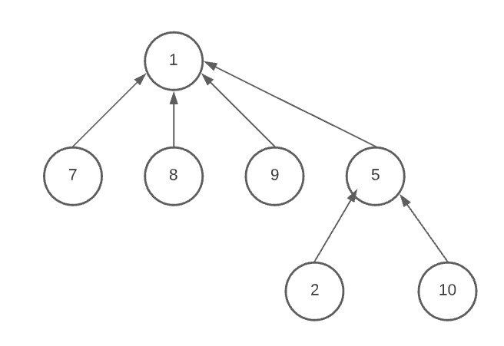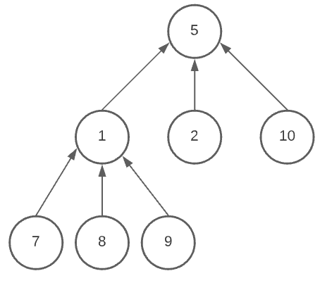

To obtain the union of 2 sets all that has to be done is to set the parent of one of the roots to the other root. This can be accomplished easily if, with each set name, we keep a pointer to the root of the tree representing the set.
If in addtion each root has a pointer to set name, then to detemine which set an element is currently in, we follow parent links to the root of its tree and use the pointer to the set name.
S₁, S₂, and S₃ may be of the form.

S1 | -1
S2 | -1
S3 | -1

3
5
1

₁₀

6

4

9

8

7

2

We represent the element with their parent elements using an array parent [] as follows
i | 1 | 2 | 3 | 4 | 5 | 6 | 7 | 8 | 9 | 10
P[i] | -1 | 5 | -1 | 3 | 1 | 3 | 1 | 1 | 1 | 5

S₁US₂
S1 | -1
S2 | -1
S3 | -1

3
5
1

6

4

₁₀

2

9

8

7

Union(i,j) is a simple operation. We pass into union() roots of 2 trees i and j and make the first tree as child of second as vice versa find(i) starts at index i and follows the parent indices until the parent value is -1

For the above eg,
i | 1 | 2 | 3 | 4 | 5 | 6 | 7 | 8 | 9 | 10
P[i] | -1 | 5 | -1 | 3 | 1 | 3 | 1 | 1 | 1 | 5

Find (10) parent [10] = 5 > 0 and
Parent [5] = 1 > 0
Parent [1] = -1 < 0
∴ return 1

Algorithm SimpleUnion( i, j)
{
// i and j are roots of 2 sets and i ≠ j, p[i] stores the parent of the element i, p[] stores
// the parent nodes of all the elements of sets
p[i] $∶=$j; //p[j] $∶=$i;
}

Algorithm SimpleFind(i)
{
// i is an element whose set is to be found.
// p[] is an array which stroes the parent
// elements.
while (p[i] ≥ 0) do
{
i$∶=$ p[i];
}
return i;
}

Weighting rule for Union(i, j) :- If the number of nodes in the tree with root i is less than the number of nodes in the tree with root j, then make j the parent of i, otherwise make i the parent of j.
Eg.
S₁ 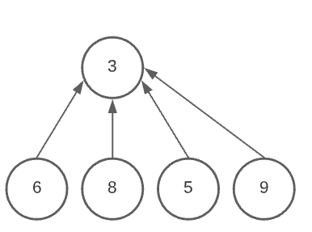
S₂
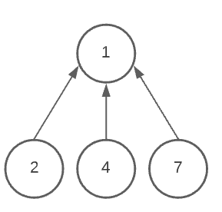
No, of nodes in S₂ is greater than S₂
∴ S₂ is made parent of S₁
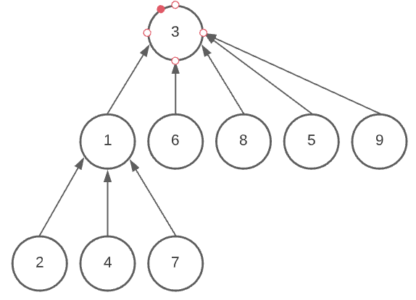
Algorithm Weighted Union(i, j)
{
// i and j are root nodes of 2 sets, i ≠ j
// ct[i] and ct[j] are the counts of the
// nodes present in sets i and j , p[] is parent
// array
temp $∶=$ ct[i] + ct[j];
if (ct[i] > ct[j]) then
{
// j has fewer nodes
p[j] $∶=$i ;
ct[i] $∶= temp ;$
}
else
{
p[i] $∶=$ j;
ct[j] $∶=$ temp;
}
}

Collapsing Rule for Find :- If j is a node on the path from i to its roots and p[i] ≠ root then set p[j] to root[i].
Algorithm Collapsing Find (i)
{
// Find the root of the tree containing
// element i. Use the collapsing rule to
// collapse all nodes from i to the root.
r $∶=$ i;
while (p[r] > 0) do
{
r $∶=$ p[r];
}
While (i ≠ r) do
{
s $∶=$ p[i];
p[i] $∶=$r;
i $∶=$ s;
}
return r;
}

import java.util.*;
public class UnionFind
{
static int n;
static int p[];
static int find(int i)
{
while(p[i]>0)
i=p[i];
return i;
}
static void union(int i,int j)
{
if(p[i]!=-1)
i=find(i);
if(p[j]!=-1)
j=find(j);
p[i]=j;
}

public static void main(String[] args)
{
Scanner s=new Scanner(System.in);
System.out.println("Enter number of vertices");
n=s.nextInt();
p=new int[n+1];
for(int i=1;i<=n;i++)
{
p[i]=-1;
}
union(3,1);
union(5,1);
union(9,5);
union(4,2);
union(6,4);
union(7,8);
union(10,8);
for(int i=1;i<=n;i++)
{
System.out.print(p[i]+" ");
}
System.out.println();
}
}

