Divide And Conquer
Let P be a problem to be solved. We assume problem has n inputs.
Small(p)is a Boolean valued function that determine whether the input size is smaller enough so that the answer can be computed without splitting
S(P) is a function which finds solution of P
D and C (P) is a function which finds the solution of every subproblem after the problem is divided into K subproblems K>1
Combine() is a function which determines solution P using the solutions of K subproblems. The computing time is described using the recurrence relation

T(n)=$\left\{\begin{aligned}g(n) , if n is small \\ T(n1)+T(n2)+....+T(nk)+f(n) otherwise\end{aligned}\right.$ 1

g(n) is time to compute answer for smaller inputs f(n) is the time for dividing P and combing solutions to subproblems.
Control Abstraction for Divide and Conquer
Algorithm D and C (P)
{
if small(P) then return S(P);
else
{
Divide P into smaller instances P1,P2,…..P_{k}, k ≥ 1;
Apply D and C to each of these subproblems ;
return combine(D and C(P_{1 ),} D and C(P₂)……….D and C(P_{K}));
}
}
Assuming smallest sized input as T(1), size of each subproblem as n/b and there are ‘a’ subproblems where ‘a’ and ‘b’ are known constants and n=b^{k} the recurrence relation 1 will be as follows.
T(n)=$\left\{\begin{aligned}T(1) , if n =1 \\ aT\left(\frac{n}{b}\right)+ f(n) if n > 1\end{aligned}\right.$

E.g. Considering the case where a=2, b=2,
T(1)=2 and f(n)=n
T(n)= 2T$\left(\frac{n}{2}\right)$+n (n=2^{k}, k=log₂n)
=2$\left[2T\left(\frac{n}{4}\right)+\frac{n}{2}\right]$+ n
= 4T$\left(\frac{n}{4}\right)$+n+n
= 4T$\left(\frac{n}{4}\right)$+2n
=4$\left[2T\left(\frac{n}{8}\right)+\frac{n}{4}\right]$+ 2n
=8T$\left(\frac{n}{8}\right)$+n+2n
=8T$\left(\frac{n}{8}\right)$+3n
=2³T$\left(\frac{n}{2^{3}}\right)$+3n
:
:
=2^{k}T$\left(\frac{n}{2^{k}}\right)$+K_{n}
= n T(1)+nlog₂^{n}
= 2n + nlog₂^{n}
$≅$O(nlog₂^{n})

Applications
- Binary search
- Quick sort
- Merge sort
- Strassen matrix multiplication
- Select algorithm
- Maximum and minimum

Binary Search
Let a_{i} , 1≤ I ≤ n be a list of elements in sorted non decreasing order. We must check whether an element x is present or not

Steps
- Assume I position as lower bound(l) and n^{th} position as upper bound(n)
- Find the middle position, mid=[ (l+4)/2]
- if x=A[mid] then return mid
- if x>a[mid] then l=mid+1 and repeat from 2
- if x<a[mid] then 4=mid-1 and repeat from 2
- If l > 4 return -1 indicating element not found

E.g.1
A ll 2 3 4 5 6 7 8 9 10u
-5 | -2 | 0 | 3 | 6 | 9 | 12 | 15 | 17 | 19

mid
^{X>a[mid]}
^{l=mid+1}
mid=[(1+10)/2]=5
l6 7 8 9 10u
9 | 12 | 15 | 17 | 19

Mid
Mid=[(6+10)/2]=8 x<A[mid]
m=mid-1
9 | 12
l u

6 7

Mid=[(6+7)/2]=6 x>A[mid]
L=mid+1

l u
12

Mid
7
Mid=[(7+7)/2]=7 x=A[mid] , return mid

E.g.2:
ll2 3 4 5 6 7 8 9 10 u
-5 | -2 | 0 | 3 | 6 | 9 | 12 | 15 | 17 | 19

mid x>A[mid] , l=mid+1
mid =[(1+10)/2]=5
l6 7 8 9 10 u
9 | 12 | 15 | 17 | 19

mid
mid=[(6+10)/2]=8 x<A[mid] , u=mid-1

l6 7 u
9 | 12

mid
mid=[(6&)/2]=6 x>A[mid] , l=mid+1
l7 u
12

mid
mid=[(7+7)/2]=7 x>A[mid] , l=mid+1
l=8 u=7
. .
. l> u element not found

Recursive Algorithm
Algorithm RBinary Search(A, l, u, x)
{
//A is a sorted array of n elements, l
// is lower bound, u is upper bound, x is
// the element to search.
if (l=u) then
{
if(x=A[l]) then
return l;
else
return -1;
}
else if(l <u) then
{
mid=[(l+u)/2];
if (x=A[mid]) then
return mid;
else if(x> A[mid]) then
return RBinary Search(A,mid+1,ux);
else
return RBinarySearch(A, l, mid-1, x);
}
}

Iterative Algorithm
Algorithm BinarySearch(A, n,x)
{
// A is a sorted array of size n ; x is
// the element to search
l$∶=$1;
u $∶= n ;$
while (l ≤ u) do
{
mid $∶=$[(l+u)/2];
if(x = A[mid]) then
return mid;
else if(x > A[mid]) then
l $∶=$ mid+1;
else
u $∶=$mid -1;
}
return -1;
}

Time Complexity (Average and worst case)

T(n)=$\left\{\begin{aligned}T(1) , if n =1 \\ T\left(\frac{n}{2}\right)+ 1 if n > 1\end{aligned}\right.$ n=2^{k}
K=log₂^{n}
T(n)=T$\left(\frac{n}{2}\right)$+1
=T$\left(\frac{n}{4}\right)$+1+1
=T$\left(\frac{n}{4}\right)$+2
=T$\left(\frac{n}{8}\right)$+1+2
=T$\left(\frac{n}{8}\right)$+3
=T$\left(\frac{n}{2^{3}}\right)$+3
:
= T$\left(\frac{n}{2^{k}}\right)$+k
=T(1)+log₂n
=log₂n + 1
= O(llog₂n)

Best case= O(1) if element is exactly in middle position
Quick Sort

- Assume first position as l and last position as u
- Assume first value as pivot.
- Compare assume i as l+1, j as u
- Compare ith position value with pivot. It ith position value is less than or equal to pivot increment iby l.
- Repeat step 4 until ith position value becomes greater than pivot.
- Compare j th position value with pivot. If j th position value is greater than pivot decrement j by 1.
- Repeat step 6 until j th position value becomes lesser than pivot.
- If i<j swap ith position value by j th position value and repeat step 4 to 7.
- If i>j swap j th position value by value present in ith position.
- If l<u repeat step 1 to 9 for l to j-1 and j+1 to u.

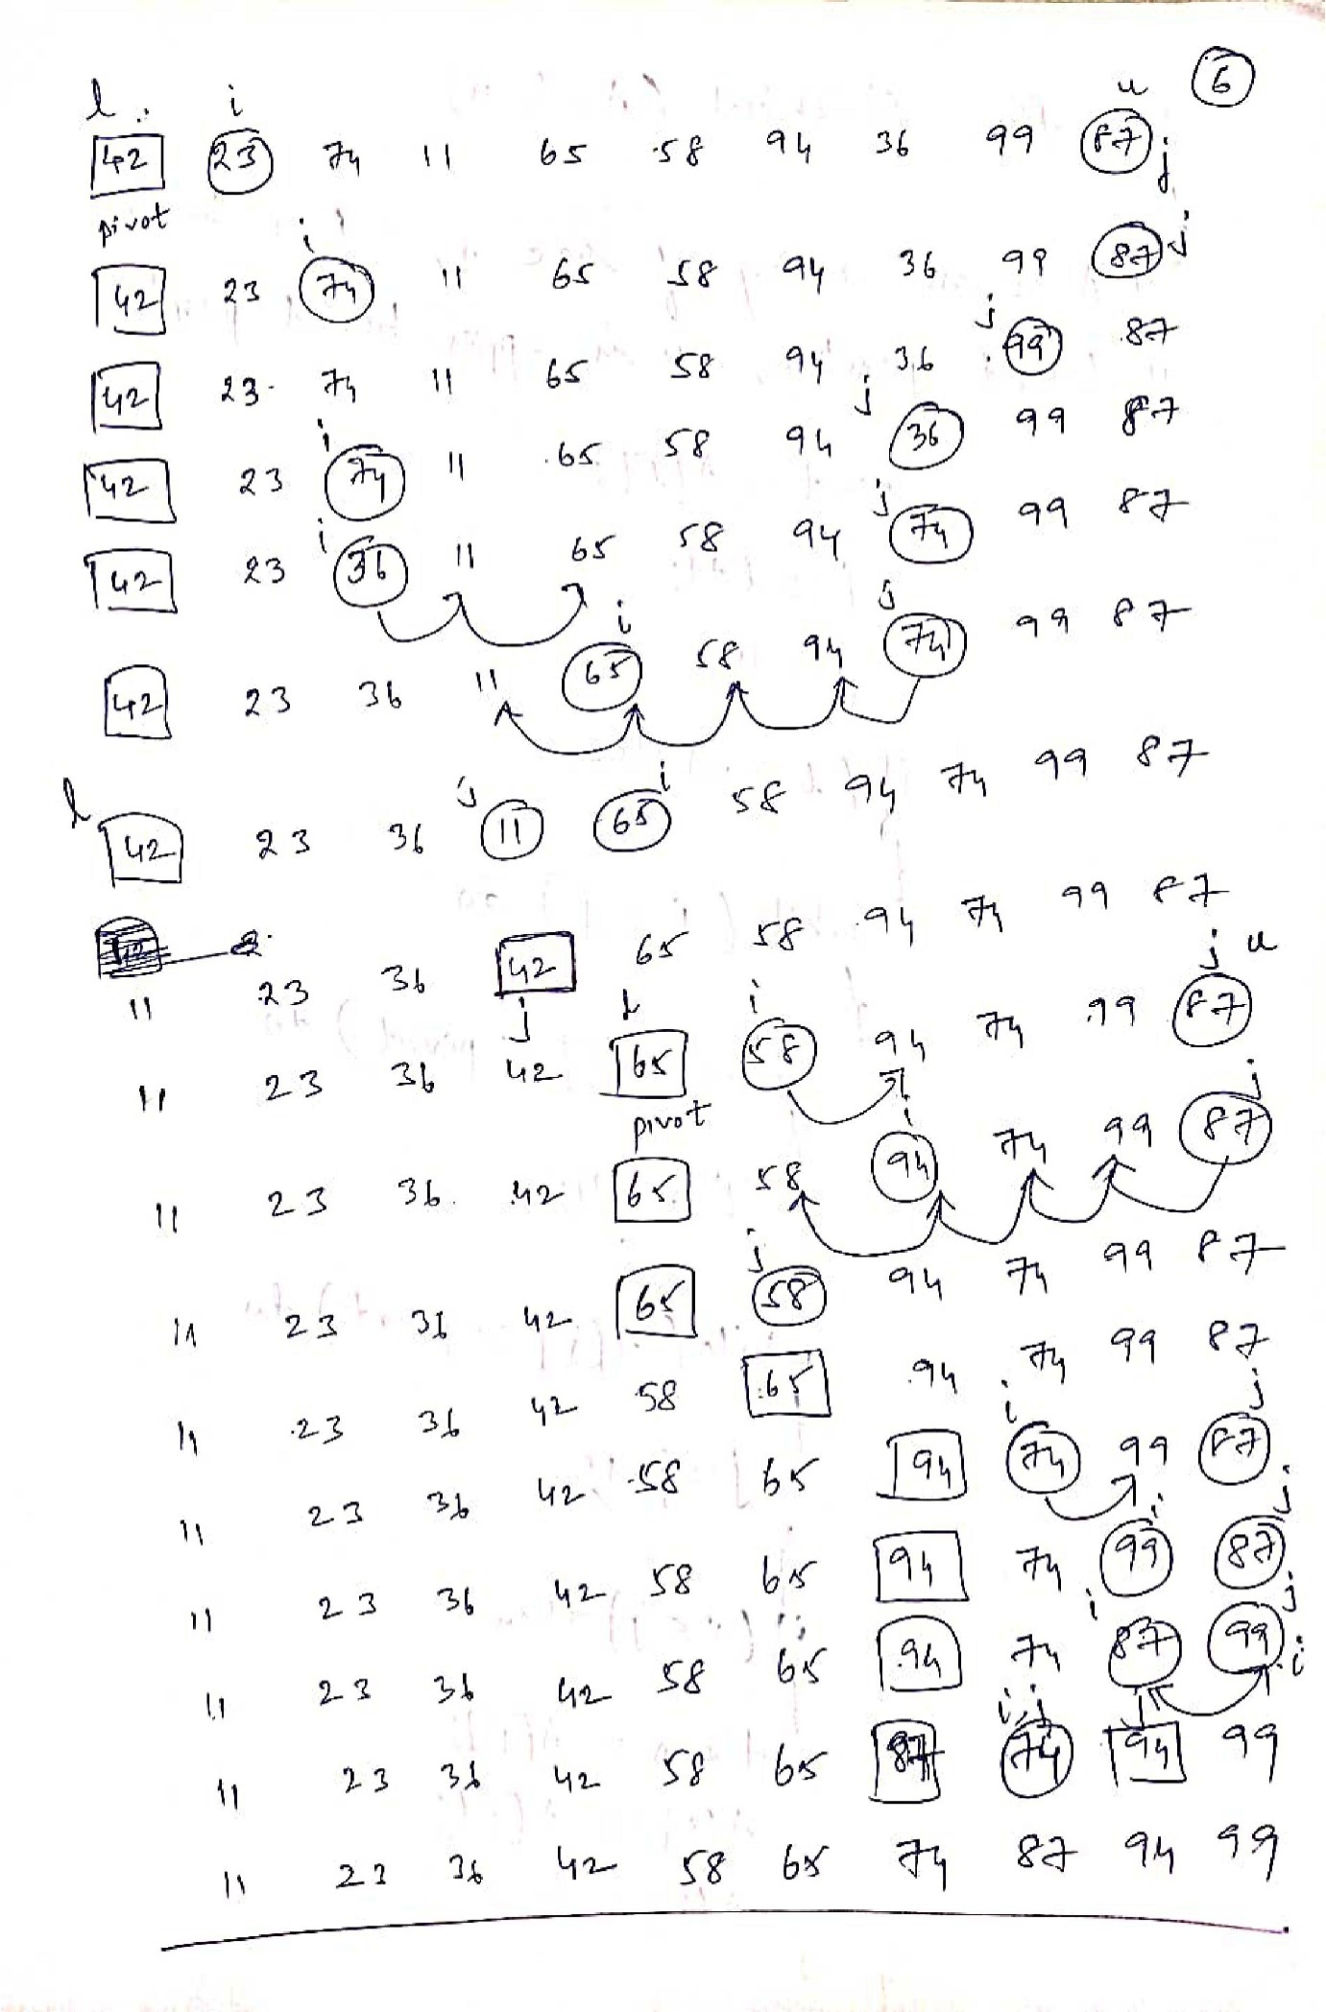
Algorithm Quicksort(A, l, n)
{
// A is an array of size n, l is lower
// bound position, u is upper bound position
Pivot $∶=$ A[l];
i$∶=$ l+1;
j $∶=$ u;
if (l < u) then
{
while (i ≤ j) do
{
while (A[i] ≤ pivot) do
{
i$∶=$ i+1;
}
while(A[j] > pivot) do
{
j$∶=$j-1;
}
if(i< j) then
{
temp $∶=$A[i];
A[i] $∶=$A[j];
A[i] $∶=$temp;
}
}
temp $∶=$ A[j];
A[j] $∶=$A[l];
A[l] $∶=$temp;
Quicksort(A, l, j-1);
Quicksort(A, j+1, u);
}
}

Time Complexity :-
Best and average cases
T(n)=$1\left\{\begin{aligned}1 , if n =1 \\ 2T\left(\frac{n}{2}\right)+ cn if n > 1\end{aligned}\right.$

T(n)= $2T\left(\frac{n}{2}\right)+ cn$
= 2$\left[2T \left(\frac{n}{4}\right)+\frac{cn}{2}\right]+cn$
=4T$\left(\frac{n}{4}\right)$+cn+cn
=4T$\left(\frac{n}{4}\right)$+2cn
=4$\left[2T \left(\frac{n}{8}\right)+\frac{cn}{4}\right]+2cn$
=8T$\left(\frac{n}{8}\right)$+cn+2cn
=8T$\left(\frac{n}{8}\right)$+3cn
=2³T$\left(\frac{n}{2^{3}}\right)$+3cn
= : n= 2^{k} , k=log₂n
= 2^{k}T$\left(\frac{n}{2^{k}}\right)$+kcn
= n T(1) +cnlog₂^{n}
= n+cnlog₂^{n}$≅$ O(nlog₂^{n})

Worst Case(If list already sorted)
T(n)=$\left\{\begin{aligned}1 , if n =1 \\ T\left(n-1\right)+ n +n\end{aligned}\right.$

T(n)=n+T(n-1)
=n+(n-1)+T(n-2)
=n+(n=1)+(n-2+T(n-3)
:
:
=n+(n+1)+(n-2)+(n-3)+……..T(1)
=n+(n-1)+(n-2)+(n-3)+………..1
=$\frac{n(n+1)}{2}$ = $\frac{n^{2}+n}{2}$ = O(n²)

Merge Sort
- Assume first position as l and last position as u;
- Find mid position as mid=(l+u)/2
- Repeatedly divide the lists into 2 equal halves as (l to mid and (mid+1 to u)
- Repeat step 3 until l<u.
- After dividing the list we merge two lists into a single list by comparing the elements of the two lists.
- Repeat step 6 until all the elements are combined into a single list.

Algorithm mergesort(A, l, u)
{
// A is an array of size n, l is lower
// bound, u is upper bound.

if(l < u) then
{
mid=[(l+4)/2];
merge sort (A, l ,mid);
merge sort(A, mid+1, u);
merge (A, l, mid+1, u);
}
}
Algorithm merge (A, l, m, u)
{
// A is an array, l is lower
// bound, m is mid+1 position, u is upper
// bound position.
l_{pos}$∶=$ l;
mid $∶=$ m-1;
j $∶=$1;
while(l_{pos} ≤ mid) and (m ≤ u)) do
{
if(A[l_{pos}] ≤ A[m]) then
{
temp[j] $∶=$ A[l_{pos}];
l_{pos}$∶=$ l_{pos}+1;
j $∶=$j+1;
}
else
{
temp[j] $∶=$ A[m];
m$∶=$m+1;
j$∶=$j+1;
}
}
while(l_{pos}≤ mid) do
{
temp[j] $∶=$A[l_{pos}];
l_{pos}$∶=$l_{pos} +1;
j $∶=$ j+1;
}
while (m ≤ u ) do
{
temp[j] $∶=$ A[m];
m $∶=$ m+1;
j $∶=$ j+1;
}
j$∶=$ 1;
for i$∶=$ l to u step 1 do
{
A[i] $∶=$ temp[j];
j$∶=$ j+1;
}
}

Time Complexity (Best, Average, Worst)
Since list is always divided into 2 equal valves
T(n)=$\left\{\begin{aligned}1 , if n =1 \\ 2T\left(\frac{n}{2}\right)+ cn if n>1\end{aligned}\right.$

T(n)= 2T$\left(\frac{n}{2}\right)$+cn
=2$\left[2T \left(\frac{n}{4}\right)+\frac{cn}{4}\right]+cn$
=4T$\left(\frac{n}{4}\right)$+cn+cn
=4T$\left(\frac{n}{4}\right)$+2cn
=4$\left[2T \left(\frac{n}{8}\right)+\frac{cn}{4}\right]+2cn$
=8T$\left(\frac{n}{8}\right)$+cn+2cn
=8T$\left(\frac{n}{8}\right)$+3cn n=2^{k}, k=log₂n
=2³T$\left(\frac{n}{2^{3}}\right)$+3cn
:
:
=2^{k}T$\left(\frac{n}{2^{k}}\right)$+kcn
=nT(1)+cnlog₂^{n}
=n+cnlog₂^{n}
$≅$ O(nlog₂^{n})

Maximum and Minimum
Problem is to find the maximum and minimum from the list of given numbers
Algorithm StraightMaxMin (a, n, max, mn)
{
max $∶=$ min $∶=$ a[1];
for i$∶=$2 to n step 1 do
{
if (a[i] >max) then
max $≔a\left[i\right];$
if (a[i] <min) then
min $≔$a[i];
}
}

The number of compassions is 2(n-1)
We can reduce the number of compressions by changing conditional stunts as
if(a[i] > max) than
max $≔$a[i];
else if(a[i] < min) then
min $≔$a[i];

If an element is greater than max then if cannot be less than min.
∴Second conditional stunt is written in else block
Best case occurs when elements are in increasing order. i.e (n-1) comparisons
Worst case occurs when elements are in decreasing order. i.e 2 (n-1) comparisons
Average case : $\frac{2n-2+n-1}{2}$= $\frac{3n-3}{2}=\frac{8n}{2}$-1.5

Divide and conquer algorithms for maximin problem would be as follows
Let p=(n, a[i] ,….a[n])
if (n≤ 2) then it is a small problem
else
we split the list into 2 sublists
P1=(n/2,a[i]…..a[n/2])
P2=(n-n/2,a[n/2+1],….a[n])

Find max1,min1 from list p1
max1,min2 from list p2
Then max and min of whole list P will be as follows
if(max1 > max2)
max $∶=$ max1;
else
max $∶=$ max2;
if (min1 < min2)
min $∶=$min 1;
else
min $∶= min2;$

Algorithm MaxMin(I, j, max, min)
{
//a[1:n] is aglobal array. Parameters I and j are
//integers 1≤i≤j≤n . We must set max and min
// to largest and smallest values in a[i:j]
//respectively
if(i= j) then //small(P)
max $∶=$ min $∶=$a[i];
else if (i=j-1) then
{
if(a[i] < a[j]) then
{
max $∶=$a[j];
min $∶=$ a[i];
}
else
{
max $∶=$ a[i];
min $:=a\left[j\right];$
}
}
else
{
// if p is not small, divide p into subproblems
// find where to split the set
Mid $:=\left[\left(i+j\right)/2\right];$
// solve subproblems
maxmin(i, mid, max, min);
maxmin(mid+1, j, max1, min1);
// combine the solutions.
if(max < max1) then
max $:=$ max1;
if(min > min1) then
Min $:=$ min1;
}
}

E.g.
1 2 3 4 5 6 7 8 9
22 | 13 | -5 | -8 | 15 | 60 | 17 | 31 | 47

1, 9, 60, -8

6,9,60,17
1,5 , 22,-8

1,5 , 22,-8
6,7,60,17
8,9
1,3,2,2,5

1,5 , 22,-8
1,2,22,13

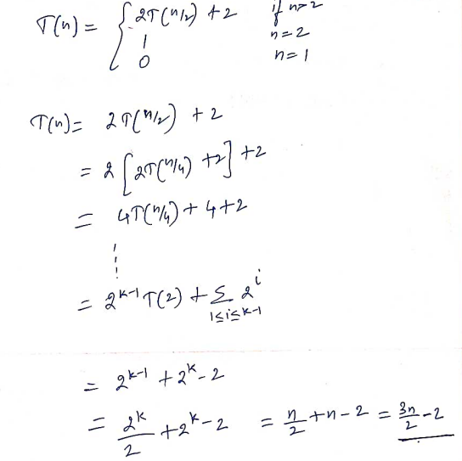

Brute Force Algorithms

Brute force = try all possible solutions, evaluate each, and pick the best/valid one. Simple to design and prove correct, but typically exponential (or worse) in running time.

1. Knapsack Problem (0/1)
Problem: Given n items with weights w_i, values v_i, and knapsack capacity W, choose a subset maximizing total value without exceeding capacity W.

Brute Force Approach
- Every item is either included or excluded → 2^n possible subsets.
- Generate all subsets, discard those exceeding capacity W, and track the maximum-value valid subset.

Pseudocode
maxValue = 0
for each subset S of {1, 2, ..., n}: # 2^n subsets
totalWeight = sum(w[i] for i in S)
totalValue = sum(v[i] for i in S)
if totalWeight <= W and totalValue > maxValue:
maxValue = totalValue
bestSet = S
return maxValue, bestSet

Complexity
- Time: O(2^n · n) — 2^n subsets, O(n) to evaluate each.
- Space: O(n) if subsets are generated iteratively rather than stored.

2. Traveling Salesman Problem (TSP)
Problem: Given n cities and pairwise distances, find the shortest possible route that visits every city exactly once and returns to the starting city.

Brute Force Approach
- Fix a starting city (removes redundant rotations of the same tour).
- Generate all permutations of the remaining n − 1 cities.
- Compute the total tour cost for each permutation; keep the minimum.

Pseudocode
minCost = infinity
for each permutation P of {2, 3, ..., n}: # (n-1)! permutations
route = [1] + P + [1]
cost = sum of distances along route
if cost < minCost:
minCost = cost
bestRoute = route
return minCost, bestRoute

Complexity
- Time: O(n!) — or O((n-1)!) with a fixed start; each tour costs O(n) to evaluate, so overall O(n! · n).
- Space: O(n) per permutation.

3. Convex Hull
Problem: Given n points in the plane, find the smallest convex polygon (a subset of the points) that contains all of them.

Brute Force Approach
Key geometric fact: an edge (p_i, p_j) is part of the convex hull if and only if all other points lie strictly on one side of the line through p_i and p_j.
- Check every pair of points (p_i, p_j).
- For each pair, test all other n − 2 points: are they all on the same side (using the cross-product sign)?
- If yes, (p_i, p_j) is a hull edge.

Pseudocode

hullEdges = []
for each pair (p_i, p_j), i ≠ j: # O(n^2) pairs
positive = 0; negative = 0
for each point p_k, k ≠ i, j: # O(n) check
d = cross(p_j - p_i, p_k - p_i)
if d > 0: positive++
if d < 0: negative++
if positive == 0 or negative == 0:
hullEdges.add((p_i, p_j)) # all points on one side
return hullEdges

Complexity
- Time: O(n³) — O(n²) pairs × O(n) side-check per pair.
- Space: O(n) for storing hull edges.

A convex hull edge must have all other points on the same side of its supporting line.

QuickSort

/*
Java Program to sort a set of values using Quick Sort
Sample Input and Output:
Input:
10
42 23 74 11 65 58 94 36 99 87
Output:
11 23 36 42 58 65 74 87 94 99
*/

import java.util.*;
class QuickSort
{
static void qsort(int a[],int l,int u)
{
int pivot,i,j,temp;
if(l<u)
{
pivot=a[l];
i=l+1;
j=u;
while(i<=j)
{
while(i<=u&&a[i]<=pivot)
i++;
while(j>=l&&a[j]>pivot)
j--;
if(i<j)
{
temp=a[i];
a[i]=a[j];
a[j]=temp;
}
}
temp=a[j];
a[j]=a[l];
a[l]=temp;
qsort(a,l,j-1);
qsort(a,j+1,u);
}
}

public static void main(String[] args)
{
Scanner s=new Scanner(System.in);
int n=s.nextInt();
int a[]=new int[n];
for(int i=0;i<n;i++)
a[i]=s.nextInt();
qsort(a,0,n-1);
for(int i=0;i<n;i++)
System.out.print(a[i]+" ");
}
}

MergeSort

/*
Java Program to sort a set of values using Merge Sort
Sample Input and Output:
Input:
10
42 23 74 11 65 58 94 36 99 87
Output:11 23 36 42 58 65 74 87 94 99
*/

import java.util.*;
class MergeSort
{
static void mergesort(int a[],int l,int u)
{
int mid;
if(l<u)
{
mid=(l+u)/2;
mergesort(a,l,mid);
mergesort(a,mid+1,u);
merge(a,l,mid+1,u);
}
}
static void merge(int a[],int l,int m,int u)
{
int mid=m-1,lpos=l,i,j=0;
int temp[]=new int[a.length];
while(lpos<=mid&&m<=u)
{
if(a[lpos]<=a[m])
temp[j++]=a[lpos++];
else
temp[j++]=a[m++];
}
while(lpos<=mid)
temp[j++]=a[lpos++];
while(m<=u)
temp[j++]=a[m++];

for(i=l,j=0;i<=u;i++,j++)
a[i]=temp[j];
}

public static void main(String[] args)
{
Scanner s=new Scanner(System.in);

int n=s.nextInt();
int a[]=new int[n];

for(int i=0;i<n;i++)
a[i]=s.nextInt();
mergesort(a,0,n-1);

for(int i=0;i<n;i++)
System.out.print(a[i]+" ");
}
}

Binary Search

import java.util.*;
class BinarySearch
{
static int bsearch(int a[],int n,int x)
{
int l=0,u=n-1;
while(l<=u)
{
int mid=(l+u)/2;
if(x>a[mid])
l=mid+1;
else if(x<a[mid])
u=mid-1;
else
return mid+1;
}
return -1;
}
public static void main(String[] args)
{
Scanner s=new Scanner(System.in);
System.out.println("Enter the size of the array");
int size=s.nextInt();
int a[]=new int[size];
System.out.println("Enter array elements in sorted order");
for(int i=0;i<size;i++)
{
a[i]=s.nextInt();
}
System.out.println("Enter element to search");
int x=s.nextInt();
int p=bsearch(a,n,x)
if(p==-1)
{
System.out.println(" Element not found ");
}
else
{
System.out.println("Element found at position "+p);
}
}
}

Maximum and Minimum

import java.util.*;
class MaxMin
{
int max;
int min;

MaxMin(int max, int min)
{
this.max = max;
this.min = min;
}
}

public class DivideAndConquerMaxMin {

// Function to find maximum and minimum using Divide and Conquer
static MaxMin findMaxMin(int arr[], int low, int high) {

// If there is only one element
if (low == high) {
return new MaxMin(arr[low], arr[low]);
}

// If there are two elements
if (high == low + 1) {
if (arr[low] > arr[high])
return new MaxMin(arr[low], arr[high]);
else
return new MaxMin(arr[high], arr[low]);
}

// Divide the array into two halves
int mid = (low + high) / 2;

MaxMin left = findMaxMin(arr, low, mid);
MaxMin right = findMaxMin(arr, mid + 1, high);

// Combine the results
int maximum = Math.max(left.max, right.max);
int minimum = Math.min(left.min, right.min);

return new MaxMin(maximum, minimum);
}

public static void main(String[] args)
{
Scanner sc = new Scanner(System.in);
System.out.print("Enter the number of elements: ");
int n = sc.nextInt();
int arr[] = new int[n];
System.out.println("Enter the array elements:");
for (int i = 0; i < n; i++)
{
arr[i] = sc.nextInt();
}
MaxMin result = findMaxMin(arr, 0, n - 1);
System.out.println("Maximum Element = " + result.max);
System.out.println("Minimum Element = " + result.min);
}
}

