**Create a write-up summarizing your major findings. This should include a heading for each "question" you asked of your data, and under each heading, a short description of what you found and any relevant plots.**

1. Are certain months or years more crime prone?
   * Over the years, 2010 to 2017, violent crimes have increased in Los Angeles.

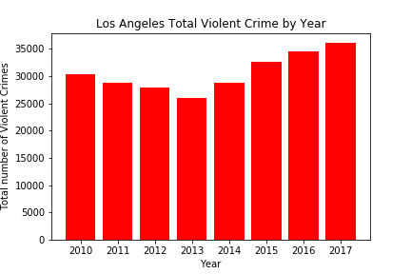

* + With the exception of months like February, November and December, there is a lack of significant monthly variations in incidence of violent crime.

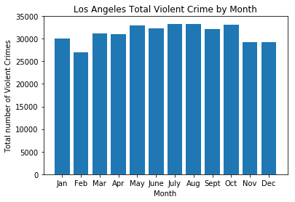

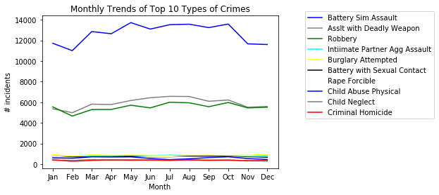

1. Can we identify safe versus not-so-far neighborhoods?

* In general violent crime rate (as measured by the number of incidences per 100,000 individuals) has increased in the city of Los Angeles for the time period 2010 to 2017, at the zip-code level.

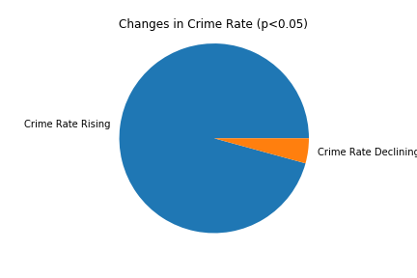

* There are, however, some zip-codes that have experienced significant decreases in crime rate over this time period, while others have become more unsafe. See charts on next page.

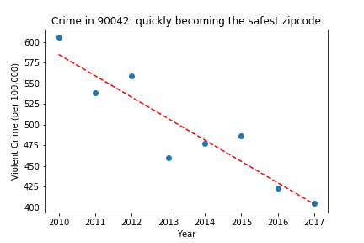

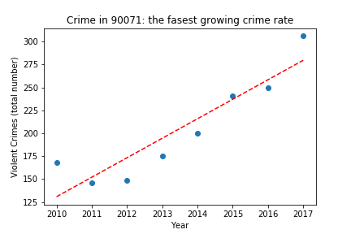

1. Do demographics matter in the incidence of crime?
   * **Population Density** (persons per square miles) has a positive correlation with crime rate.

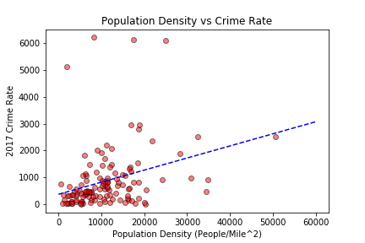

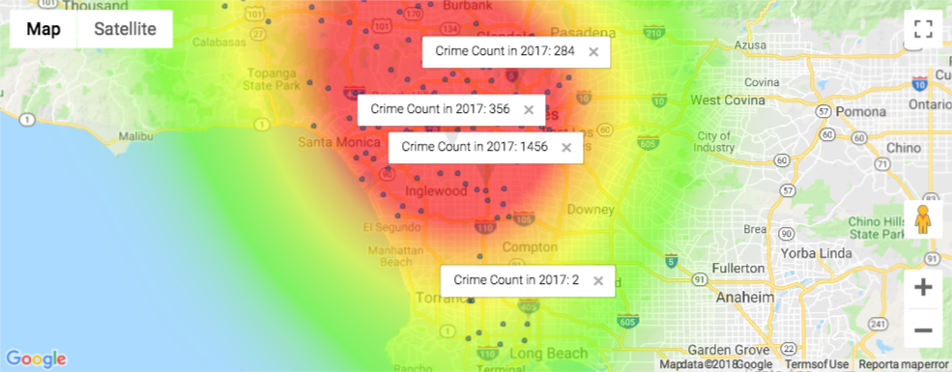

* + **Minority Groups**: Anecdotal evidence using heatmaps show that zip-codes with a higher percentage of non-Hispanic Black and Hispanic population are correlated with higher crime counts.

The following a heat map for the percentage of **Blacks** at the neighborhood of where the crime occurred in 2017.

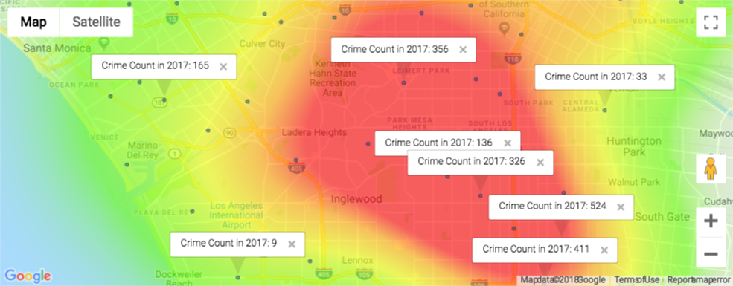

The following a heat map for the percentage of **Hispanics** at the neighborhood of where the crime occurred in 2017.

