AUTOSAR Document Intelligence Assistant
RAG-Powered ML Software Engineering Assignment Report
Course: AIMLCZG546 - Software Engineering for Machine Learning
Assignment I | Group 151 | BITS Pilani WILP
Submission artifacts: 151.docx, 151.pdf, 151.ipynb, source code repository
Submission readiness statement
This report consolidates the required project details, GR4ML requirement views, system architecture, selected architectural patterns, implementation evidence, screenshots, code references, testing evidence, and contribution details for Group 151.

# | BITS ID | Name | Qualitative Contribution | %
1 | 2025aa05473 | Abhinav Mandloi | Project integration, FastAPI gateway, report packaging, final verification | 30
2 | 2025aa05686 | Pritish Joshi | Retrieval pipeline, vector search, prompt/citation design | 25
3 | 2025aa05553 | Satwinder Singh | Quality requirements, health monitoring, heartbeat, reliability checks | 23
4 | 2025aa05533 | Shray Vijay | UI, feedback loop, tests, screenshots, documentation support | 22

1. Executive Summary
The AUTOSAR Document Intelligence Assistant is a local Retrieval-Augmented Generation (RAG) system for querying AUTOSAR Basic Software specification PDFs. It ingests PDF documents, extracts and chunks technical content, embeds chunks with a local neural embedding model, indexes them in ChromaDB, and answers natural language questions with source citations through a FastAPI application and chat UI.
- Domain: Automotive embedded software and AUTOSAR Basic Software specifications.
- ML task: semantic retrieval plus grounded answer generation using local Ollama models.
- Current indexed corpus: 5 AUTOSAR PDFs, 2,717 pages, 4,768 chunks.
- Verification: healthy service checks, passing focused tests, API search smoke test, and live UI answer screenshot.

2. Assignment Requirement Coverage
Assignment item | Evidence in submission
Problem statement and ML domain | Defined in README, GR4ML_Requirements.md, and this report.
Measurable goals and requirement specifications | GR4ML goals, functional requirements, and non-functional requirements documented.
GR4ML Business View | docs/Business_View.md plus summarized in this report.
GR4ML Analytics Design View | docs/Analytics_Design_View.md plus summarized in this report.
GR4ML Data Preparation View | docs/Data_Preparation_View.md plus ingestion implementation.
Top three quality requirements | Accuracy, explainability, and availability documented with rationale.
System architecture diagram | HLD.png embedded below.
Two architectural patterns | RAG pattern and service-oriented/API-gateway decomposition with heartbeat/circuit breaker.
Implementation using technologies/tools | FastAPI, ChromaDB, Ollama, PyMuPDF, static chat UI, pytest.
Screenshots of application | UI, API docs, and generated answer screenshots included.
Code and contribution details | Code references and group contribution table included.

3. Problem Statement and ML Justification
AUTOSAR specifications are large, cross-referenced, and written in precise technical language. Engineers often need to locate exact configuration parameters, APIs, requirement IDs, and module relationships across multiple PDFs. Manual lookup can take 15-30 minutes per question and can miss relevant sections.
The selected ML solution is appropriate because semantic search is a relevance prediction task. Learned embeddings can match user questions to relevant specification chunks even when the wording differs, and the LLM can synthesize a readable answer from retrieved context while citations preserve traceability.
Goal ID | Metric | Target / evidence
G1 | Retrieval Precision@5 | Target >= 85%; designed through semantic chunking, embeddings, and reranking.
G2 | Retrieval latency | /query/search observed at 29-428 ms in smoke tests; full /query reports local LLM latency.
G3 | Hallucination control | Prompt guardrails plus citations; unsupported claims target < 5%.
G4 | Citation accuracy | Responses return document, page, section, and source chunks.
G5 | Ingestion throughput | Large System Template PDF ingested in 278.75 seconds for 2,261 pages.
G6 | Availability | Health and heartbeat endpoints check Ollama, models, and vector store.

4. GR4ML Views

4.1 Business View
Primary actors are embedded systems engineers, AUTOSAR integrators, technical leads, and QA/testing teams. The business goal is to query AUTOSAR specifications quickly and reliably so engineering decisions can be traced back to official source content.
- Decision goal: decide the correct technical implementation from AUTOSAR specification evidence.
- Question goal: identify the relevant specification content for a user query.
- Insight: the RAG system generates citation-backed answers and source snippets.

4.2 Analytics Design View
The analytics goal is semantic retrieval and answer generation for AUTOSAR questions. The design uses nomic-embed-text for embeddings, cosine similarity/HNSW search through ChromaDB, optional LLM reranking, prompt construction, and local llama3.2 generation.

4.3 Data Preparation View
The data pipeline parses PDFs, detects section-like headings and requirement IDs, chunks content by semantic boundaries, generates dense embeddings, and stores vector plus metadata records for citation-backed retrieval.
Operator | Implementation file | Purpose
PDF parsing | app/services/ingestion/parser.py | Extract text, page metadata, headings, and requirement IDs.
Semantic chunking | app/services/ingestion/chunker.py | Split by sections and token limits with overlap.
Embedding | app/services/ingestion/embedder.py | Generate local Ollama embeddings.
Vector indexing | app/storage/vector_store.py | Persist searchable vectors in ChromaDB.
Metadata store | app/storage/metadata_store.py | Track ingested documents and chunking parameters.

5. Top Three Quality Requirements
Quality requirement | Why it matters | Architectural response
Accuracy | Wrong AUTOSAR guidance can lead to incorrect embedded software decisions. | Section-aware chunking, embeddings, reranking, and source metadata.
Explainability | Engineers must verify answers against official specifications. | Citations include document, page, section, and source chunks.
Availability | The tool should not fail silently when local models or vector storage are unavailable. | Heartbeat checks, health endpoints, retry logic, and circuit breaker behavior.

6. System Architecture
The architecture separates one-time ingestion from runtime retrieval and generation. It also identifies ML and non-ML components, API surfaces, storage, feedback, and cross-cutting concerns.
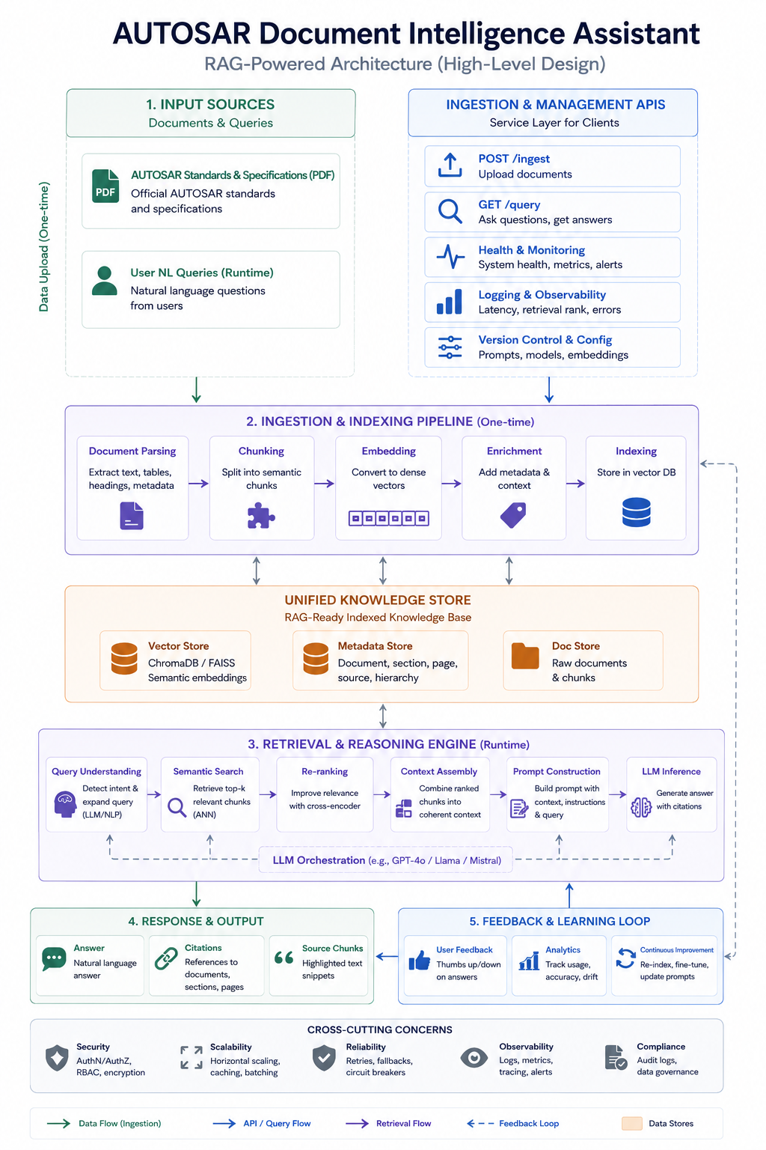
Figure 1. High-level architecture diagram showing ingestion, vector store, retrieval, response, feedback, and cross-cutting concerns.

7. Architectural Patterns Implemented

7.1 Pattern 1: Retrieval-Augmented Generation
RAG decouples domain knowledge from the LLM. AUTOSAR content is indexed in a vector store, relevant chunks are retrieved for a query, and the LLM is constrained to answer from the retrieved context with citations.
# app/services/retrieval/router.py
search_results = await semantic_search(query=request.question, top_k=retrieval_top_k)
ranked_results = await rerank(query=request.question, search_results=search_results, top_n=request.top_k)
context = assemble_context(ranked_results)
answer = await generate_completion(prompt=query_prompt, system_prompt=system_prompt)
citations = extract_citations(answer, ranked_results)

7.2 Pattern 2: Service-Oriented API Gateway with Heartbeat Reliability Tactic
The FastAPI application exposes bounded service routers for ingestion, retrieval, feedback, and monitoring. Cross-cutting middleware adds correlation IDs, and the heartbeat checks dependencies such as Ollama, the embedding model, the LLM model, and ChromaDB.
# app/main.py
app.include_router(health_router)
app.include_router(ingestion_router)
app.include_router(retrieval_router)
app.include_router(feedback_router)
# app/monitoring/health.py
await asyncio.gather(
check_ollama_api(), check_embedding_model(), check_llm_model(), check_vector_store()
)

8. Implementation Summary
Layer | Technology | Implemented capability
Frontend | Static HTML/CSS/JS | Chat UI, health status, feedback controls, source display.
API | FastAPI + uvicorn | REST endpoints, middleware, docs, global error handling.
Ingestion | PyMuPDF + custom chunker | PDF parsing, chunk creation, metadata enrichment.
ML embeddings | Ollama nomic-embed-text | Dense vector representations for document chunks and queries.
Vector DB | ChromaDB | Persistent similarity search over AUTOSAR chunks.
LLM | Ollama llama3.2 | Local grounded answer generation and reranking.
Monitoring | Health/metrics routers | Heartbeat, dependency checks, latency and usage metrics.
Testing | pytest | Parser, chunker, citations, health, error handling, UI regression, RAG checks.

9. Application Screenshots
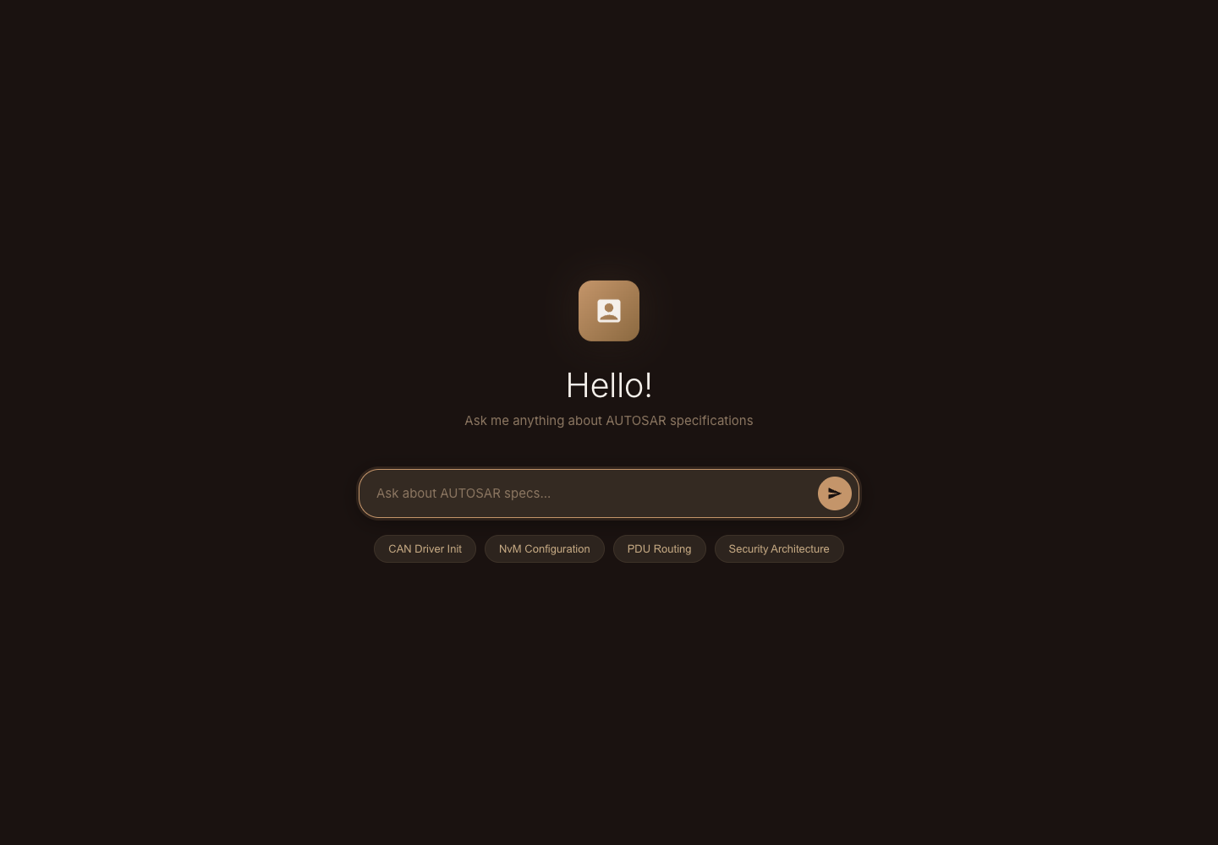
Figure 2. Chat UI home screen with healthy local service status.
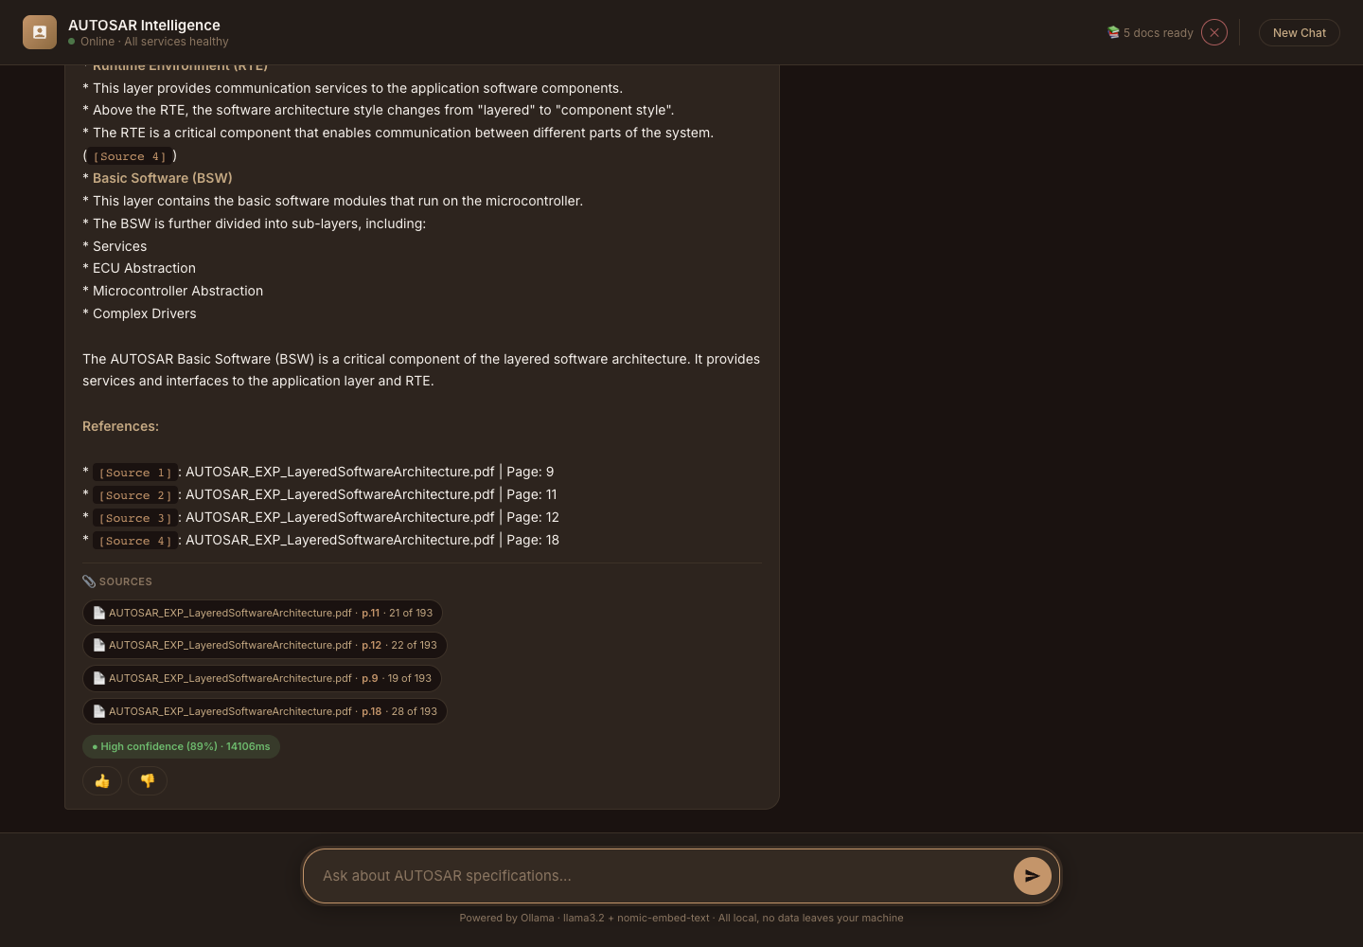
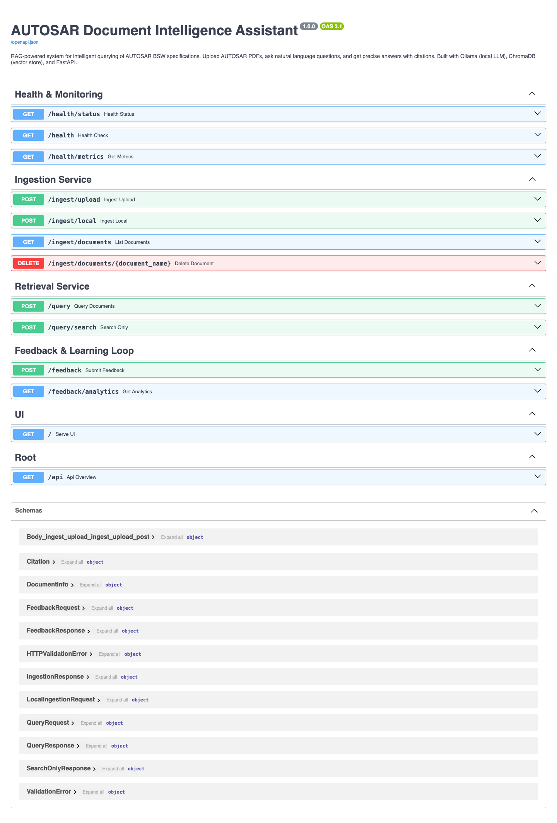
Figure 3. FastAPI OpenAPI documentation showing health, ingestion, retrieval, feedback, UI, and root endpoints.

10. Verification Evidence
Dependency | Status | Last healthy
ollama_api | healthy | 2026-07-02T16:25:27.725759+00:00
embedding_model | healthy | 2026-07-02T16:25:27.758559+00:00
llm_model | healthy | 2026-07-02T16:25:28.018646+00:00
vector_store | healthy | 2026-07-02T16:25:27.722577+00:00

Ingestion registry evidence:
Document | Pages | Chunks | Ingestion time
AUTOSAR_CP_SWS_CANDriver.pdf | 131 | 531 | 15.07 s
AUTOSAR_CP_TPS_SystemTemplate.pdf | 2261 | 3518 | 278.75 s
AUTOSAR_EXP_LayeredSoftwareArchitecture.pdf | 182 | 209 | 9.76 s
AUTOSAR_EXP_SecurityOverview.pdf | 26 | 86 | 3.72 s
AUTOSAR_SWS_EthernetDriver.pdf | 117 | 424 | 17.18 s

Retrieval smoke test evidence:
Question | Results | Latency | Top source
What is AUTOSAR layered software architecture? | 3 | 178.5 ms | AUTOSAR_EXP_LayeredSoftwareArchitecture.pdf

Latency note
The system intentionally uses local Ollama models for privacy and zero external API cost. Search-only retrieval is fast on the prepared vector store. Complete natural-language answer generation is local-LLM dependent and exposes latency_ms in the API/UI; observed full-answer runs ranged from about 21.7s to 44.5s on this machine.

11. Testing Summary
- Focused verification: 12/12 UI regression and non-expensive API tests passed.
- Broader pytest run: 51 tests passed before stopping the expensive full-ingestion integration path that reprocesses all PDFs.
- Notebook code cells were executed successfully against the local server: health, metadata, and query/search checks passed.
- Live UI screenshot captured a generated answer with citations from AUTOSAR_EXP_LayeredSoftwareArchitecture.pdf.

12. Final Submission Checklist
Item | Status
151.docx final report | Created
151.pdf final report | Created from DOCX via LibreOffice
151.ipynb notebook | Created and code cells validated
Group member details and contribution percentages | Included and totals 100%
Screenshots of application | Included
Architecture diagram | Included
Code references and snippets | Included
README group/member consistency | Fixed
README HLD image link | Fixed
Latency claims | Updated to measured retrieval/full-generation behavior

Deadline note
The assignment brief lists the due date as 30 June 2026, 23:00. This report cannot change the portal timestamp; it makes the local project and submission artifacts complete and consistent for upload or resubmission.

