NODE JS
Create app.js
And write a function
function hello(name){
console.log("Hello "+name)
}

hello("Chummu")
to run the code
>> node app.js

Creating a module <logger.js >
var url="";

function log(message){
console.log(message);
}

// module.exports.publicInterface=privateInterface;
module.exports.endPoint=url;
module.exports.log=log;

load this module from <logger.js> in <app.js>
const logger = require('./logger')
// require('./name.js') #to indicate current folder directory
// require('./subFolder/name.js') #to indicate subFolder folder directory
// require('../name.js') #to indicate parent folder directory
logger.log("Hello World");
to export only function instead of object from a js file
var url="";
function log(message){
console.log(message);
}
// module.exports.publicInterface=privateInterface;
// module.exports.endPoint=url;
// module.exports.log=log;
module.exports=log; // to export function only instead of object "log"
in <app.js>
const log = require('./logger')
// require('name') #to indicate built in module
// require('./name.js') #to indicate current folder directory
// require('./subFolder/name.js') #to indicate subFolder folder directory
// require('../name.js') #to indicate parent folder directory

// only log funtion now from <logger.js> in <app.js>
log("Hello World");

BUILT IN “EVENT MODULE”
const EventEmitter=require('events'); // EventEmitter is a class
const emitter = new EventEmitter(); // creating a object

// Register a Listener
emitter.on('messageLogged', function(eventArg){
console.log('Listener called',eventArg );
});
//Raise an Event
emitter.emit('messageLogged',{ id:1, url:'https://'});

CALLING EVENT ON <logger.js> AND LISTENING IT ON <app.js>
Logger.js :
const EventEmitter=require('events'); // EventEmitter is a class
var url="";

// Wrapping func in Logger class
class Logger extends EventEmitter{
log(message){
// send an HTTP request
console.log(message);
//Raise an Event
this.emit('messageLogged',{ id:1, url:'https://',loggedmessage:message
});
}
}
module.exports=Logger; // to export Logger Class
app.js
const EventEmitter=require('events'); // EventEmitter is a class

const Logger=require('./logger')
const logger=new Logger();

// Register a Listener
logger.on('messageLogged', (event)=>{
console.log('Listener called',event);
});
logger.log('Hello World');
output
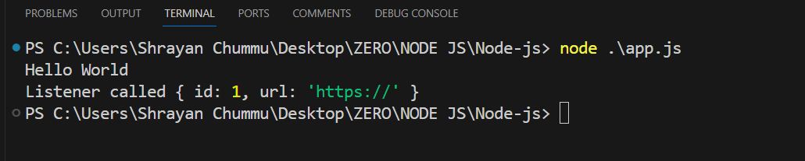
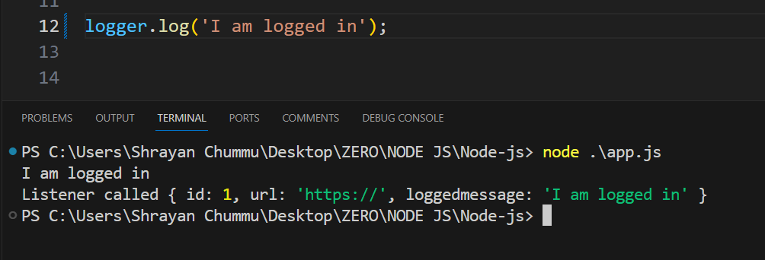
HTTP MODULE
Basics
const http=require('http');
const server=http.createServer();

server.on('connection',(socket)=>{
console.log('New Connection');
});

server.listen(3000);
console.log('Listening on Port 3000');
output (whenever you go to port 3000 <localhost:3000>)
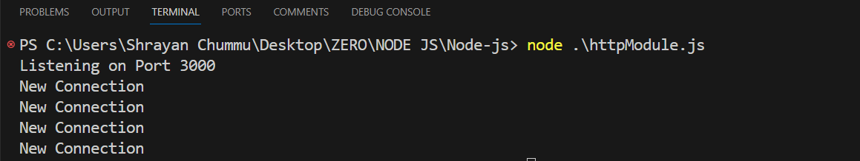
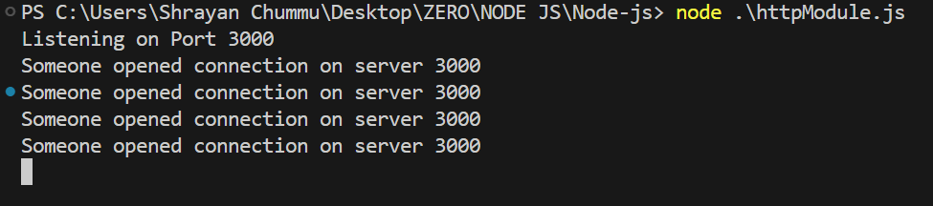
To exit from the console…press CTRL+C
ANOTHER VERSION OF HTTP MODULE WITH REQUEST AND RESPONSE
const http=require('http');
const server=http.createServer((req,res)=>{
if(req.url==='/'){
res.write('You are in Home Page');
res.end();
}
if(req.url==='/api'){
res.write('You are in /api page');
res.end();
}
});

server.listen(3000);
console.log('Listening on Port 3000');

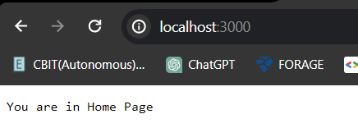
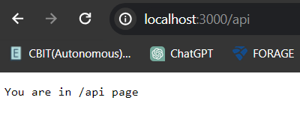
NPM (NODE PACKAGE MANAGER)
Before starting any project, we need to install some dependencies…so
>> npm init // npm init --yes
This creates <package.json> file
INSTALL <underscore> package
>>npm install underscore
Output:
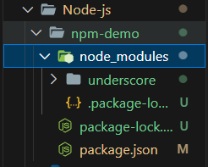
Using that UNDERSCORE Package
Create <index.js> in root folder <node-demo>
var _=require('underscore');
var result = _.contains([1,2,3],2);
console.log(result);

TO CHECK THE VERSION OF DEPENDENCIES USED
// npm list
or
// npm list –depth=0
TO INSTALL A SPECIFIC VERSION OF A DEPENDANCY
// npm install mongoose@x.x.x
TO INSTALL DEVELOPMENT DEPENDENCIES (which should not go in production environment)
// npm i <name> --save-dev
Example : // npm i jshint –save-dev
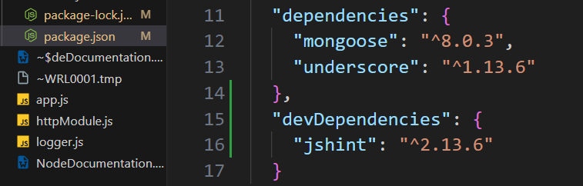

UNINSTALL DEPENDANCY
//npm uninstall <name>

EXPRESS.JS
Create a new folder <express-demo>
//npm init –yes (creates package.json file)
// npm i express
// create <index.js>
const express = require('express')
const app = express()
// this app object have all these methods
// app.get(); ('path',callback function)
// app.post();
// app.put();
// app.delete();

const express = require('express')
const app = express()

app.get('/', (req, res) => {
res.send('Hello World!');
});

app.listen(3000,()=>{
console.log('Listening on port 3000')
});

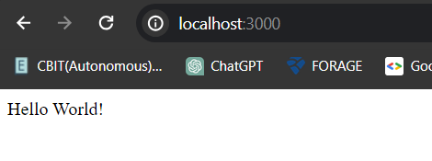
app.get('/api', (req, res)=>{
res.send([1,2,3]);
});

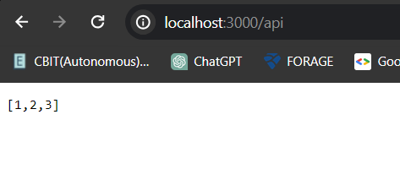
Environment variable for PORT
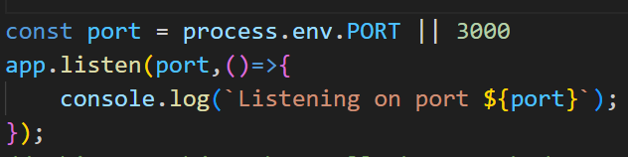
NODEMON
// npm i -g nodemon
// automatically saves and restarts the server
Use //nodemon <index.js> instead of node <index.js>
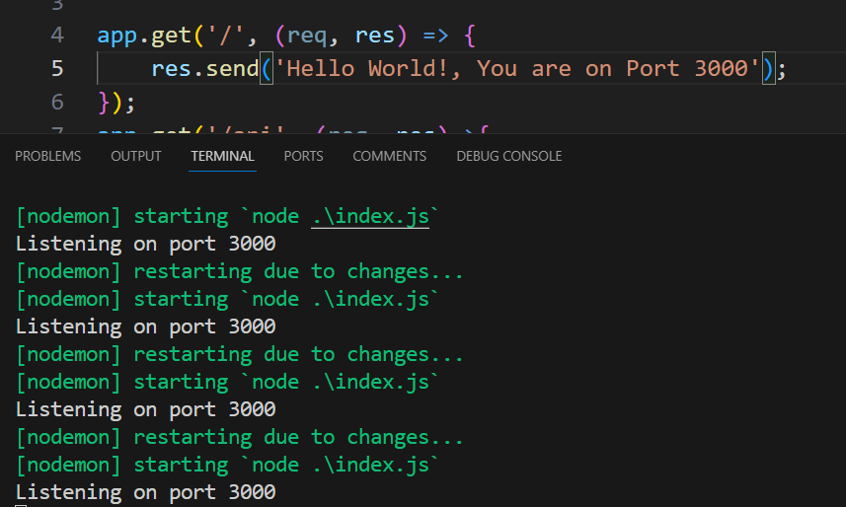
ROUTING PARAMETERS
// id & name are parameters
app.get('/api/:id/:name', (req, res)=>{
res.send(req.params); // req.params.id for only id
});

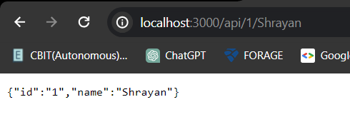
QUERY STRING PARAMETERS
http://localhost:3000/api/1/Shrayan?sortBy=id
http://localhost:3000/api/ROUTE_PARAMETERS?QUERY_STRING_PARAMETERS
app.get('/api/:id/:name', (req, res)=>{
res.send(req.query);
});

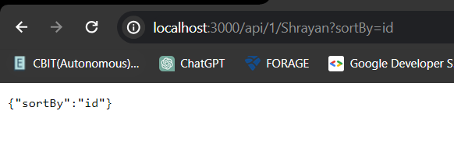
GET REQUEST
const express = require('express')
const app = express()
app.use(express.json());

const names = [
{id:1,name:'NAME1'},
{id:2,name:'NAME2'},
{id:3,name:'NAME3'},
];
app.get('/', (req, res) => {
res.send('Hello World!, You are on Port 3000');
});
app.get('/api/names', (req, res)=>{
res.send(names);
});
app.get('/api/names/:id', (req, res)=>{
const name=names.find(n => n.id === parseInt(req.params.id));
if(!name)
{
res.status(404).send('given id not found');
}
else
{
res.send(name);

}
});

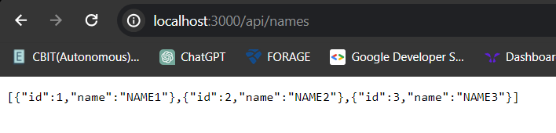
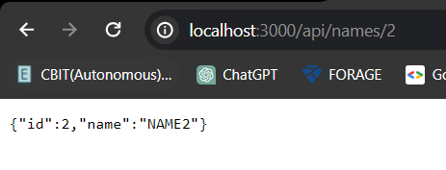
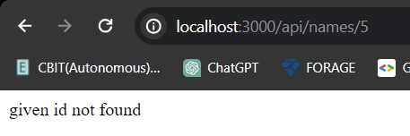
To check the status code
// inspect the page >> go to Networks >> press Ctrl+R

POST REQUEST
const express = require('express')
const app = express()
app.use(express.json());

const names = [
{id:1,name:'NAME1'},
{id:2,name:'NAME2'},
{id:3,name:'NAME3'},
];

app.post('/api/names',(req, res)=>{
const newName={
id:names.length+1,
name:req.body.name
};
names.push(newName);
res.send(name);
});
POSTMAN :
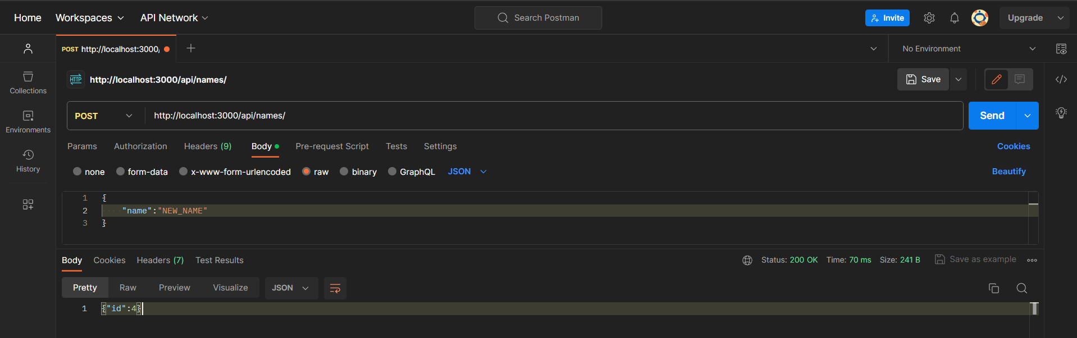

RESPONSE VALIDATION
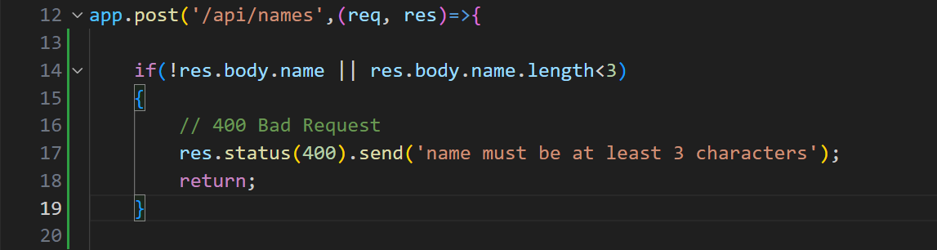
NPM JOI PACKAGE (Joi is a Class)
//npm i joi@13.1.0
const Joi= require('joi')

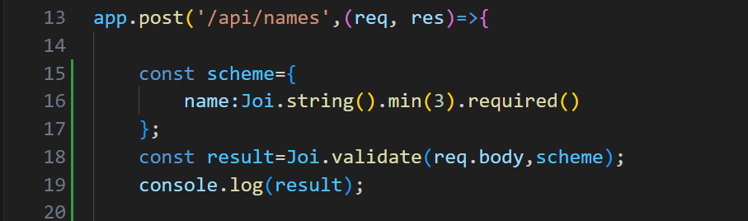
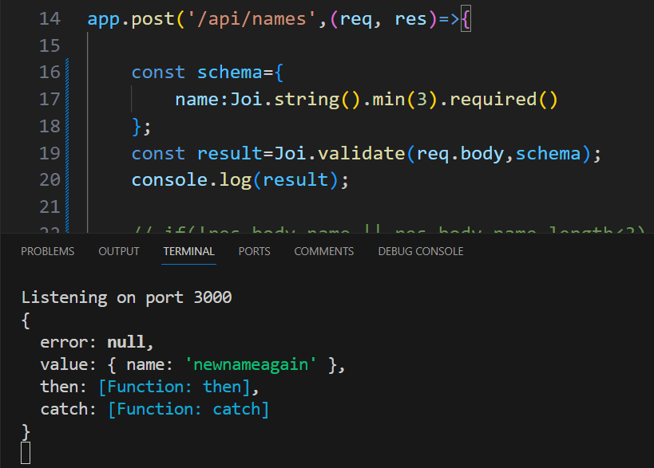
If no name in body:
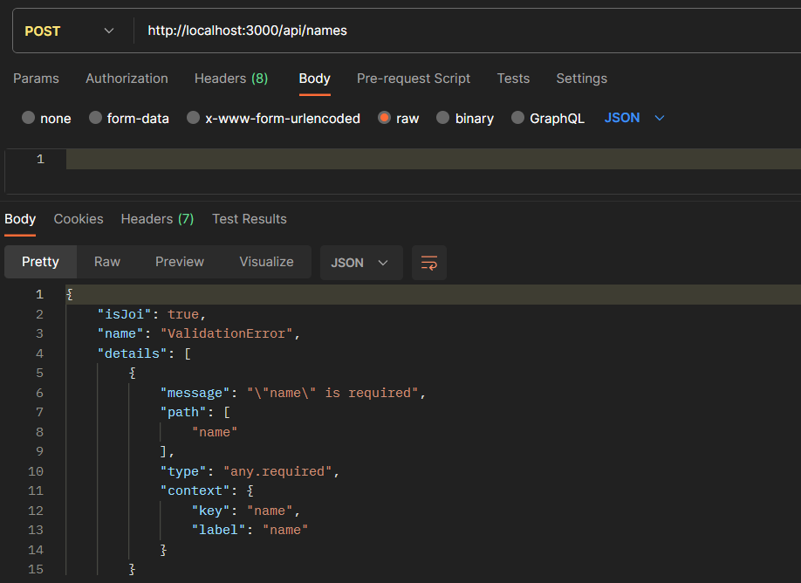
res.status(400).send(result.error.details[0].message);

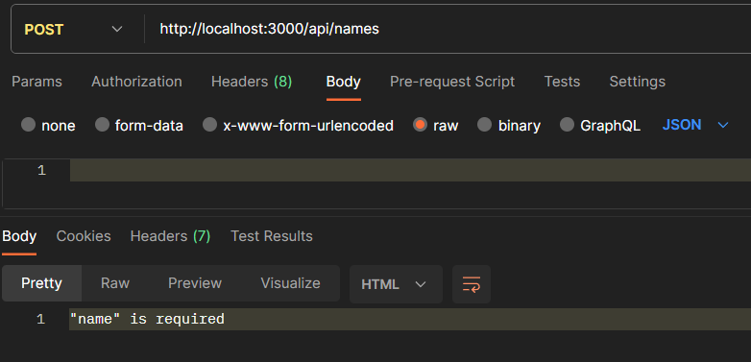
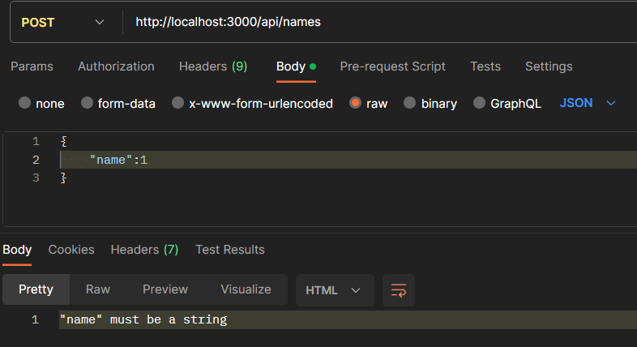
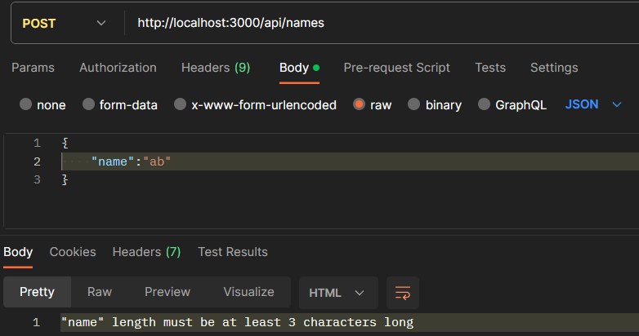
PUT REQUEST
app.put('/api/names/:id',(req, res) => {
// Look up the names
// If not found throw 404 error
// If found,Validate the request
// If invalid,throw an 400 Bad Request error
// If valid, Update the names
// Return the updated names
});

app.put('/api/names/:id',(req, res) => {
// Look up the names
// If not found throw 404 error
const name=names.find(n => n.id === parseInt(req.params.id));
if(!name)
{
res.status(404).send('given id not found');
}
// If found,Validate the request
const schema={
name:Joi.string().min(3).required()
};
const result=Joi.validate(req.body,schema);
// If invalid,throw an 400 Bad Request error
if(result.error)
{
// 400 Bad Request
res.status(400).send(result.error.details[0].message);
return;
}
// If valid, Update the names
// Return the updated names
name.name=req.body.name;
res.send(names);

});

//function to validate names
function validateNames(name)
{
const schema={
name:Joi.string().min(3).required()
};
return Joi.validate(name,schema);
}
Validation and throwing error :
const {error} = validateNames(req.body);
if(error)
{
res.status(400).send(result.error.details[0].message);
return;
}

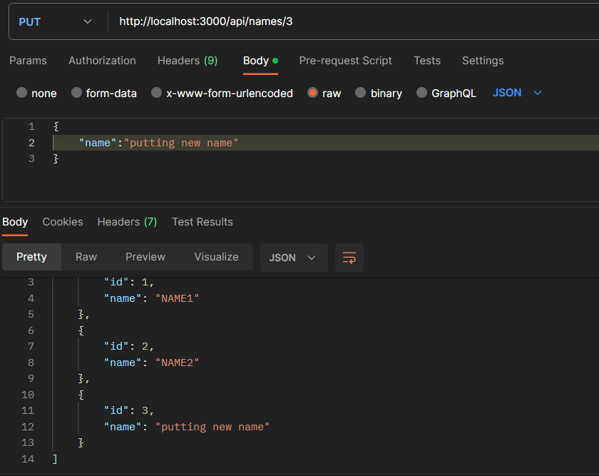
DELETE REQUEST
app.delete('/api/names/:id',(req, res) =>{
// Look up the names
// if not found,return 404
// if found,delete the name and return it.
});

app.delete('/api/names/:id',(req, res) =>{
// Look up the names
// if not found,return 404
const name=names.find(n => n.id === parseInt(req.params.id));
if(!name)
{
res.status(404).send('given id not found');
}
// if found,delete the name and return it.
const index= names.indexOf(name);
names.splice(index,1);
res.send(name);
});
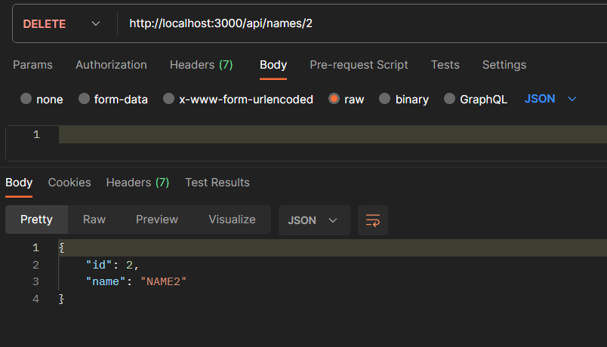
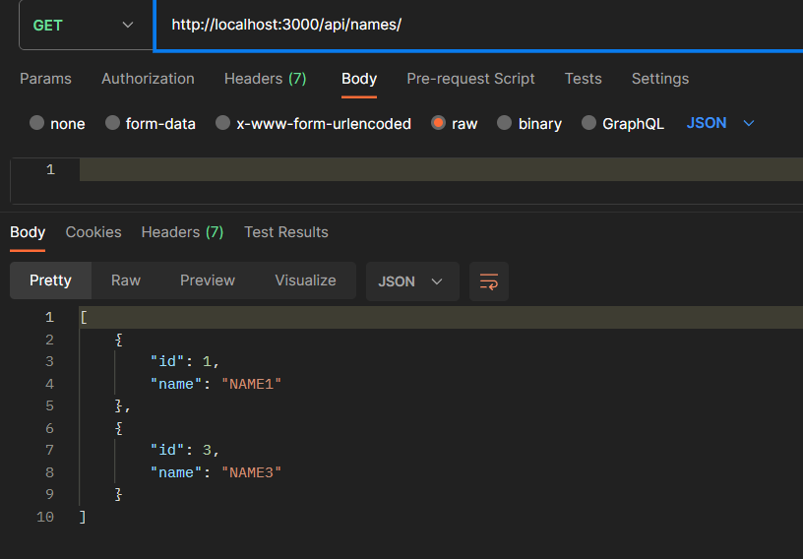
FIXING BUGS
// return after not found (in all get,post,put,delete)
// if wont returned…below blocks will be executed
if(!name)
{
return res.status(404).send('given id not found');
}

MIDDLEWARE FUNCTIONS
Executes this function when we use CRUD OPERATIONS
// middleware functions
app.use(function(req, res, next){
console.log('Logging (Middleware Function)');
next();
});
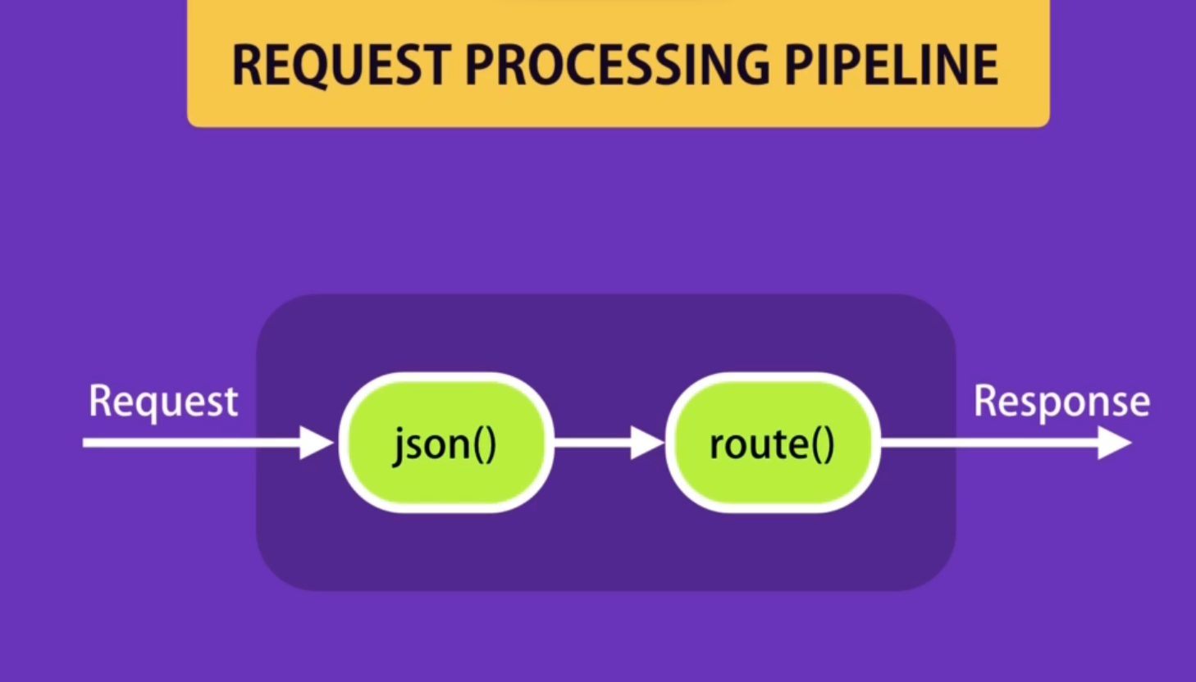

Saving this logger function in <logger.js>
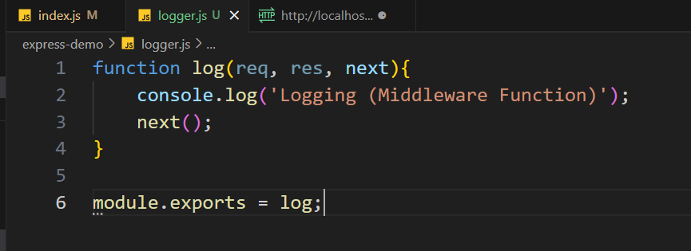
Using it in <index.js>
const logger = require('./logger');
// middleware functions
app.use(logger);

BUILT-IN MIDDLEWARE FUNCTION
app.use(express.urlencoded());
// Used for HTML forms

STATIC MIDDLEWARE FUNCTION
// static middleware function
app.use(express.static('public'));
// create a public folder and store all static files there
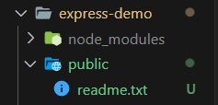
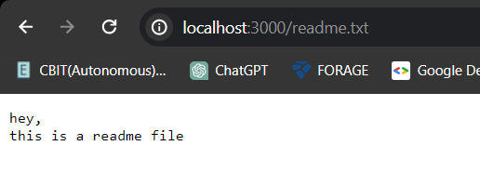
THIRD PARTY MIDDLEWARE FUNCTIONS
// first npm install those functions and then use them
helmet – for secure https headers
morgan – for logging
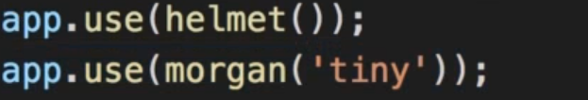
ENVIRONMENT VARIABLE
console.log(`NODE_ENV: ${process.env.NODE_ENV}`);
console.log(`app: ${app.get('env')}`);
if process.env.NODE_ENV is undefined, then app.get(‘env’) stays at development environment by default
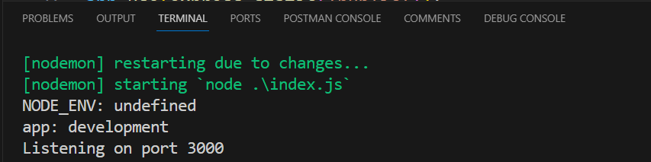
if(app.get('env') === 'production')
{
app.use(helmet());
console.log('Testing Helmet');
}
if(app.get('env') === 'development')
{
app.use(morgan('tiny'));
console.log('Testing Morgan');
}

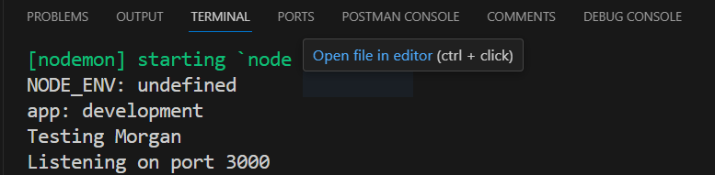
MANAGING CONFIGURATION
// create <config> folder and create default,development,production jsons
// npm i config
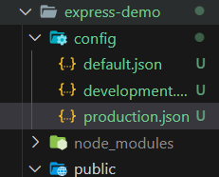
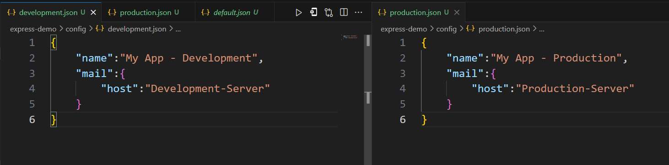

In index.js
//config managing
const config=require('config');
console.log('App name:'+config.get('name'));
console.log('Mail Server name:'+config.get('mail.host'));
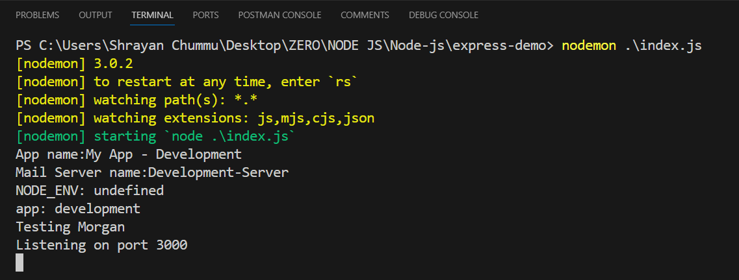
To store passwords/ imp info ->use custom environment variables
// create <custom-environment-variables>.json and store there
DEBUGGING PACKAGE
//npm i debug
const startupDebug = require('debug')('app:startup');
const dbDebug = require('debug')('app:db');

if(app.get('env') === 'production')
{
app.use(helmet());
dbDebug('Testing Helmet');
}
if(app.get('env') === 'development')
{
app.use(morgan('tiny'));
startupDebug('Testing Morgan');
}
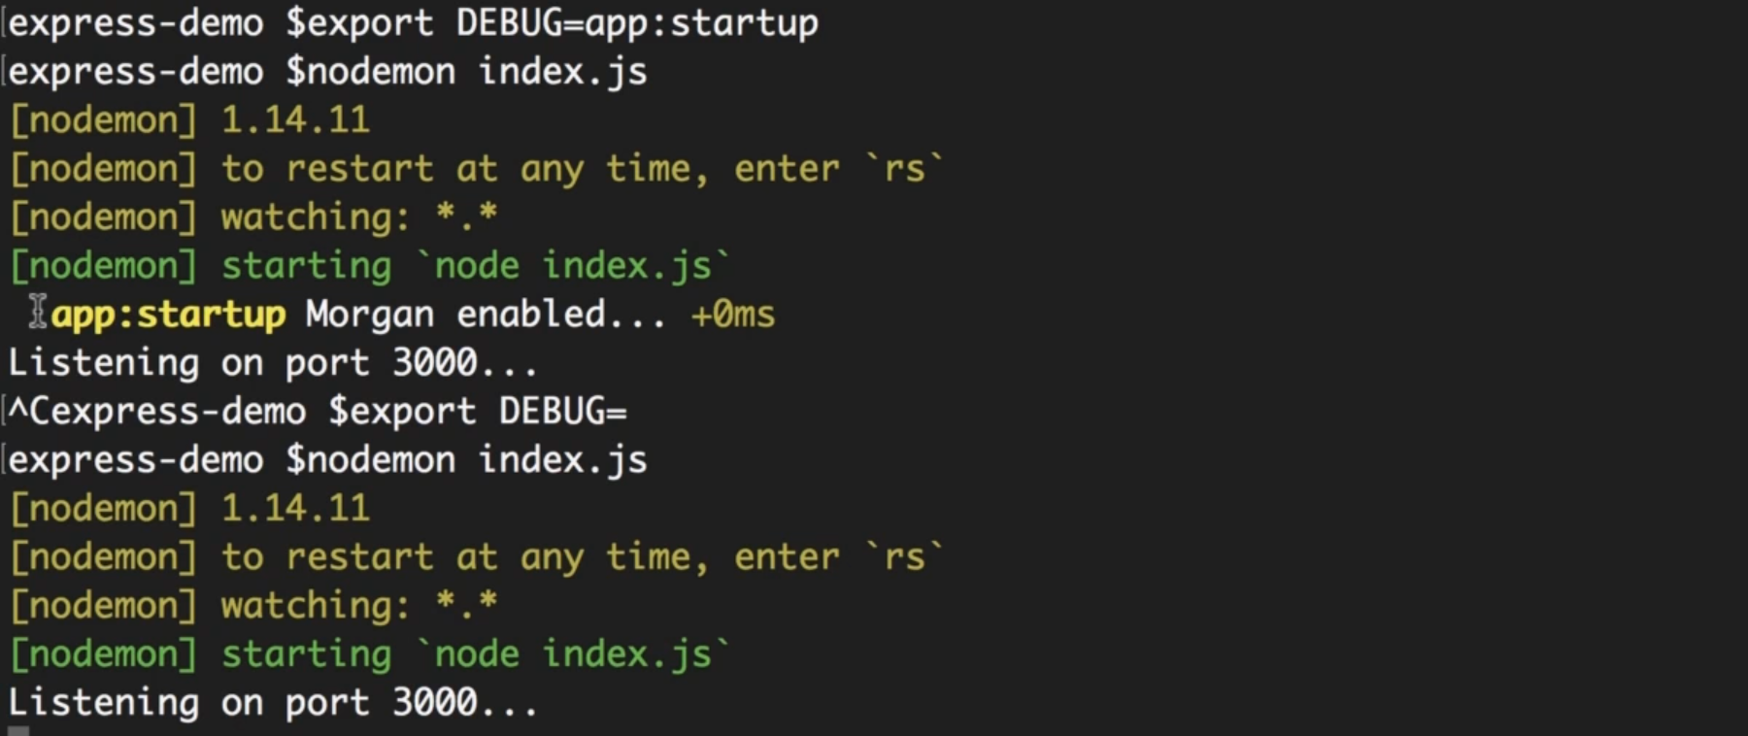
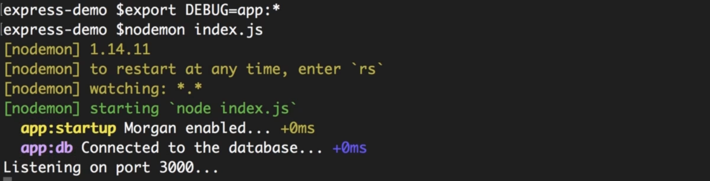
Prefer debug() instead of console.log statements
TEMPLATING ENGINES (Pug, Mustache,EJS)
To generate dynamic html code
//npm i pug
In index.js
app.set('view engine', 'pug');
app.set('views','./views'); //default and optional
create <views> folder and index.pug in it
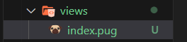
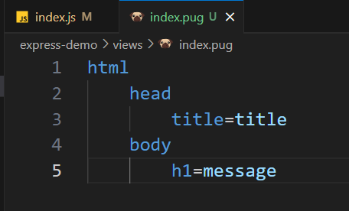
In index.js use res.render(‘filename’,{attributes used in that file})
app.get('/', (req, res) => {
res.render('index',{title:"My App",message:"Hello world"});
//res.send('Hello World!, You are on Port 3000');
});
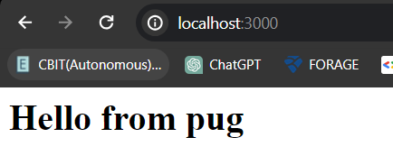
STRUCTING THE APPLICATION
// every api endpoint in separate file
//create <routes> folder
// add <names.js>
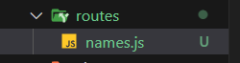
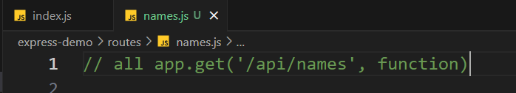
Store all /api/names which you have created before
const express = require('express');
const router = express.Router();
change all app.get in to router.get (by Ctrl+F2)
and export this router module
module.exports=router;
now load this module in <index.js>
//router module
const names = require('./routes/names');
app.use('/api/names',names);
now go to names.js and remove the /api/names from the path
// app.get(‘/’);
// app.post(‘/’);
// app.put(‘/:id’);
// app.delete(‘/:id’);

Now go edit home route
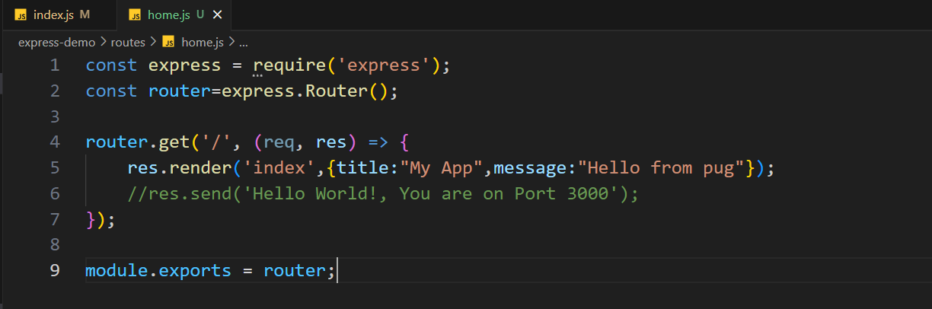
Now load the home module route in <index.js>
const home= require('./routes/home');
app.use('/',home);

now keep all middlewares in <middleware> folder
keep the <logger.js> in that middleware folder since it is a middleware
update the path
const logger = require('./middleware/logger');

ASYNCHRONOUS FUNCTION
Non-blocking programming
// create new folder <async-demo>
//npm init –yes
// create <index.js>
console.log('Before');
setTimeout(()=>{
console.log('this statement executes in future');;
},2000);
console.log('After');
setTimeout(); is an async function which executes in future…(after 2000ms)
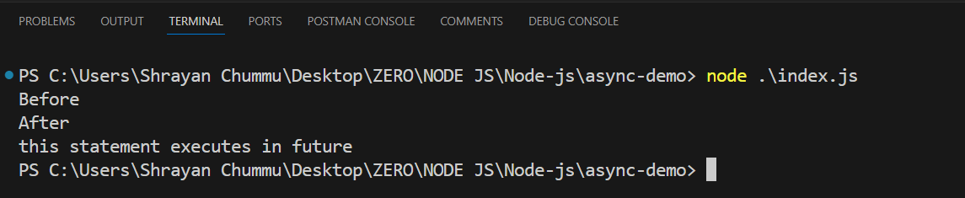
New example
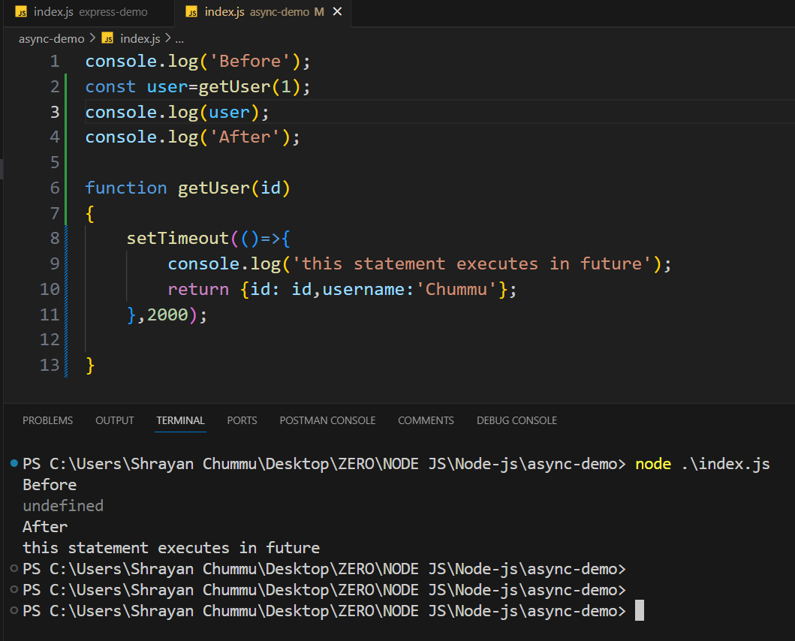
Here user is undefined because it the inside function executes after 2000ms
To get the user…we use ASYNC PATTERNS in the code
-callbacks
-promises
-async/await blocks
CALLBACKS:
Callback is used when the result of an asynchronous operation is ready
console.log('Before');
// getUser(id, function)
getUser(1, function(result){
console.log(result);
});
console.log('After');

function getUser(id,callback)
{
setTimeout(()=>{
console.log('this statement executes in future');
// callback is called when the result of the asynchronous operation is ready
callback({id: id,username:'Chummu'});
},2000);
}
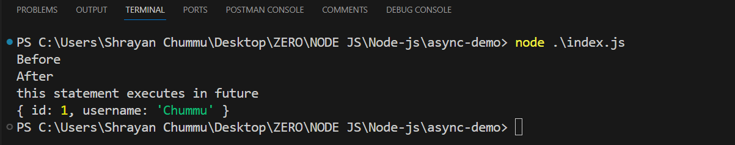
Calling CALLBACK in a CALLBACK
console.log('Before');
// getUser(id, function)
getUser(1, function(result){
console.log(result);
username=result.username;
getRepositories(username, function(repo){
console.log(repo);
});
});
console.log('After');

function getUser(id,callback)
{
setTimeout(()=>{
console.log('getting username'); // executes in future after 2000ms
// callback is called when the result of the asynchronous operation is ready
callback({id: id,username:'Chummu'});
},2000);
}
function getRepositories(username,callback)
{
setTimeout(()=>{
console.log('getting repositories of '+username +' by gitbuh API'); // executes in future after 2000ms
callback(['repo1','repo2','repo3']);
},2000);
}
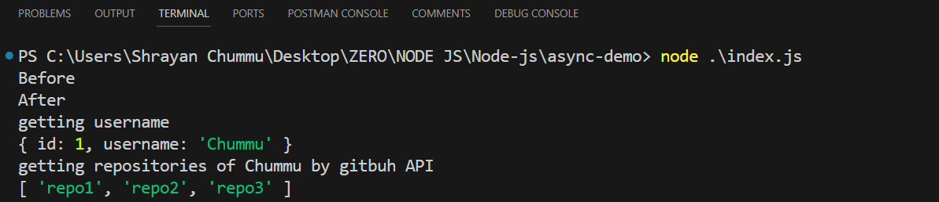

ASYNCHRONOUS vs SYNCHRONOUS
//Asynchronous
console.log('Before');
getUser(1,(result)=>{
getRepositories(result.username,(repo)=>{
anotherFunction(repo,(anotherParameter)=>{
console.log(anotherParameter);
// called as CALLBACK HELL prob
});
});
});
console.log('After');

//Synchronous
console.log('Before');
const result=getUser(id);
const repo=getRepositories(result);
const anotherParameter=anotherFunction(repo);
console.log(anotherParameter);
console.log('After');

solving CALLBACK HELL problem:
creating new functions “display---” and replacing by their reference (just name, not function();)
//Asynchronous
console.log('Before');
getUser(1,displayResult);
console.log('After');

//solving CALLBACK HELL
function displayParameter(Parameter){
console.log(Parameter);
}
function displayRepository(repo){
anotherFunction(repo,displayParameter);
}
function displayResult(result){
getRepositories(result.username,displayRepository);
}

