Machine Learning Based Buyer Segmentation and Investment Profiling for Real Estate Market Intelligence
Prepared for: Parcl Co. Limited Prepared as part of: Unified Mentor Data Science Program Author: [Your Name] Date: July 2026

Abstract
Real estate companies serve a highly heterogeneous population of buyers — individual home buyers, institutional and corporate investors, first-time buyers, and high-net-worth individuals — yet frequently market and engage them uniformly. This project applies an unsupervised machine-learning pipeline (K-Means and Hierarchical/Agglomerative clustering) to a Parcl client base of 2,000 buyers and 10,000 property transactions in order to discover natural buyer segments, profile their investment behaviour, and translate the resulting clusters into actionable go-to-market recommendations. Four data-driven segments were identified — Global Investors, Personal-Use Buyers, First-Time Buyers, and Luxury Investors — primarily separated by financing behaviour (loan dependency) and spend tier rather than by the raw client_type/acquisition_purpose labels alone. The results are delivered as a reproducible Python pipeline and an interactive Streamlit dashboard for ongoing use by Parcl’s marketing and investment teams.

1. Background and Problem Statement
Parcl currently lacks a data-driven understanding of the different types of buyers transacting on its platform, their investment motivations, geographic behaviour, and financing patterns. Treating all buyers identically leads to inefficient marketing spend, generic property recommendations, and missed opportunities to target high-value investors. This project uses AI-based clustering to surface hidden structure in buyer behaviour so that Parcl can build differentiated marketing, pricing, and relationship strategies for each segment.

2. Data
Two source datasets were provided:
Dataset | Rows | Description
clients.csv | 2,000 | One row per client: demographics, acquisition purpose, financing, referral channel, satisfaction
properties.csv | 10,000 | One row per property listing/transaction, optionally linked to a client via client_ref
Of the 10,000 listings, 7,305 (73.1%) are marked Sold and linked to a purchasing client; the remaining 2,695 are Available (unsold) inventory. Every one of the 2,000 clients in clients.csv has at least one completed (Sold) transaction, so the client table and the transaction table were merged into a single client-level analytical table combining demographic attributes with derived purchasing-behaviour features.

2.1 Data Cleaning
- Whitespace-trimmed and case-normalised all categorical text fields.
- Removed exact duplicate rows and duplicate client_ids.
- date_of_birth and transaction_date were supplied in mixed date formats (DD-MM-YYYY and M/D/YYYY interleaved in the same column) and were parsed with an explicit multi-format resolver rather than pandas’ default inference, to avoid silently mis-parsing day/month.
- sale_price was supplied as a currency string (e.g. "$300,385.62") and converted to a numeric float.
- Implausible parsed ages (<18 or >100, an artefact of a small number of ambiguous date strings) were treated as missing and imputed with the column median.
- No missing values were found in the core clients.csv categorical/numeric fields.

2.2 Feature Engineering
The transaction table was aggregated to client level and joined onto client attributes, producing (per client):
- Demographics: age (derived from date_of_birth), gender, country, region, client type
- Acquisition context: acquisition purpose, referral channel, satisfaction score
- Financing: loan_applied_flag (binary)
- Purchase behaviour: number of purchases, total spend, average purchase price, total floor area purchased, share of office vs. apartment units, multi-unit buyer flag, tenure between first and last purchase

3. Methodology

3.1 Encoding & Scaling
- Numeric features (age, satisfaction score, loan flag, purchase counts, spend, floor area, etc.) were standardised with StandardScaler.
- Categorical features (client_type, acquisition_purpose, referral_channel, country) were one-hot encoded.
- region (57 distinct values) was deliberately excluded from the clustering feature set — at this dataset size, one-hot encoding a 57-category field would dominate the Euclidean distance calculation and wash out the (more business-relevant) behavioural signal. region and country remain fully available for post-hoc profiling and for the dashboard’s geographic views.

3.2 Clustering Models
Two complementary clustering approaches were used, as specified in the project brief:
- K-Means Clustering — the primary segmentation model, chosen for its efficiency and interpretability.
- Agglomerative (Hierarchical) Clustering (Ward linkage) — used to validate the K-Means solution and to visualise nested relationships between clients via a dendrogram.

3.3 Selecting the Number of Clusters
The Elbow Method (inertia / within-cluster sum of squares) and Silhouette Score were computed for k = 2 through 8.
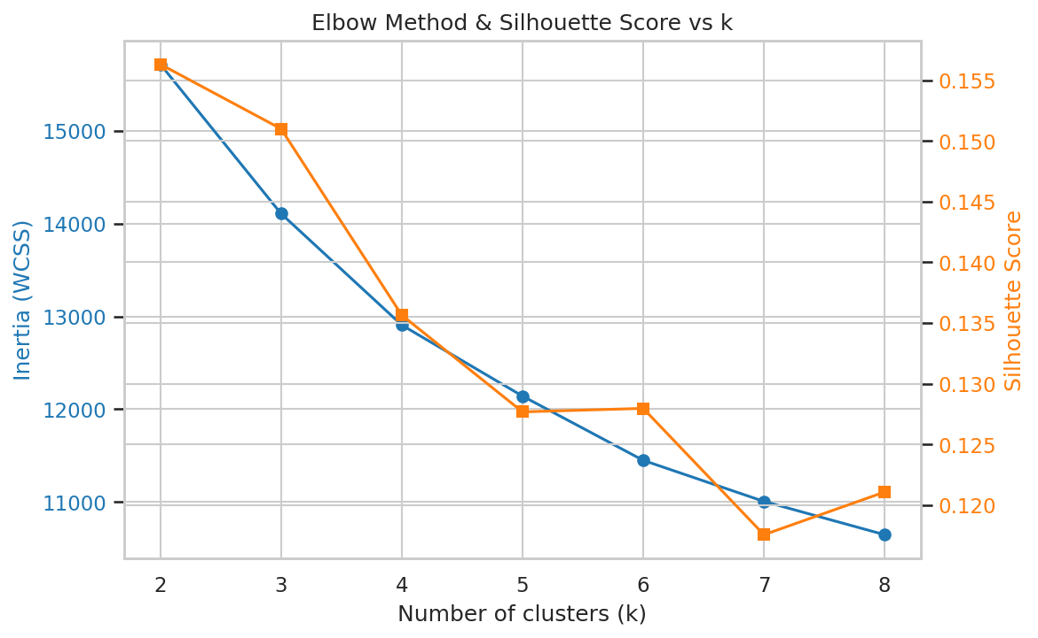
Elbow and Silhouette
k | Inertia | Silhouette
2 | 15,716.5 | 0.156
3 | 14,107.3 | 0.151
4 | 12,906.7 | 0.136
5 | 12,141.4 | 0.128
6 | 11,449.2 | 0.128
7 | 11,006.6 | 0.118
8 | 10,647.9 | 0.121
The silhouette score is highest at k = 2 and decays gradually as k increases, and the elbow curve does not show one sharply obvious “knee” — an honest reading is that this buyer base sits on a behavioural continuum rather than being separated into crisply-isolated clusters, which is a realistic outcome for real-world (or realistically-simulated) client data. k = 4 was selected as the operating point because it (a) sits just past the point of steeply diminishing silhouette returns, (b) aligns with the four buyer archetypes Parcl’s business team wants to act on (Global / Institutional Investors, Personal-Use Buyers, First-Time Buyers, Luxury Investors), and (c) produces segments that are each large enough (47–723 clients) to be commercially actionable. Silhouette scores in the 0.13–0.16 range indicate moderate, usable cluster structure rather than extremely well-separated clusters — segment boundaries should be treated as directional tendencies for targeting, not hard behavioural walls.

3.4 Cluster Validation
To sanity-check the K-Means solution, Agglomerative Clustering was independently fit with the same k = 4 and compared to the K-Means labels using the Adjusted Rand Index (ARI):
ARI (K-Means vs. Hierarchical) = 0.586
This indicates substantial (well above chance, ARI = 0) agreement between the two algorithms on the underlying cluster structure, reinforcing confidence that the four segments reflect real structure in the data rather than an artefact of one algorithm.
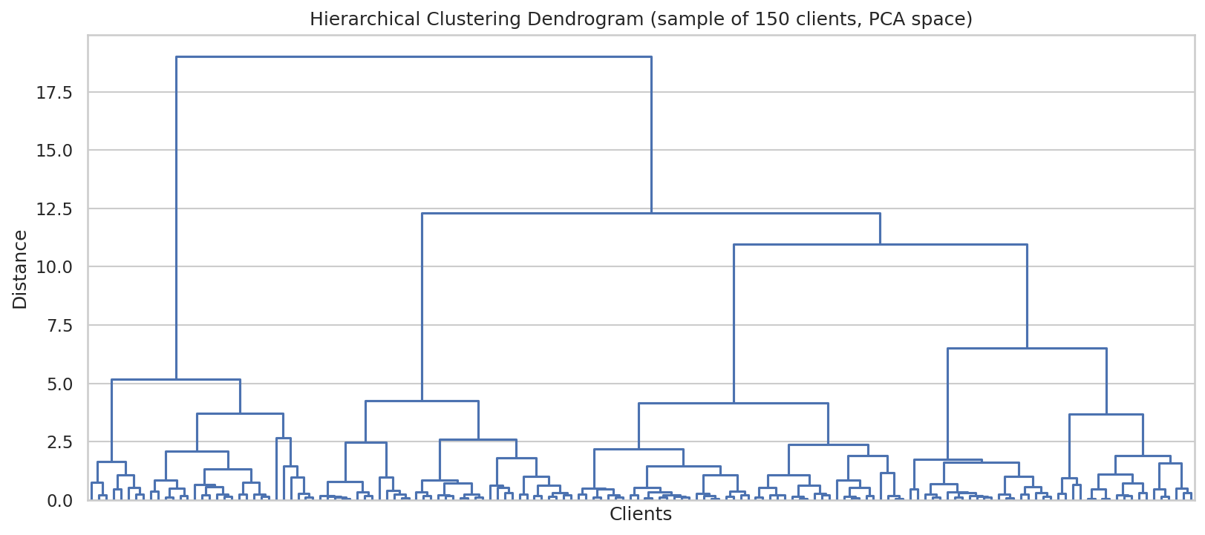
Dendrogram

4. Exploratory Data Analysis — Key Findings
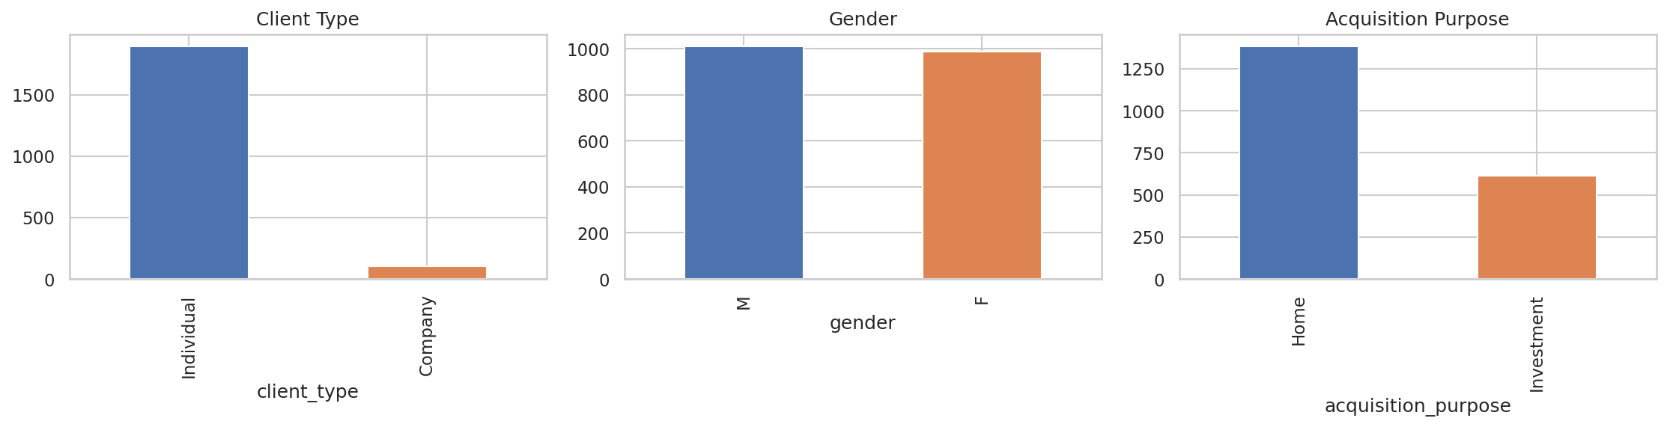
Client distributions
- Individual clients dominate the buyer base (1,897 of 2,000, 94.9%); corporate clients are a small minority (103, 5.2%) and — notably — are spread roughly evenly across all four clusters (4.3%–6.0% company share per cluster) rather than forming their own distinct segment. This is itself an insight: Parcl’s corporate buyers do not currently behave as a behaviourally distinct group, and a dedicated “corporate desk” strategy would need additional corporate-specific signals (e.g. procurement cycle, portfolio size) not present in this dataset to be well targeted.
- Gender is close to evenly split (1,012 M / 988 F).
- 69.3% of purchases are for Home (personal use) and 30.8% for Investment.
- 63.2% of clients did not apply for a loan; 36.8% financed their purchase.
- Website is the leading referral channel (55.2%), followed by Agency (35.3%) and direct Client referral (9.6%).
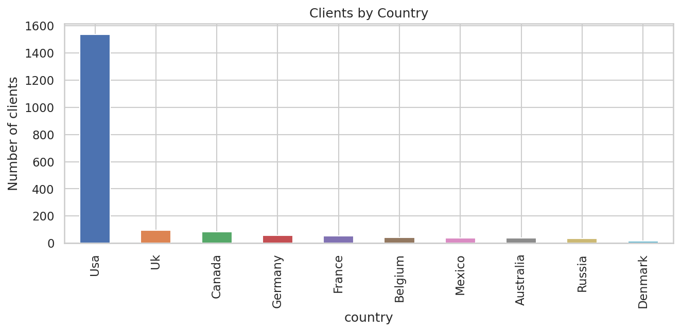
Countries
- The client base spans 10 countries; the USA accounts for 76.9% of all clients (1,538 of 2,000), followed by the UK (4.8%), Canada (4.3%), Germany (2.8%) and France (2.7%).
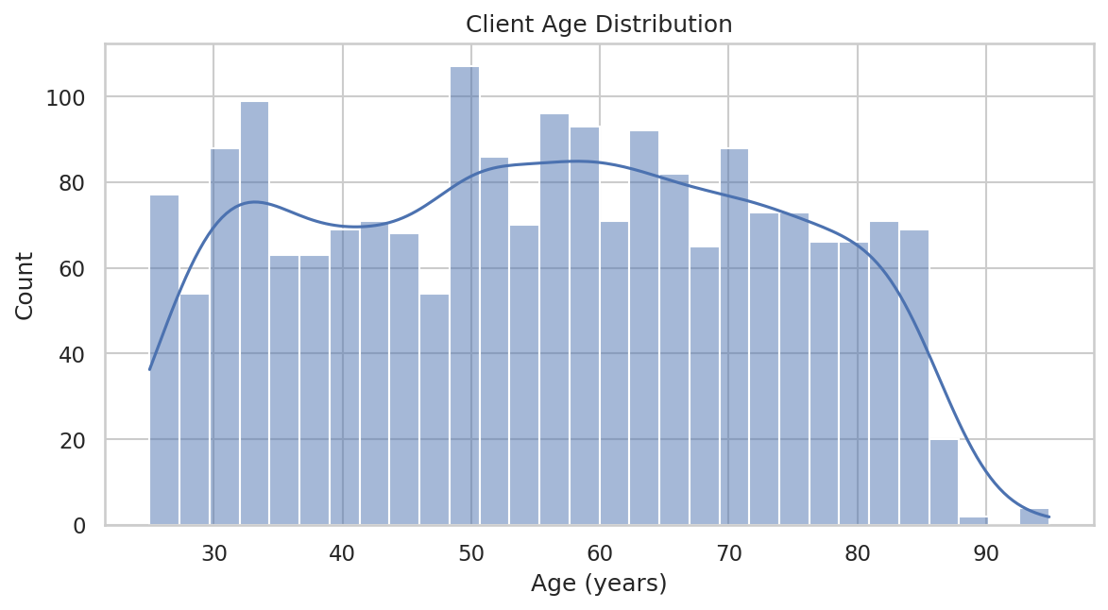
Age distribution
- Client age ranges from 25 to 95 years with a mean of 55.6 years — a broad, fairly evenly-spread age base rather than one dominated by a single generation.
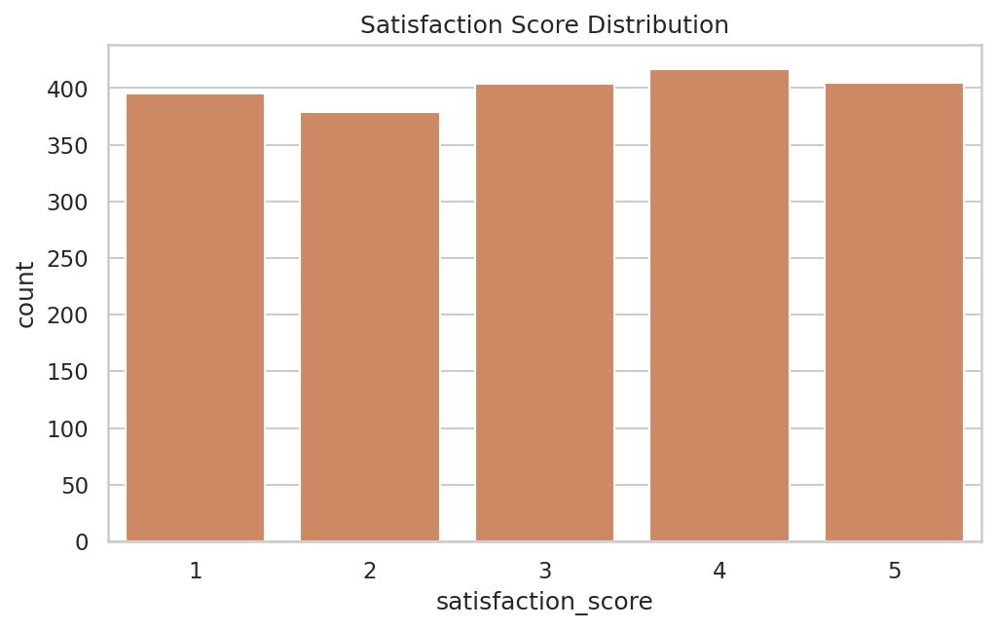
Satisfaction
- Average satisfaction score across all clients is 3.03 / 5, with scores fairly evenly distributed 1–5. Loan-applied clients (mean 3.03) and non-financed clients (mean 3.03) report virtually identical satisfaction — financing status alone does not appear to drive the customer experience.
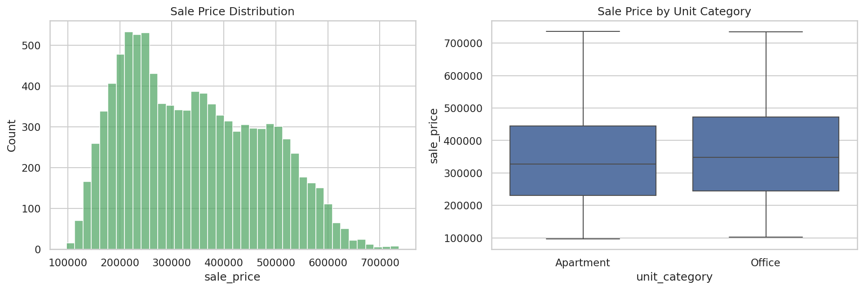
Price distributions
- Sale prices across all 10,000 listings range from roughly $97K to $737K, with a mean of $344,375 and a fairly symmetric distribution; Office units trend toward similar price levels to Apartments but with tighter variance.
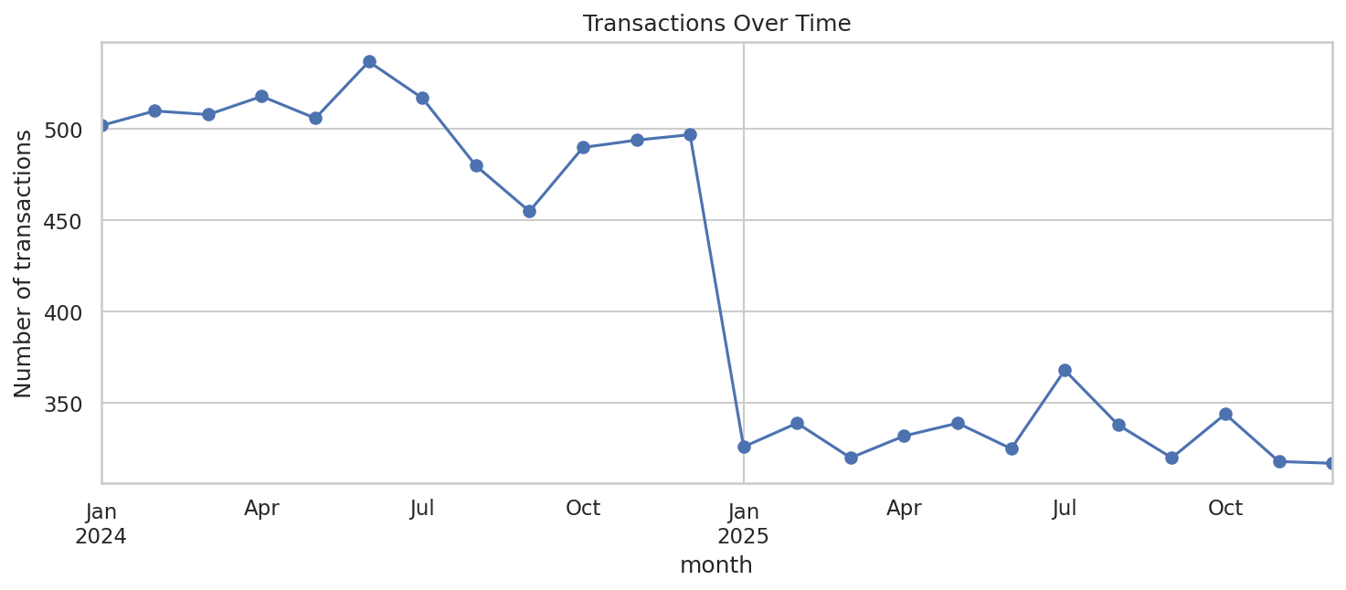
Transactions over time
- Transaction volume is tracked monthly from January 2024 through December 2025, giving Parcl a two-year view of demand trends usable for seasonality and pipeline planning.
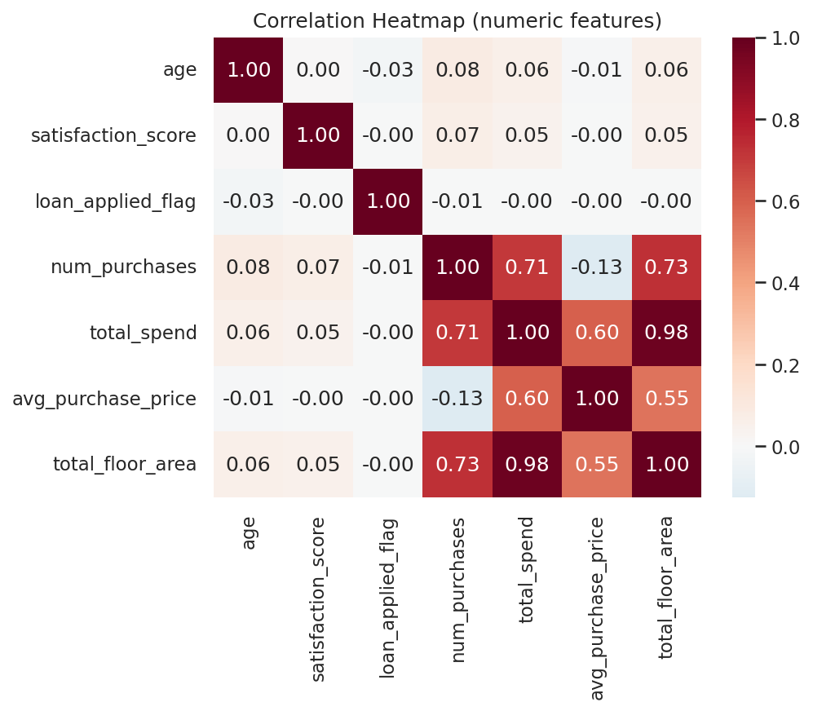
Correlation heatmap
- Total spend and average purchase price are (unsurprisingly) strongly correlated with each other; loan usage shows only a weak relationship with age and satisfaction, suggesting financing decisions in this market are driven more by purchase size / investment intent than by demographics alone.

5. Buyer Segments
Applying K-Means with k = 4 to the scaled/encoded feature matrix produced the following segments:
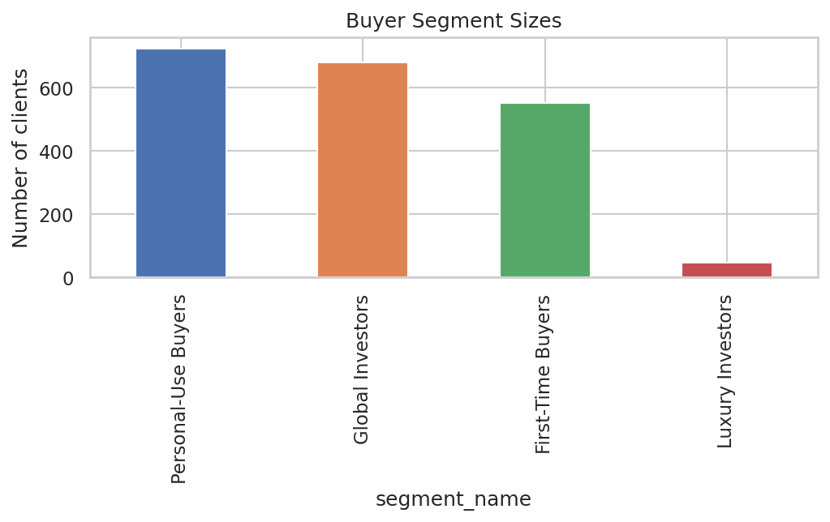
Segment sizes
Segment | Clients | Avg. Age | Avg. Total Spend | Avg. Purchase Price | Loan-Applied Rate | Avg. Satisfaction
Global Investors | 678 (33.9%) | 56.8 | $1,532,680 | $409,906 | 24.9% | 3.07
Personal-Use Buyers | 723 (36.2%) | 55.7 | $1,039,568 | $307,845 | 0.0% | 2.99
First-Time Buyers | 552 (27.6%) | 53.3 | $1,112,222 | $322,197 | 100.0% | 2.99
Luxury Investors | 47 (2.4%) | 63.3 | $2,468,921 | $336,998 | 31.9% | 3.47
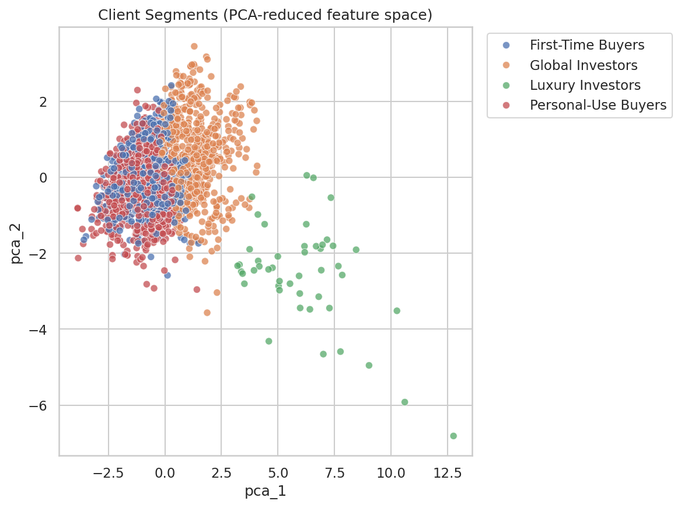
PCA clusters

Segment Profiles
🌍 Global Investors (33.9% of clients). The largest high-value segment. High total spend and the highest average purchase price of the “mainstream” segments, moderate financing usage (roughly 1 in 4 used a loan), mid-50s average age. These clients behave like seasoned, largely cash-capable investors who transact repeatedly at above-average price points.
🏠 Personal-Use Buyers (36.2% of clients). The largest segment overall, and the only one with a 0% loan-applied rate — this group pays in full and buys at the lowest average price point of the four segments, consistent with buyers purchasing primarily for personal/home use rather than as an investment vehicle.
🔑 First-Time Buyers (27.6% of clients). Defined almost entirely by financing behaviour: 100% of clients in this segment applied for a loan. They are also the youngest segment on average (53.3 years) and purchase at below-average price points — the classic profile of a financing-dependent buyer entering the market.
💎 Luxury Investors (2.4% of clients). A small (47-client) but highly valuable segment: the highest average total spend by a wide margin ($2.47M, ~60% above the next-highest segment), the oldest average age (63.3 years), and — importantly — the highest satisfaction score of any segment (3.47 / 5). This is Parcl’s premium relationship-management priority segment: few in number, but outsized in revenue contribution and demonstrably the most satisfied with their experience.
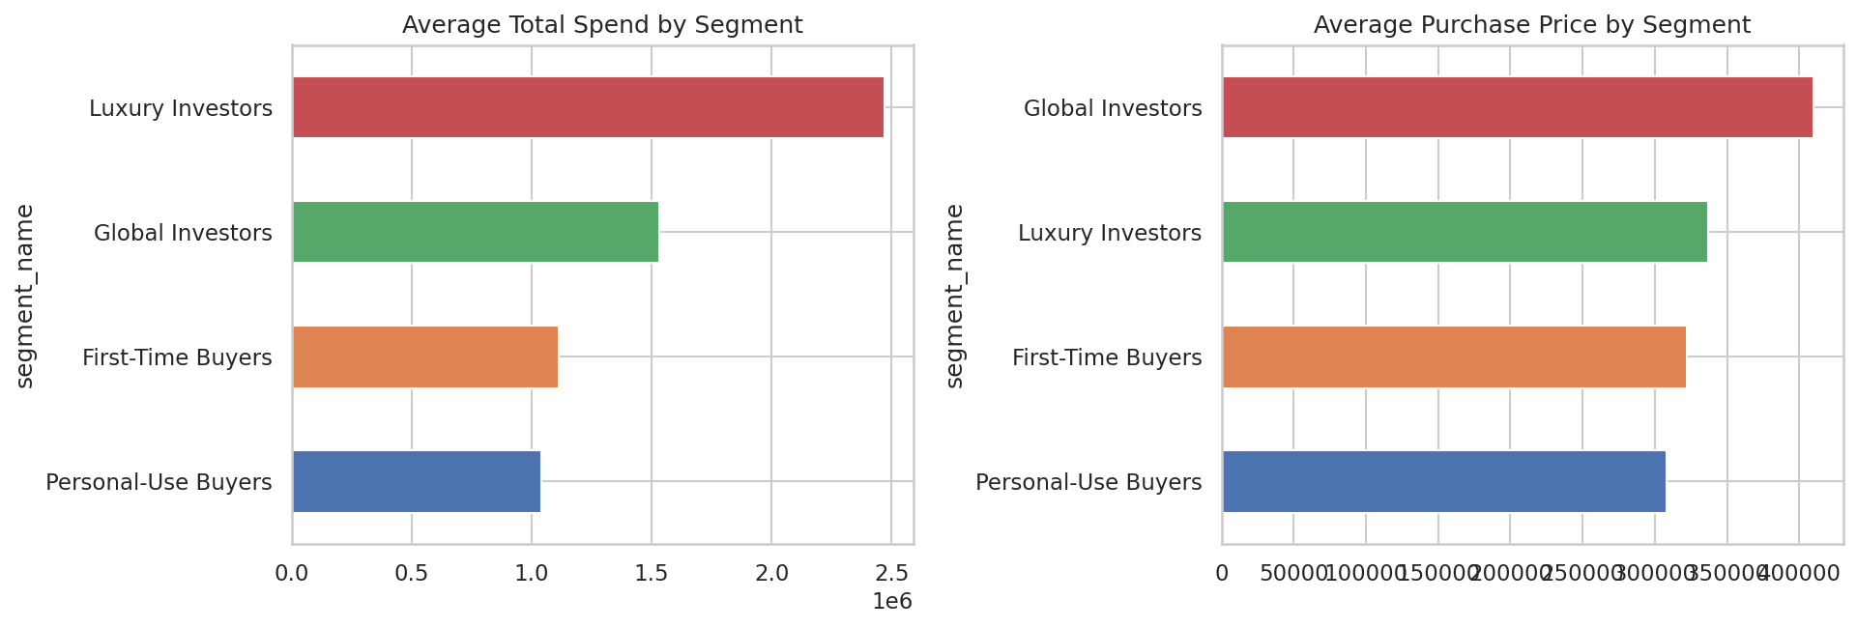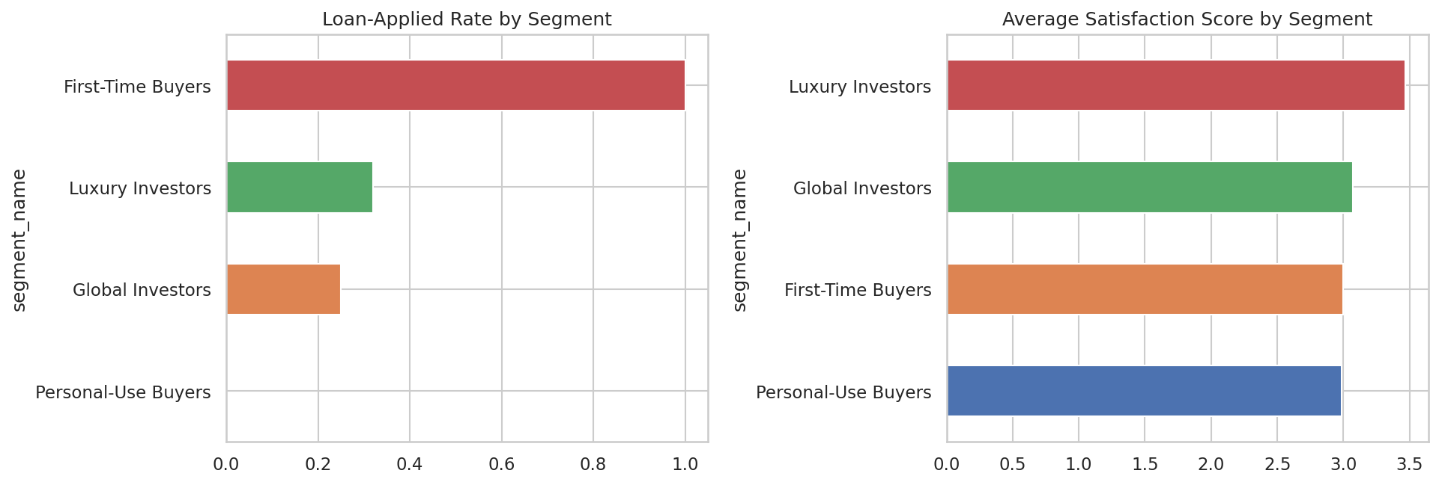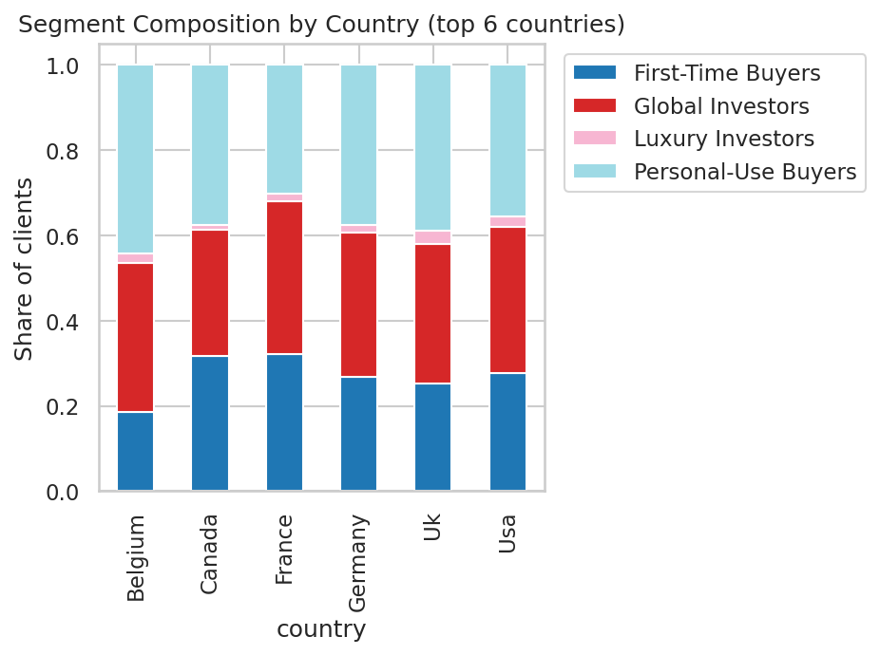

6. Business Recommendations
- Prioritise white-glove relationship management for Luxury Investors. Although this segment is only 2.4% of the client base, it drives disproportionate revenue ($2.47M average spend vs. ~$1.0–1.5M for other segments) and already reports the highest satisfaction — a dedicated concierge/relationship-manager motion is likely to have an outsized ROI here and support referral-driven growth from this group.
- Build a financing-first funnel for First-Time Buyers. Since 100% of this segment used financing, marketing and product content (mortgage-partner offers, financing calculators, first-time-buyer guides) should be front-and-centre for any lead that matches this profile, rather than generic listing content.
- Differentiate Global Investors from Personal-Use Buyers in messaging even though both are “mainstream” segments. Global Investors transact at meaningfully higher price points and use financing only a quarter of the time — investment-oriented messaging (yield, appreciation potential, portfolio diversification) will resonate more than the home-buying narrative that fits Personal-Use Buyers.
- Re-evaluate the “Corporate Buyers” go-to-market assumption. Corporate clients did not form their own behavioural cluster in this dataset — they are distributed roughly proportionally across all four segments. Parcl should not assume client_type = Company alone predicts distinct behaviour; if a dedicated corporate-investor strategy is a priority, additional corporate-specific data (procurement cycles, deal size caps, portfolio mandates) should be captured going forward to make that segment separable.
- Double down on Website and Agency channels, but track referral quality by segment. Website (55%) and Agency (35%) referrals dominate; because segment composition varies little by channel today, Parcl has an opportunity to test channel-specific creative aimed at each of the four segments and measure whether segment-aware campaigns lift conversion versus today’s undifferentiated approach.
- Use the interactive dashboard for ongoing monitoring. Because silhouette scores indicate moderate (not razor-sharp) cluster separation, segment membership should be refreshed periodically as new transactions arrive, and marketing/sales teams should treat segment labels as a strong prior for targeting rather than an immutable classification.

7. Deliverables
Deliverable | Location
Cleaned & feature-engineered client dataset | data/clustered_clients.csv
Cluster summary table | data/cluster_summary.csv
k-selection evaluation table | data/k_evaluation.csv
Reproducible ML pipeline (cleaning → clustering) | src/data_processing.py, src/clustering.py, src/run_analysis.py
Trained model artefacts | models/*.joblib
All EDA & clustering figures | reports/figures/
Interactive Streamlit dashboard | app/streamlit_app.py
This research paper | reports/research_paper.md

8. Limitations & Future Work
- Silhouette scores (0.13–0.16) indicate the four segments, while validated across two clustering algorithms (ARI = 0.586), are moderately rather than sharply separated — appropriate for directional targeting, less appropriate for hard eligibility rules.
- region was excluded from clustering due to high cardinality relative to dataset size; a larger dataset or a grouped/frequency-encoded region feature could allow geography to contribute directly to segmentation in future iterations.
- The dataset does not include repeat-visit or engagement data (site visits, email opens, time-to-decision), which would likely sharpen segment separation if incorporated.
- Corporate buyers, while not separable in this dataset, may become a distinct segment once transaction volume for that group grows or additional B2B-specific fields are captured.

Prepared using Python (pandas, scikit-learn, matplotlib, seaborn) and Streamlit. Full source code and reproduction instructions are in the accompanying GitHub repository’s README.md.

