**MISP**

Imp- **VGeErRg7TjnTu7riuVNkA69U9R2MOdgxGz29FJtV**

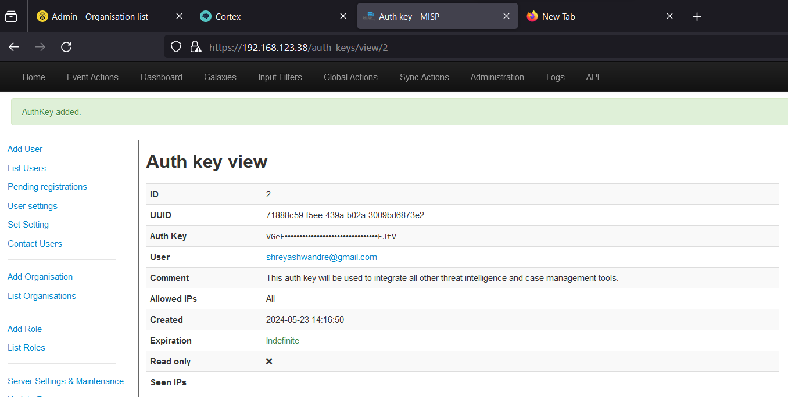

**CORTEX**

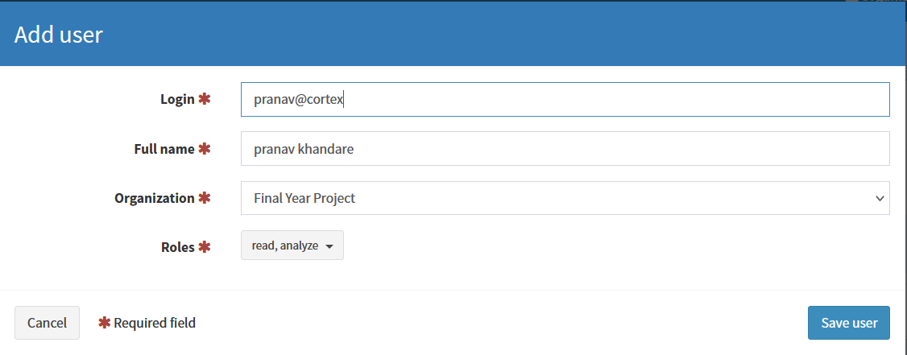

**Shreyash W API key - LOE0jmFtlilGdCRhxgVePYuz7OFj0I85**

**TheHive**



