**Requirement Gathering and Analysis Phase**

**Data Flow Diagram & User Stories**

|  |  |
| --- | --- |
| Date | 6 July 2024 |
| Team ID | SWTID1720110658 |
| Project Name | BookStore |
| Maximum Marks | - |

**Data Flow Diagrams:**

A Data Flow Diagram (DFD) is a traditional visual representation of the information flows within a system. A neat and clear DFD can depict the right amount of the system requirement graphically. It shows how data enters and leaves the system, what changes the information, and where data is stored.

Data Flow Diagram for Book Store web app

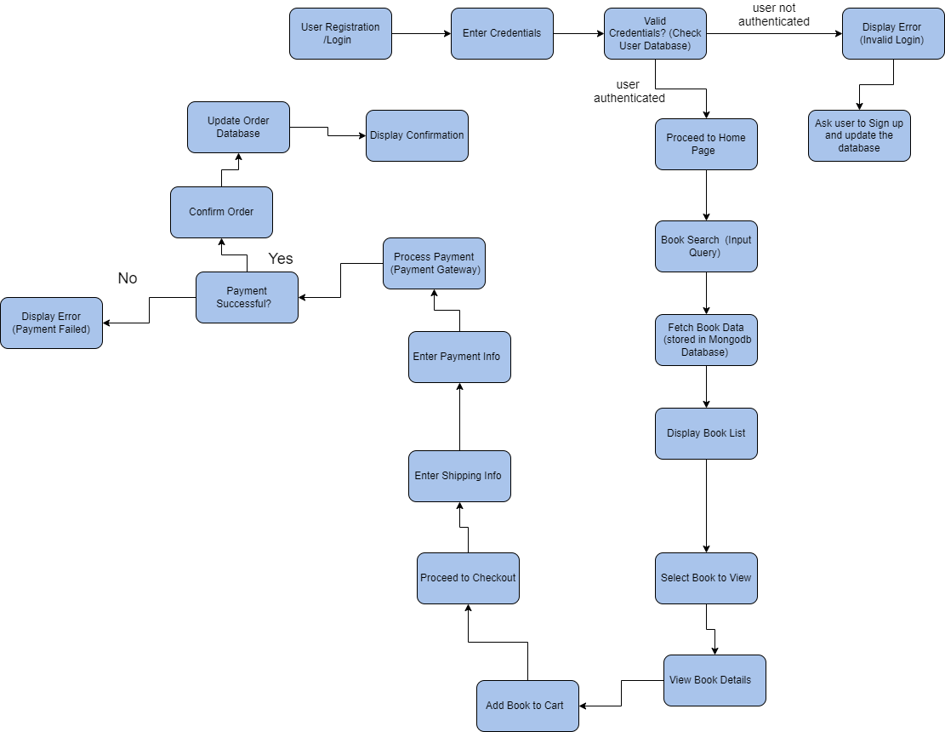

**User Stories**

Use the below template to list all the user stories for the product.

| **User Type** | **Functional Requirement (Epic)** | **User Story Number** | **User Story / Task** | **Acceptance criteria** | **Priority** | **Release** |
| --- | --- | --- | --- | --- | --- | --- |
| Customer | Registration | USN-1 | As a user, I can register for the application by entering my Firstname, lastname, email, contact information, password, and confirming my password, address, city, state, country, postal code, DOB, preferred genre. | I can access my account / dashboard | High | Sprint-1 |
|  |  | USN-2 | As a user, I will receive a confirmation email once I have registered for the application | I can receive confirmation email & click confirm | High | Sprint-1 |
|  |  | USN-3 | As a user, I can register for the application through Gmail | I can register & access the dashboard with Gmail Login | Medium | Sprint-1 |
|  | Login | USN-4 | As a user, I can log into the application by entering email & password | |  | | --- | | I can access my account / dashboard |  |  | | --- | |  | | High | Sprint-1 |
|  |  | USN-5 | As a user, I can log into the application by Gmail directly | I can access my account / dashboard | High | Sprint-1 |
|  | |  | | --- | | Book Listing |  |  | | --- | |  | | USN-6 | As a user, I can view a list of available books with details like title, author, genre, description, price, and availability status | I can see a comprehensive list of books with all relevant details | High | Sprint-2 |
|  | Book Selection | USN-7 | As a user, I can filter and select books based on genre, author, ratings, and popularity | I can filter and view books according to my preference | High | Sprint-2 |
|  | Cart Functionality | USN-8 | As a user, I can add books to my cart and specify quantities | I can add books to my cart and specify the number of copies | High | Sprint-2 |
|  | Purchase Process | USN-9 | As a user, I can securely purchase books, generating an order and updating inventory | I can complete the purchase process securely | High | Sprint-3 |
|  | Order Confirmation | USN-10 | As a user, I receive an order confirmation with details of my order | I can see the order details and confirmation | High | Sprint-3 |
|  | Order History | USN-11 | As a user, I can view my past and current orders, track shipments, and rate my shopping experience | I can view my order history and track shipments | Medium | Sprint-4 |
| Organizer | Organizer Dashboard | USN-12 | As an organizer, I can manage book listings, inventory levels, and orders | I can access and manage book listings, inventory, and orders | High | Sprint-5 |
|  |  | USN-13 | As an organizer, I can create, view, and update book items | I can create new book items and update existing ones | High | Sprint-5 |
| Administrator | Admin Dashboard | USN-14 | As an admin, I can manage user accounts, orders, and platform-related activities | I can manage user accounts and orders | High | Sprint-6 |
|  |  | USN-15 | As an admin, I can manage user and organizer accounts comprehensively | I can manage both user and organizer accounts | High | Sprint-6 |
| Customer (Mobile & Web) | Integration | USN-16 | As a user, I can securely make payments through a third-party payment API | I can complete payments securely | High | Sprint-7 |
|  |  | USN-17 | As a user, I can track shipments through a third-party shipping logistics API | I can track my shipments using the provided tracking information | |  | | --- | | Medium |  |  | | --- | |  | | Sprint-7 |
|  |  | USN-18 | As a user, I can receive book recommendations through a third-party API | I can see book recommendations based on my preferences | Medium | Sprint-7 |