**Assignment No. 5**

Name : Tejas K. Pulli.

Roll No. 65

**Aim : Problem Statement**

Automate Deployment using Jenkins plugin "Deploy to container".

* Install the Plugins:

Install “Deploy to container” plugin in the Jenkins instance from Dashboard -> Manage Jenkins -> Available Plugins search for “Deploy to container “ and install.

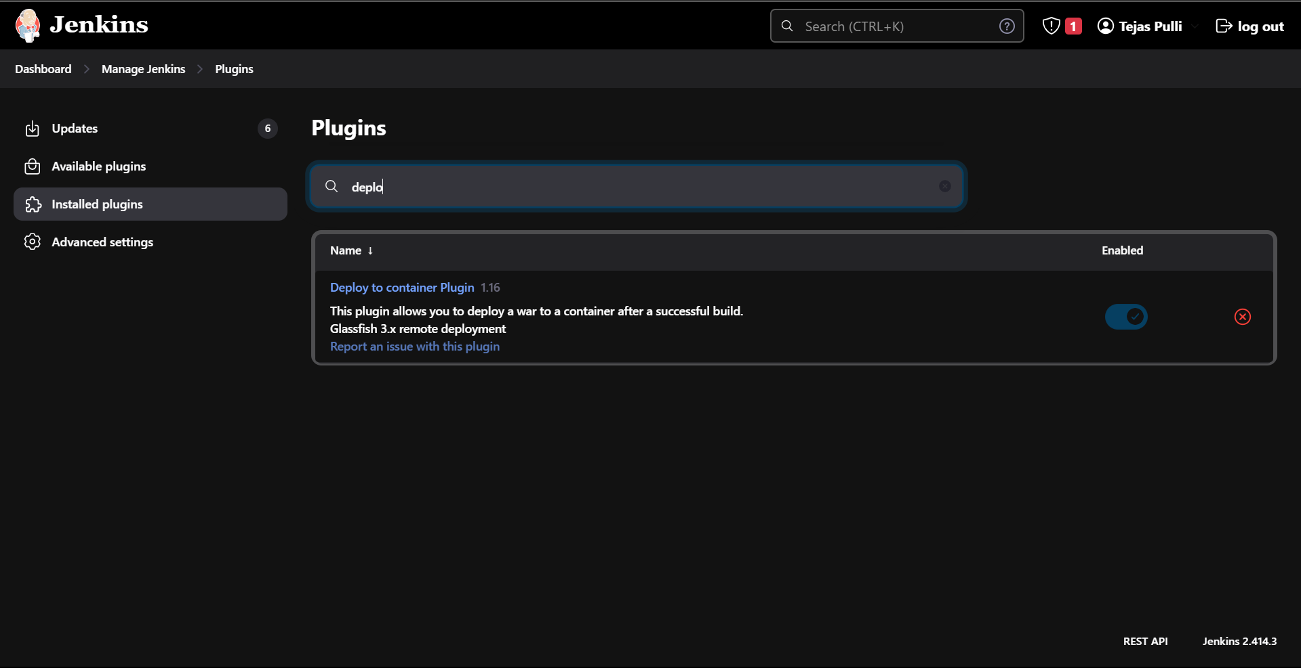

* Configure Jenkins Credentials :

Set up the credentials in Jenkins to authenticate with the container (i.e. Tomcat). Use thee credentials to deploy the application.

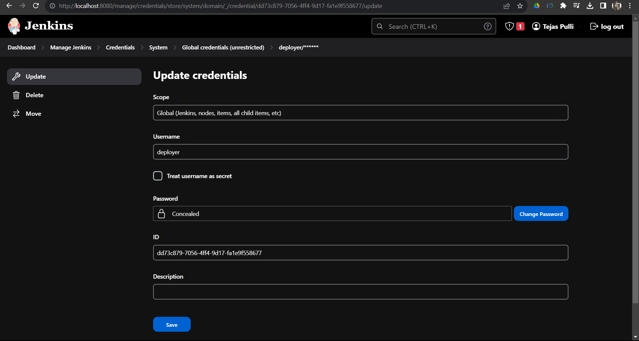

* Create a Jenkins Job:

Create a new job from the dashboard select New Item to create a new job , name it and choose Freestyle project.

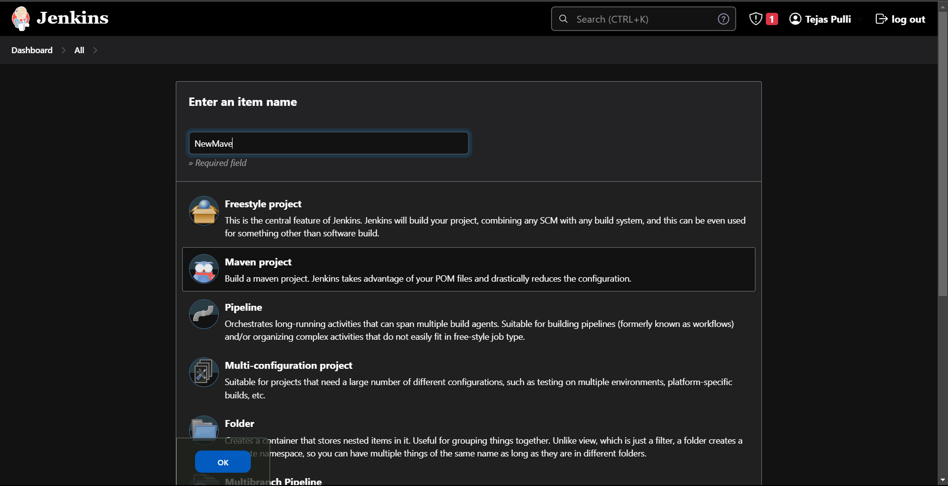

* Configure Project :

In Source Code Management choose Git and add github repository link

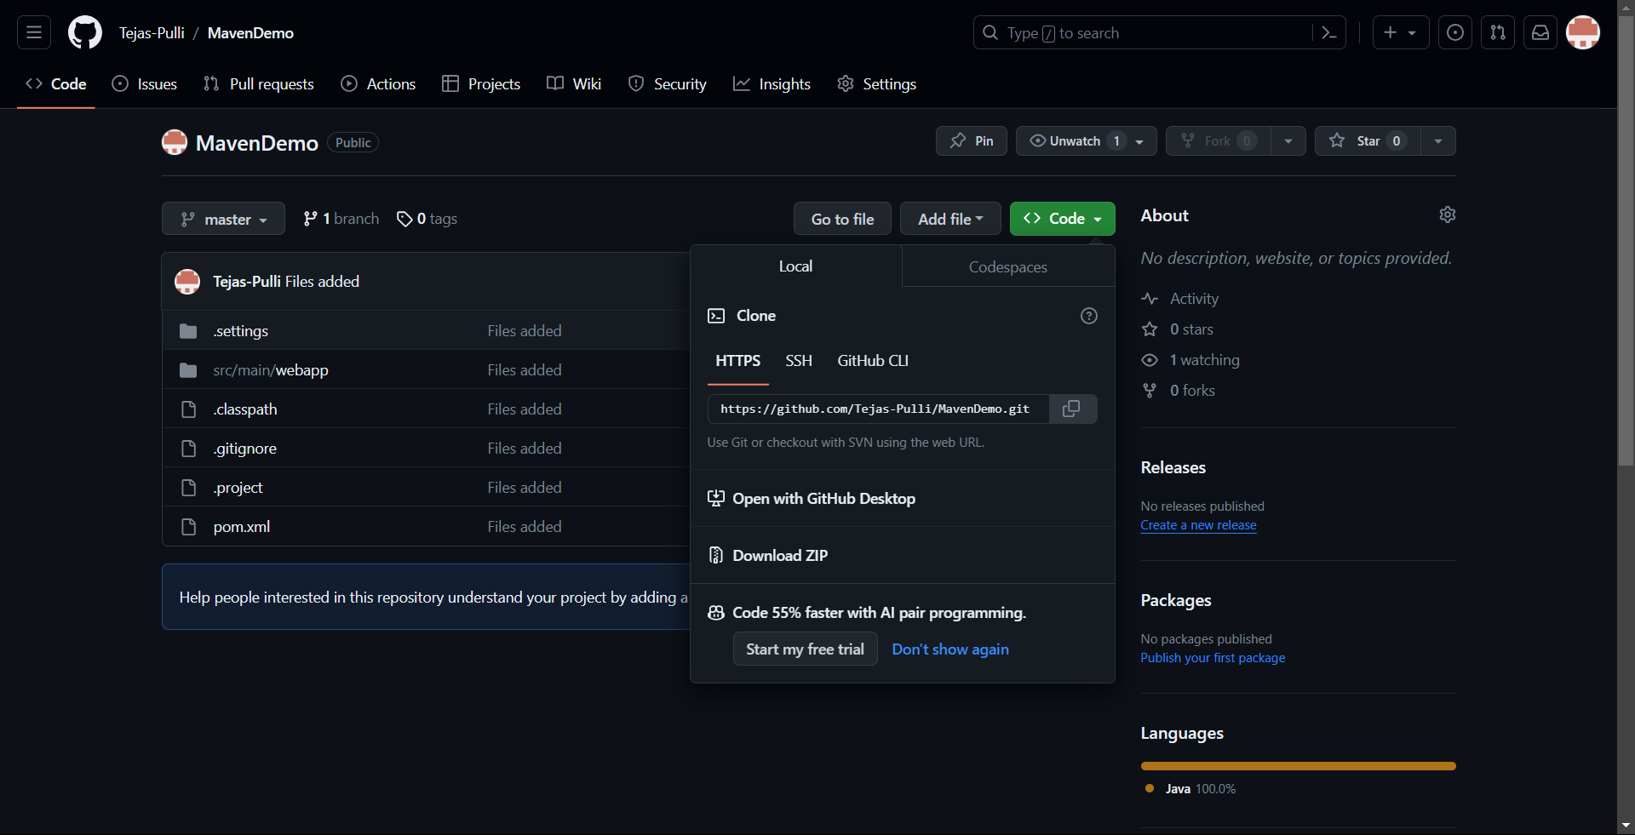

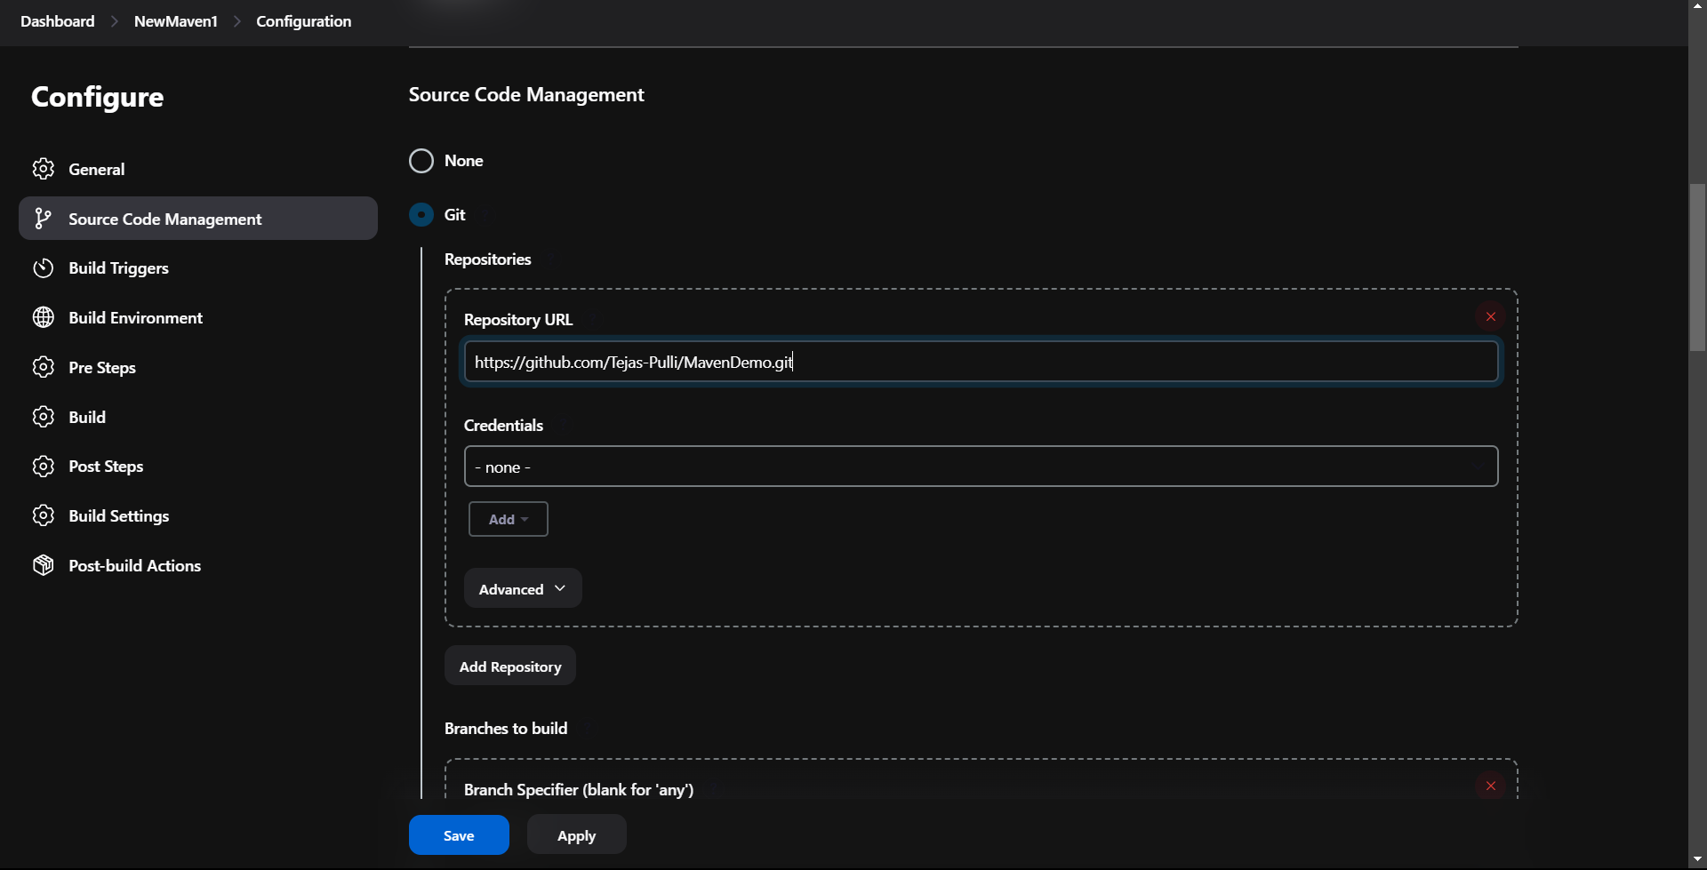

To poll SCM choose every minute i.e. “* * * * * *”

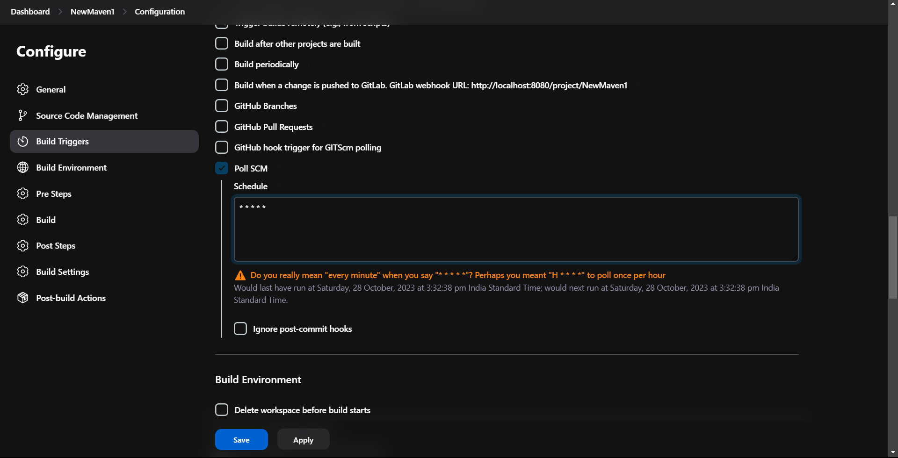

Build Steps:

Choose Invoke top-level Maven targets and Choose Maven version which is configured and set goals as clean install

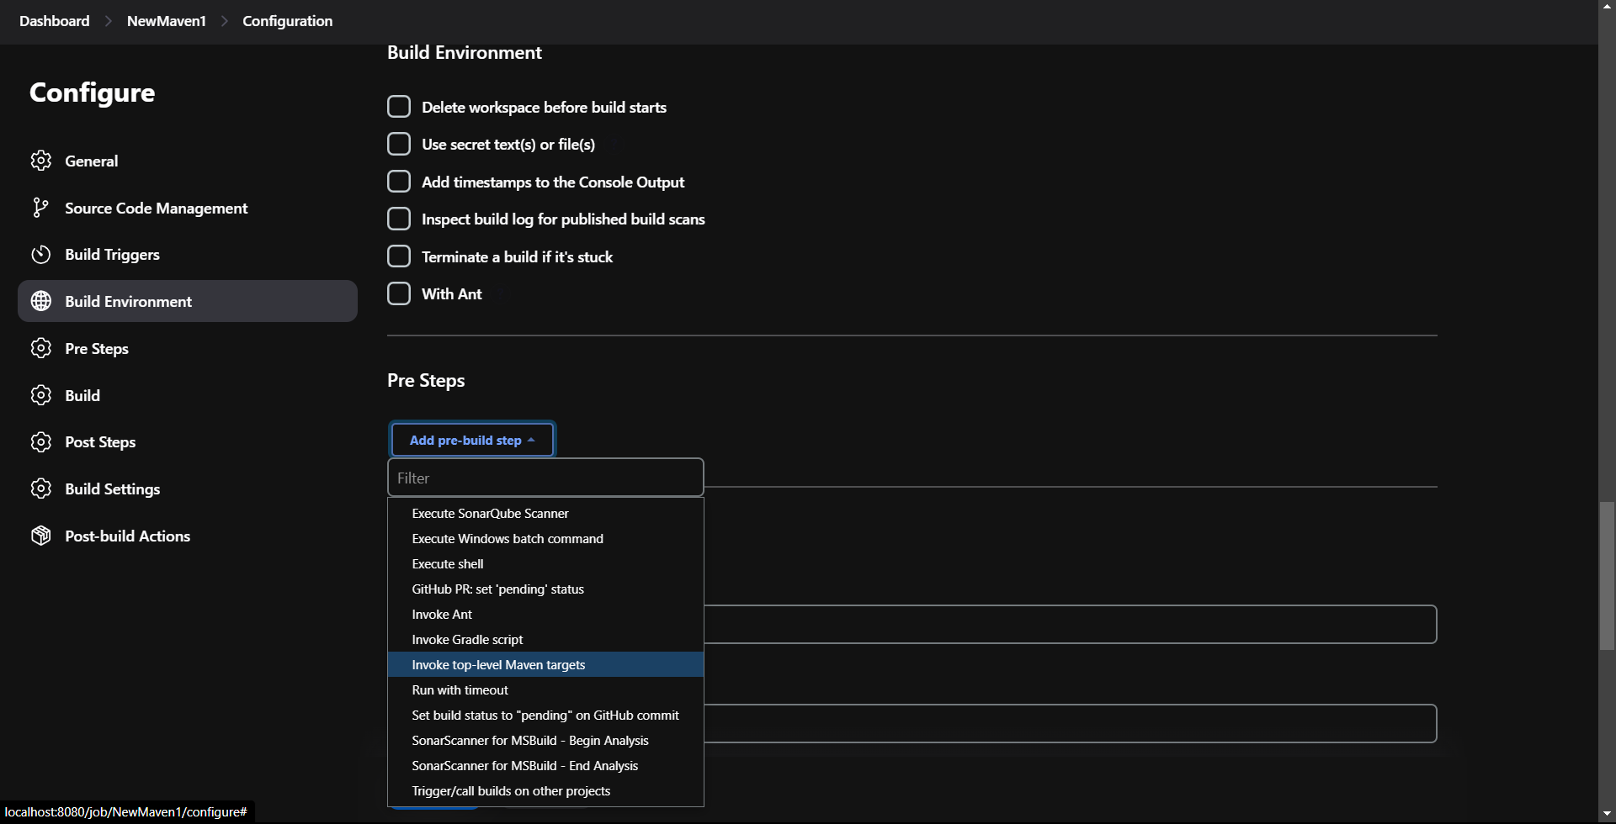

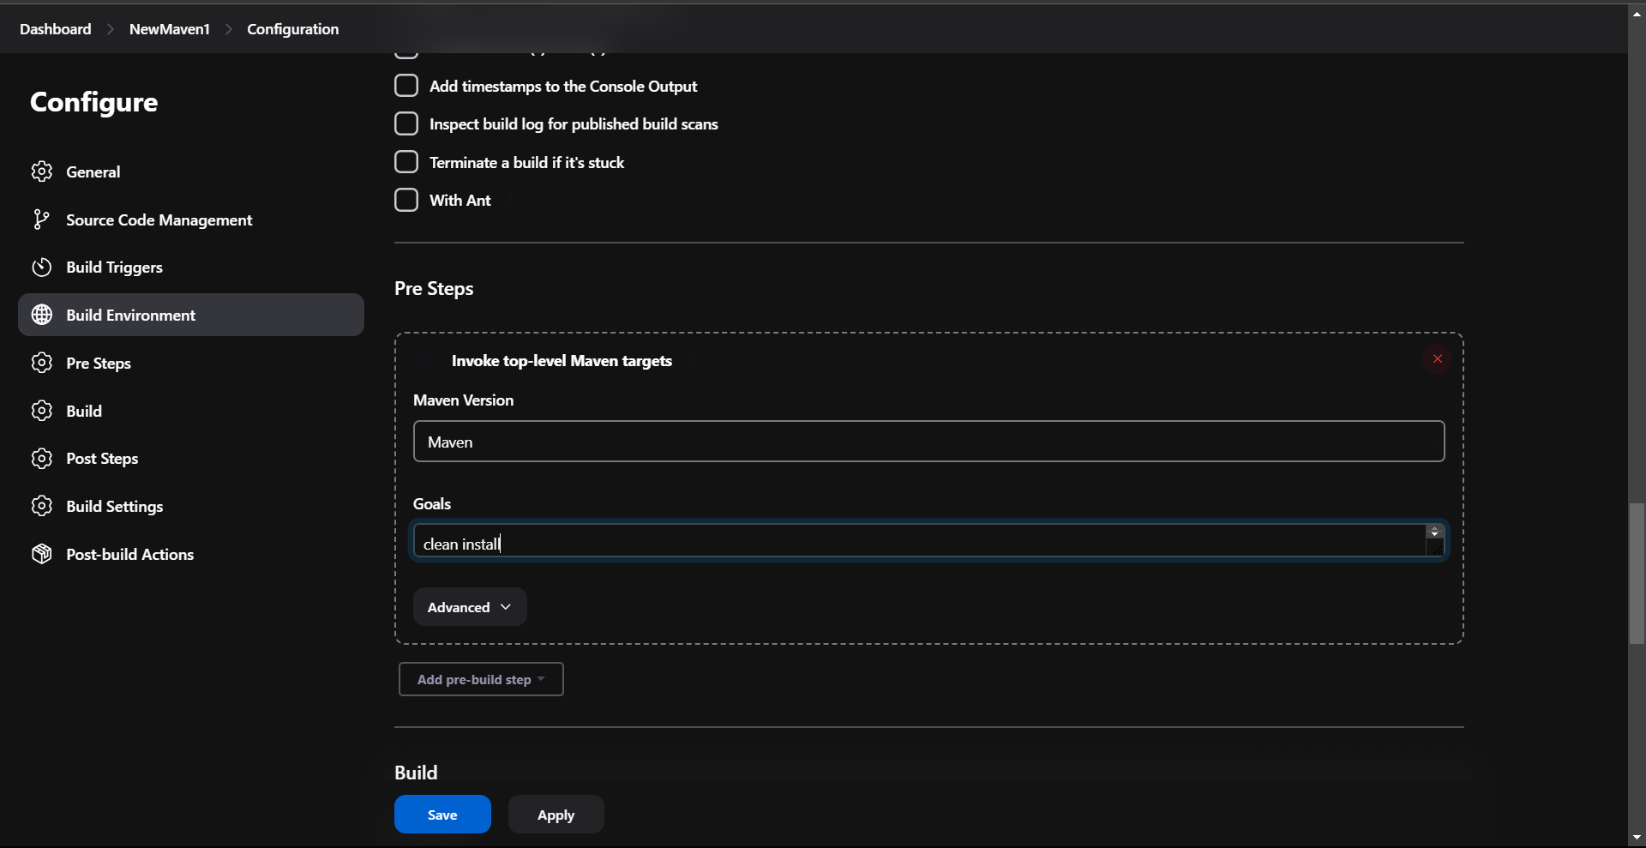

* Post-build Actions :

Choose Deploy war/ear to a container. Give WAR/EAR files location as **/*.war and any context path like “SampleMaven”

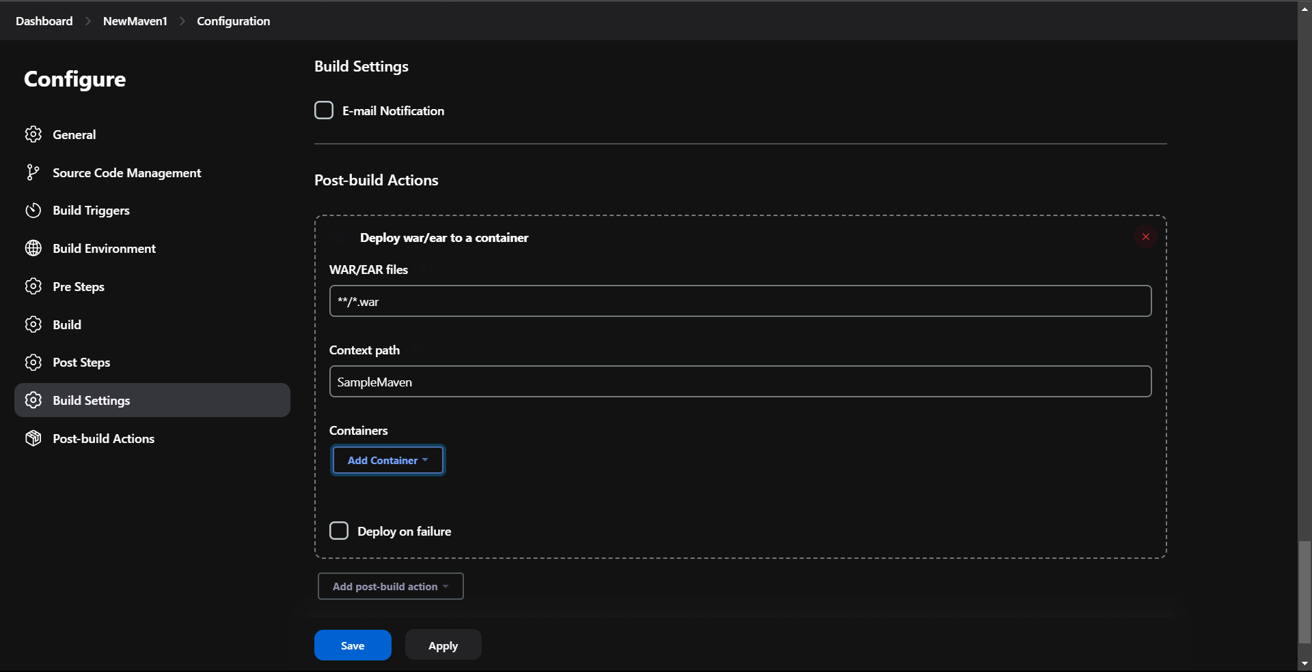

Add Tomcat container of appropriate version configured

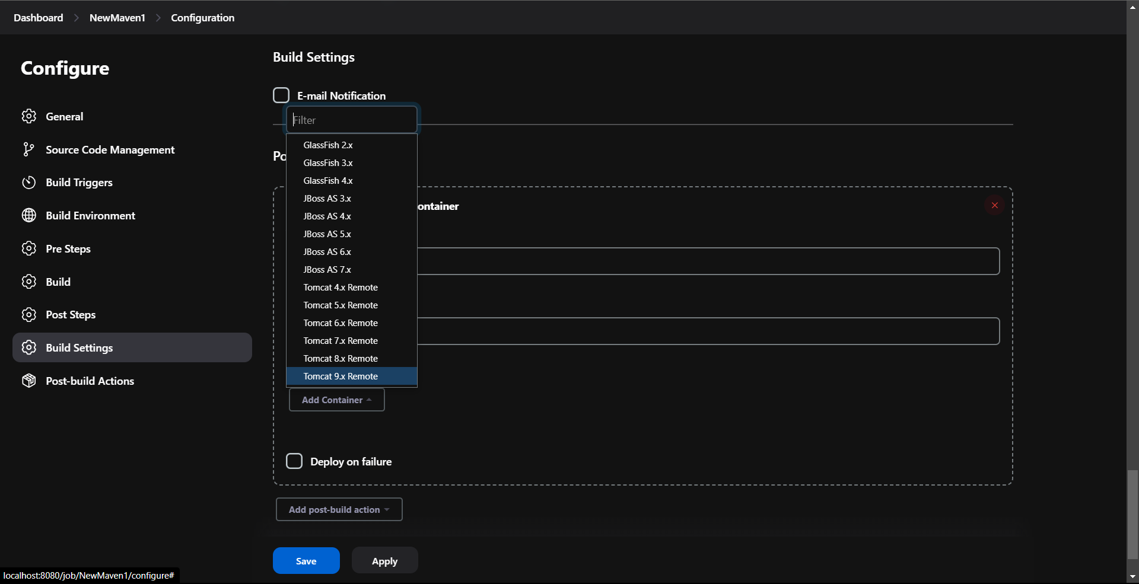

Add the credentials used at the configuration and give the Tomcat URL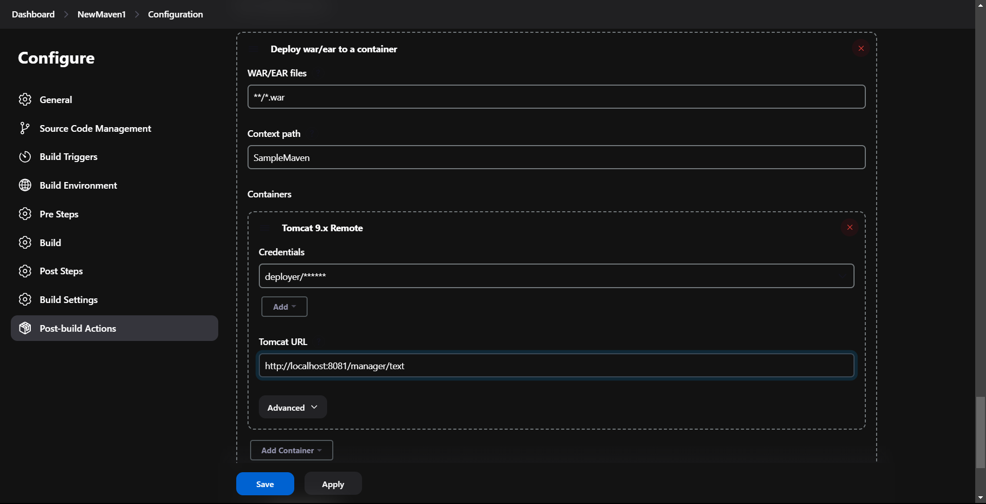

Build :

Save and Build the project

