Date- 08/10/2024
Shrikant Kailas More
C Language End Module Test

Q.1 count words in string.

Program:-

//Question 1 : count words in string
#include<stdio.h>
void main(){
int i,count=0;
char str[300];
printf("Enter the String :");
fflush(stdin);
fgets(str,300,stdin);

for(i=0;str[i]!='\0';i++){

if(str[i]==' '){

count++;
}

}
count++;
printf("\n Number of Words in Given String : %d",count);
}

Output:-

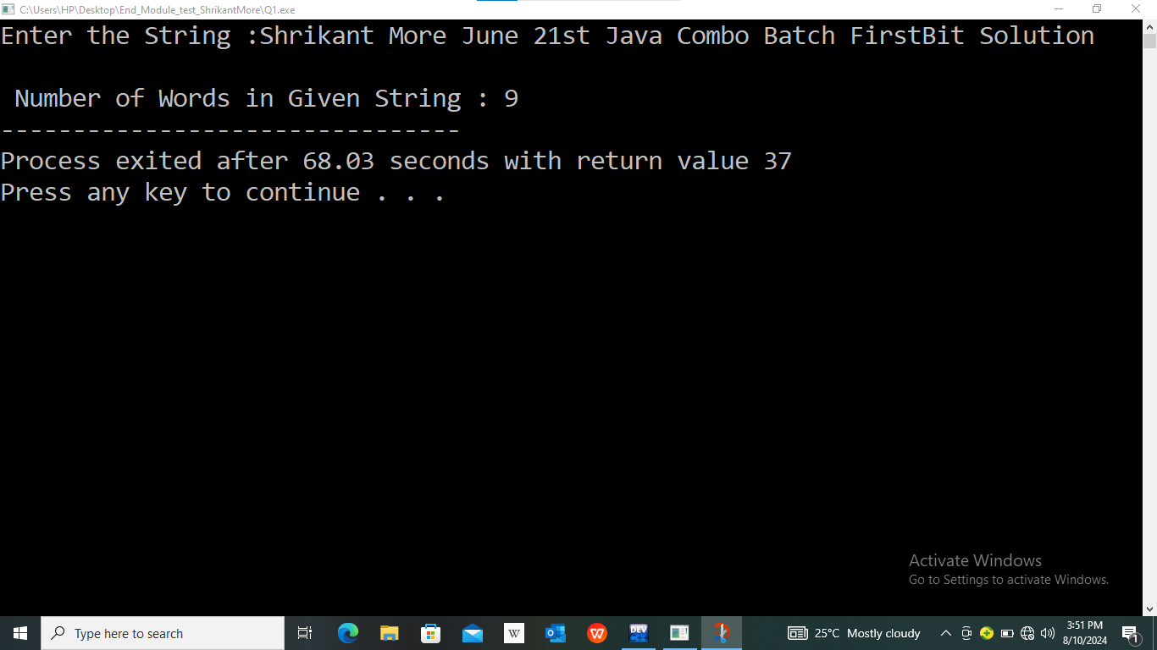

Q2. 1+11+111+1111+n

Program:-

//Question 2 : 1+11+111+1111+n
#include<stdio.h>
void main(){
int i,j,count;
printf("Enter the Number How many time You Want to print 1 :");
scanf("%d",&count);
for(i=1;i<=count;i++){
for(j=i;j>0;j--){
printf("1");
}
if(i<count){
printf("+");
}
}
}

Output:-

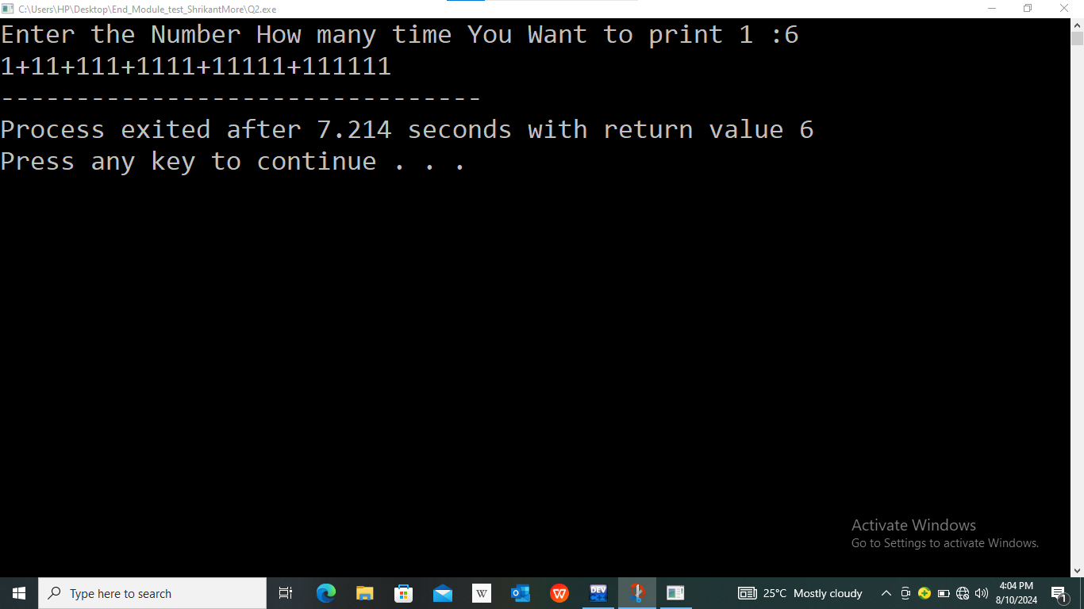
Q3. Create a struct of Song And add add song ,see the all songs list and remove songs.
Song(ID ,Title ,Name of Artist ,Duration)

Program:-

#include<stdio.h>
int list;
typedef struct Song{
int id;
char title[40];
char artist[40];
int Duration;
}Song;
void storesong(Song*);
void showsong(Song* );
void main(){
list=0;
Song s1[50];
int ch;
do{
printf("\n EXIT : 0");
printf("\n Add Songs : 1");
printf("\n Display Song Library : 2");
printf("\n__________________________________________________\n");
printf("\n\n Enter Your choise :");
scanf("%d",&ch);
switch(ch!=0){
case 0:
if(ch==0){
printf("\n__________________________________________________\n");
printf("\n\n THANKS FOR USE....");
break;
}
case 1:
if(ch==1){
storesong(s1);
break;
}
case 2:
if(ch==2){
showsong(s1);
break;
}
default:
printf("\n\nInvalid Choise..... ");
break;
}
}while(ch!=0);
}
void storesong(Song* s1){
int i=list,count;
printf("\n How Many Songs You want to enter now :");
scanf("%d",&count);
list=count+list;
for(;i<list;i++){
printf("Enter Song id :");
scanf("%d",&s1->id);
printf("Enter Song Title :");
fflush(stdin);
fgets(s1->title,300,stdin);
printf("Enter Artist Name :");
fflush(stdin);
fgets(s1->artist,300,stdin);
printf("Enter Song Duration :");
scanf("%d",&s1->Duration);
}
}
void showsong(Song* s1){
int i;
for(i=0;i<list;i++){
printf("\n Song id : %d",s1->id);
printf("\n Song Title : %s",s1->title);
printf("\n Artist Name : %s",s1->artist);
printf("\n Song Duration :%d",s1->Duration);
}
}

Output:-

