**IT1140 PYTHON PROGRAMMING**

**A**

**CYCLE TEST 1**

**MAX MARKS: 25 DATE: 02.08.2016**

**PART – A (ANSWER ANY THREE) 3*4 = 12 marks**

1. **Write the steps in execution of a Python program**

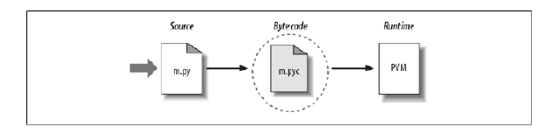

1. **An online retailer provides express shipping for many of its items at a rate of Rs.55 for the first item, and Rs.75 for each subsequent item. Write a function that takes the number of items in the order as its only parameter. Return the shipping charge for the order as the function’s result.**

def shipping(no):

charge = 55 + (no-1) * 75

return charge

print(shipping(5))

1. **What will be the output of the below statements when typed in shell**
2. **os.path.split(r'C:\Sample\data.txt')**

('C:\\Sample', 'data.txt')

1. **os.path.join(r'C:\Sample','sample','output.txt')**

'C:\\Sample\\sample\\output.txt'

1. **name = r'C:\temp\data.txt'**

**os.path.basename(name)**

'data.txt'

1. **os.path.splitext(r'C:\PP4thEd\Examples\PP4E\PyDemos.pyw')**

('C:\\PP4thEd\\Examples\\PP4E\\PyDemos', '.pyw')

1. **How do you add a directory to the system path variable? Explain with example.**

import sys

sys.path.append(r’C:\Sample’)

**PART – B**

1. Realize the below classes and inheritance in Python. Demonstrate by creating instances. Override the method execute() in the child classes. Assume the methods’ functionality according to their self-explanatory names. **(13 marks)**

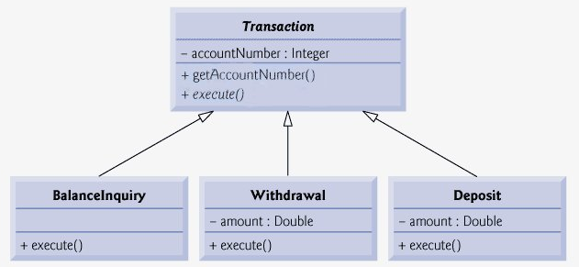

Class Creation : 4 marks

Method Overriding: 3 marks

Constructors: 3 marks

Instance Creation and method invocation : 3 marks

Sample Program:

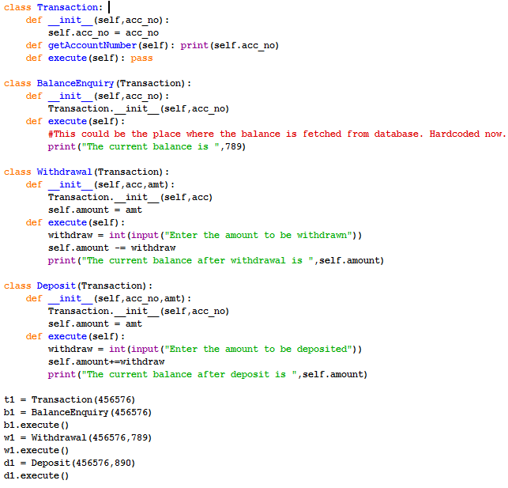

**(OR)**

1. Create a program that reads words from the user until the user enters 0. After the user enters 0 the program should display each word entered by the user exactly once. The words should be displayed in the same order that they were entered. Use lists. For example, if the user enters:

first

second

first

third

second

then your program should display:

first

second

third

Sample Program:

Getting inputs : 6 marks

Logic : 6 marks

Looping Construct: 1 mark

