**DEPARTMENT OF INFORMATION TECHNOLOGY**

**IT1140 PYTHON PROGRAMMING**

**A**

**CYCLE TEST 2**

**MAX MARKS: 50 DATE: 01.09.2016**

**PART – A (ANSWER ANY FIVE) 5*4 = 20 marks**

1. Detail the administrative tools in os module

og.getpid, os.getcwd, os.chdir

1. Detail on how to generate a random integer from a range [e.g a random number between 56 to 189.] and how to randomly pick an element from a list.

import random

random.randint(56,189)

1. List the basic and extended modes of opening a file.

Basic modes – r, w, a

Extended modes – r+, w+, a+

1. Write test cases for doctest module for the below defined function

def plus_overload(a,b):

return a + b

def my_function(a, b):

"""

>>> my_function(2, 3)

5

>>> my_function('a', ‘b’)

'ab'

"""

return a + b

python -m doctest -v doctest_simple.py

1. What is abstraction? What are the different types of abstraction?

Purposefully hide low level details so that high level details are visible.

* Achieved via Functions
* Types
  + What level
  + How level

1. Give the time complexity of the below operations:

|  |  |
| --- | --- |
| **Operation** | **Complexity** |
| Accessing any slice of length M from a list of N elements | O(M) |
| len() of a string of N characters | O(1) |
| Removing a dictionary item of N elements | O(1) |
| Reverse a list of N elements | O(N) |

**PART – B (2*15 = 30 marks)**

**[ANSWER ANY ONE IN EITHER OR PART]**

1. a. Create the below table and execute the insert, update and select statements.

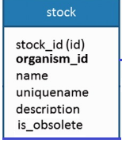

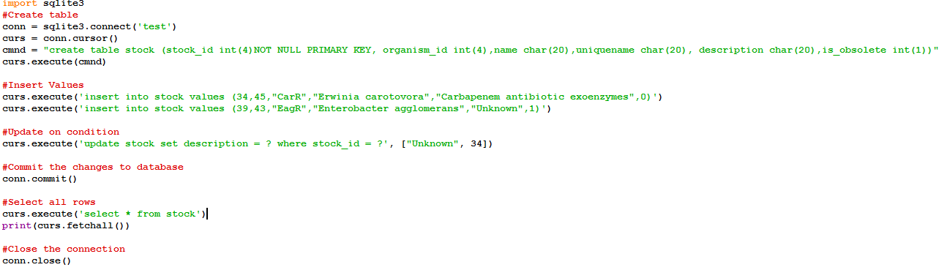

(OR)

b. Write a program using threads to connect to urls. Declare a list of urls in your program. Give the work of connecting to url and printing output to threads.

Note: The below code snippet is used to connect to url.

from urllib.request import urlopen

remoteaddr = “” #Address from which to download. Read this from a list one by one.

page_content = urlopen(remoteaddr).readlines()#pagecontent variable has the url content.

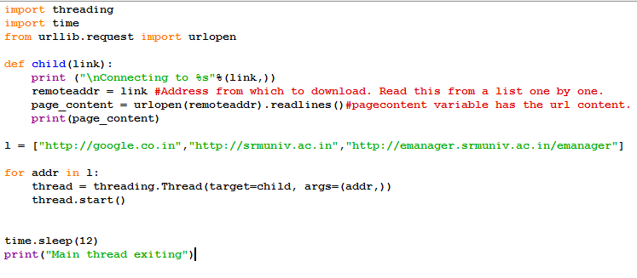

1. a. Create a Python program to concatenate and display two or more files whose names are provided as user input, till the user types “end”. Display an appropriate error message if the file does not exist.

Hint: Assume the files are in the same directory as the .py source file.

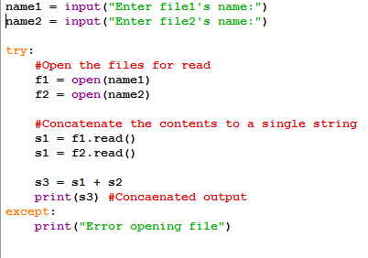

(OR)

b. Write code snippets to perform the below date operations:

1. Print current date and time stamp.

import datetime

today = datetime.datetime.today()

print(today)

print(today.ctime())

print(datetime.datetime.now())

1. Create a date object for April 30, 2014.

date1 = datetime.date(2014,5,30)

1. Add 45 days to the above date and print.

days_45 = datetime.timedelta(days=45)

result = date1+days_45

print(result)

1. Check if the date obtained from the above point 3, is less than June10, 2014.

date2 = datetime.date(2014,6,10)

print(result<date2)

1. Find the difference between the date obtained from the above point 3 and current date

y = today.year-result.year

m = today.month-result.month

d = today.day – result.day