Short text!

Short text!

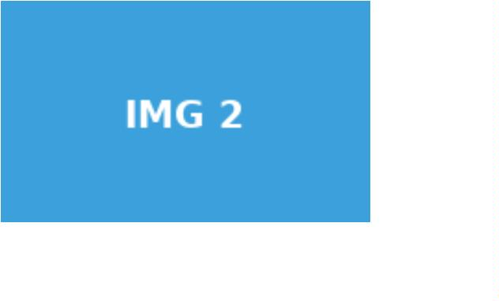

This is a long text, longer than thirty-two characters. It goes on a bit.

This is a long text, longer than thirty-two characters. It goes on a bit.

