THE CALCULUS GROUP
A python project report

Submitted in partial fulfilment of the requirement of
Class X Computer Applications / AI Practical Examination
Submitted by:
- Abish Bista — Roll No. 4
- Nisham Ingam Limbu — Roll No.
- Sijan Shahi — Roll No.
- Subin Shrestha— Roll No.
- Ritwiz Khadka — Roll No.
- Gunjan Gurung— Roll No.
Under the guidance of
Bijesh Maharjan
Trungram International Academy
Academic Session 2026–27
CERTIFICATE
This is to certify that the project titled “The Calculus Group” has been developed by Abish Bista and group members of Class X, Trungram International Academy, during the academic session 2026–27, under my guidance and supervision.
This project has been prepared in partial fulfilment of the requirement for the Computer Applications / Artificial Intelligence practical examination and represents the original work of the students.
I wish them success in all their future endeavors.
_______________________
Teacher's Signature
_______________________
External Examiner

ACKNOWLEDGEMENT
We would like to express our sincere gratitude to our Computer Applications teacher, Bijesh Maharjan, and Ujjwal Rijal for their valuable guidance, encouragement, and support throughout the completion of this project.
We are also thankful to our Principal, Neema Pradhan, and Trungram International Academy for providing us with the necessary computer laboratory facilities and resources required to complete this project.
Finally, we would like to thank our parents and friends for their constant support and motivation during the development of this project.
– Abish Bista and Group Members

INDEX / TABLE OF CONTENTS
Chapter | Page No.
Certificate | 2
Acknowledgement | 3
Introduction | 4
Objectives of the Project | 5
System Requirements | 6
Proposed System | 7
Features of the Calculator | 8
Source Code | 15
Sample Output | 16
Testing | 17
Future Scope | 18
References | 19

INTRODUCTION
The Advanced Scientific Calculator is a software application developed using Python, HTML, and CSS to perform mathematical calculations and utility conversions. Unlike a basic calculator, this system is capable of handling scientific functions such as sine, cosine, tangent, logarithms, square roots, powers, and other advanced operations.
The project also includes features such as calculation history, personal notes, currency conversion for more than 20 countries, and measurement conversion for units like length, weight, temperature, and speed.
The main purpose of this project is to apply programming concepts in a real-life application while creating a useful and user-friendly tool for students and general users.

OBJECTIVES OF THE PROJECT
The main objectives of this project are:
- To develop a scientific calculator capable of performing advanced mathematical operations.
- To implement trigonometric functions such as sin, cos, and tan.
- To store and display calculation history using file handling or a database.
- To provide a notes section where users can save important information.
- To perform currency conversion for more than 20 countries using live exchange rates.
- To convert measurements such as length, weight, temperature, and speed.
- To improve programming, problem-solving, and teamwork skills through project development.

SYSTEM REQUIREMENTS
Hardware Requirements
- Processor: Intel Pentium or above
- RAM: 2 GB or more
- Storage: 20 GB free space or more
- Keyboard, mouse, and monitor
Software Requirements
- Operating System: Windows 10/11
- Programming Language: Python 3.x
- Frontend: HTML5, CSS3, JavaScript
- Framework: Flask (Python backend)
- Database: SQLite
- IDE: VS Code / PyCharm

PROPOSED SYSTEM
The proposed system is a web-based calculator application with a graphical user interface. The user interacts with the calculator through buttons and input fields designed using HTML and CSS. JavaScript handles user interactions, while Python processes calculations, stores data, and manages conversions.
The system contains the following modules:
- Basic Calculator Module
- Scientific Calculator Module
- History Module
- Notes Module
- Currency Converter Module
- Measurement Converter Module
This modular design makes the application easy to maintain and extend with new features in the future.
Feature | Description
10-Digit Calculation Support | Handles calculations up to 10 digits or more
Scientific Functions | Supports sin, cos, tan, log, ln, √, x², xʸ, π, e, factorial, etc.
Calculation History | Stores previous calculations for later reference
Notes | Allows users to save and manage personal notes
Currency Converter | Converts currencies for 20+ countries using exchange rates
Measurement Converter | Converts units of length, weight, temperature, speed, and more
User-Friendly Interface | Designed with HTML and CSS for easy usage
Python Backend | Processes calculations, stores data, and manages conversions
FEATURES OF THE CALCULATOR

Source Code Frontend

“<HTML FILE>”

<!DOCTYPE html>
<html lang="en">
<head>
<meta charset="UTF-8">
<meta name="viewport" content="width=device-width, initial-scale=1.0">
<title>Advanced Scientific Calculator</title>
<link rel="stylesheet" href="styles.css">
</head>
<body>
<div class="app">
<aside class="sidebar">
<div class="brand">ADVANCED SCIENTIFIC CALCULATOR</div>
<nav class="nav" role="navigation" aria-label="Main">
<button id="btn-calc" class="active"><span class="icon">🧮</span><span>Calc</span></button>
<button id="btn-history"><span class="icon">📜</span><span>History</span></button>
<button id="btn-notes"><span class="icon">📝</span><span>Notes</span></button>
<button id="btn-scientific"><span class="icon">🔬</span><span>Scientific</span></button>
<button id="btn-currency"><span class="icon">💱</span><span>Currency</span></button>
<button id="btn-measure"><span class="icon">📏</span><span>Measure</span></button>
<button id="btn-settings"><span class="icon">⚙️</span><span>Settings</span></button>
</nav>
<div style="margin-top:auto;display:flex;justify-content:center"><small class="small">Build 0.1</small></div>
</aside>

<main class="main">
<div class="main-header">
<div class="title">Main Working Area</div>
<div style="display:flex;align-items:center;gap:10px">
<div class="small">☾</div>
</div>
</div>

<section class="work">
<div class="left-panel">
<div id="panel-calc" class="panel">
<div class="calc-display" id="display">0</div>
<div class="keypad" id="keypad">
<div class="key">7</div>
<div class="key">8</div>
<div class="key">9</div>
<div class="key">/</div>
<div class="key">4</div>
<div class="key">5</div>
<div class="key">6</div>
<div class="key">*</div>
<div class="key">1</div>
<div class="key">2</div>
<div class="key">3</div>
<div class="key">-</div>
<div class="key">0</div>
<div class="key">.</div>
<div class="key">C</div>
<div class="key">+</div>
<div class="key">(</div>
<div class="key">)</div>
<div class="key">=</div>
<div class="key">^</div>
</div>
</div>

<div id="panel-history" class="panel" style="display:none;margin-top:12px">
<div style="font-weight:600;margin-bottom:8px">History</div>
<div id="historyList" class="small">No history yet.</div>
</div>

<div id="panel-notes" class="panel" style="display:none;margin-top:12px">
<div style="font-weight:600;margin-bottom:8px">Notes</div>
<textarea id="notes" style="width:100%;height:160px;border-radius:6px;padding:8px;background:#07121a;color:#e6eef8;border:1px solid rgba(255,255,255,0.03)"></textarea>
</div>
<div id="panel-scientific" class="panel" style="display:none;margin-top:12px">
<div style="font-weight:600;margin-bottom:8px">Scientific Functions</div>
<div id="sciButtons" style="display:grid;grid-template-columns:repeat(4,1fr);gap:8px"></div>
<div class="small" style="margin-top:10px">Click a function to insert it into the calculator input.</div>
</div>
<div id="panel-currency-left" class="panel" style="display:none;margin-top:12px">
<div style="font-weight:600;margin-bottom:8px">Currency</div>
<div id="currencyControlRoot">Loading...</div>
</div>
<div id="panel-measure-left" class="panel" style="display:none;margin-top:12px">
<div style="font-weight:600;margin-bottom:8px">Measurement</div>
<div id="measureControlRoot">Loading...</div>
</div>
</div>

<aside class="right-column">
<div id="settingsPanel" class="panel small" style="display:none;">
<div style="font-weight:600;margin-bottom:8px">Settings</div>
<div id="settingsRoot">Loading...</div>
</div>
</aside>
</section>

<footer>© Advanced Calculator — prototype</footer>
<footer class="small" style="margin-top:4px">Made by : Abish Bista--(Lead Developer)<br>Nisham Limbu<br>Sijan--(Shahi)<br>Subin Shrestha<br>Ritwiz Khadka<br>Gunjan Gurung</footer>
</main>
</div>

<script type="module" src="js/main.js"></script>
</body>
</html>

Sample Output
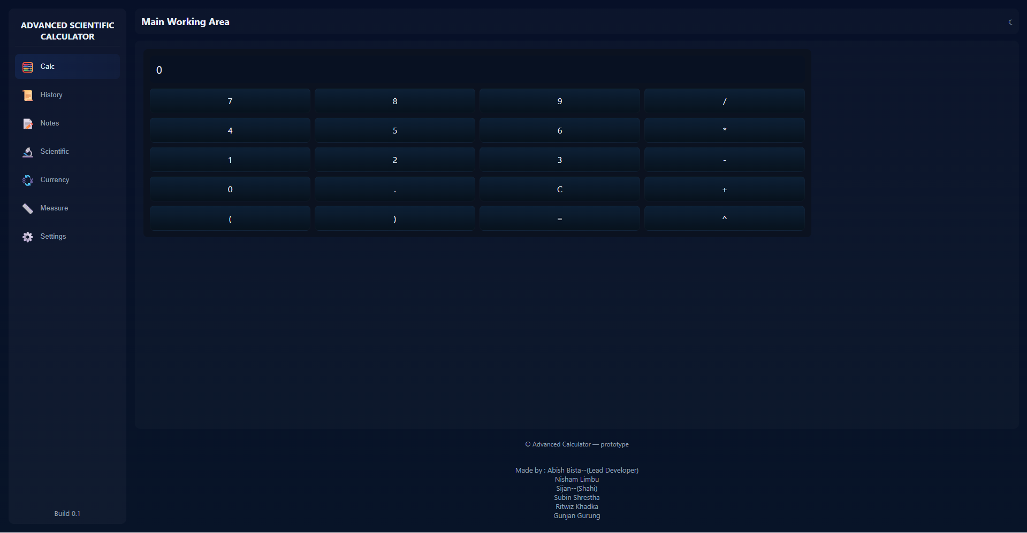

TESTING
The following test cases were performed:
- Basic arithmetic calculations (addition, subtraction, multiplication, division)
- Scientific calculations using sin, cos, tan, log, and square root
- Saving and displaying calculation history
- Creating, editing, and deleting notes
- Converting currencies between different countries
- Converting measurements such as km to miles and kg to pounds
- Entering invalid expressions to ensure the program handles errors correctly
All test cases produced the expected results, confirming that the application works correctly

FUTURE SCOPE
This project can be improved further by adding:
- Graph plotting for mathematical functions
- Voice input for calculations
- User login and cloud synchronization
- Mobile application version
- Offline currency conversion using stored exchange rates
- Custom themes and personalization options
- Export history and notes as PDF files

REFERENCES
- Python Official Documentation – https://docs.python.org
- Flask Documentation – https://flask.palletsprojects.com
- W3Schools HTML, CSS & JavaScript Tutorials – https://www.w3schools.com
- GeeksforGeeks – https://www.geeksforgeeks.org
- Class notes and practical files provided by our teacher

