UML COMPONENT DIAGRAM

SRN: Shreedhar r
NAME: PES2UG25CS823
SEC: H

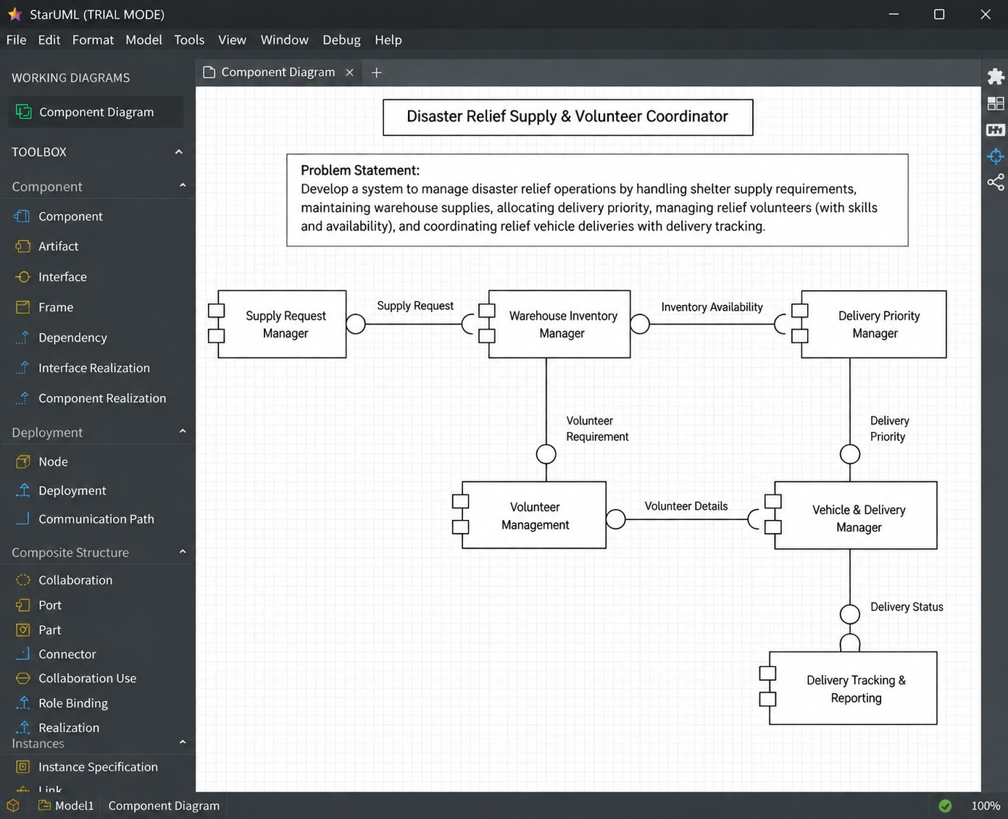

Scenario Review
Problem: Disaster Relief Supply & Volunteer Coordinator. The system manages shelter supply requirements, warehouse inventory, delivery priority, relief volunteer assignment and availability, vehicle deliveries, and delivery tracking.
Key functional requirements:
- Manage shelter supply requests and check warehouse inventory.
- Allocate delivery priority for relief requirements.
- Assign relief volunteers and maintain their skills and availability.
- Manage vehicle deliveries and track delivery progress.
- Report delivery delays.
Main challenges:
- Performance: supply, priority, volunteer, and delivery information must move efficiently between components.
- Usability: disaster managers and logistics officers need a clear, organized system flow.
- Security: operational, volunteer, inventory, and delivery information should be protected.

Architectural Style Analysis
Layered Architecture
Structure: Presentation, Business, and Data layers.
Pros: clear separation of concerns, easy to understand, good for traditional applications.
Cons: performance overhead, tight coupling between layers, difficult to scale individual components. Microservices Architecture
Structure: small, independently deployable services.
Pros: independent scaling, fault isolation, technology diversity, independent deployment.
Cons: operational complexity, network latency, data consistency challenges.
Client-Server Architecture
Structure: centralized server with multiple clients.
Pros: centralized control, simple deployment, easy data consistency.
Cons: single point of failure, scalability bottleneck, limited fault tolerance.

Architecture Selection
Selected Architecture: Layered Architecture
The system is organized into Presentation, Business, and Data layers. This separates user interaction from relief-management logic and data handling, making the system structure clear.
Two scenario-related reasons:
- The system contains distinct functions such as supply requests, inventory, priority allocation, volunteers, and deliveries which can be organized clearly within business-layer components.
- Separation of presentation, business logic, and data makes the system easier to understand and maintain.

Component Identification
A component is a replaceable and executable piece of a system whose implementation details are hidden. It encapsulates specific functionality, can be replaced by another component providing the same interface, and behaves as a black box through its interfaces.
Components:
- Supply Request Manager – manages shelter supply requests.
- Warehouse Inventory Manager – checks and provides warehouse stock information.
- Delivery Priority Manager – allocates delivery priority.
- Volunteer Management – assigns volunteers and maintains skills and availability.
- Vehicle & Delivery Manager – manages relief vehicle deliveries.
- Delivery Tracking & Reporting – tracks deliveries and reports delays.

Interfaces
A provided interface represents services offered by a component and is shown using a ball. A required interface represents services needed from another component and is shown using a socket.
- Supply Request – transfers shelter supply requirements from Supply Request Manager to Warehouse Inventory Manager for checking available supplies.
- Inventory Availability – provides available warehouse stock information to Delivery Priority Manager for allocating delivery priority.
- Volunteer Requirement – transfers required volunteer information to Volunteer Management for assigning suitable relief volunteers.
- Delivery Priority – transfers assigned delivery priority to Vehicle & Delivery Manager for coordinating deliveries. 5. Volunteer Details – provides volunteer skills and availability to Vehicle & Delivery Manager for delivery coordination.
6. Delivery Status – transfers delivery progress/status to Delivery Tracking & Reporting for monitoring and delay reporting.

Security Advantage
The layered structure separates presentation, business logic, and data handling. Security controls can therefore be applied at appropriate layers, helping protect operational and data-access functions.

Performance Benefit
Separating responsibilities into layers and focused components provides a clear path for processing supply, inventory, volunteer, and delivery operations, while avoiding unnecessary mixing of presentation and data-handling logic.

UML Component Diagram Elements
Component: rectangle with component notation; implementation details remain hidden.
Provided Interface: ball notation showing a service offered by a component.
Required Interface: socket notation showing a service needed by a component.
Port: interaction point that can group related provided and required interfaces.
Assembly Connector: connects a provided interface to a required interface.
Usage Dependency: dashed arrow with <<use>> stereotype when a usage dependency is required.

