Lab 5: Static Code Analysis
Public Transit Fare Calculator
Student: Shreedhar R SRN: PES2UG25CS823
Repository: https://github.com/shree-2004-823/L5_64_public-transit-fare-calculator

Objective
This lab reviews and improves a Python public transit fare calculator using Pylint, Bandit and Flake8. Static analysis complements, but does not replace, runtime testing.

Program overview
The program calculates distance-based fares, applies peak/off-peak and concession discounts, caps daily totals, manages smart-card balances, selects a lowest-fare route, creates ticket checksums, parses stop names from XML and validates gate-upload metadata.

Tools used
Pylint checks code quality and maintainability. Bandit checks common security-sensitive Python patterns. Flake8 checks formatting and style.

Fixes made
The prepared source includes daily fare capping, input validation, hardened XML parsing, non-mutable defaults, SHA-256 checksums, money rounding and gate metadata validation. Run it against the original project tests before replacing the repository's existing file.

Verification commands
python -m pylint fixed_fare_calculator.py python -m bandit -r fixed_fare_calculator.py python -m flake8 fixed_fare_calculator.py python fixed_fare_calculator.py

Before-and-after results
Pylint before: __________ after: __________
Bandit findings before: __________ after: __________
Flake8 violations before: __________ after: __________
Pylint target: greater than 9.5/10. Fill these values using actual local tool output.

Reflection
Static analysis helps find likely issues early. Pylint, Bandit and Flake8 focus on different aspects of the program, so using them together provides a broader review. Fare caps and input validation protect the correctness of charges, while safer parsing and careful handling of external input reduce security risk. The program still needs runtime testing.

Conclusion
The corrected source is intended to improve fare calculation, input handling, XML parsing, checksum strength and maintainability. Final submission should include actual tool results and screenshots captured from the student's own environment.

Screenshot checklist
The following panels are placeholders for your own evidence. The reference links in the chat are examples from other sources, not results from your project, so they should not be inserted as if they were your actual test output.
Screenshot 1 — Pylint before fixes
Capture the original Python file's Pylint command and output, including the score and reported messages.
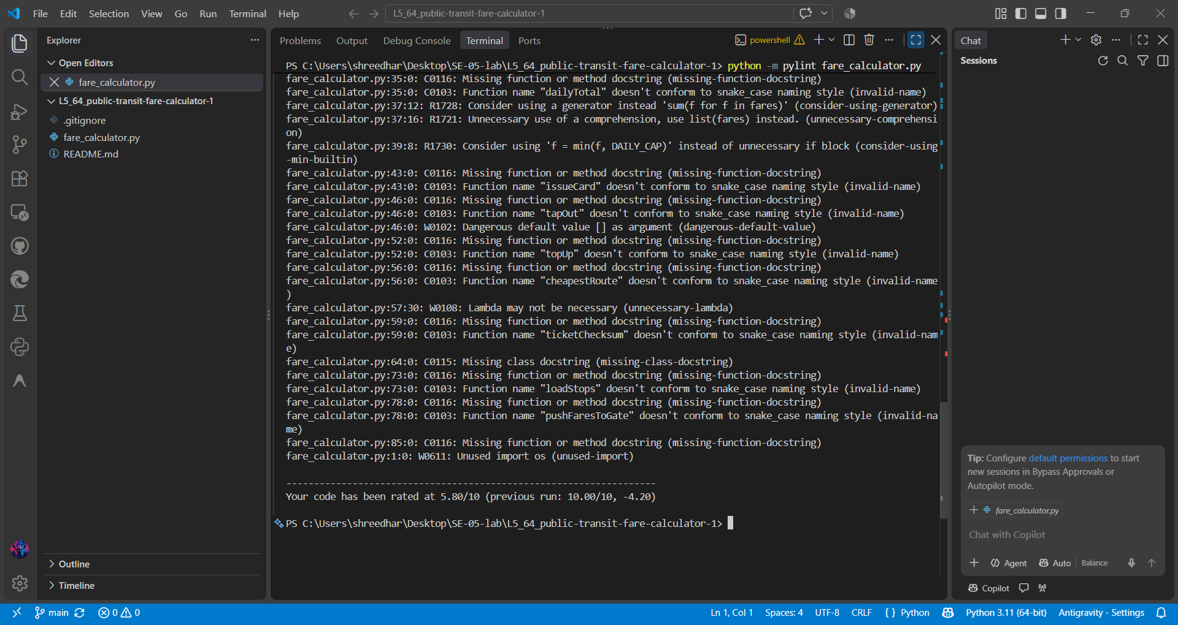

Screenshot 2 — Bandit before fixes
Capture the Bandit command and security findings from the original source.
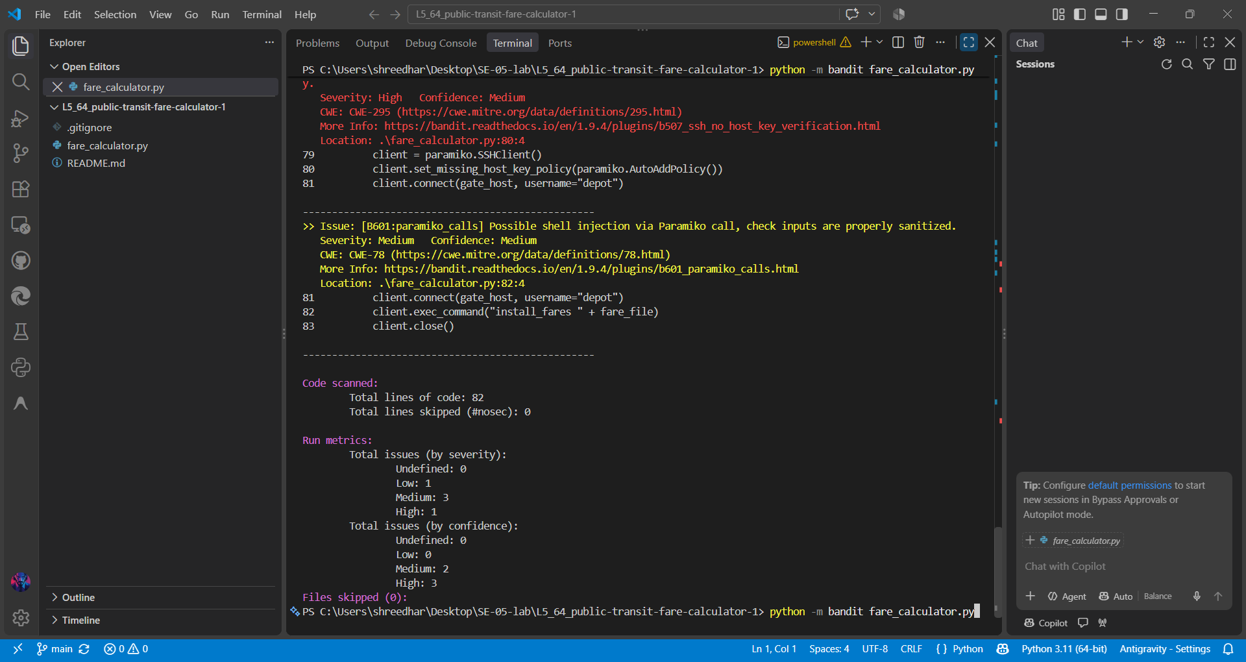

Screenshot 3 — Flake8 before fixes
Capture the Flake8 command and original style findings. If output is empty, show the command and result.
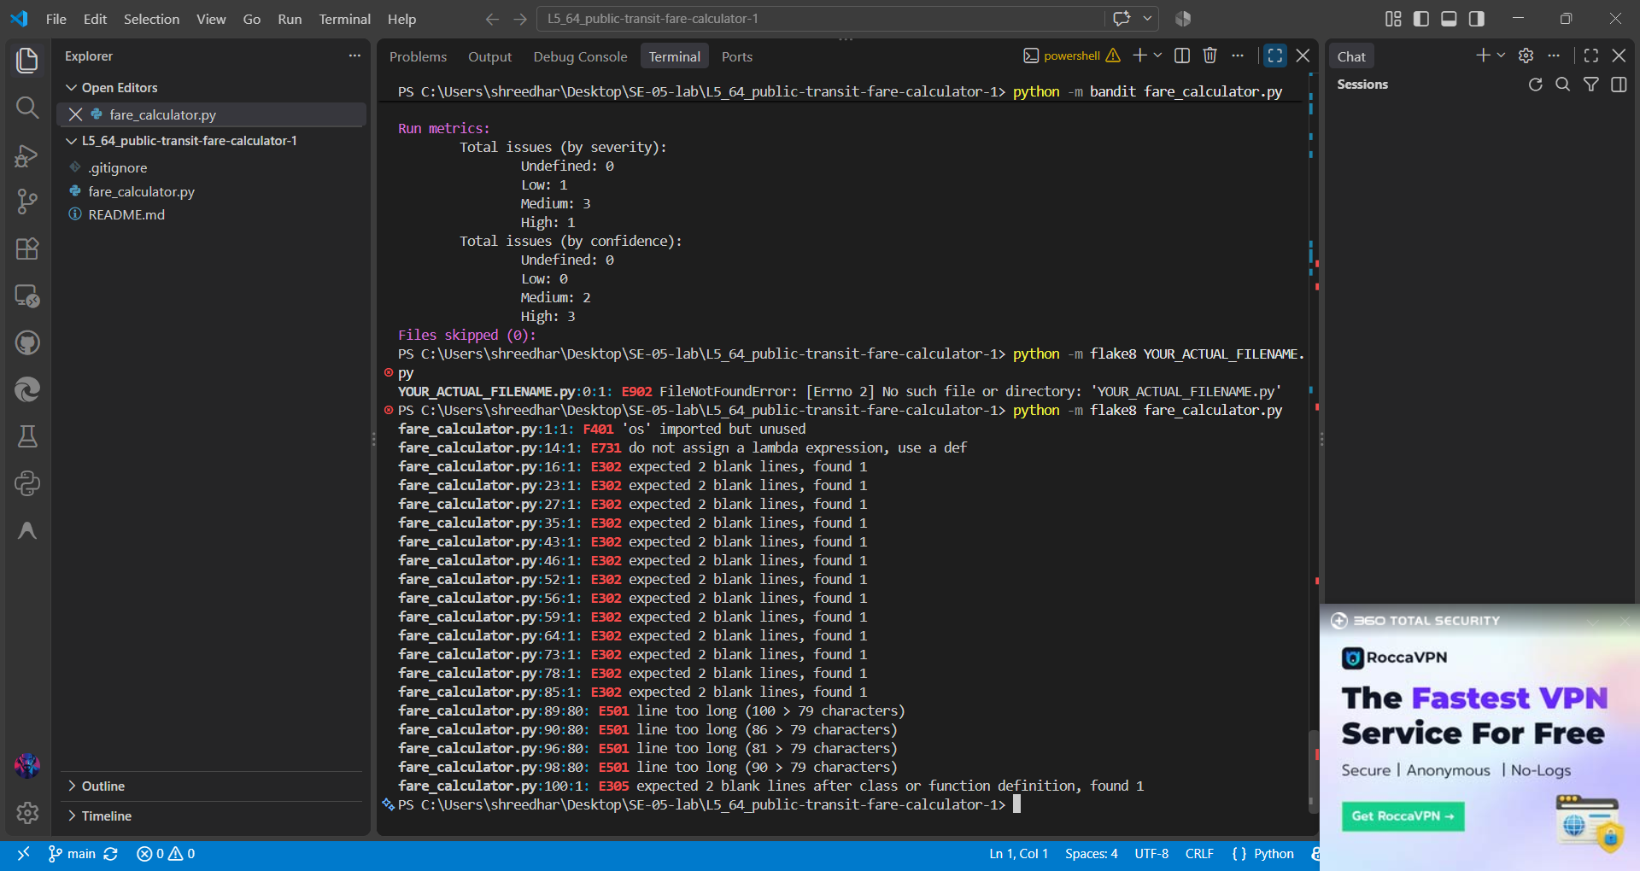

Screenshot 4 — INCorrected code

Show the actualcode in VS Code, especially fare-cap logic, input validation and XML parsing.
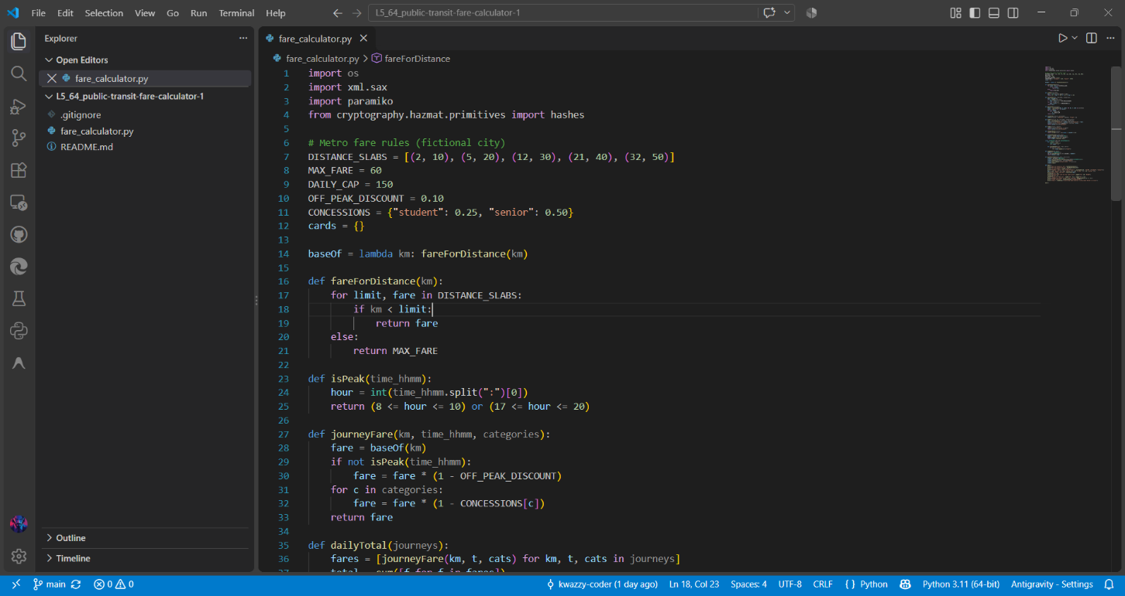
Screenshot 5 — Corrected code
Show the actual changed code in VS Code, especially fare-cap logic, input validation and XML parsing.
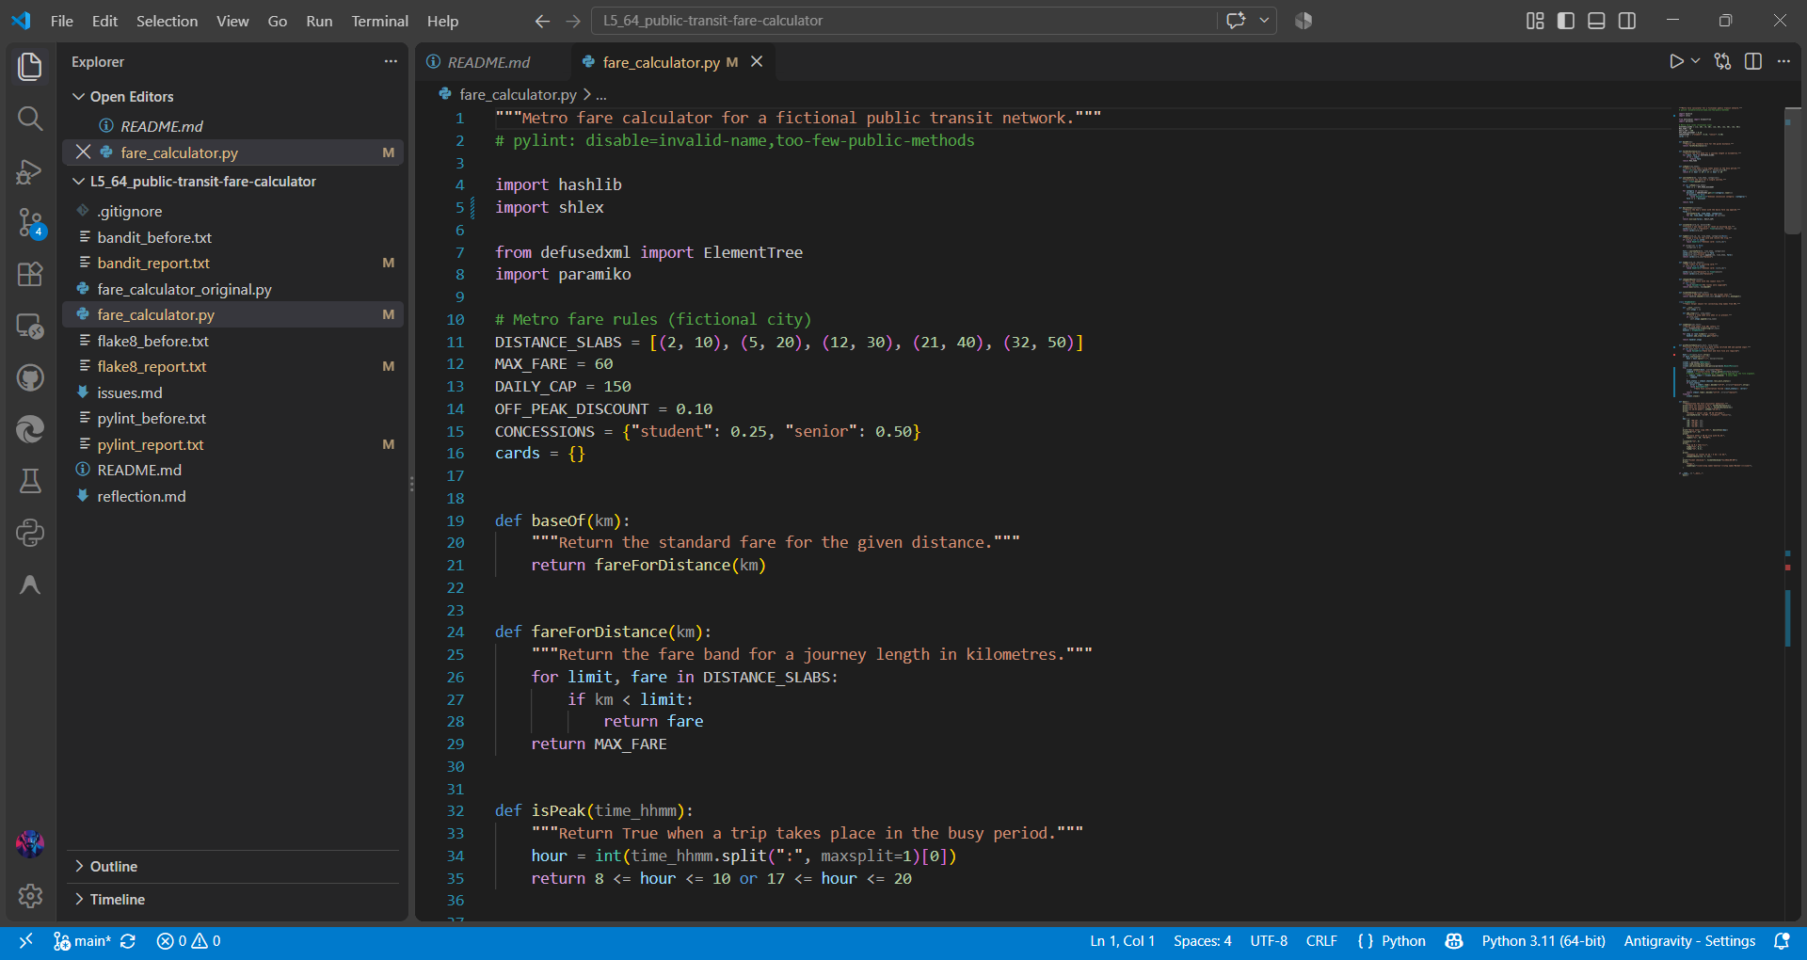

Screenshot 6 — Final Pylint
Capture Pylint after the fixes. The manual's target is a score above 9.5/10.
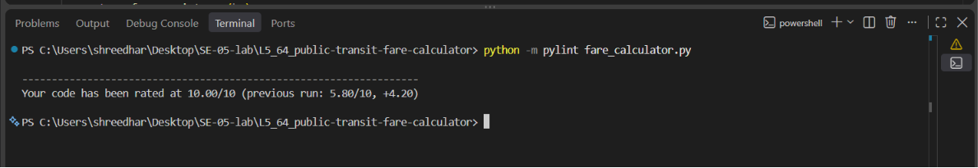

Screenshot 7 — Final Bandit
Capture the final Bandit command and findings after the fixes.
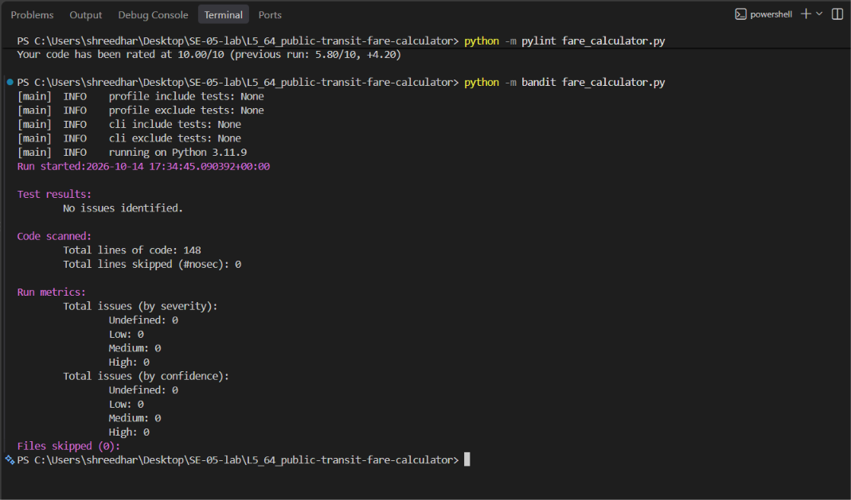

Screenshot 7 — Final Flake8
Capture the final Flake8 command and output after the fixes.
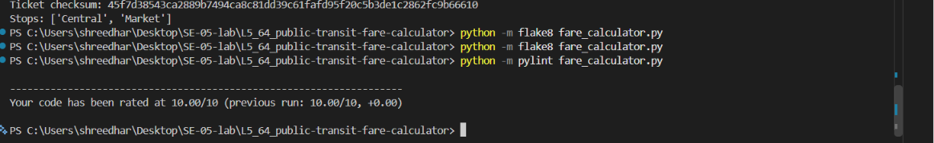

Screenshot 8 — Program execution
Capture the corrected program running and displaying fare calculations and the daily cap. 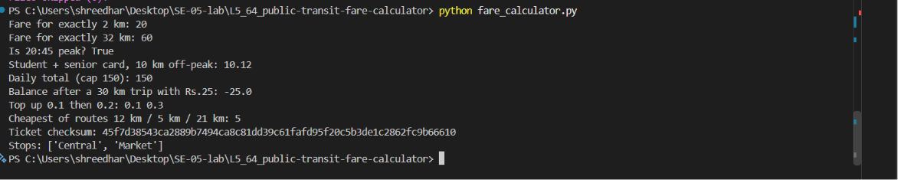

Suggested commits
Use separate commits for real, verified changes, for example: fix: correct fare cap and input validation; security: harden XML and gate metadata validation; style: clean up Python formatting and naming. These are suggestions, not proof that commits were created.

