Lab 2: Agile Backlog Creation &
Sprint Simulation in Jira

NAME : shreedhar r
SRN : PES2UG25CS823
SECTION “: H

Project : disaster relief supply and volunteer coordinator (DRS)

Deliverables: Epics User Stories and Story points , Sprint boards , and Burndown Charts

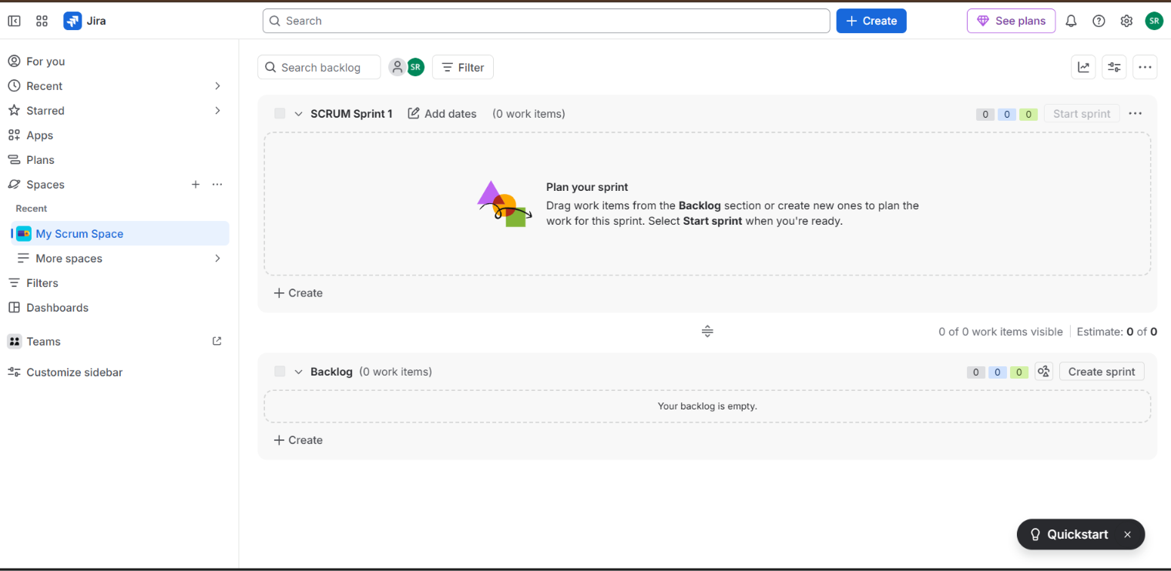
Jira workspace home showing the initial empty Scrum board and backlog before project setup.
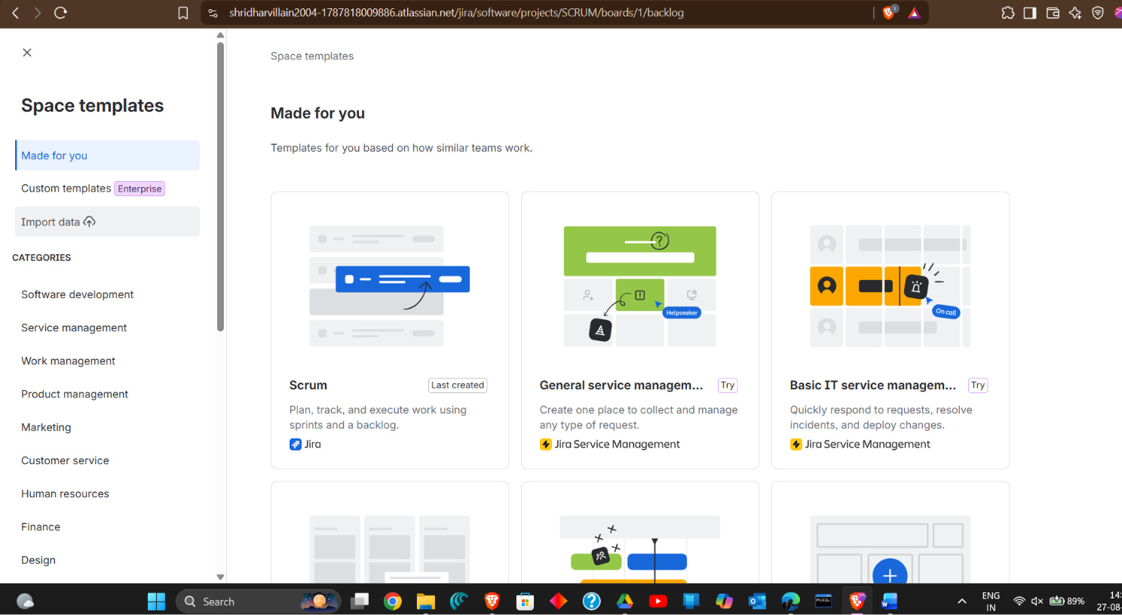
Selecting a Space template in Jira — choosing the Scrum template to plan, track, and execute work using sprints and a backlog.
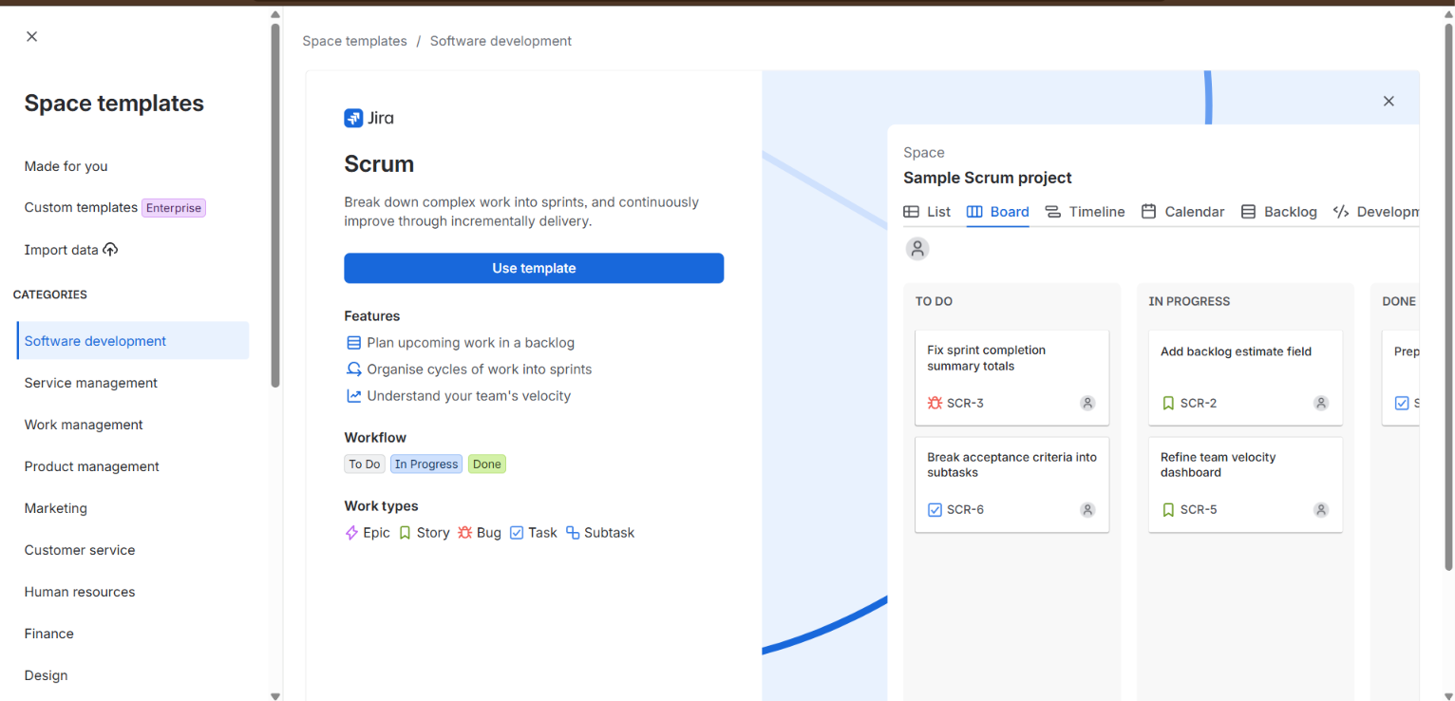
Scrum template overview showing its features (backlog planning, sprint cycles, velocity tracking) before applying it.
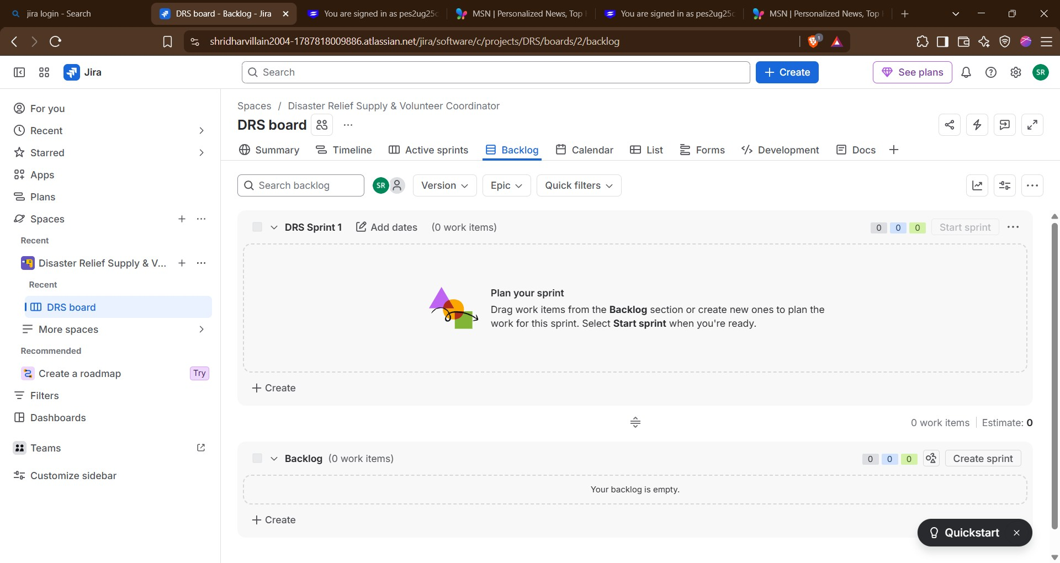
New project created — 'Disaster Relief Supply & Volunteer Coordinator' (DRS) board with an empty Sprint 1 and backlog.
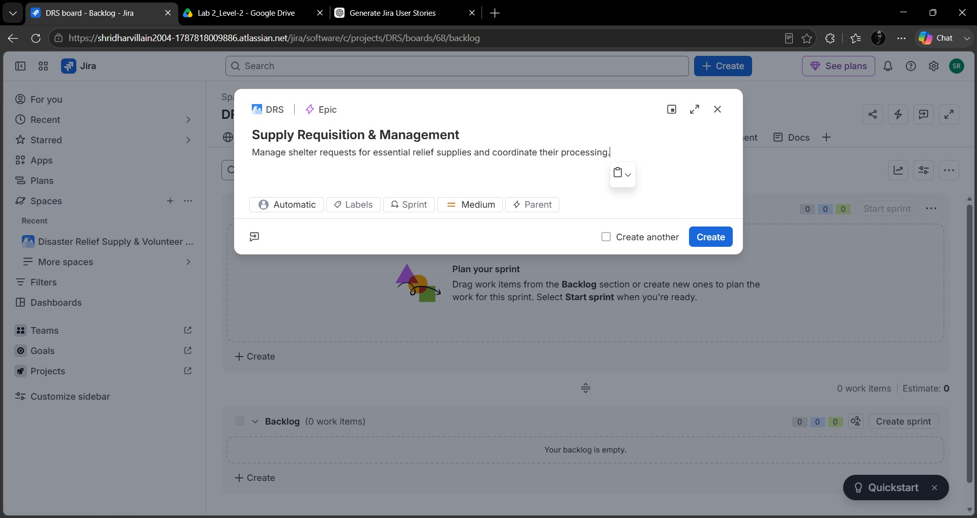
Creating Epic 1: 'Supply Requisition & Management' — description added for managing shelter supply requests.
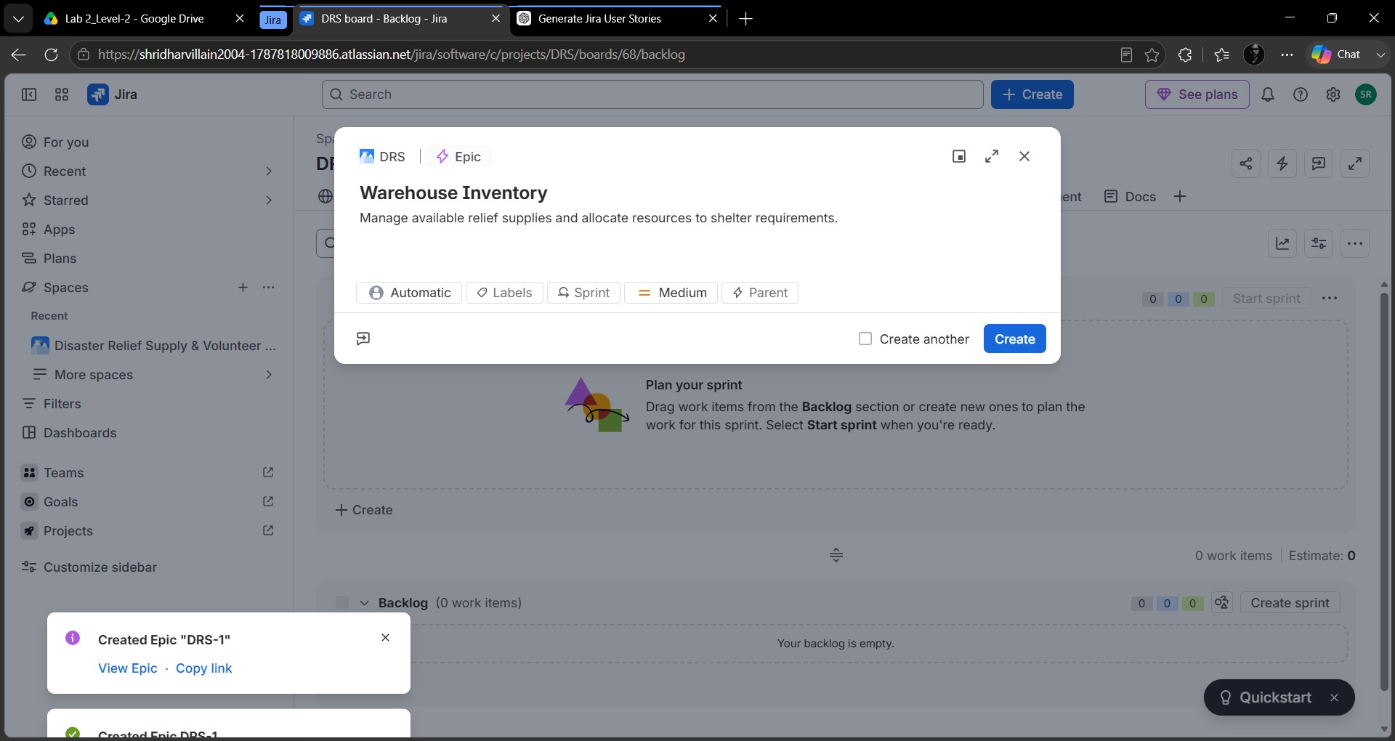
Epic DRS-1 successfully created; now creating Epic 2: 'Warehouse Inventory' to manage supply allocation.
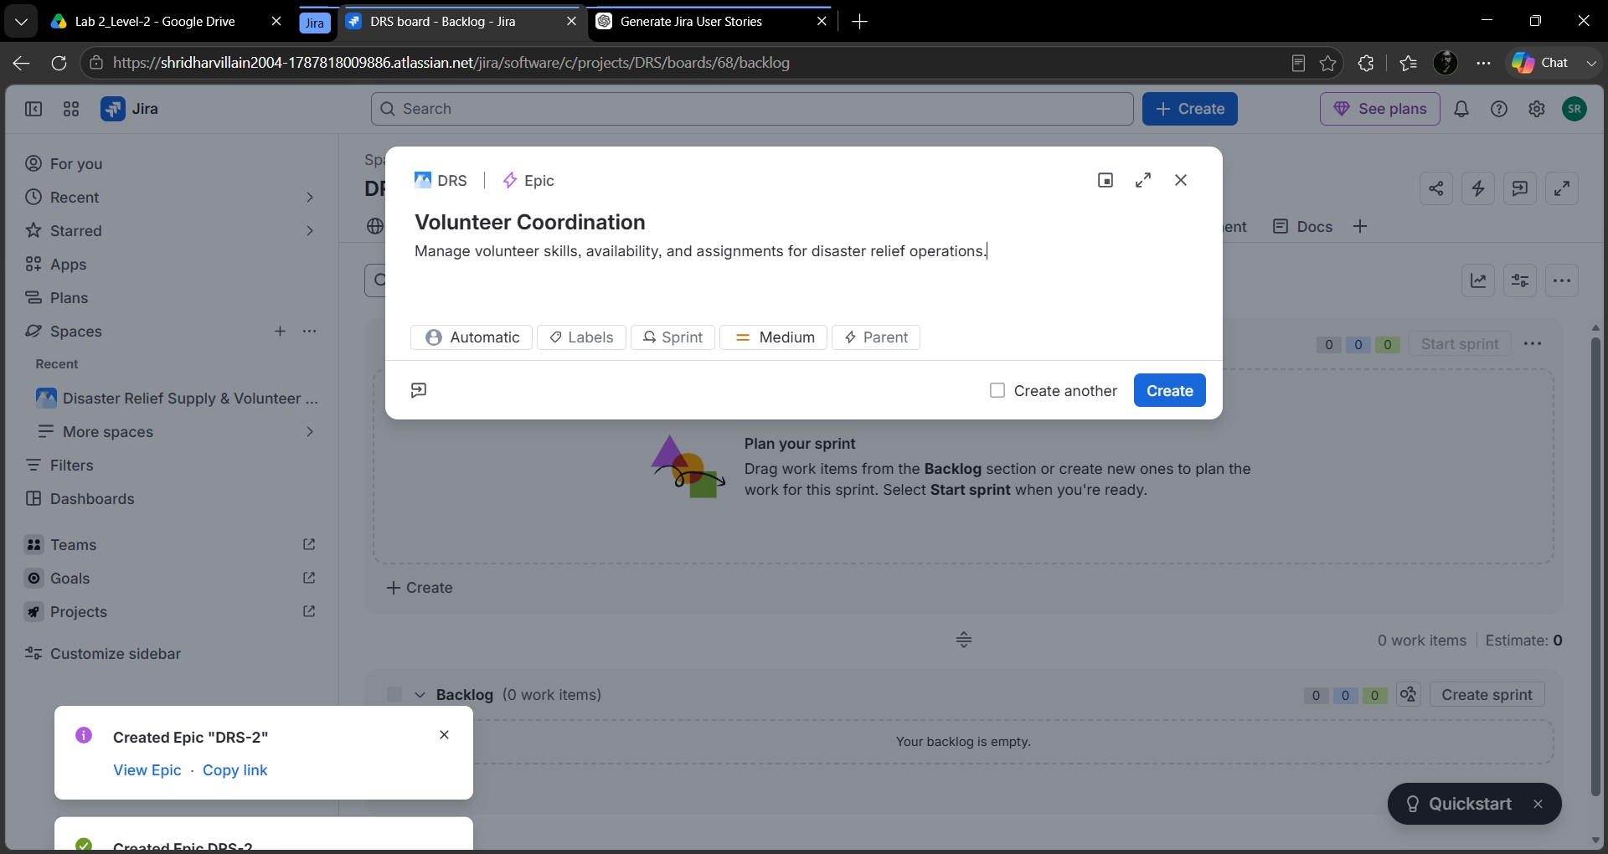
Epic DRS-2 created; now creating Epic 3: 'Volunteer Coordination' to manage volunteer skills and assignments.
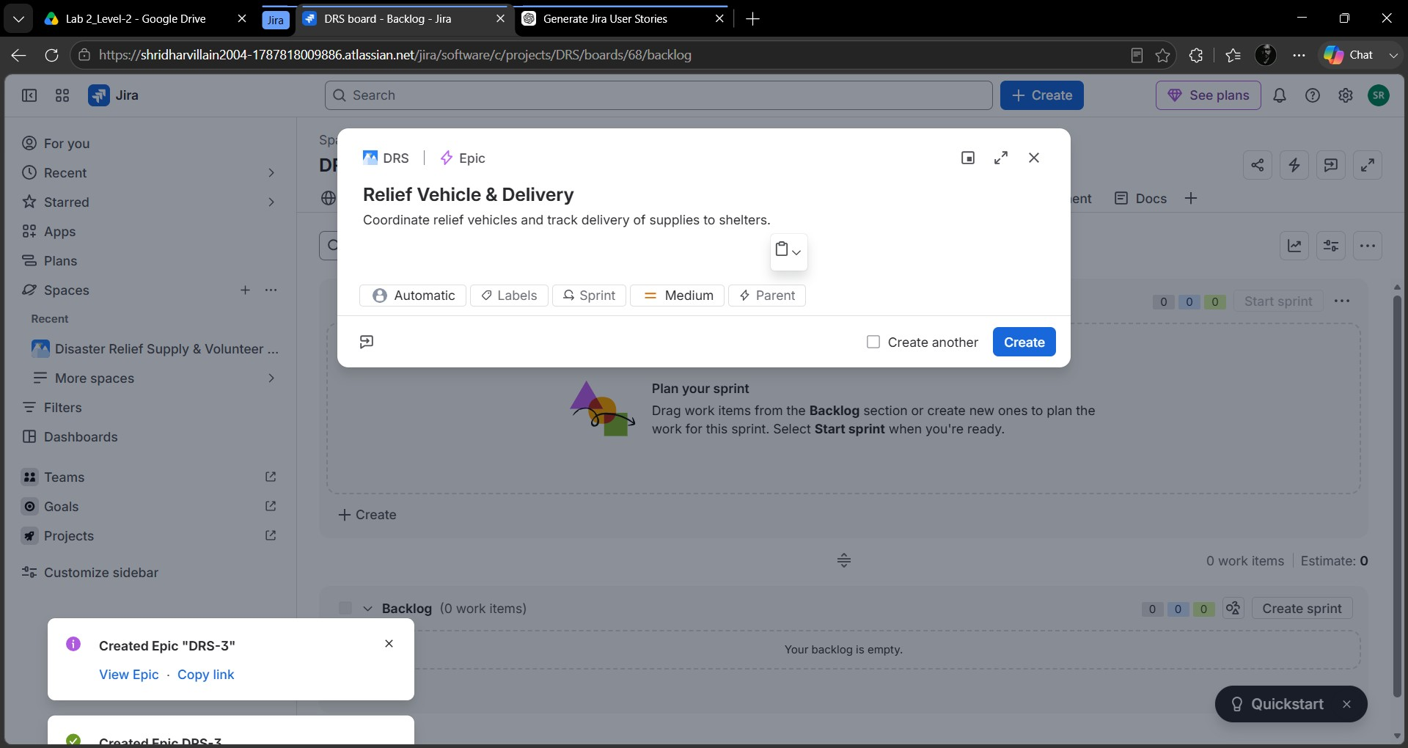
Epic DRS-3 created; now creating Epic 4: 'Relief Vehicle & Delivery' to coordinate delivery of supplies.
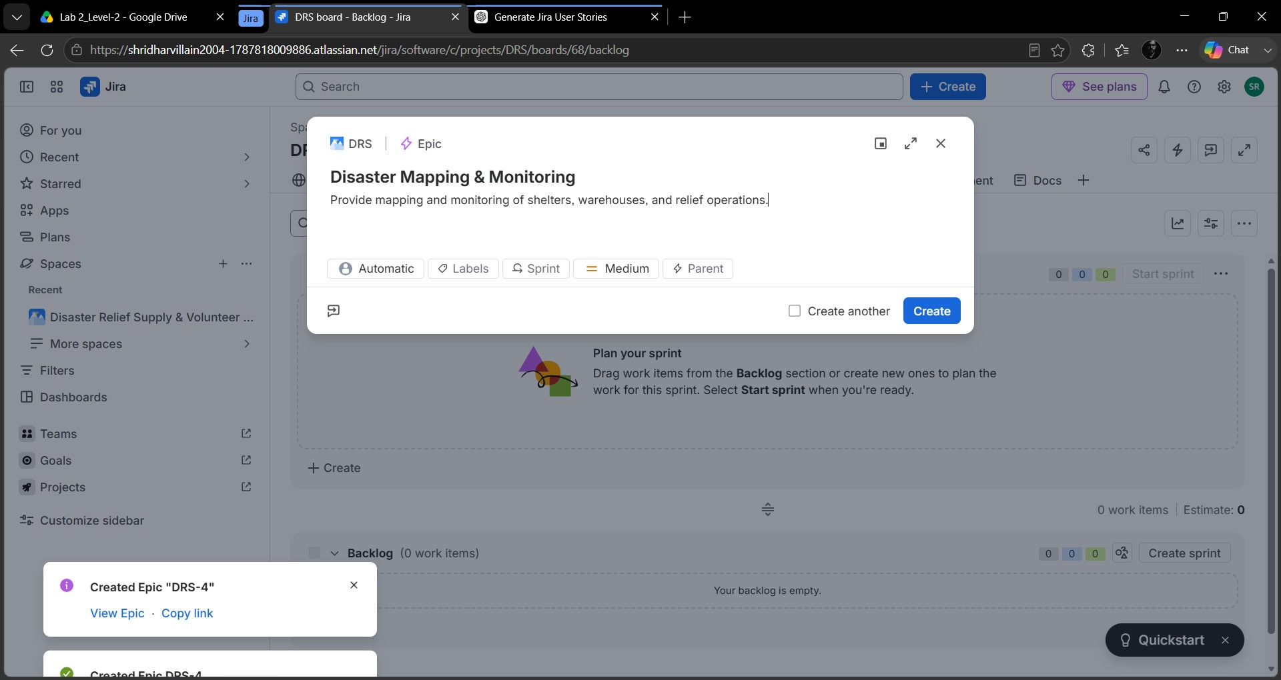
Epic DRS-4 created; now creating Epic 5: 'Disaster Mapping & Monitoring' for shelter and warehouse mapping.
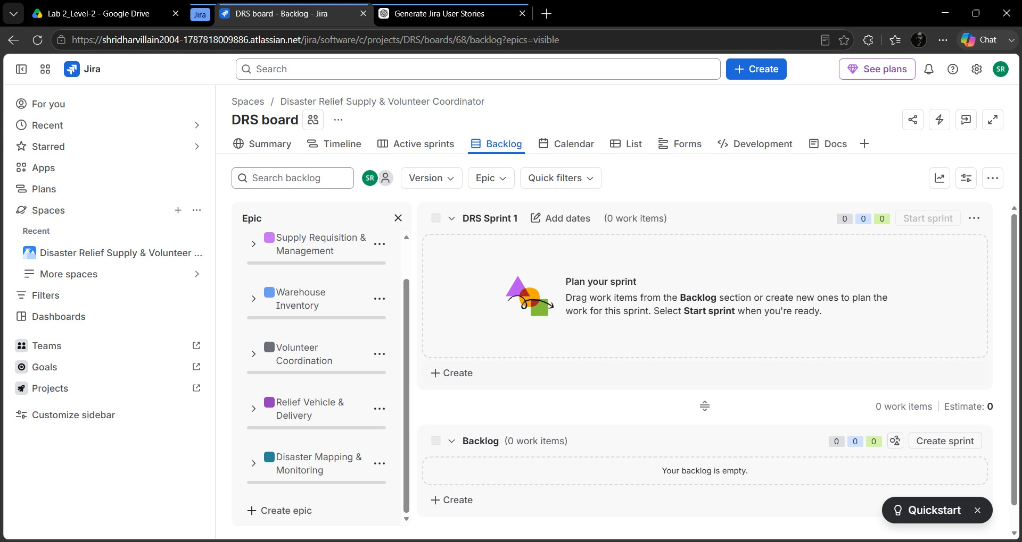
All 5 Epics now visible in the Epic panel: Supply Requisition & Management, Warehouse Inventory, Volunteer Coordination, Relief Vehicle & Delivery, and Disaster Mapping & Monitoring.
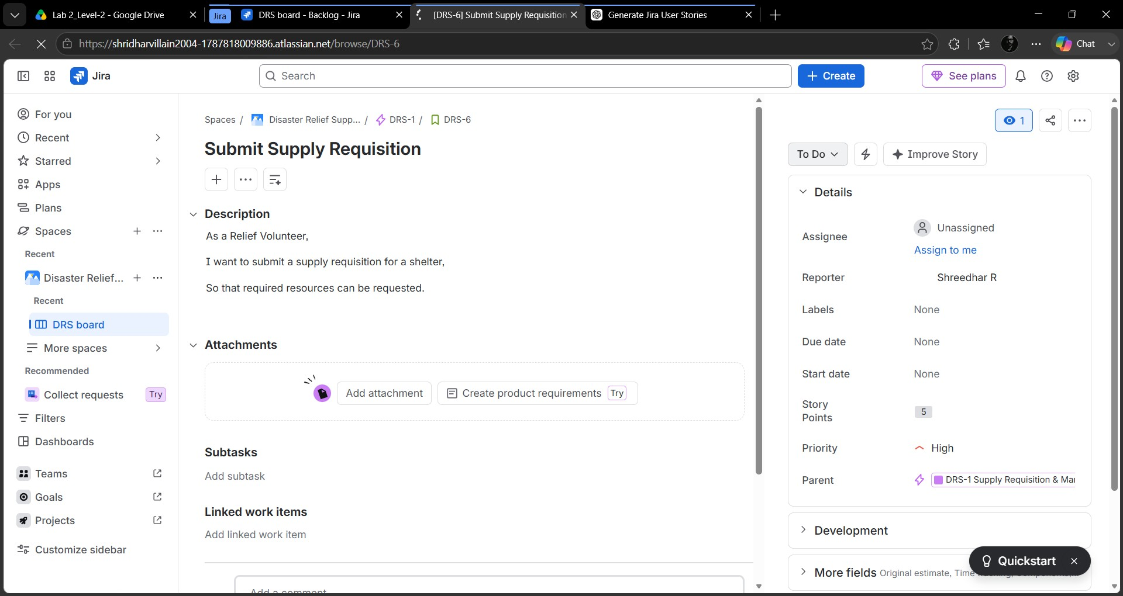
User Story DRS-6 'Submit Supply Requisition' created under Epic 1, written in As-a/I want/So-that format with Story Points (5) and Priority (High) assigned.
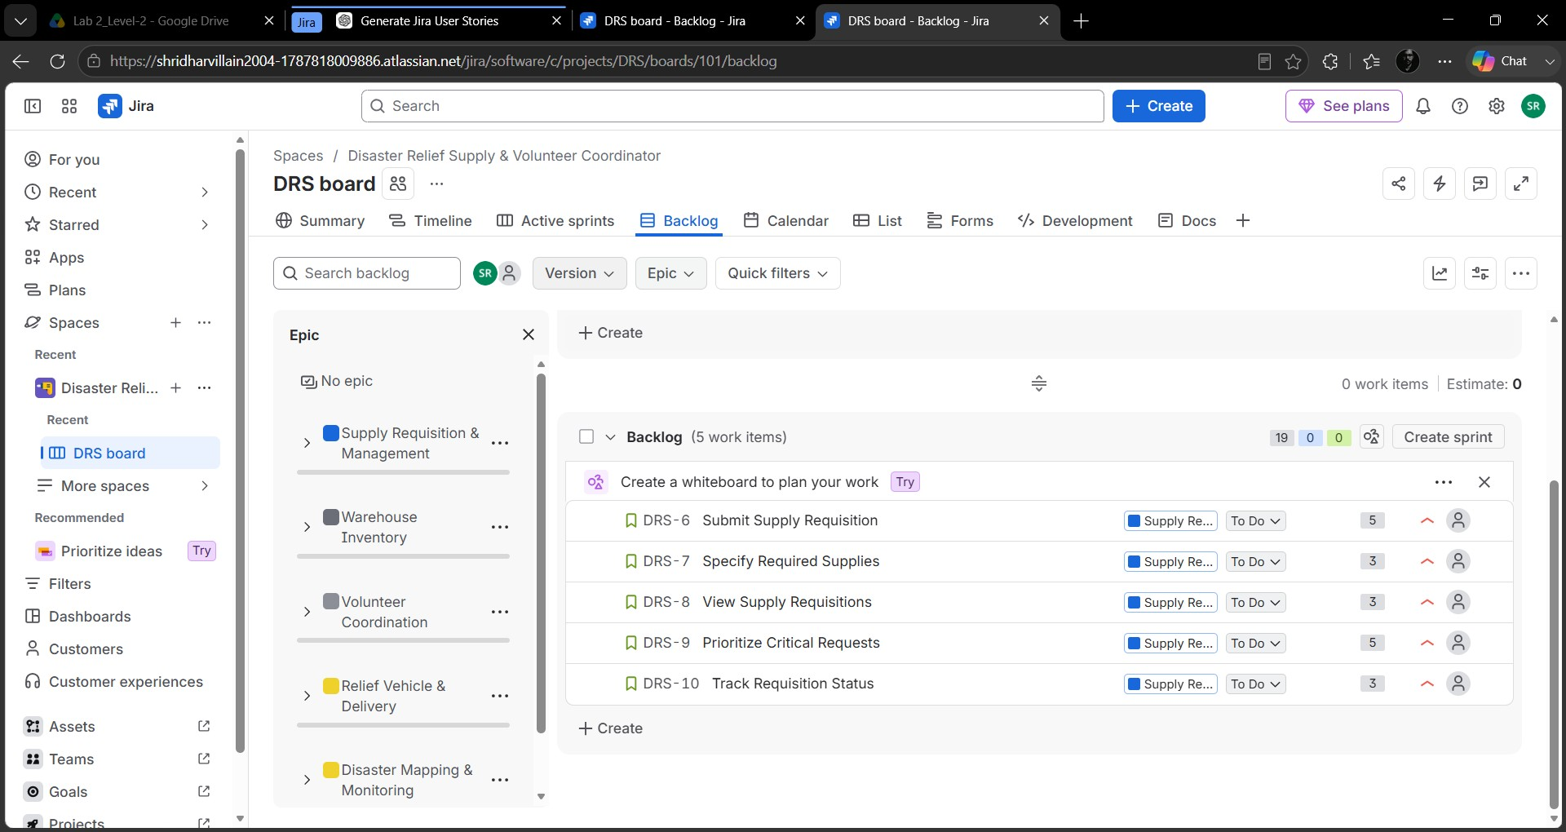
Backlog populated with 5 User Stories under Epic 1 (Supply Requisition & Management): DRS-6 to DRS-10, each with story points and priority set.
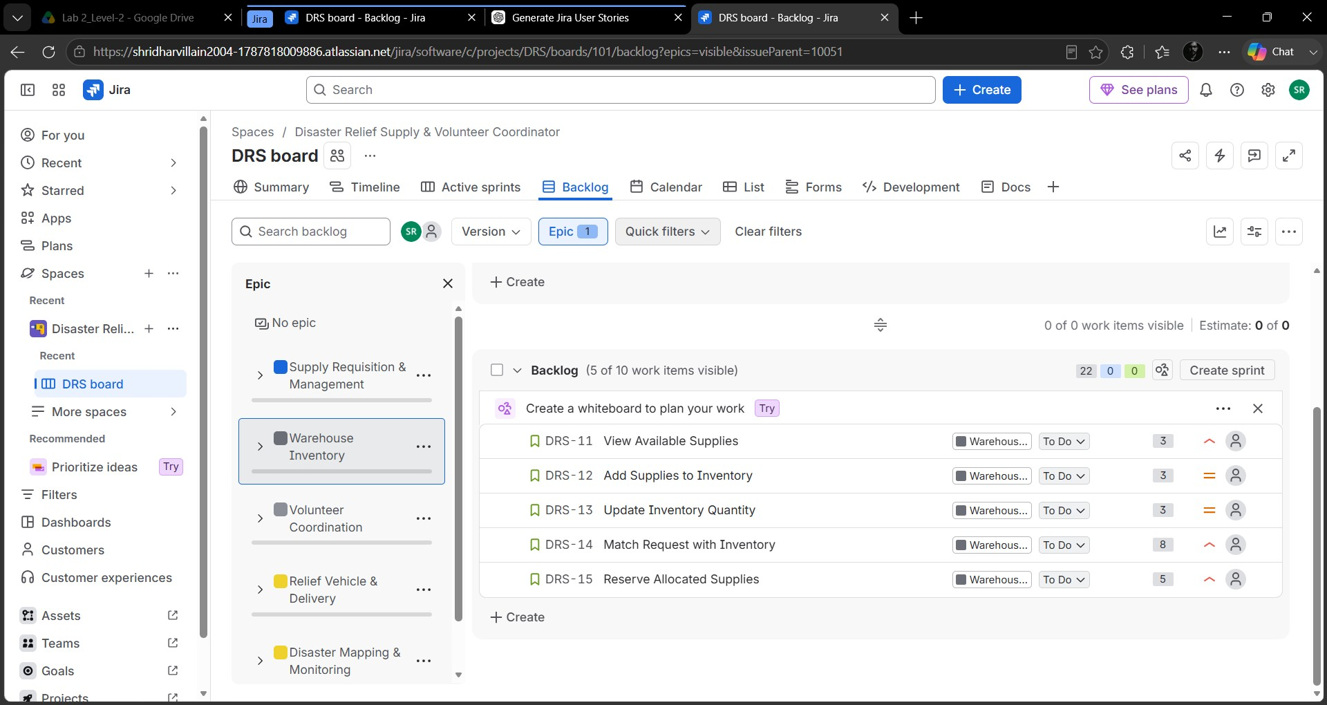
Backlog populated with 5 User Stories under Epic 2 (Warehouse Inventory): DRS-11 to DRS-15, each estimated and prioritized.
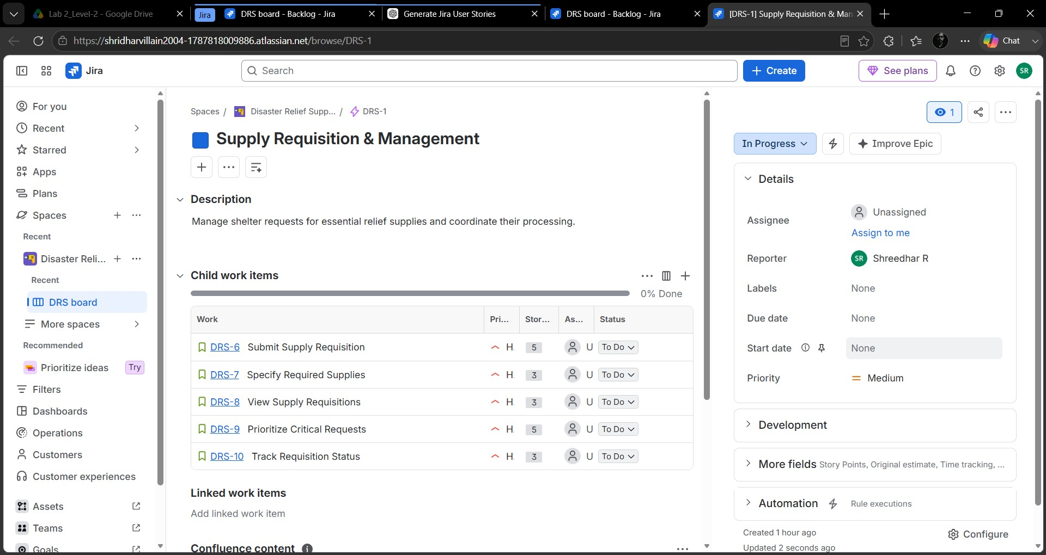
Epic DRS-1 detail view listing all 5 child User Stories with their priority and story point assignments.
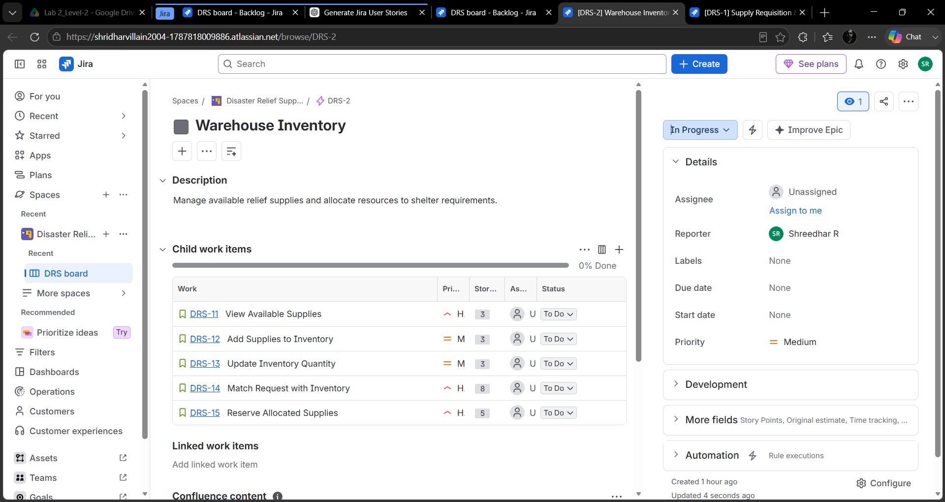
Epic DRS-2 (Warehouse Inventory) detail view listing its 5 child User Stories with priorities and story points.
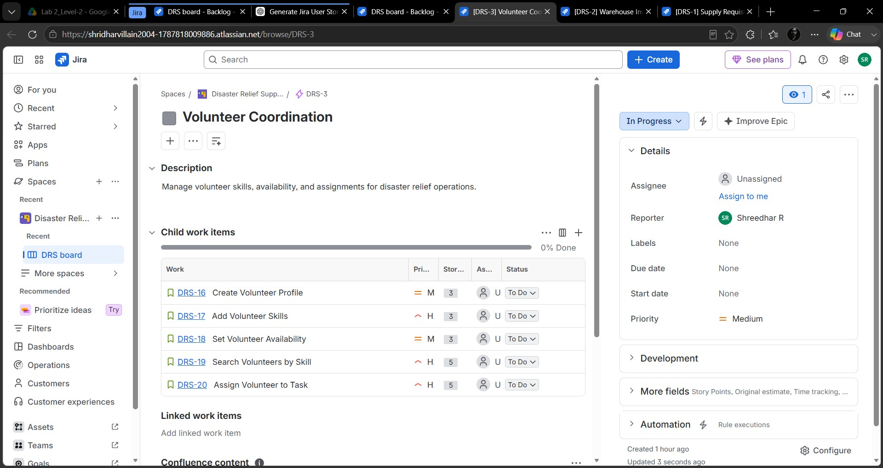
Epic DRS-3 (Volunteer Coordination) detail view showing its 5 User Stories: Create Volunteer Profile, Add Volunteer Skills, Set Volunteer Availability, Search Volunteers by Skill, and Assign Volunteer to Task.
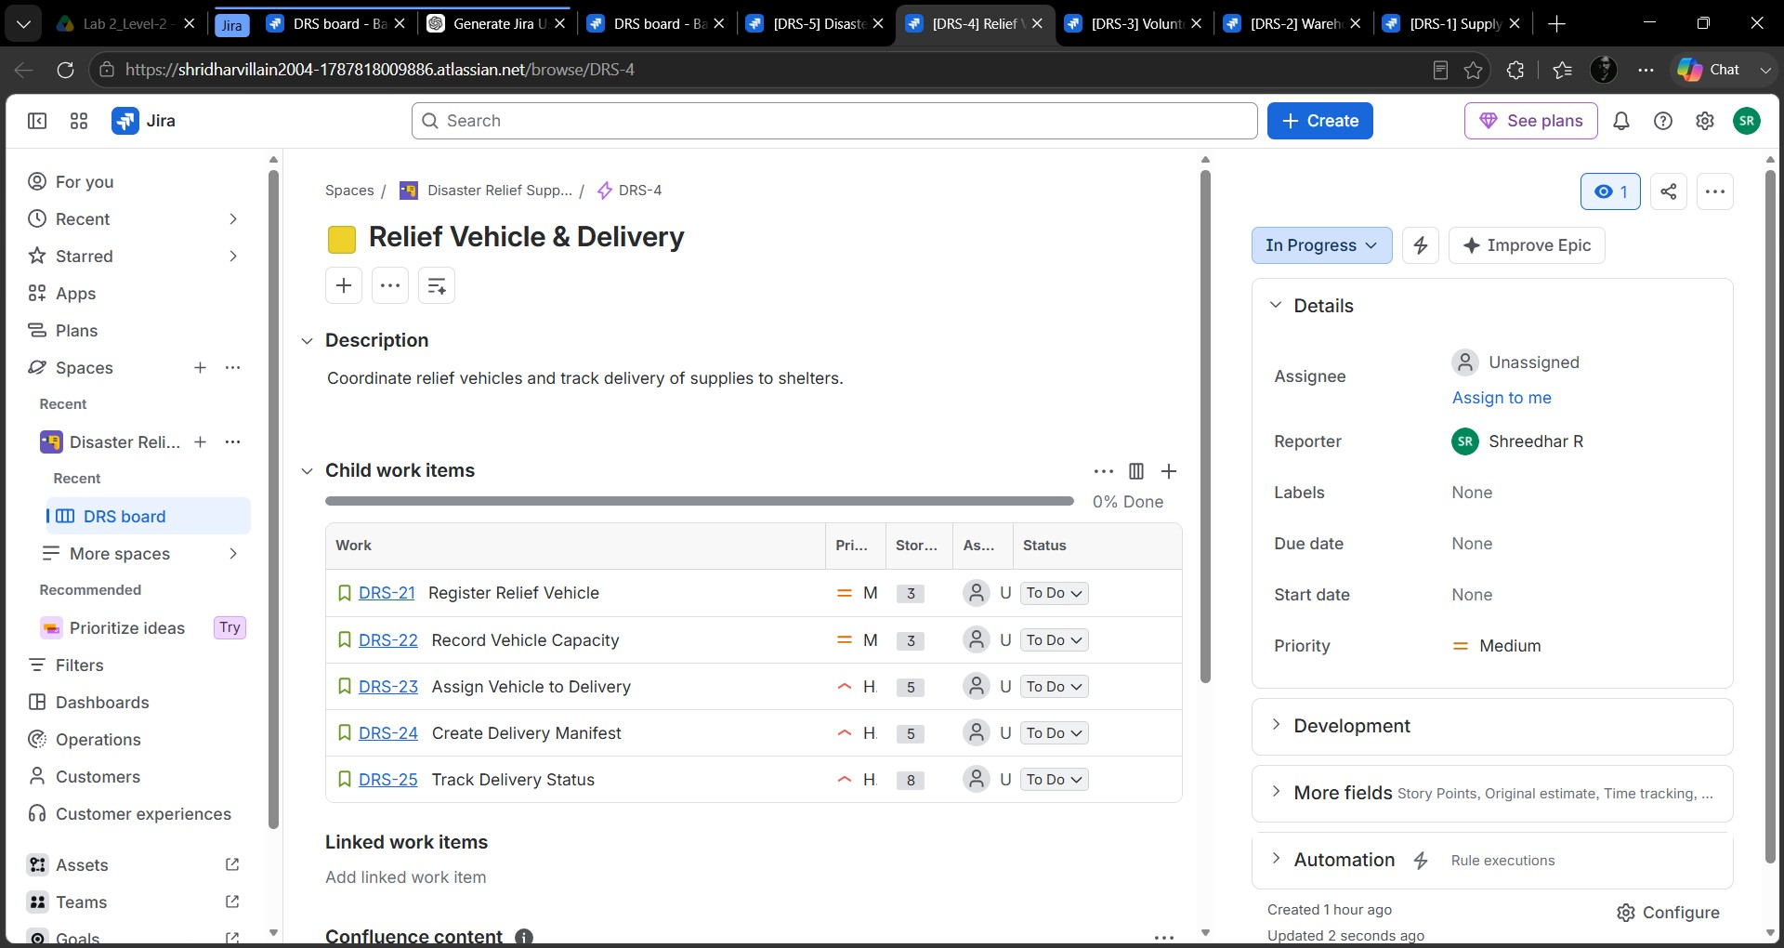
Epic DRS-4 (Relief Vehicle & Delivery) detail view showing its 5 User Stories covering vehicle registration, capacity, assignment, delivery manifest, and status tracking.
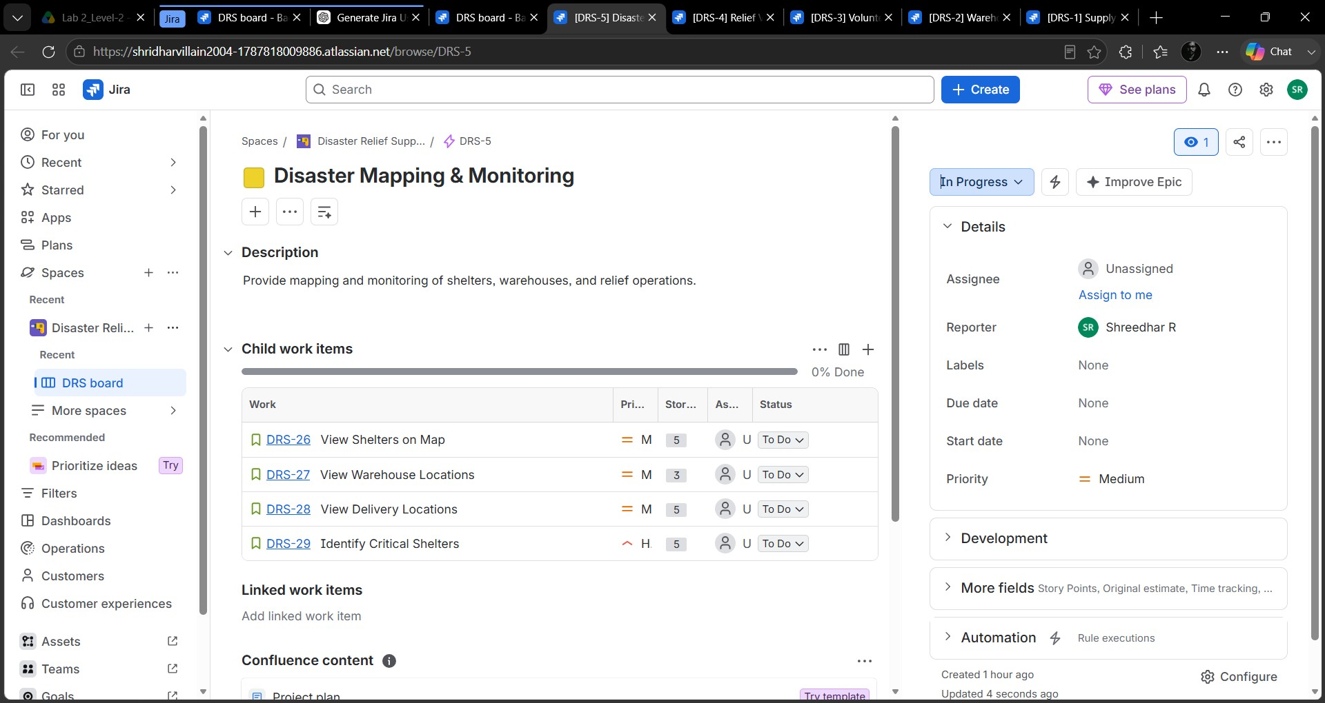
Epic DRS-5 (Disaster Mapping & Monitoring) detail view showing its 4 User Stories for mapping shelters, warehouses, delivery locations, and identifying critical shelters.
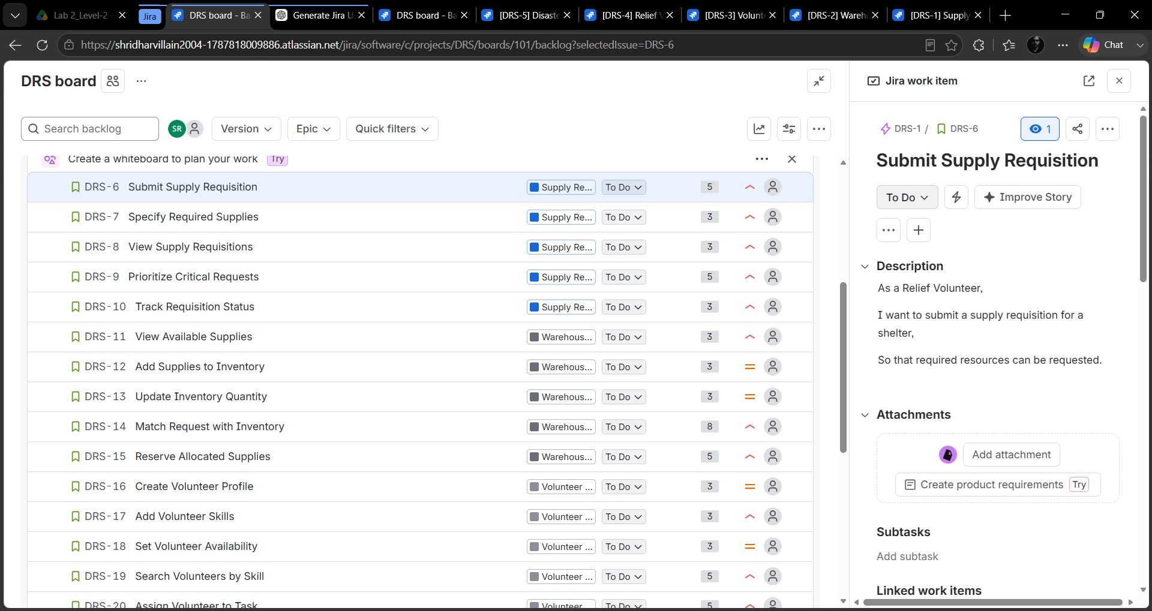
Full backlog view listing User Stories across all Epics (DRS-6 through DRS-20) with story points, priority, and status columns.
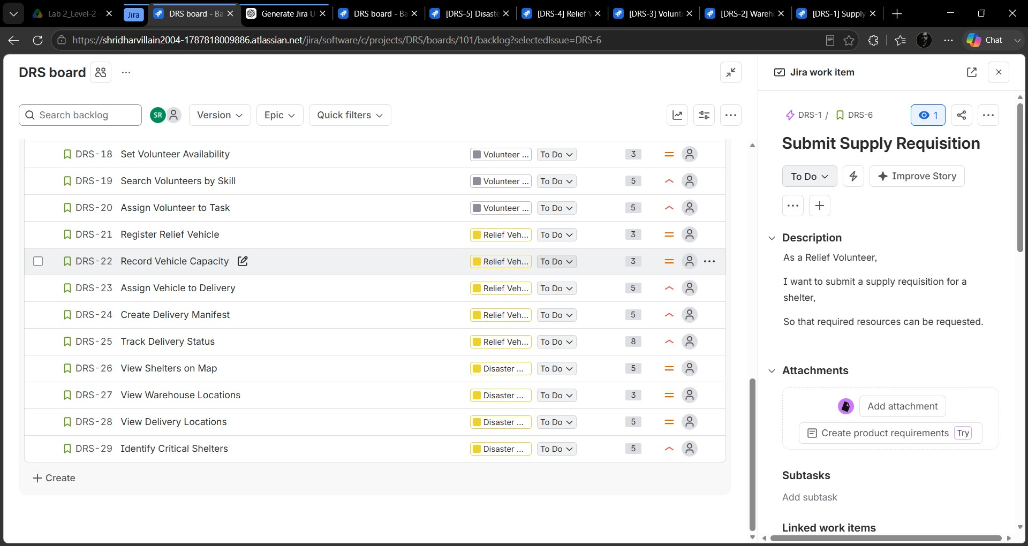
Full backlog view continued, showing the remaining User Stories (DRS-18 through DRS-29) fully estimated and prioritized.
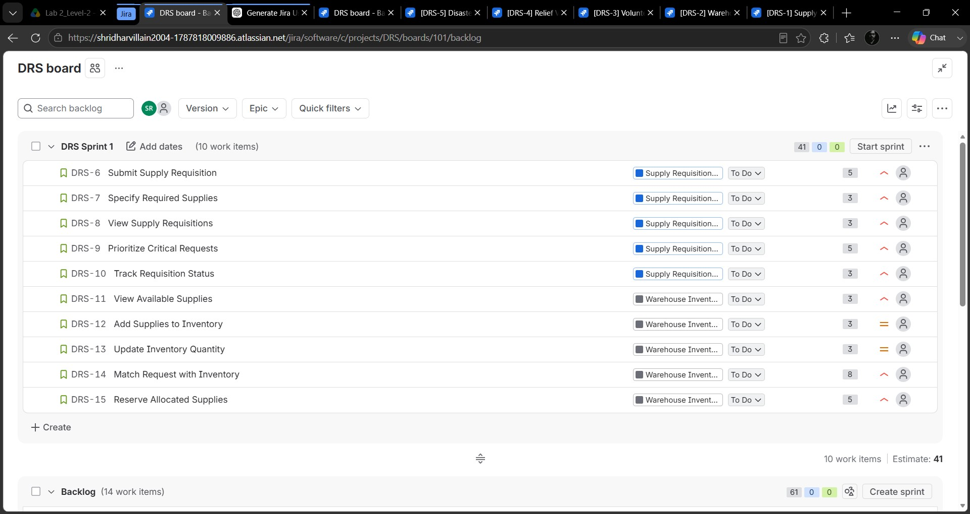
Sprint 1 populated by dragging 10 User Stories (DRS-6 to DRS-15) into it, totaling 41 story points, ready to start.
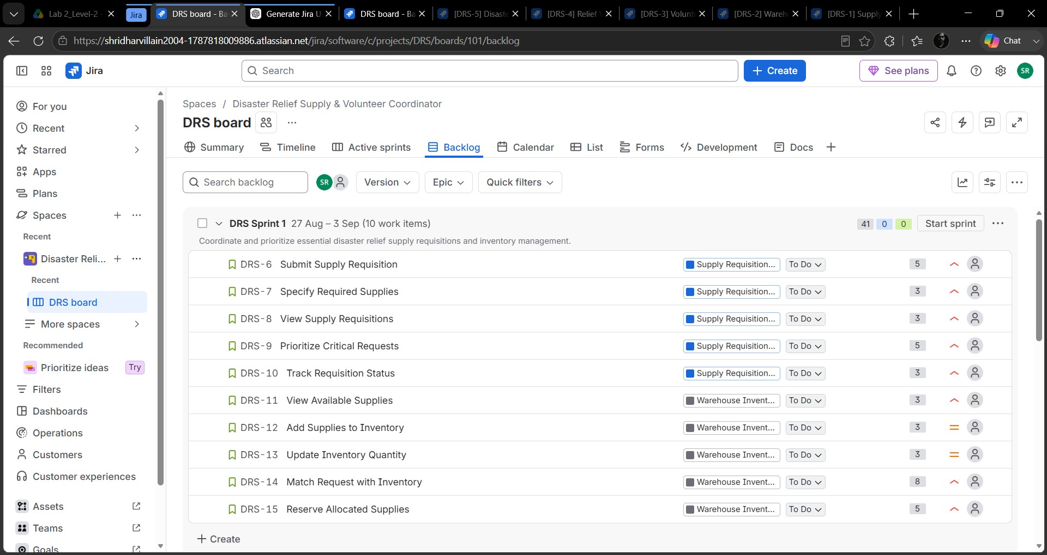
Sprint 1 configured with a date range (27 Aug - 3 Sep) and a Sprint Goal describing the focus on supply requisitions and inventory.
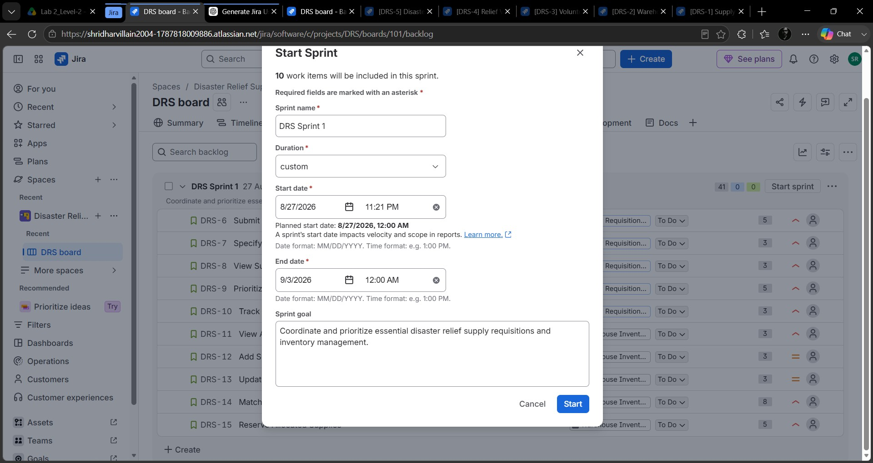
Start Sprint dialog — setting Sprint 1's duration, start/end dates, and sprint goal before launching it.
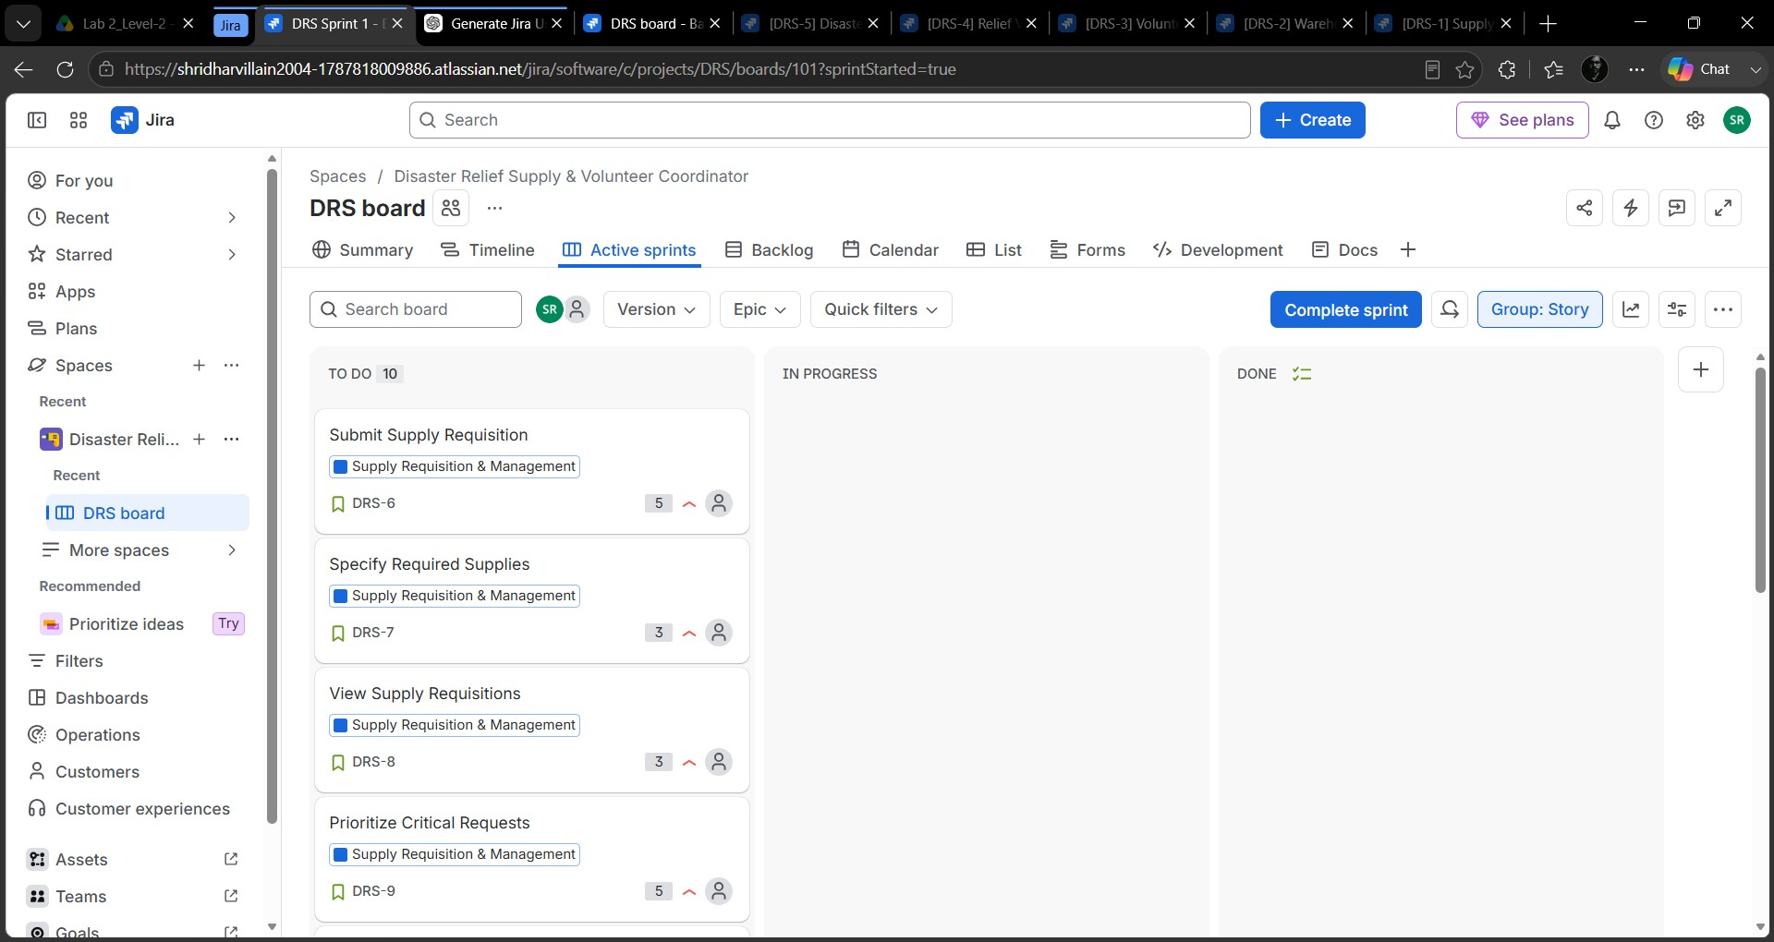
Sprint 1 started — Active Sprint board showing all 10 work items placed in the To Do column.
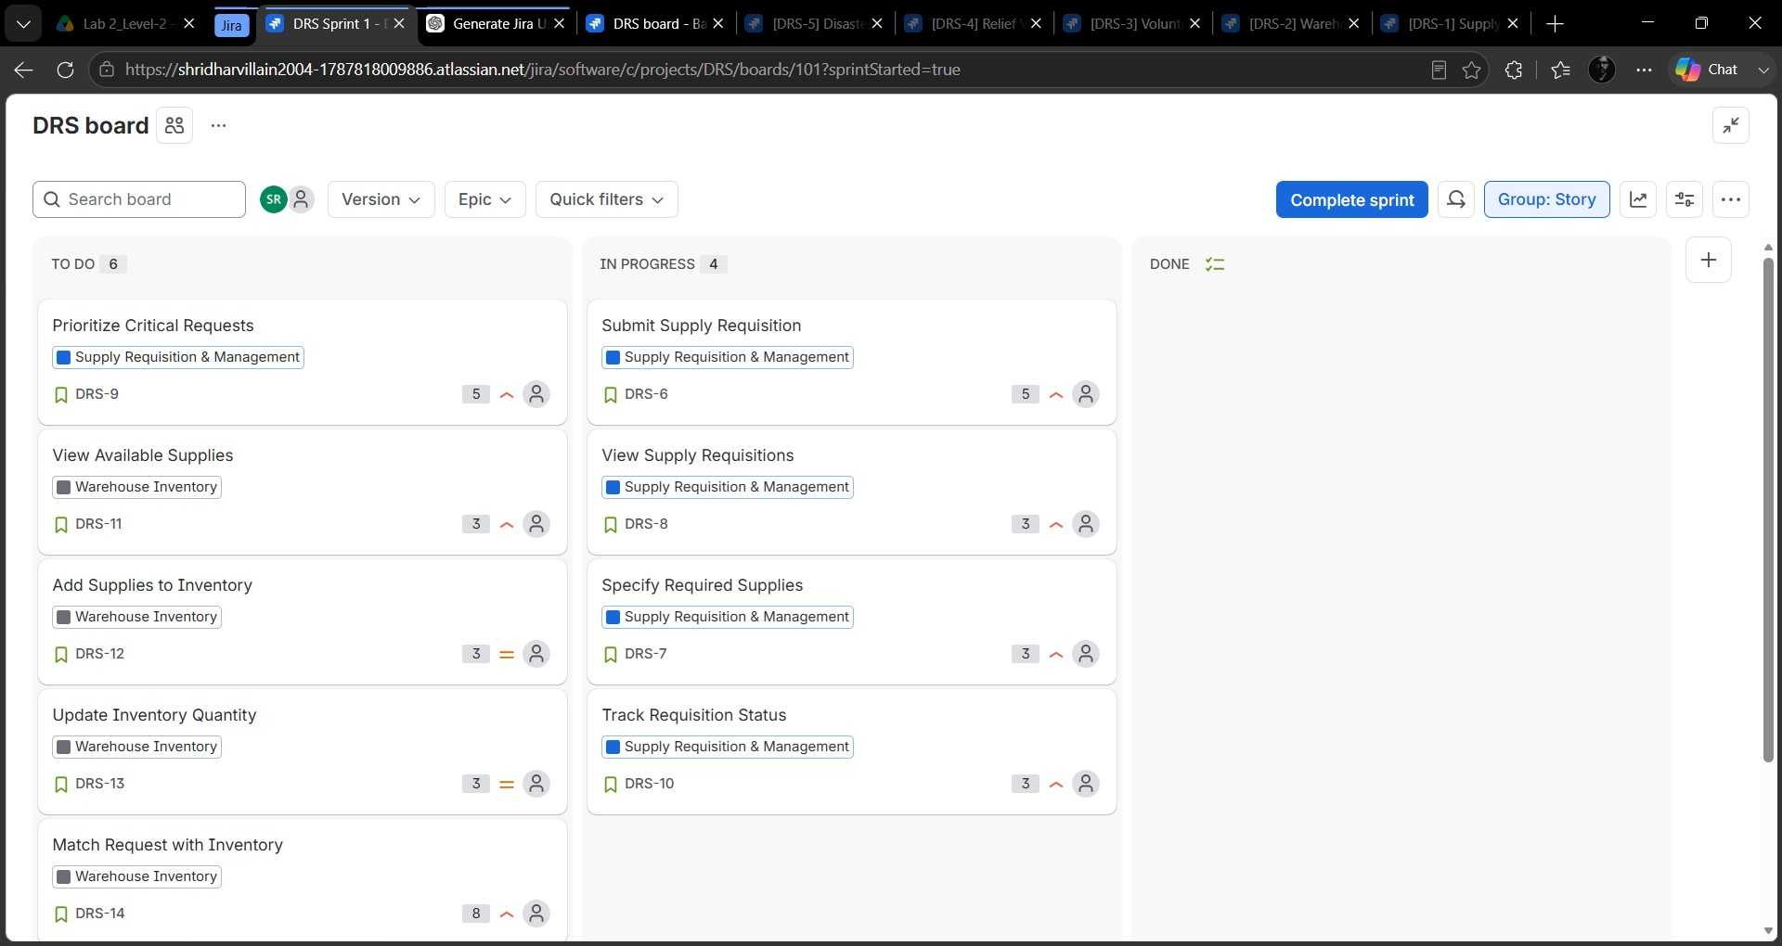
Sprint simulation in progress — several User Stories dragged from To Do into the In Progress column.
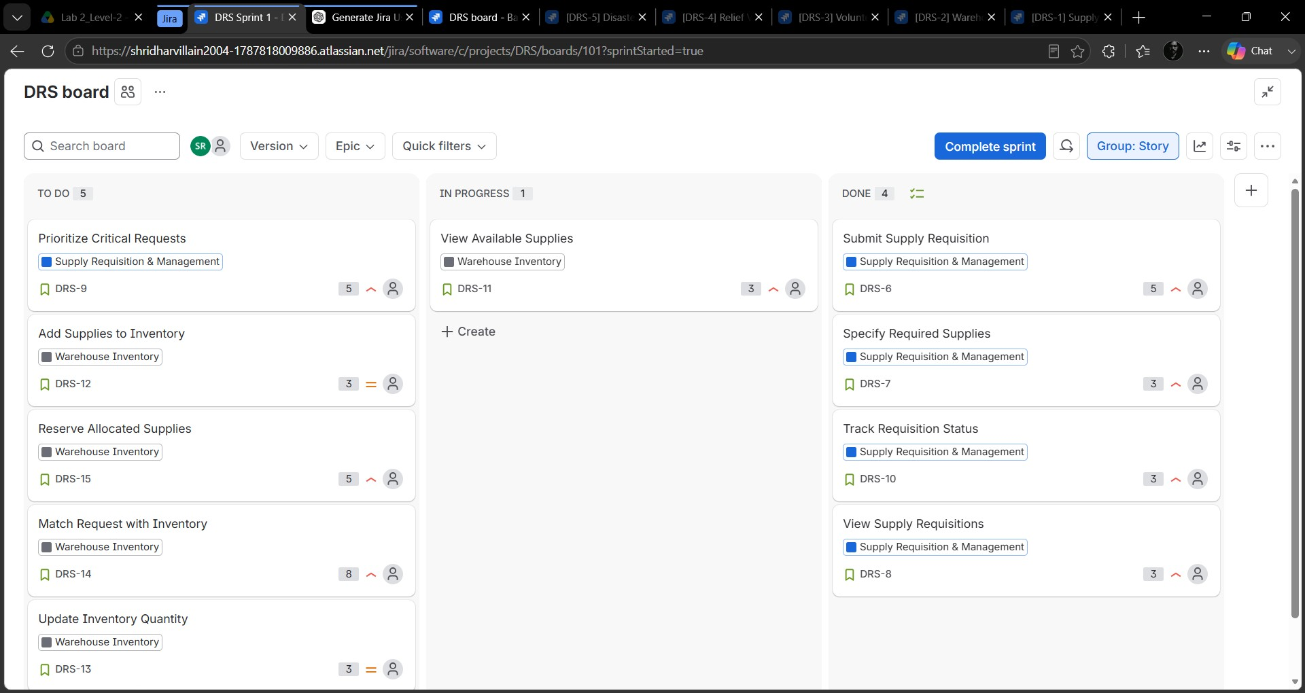
Sprint progressing further — 4 User Stories completed and moved to Done, others advancing through In Progress.
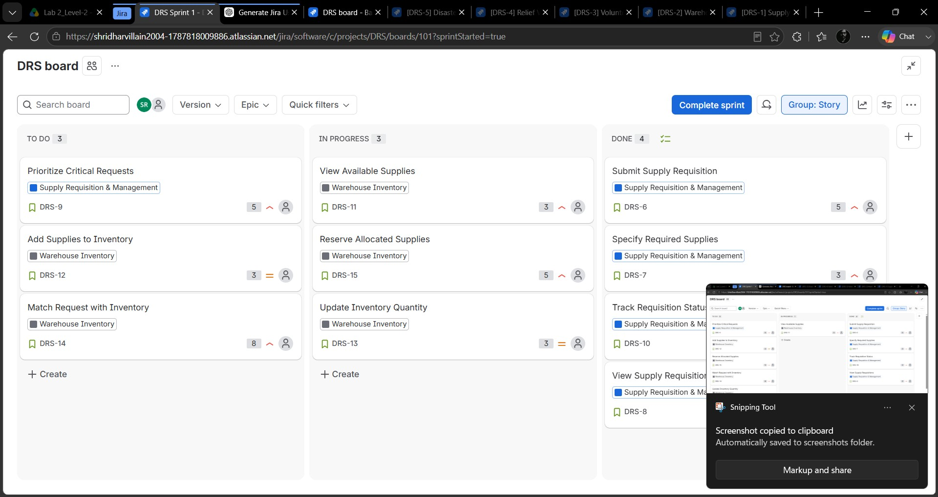
Sprint 1 nearing completion — 8 of 10 User Stories now in Done, remaining items split between To Do and In Progress.
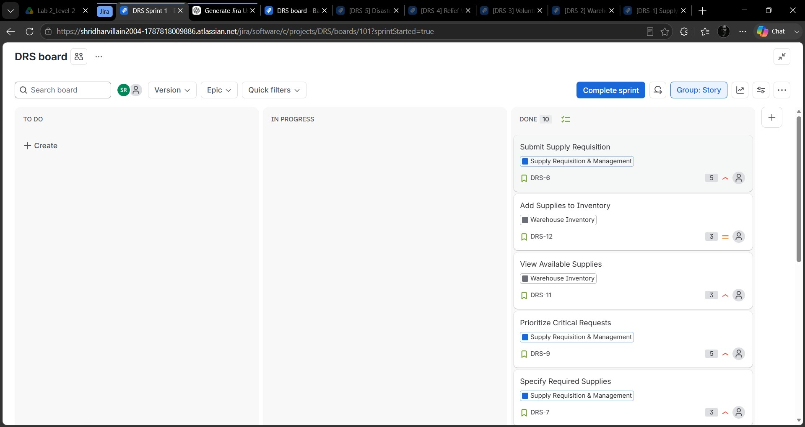
All 10 User Stories in Sprint 1 moved to Done, completing the simulated sprint work.
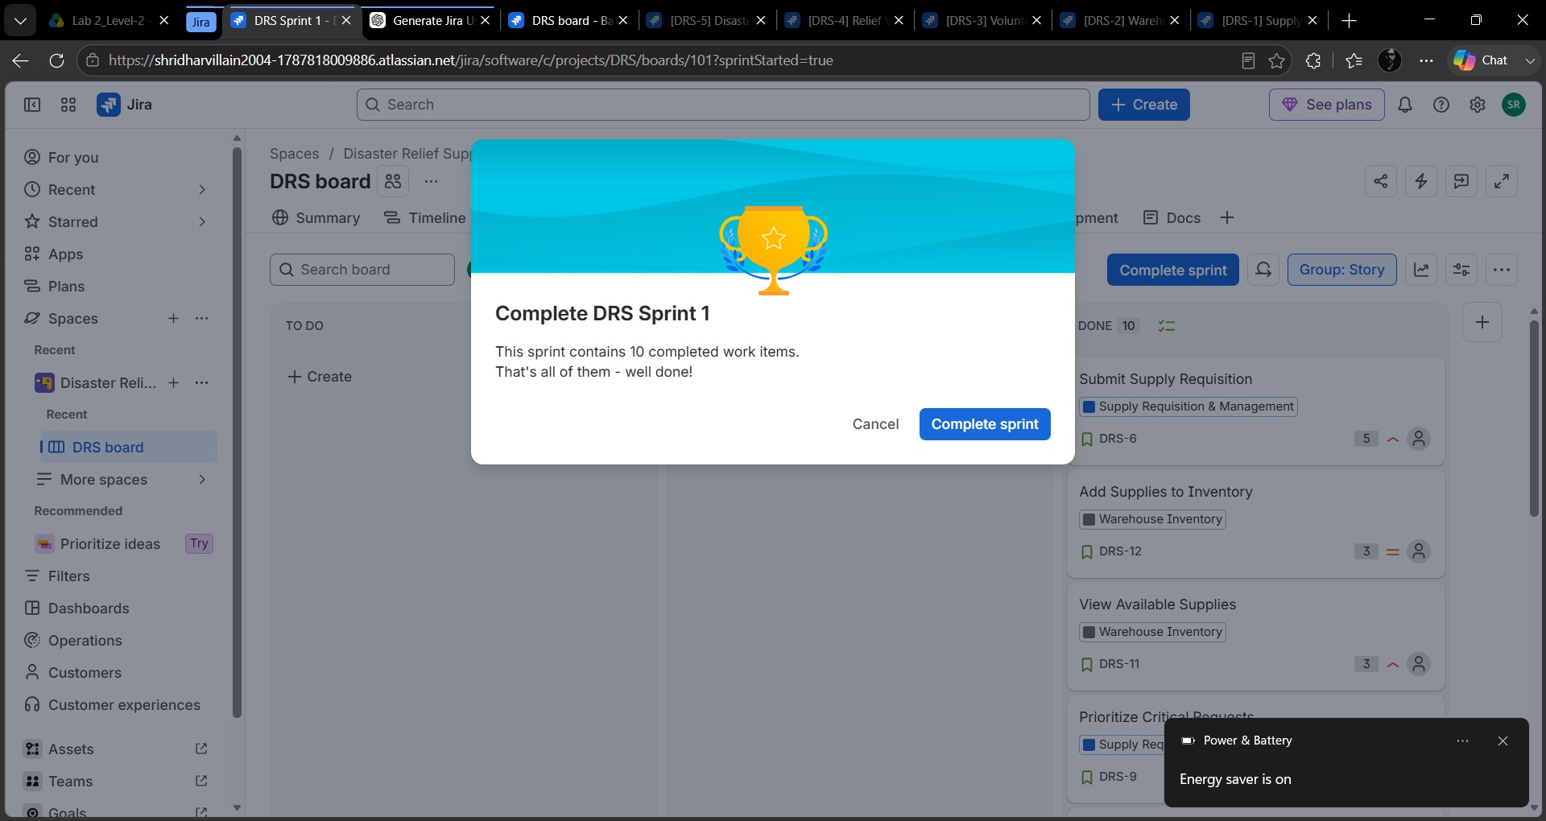
Completing Sprint 1 — confirmation dialog showing all 10 planned work items were completed.
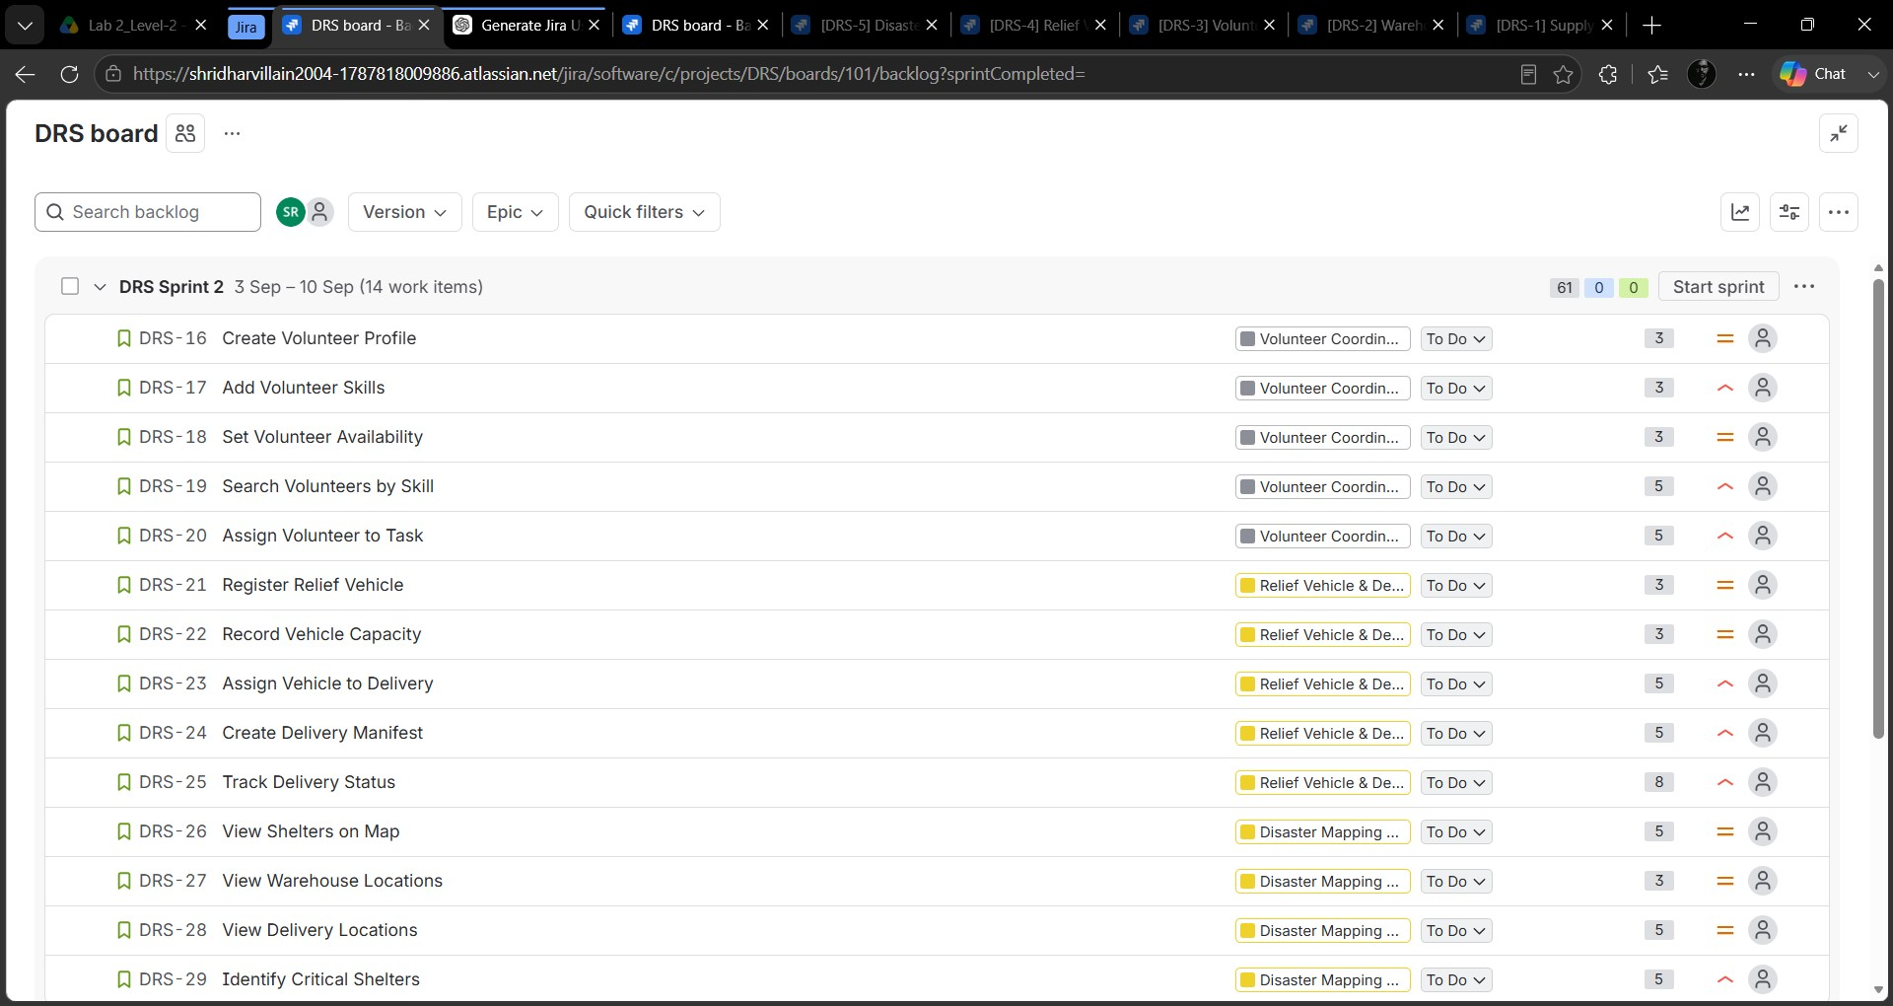
Sprint 1 marked complete; Sprint 2 auto-populated with the remaining 14 User Stories (61 story points) from the backlog.
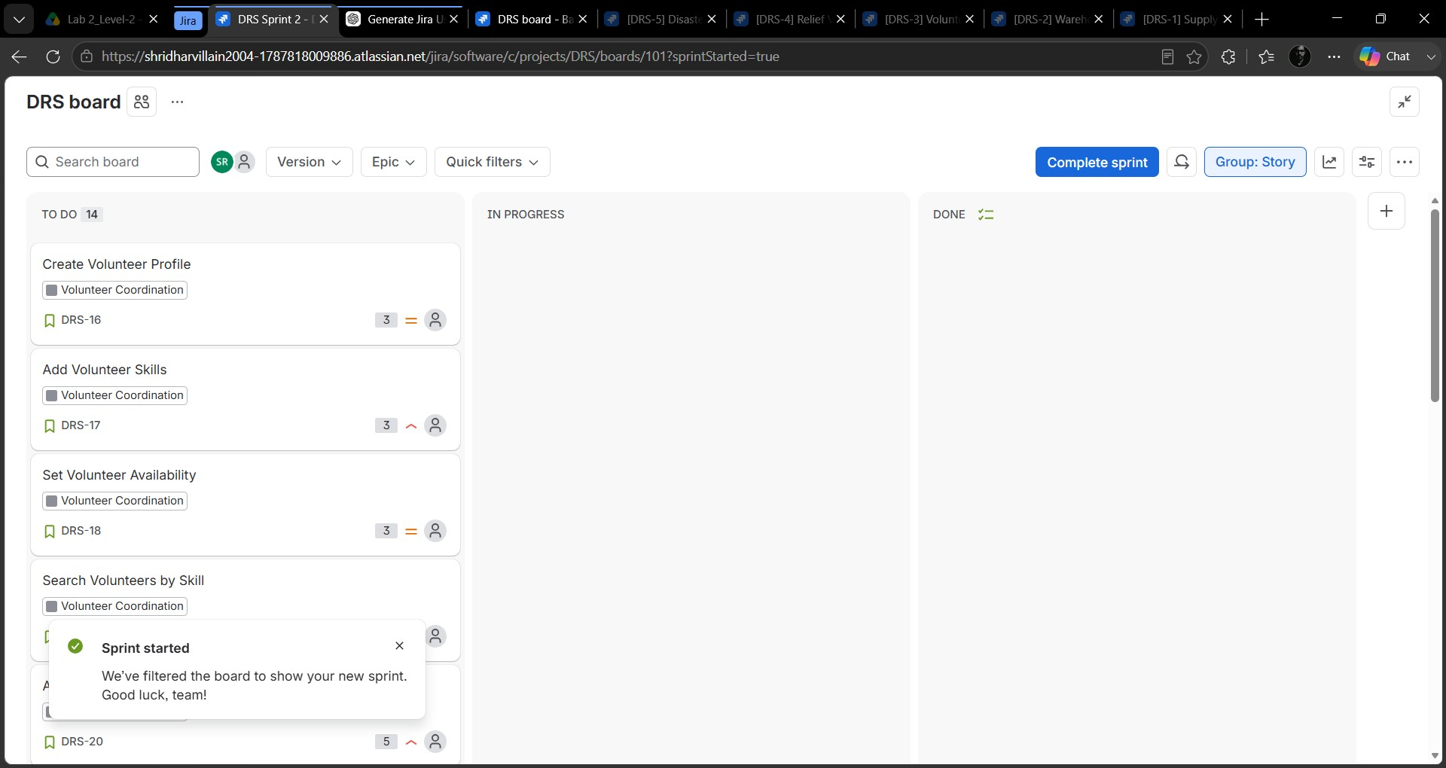
Sprint 2 started — Active Sprint board showing all 14 work items placed in To Do.
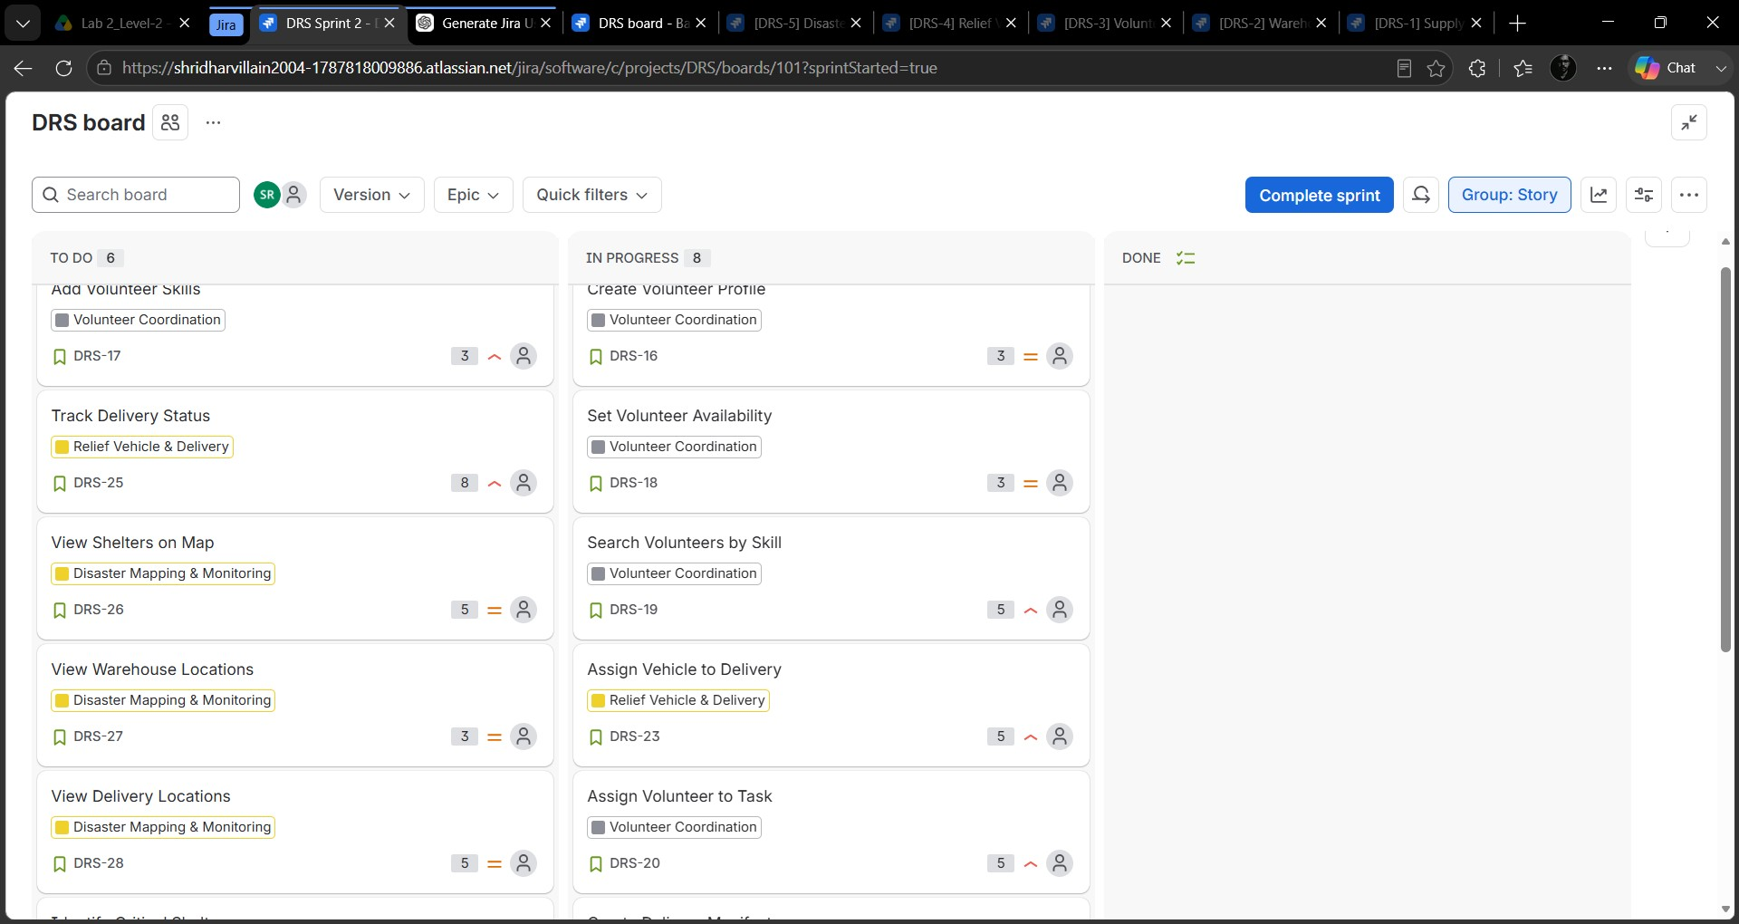
Sprint 2 simulation in progress — User Stories moved into In Progress across Volunteer Coordination, Relief Vehicle & Delivery, and Disaster Mapping epics.
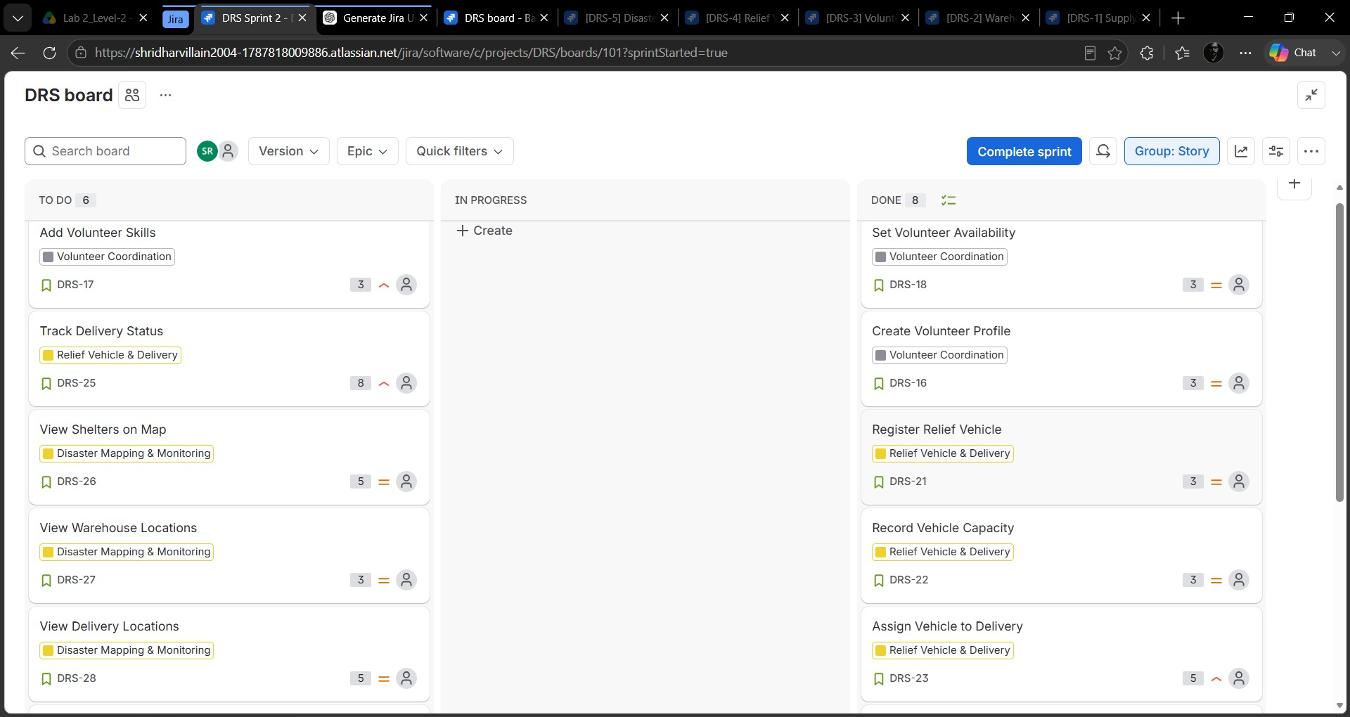
Sprint 2 progressing — 8 of 14 User Stories completed and moved to Done.
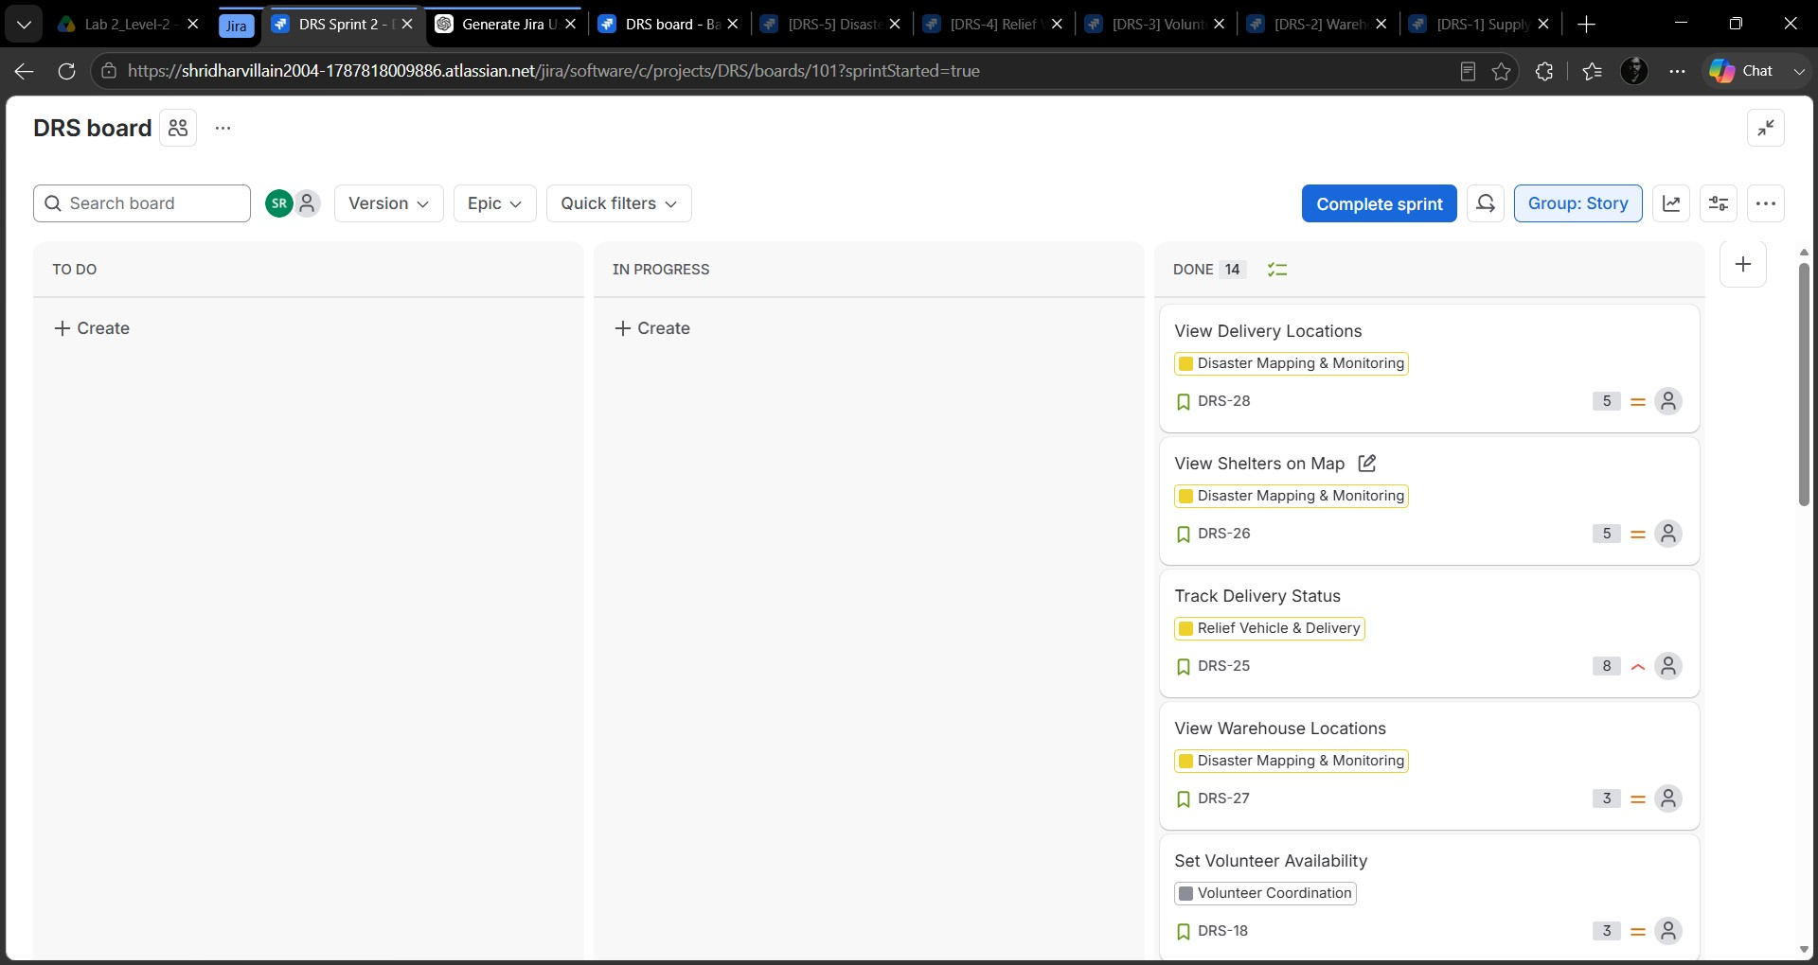
All 14 User Stories in Sprint 2 moved to Done, completing the second simulated sprint.
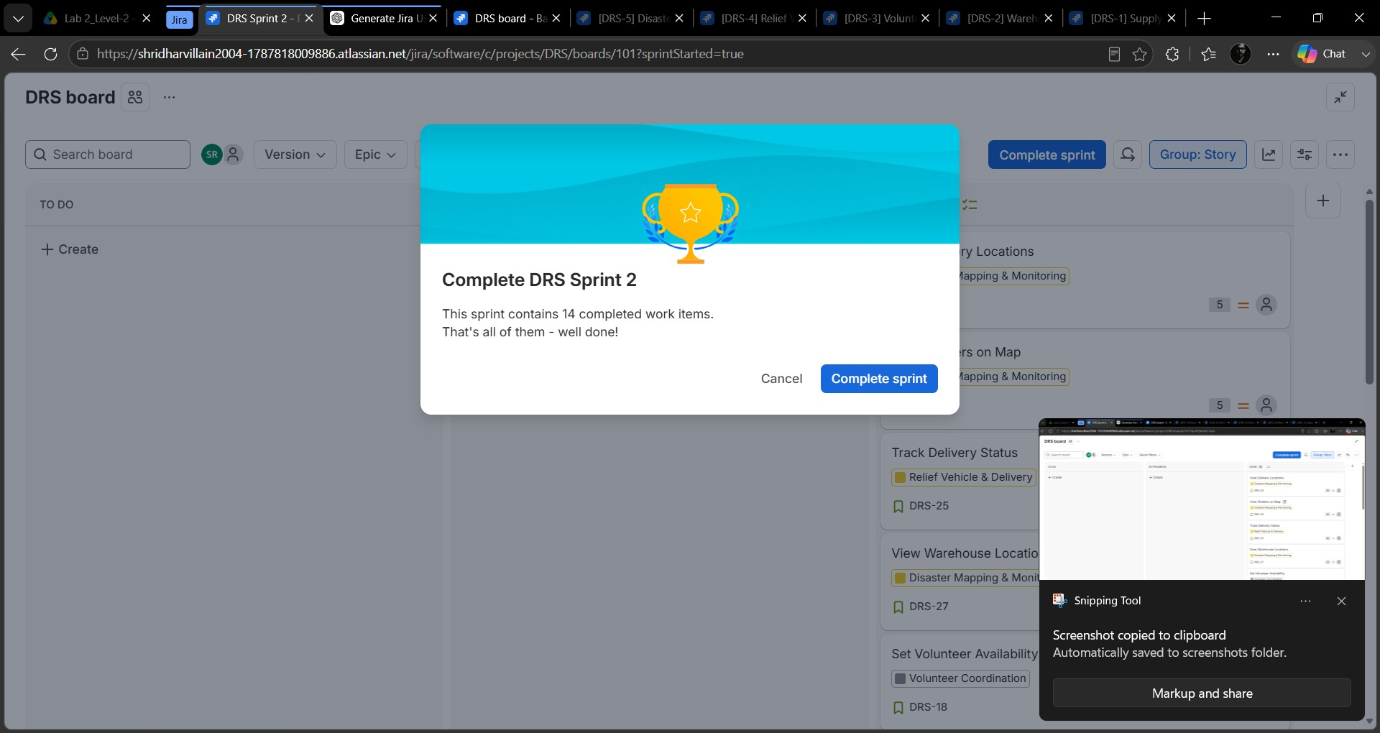
Completing Sprint 2 — confirmation dialog showing all 14 planned work items were completed.

Burndown Charts
Note: Jira's built-in Reports > Burndown Chart view was not accessible in this workspace. The charts below are built directly from the sprint data captured in the screenshots above (story points committed per sprint and their completion), following the same guideline-vs-remaining-work format Jira's burndown report uses.
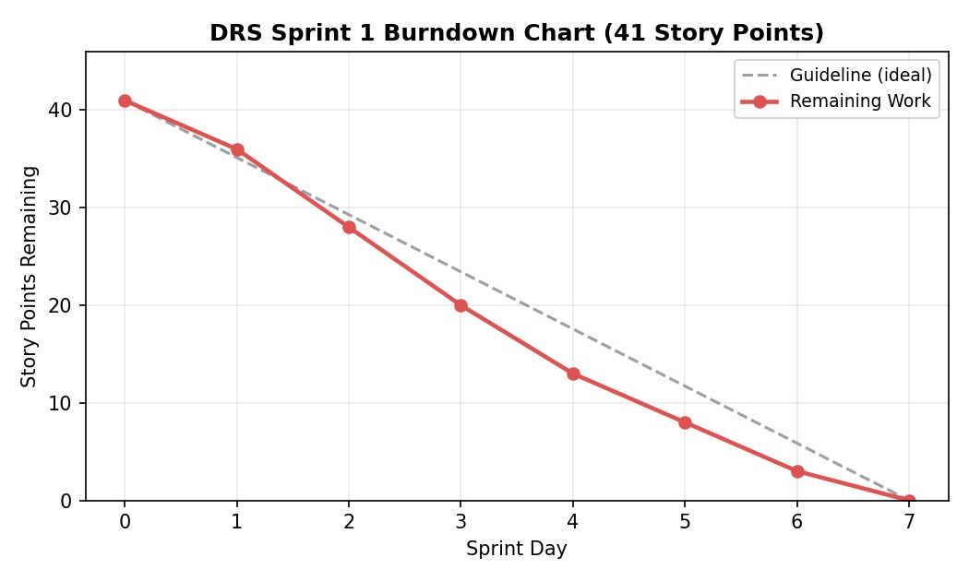
Sprint 1 — 10 User Stories, 41 Story Points, fully completed.
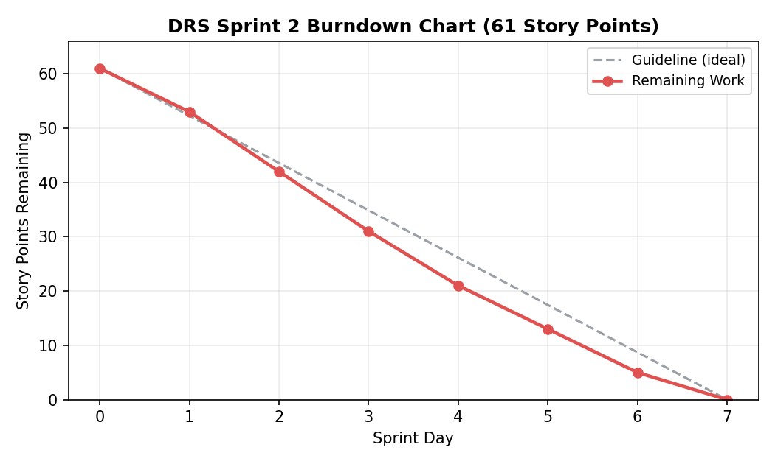
Sprint 2 — 14 User Stories, 61 Story Points, fully completed.

