LAB 1: REQUIREMENTS ENGINEERING & UML USE-CASE MODELLING
Problem Statement #64 — Disaster Relief Supply & Volunteer Coordinator
Software Engineering Lab 1 Submission
Name: Shreedhar R
SRN: PES2UG25CS823
Section: H

1. Requirements Table
Req ID | Type | Description | Priority | Acceptance Criteria | Rationale | Comments
FR-001 | Functional | The system shall match incoming field shelter supply requisitions against available central warehouse supplies and allocate delivery priority. | High | Pass: A critical-need requisition (e.g., water/medical) is matched against warehouse stock and assigned the highest dispatch priority, routed to the logistics manifest. Fail: A low-priority item is dispatched ahead of an outstanding water/medical requisition. | Given in problem statement; ensures scarce relief supplies reach the most urgent shelter needs first. | Baseline requirement from problem statement.
FR-002 | Functional | The system shall allow a Disaster Manager to create and submit a shelter supply request specifying item type, quantity, and shelter location. | High | Pass: On submission, a new requisition record is created with status "Pending" and appears in the requisition queue within 5 seconds. Fail: The request is not saved, or required fields (item, quantity, location) are missing and the system allows submission anyway. | Entry point for the core relief workflow; without it no downstream matching or dispatch can occur.
FR-003 | Functional | The system shall allow a Logistics Officer to view real-time central warehouse inventory levels for water, blankets, and medical kits. | High | Pass: Inventory screen shows current on-hand quantity per item, refreshed within the last 2 minutes. Fail: Displayed quantity differs from the warehouse ledger by more than the defined tolerance, or the screen shows stale data older than 10 minutes. | Accurate stock visibility is required before requisitions can be matched or supplies allocated. | Supports FR-001 (invoked as an included use case).
FR-004 | Functional | The system shall allow a Disaster Manager to assign a Relief Volunteer to a delivery task based on the volunteer's registered skill set and current availability. | Medium | Pass: Only volunteers marked "Available" and whose skill tags match the task requirement appear in the assignment list, and the selected volunteer's status changes to "Assigned". Fail: A volunteer marked "Unavailable" or lacking the required skill tag can be assigned. | Correct skill-to-task matching improves response effectiveness and avoids sending unqualified volunteers.
FR-005 | Functional | The system shall allow a Logistics Officer to record and track the delivery status of a relief vehicle (e.g., Dispatched, In-Transit, Delivered, Delayed) against an assigned requisition. | Medium | Pass: Status updates are timestamped and visible to the Disaster Manager within 1 minute of entry, and the status history is preserved. Fail: A status update is lost, overwritten without history, or not visible to the Disaster Manager. | Enables end-to-end visibility of relief delivery so managers can react to delays in real time. | Base use case for the "Report Delivery Delay" extension (UC-08).

2. UML Use-Case Diagram
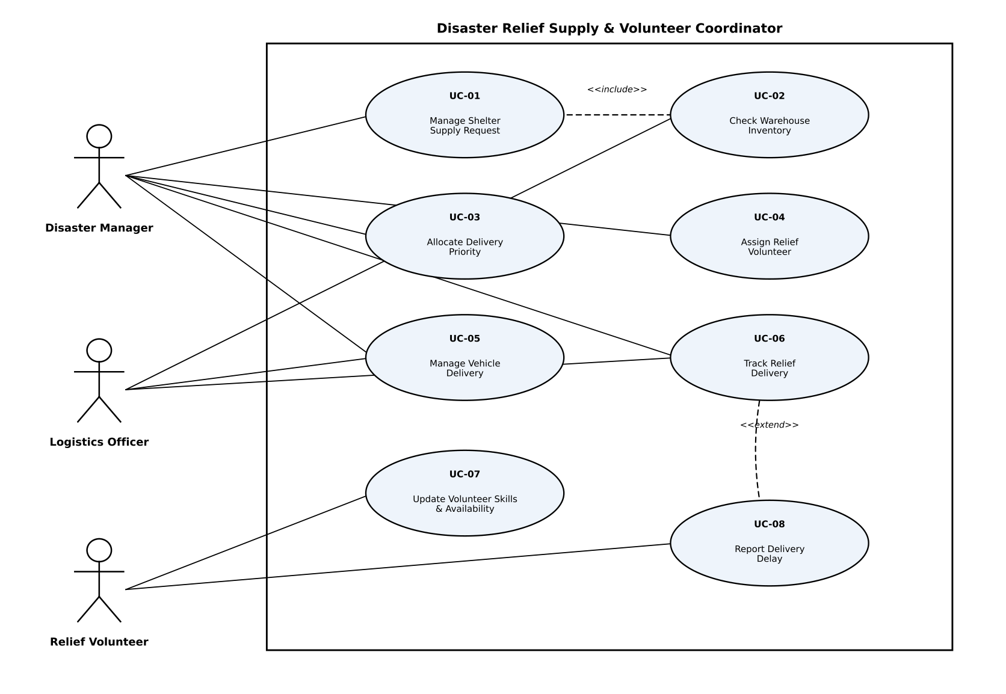
Figure 1: UML Use-Case Diagram

3. Use-Case Flow Specification
Use Case: UC-01 Manage Shelter Supply Request
Primary Actor: Disaster Manager
Supporting Actor: Logistics Officer (supplies warehouse inventory data)
Includes: UC-02 Check Warehouse Inventory (<<include>>)
Preconditions
1. The Disaster Manager is authenticated and logged into the system.
2. At least one active shelter exists in the system with a registered location.
3. The central warehouse inventory system is reachable (online or via cached data).
Postconditions
Success: A new shelter supply requisition is created, matched against warehouse stock, assigned a delivery priority, and placed on the logistics manifest.
Failure: No requisition is created, or the requisition remains in "Pending" status pending manual review.
Main Success Scenario
The Disaster Manager selects "New Shelter Supply Request" from the dashboard.
The system displays a request form for shelter location, item type (water, blankets, medical kits), and quantity needed.
The Disaster Manager enters the shelter location, item type, and quantity, and submits the request.
The system validates that all required fields are present and quantities are positive numbers.
The system invokes UC-02 Check Warehouse Inventory (<<include>>) to retrieve current stock levels for the requested item.
The system compares the requested quantity against available warehouse stock.
The system matches the requisition to available supply and calculates a delivery priority based on item criticality (e.g., water and medical kits rank above blankets) and shelter urgency.
The system assigns the requisition the calculated priority and adds it to the logistics manifest with status "Matched".
The system displays a confirmation to the Disaster Manager showing the requisition ID, assigned priority, and matched quantity.
Use case ends successfully.
Alternate Flow
6a. Requested Supply Unavailable or Insufficient in Central Warehouse
6a1. The system determines that available warehouse stock is less than the requested quantity, or the item is out of stock.
6a2. The system marks the requisition status as "Partially Matched" or "Backordered" and records the shortfall quantity.
6a3. The system automatically raises the requisition's delivery priority flag for manager review and notifies the Disaster Manager of the shortage.
6a4. The Disaster Manager may choose to (a) accept a partial allocation, (b) redirect the request to an alternate supply source, or (c) keep the requisition pending until stock is replenished.
6a5. The system logs the decision and resumes at step 8 of the Main Success Scenario with the adjusted quantity, or ends the use case if the Disaster Manager cancels the request.

4. Submission Checklist
✓ Exactly 5 Functional Requirements: FR-001 to FR-005
✓ Exactly 2 Non-Functional Requirements: NFR-001 and NFR-002
✓ At least 3 actors: Disaster Manager, Logistics Officer and Relief Volunteer
✓ At least 5 use cases, labelled UC-01 to UC-08
✓ UC-01 includes UC-02
✓ UC-08 extends UC-06
✓ Use-case flow contains Preconditions, Postconditions, Main Success Scenario and Alternate Flow

