# **Team 29 – Primary Key Players**

# **Main 80 Questions**

1. Update the demography table. Add a random age for each patient that falls within their respective age category. This newly added age should be an integer.

--Add New Column 'age' to demography table  
ALTER TABLE IF EXISTS public.demography  
ADD COLUMN age INTEGER;  
  
--UPDATE 'age' with random age for each patiente based on 'agecat'  
UPDATE demography  
SET age =FLOOR(CAST(LEFT(agecat, 2) AS INTEGER) + (RANDOM() * 7));

Output:

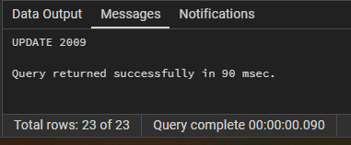

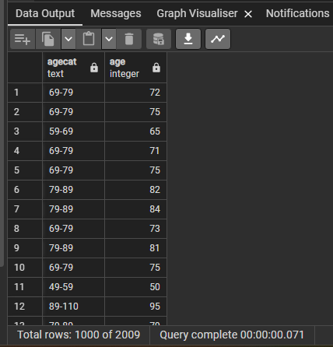

1. Calculate patient's year of birth using admission date from the hospitalization_discharge and add to the demography table.

--Add column 'year_of_birth' to demography table  
ALTER TABLE IF EXISTS public.demography  
ADD COLUMN year_of_birth INTEGER;  
  
--calculate Update column 'year_of_birth' in demograhy table using 'admissin_date' column in hospitilaition_date' table   
UPDATE demography d  
SET year_of_birth = (extract(year from h.admission_date)) - d.age  
FROM hospitalization_discharge h  
WHERE h.inpatient_number=d.inpatient_number

Output:

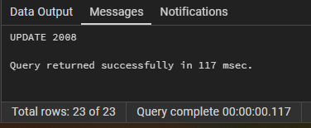

select h.admission_date,d.age,((extract(year from h.admission_date)) - d.age) as calc_yearofbirth, d.year_of_birth

FROM hospitalization_discharge h

JOIN demography d

ON h.inpatient_number=d.inpatient_number

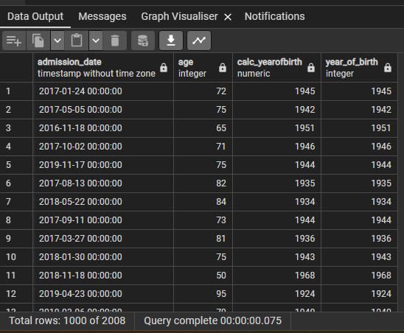

1. Create a User defined function that returns the age in years of any patient as a calculation from year of birth

CREATE OR REPLACE FUNCTION patient_age_calc(inpatient_id bigint) RETURNS INTEGER  
LANGUAGE plpgsql AS $$  
DECLARE  
patient_age INTEGER;  
BEGIN  
SELECT EXTRACT(YEAR FROM CURRENT_DATE) - year_of_birth into patient_age  
from public.demography  
where inpatient_number = inpatient_id;  
IF NOT FOUND THEN  
RAISE EXCEPTION 'Patient Id % Not found',inpatient_id;  
END IF;  
RETURN patient_age;  
END;  
$$;

Output:

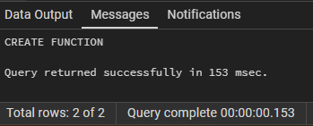  
  
SELECT patient_age_calc(741318);

Output:

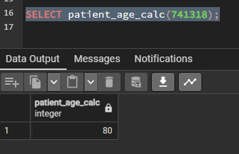

1. What % of the dataset is male vs female?

select

COALESCE(gender,'Unknown') as gender_category,

CONCAT(ROUND(count(gender) * 100.0 / SUM(COUNT(*)) OVER (),0),'%') AS gender_percentage

from public.demography

where gender != 'Unknown'

group by gender_category

Output:

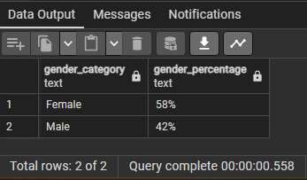

1. How many patients in this dataset are farmers?

SELECT COUNT(inpatient_number) as count_patinets_farmers FROM demography

WHERE occupation = 'farmer';

Output:

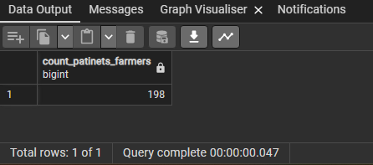

1. Group the patients by age category and display it as a pie chart

select agecat, count(agecat)

from public.demography

where agecat IS NOT NULL

group by agecat

order by agecat ASC

Output:

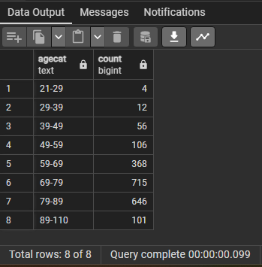

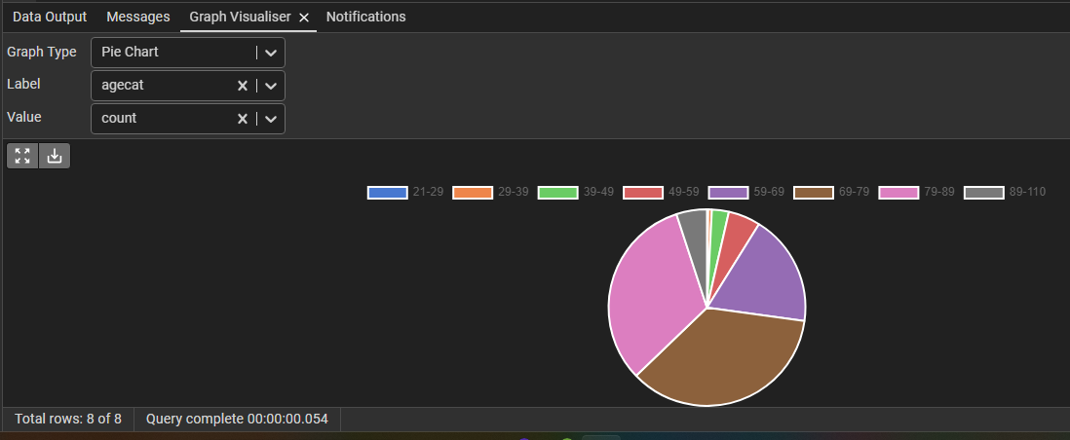

1. Divide BMI into slabs of 5 and show the count of patients within each one, without using case statements.

WITH BMI AS

(select ROUND(CAST(BMI AS numeric),2) as bmi_rounded,count(bmi) as bmi_count

from public.demography

group by bmi_rounded

order by bmi_rounded ASC)

SELECT

width_bucket(bmi_rounded,array[0,18.5,25,30,35]) as bmi_bucket,

int4range(CAST(min(BMI_rounded) as integer),CAST(max(BMI_rounded) as integer),'()')as starting_ending_range,

COUNT(bmi_count) as count_bmi

FROM BMI

GROUP BY bmi_bucket

ORDER BY bmi_bucket ASC

Output:

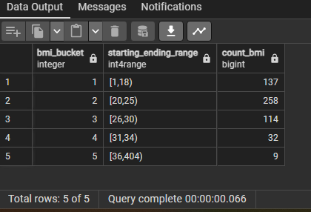

1. What % of the dataset is over 70 years old

SELECT ROUND(COUNT(age)*100/(select count(inpatient_number) from public.demography),0) as percentage_over_70

FROM public.demography

where age >70

Output:

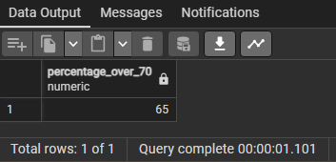

1. What age group was least likely to be readmitted within 28 days

WITH CTE AS

(select d.agecat as least_likely_readmission_agecat_within_28_days,

COUNT(hd.re_admission_within_28_days)

from public.hospitalization_discharge hd

JOIN public.demography d

ON hd.inpatient_number = d.inpatient_number

group by d.agecat

order by COUNT(hd.re_admission_within_28_days) ASC

LIMIT 1)

SELECT least_likely_readmission_agecat_within_28_days

from CTE

Output:

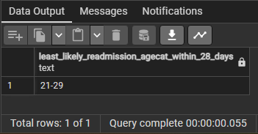

1. Create a procedure to insert a column with a serial number for all rows in demography.

CREATE OR REPLACE PROCEDURE public.generate_series()

LANGUAGE 'sql'

AS $BODY$

ALTER TABLE IF EXISTS public.demography

ADD COLUMN series SERIAL;

$BODY$;

Output:

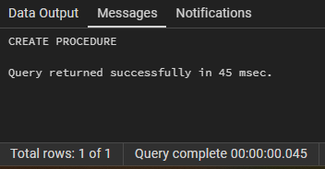

Select * from public.demography; -- Shows Series column with values generated:

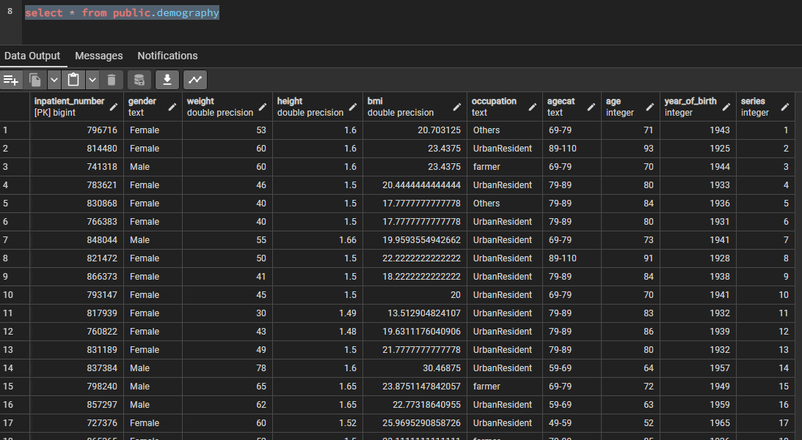

1. what was the average time to readmission among men?

select ROUND(AVG(hd.readmission_time_days_from_admission)) as Avg_readmission_time_days

from public.hospitalization_discharge hd

JOIN public.demography d

ON hd.inpatient_number = d.inpatient_number

AND d.gender='Male'

Output:

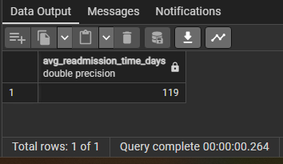

1. Display NYHA_cardiac_function_classification as
   1. Class I: No symptoms of heart failure
   2. Class II: Symptoms of heart failure with moderate exertion
   3. Class III: Symptoms of heart failure with minimal exertion and show the most common type of heart failure for each classification

WITH common_heart_failure_classification AS

(WITH classification AS

(select

CASE

WHEN NYHA_cardiac_function_classification = 1 THEN 'Class I: No symptoms of heart failure'

WHEN NYHA_cardiac_function_classification = 2 THEN 'Class II: Symptoms of heart failure with moderate exertion'

WHEN NYHA_cardiac_function_classification = 3 THEN 'Class III: Symptomsof heart failure with minimal exertion'

ELSE 'Unknown'

END AS NYHA_classification, type_of_heart_failure,

count(inpatient_number) as count_patinet_id

from public.cardiaccomplications

group by NYHA_cardiac_function_classification, type_of_heart_failure

ORDER BY NYHA_classification, count_patinet_id DESC)

SELECT NYHA_classification, type_of_heart_failure,

RANK() OVER (PARTITION BY NYHA_classification ORDER BY count_patinet_id DESC) as ranking

from classification

group by NYHA_classification, type_of_heart_failure, count_patinet_id)

SELECT NYHA_classification, type_of_heart_failure

from common_heart_failure_classification

where ranking =1

and NYHA_classification !='Unknown'

Output:

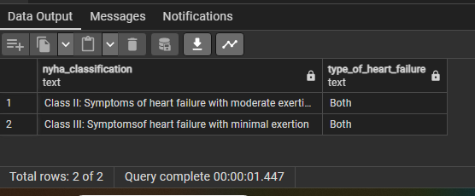

1. Identify any columns relating to echocardiography and create a severity score for cardiac function. Add this column to the table

**Below code computes severity score for each of the columns relating to echocardiography:**

**Columns identified:** lvef, left_ventricular_end_diastolic_diameter_lv, ea, mitral_valve_ems, mitral_valve_ams, tricuspid_valve_return_velocity, tricuspid_valve_return_pressure

**Scoring range:**

**0 – Good**

**1 - Normal**

**2 - Mild**

**3 - Moderate**

**4 – Severe**

**Total Severity score range:**

| **Total Score** | **Severity** |
| --- | --- |
| **0-3** | **Low Risk** or **Normal** |
| **4-6** | **Mild Dysfunction** |
| **7-9** | **Moderate Dysfunction** |
| **10-12** | **Severe Dysfunction** |
| **13+** | **Dangerous** |

WITH cardiac_severity_score AS

(SELECT inpatient_number,

CASE

WHEN lvef >70 THEN 0

WHEN lvef BETWEEN 50 AND 70 THEN 1

WHEN lvef BETWEEN 40 AND 49 THEN 2

WHEN lvef BETWEEN 30 AND 39 THEN 3

WHEN lvef < 30 THEN 4

ELSE 0

END AS lvef_score,

CASE

WHEN left_ventricular_end_diastolic_diameter_lv <37 THEN 0

WHEN left_ventricular_end_diastolic_diameter_lv BETWEEN 37 AND 56 THEN 1

WHEN left_ventricular_end_diastolic_diameter_lv BETWEEN 57 AND 61 THEN 2

WHEN left_ventricular_end_diastolic_diameter_lv BETWEEN 62 AND 65 THEN 3

WHEN left_ventricular_end_diastolic_diameter_lv < 65 THEN 4

ELSE 0

END AS lvedd_score,

CASE

WHEN ea >0.8 THEN 0

WHEN ea BETWEEN 0.8 AND 1.5 THEN 1

WHEN ea BETWEEN 0.6 AND 0.8 THEN 2

WHEN ea BETWEEN 0.4 AND 0.6 THEN 3

WHEN ea < 0.4 THEN 4

ELSE 0

END AS ea_score,

CASE

WHEN mitral_valve_ems <0.6 THEN 0

WHEN mitral_valve_ems BETWEEN 0.6 AND 0.9 THEN 1

WHEN mitral_valve_ems BETWEEN 1.0 AND 1.2 THEN 2

WHEN mitral_valve_ems BETWEEN 1.3 AND 1.5 THEN 3

WHEN mitral_valve_ems > 1.5 THEN 4

ELSE 0

END AS mvems_score,

CASE

WHEN mitral_valve_ams >=0.12 THEN 0

WHEN mitral_valve_ams BETWEEN 0.09 AND 0.12 THEN 1

WHEN mitral_valve_ams BETWEEN 0.07 AND 0.09 THEN 2

WHEN mitral_valve_ams BETWEEN 0.05 AND 0.07 THEN 3

WHEN mitral_valve_ams < 0.05 THEN 4

ELSE 0

END AS mvams_score,

CASE

WHEN tricuspid_valve_return_velocity <=2.8 THEN 0

WHEN tricuspid_valve_return_velocity =2.9 THEN 1

WHEN tricuspid_valve_return_velocity BETWEEN 3.0 AND 3.1 THEN 2

WHEN tricuspid_valve_return_velocity BETWEEN 3.2 AND 3.4 THEN 3

WHEN tricuspid_valve_return_velocity >= 3.5 THEN 4

ELSE 0

END AS tvrv_score,

CASE

WHEN tricuspid_valve_return_pressure <=25 THEN 0

WHEN tricuspid_valve_return_pressure BETWEEN 26 AND 35 THEN 1

WHEN tricuspid_valve_return_pressure BETWEEN 36 AND 50 THEN 2

WHEN tricuspid_valve_return_pressure BETWEEN 51 AND 70 THEN 3

WHEN tricuspid_valve_return_pressure < 70 THEN 4

ELSE 0

END AS tvrp_score

from public.cardiaccomplications)

SELECT

inpatient_number,

lvef_score,

lvedd_score,

ea_score,

mvems_score,

mvams_score,

tvrv_score,

tvrp_score,

(lvef_score +

lvedd_score +

ea_score +

mvems_score +

mvams_score +

tvrv_score+

tvrp_score) as total_severity_score

from cardiac_severity_score

Output:

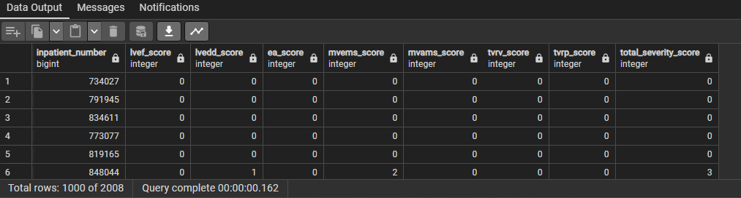

**Below statement adds a new column total_severity_score in cardiacomplications**

ALTER TABLE cardiaccomplications

ADD COLUMN total_severity_score INT;

**Below query updates total_severity_score score to cardiaccomplications**

UPDATE cardiaccomplications

SET total_severity_score =

(

CASE

WHEN lvef >70 THEN 0

WHEN lvef BETWEEN 50 AND 70 THEN 1

WHEN lvef BETWEEN 40 AND 49 THEN 2

WHEN lvef BETWEEN 30 AND 39 THEN 3

WHEN lvef < 30 THEN 4

ELSE 0

END +

CASE

WHEN left_ventricular_end_diastolic_diameter_lv <37 THEN 0

WHEN left_ventricular_end_diastolic_diameter_lv BETWEEN 37 AND 56 THEN 1

WHEN left_ventricular_end_diastolic_diameter_lv BETWEEN 57 AND 61 THEN 2

WHEN left_ventricular_end_diastolic_diameter_lv BETWEEN 62 AND 65 THEN 3

WHEN left_ventricular_end_diastolic_diameter_lv < 65 THEN 4

ELSE 0

END +

CASE

WHEN ea >0.8 THEN 0

WHEN ea BETWEEN 0.8 AND 1.5 THEN 1

WHEN ea BETWEEN 0.6 AND 0.8 THEN 2

WHEN ea BETWEEN 0.4 AND 0.6 THEN 3

WHEN ea < 0.4 THEN 4

ELSE 0

END +

CASE

WHEN mitral_valve_ems <0.6 THEN 0

WHEN mitral_valve_ems BETWEEN 0.6 AND 0.9 THEN 1

WHEN mitral_valve_ems BETWEEN 1.0 AND 1.2 THEN 2

WHEN mitral_valve_ems BETWEEN 1.3 AND 1.5 THEN 3

WHEN mitral_valve_ems > 1.5 THEN 4

ELSE 0

END +

CASE

WHEN mitral_valve_ams >=0.12 THEN 0

WHEN mitral_valve_ams BETWEEN 0.09 AND 0.12 THEN 1

WHEN mitral_valve_ams BETWEEN 0.07 AND 0.09 THEN 2

WHEN mitral_valve_ams BETWEEN 0.05 AND 0.07 THEN 3

WHEN mitral_valve_ams < 0.05 THEN 4

ELSE 0

END +

CASE

WHEN tricuspid_valve_return_velocity <=2.8 THEN 0

WHEN tricuspid_valve_return_velocity =2.9 THEN 1

WHEN tricuspid_valve_return_velocity BETWEEN 3.0 AND 3.1 THEN 2

WHEN tricuspid_valve_return_velocity BETWEEN 3.2 AND 3.4 THEN 3

WHEN tricuspid_valve_return_velocity >= 3.5 THEN 4

ELSE 0

END +

CASE

WHEN tricuspid_valve_return_pressure <=25 THEN 0

WHEN tricuspid_valve_return_pressure BETWEEN 26 AND 35 THEN 1

WHEN tricuspid_valve_return_pressure BETWEEN 36 AND 50 THEN 2

WHEN tricuspid_valve_return_pressure BETWEEN 51 AND 70 THEN 3

WHEN tricuspid_valve_return_pressure < 70 THEN 4

ELSE 0

END )

WHERE inpatient_number IS NOT NULL;

Output:

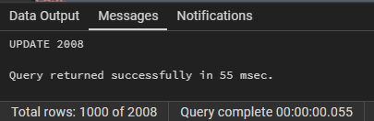

**Below is a test select query that show the score in total_severity_score from cardiaccomplications**

select total_severity_score from cardiaccomplications

Output:

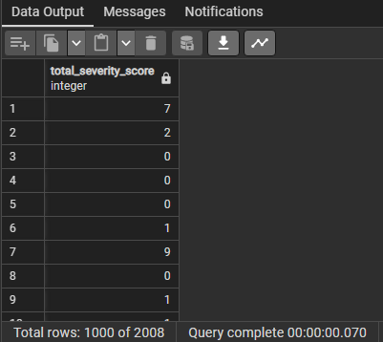

1. What is the average height of women in cms?

select ROUND(AVG(height*100)) as avg_height_cm

from public.demography

where gender = 'Female'

Output:

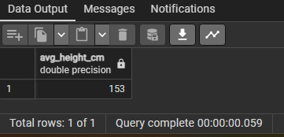

1. Using the cardiac severity column from q13, find the correlation between hospital outcomes and cardiac severity

select

CORR(CASE WHEN hd.outcome_during_hospitalization = 'Dead' THEN 1 ELSE 0 END, CAST(cc.total_severity_score as integer)) as corr_dead,

CORR(CASE WHEN hd.outcome_during_hospitalization = 'DischargeAgainstOrder' THEN 1 ELSE 0 END, CAST(cc.total_severity_score as integer)) as corr_DAO,

CORR(CASE WHEN hd.outcome_during_hospitalization = 'Alive' THEN 1 ELSE 0 END, CAST(cc.total_severity_score as integer)) as corr_alive

from public.hospitalization_discharge hd

JOIN public.cardiaccomplications cc

ON hd.inpatient_number = cc.inpatient_number

Output:

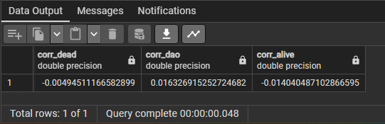

**-0.004945111665828978 corr_dead Negative Corrolation**

**0.016326915252724727 corr_DAO Very weak Correlation**

**-0.014040487102866631 corr_alive Negative Corrolation**

Interpretation of Correlation Coefficient

0 to 0.1: Very weak positive correlation.

0.1 to 0.3: Weak positive correlation.

0.3 to 0.5: Moderate positive correlation.

0.5 to 0.7: Strong positive correlation.

0.7 to 1: Very strong positive correlation.

Negative values: Indicate a negative correlation, where as one variable increases, the other tends to decrease.

1. Show the no. of patients for everyday in March 2017. Show the date in March along with the days between the previous recorded day in march and the current.

SELECT

DATE(admission_date) as Admission_Date,

DATE(admission_date) - LAG(DATE(admission_date)) OVER (ORDER BY DATE(admission_date)) as Difference_in_Days,

COUNT(inpatient_number) as Patient_Count

FROM public.hospitalization_discharge

where

EXTRACT(YEAR FROM admission_date) ='2017'

and EXTRACT(Month FROM admission_date) ='03'

GROUP BY

DATE(admission_date)

Output:

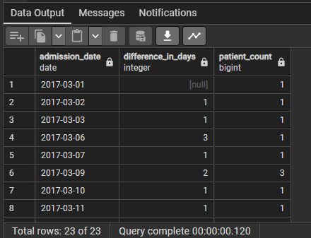

1. Create a view that combines patient demographic details of your choice along with pre-exisiting heart conditions like MI,CHF and PVD

create or replace view cardiac_patients

as

select d.inpatient_number, d.gender, d.occupation, d.age, c.myocardial_infarction, c.congestive_heart_failure, c.peripheral_vascular_disease

from public.demography d

join cardiaccomplications c on c.inpatient_number = d.inpatient_number

where c.myocardial_infarction = 1 or c.congestive_heart_failure = 1 or c.peripheral_vascular_disease = 1;

Output:

**Below is a query that selects all records from the view:**

select * from cardiac_patients;

Output:

1. Create a function to calculate total number of unique patients for every drug. Results must be returned as long as the first few characters match the user input.

create or replace function get_count_of_prescribed(name_of_drug text)

returns table (count_of_users bigint, name_of_drugs text)

as

$$

declare first_three_letters text;

begin

first_three_letters =lower(left(name_of_drug,3));

return query

select count(inpatient_number), drug_name

from public.patient_precriptions

where lower(drug_name) like first_three_letters||'%'

group by drug_name;

end

$$language plpgsql;

Output:

**Below queries are used to call the function with the drug name:**

select * from get_count_of_prescribed('furo');

Output:

select * from get_count_of_prescribed('a');

Output:

1. break up the drug names in patient_precriptions at the ""spaces"" and display only the second string without using Substring. Show unique drug names along with newly broken up string

select distinct drug_name, split_part(drug_name,' ',2) as second_string

from patient_precriptions;

Output:

1. Select the drug names starting with E and has x in any position after

select distinct drug_name

from patient_precriptions

where drug_name like 'E%x%';

Output:

1. Create a cross tab to show the count of readmissions within 28 days, 3 months,6 months as rows and admission ward as columns

select * from

crosstab(

'

SELECT ''180Days'' as day_range,admission_ward,SUM(re_admission_within_6_months) as count_patients

FROM public.hospitalization_discharge

GROUP BY hospitalization_discharge.admission_ward

UNION ALL

SELECT ''28Days'' as day_range,admission_ward,SUM(re_admission_within_28_days) as count_patients

FROM public.hospitalization_discharge

GROUP BY hospitalization_discharge.admission_ward

UNION ALL

SELECT ''90Days'' as day_range,admission_ward,SUM(re_admission_within_3_months) as count_patients

FROM public.hospitalization_discharge

GROUP BY hospitalization_discharge.admission_ward

UNION ALL

SELECT ''DWithin6Months'' as day_range,admission_ward,SUM(death_within_6_months) as value

FROM public.hospitalization_discharge

GROUP BY hospitalization_discharge.admission_ward

',

'SELECT DISTINCT admission_ward FROM hospitalization_discharge details ORDER BY admission_ward ASC')

as adm_columns(day_range varchar,Cardiology int,GeneralWard int,ICU int, Others int);

Output:

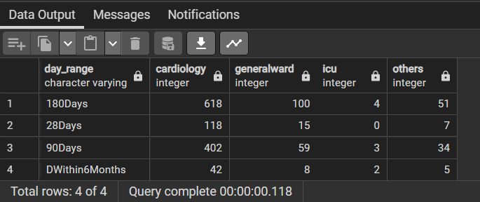

1. Create a trigger to stop patient records from being deleted from the demography table

Query to create function:

create or replace function deletion_not_allowed()

returns trigger as

$$

begin

raise exception 'Deletion is not allowed on this table.';

return null;

end

$$ language plpgsql;

Output:

**Query to create trigger:**

create trigger no_delete_demography

before delete on public.demography

for each row execute function deletion_not_allowed();

Output:

**Query to test trigger by trying to delete a row from demography table:**

delete from demography where inpatient_number = 5;

Output:

1. What is the total number of days between the earliest admission and the latest

select (max(admission_date)::date-min(admission_date)::date) as day_interval_between_first_and_last_admission

from hospitalization_discharge;

Output:

1. Divide discharge day by visit times for any 10 patients without using mathematical operators like '/'

select inpatient_number,dischargeday, visit_times, div(dischargeday,visit_times) as division_result

from hospitalization_discharge

limit 10;

Output:

1. Show the count of patients by first letter of admission_way.

select substring(admission_way,1,1) as first_letter_of_admission_way,count(inpatient_number)

from hospitalization_discharge

group by admission_way;

Output:

1. Display an array of personal markers:gender, BMI, pulse, MAP for every patient. The result should look like this

select d.inpatient_number, array[d.gender, cast(cast(d.bmi as decimal(10,2)) as text), cast(cast(l.pulse as decimal(10,2)) as text), cast(cast(l.map_value as int) as text)] as markers

from demography d, labs l

where d.inpatient_number = l.inpatient_number;

Output:

1. Display medications With Name contains 'hydro' and display it as 'H20'.

**For this query we also considered drug names that contained ‘Hydro’ with capital H. Any drug name that contains ‘hydro’ or ‘Hydro’ will be replaced with H2O.**

select distinct drug_name, replace(lower(drug_name),'hydro','H2O') as modified_drug_name from patient_precriptions

where drug_name ilike '%hydro%';

Output:

1. Create a trigger to raise notice and prevent deletion of the view created in question 17

**Query to create function:**

create or replace function view_deletion_not_allowed()

returns event_trigger as

$$

declare

rec record;

begin

for rec in select * from pg_event_trigger_dropped_objects()

loop

if rec.object_type = 'view' AND rec.object_name = 'cardiac_patients' then

raise notice 'Deletion of view cardiac_patients is not allowed';

end if;

end loop;

end;

$$language plpgsql;

Output:

**Query to create trigger:**

create event trigger cardiac_patients_view_no_deletion on sql_drop

when TAG in ('DROP VIEW')

execute function view_deletion_not_allowed();

Output:

**Testing the trigger by trying to drop the view cardiac_patients:**

drop view cardiac_patients;

Output:

1. How many unique patients have cancer?

**For this query, we have considered patients having leukemia or malignant lymphoma as having cancer. Solid tumor patients have not been considered as tumors may or may not be cancerous.**

select distinct count(inpatient_number) as count_of_patients_having_cancer

from patienthistory

where leukemia = 1 or malignant_lymphoma = 1;

Output:

1. Show the moving average of number of patient admitted every 3 months.

select date_trunc('month', admission_date) as ma_month,

count(inpatient_number) as patients_admitted,

round((avg(count(inpatient_number)) over (order by date_trunc('month', admission_date) rows between 2 preceding and current row)),2) as moving_average_3_month

from hospitalization_discharge

group by date_trunc('month', admission_date)

order by ma_month;

Output:

1. Write a query to get a list of patient IDs' who recieved oxygen therapy and had a high respiration rate in February 2017

**We have considered respiration rate > 20 breaths per minute as high respiration for this query.**

select distinct hd.inpatient_number

from hospitalization_discharge hd, labs l

where hd.inpatient_number = l.inpatient_number

and l.respiration >20

and hd.oxygen_inhalation = 'OxygenTherapy'

and extract(month from admission_date) = 02

and extract(year from admission_date) = 2017;

Output:

1. Display patients with heart failure type: "both" along with highest MAP and higest pulse without using limit

**For this question, we are considering the patients with heart failure type: “both” and amongst them we are displaying the patient with highest MAP and the patient with highest pulse.**

select cc.inpatient_number, cc.type_of_heart_failure, l.map_value,l.pulse

from cardiaccomplications cc

JOIN labs l

ON cc.inpatient_number = l.inpatient_number

where cc.type_of_heart_failure ='Both'

and (l.map_value = (select max(map_value) from labs)

or l.pulse = (select max(pulse) from labs))

Output:

1. Create a stored procedure that displays any message on the screen without using any tables/views.

**creating stored procedure without variable:**

create or replace procedure stored_procedure()

language plpgsql

as $$

--declaring variable to store the value that is returning from block

declare team text;

begin

select 'Team_29 Primary Key Players' into team;

--raise notice is used to show the output while calling

raise notice '%',team;

end;

$$;

– calling procedure

call stored_procedure();

Output: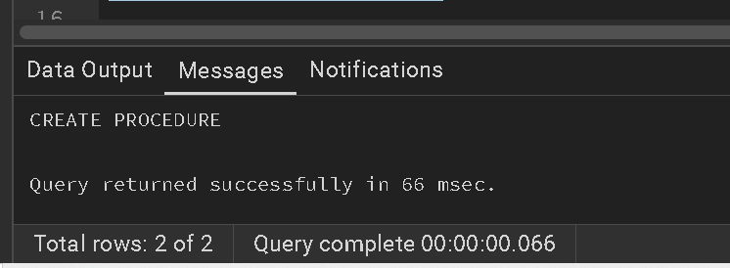

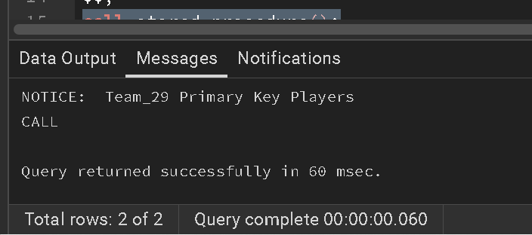

1. In healthy people, monocytes make up about 1%-9% of total white blood cells. Calculate avg monocyte percentages among each age group

select

agecat,

round(avg((monocyte_count::numeric/white_blood_cell::numeric)*100),2) as monocyte_percentage

from labs lb

join demography dm

on lb.inpatient_number=dm.inpatient_number

group by dm.agecat

Output:

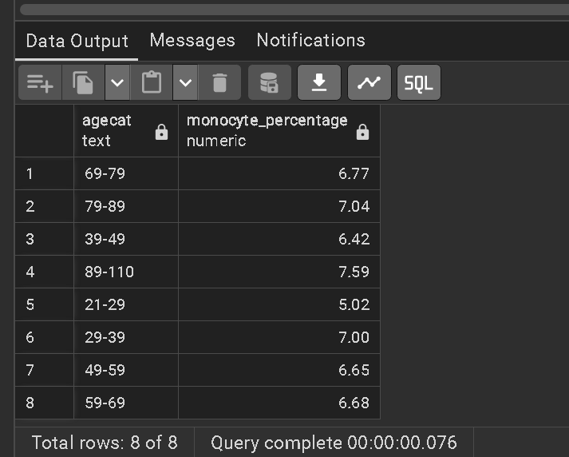

1. Create a table that stores any Patient Demographics of your choice as the parent table. Create a child table that contains systolic_blood_pressure,diastolic_blood_pressure per patient and inherits all columns from the parent table

**droping tables if exists:**

drop table blood_pressure;

drop table BP_child ;

**parent table:**

create table blood_pressure

(inpatient_number bigint PRIMARY KEY,

gender text,

bmi double precision,

agecat text);

**child table:**

CREATE TABLE BP_child (

systolic_blood_pressure INTEGER,

diastolic_blood_pressure INTEGER

) INHERITS (blood_pressure);

**insert values:**

iNSERT INTO BP_child( inpatient_number,gender,bmi,agecat,systolic_blood_pressure,diastolic_blood_pressure)

select

dm.inpatient_number,

gender,

bmi,

agecat,

systolic_blood_pressure,

diastolic_blood_pressure

from demography dm

join labs lb on

dm.inpatient_number=lb.inpatient_number

**checking the tables:**

select* from BP_child

select* from blood_pressure

Output:

**Parent table:**

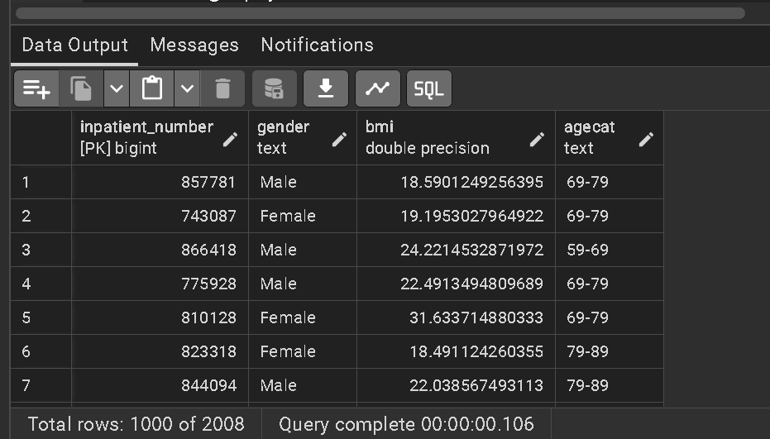

**Child table:**

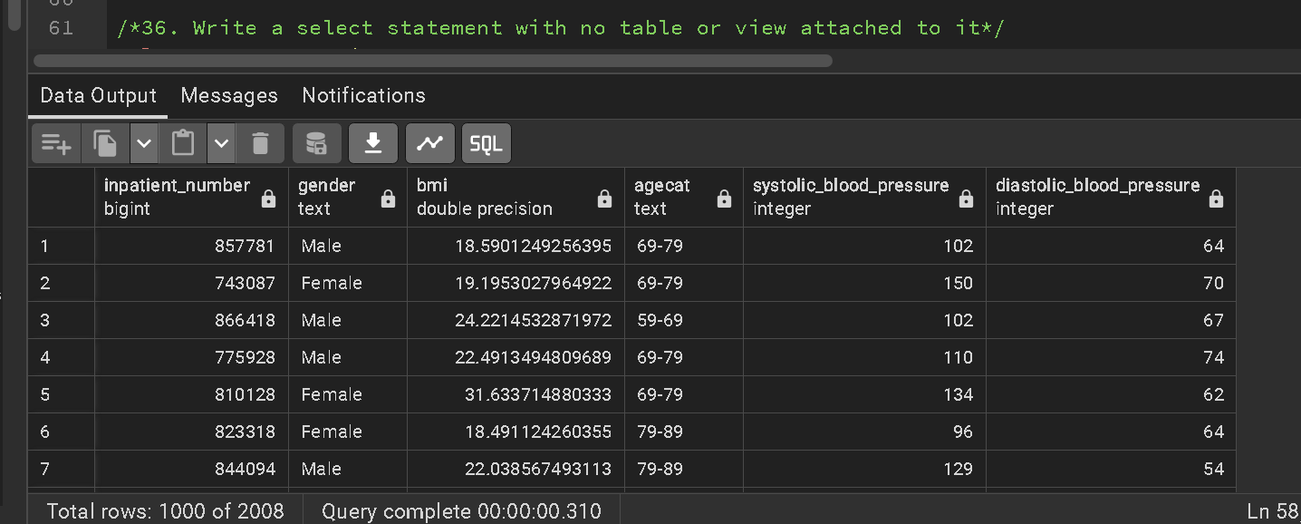

1. Write a select statement with no table or view attached to it

select 'TEAM 29 Primary Key Players' as team;

Output:

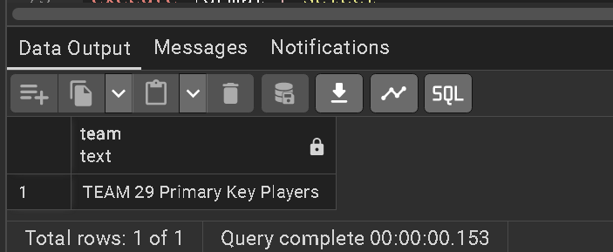

1. Create a re-usable function to calculate the percentage of patients for any group. Use this function to calculate % of patients in each admission ward."

**create the reusable function:**

create or replace function percentage_patients(tablename text ,group_column text)

returns table (percentage numeric ,count bigint ,column_group text) as

$$

begin

return query

/*-- this function was unable to take the tablename and column name so used %I as

a placeholder for table name and column name*/

execute format ('select

round((count(inpatient_number)*100.0/(select count(inpatient_number) from %I)),2) as percentage,

count(inpatient_number) as count_by_group,

%I

from %I

group by %I',

tablename,

group_column,

tablename,

group_column);

end;

$$ language plpgsql

**calling function:**

select * from percentage_patients('hospitalization_discharge','admission_ward')

Output:

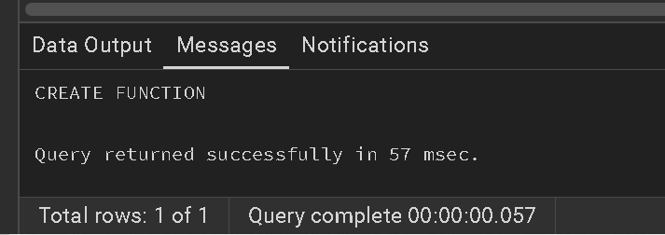

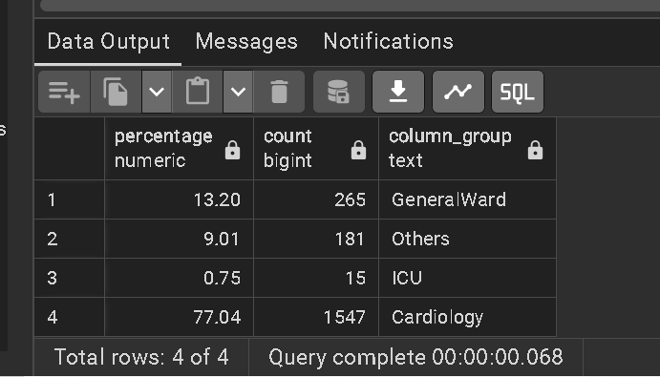

1. Write a query that shows if CCI score is an even or odd number for any 10 patients.

select

inpatient_number,

cci_score,

case

when(cci_score::integer % 2)=0 then 'Even Number'

else 'Odd Number' end

as cci_score_status

from patienthistory

limit 10;

Output:

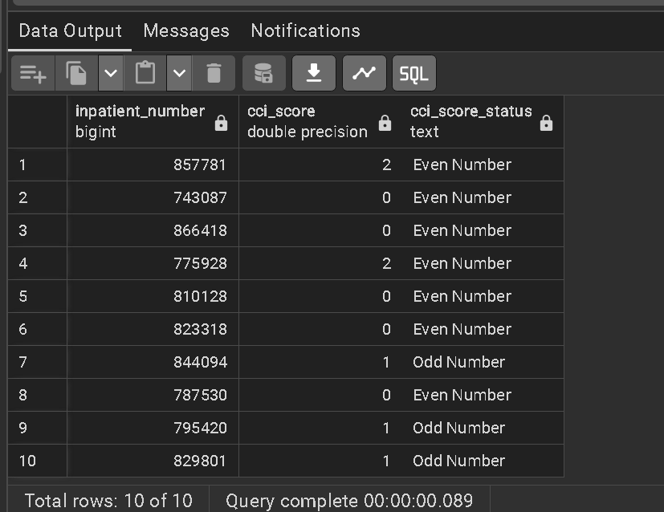

1. Using windows functions show the number of hospitalizations in the previous month and the next month.

with monthly_counts as (

select

count(inpatient_number) as number_patients,

extract(month from admission_date) as months

from hospitalization_discharge

group by extract(month from admission_date)

)

select

months,

number_patients,

lag(number_patients,1,0)over(order by months) as previous_month,

lead(number_patients,1,0)over(order by months) as next_month

from monthly_counts

order by months

Output:

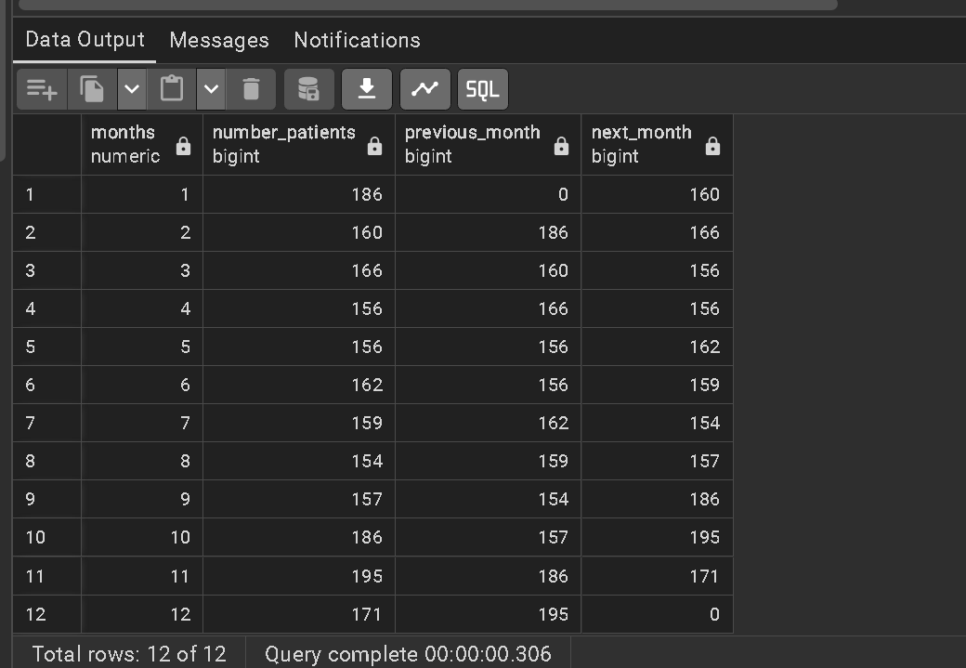

1. Write a function to get comma-separated values of patient details based on patient number entered by the user. (Use a maximum of 6 columns from different tables).

**creating a function**

create or replace function comma_separated_patient_details()

returns table (

patient_details text

)

as $$

begin

return query

Select

concat_ws(',',dm.inpatient_number,dm.gender,cc.type_of_heart_failure,hd.outcome_during_hospitalization,round(lb.map_value::numeric,2),pp.drug_name,ph.cci_score)

from demography dm

join cardiaccomplications cc

on cc.inpatient_number=dm.inpatient_number

join hospitalization_discharge hd

on hd.inpatient_number=cc.inpatient_number

join labs lb

on lb.inpatient_number=hd.inpatient_number

join patient_precriptions pp

on pp.inpatient_number=lb.inpatient_number

join patienthistory ph

on ph.inpatient_number=pp.inpatient_number;

end;

$$language plpgsql

--calling function

select * from comma_separated_patient_details()

Output:

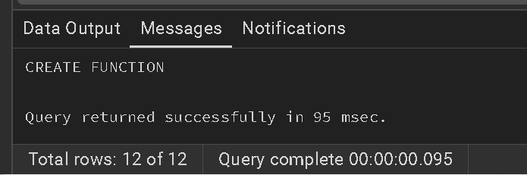

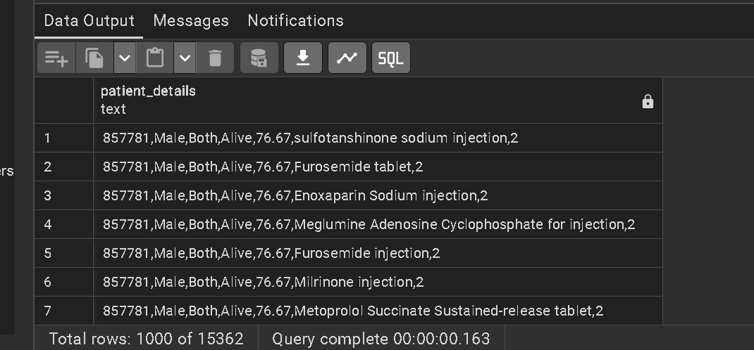

1. Which patients were on more than 15 prescribed drugs? What was their age and outcome? show the results without using a subquery

select

pp.inpatient_number,

age,

outcome_during_hospitalization,

count(drug_name)

from patient_precriptions pp

join demography dm on

dm.inpatient_number=pp.inpatient_number

join hospitalization_discharge hd on

hd.inpatient_number=dm.inpatient_number

group by pp.inpatient_number,age,outcome_during_hospitalization

having count(drug_name)>15

Output:

1. Write a PLSQL block to return the patient ID and gender from demography for a patient if the ID exists and raise an exception if the patient id is not found. Do this without writing or storing a function.

**Patient ID can be hard-coded for the block.**

--Declaration section

do $$

declare

gender_p text;

P_ID bigint := 827040;

--execution section

begin

if not exists(select inpatient_number from demography where inpatient_number=P_ID) then

raise notice 'The patient id is not found is %',P_ID;

else

select

gender into gender_p

from demography

where inpatient_number=P_ID;

raise notice 'The gender is %',gender_p;

end if;

end $$;

Output:

**For the existing patient ID:**

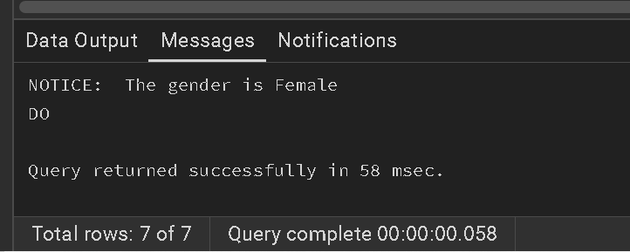

**For the non existing patient id:**

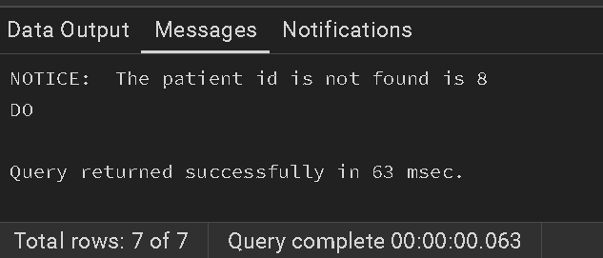

1. Display any 10 random patients along with their type of heart failure select inpatient_number,type_of_heart_failure from cardiaccomplications

order by random()

limit 10;

Output:

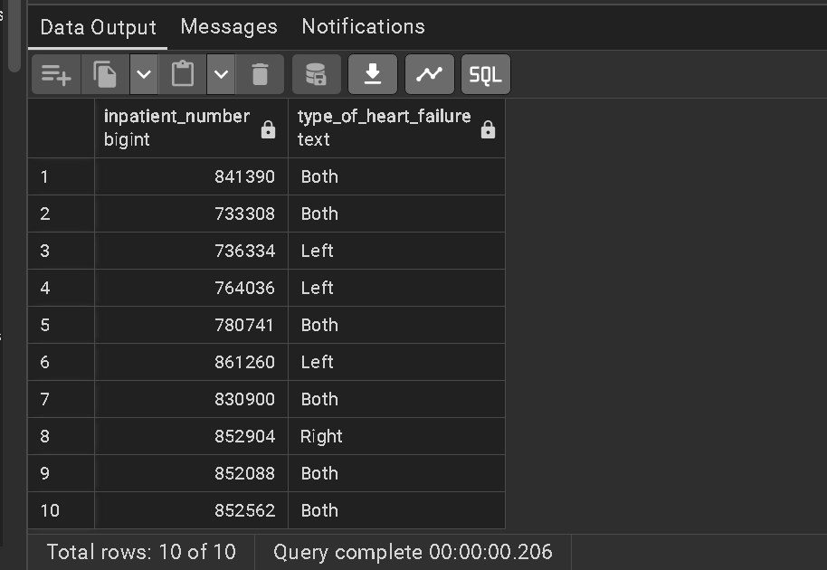

1. How many unique drug names have a length >20 letters?

SELECT COUNT(DISTINCT drug_name) AS unique_drug_count

FROM patient_precriptions

WHERE LENGTH(drug_name) > 20;

Output:

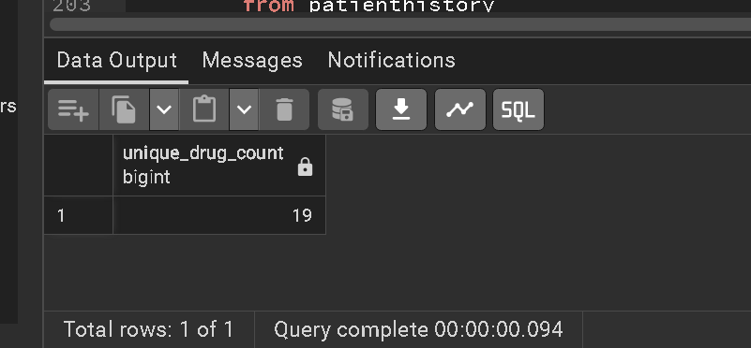

1. Rank patients using CCI Score as your base. Use a windows function to rank them in descending order. With the highest no. of comorbidities ranked 1.

select

inpatient_number,

cci_score,

rank()over(order by coalesce (cci_score,-1) desc)

from patienthistory

Output:

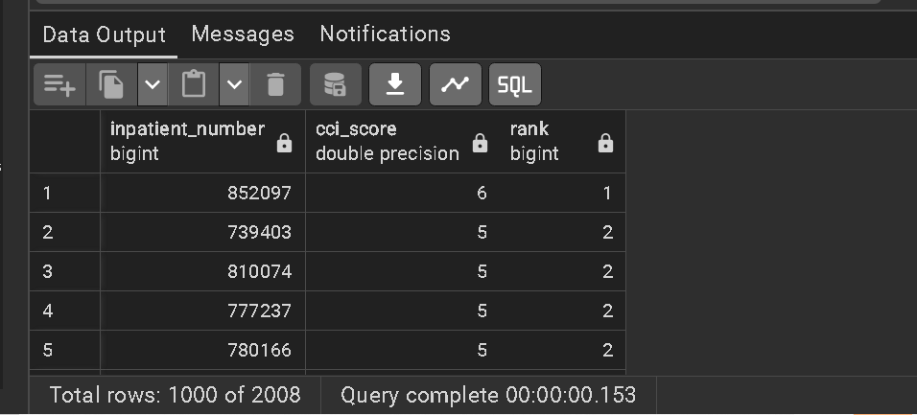

1. What ratio of patients who are responsive to sound vs pain?

select

round((select count(inpatient_number)

from responsivenes

where consciousness='ResponsiveToSound'

group by consciousness)*1.0/(

select count(inpatient_number)

from responsivenes

where consciousness='ResponsiveToPain'

group by consciousness),2) as ratio_of_patients

Output:

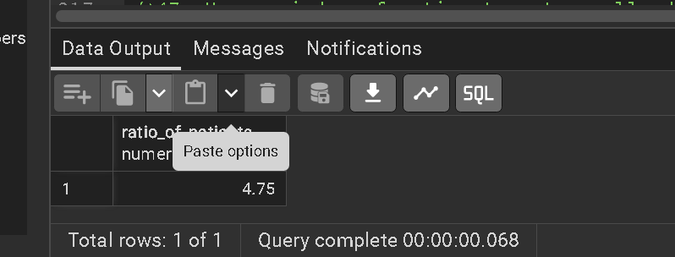

1. Use a windows function to return all admission ways along with occupation which is related to the highest MAP value.

with admission_rank as

(select

hd.admission_way,

d.occupation,

l.map_value,

rank()over(partition by hd.admission_way order by l.map_value desc) as rank_map from hospitalization_discharge hd

join demography d on hd.inpatient_number = d.inpatient_number

join labs l on hd.inpatient_number= l.inpatient_number

order by 1,2,3 )

select distinct admission_way,occupation, map_value

from admission_rank

where rank_map =1

Output:

1. Display the patients with the highest BMI.

select inpatient_number,

bmi

from demography

where bmi=(select max(bmi) from demography)

Output:

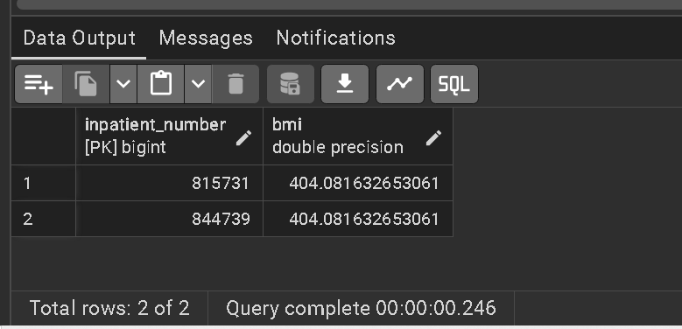

1. Find the list of Patients who has leukopenia.

Select inpatient_number, white_blood_cell

From labs where white_blood_cell <= 3.0e9;

Output:

1. What is the most frequent weekday of admission?

SELECT to_char(admission_date, 'Day') AS Day_of_week,

Count (*)

FROM hospitalization_discharge

group by Day_of_week;

Output:

1. Create a console bar chart using the '▰' symbol for count of patients in any age category where theres more than 100 patients"

SELECT agecat,

COUNT(inpatient_number) as patient_count,

RPAD('' ,(COUNT(inpatient_number)/50)::int,'▰'::varchar) AS bar_chart

FROM demography

GROUP by agecat

HAVING COUNT(inpatient_number)>100

ORDER BY patient_count ASC;

Output:

1. Find the variance of the patients' D_dimer value and display it along with the correlation to CCI score and display them together.

WITH cte_varaince AS

(

SELECT labs.inpatient_number,

VARIANCE(labs.d_dimer) over() AS var_dimer

FROM labs

)

SELECT var_dimer,

corr(var_dimer,ph.cci_score)

FROM cte_varaince AS var

JOIN patienthistory as ph

ON var.inpatient_number = ph.inpatient_number

GROUP BY var_dimer;

Output:

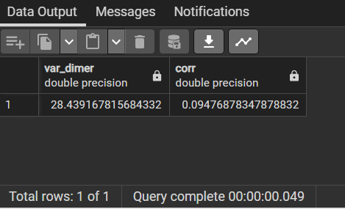

1. Which adm ward had the lowest rate of Outcome Death?

select admission_ward, COUNT(outcome_during_hospitalization) AS death_count

from hospitalization_discharge

where outcome_during_hospitalization = 'Dead'

group by admission_ward,outcome_during_hospitalization

ORDER BY death_count Asc;

Output:

1. What % of those in a coma also have diabetes. Use the GCS scale to evaluate.

WITH coma_patients AS (

SELECT r.inpatient_number

FROM responsivenes r

WHERE r.gcs <= 8

),

coma_with_diabetes AS (

SELECT

cp.inpatient_number

FROM

coma_patients cp JOIN patienthistory ph

ON cp.inpatient_number = ph.inpatient_number

where ph.diabetes = 1)

SELECT

case

when COUNT(coma_patients.inpatient_number) = 0 THEN 0

else (COUNT(coma_with_diabetes.inpatient_number) * 100) / COUNT(coma_patients.inpatient_number)

end AS coma_patients_with_diabetes_percentage

FROM coma_patients

LEFT JOIN coma_with_diabetes

ON coma_patients.inpatient_number = coma_with_diabetes.inpatient_number;

Output:

1. Display the drugs prescribed by the youngest patient

select * from patient_precriptions

where Inpatient_number =

(select Inpatient_number from demography

order by agecat asc

limit 1);

Output:

1. Create a view on the public.responsivenes table using the check constraint

create or replace view public.responsivenes_view as

select inpatient_number,

eye_opening,

verbal_response,

movement,

consciousness,

gcs

from responsivenes

where

gcs between 3 and 15

and eye_opening in (0,1,2,3,4)

and verbal_response in (0,1,2,3,4,5)

and movement in (0,1,2,3,4,5,6)

with check option;

Output:

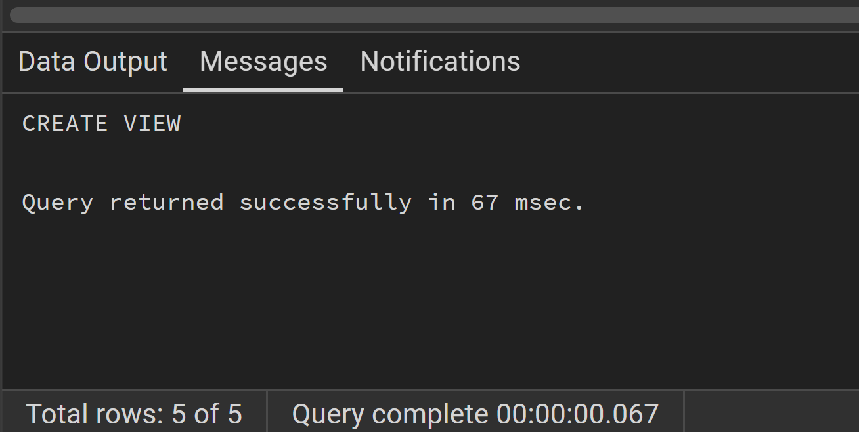

**selecting all the records in the view**

select * from responsivenes_view;

Output:

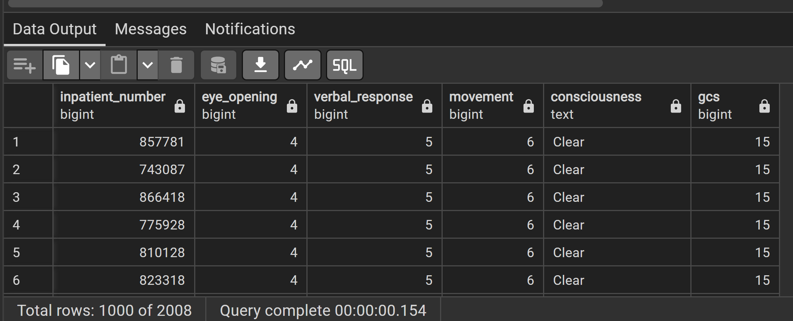

1. Determine if a word is a palindrome and display true or false. Create a temporary table and store any words of your choice for this question

create Temporary table temporary_words (

word varchar(100)

);

insert into temporary_words (word) values

('favor'),

('level'),

('flex'),

('rotor'),

('public'),

('madam'),

('fixed'),

('better'),

('radar'),

('expect');

Select * from temporary_words;

select temporary_words ,

case

when word = reverse(word) then 'true'

else 'false'

end as palindrome

from temporary_words;

Output:

1. How many visits were common among those with a readmission in 6 months

select visit_times, count(inpatient_number) as patient_count from hospitalization_discharge where re_admission_within_6_months = 1 group by visit_times order by visit_times LIMIT 1

Output:

1 visit was common among those with a readmission in 6 months

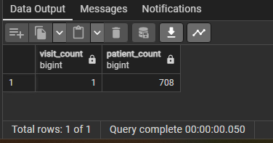

1. What is the size of the database Cardiac_Failure

Select pg_Size_pretty(pg_database_size('Cardiac_Failure')) as Cardiac_Failure_Database_Size;

Output:

1. Find the greatest common denominator and the lowest common multiple of the numbers 365 and 300. show it in one query

SELECT GCD(365,300) AS Graetest_common_denominator,

LCM(365,300) AS Least_common_multiple;

Output:

1. Group patients by destination of discharge and show what % of all patients in each group was re-admitted within 28 days.Partition these groups as 2: high rate of readmission, low rate of re-admission. Use windows functions.

with readmission_count as

(select destinationdischarge, count(inpatient_number) as count_patients,

sum(case when re_admission_within_28_days = 1 then 1 else 0 end) as readmitted_patients

from hospitalization_discharge

group by destinationdischarge),

readmission_percentage AS

(select destinationdischarge,

count_patients,

readmitted_patients,

(readmitted_patients*100.0/count_patients) as readmission_percentage

from readmission_count

)

select destinationdischarge,

readmission_percentage,

case when readmission_percentage > (select percentile_cont(0.5) within group(order by readmission_percentage) from readmission_percentage)

then 'High'

ELSE 'Low'

END AS readmission_rate_category

from readmission_percentage

group by destinationdischarge,readmission_percentage,readmission_rate_category

order by readmission_rate_category

Output:

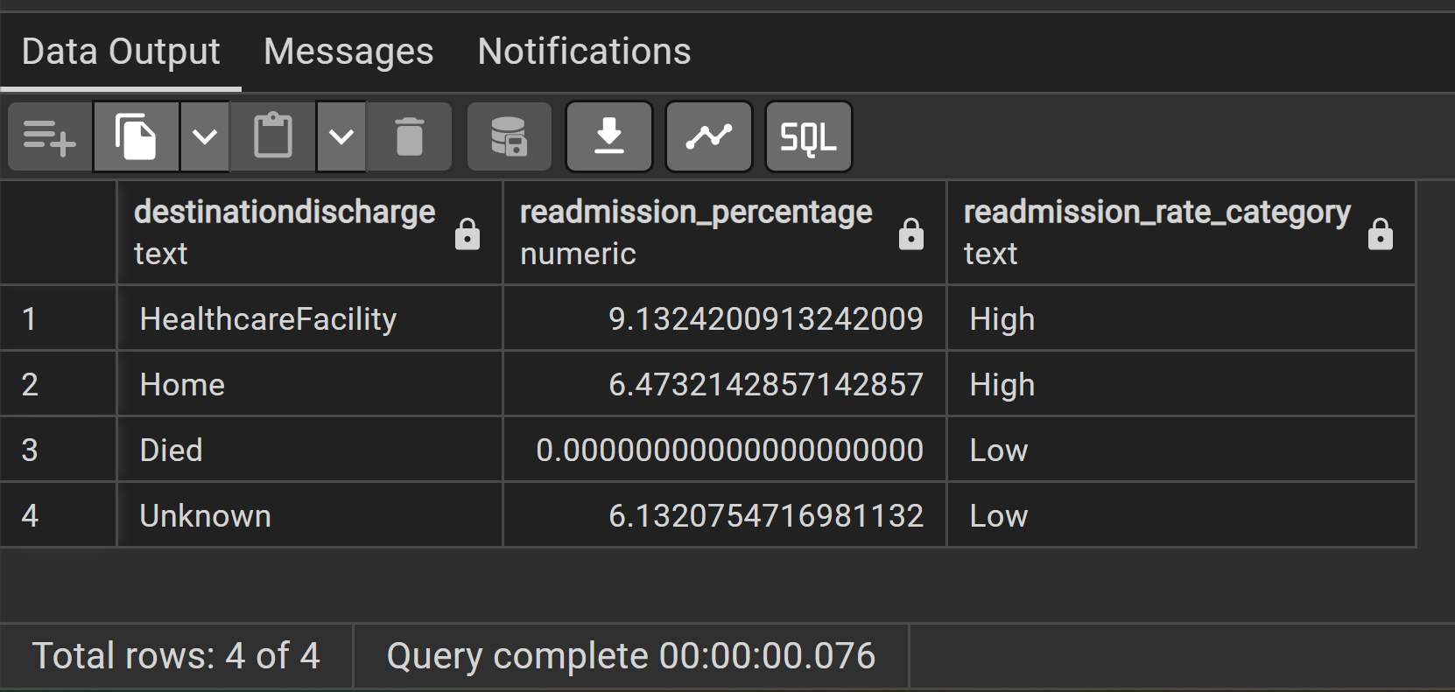

1. What is the size of the table labs in KB without the indexes or additional objects

Select pg_Size_pretty(pg_relation_size('labs'));

Output:

1. concatenate age, gender and patient ID with a ';' in between without using the || operator

Select Concat(agecat,' ; ',gender, ' ; ', inpatient_number) as patient_details from demography;

Output:

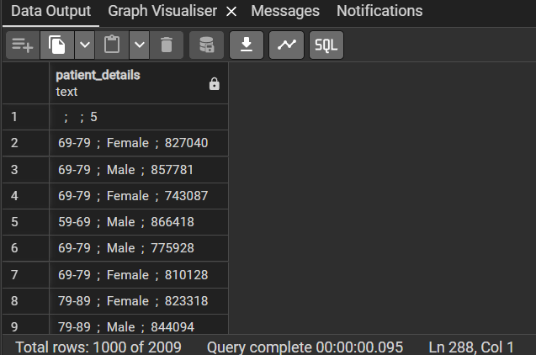

1. Display a reverse of any 5 drug names

Select drug_name,

Reverse(drug_name)

from patient_precriptions

order by drug_name asc

limit 5;

Output:

1. What is the variance from mean for all patients GCS score

SELECT inpatient_number,

gcs,

round(avg(gcs) over (),2) AS mean_gcs,

variance(gcs) over () AS variance_gcs,

round(( gcs - avg(gcs) over () )/ ( variance(gcs) over ()),5 )as gcs_variance_from_mean

from responsivenes

GROUP BY inpatient_number,gcs;

Output:

1. Using a while loop and a raise notice command, print the 7 times table as the result

do $$

declare

counter integer := 0;

begin

while counter < 20 loop

raise notice '7 * % = %',counter,counter * 7;

counter := counter + 1;

end loop;

end;

$$;

Output:

1. Show month number and month name next to each other(admission_date), ensure that month number is always 2 digits. eg, 5 should be 05".

SELECT inpatient_number,

admission_date,

(CONCAT(TO_CHAR(DATE_PART('month',admission_date), 'fm00'),

',' ,

TO_CHAR(admission_date,'Mon') )) AS Month

FROM hospitalization_discharge;

Output:

1. How many patients with both heart failures had kidney disease or cancer.

SELECT SUM(ph.moderate_to_severe_chronic_kidney_disease) AS Kidney_disease,

SUM(ph.leukemia + ph.malignant_lymphoma) AS cancer,

count(ph.inpatient_number) AS Total_patients_with_kidneyorcancer

FROM cardiaccomplications AS comp

JOIN patienthistory AS ph

ON comp.inpatient_number = ph.inpatient_number

WHERE type_of_heart_failure = 'Both'

AND( ph.moderate_to_severe_chronic_kidney_disease =1

OR ph.leukemia = 1 OR ph.malignant_lymphoma = 1);

**Did not consider solid_tumor as cancer because, not all solid_tumor is cancer.**

1. Return the number of bits and the number of characters for every value in the column: Occupation

SELECT DISTINCT occupation,

bit_length(occupation) as number_of_bits,

length(occupation) as number_of_characters

FROM demography

WHERE occupation is not null

GROUP BY occupation;

Output:

1. Create a stored procedure that adds a column to table cardiaccomplications. The column should just be the todays date.

-- Create a Procedure

CREATE OR REPLACE PROCEDURE pr_date_today ()

language plpgsql

as

$$

begin

-- create and update the date_today column to cardiaccomplications table

ALTER TABLE cardiaccomplications

ADD COLUMN date_today date default current_date;

commit;

end;

$$;

Output:

-- Call the procedure

call pr_date_today();

Output:

SELECT inpatient_number,date_today FROM cardiaccomplications;

Output:

1. What is the 2nd highest BMI of the patients with 5 highest myoglobin values. Use windows functions in solution.

WITH temp_myoglobin AS

(

SELECT labs.inpatient_number,

labs.myoglobin,

demo.bmi,

rank() over (ORDER BY labs.myoglobin DESC) AS myoglobin_rank

FROM labs

JOIN demography as demo

ON labs.inpatient_number = demo.inpatient_number

WHERE myoglobin is not null

),temp_bmi AS (

SELECT inpatient_number,

myoglobin,

round(bmi::numeric, 2),

rank () over (order by bmi DESC) AS bmi_rank,

myoglobin_rank from temp_myoglobin

WHERE myoglobin_rank <=5

ORDER BY bmi DESC

)

SELECT * FROM temp_bmi WHERE bmi_rank = 2;

Output:

1. What is the standard deviation from mean for all patients pulse.

SELECT inpatient_number,

pulse,

round(avg(pulse) over (),2) AS mean_pulse,

round(stddev(pulse) over (),2) AS stddev_pulse,

round(( pulse - avg(pulse) over () )/ ( stddev(pulse) over ()),5 )as pulse_stdev_from_mean

from labs

GROUP BY inpatient_number,pulse;

Output:

1. Create a procedure to drop the age column from demography.

CREATE OR REPLACE PROCEDURE pr_age_del ()

language plpgsql

as

$$

begin

-- Query to delete the age column from demography

ALTER TABLE demography DROP COLUMN age;

commit;

end;

$$;

Output:

SELECT * FROM demography;

Output:



-- call the procedure pr_age_del

call pr_age_del();

Output:

SELECT * FROM demography;

Output:

1. What was the average CCI score for those with a BMI>30 vs for those <30.

SELECT --COUNT(demo.bmi),

CASE

WHEN demo.bmi>30 THEN 'BMI>30'

WHEN demo.bmi<30 THEN 'BMI<30'

END AS bmi_range,

AVG(ph.cci_score) AS avg_cci

FROM demography as demo

JOIN patienthistory AS ph

ON demo.inpatient_number = ph.inpatient_number

GROUP BY bmi_range;

Output:

1. Write a trigger after insert on the Patient Demography table. if the BMI >40, warn for high risk of heart risks.

CREATE FUNCTION bmi_trigg_fn() -- Create function

RETURNS TRIGGER AS $$

BEGIN

if NEW.bmi > 40 THEN

RAISE NOTICE 'High risk of heart risks for patient id % with BMI (% )',NEW.inpatient_number,NEW.bmi;

end if;

RETURN NEW;

END;

$$ LANGUAGE plpgsql;

Output:

CREATE TRIGGER bmi_trigg --- Create trigger

AFTER INSERT ON "demography"

FOR EACH ROW

EXECUTE FUNCTION bmi_trigg_fn();

Output:

--Insert records to demography

INSERT INTO demography (inpatient_number,gender,weight,height,bmi,occupation,agecat)

VALUES(987665,'Female',120,1.5,41,'UrbanResident','79-89');

Output:

1. Most obese patients belong to which age group and gender. You may make an assumption for what qualifies as obese based on your research.

SELECT agecat,

gender,

COUNT(inpatient_number) AS number_obese

FROM demography

WHERE bmi>=30 -- considering 30 as obese

AND gender is not null

GROUP BY agecat,gender

ORDER BY number_obese DESC LIMIT 1;

* **This is the output from the original dataset, did not include inserted values from Q75**

Output:

1. Show all response details of a patient in a JSON array.

SELECT array_to_json(array_agg(row_to_json(responsivenes))) AS json_resp

FROM responsivenes;

Output:

1. Update the table public.patienthistory. Set type_ii_respiratory_failure to be upper case, query the results of the updated table without writing a second query.

UPDATE

patienthistory

SET

type_ii_respiratory_failure =UPPER(type_ii_respiratory_failure)

RETURNING type_ii_respiratory_failure;

Output:

1. Find all patients using Digoxin or Furosemide using regex.

SELECT DISTINCT inpatient_number

FROM patient_precriptions

WHERE drug_name ~* '(Digoxin|Furosemide)';

Output:

1. Using a recursive query, show any 10 patients linked to the drug: "Furosemide injection".

WITH RECURSIVE cte_rec_query

AS (

SELECT

inpatient_number,

drug_name

FROM

patient_precriptions

WHERE

drug_name = 'Furosemide injection'

UNION

SELECT

p.inpatient_number,

p.drug_name

FROM patient_precriptions p

INNER JOIN cte_rec_query r1

ON r1.inpatient_number = p.inpatient_number

)

SELECT * FROM cte_rec_query LIMIT 10 ;

Output:

