

**LA GRANDEE INTERNATIONAL COLLEGE**

**Simalchaur, Pokhara Nepal**

A Final Project

On

**“Futsal Event Management System”**

**Submitted to:**

Bachelor of Computer Application (BCA) Program

In partial fulfilment of the requirements for the degree of BCA under

Pokhara University

**Submitted by:**

|  |  |  |  |
| --- | --- | --- | --- |
| **Name:** | **Course** | **Semester** | **P.U. Registration Number** |
| Bishal Adhikari | BCA | 4th | 2021-1-53-0348 |
| Deepak Chhantyal | BCA | 4th | 2021-1-53-0349 |
| Roshan Adhikari | BCA | 4th | 2021-1-53-0363 |
|  |  |  |  |

**Date: February 2024**

# Acknowledgement

We would like to express our gratitude to our project supervisor Mr. Rishi Khanal and BCA coordinator Mr. Ramesh Chalise for guiding us throughout the project. And we are thankful toward each other we worked as a team supportively.

Sincerely,

Bishal Adhikari (PU Exam Roll no): 21535149

Deepak Chhantyal (PU Exam Roll no): 21535150

Roshan Adhikari (PU Exam Roll no): 21535164

**Declaration for**

**“Futsal Event Management System”**

# Student’s Declaration

We hereby declare that we are the only authors of this work and that no source other than the listed here have been used in this work.

Bishal Adhikari (PU Exam Roll no): 21535149

Deepak Chhantyal (PU Exam Roll no): 21535150

Roshan Adhikari (PU Exam Roll no): 21535164

Program: BCA, 4nd Semester

Date: February 2024

# Letter of Approval

We certify that we have examined this report entitled “Futsal Event Management System” and are satisfied with the project defense. It is satisfactory in the scope and quality as project in partial fulfilment of the requirement for the degree of **BCA** under **Pokhara University.**

|  |  |  |
| --- | --- | --- |
| ___________________  **Supervisor**  Er. Rishi Saran Khanal  Ast. Professor  LA GRANDEE International College | __________________  **External Examiner**  Er. Santosh Panth  Ast.Professor  Gandaki College of Engineering and Science  Date: February 2024 | ____________________  **Program Coordinator**  Mr. Ramesh Chalise  Ast. Professor  LA GRANDEE International College |
|  |  |  |

# Abstract

The Futsal Event Management System is a software designed to organize futsal events effectively. This system simplifies the entire process of registering and managing futsal tournaments or matches. It provides a user-friendly interface for event organizers, making it easy to schedule games and manage participant registrations. The system also facilitates communication between organizers and players.

User can register the event with the team and player and manage it, reducing paperwork and manual efforts. The system includes features for managing match schedules, team details. Moreover, it offers a secure and centralized database for storing participant information and other relevant data.

One of the key advantages of this system is its ability to generate reports in a data grid view, evaluating the success of the event. With the Futsal Event Management System, the entire event management process becomes more efficient, allowing organizers to focus on creating a seamless and enjoyable experience for both participants and spectators.

**Table of Contents**

Acknowledgement ii

Student’s Declaration iii

Letter of Approval iv

Abstract v

1. Introduction 1

2. Problem Statement 2

3. Objectives 3

4. Background Study 4

5. Requirement Document 5

5.1 Requirement Matrix: 5

5.2 Types of Requirement 6

User Requirement 6

Functional requirements 6

Nonfunctional requirements 6

6. System Design 7

6.1 Data Flow Diagram 7

6.1.1 Level-1 DFD 7

6.1.2 Level – 2 Registration DFD 9

6.1.3 Level - 2 Login DFD 9

6.1.4: Level - 2 Team Registration DFD 10

6.1.5 Level – 2 Event Registration DFD 10

6.1.6 Level-2 Update Event and Team DFD 11

6.2 ER-Diagram 12

6.3 Database Diagram 13

7. Development 14

7.1 Development Methodology 14

7.2 Work Assign 15

7.3 Project Gantt chart 16

8. Testing 17

8.1 Test Cases 17

8 Project Result 23

9 Future Enhancements 24

10 Conclusion 25

11 References 26

12 Annexes 27

**List of Figures**

Figure 5.1: Requirement Matrix 5

Figure 6.1.1: Level-1 DFD 8

Figure 6.1.2: Level -2 Registration DFD 9

Figure 6.1.3: Level -2 Login DFD 9

Figure 6.1.4: Level -2 Team Registration DFD 10

Figure 6.1.5 Level – 2 Event Registration DFD 10

Figure 6.1.6: Level-2 Update DFD 11

Figure 6.2: ER-Diagram 12

Figure 6.2: Database Diagram 13

Figure 7.1: Waterfall Model 14

Figure 7.2: Work Assign 15

Figure 7.3: Gantt Chart 16

Figure: 8. 1: Software Testing Life Cycle 17

Table 8.1.1 Testing of Login 18

Table 8.1.2: Testing of Login Registration 19

Table 8.1.3: Testing of Registration 20

Table 8.1.4: Testing of View 21

Table 8.1.5: Testing of Update 22

**Abbreviations**

|  |  |
| --- | --- |
| FEMS: | Futsal Event Management System |
| MSSQL: | Microsoft SQL |
| VB.NET: | Visual Basic .NET |

# Introduction

A Futsal Event Management System (FEMS) is a software application provides good service for the futsal business. Organizing and managing futsal events can be a difficult task, various challenges occur effect on the smooth execution of futsal competitions. One of the primary issues face by the event organizer is the manual and timer-consuming of the planning process. A FEMS provide a system that facilitates seamless and real-time updates for all people involved in the futsal event.

One common problem in futsal events is the manual and time-consuming process of handling registrations and generating match schedules. This often leads to errors, confusion, and delays, impacting the overall efficiency of the event. Implementing a Futsal Event Management System developed in VB.NET for desktop can address this challenge by using the different menus considering different functionalities. The system can provide a user-friendly interface for participants to easily register, reducing paperwork and minimizing the chances of errors. Through the use of VB.NET, the desktop application can efficiently process and store registration data, allowing organizers to quickly organize teams.

Futsal, a sport steadily gaining popularity, deserves an event management system that not only simplifies logistics but enhances the overall engagement. Our system is designed as a trusted companion, promising a seamless and enjoyable futsal experience from event registration to the final whistle.

# Problem Statement

Futsal, a thrilling and growing indoor sport, is currently faced with several challenges on organizing that hinder its seamless organization and participation. These challenges include:

1. **Complex Event Registration:** The existing futsal event registration processes are often cumbersome and time-consuming. Participants encounter difficulties when signing up for events, impacting the overall user experience.
2. **Scheduling and time management:** Conflict in scheduling and time availability can negatively impact the overall event experience.
3. **Manual processes:** Many futsal event organizers still rely on manual processes for registrations, scheduling, and communication with participants. This leads to errors, delays and a lack of real-time information.
4. **Payment and Registration issues:** Handling participant registration, cash collections and financial manually can result in errors, delays and security concerns.

Addressing these challenges is vital to provide futsal enthusiasts with a more accessible, convenient, and enjoyable experience. The “Futsal Event Management System” aims to resolve these issues and offer a streamlined and user-friendly platform for futsal event organizer.

# Objectives

The main objective of the Futsal Event Management System (FEMS) is to give the customer easier way to make a court booking and also make futsal owner easy to manage their daily business transaction.

* To manage resource efficiently
* To enhance data storing system
* To simplify event management process

# Background Study

At the beginning, when the group formation is done. We all started to find a topic that will have some scope and is feasible to work. Our main aim was to develop a system that could solve the problems, that people are facing day-to-day basis. We research that some small business doesn’t have a digitalized system of Managing the futsal Events, then we decided to work on the project “Futsal Event management system”. Traditional methods rely on paper-based registrations, manual scheduling, causes on leading to potential errors, delays, and a lack of overall efficiency. Recognizing these limitations, the development of a digital solution aims to address these issues and encounter the overall management of futsal events.

By understanding traditional event management practices and leveraging the potential of digital solutions, the Futsal Event Management System aims to provide a user-friendly, efficient, and centralized platform for organizing futsal events, ultimately enhancing the overall experience for both organizers and participants.

# Requirement Document

While developing a project, requirements are necessary. Without requirements, a project cannot be developed. It outlines the essential features and functionalities necessary for efficiently organizing and coordinating futsal events.

## **5.1 Requirement Matrix:**

|  |  |  |  |  |
| --- | --- | --- | --- | --- |
| SN. | Required modules, system and features. | Description for the modules | Priority (High, Moderate, low) | Remarks |
| 1. | Login and security system | Easy and secure login/logout functionality | High |  |
| 2. | Registration and user profiles | Player registration, team related information | High |  |
| 3. | Scheduling | Schedule management for futsal events, including match fixtures | High |  |
| 4. | Payments | Played match payment Integration | High |  |
| 5 | Event Creation and management | Creating events where match has to play and manage it | High |  |
| 6 | Deletion module | User can delete events, profile, and team details | High |  |

Figure 5.1: Requirement Matrix

## **5.2 Types of Requirement**

## **User Requirement**

* **User Registration and Login:** User can register, and have secure and straightforward login process.
* **Dashboard:** User can view of match fixture, team information, etc.
* **Team and event registration:** User can add or register the details easily.
* **Event management:**  User should be able schedule the time according the events
* **Report:** User can add manually points, then presented in statistics form.

## **Functional requirements**

* **User Authentication:** User registration with unique usernames and passwords, login functionality to access the system.
* **Event Scheduling:** Scheduling of futsal events, including date, time.
* **Result and Statistics:** User manual add and display the match details statistics.
* **Team and Event management:** Feature of creating, view, updating and deleting the team and event details.

## **Nonfunctional requirements**

* **Security**: The system will be secured, and management of configuration and errors.
* **Reliability**: The system operates free of failure and reliable with the hardware.
* **Data Integrity**: The system will have the efficient data collection, store access and usage.
* **Performance**: Provide a minimum response time, while with the user interactions.

# System Design

System Design is the process of designing the elements of a system such as modules, interfaces and the data that goes through that system.

We represent the design of our system by using DFD diagram.

## **Data Flow Diagram**

Data Flow Diagram (DFD) is a graphical representation of the flow of data and the too used to visualize how data is flow, process and stored within a system. The DFD of our system is given below:

### **6.1.1 Level-1 DFD**

**Indexes:**

* **External Entity**
* User
* Customer
* **Processes**
* Registration
* Login
* Add Event
* Add details
* Edit details
* View details
* Update details
* Billing Info

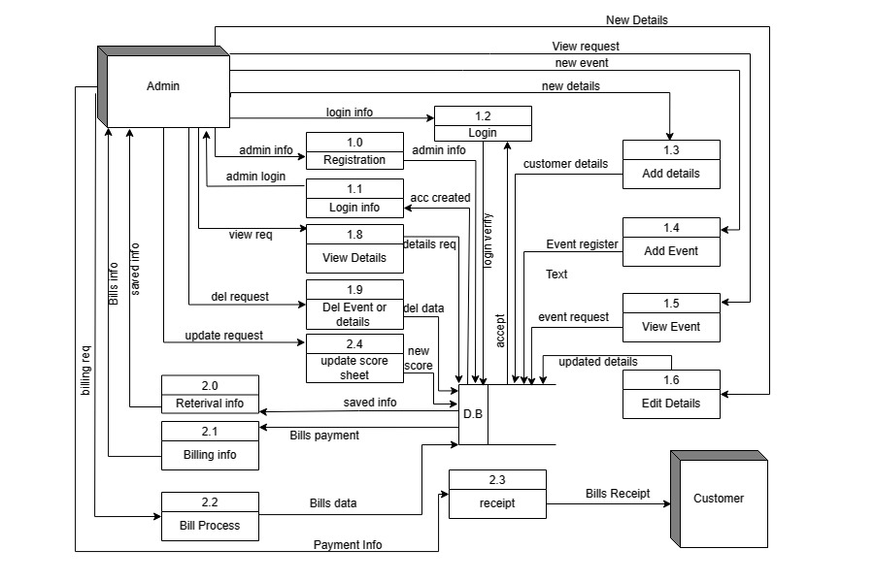

**Figure 6.1.1: Level-1 DFD**

### **6.1.2 Level – 2 Registration DFD**

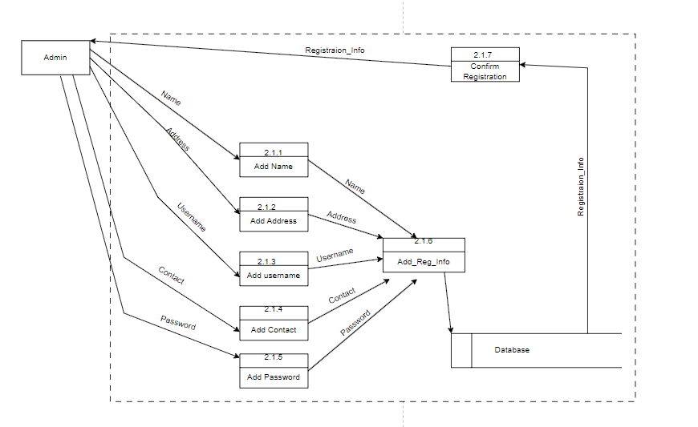

Figure 6.1.2: Level -2 Registration DFD

### **6.1.3 Level - 2 Login DFD**

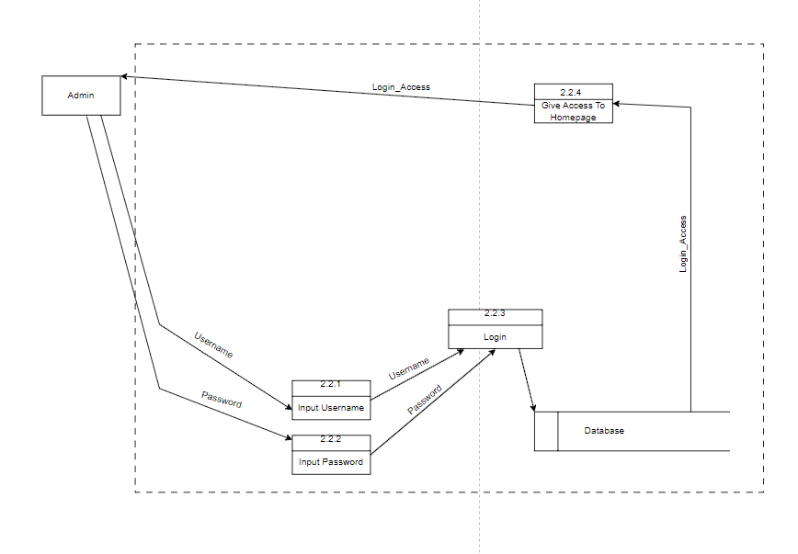

Figure 6.1.3: Level -2 Login DFD

### **6.1.4: Level - 2 Team Registration DFD**

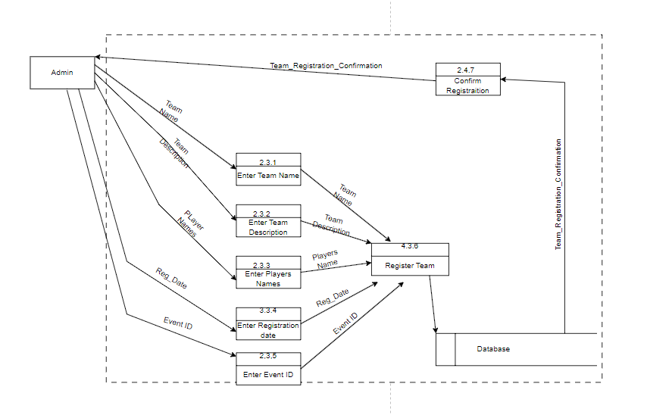

Figure 6.1.4: Level -2 Team Registration DFD

### **6.1.5 Level – 2 Event Registration DFD**

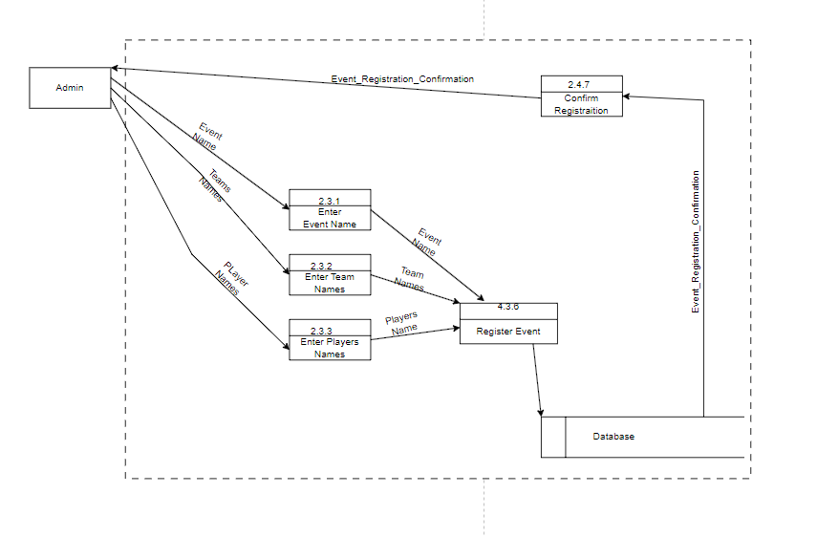

Figure 6.1.5 Level – 2 Event Registration DFD

## **6.1.6 Level-2 Update Event and Team DFD**

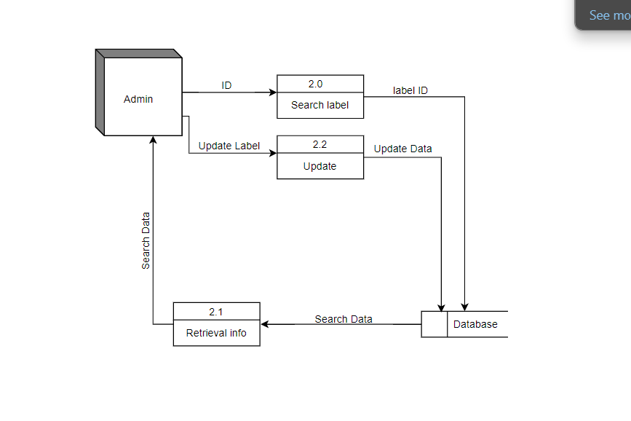

Figure 6.1.6: Level-2 Update DFD

## **ER-Diagram**

Entity-Relationship (ER) diagram for a Futsal Event Management System involves identifying the main entities, their attributes, and the relationships between them. Here's a simplified ER diagram for a Futsal Event Management System:

**Entities:**

* **Customer**
* **Event**
* **Futsal Center**
* **Billing System**

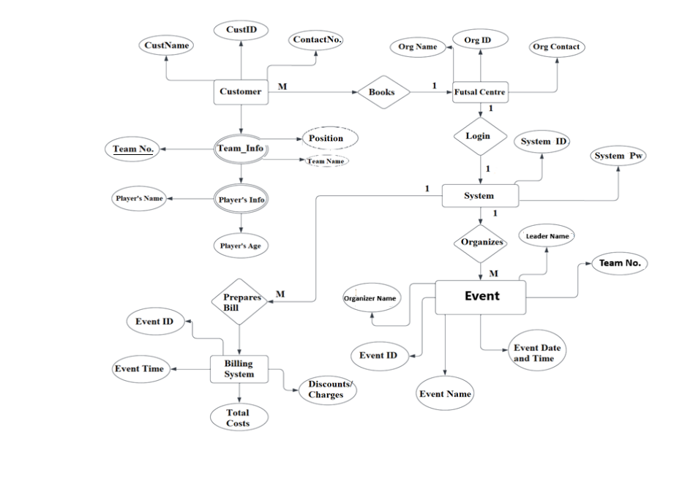

Figure 6.2: ER-Diagram

## **Database Diagram**

The database is designed on the basis of the following diagram. Different tables are created as follows:

Admin table- It consists of admin details who has registered into the system.

Event table-It consists of event details stored after the registration of events.

Teams table- It consists of Team details that are registered in their specific events. They should be compulsorily linked with events.

Players table- It consist of players details that are linked with teams from specific events.

Billing table- Billing consist of billing details of billings.

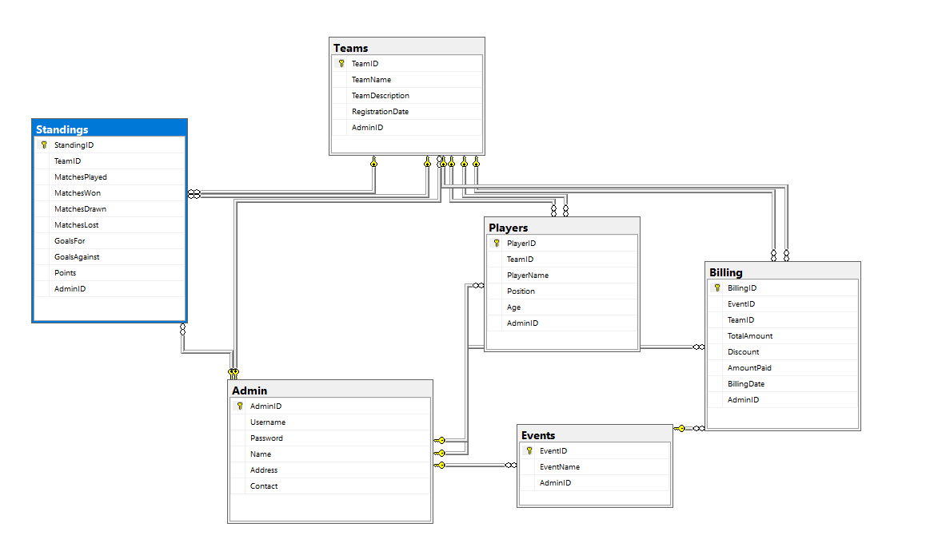

Figure 6.2: Database Diagram

# Development

Project development is the process and the facility of planning, organizing, allocating resources to fully develop a project. Development is basically a roadmap to provide a guidance to develop and build a project. On the documentation of a project, we have use MS-Word., which allows us document the report. We use a web application “Lucid Chart “for the DFD and Flowchart of the system. For the Gantt chart of the project progress, MS-Excel is used.

## **7.1 Development Methodology**

We have use “Waterfall Model” for the development of our project.

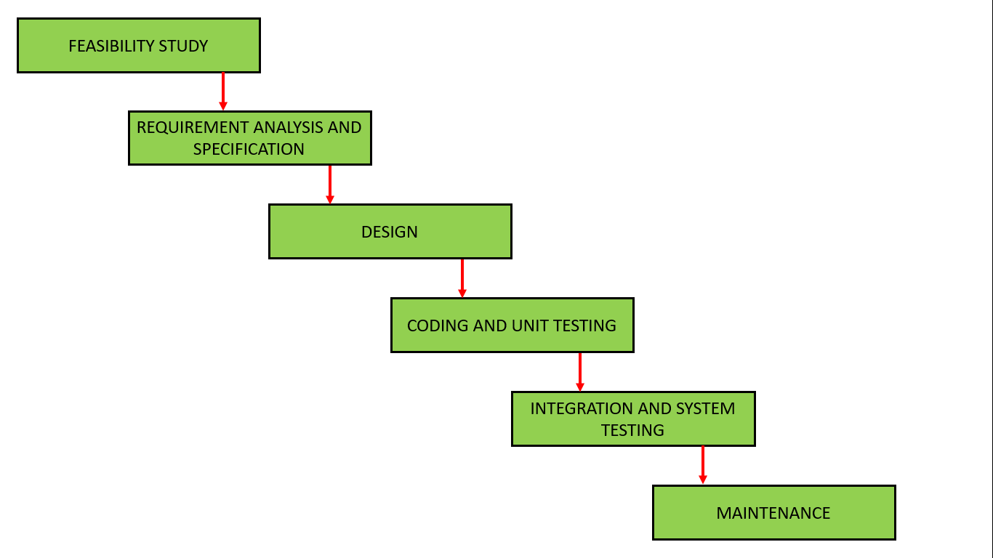

Figure 7.1: Waterfall Model

## **7.2 Work Assign**

The following table shows the activities done by the team members:

|  |  |  |  |
| --- | --- | --- | --- |
| S.N. | Name of the member | Work assigned | Remarks |
| 1. | Bishal Adhikari | * Document * Problem Identification * System Design * System coding |  |
| 2. | Deepak Chhantyal | * Documentation * Planning * System Coding * System Design * Testing |  |
| 3. | Roshan Adhikari | * Testing * Coding * Requirement Document * Documentation |  |

Figure 7.2: Work Assign

## **Project Gantt chart**

In the context of developing a Futsal Event Management System, a Gantt chart for the project might include various tasks and milestones related to the system's development.

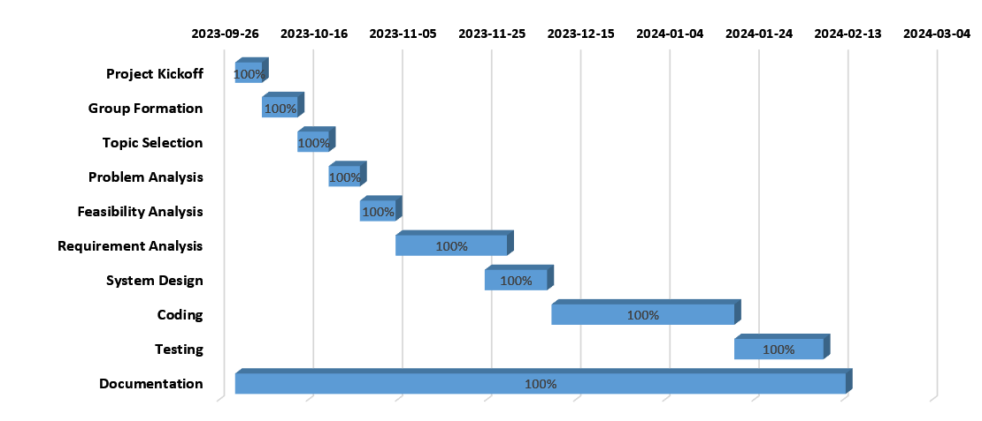

Figure 7.3: Gantt Chart

# Testing

Testing is the process of validating the correctness of a program. There are different types of software testing methods that is followed by the testers. Among them is STLC. STLC is a sequence of different activities performed by the testing team to ensure the quality of the software or the product.

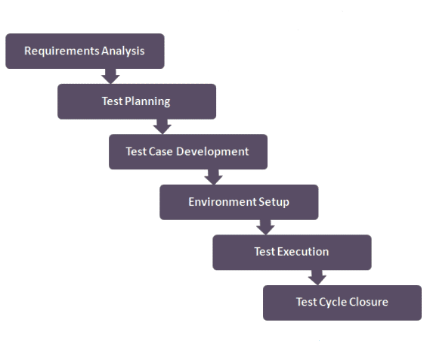

Figure: 8. 1: Software Testing Life Cycle

* 1. Test Cases

Title: Module testing of a login function- Authentication for Admin

TID: 001, 002, 003, 004

Description: A user should be able to log in using the proper username and password.

Precondition: The user must have previously registered username and password.

Test steps: Open the source file in Visual Studio software and compile it and run the program, then move to login screen and enter the username and password.

|  |  |  |  |  |  |
| --- | --- | --- | --- | --- | --- |
| Test Case # | Test ID | Test Case | Test Steps | Test Data | Expected result |
| 1 | 001 | Verify Login for Admin | 1. Goto Login page of Admin  2. Enter Username  3. Enter Password | Valid username and password | Login Successful |
| 2 | 002 | Verify Login for Admin | 1. Goto Login page of Admin  2. Enter Username  3. Enter Password | Invalid username, valid password | Error message: Invalid username |
| 3 | 003 | Verify Login for Admin | 1. Goto Login page of Admin  2. Enter Username  3. Enter Password | Valid username, invalid password | Error message: Invalid password |
| 4 | 004 | Verify Login for Admin | 1. Goto Login page of Admin  2. Enter Username  3. Enter Password | Empty username and password fields | Error message: Both fields are required |

Table 8.1.1 Testing of Login

Title: Module testing of Login Registration

TID: 005, 006, 007, 008, 009

Description: The user must be able to register new account entering their details.

Test steps: Go to the registration form and attempt registration.

|  |  |  |  |  |  |
| --- | --- | --- | --- | --- | --- |
| Test Case # | Test ID | Test Case | Test Steps | Test Data | Expected result |
| 5 | 005 | Valid Registration | 1. Go to Registration Page  2. Input Details | Properly filled registration form with unique username and strong password | Successful registration, redirection to login screen |
| 6 | 006 | Existing Username | 1. Go to Registration Page  2. Input Details | Registration with a username that already exists | Error message: Username already taken |
| 7 | 007 | Mismatched Passwords | 1. Go to Registration Page  2. Input Details | Registration with mismatched passwords | Error message: Passwords do not match |
| 8 | 008 | Empty Fields | 1. Go to Registration Page  2. Input Details | Attempt registration with empty fields | Error message: All fields are required |

Table 8.1.2: Testing of Login Registration

Title: Module testing of Registration

TID: 010, 011, 012

Description: The user must be able to register Event and Team Registration.

Test steps: Go to Application dashboard after login.

|  |  |  |  |  |  |
| --- | --- | --- | --- | --- | --- |
| Test Case # | Test ID | Test Case | Test Steps | Test Data | Expected result |
| 10 | 010 | Valid Registration | 1. Go to Registration menu | Properly filled registration form according the label | Successful registration, redirection |
| 11 | 011 | Event Registration | 1. Event Registration | Filled form with proper input label | Register Successful |
| 12 | 012 | Team Registration | 1. Team Registration 2. Input details | Registration team details | Error message: Passwords do not match |
| 13 | 013 | Player Registration | 1. Go to Player Registration  2. Input Details | Attempt registration with empty fields | Error message: All fields are required |

Table 8.1.3: Testing of Registration

Title: Module testing of view

TID: 014, 015, 016

Description: The user can view all the details about the event and team.

Test steps: Go to Application dashboard view after login.

|  |  |  |  |  |  |
| --- | --- | --- | --- | --- | --- |
| Test Case # | Test ID | Test Case | Test Steps | Test Data | Expected result |
| 14 | 014 | Check Events | 1. Go to view Module 2. Check Events | View all events or search specified Event using Event ID | Result showed in the Data Grid view |
| 15 | 015 | Check Teams | 1. Go to view Module 2. Check Teams | View all teams details or specified teams details (Event ID) | All details showed in below Data Grid view |
| 16 | 016 | Check Players | 1. View Module 2. Check Players | Search Players using Event ID or Team ID | Details show in Data Grid view |

Table 8.1.4: Testing of View

Title: Module testing of update module

TID: 017, 018, 019

Description: The user must be able to update the details

Test steps: Go to Application dashboard after login.

|  |  |  |  |  |  |
| --- | --- | --- | --- | --- | --- |
| Test Case # | Test ID | Test Case | Test Steps | Test Data | Expected result |
| 17 | 017 | Update Event | 1. Go to Update menu 2. Select Update Event | Enter event ID and entering the new data | Modify successful |
| 18 | 018 | Update Team | 1. Go to Update menu 2. Select update team | Select option to modify by entering event ID and entering the new data | Modification completed |
| 19 | 019 | Update Player | 1. Go to Update menu 2. Select update player | Select player ID to change and enter new data | Modified Player details |

Table 8.1.5: Testing of Update

# Project Result

The project results demonstrate the successful development and implementation of the Futsal Event Management System, showcasing a robust and user-friendly platform tailored for efficient event organization and participant engagement.

**Key achievements:**

**Streamlined Event Management:** The system provides a centralized platform for organizing futsal events, enabling event planners to easily create, schedule, and manage events.

**Comprehensive Team and Player Management:** Teams and players are effectively managed through the system, allowing organizers to track participant details, team compositions, and player registrations.

**Registration Process:** Admin can easily register for events through a registration process. The system stores participant information, simplifying the check-in process on the event day.

**User-Friendly Interface:** The system features is responsive user interface, addition to the overall user experience for both event organizers and participants.

In conclusion, the project results shows a successful culmination of efforts in designing, developing, and implementing the Futsal Event Management System. The achieved system provide a valuable tool for simplifying overall management of futsal events, providing a foundation for future improvements.

# Future Enhancements

After the successful implementation of the “Futsal Event Management System”, it provides the overall all the functionalities that presented in the requirement document. As we mention below, the following functionalities are enhanced in the future.

1. **Enhanced User Experience:** Implement best user interface to improve overall usability for organizers and participants.
2. **Advanced Reporting:** Implement comprehensive reporting feature to provide organizers with insights, metrics and financial summaries.
3. **Player Profiles and Statistics:** Enhance the system to include individual player profiles and Statistics.
4. **Multi-language support:** Extend the system having multi-language support.

# Conclusion

In conclusion, the Futsal Event Management System, developed using the Waterfall model, stands as a robust solution for efficiently organizing and managing futsal events. VB.NET for Desktop application development and MSSQL Server for database management, the system follows a structured and sequential approach in line with the Waterfall model's planning. Through a user-friendly interface, it allows effortless team and player management, facilitating the creation, viewing, updating, and deletion of event and team details. The system's scheduling capabilities provide managing events, coordination and easy access to match details for participants. The developed system helps customer to make easy court booking and also manage futsal owner daily business transaction.

# References

Petroutsos, E. (2006). *Mastering Visual Basic.NET.* New Jersey: John Wiley & Sons.

# Annexes

