
LA GRANDEE INTERNATIONAL COLLEGE
Simalchour – 8, Pokhara

A Project Proposal
On
EDUCATIONAL EVENT MANAGEMENT SYSTEM

Submitted To:
LA GRANDEE INTERNATIONAL COLLEGE
Bachelor of Computer Application (BCA) Program

In partial fulfillment of the requirements for the degree of Program Name under
POKHARA UNIVERSITY

Submitted By:
Name | Program, Semester | PU Registration No.
Saroj Baral | BCA VI | 2022-1-53-0143
Srenka Bhandari | BCA VI | 2022-1-53-0146
Anish Acharya | BCA VI | 2022-1-53-
Dipen Pun | BCA VI | 2022-1-53-

May, 2024

Abstract
The Educational Event Management System is a web-based platform designed to manage and streamline event-related activities within a school or college. It supports different event types—Open, College, Faculty, and Committee—and accommodates various formats such as skill development, certified, fun, and paid events.

Users are categorized as Open Users, Registered Students, Faculty, Committee Members, and Super Admins. Each user type has defined roles, including event proposal, approval, and participation. Events can be proposed by students, committee members, or faculty and are approved through a structured process based on user roles.

Registration includes verification steps like email, ID proof, and contact details. After registration, users receive unique QR codes used for attendance tracking, verified by volunteers. The system supports digital payments (eSewa, Khalti) and auto-certification via email for qualified events.

This system ensures efficient event coordination, secure registration, and transparent user participation, making event management easier for institutions.

Table of Contents
Abstract ii
1. Introduction 1
2. Problem Statement 2
3. Objectives 3
4. Methodology 4
5. Project Gantt Chart 5
6. Deliverables 6
7. References 7

List of Figures
Figure Project Gantt Chart-1 Gantt Chart 5

Introduction
In educational institutions, managing events can be a complex task involving multiple stakeholders, from students and faculty to administrators and volunteers. To streamline and modernize this process, we propose the development of a Educational Event Management System (EEMS)—a centralized, web-based platform designed to simplify the proposal, approval, registration, participation, and verification processes of academic and extracurricular events.[EEMS]

The EEMS will support various user roles including open users, registered students, faculty members, committee members, and super administrators [EEMS]. The system will facilitate multiple event types such as open events, faculty-specific events, and committee-driven initiatives. It will also offer features like QR code-based attendance tracking, online registration, and automated email certification for certified events. Paid event integration with popular digital payment systems like eSewa and Khalti will be incorporated for financial transactions.

With user-friendly registration, dynamic QR code generation, and role-based access control, this system aims to bring transparency, efficiency, and accountability to school event operations. By digitizing and automating key components of event management, the proposed solution will enhance user experience, encourage participation, and ensure proper documentation and verification of every event [CT].

Problem Statement
In many educational institutions, the management of events—ranging from skill development workshops to fun activities and certified programs—is often handled manually or through fragmented digital tools. This traditional approach results in several challenges, including:

- Inefficient Communication and Coordination: Event proposals, approvals, and user registrations are often delayed due to lack of a centralized system connecting students, faculty, committees, and administrators.
- Manual Attendance Tracking: Attendance is typically recorded manually, which is time-consuming, prone to errors, and difficult to verify.
- Limited Transparency and Oversight: There is no streamlined way to track who proposed events, who approved them, and which users participated, making accountability and follow-up difficult.
- Inconvenient Registration Process: Open users and registered students face complex or unclear registration procedures, often lacking verification mechanisms.
- No Integrated Certification or Payment System: Certification for attendees and integration with digital payment gateways for paid events are usually handled separately, causing delays and inconsistencies.

These issues lead to reduced participation, poor record-keeping, and dissatisfaction among users. Therefore, there is a need for an efficient, user-friendly, and secure event management system that automates and centralizes all aspects of school event operations—from registration and participation to attendance and certification.

Objectives
The primary objective of this project is to develop an efficient and centralized Educational Event Management System that addresses the current challenges in organizing, managing, and participating in institutional events. The specific goals include:
The problems before the proposal of this system were:
- To simplify the event proposal and approval process across various user roles including students, faculty, and administrators.
- To implement a streamlined registration and attendance system, using unique QR codes for efficient user tracking.
- To support different types of events (open, faculty, committee, etc.) with appropriate access controls.
- To integrate key features such as digital certification and payment gateways for a seamless event experience.

Methodology
To ensure iterative development, timely feedback, and continuous improvement, the Agile Software Development methodology will be adopted for this project. Agile promotes collaboration, flexibility, and user-centered design—making it ideal for building a dynamic system like the Educational Event Management System (EEMS).
1. Project Planning and Requirement Gathering
- Identify stakeholders (students, faculty, super admins).
- Finalize core features through brainstorming sessions and feedback.
- Break down the system into manageable modules (User Registration, Event Management, Attendance, etc.).
2. Sprint-Based Development
- The project will be divided into multiple sprints, each lasting 1–2 weeks.
- Each sprint will focus on designing, developing, and testing specific modules.
- At the end of each sprint, a functional prototype will be presented for feedback and refinement.
3. Iterative Design and Development
- Use wireframes and UI mockups to finalize designs.
- Develop backend functionality in parallel with the frontend UI.
- Implement core modules progressively, starting from registration to event participation.
4. Testing and Quality Assurance
- Conduct unit testing, integration testing, and user acceptance testing (UAT) in each sprint.
- Fix bugs and refine features based on stakeholder feedback.
5. Deployment and Feedback
- Deploy the system on a local or cloud server for real-time testing.
- Collect user feedback and make final adjustments.
6. Documentation and Handover
- Prepare technical and user documentation.
- Provide training/guidance for end users if required.

Project Gantt Chart
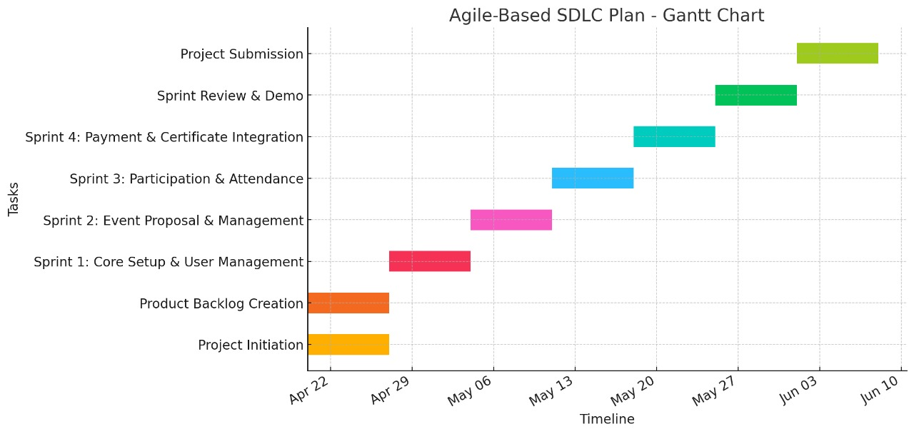

Figure -1 Gantt Chart

Deliverables
Event Management: Create and manage event types (Skill, Fun, Certified, Paid, Collaborative, Questionnaire).Proposal submission and approval workflow. Payment integration for paid events. Automated certification emails for certified events.
User Management: Role-based access: Open Users, Registered Users, Faculty, Committees, Super Admins. Auto-registration and verification via email, contact, and college ID/photo. 7-day verification limit for open users.
Committee Management: Committee creation by faculty/super admins (1 leader + 5 members). Account setup for committee members.
Attendance Tracking: QR code scanning for real-time attendance logging.
Payment Integration: Support for Esewa/Khalti for paid events. Receipt generation and confirmation emails.
Notifications: Automated emails/SMS for event updates, registrations, certifications, and reminders.
Reporting: Dashboards for participation stats, revenue tracking, and committee performance.
Security: Secure data handling and role-based access control.
Documentation: User guides and technical documentation (APIs, database, deployment).
Testing & Deployment: QA testing and secure system deployment.
These deliverables ensure the system meets the functional and non-functional requirements outlined in the diagram, covering event lifecycle management, user engagement, compliance, and scalability.

References
EEMS: idloom, LibreOffice, 2012, https://www.idloom.com/en/resources/case-studies/idloom-events-education
CT: cvent, Event Management Software, , https://www.cvent.com/en/event-management-software

