STUDENT PROJECT REPORT
GridGuard
ESP32 voltage, current and power protector with a relay cut-off
Submitted by
Team members
Department / Class
College / Institution
Project guide
Academic year

Mains voltage
This project switches 230 V AC. Work on it only when it is unplugged, keep every module inside a closed box, keep the MCB as the real protection, and never connect USB while it is on mains.

1. Introduction
GridGuard sits between the wall socket and an appliance. It measures the mains voltage and the load current continuously and keeps a relay on the live wire closed only while voltage, current and power are all inside limits that the user chooses. If one of them stays outside its limit for 2 seconds, the relay opens and the reason is logged. Everything is shown on a colour TFT and on a web page served over GridGuard's own WiFi hotspot, where the limits can be set, the relay switched and the readings calibrated.
Aim: to protect appliances such as fridges, pumps and chargers from bad supply voltage and from overload or dry-running, with clear local and phone feedback, using low-cost parts.

2. Specifications
Table 1. GridGuard specifications
Item | Value
Supply and load | 230 V AC, 50 Hz, single phase; load up to 6 A
Switching | 5 V relay module, 10 A contacts, live wire, normally open (no power = load off)
Protection limits | lower (LSL) and upper (USL) limit for voltage, current and power, any values with LSL below USL; LSL 0 = not used
Default limits | voltage 190–250 V, current 0–6 A, power 0–1300 W
Trip delay | 2 s (a value must stay outside its window this long)
After a voltage trip | automatic: relay closes 10 s after the voltage is back inside its window
After a current or power trip | locked off until reset (button hold 5 s or web ON)
Start grace | current and power LSL checked from 5 s after the relay closes
Measurement | 1600 samples per channel in 200 ms (8 kHz); V, I, P, PF five times a second
Display | 1.77" ST7735S TFT, 128 x 160, SPI; five screens; Bai Jamjuree font
Controls | push button (screens, reset, relay off); web ON/OFF switch
Indicator | red LED in the relay input: LED ON = relay closed (socket powered), LED OFF = relay open
Web | own WiFi "GridGuard" (password gridguard), http://192.168.4.1: live values, 60 s graph, limits table, relay switch, calibration, trip log
Kept after power-off | limits and calibration (ESP32 flash)

3. How it works
Figure 1 (next page) shows the blocks. The live wire runs from the plug through the MCB, the relay contacts, the current sensor and the rocker switch to the socket. The voltage sensor and the 5 V supply are connected after the MCB but before the relay, so GridGuard keeps running and keeps measuring the supply after it has cut the load off.

3.1 Sensing and maths
- Voltage: ZMPT101B transformer module; current: ACS712-20A Hall sensor in the live wire (100 mV/A).
- Both outputs pass a 10 kΩ / 20 kΩ divider (5 V to 3.3 V) with a 100 nF filter into GPIO34 and GPIO35 (ADC1, works with WiFi on).
- Every 200 ms the ESP32 reads 1600 samples per channel (10 mains cycles), removes the DC midpoint and computes Vrms, Irms, real power P = mean(v × i) and power factor. Windows stretched by WiFi (outside 196–204 ms) are dropped.

3.2 Limits and states
Each quantity has a window from LSL to USL. Voltage is checked all the time. Current and power can only be seen while the relay is on, so they are checked only then, and their LSL (under-current, under-power, for example a pump running dry) only from 5 s after the relay closes, to let a motor start. Figure 4 in Section 5 shows the state machine.
Table 2. Protection states
State | Relay | Meaning and what happens next
WAITING | off | power-up or after a voltage trip; counts 10 s while the voltage is inside its window, then closes the relay
ARMED | on | everything inside its window; watching
TRIPPING | on | a value is outside its window; counting 2 s. Back inside in time: ARMED again
TRIPPED | off | relay opened, trip logged; shown for 3 s
LOCKED | off | after a current or power trip; stays off until reset (button hold 5 s or web ON)
OFF (manual) | off | turned off by hand (button hold 2 s or web OFF); stays off until turned on

3.3 Setting the limits and resetting
- Set the limits on the web page, section Limits: type LSL and USL for voltage, current and power (0 as LSL switches a lower limit off) and press Save limits. They are saved in flash.
- After a voltage trip nothing needs to be done: the relay closes by itself 10 s after the voltage is back inside its window.
- After a current or power trip the relay stays off (screen: HOLD 5s RESET). After fixing the cause, hold the button 5 s (the screen counts RESETTING 5 4 3 2 1; letting go cancels) or tap ON on the web page. The relay closes and every limit is checked again.
- Relay off by hand: hold the button 2 s while the relay is on, or tap OFF on the web page.

3.4 Relay drive and indicator
Most 5 V relay modules are active-low: IN at 0 V switches the relay on, IN left unconnected keeps it off. To switch them off through a wire, IN must be pulled almost to 5 V, which a 3.3 V ESP32 cannot do. GridGuard therefore pulls GPIO26 to 0 V for ON and releases the pin (nothing driven) for OFF, and a red LED in series with IN takes up about 1.8 V so that a released pin really means OFF. The same LED is the indicator: red LED ON = relay closed (socket powered), red LED OFF = relay open. Because the pin is released while the ESP32 boots, resets or is being flashed, the relay is always off then.

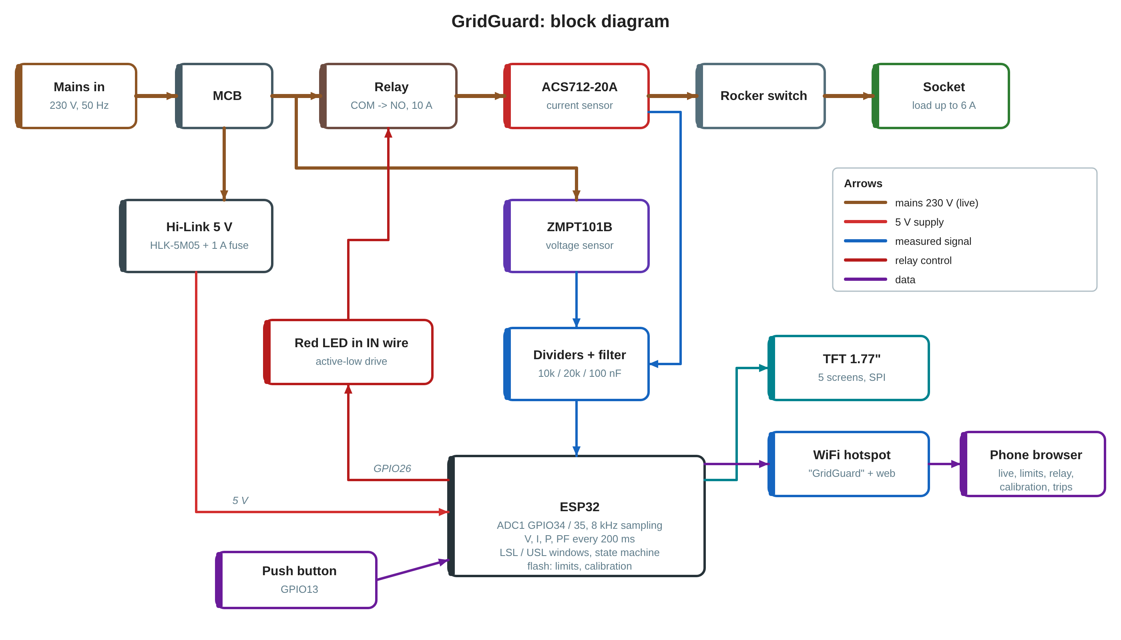
Figure 1. GridGuard block diagram

4. Components list
Table 3. Components
# | Component | Specification | Purpose
1 | ESP32 DevKit | 38-pin, ESP-WROOM-32, CP2102 USB | controller, WiFi, web server
2 | Voltage sensor | ZMPT101B module, 5 V | measures mains voltage
3 | Current sensor | ACS712-20A module, 5 V (100 mV/A) | measures load current
4 | TFT display | 1.77" ST7735S, 128 x 160, SPI (8 pins incl. BLK) | local display
5 | Relay module | 5 V, 1 channel, 10 A, relay SRD-05VDC-SL-C | switches the live wire
6 | Red LED | 5 mm red, in series with relay IN | makes the relay switch off; relay-on indicator
7 | Push button | 12 mm tactile or panel push button | screens, reset, relay off
8 | Power supply | Hi-Link HLK-5M05, 5 V 1 A | powers the electronics
9 | Fuse + holder | 1 A slow-blow | protects the Hi-Link input
10 | Resistors | 10 kΩ 1 % x2, 20 kΩ 1 % x2 | 5 V to 3.3 V dividers
11 | Capacitors | 100 nF ceramic x2 | divider noise filter
12 | MCB | single pole, modular | short-circuit protection
13 | Socket, rocker switch | 6 A modular | load socket, manual ON/OFF
14 | Enclosure | modular plate + surface box | housing
15 | Plug and cord | 6 A 3-pin plug, 3-core cord | mains input

5. Wiring

5.1 Pin map
Table 4. ESP32 connections
ESP32 pin | Goes to | Note
5V / VIN | 5 V rail (Hi-Link +Vo) | no series diode
GND | GND rail | common ground
3V3 | TFT VCC and BLK | 3.3 V output
GPIO34 | voltage divider node | ADC1, input only
GPIO35 | current divider node | ADC1, input only
GPIO23 | TFT SCK | SPI clock
GPIO19 | TFT SDA | SPI data (MOSI), not I2C
GPIO5 | TFT CS
GPIO4 | TFT RST
GPIO27 | TFT DC
GPIO26 | relay IN through a red LED | LED long leg to IN, short leg to GPIO26; no resistor
GPIO13 | push button to GND | internal pull-up, no resistor

Table 5. Module connections
Module | Pin | Connect to
ZMPT101B | VCC / GND / OUT | 5 V / GND / 10 kΩ to the GPIO34 node; L / N input after the MCB, before the relay
ACS712-20A | VCC / GND / OUT | 5 V / GND / 10 kΩ to the GPIO35 node; IP+ / IP− in the live wire after the relay
Relay module | VCC / GND / IN | 5 V / GND / red LED to GPIO26; COM to live from the MCB, NO to ACS712 IP+
TFT | VCC, BLK / GND / CS, RST, DC, SDA, SCK | 3V3 / GND / GPIO5, 4, 27, 19, 23
Hi-Link | AC L / AC N; +Vo / −Vo | live after the MCB via 1 A fuse / neutral; 5 V rail / GND

Note
Dividers: 10 kΩ from the sensor output to the node, 20 kΩ and 100 nF from the node to GND. Each node reads about 1.65 V with nothing flowing.

5.2 Diagrams
Figure 2 shows every low-voltage connection on the real 38-pin pin order. Figure 3 shows the 230 V path. Figure 4 shows the protection states.

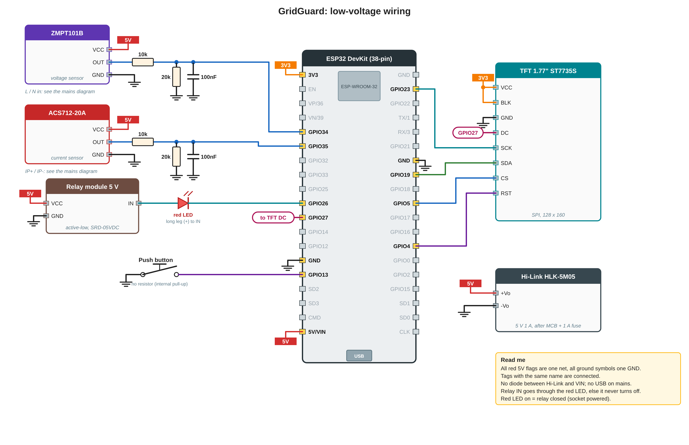
Figure 2. GridGuard low-voltage wiring
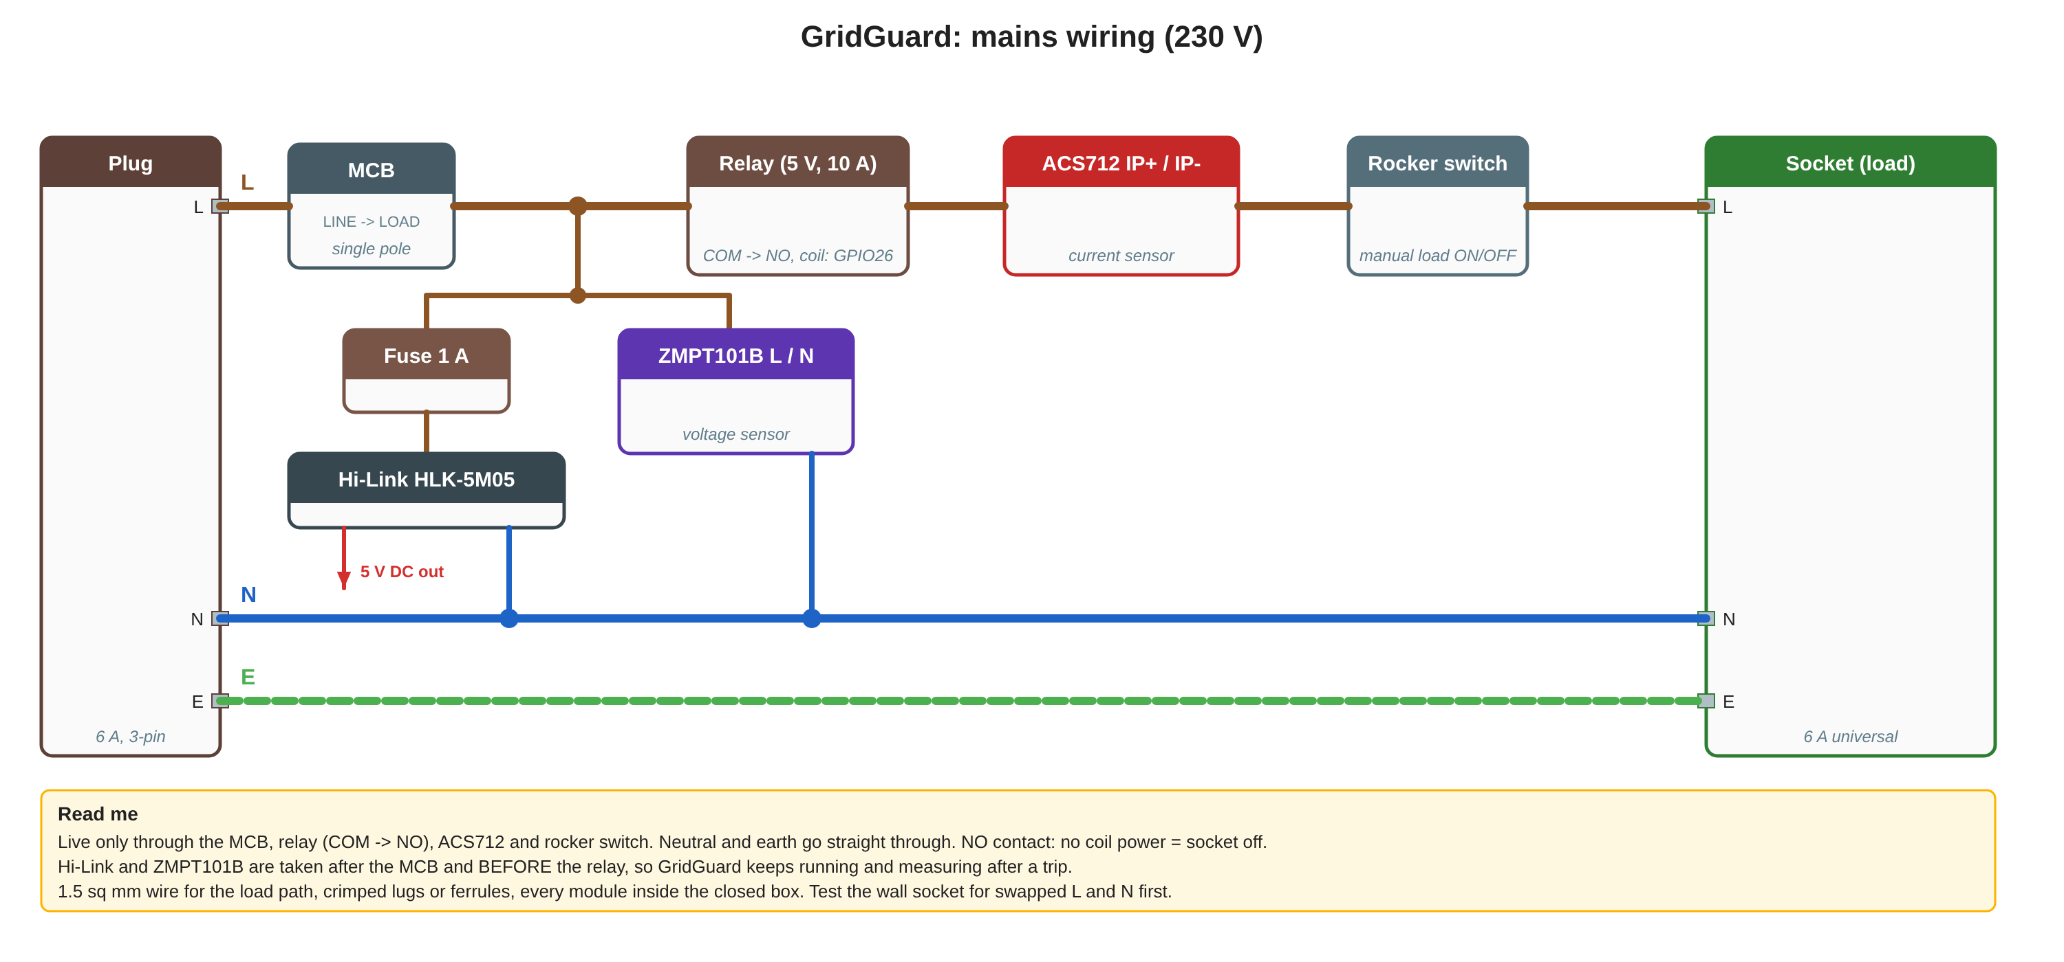
Figure 3. GridGuard mains wiring (230 V)
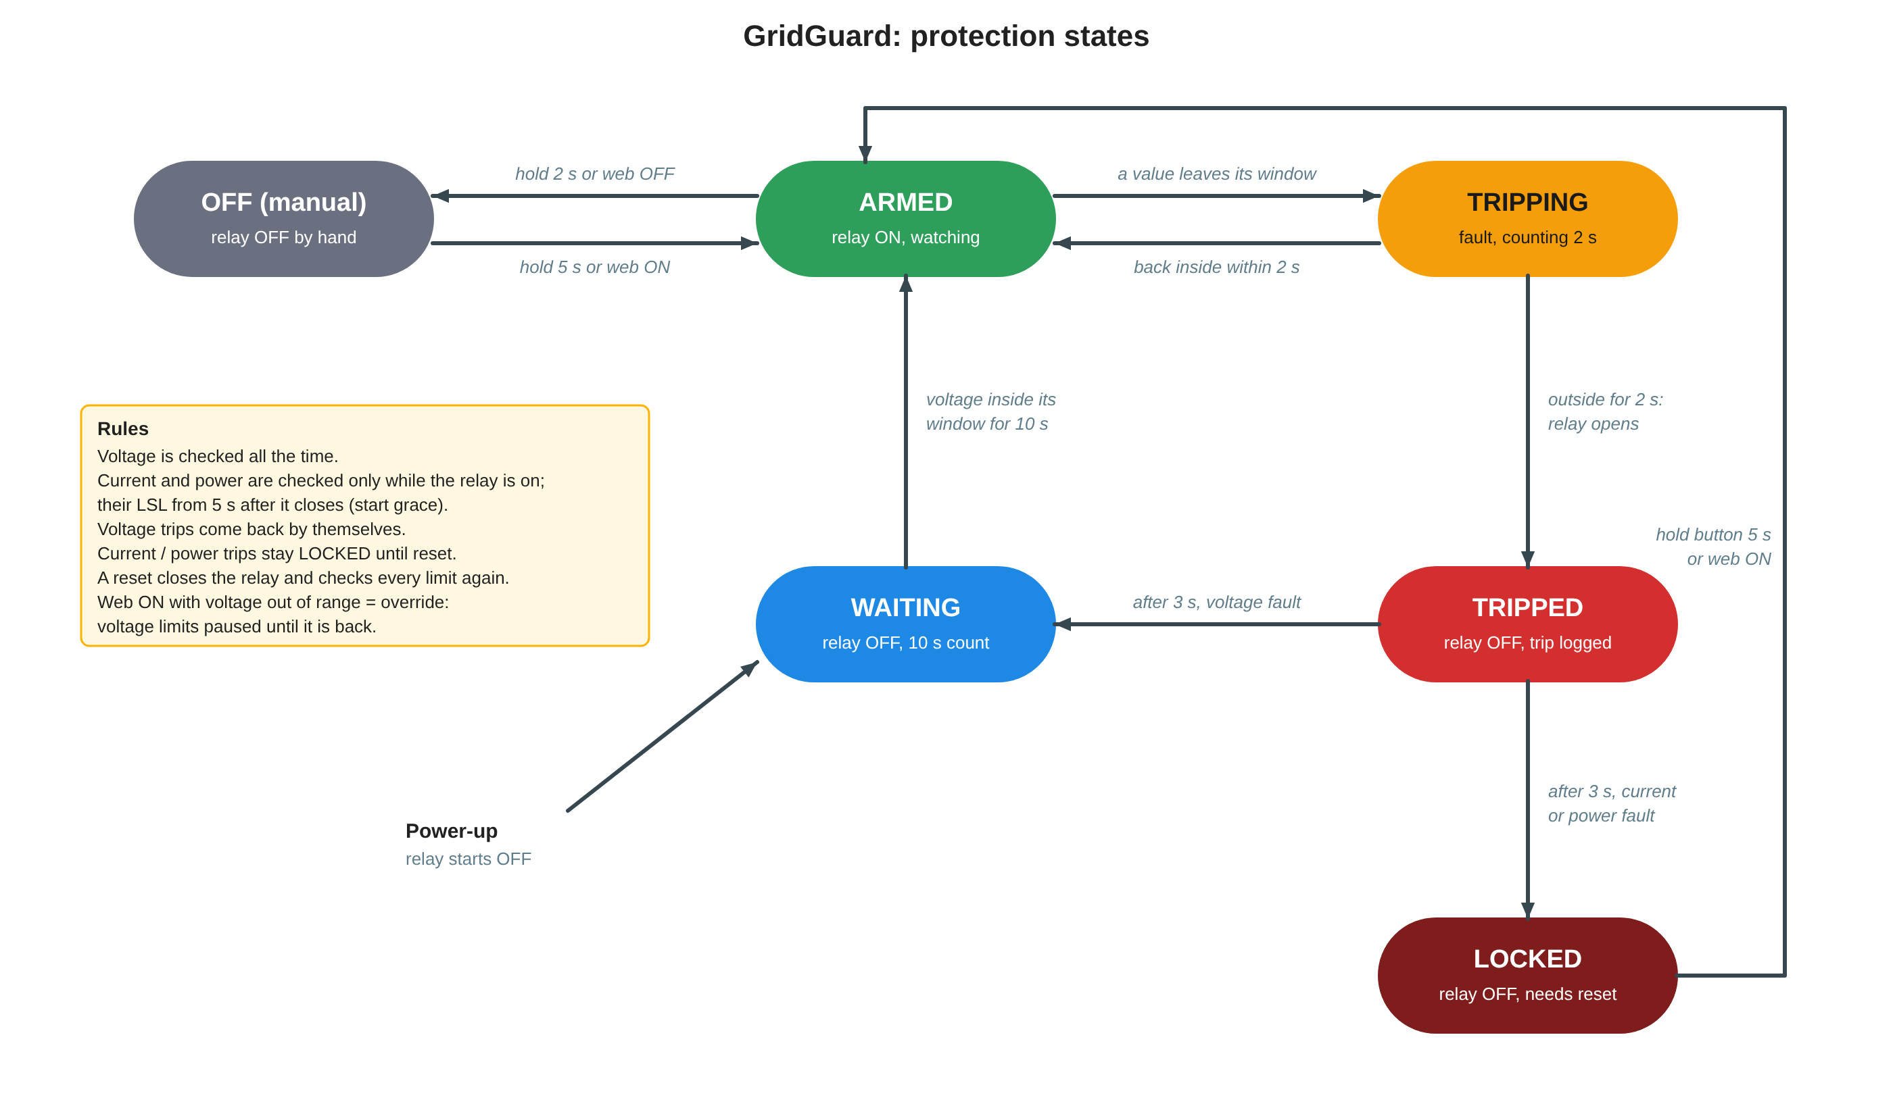
Figure 4. GridGuard protection states

6. Flashing and first setup
- Install the Arduino IDE and the ESP32 board package (Espressif). Select board ESP32 Dev Module.
- Set Tools > Partition Scheme > Huge APP (3MB No OTA/1MB SPIFFS).
- Install libraries: Adafruit GFX Library and Adafruit ST7735 and ST7789 Library (Library Manager); ESPAsyncWebServer and AsyncTCP by ESP32Async (download each as a ZIP, then Sketch > Include Library > Add .ZIP Library).
- Unzip the provided GridGuard.zip. It contains the folder GridGuard with GridGuard.ino, BaiJamjuree.h and web_index.h; keep the three files together in that folder. Open GridGuard.ino.
- Connect the ESP32 by USB (mains unplugged), choose the COM port and press Upload. Serial Monitor at 115200, line ending "Newline".
- On a phone, join WiFi GridGuard / gridguard and open http://192.168.4.1.

Board ESP32 Dev Module
Partition Scheme Huge APP (3MB No OTA/1MB SPIFFS)
Libraries Adafruit GFX, Adafruit ST7735 and ST7789, ESPAsyncWebServer, AsyncTCP
Files GridGuard.zip -> GridGuard/GridGuard.ino + BaiJamjuree.h + web_index.h
Serial Monitor 115200 baud

7. Calibration and testing
Open the Calibration section of the web page (tap to expand). Values are saved in flash immediately. The same works from the Serial Monitor: V 231.5, I 4.20, O -2.5, Z, F, D (defaults), ?.

7.1 Calibration steps
- Voltage: measure the socket with a multimeter, type it under "Multimeter reads" and press Match. This sets the gain; the offset (−30 to +30 V) can also be typed.
- Current: run a kettle or heater (at least 0.5 A) with the relay on, type the clamp meter reading under "Clamp meter reads" and press Match.
- Zero offset: unplug the load and press Measure zero (about 4 s). It refuses if a load still draws current. An empty socket then reads 0.00 A.
- Direction: press Flip direction if power reads wrong on a known load.
- Defaults restores the factory calibration; the limits are not changed.

Table 6. Calibration values (defaults)
Value | Default | Range / meaning
Voltage gain | 0.946 | 0.5 to 1.5; mains volts per mV at the pin
Voltage offset | 0 V | −30 to +30 V added after the gain
Current trim | 1.00 | 0.5 to 2.0; clamp meter A / shown A
Zero offset | 0.195 A | 0 to 1 A; idle noise of the current sensor
Direction | −1 | +1 or −1

7.2 Protection tests
# | Check | Expected | Result
1 | Power-up with good mains | STARTING 10 s, then ARMED, relay clicks on, red LED on | ☐ pass ☐ fail
2 | Voltage USL set just below the mains voltage | TRIP IN 2 s, TRIPPED, relay off, red LED off; WAITING; back on 10 s after USL is restored | ☐ pass ☐ fail
3 | Current USL 0.5 A with a kettle on | trips, then LOCKED (HOLD 5s RESET) | ☐ pass ☐ fail
4 | Hold the button 3 s, release | RESETTING countdown, then "Reset cancelled", stays LOCKED | ☐ pass ☐ fail
5 | Hold the button 5 s (USL back to 6 A) | relay on, ARMED | ☐ pass ☐ fail
6 | Current LSL 0.5 A, nothing plugged in | after 5 s grace and 2 s delay: under-current trip, LOCKED | ☐ pass ☐ fail
7 | Web OFF, then web ON | relay off (OFF manual), then on (ARMED) | ☐ pass ☐ fail
8 | Button hold 2 s with relay on | relay off (OFF manual) | ☐ pass ☐ fail
9 | ESP32 EN (reset) button | relay off while the ESP32 restarts | ☐ pass ☐ fail
10 | Power-cycle | limits and calibration kept; trip log cleared | ☐ pass ☐ fail
11 | Multimeter / clamp meter vs GridGuard | within 1 % / 2 % after calibration | ☐ pass ☐ fail

8. Display and web page guide

8.1 TFT screens and button
A short press of the button shows the next screen; otherwise the screen stays where it is. A trip always brings Home back. Holding the button: with the relay on, 2 s turns it off; with the relay off, 5 s resets (RESETTING 5 4 3 2 1 on the screen).
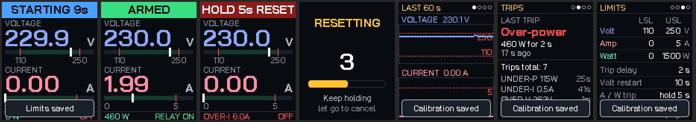
Figure 5. TFT screens: STARTING, ARMED, LOCKED, RESETTING countdown, Graph, Trips, Limits
Screen | Shows
Home | status bar (ARMED green, TRIP IN amber, TRIPPED red, WAITING / STARTING blue, LOCKED dark red, OFF grey), voltage and current with bars showing the LSL–USL window, power and relay state
Graph | last 60 s of voltage and current with the limits as dashed lines
Trips | last trip with reason, value and time, total since power-up, earlier trips
Limits | LSL and USL of voltage, current and power; trip and restart delays
Connect | WiFi name, password, address, phones connected, firmware version, button help

8.2 Web dashboard
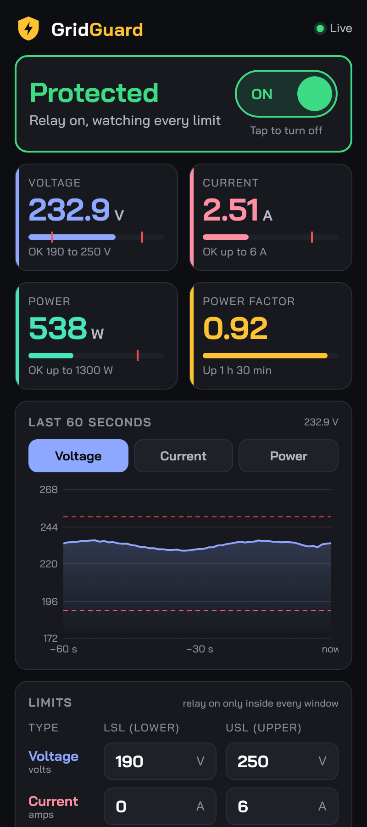  Status, relay switch, live values | 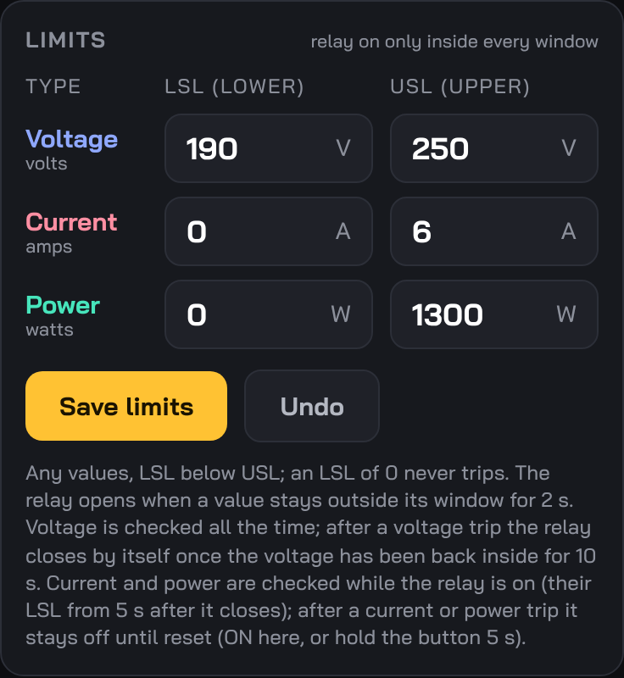  Limits table (LSL / USL) | 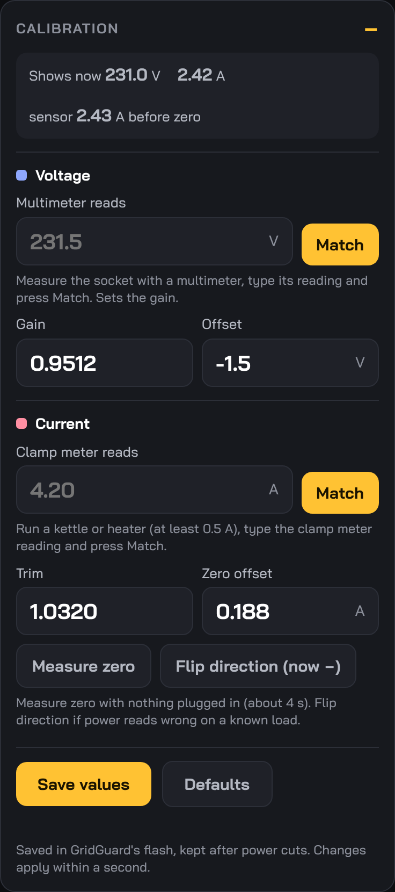  Calibration
Figure 6. GridGuard web page
Part | What it does
Status card | state in words with the reason and countdown; the ON/OFF switch turns the relay on or off (OFF asks to confirm)
Live tiles | voltage, current, power with their windows marked, power factor and uptime
Last 60 seconds | graph of voltage, current or power with the limits
Limits | LSL and USL for each quantity; Save limits / Undo
Calibration | match to meters, gain, offset, trim, zero offset, measure zero, flip, defaults
Trip log | last 10 trips with reason, value and time ago

Web ON while the voltage is out of range
Tapping ON on the web page while the voltage is outside its window starts an override: the relay closes and the voltage limits are ignored until the voltage comes back inside them. Current and power protection stay on. The button reset never overrides: it checks all limits straight away.

9. Troubleshooting
Problem | Likely cause | Fix
TFT stays white | SDA / SCK swapped or on other pins than the sketch; RST / DC / CS loose | check the wiring against Table 4; BLK to 3V3
Picture shifted, mirrored or red / blue swapped | different ST7735 panel variant | try INITR_GREENTAB or INITR_REDTAB in initR()
Relay always ON, even when off | active-low module: a released 3.3 V pin still looks low | put a red LED in series with IN (long leg to IN); RELAY_ACTIVE_LOW = true
Relay ticks or buzzes | IN driven to 3.3 V, half on | same fix: series LED and the current firmware
Relay LED lights but no click | 12 V relay (SRD-12VDC) on 5 V, or JD-VCC not powered | use a 5 V relay; on JD-VCC boards power JD-VCC from 5 V or refit the jumper
Works on USB, resets on the Hi-Link | series diode dropped VIN to about 3.6 V | no diode between the Hi-Link and VIN
Compile error "declared void" | an older copy of the sketch | use GridGuard.ino from the provided zip
"Sketch too big" | default partition | Huge APP (3MB No OTA/1MB SPIFFS)
Relay never closes after power-up (BAD SUPPLY) | voltage outside its LSL–USL window, or voltage not calibrated | check the limits and calibrate the voltage
Keeps showing HOLD 5s RESET | a current or power trip; locked on purpose | fix the cause, then hold 5 s or tap ON
Under-current trips right after reset | current LSL above the load's real current | lower or zero the current LSL; the start grace is 5 s
Current match refused | less than 0.5 A flowing | use a kettle or heater with the relay on
Measure zero refused | a load is still connected | unplug the load and try again
Small loads read 0 A | below the noise floor (about 0.2 A) | expected with the 20 A sensor

