PROJECT DOCUMENT · BUILD, OPERATION AND REPORT
PowerScope
ESP32 energy monitor for single-phase 230 V loads up to 6 A
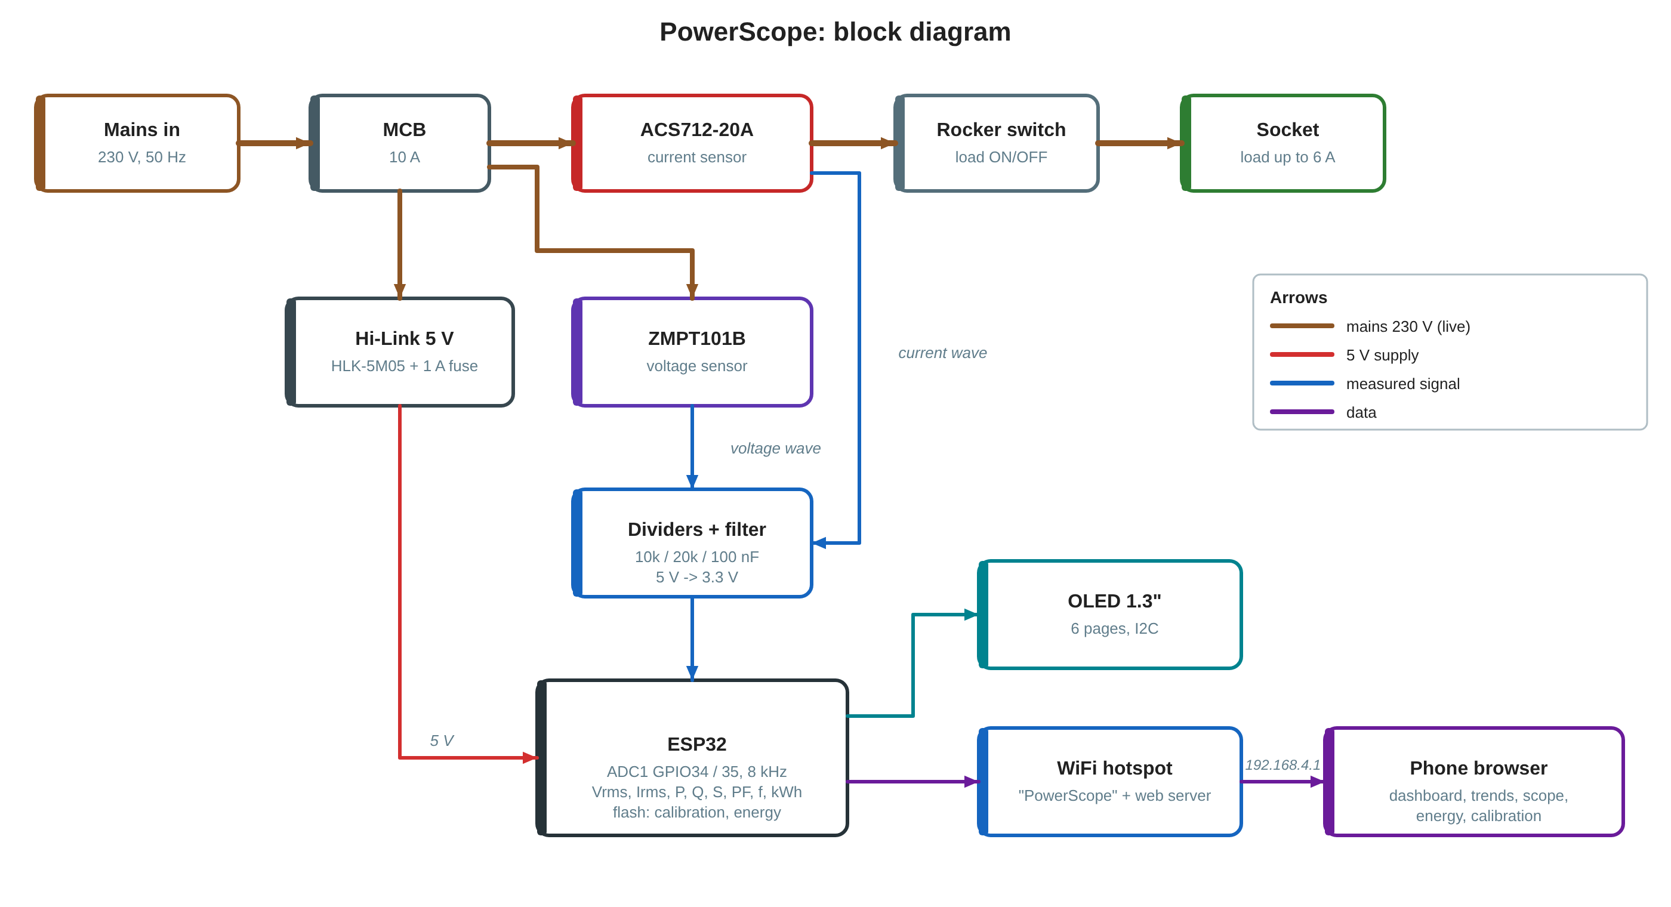
Document | Build guide, standard operating procedure and project report
Firmware | PowerScope 1.3.0 (Arduino, ESP32)
Hardware | ESP32 DevKit, ZMPT101B, ACS712-20A, 1.3" SH1106 OLED, Hi-Link HLK-5M05
Repository | github.com/shree-surya/PowerScope
Date / revision | October 2026, revision 1.0
Prepared by

Mains voltage
This project connects to 230 V AC. Build and test it only with supervision if you are new to mains wiring. Read Section 6.1 before you start.

Contents
# | Section | What it covers
1 | Introduction | aim, what PowerScope does and does not do
2 | Specifications | ratings, measured values, accuracy
3 | How it works | block diagram, sensing, maths
4 | Components list | parts, quantities, approximate cost, tools
5 | Wiring | pin map, low-voltage and mains diagrams, box layout
6 | Standard operating procedure | safety, assembly, checks, daily use, shutdown, maintenance
7 | Flashing and first setup | Arduino IDE, libraries, upload, WiFi
8 | Calibration and testing | voltage, current, zero, phase; acceptance checklist
9 | Display and web page guide | OLED pages and dashboard sections
10 | Troubleshooting | problems met while building and their fixes
11 | Limitations and future work
A–C | Appendices | web API, settings in flash, files

1. Introduction
PowerScope is a plug-in energy monitor built into a modular wall-plate box. A load (fan, cooler, kettle, charger) plugs into its front socket. PowerScope measures the mains voltage and the load current many thousand times a second and works out voltage, current, real, reactive and apparent power, power factor, phase angle, crest factor, frequency and energy. It shows them on a small OLED screen and on a dashboard served over its own WiFi hotspot, so any phone can open it without the internet.
Aim: to build a low-cost, safe, self-contained instrument that makes the electrical behaviour of everyday loads visible, for learning and demonstration.

What PowerScope does not do
- It does not switch or protect the load. The MCB is the only protection (see the sister project GridGuard for a relay cut-off).
- It is not a billing meter. After calibration it is accurate to a few percent.
- It is for single-phase loads up to 6 A. Do not plug in heaters or geysers above about 1.3 kW.

2. Specifications
Table 1. PowerScope specifications
Item | Value
Supply and load | 230 V AC, 50 Hz, single phase; load up to 6 A (about 1.3 kW)
Protection | 10 A single-pole MCB (6 A recommended); 1 A slow-blow fuse on the internal supply
Measured | Vrms, Irms, real power P (W), reactive power Q (var), apparent power S (VA), power factor, phase angle, crest factor, frequency, energy (kWh), load-on time, peak power
Sampling | 1600 samples per channel in 200 ms (8 kHz), 10 mains cycles per window; new values 5 times a second
Voltage sensor | ZMPT101B transformer module, through a 10k / 20k divider into GPIO34
Current sensor | ACS712-20A Hall sensor (100 mV/A), in series with the live wire, divider into GPIO35 (66.7 mV/A at the pin)
Smallest readable load | about 0.2 A (40 W) with WiFi on; smaller loads read 0 A
Accuracy | a few percent after calibration against a multimeter and a clamp meter
Display | 1.3" OLED SH1106, 128 x 64, I2C; six pages that change every 5 s
Web | own WiFi hotspot "PowerScope" (password powerscope), http://192.168.4.1; live values, trends, scope, energy and cost, calibration
Data kept after power-off | energy total, 62 days and 12 months of kWh, tariff, calibration, PIN (ESP32 flash, saved at most every 10 minutes)
Power use | about 1 W for the electronics, from a Hi-Link HLK-5M05 (5 V, 1 A)

3. How it works
Figure 1 (next page) shows the blocks. The power path is on top: mains, MCB, the current sensor in the live wire, the rocker switch and the socket. Two taps after the MCB feed the voltage sensor and the 5 V supply. Both sensor outputs go through a divider and filter into the ESP32, which does all the maths and drives the screen and the web page.

3.1 Sensing
- Voltage: the ZMPT101B is a small transformer with an op-amp. It gives an AC wave around about 2.5 V, about 1 mV at its output per volt of mains (as trimmed).
- Current: the ACS712-20A sits in the live wire. Its output is 2.5 V at zero current and moves 100 mV per amp.
- Divider: both modules run on 5 V, but the ESP32 input must stay below 3.3 V. A 10 kΩ resistor from the sensor output to the input pin and 20 kΩ from the pin to ground scale the signal by 2/3. The 100 nF capacitor across the 20 kΩ removes high-frequency noise.
- ADC: GPIO34 and GPIO35 are on ADC1, which keeps working while WiFi is on (ADC2 does not).

3.2 Maths, every 200 ms
- Read 1600 voltage and current samples back to back at 8 kHz (exactly 10 mains cycles).
- If the window took less than 196 ms or more than 204 ms (WiFi can stretch it), drop it and keep the last good values.
- Remove the DC midpoint of each channel, scale to volts and amps with the calibration values.
- Vrms and Irms are the root of the mean square. Real power P is the mean of v × i. S = Vrms × Irms, PF = |P| / S, Q = √(S² − P²), phase angle = acos(PF), crest factor = peak current / Irms.
- Frequency comes from the rising zero crossings of the voltage (with hysteresis).
- The current sensor shows about 0.19 A of random noise even with no load. Noise adds in quadrature, so it is removed as I = √(Imeasured² − Inoise²). Readings below 1.35 × the noise count as no load (0 A, 0 W).
- Energy adds P × time. Days and months use the phone's clock, sent by the web page when it opens (the ESP32 has no battery clock).

Figure 1. PowerScope block diagram

4. Components list
Table 2. Bill of materials (one unit). Prices are approximate, in rupees.
# | Component | Specification | Qty | Purpose | Rs
1 | ESP32 DevKit | 38-pin, ESP-WROOM-32, CP2102 USB | 1 | controller, WiFi, web server | 450
2 | Voltage sensor | ZMPT101B module, 5 V | 1 | measures mains voltage | 150
3 | Current sensor | ACS712-20A module, 5 V (100 mV/A) | 1 | measures load current | 120
4 | OLED display | 1.3" SH1106, 128 x 64, I2C (4 pins) | 1 | local readout | 250
5 | Power supply | Hi-Link HLK-5M05, 230 V AC to 5 V 1 A | 1 | powers the electronics | 225
6 | Fuse + holder | 1 A slow-blow, panel or inline | 1 | protects the Hi-Link input | 40
7 | Resistors | 10 kΩ 1 % x2, 20 kΩ 1 % x2, 1/4 W | 4 | 5 V to 3.3 V dividers | 20
8 | Capacitors | 100 nF ceramic x2 | 2 | divider noise filter | 10
9 | Capacitor | 470 µF 16 V electrolytic (recommended) | 1 | steadies the 5 V rail on WiFi bursts | 10
10 | MCB | single pole, 10 A (6 A preferred), modular | 1 | short-circuit and overload protection | owned
11 | Socket | 6 A universal, modular | 1 | load socket | owned
12 | Rocker switch | modular, 6 A or more | 1 | manual load ON/OFF | owned
13 | Enclosure | modular plate + surface box, blank module | 1 | housing | owned
14 | Plug and cord | 6 A 3-pin plug, 2 m 3-core flexible cord | 1 | mains input | 50
15 | Wire | 1.5 sq mm for the load path; 0.5 sq mm or jumper wire for low voltage | 1 set | connections | 100
16 | Terminals | terminal blocks, crimp lugs or ferrules, heat shrink | 1 set | safe joints | 100
17 | Board | perfboard, female headers for the ESP32 | 1 | mounts ESP32 and dividers | 100
18 | Hardware | standoffs, cable gland, zip ties, terminal covers | 1 set | mounting and strain relief | 100
19 | Labels | printed nameplate, colour strip | 1 | finish | 50
20 | Test bulb | 60–100 W incandescent + holder | 1 | first mains test (series bulb) | 100
 | Total (all parts new) |  |  |  | about 1,900

Notes on parts
The 0.96" SSD1306 OLED also works: change one constructor line in the sketch (see Section 10).
An ACS712-5A module (185 mV/A) reads small loads better but is limited to 5 A.
A TTP223 touch pad behind the blank module is optional; firmware 1.3.0 does not use it (pages change by themselves).
Do not fit a diode between the Hi-Link and the ESP32 VIN pin (see Section 10).

Tools
- Digital multimeter (AC volts, continuity, resistance) and a clamp meter for AC amps
- Soldering iron, solder, wire stripper, crimp tool, small screwdrivers
- Socket tester (to check the wall socket's live and neutral)
- Laptop with the Arduino IDE and a USB data cable
- A resistive test load (kettle, iron or heater, 1 to 6 A)

5. Wiring

5.1 Pin map
Table 3. ESP32 connections
ESP32 pin | Goes to | Note
5V / VIN | 5 V rail (Hi-Link +Vo) | no series diode; 470 µF across VIN and GND recommended
GND | GND rail | one common ground for everything
3V3 | OLED VCC | 3.3 V output of the ESP32
GPIO34 | voltage divider node (ZMPT101B OUT) | ADC1, input only
GPIO35 | current divider node (ACS712 OUT) | ADC1, input only
GPIO21 | OLED SDA | I2C data
GPIO22 | OLED SCL | I2C clock

Table 4. Module connections
Module | Pin | Connect to
ZMPT101B | VCC / GND / OUT | 5 V / GND / 10 kΩ to the GPIO34 node
ZMPT101B | L / N (input screw terminals) | live after the MCB and neutral
ACS712-20A | VCC / GND / OUT | 5 V / GND / 10 kΩ to the GPIO35 node
ACS712-20A | IP+ / IP− | in series with the live wire: MCB out to IP+, IP− to the rocker switch
Divider nodes | – | 20 kΩ to GND and 100 nF to GND at each node
OLED 1.3" | VCC / GND / SCL / SDA | 3V3 / GND / GPIO22 / GPIO21
Hi-Link | AC L / AC N | live after the MCB through the 1 A fuse / neutral
Hi-Link | +Vo / −Vo | 5 V rail / GND rail

Get the divider the right way round
The 10 kΩ goes from the sensor output to the node; the 20 kΩ and 100 nF go from the node to GND. Swapped, the ESP32 pin can see more than 3.3 V and may be damaged. With nothing flowing, each node should read about 1.65 V.

5.2 Box layout
PowerScope is one horizontal modular plate on a surface box. Left to right: socket, rocker switch, OLED, blank module, MCB. The plate is the finished front (no clear cover, which would block the MCB and the switch). Inside, the ESP32 and the dividers sit on a perfboard on standoffs, the Hi-Link is fixed to the box floor, and mains and low-voltage wiring are kept on separate sides with zip ties.

5.3 Diagrams
Figure 2 shows every low-voltage connection on the real 38-pin pin order (used pins highlighted). Figure 3 shows the 230 V path. Full-size images are in the repository under docs/.

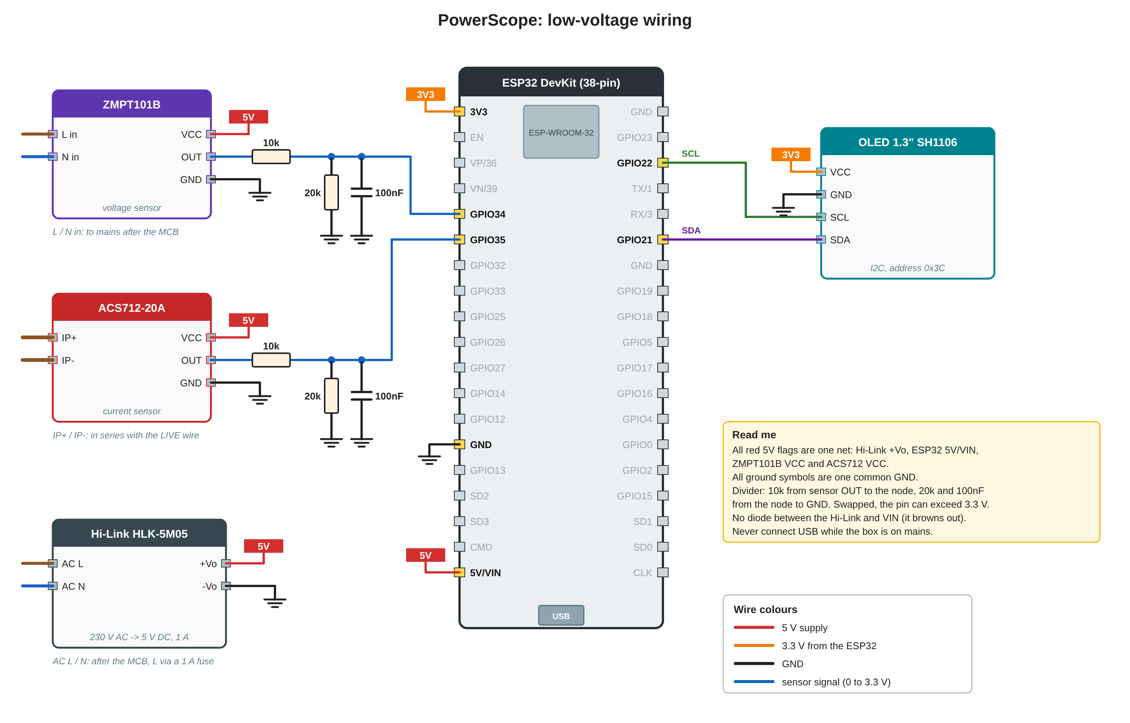
Figure 2. PowerScope low-voltage wiring
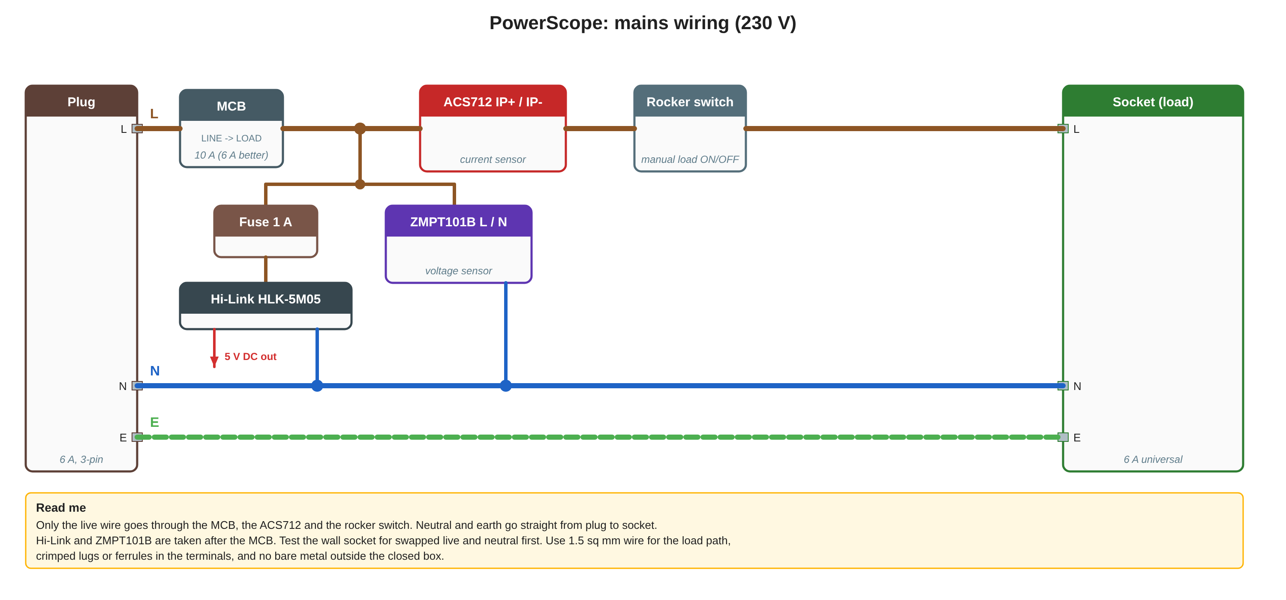
Figure 3. PowerScope mains wiring (230 V)

6. Standard operating procedure

6.1 Safety rules
- Work on the box only when it is unplugged. Switching the MCB off is not enough: the plug side stays live.
- Never connect USB while the box is plugged into mains. The ESP32 is not isolated from the Hi-Link output, and there is no diode to stop back-feeding.
- Live wire only through the MCB, current sensor and switch. Neutral and earth go straight through. Earth the socket.
- No bare metal or module outside the closed box. Cover screw terminals; use lugs or ferrules on stranded wire.
- Use 1.5 sq mm wire for the load path. Do not exceed 6 A.
- Test the wall socket with a socket tester first; swapped live and neutral put the MCB and sensor on the neutral wire.
- The first mains power-up is always through a 60–100 W bulb in series (Section 6.4).

6.2 Assembly
- Mount the modules in the plate in the order of Section 5.2 and fit the box with a cable gland for the cord.
- Solder the ESP32 headers, the two dividers (10 kΩ, 20 kΩ, 100 nF each) and the 5 V / GND rails on the perfboard (Figure 2).
- Wire the OLED to 3V3, GND, GPIO22 (SCL) and GPIO21 (SDA).
- Wire both sensors' VCC to 5 V and GND to GND; their OUT pins to the 10 kΩ resistors.
- Wire the Hi-Link output straight to the 5 V and GND rails (no diode) and fit the 470 µF across VIN and GND.
- Mains: plug L to MCB LINE; MCB LOAD to ACS712 IP+; IP− to the rocker switch; switch to socket L. Plug N and E straight to the socket (Figure 3).
- From MCB LOAD, run the taps: through the 1 A fuse to Hi-Link AC L, and to ZMPT101B L. Neutral taps to Hi-Link AC N and ZMPT101B N.
- Tie the low-voltage wires away from the mains wires and fit the terminal covers.

6.3 Checks before the first power-up
Box unplugged, multimeter in continuity / resistance mode:
# | Check | Expected | Result
1 | 5 V rail to GND | not a short (a few kΩ or more) | ☐ pass ☐ fail
2 | 3V3 to GND | not a short | ☐ pass ☐ fail
3 | Any mains point (plug L/N, MCB, IP+/IP−, ZMPT input, Hi-Link AC pins) to ESP32 GND | open (OL) | ☐ pass ☐ fail
4 | Plug L to socket L with MCB and rocker ON | continuity | ☐ pass ☐ fail
5 | Plug L to socket L with MCB OFF | open | ☐ pass ☐ fail
6 | Plug E to socket E | continuity | ☐ pass ☐ fail
7 | Divider: 10 kΩ from sensor OUT to node, 20 kΩ node to GND | values and positions correct | ☐ pass ☐ fail

6.4 First power-up
- USB only, no mains. Flash the firmware (Section 7). The OLED shows its pages; GPIO34 and GPIO35 nodes read about 1.65 V; the phone can join the PowerScope WiFi.
- Unplug USB. Plug the box into mains through a 60–100 W bulb in series with the live wire. The bulb should glow dimly or flash once, then stay dark. A bright, steady bulb means a short: unplug and find it.
- Remove the bulb, plug in directly, switch the MCB on. Check that the voltage reading is plausible (about 230 V) before calibrating.

6.5 Daily operation
- Check that the box is closed and the cord and plug are undamaged.
- Plug PowerScope into the wall socket and switch the MCB on (lever up). The OLED starts within a few seconds.
- Plug the load into the front socket and switch the rocker on.
- On a phone, join WiFi PowerScope (password powerscope) and open http://192.168.4.1. Opening the page also sets the clock for the energy history.
- Read the live values on the OLED or the page. Use Trends, Scope and Energy as needed; set the tariff once under Energy.
- To finish: rocker off, unplug the load, MCB off, unplug PowerScope.

Good to know
Energy is saved to flash at most every 10 minutes, so unplugging can lose up to the last 10 minutes of counting.
After every power-up, open the web page once so the day and month history get the right date.

6.6 Maintenance
- Every month (unplugged): check that the terminal screws are tight and no wire is warm-coloured or loose.
- Every six months: compare the voltage with a multimeter and the current with a clamp meter; recalibrate if they differ by more than 2 %.
- If the MCB trips, unplug the load and find the fault before switching on again.

7. Flashing and first setup
- Install the Arduino IDE and the ESP32 board package (Espressif). Select board ESP32 Dev Module.
- Set Tools > Partition Scheme > Huge APP (3MB No OTA/1MB SPIFFS). Without it the sketch is too big.
- Install libraries: U8g2 (Library Manager), and ESPAsyncWebServer and AsyncTCP by ESP32Async (GitHub > Code > Download ZIP, then Sketch > Include Library > Add .ZIP Library).
- Make a folder named PowerScope containing PowerScope.ino and web_index.h (both from firmware/PowerScope in the repository). Open the .ino.
- Connect the ESP32 by USB (mains unplugged), choose the COM port, and press Upload. Open the Serial Monitor at 115200 baud to see the readings.
- On a phone, join WiFi PowerScope / powerscope and open http://192.168.4.1.

Board ESP32 Dev Module
Partition Scheme Huge APP (3MB No OTA/1MB SPIFFS)
Libraries U8g2, ESPAsyncWebServer, AsyncTCP
Folder PowerScope/PowerScope.ino + PowerScope/web_index.h
Serial Monitor 115200 baud

To change the web page, edit web/index.html, run python tools/embed_web.py to rebuild web_index.h, and upload again.

8. Calibration and testing
Open the Calibrate section of the page and enter the PIN (1234 until you change it; five wrong tries lock it for 60 s). Every change is saved in flash and kept after a power cut.

8.1 Calibration steps
- Voltage: measure the socket with a multimeter (AC V). Type the reading under "Your multimeter reads, V" and press Apply. The shown voltage now matches the meter.
- Current: plug in a kettle, iron or heater drawing at least 1 A (not a fan or charger). Measure the live wire with a clamp meter, type the reading under "Your clamp meter reads, A" and press Apply.
- Zero current: unplug the load and press Zero (about 10 s). This measures the sensor's idle noise; afterwards an empty socket reads 0.00 A.
- Phase and direction (advanced): with the kettle on, power must be positive and the power factor 1.00. If power is negative, press Flip. If the PF is below 0.99, step the phase shift with − / + (2.25° per step) until it reads 1.00.
- Change the PIN under "PIN and defaults". Restore defaults puts back the factory calibration (the PIN is kept).

Table 5. Calibration values (defaults in brackets)
Value | Default | Meaning
Voltage gain | 0.946 | mains volts per mV at the pin; set by "multimeter reads"
Current trim | 1.00 | clamp meter A / shown A; 0.5 to 2.0
Idle noise | 0.195 A | sensor noise removed in quadrature; set by Zero
Phase shift | 0 | −20 to +20 samples, 2.25° each
Current direction | −1 | flip if power reads negative

8.2 Acceptance test
# | Check | Expected | Result
1 | Power-up with nothing plugged in | about 230 V, 0.00 A, 0 W, 50.0 Hz | ☐ pass ☐ fail
2 | Multimeter voltage vs PowerScope | within 1 % after calibration | ☐ pass ☐ fail
3 | Kettle or heater, clamp meter vs PowerScope | within 2 %, PF 0.98–1.00, power positive | ☐ pass ☐ fail
4 | Fan or cooler | PF below 1 (typically 0.7–0.9), Q above 0 | ☐ pass ☐ fail
5 | Phone opens 192.168.4.1 | dashboard shows Live, values update every second | ☐ pass ☐ fail
6 | Scope section | two cycles of voltage and current | ☐ pass ☐ fail
7 | Energy after 30 min of a known load | kWh close to P × 0.5 h | ☐ pass ☐ fail
8 | Power-cycle the box | calibration, tariff and energy total kept | ☐ pass ☐ fail
9 | MCB off | OLED and readings stop (the box is unpowered) | ☐ pass ☐ fail

9. Display and web page guide

9.1 OLED pages
The OLED changes page every 5 s. The dots at the top right show which of the six pages is on.
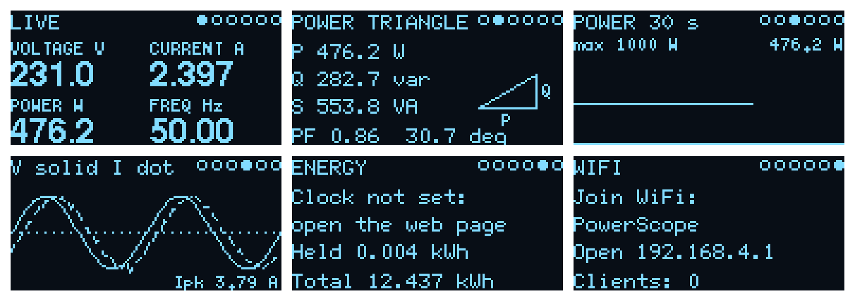
Figure 4. The six OLED pages (rendered from the firmware with a 2.4 A load at PF 0.86)
# | Page | Shows
1 | LIVE | voltage, current, real power and frequency in large digits
2 | POWER TRIANGLE | P, Q, S, power factor and phase angle, with the triangle drawn to scale
3 | POWER 30 s | a 30 s graph of real power with the maximum
4 | V solid I dot | two mains cycles of voltage (solid) and current (dotted), peak current
5 | ENERGY | today and the total; "clock not set" until a phone opens the page
6 | WIFI | WiFi name, address and the number of connected phones

9.2 Web dashboard
The page has five sections, reached from the bar at the top. If the page has never reached the device it shows demo data; once it has seen live data and loses contact, it shows "Offline" instead, so made-up numbers can never pass as real.
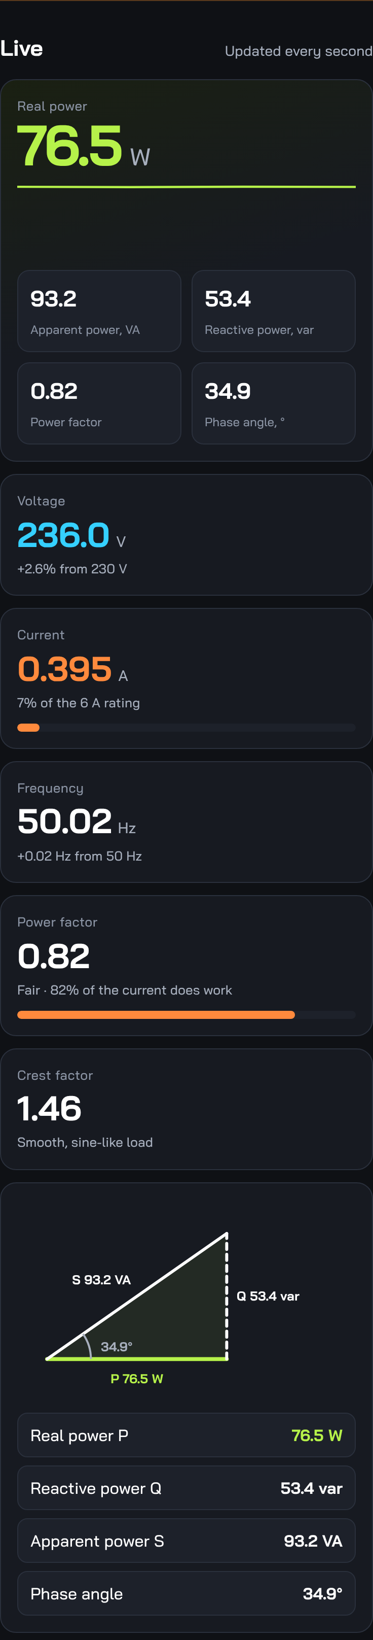  Live | 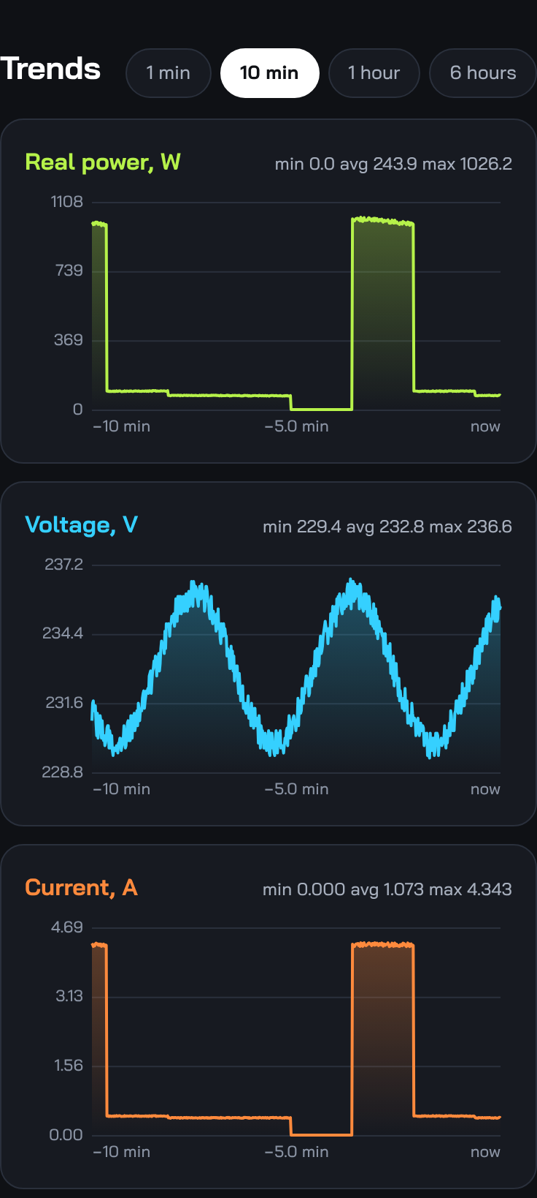  Trends | 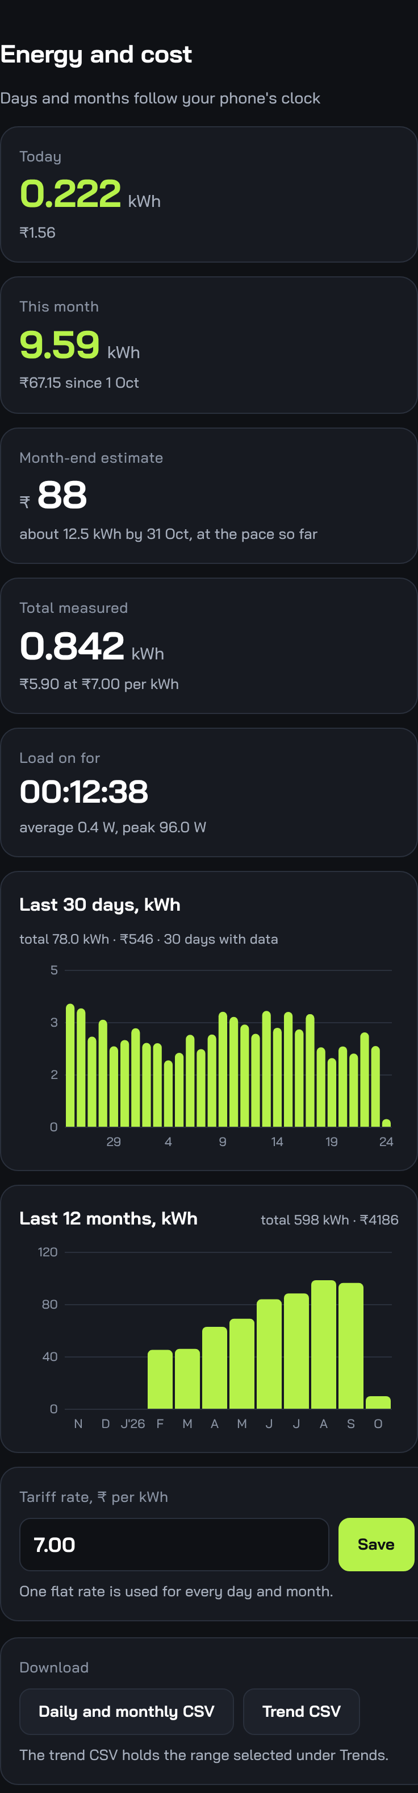  Energy and cost
Figure 5. Dashboard sections (demo data)
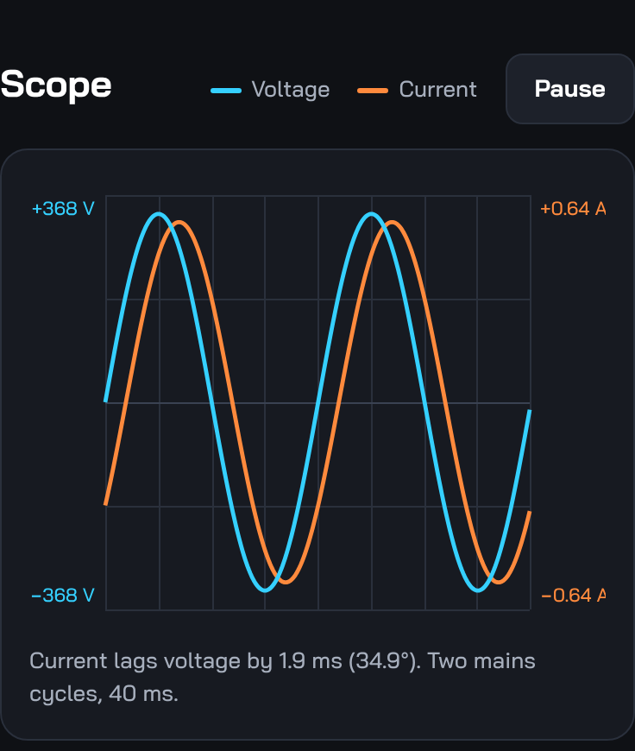  Scope | 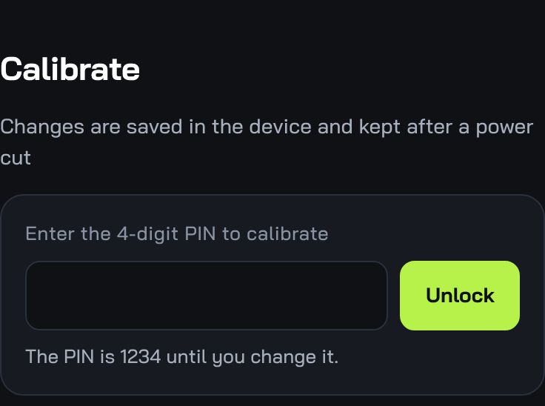  Calibrate (locked)
Section | What you can do
Live | real power, S, Q, PF, phase angle, voltage, current, frequency, crest factor, power triangle; updated every second
Trends | power, voltage and current over 1 min, 10 min, 1 h or 6 h, with min / average / max
Scope | two mains cycles of voltage and current; pause to inspect; phase lag in ms and degrees
Energy and cost | today, this month, month-end estimate, total, load-on time, 30-day and 12-month charts, tariff, CSV download
Calibrate | PIN-protected calibration (Section 8)

10. Troubleshooting
Problem | Likely cause | Fix
Works on USB, OLED dark or resets on the Hi-Link | a diode between the Hi-Link and VIN drops the 5 V to about 3.6 V; the ESP32 browns out when WiFi starts | remove the diode, wire +Vo straight to VIN; add 470 µF; never connect USB on mains
Stuck on "starting WiFi" | supply too weak (see above) | measure VIN under load; it must stay above 4.5 V
OLED blank | SDA / SCL swapped, VCC on the wrong pin, wrong driver | SDA 21, SCL 22, VCC 3V3; for a 0.96" SSD1306 use the U8G2_SSD1306 line in the sketch
OLED picture shifted by 2 px or garbled | SSD1306 panel with the SH1106 driver (or the reverse) | swap the constructor line at the top of the sketch
Compile error "Ring was not declared" / "declared void" | old 1.3.0 build with the types below the first function | use the current PowerScope.ino from the repository
"Sketch too big" | default partition scheme | Huge APP (3MB No OTA/1MB SPIFFS)
Power reads negative | current direction | Calibrate > Flip
Small loads (phone charger) read 0 A | below the noise floor (about 0.2 A with WiFi on) | expected; an ACS712-5A module reads lower
Current not 0 with nothing plugged in | zero not done for this unit | Calibrate > Zero with the load unplugged
Phone leaves the PowerScope WiFi | phone wants internet | PowerScope answers the internet checks; if a phone still drops, turn mobile data off
Days and months empty | no phone has opened the page since power-up | open the page once; held energy is added to that day
Readings jump when phones connect | WiFi bursts stretch a sampling window | those windows are dropped automatically; a few skipped updates are normal

11. Limitations and future work
- Loads under about 0.2 A (40 W) cannot be read reliably with WiFi on. Options: decoupling capacitors at the ACS712 supply, an ACS712-5A module, or a median-of-3 ADC read.
- Accuracy depends on calibration and on the ZMPT101B trimmer staying where it is.
- History of the last hours is kept in RAM and lost on a power cut; days and months are kept.
- Not yet verified on hardware: many phones connected at once, ACS712 temperature near 6 A.
- Possible additions: a page button (the touch pad), OTA updates, data export to a server.

Appendix A. Web API
Route | Purpose
GET / | the dashboard (gzip)
GET /data | live values: v, i, p, q, s, pf, phi, f, cf, kwh, on, avg, max, up, rate, inoise, clk, td, mo
GET /history?r=60|600|3600|21600 | trend arrays {dt, v[], i[], p[]}, newest last
GET /scope | 320 samples of voltage and current
GET /energy | 62 days and 12 months of kWh
POST /time?epoch=&tz= | phone clock (UTC seconds, minutes east of UTC)
POST /rate?x= | tariff in rupees per kWh
GET /cal | calibration values, defaults, zero state
POST /unlock?pin= | check the PIN
POST /cal?pin=&... | vref=, iref=, vgain=, itrim=, shift=, isign= or defaults=1
POST /zero?pin= | measure the idle noise
POST /pin?pin=&new= | change the PIN

Appendix B. What is kept in flash
Data | Saved
Energy total, load-on time, peak power, tariff | at most every 10 minutes
62 days and 12 months of kWh | with the energy total
Calibration (gain, trim, noise, shift, direction) | immediately when changed
PIN | immediately when changed
Trends (1 s, 5 s, 30 s rings) | not saved (RAM only)

Appendix C. Repository files
Path | Contents
firmware/PowerScope/ | PowerScope.ino and the generated web_index.h
firmware/bringup/ | small sensor test sketches used while building
web/index.html | the dashboard (self-contained, font embedded)
tools/embed_web.py | web/index.html to web_index.h
tests/host/ | builds the real sketch on a PC and checks the maths
docs/ | this document, diagrams, BOM, layout, idle-noise analysis

