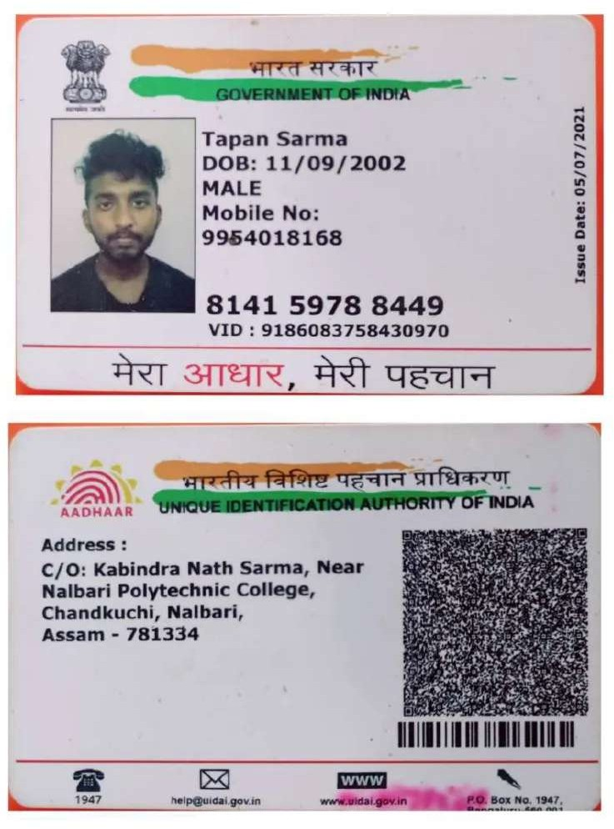

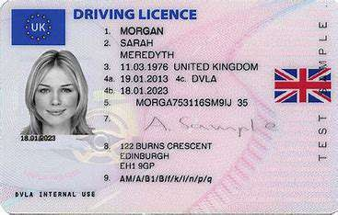

PAN CARD

Name: Sample Name

Father's Name: Sample Father's Name PAN Number: ABCDE1234F

Date of Birth: 1990-01-01