CI/CD Architecture Design for Customer Deployments on Google Cloud

1. Overview
This document describes the Continuous Integration and Continuous Deployment (CI/CD) architecture
for deploying and maintaining the product platform in customer environments on Google Cloud.
The architecture enables customers to deploy the initial solution through Google Cloud Marketplace
and subsequently receive product updates through an automated CI/CD pipeline.
Core technologies used in this implementation include:
• GitHub for source code management
• GitHub Actions for CI/CD automation
• Google Kubernetes Engine (GKE) for application hosting
• Cloud SQL for database services
• Artifact Registry for container image storage
• Google Cloud Load Balancer for external/Internal access

2. Initial Infrastructure Deployment
The initial infrastructure for the solution is deployed using Google Cloud Marketplace.
Marketplace simplifies deployment by provisioning all required infrastructure components.
Infrastructure components created during deployment:
• Virtual Private Cloud (VPC)
• Google Kubernetes Engine (GKE) Cluster
• Cloud SQL database
• Cloud Load Balancer
• Artifact Registry repository
This infrastructure provides a secure and scalable foundation for running the application services.

3. Repository Strategy
The architecture follows a product repository to customer repository model.
Product Repository
The product engineering team maintains the primary repository which contains:
• application source code
• Dockerfiles
• Kubernetes manifests or Helm charts
• CI/CD workflow definitions
Customer Repository (Fork)
Customers create a fork of the product repository. This repository allows them to:
• maintain environment-specific configuration
• customize deployment parameters
• integrate CI/CD workflows into their infrastructure

4. Repository Synchronization
Customer repositories must stay synchronized with the product repository to receive new releases,
bug fixes, and security updates.
The synchronization mechanism pulls updates from the upstream product repository into the
customer repository using an automated GitHub workflow.
Once synchronization completes, the latest code becomes available in the customer repository
and triggers the CI/CD pipeline.

CICD Architecture Design
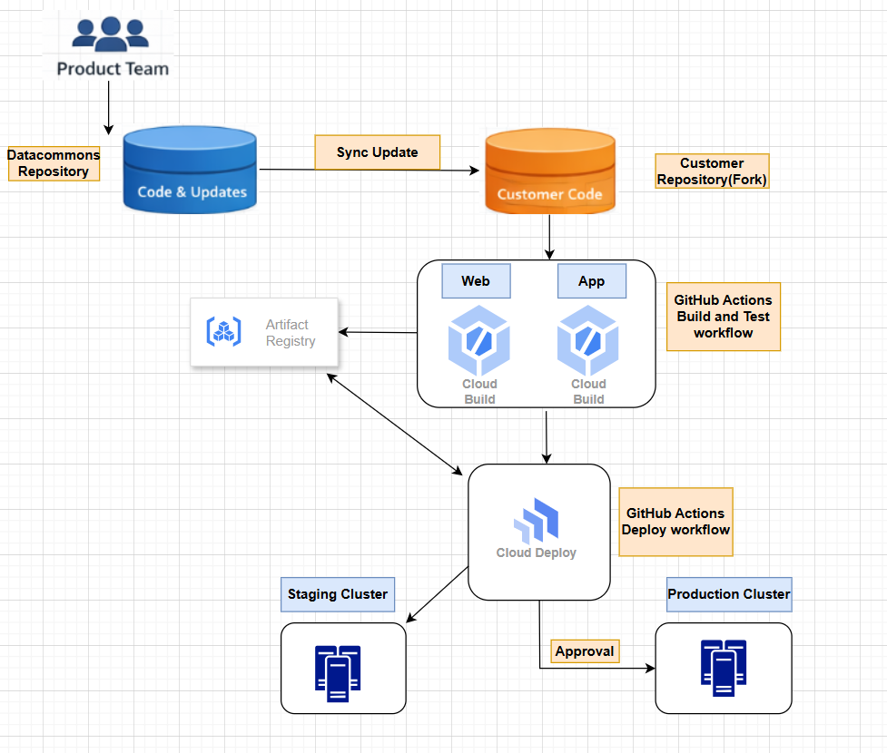

5. CI/CD Workflow Trigger
The CI/CD pipeline is implemented using GitHub Actions.
The workflow is triggered whenever:
• a repository sync occurs
• new commits are pushed to the main branch
• manual workflow execution is requested
This ensures the build pipeline runs automatically whenever the repository receives updates.

6. Build Pipeline
The CI pipeline builds container images for multiple microservices within the platform.
Services built during the pipeline:
• Web Service (frontend)
• Application Service (backend business logic)
Pipeline stages:
1. Source code checkout
2. Dependency installation
3. Unit tests execution
4. Docker image build
5. Push images to Artifact Registry

7. Artifact Storage
Container images produced by the CI pipeline are stored in Google Artifact Registry.
Benefits of Artifact Registry include:
• secure container storage
• integration with Google Kubernetes Engine
• vulnerability scanning
• IAM based access control

8. Continuous Deployment
After successful image builds, the deployment stage updates the running application in GKE.
Deployment process:
1. CI pipeline produces new container images
2. Deployment workflow updates Kubernetes deployment manifests
3. New images are deployed to the GKE cluster
4. Rolling updates ensure zero downtime deployment
This process ensures that application services are continuously updated with the latest
product releases.

