**Design Patterns and Principles**

1. **Singleton Pattern Example**

**Logger.java:**

**package** SinglePattern;

**public** **class** Logger {

**private** **static** Logger *instance*;

**private** Logger() {}

**public** **static** Logger getInstance() {

**if** (*instance* == **null**) {

*instance* = **new** Logger();

}

**return** *instance*;

}

**public** **void** log(String message) {

System.***out***.println("Log: " + message);

}

}

**TestSingleton.java:**

**package** SinglePattern;

**public** **class** TestSingleton {

**public** **static** **void** main(String[] args) {

Logger logger1 = Logger.*getInstance*();

Logger logger2 = Logger.*getInstance*();

logger1.log("First message");

System.***out***.println(logger1 == logger2); // true

}

}

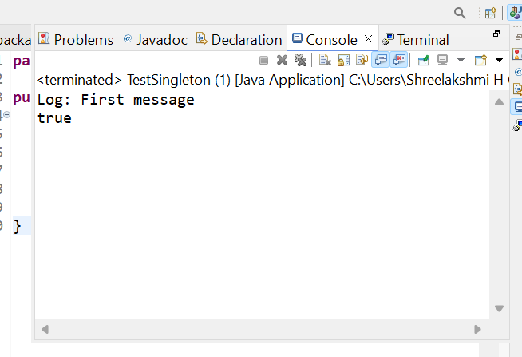

1. **Factory Method Pattern Example**

**Document.java:**

**package** FactoryMethodPattern;

**interface** Document {

**void** open();

}

**DocumentFactory.java:**

**package** FactoryMethodPattern;

**abstract** **class** DocumentFactory {

**public** **abstract** Document createDocument();

}

**ExcelDocument.java:**

**package** FactoryMethodPattern;

**class** ExcelDocument **implements** Document {

**public** **void** open() {

System.***out***.println("Opening Excel Document");

}

}

**PdfDocument.java:**

**package** FactoryMethodPattern;

**class** PdfDocument **implements** Document {

**public** **void** open() {

System.***out***.println("Opening PDF Document");

}

}

**Snippet.java:**

**package** FactoryMethodPattern;

**public** **class** Snippet {

**public** **static** **void** main(String[] args) {

}

}

**WordDocument.java:**

**package** FactoryMethodPattern;

**class** WordDocument **implements** Document {

**public** **void** open() {

System.***out***.println("Opening Word Document");

}

}

**WordFactory.java:**

**package** FactoryMethodPattern;

**class** WordFactory **extends** DocumentFactory {

**public** Document createDocument() {

**return** **new** WordDocument();

}

}

**TestFactory.java:**

**package** FactoryMethodPattern;

**public** **class** TestFactory {

**public** **static** **void** main(String[] args) {

DocumentFactory factory = **new** WordFactory();

Document doc = factory.createDocument();

doc.open();

}

}

**Output:**

