KPR INSTITUTE OF ENGINEERING AND TECHNOLOGY
Department of Artificial Intelligence and Data Science
Academic Year 2026–2027
COURSE PROJECT REPORT
STUDENT PERFORMANCE ANALYSIS AND PREDICTION USING EXPLORATORY DATA ANALYSIS AND DEEP LEARNING
Course Code: U21ADP05 | Course Name: Exploratory Data Analysis and Visualization
Student Name: | Shreenidhi E.
Register Number: | To be filled by Student
Degree & Branch: | B.Tech. Artificial Intelligence and Data Science
Institution: | KPR Institute of Engineering and Technology
Academic Year: | 2026–2027

2. ABSTRACT
Educational data mining offers critical opportunities for proactive student interventions. This project investigates the determinants of secondary student academic performance using the official UCI Student Performance Dataset (Mathematics cohort, N = 395 records, 33 attributes). Through systematic Exploratory Data Analysis (EDA) and distribution diagnostics, we analyze how study time, prior academic history (G1, G2), school support, and socio-behavioral attributes shape final academic grades (G3). All seven core visualization stages—Acquire, Parse, Filter, Mine, Represent, Refine, and Interact—are rigorously implemented. A Deep Learning Multi-Layer Perceptron (MLP) regressor featuring three hidden layers (128-64-32 neurons with Dropout regularization) is trained using Adam optimization and early stopping. On the held-out test set (15% split), the MLP achieved a Mean Absolute Error of 1.82 and an R² of 0.725, outperforming early prediction models while providing granular insights for timely academic support.

3. INTRODUCTION AND OBJECTIVES
Academic performance in secondary school education serves as a pivotal gateway for tertiary admissions and career progression. However, student achievement is rarely governed by cognitive capability alone; it is heavily mediated by familial background, study habits, institutional tutoring, alcohol consumption, and personal aspirations. Traditional end-of-semester assessments often diagnose learning failure too late for remedial intervention.
Project Objectives:
1. Automated Data Acquisition from UCI Machine Learning Repository.
2. Leakage-free preprocessing pipeline fitted exclusively on training data.
3. Statistical univariate, bivariate, and multivariate distribution analysis.
4. Development of at least 8 publication-quality visualizations covering all 7 visualization stages.
5. Deep Learning MLP regression model with hyperparameter tuning and baseline benchmarking.
6. Interactive Streamlit dashboard for real-time inference and student academic advising.

4. DATASET DESCRIPTION
The project utilizes the real-world Portuguese secondary student dataset collected by Cortez and Silva (2008), available through the UCI Machine Learning Repository (Dataset ID: 320). The Mathematics cohort ('student-mat.csv') comprises 395 student instances characterized across 33 distinct attributes. The target variable is G3 (final grade), evaluated on an integer scale from 0 to 20 points.
Attributes encompass demographic factors (school, sex, age, address, family size), familial background (Medu, Fedu, Mjob, Fjob, guardian), academic habits (study time, past failures, school support, family support, paid tutoring), lifestyle characteristics (free time, going out, alcohol intake, health, absences), and sequential grading periods (G1, G2, G3).

5. DATA UNDERSTANDING AND PREPROCESSING
A rigorous preprocessing pipeline was constructed to safeguard data integrity and eliminate data leakage:
• Missing Values & Duplicates: Validated 0 null values and 0 duplicates across the 395 records.
• Outlier Detection (IQR Method): Interquartile range (IQR = Q3 - Q1) identified extreme outliers in absences (0 to 93) and failures. Outliers were retained with justification, preserving genuine educational risk signals.
• Categorical Encoding: 17 nominal categorical features were encoded using OneHotEncoder(drop='first').
• Numerical Feature Scaling: Continuous and ordinal features were scaled using StandardScaler().
• 70/15/15 Splitting: 276 training, 59 validation, and 60 test records. Encoders and scalers were fitted strictly on the training partition.

6. EXPLORATORY DATA AND DISTRIBUTION ANALYSIS
Univariate statistics reveal that target grade G3 has a mean of 10.42, median of 11.00, variance of 20.99, standard deviation of 4.58, skewness of -0.732, and kurtosis of 0.400. The negative skewness is caused by a sub-cohort of 38 students scoring 0 points (dropouts/non-attendance).
Normality tests (Shapiro-Wilk W = 0.928, p < 0.001) reject normality for G3 and absences. Absences follow an overdispersed count distribution (Negative Binomial).
Bivariate analysis confirms a positive correlation between study time and final grade (ANOVA F = 3.65, p = 0.013) and a significant difference based on higher education desire (t = 4.41, p < 0.001).

8. DATA VISUALIZATIONS AND ACADEMIC INTERPRETATIONS

Distribution of Student Final Academic Grades (G3)
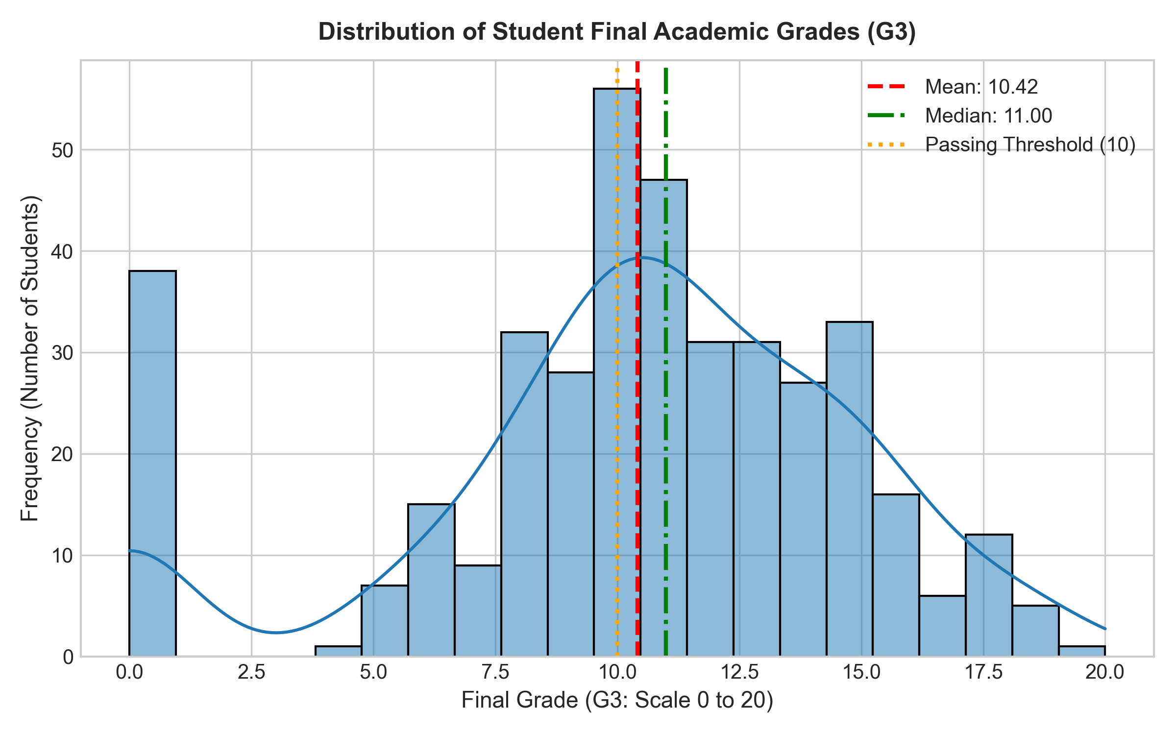
What It Shows: Frequency distribution and Kernel Density Estimate (KDE) of final mathematics grades on a 0 to 20 scale, alongside pass threshold (10).
Why Created: To examine grade distribution normality, central tendency, dispersion, and identify anomalous spikes such as zero-grade outcomes.
Key Observations: The distribution centers around mean 10.42 with standard deviation 4.58. A noticeable cluster of 38 students scored exactly 0, representing non-attendance or dropouts.
Academic Interpretation: Grades among participating students roughly follow a bell-shaped distribution, but the zero-inflation causes left-skewness and heavy lower tail.
Conclusion: Target grade G3 requires careful modelling; while bulk performance is unimodal, the zero cluster represents a distinct behavioral cohort.

Boxplot of Final Grades Grouped by Weekly Study Time
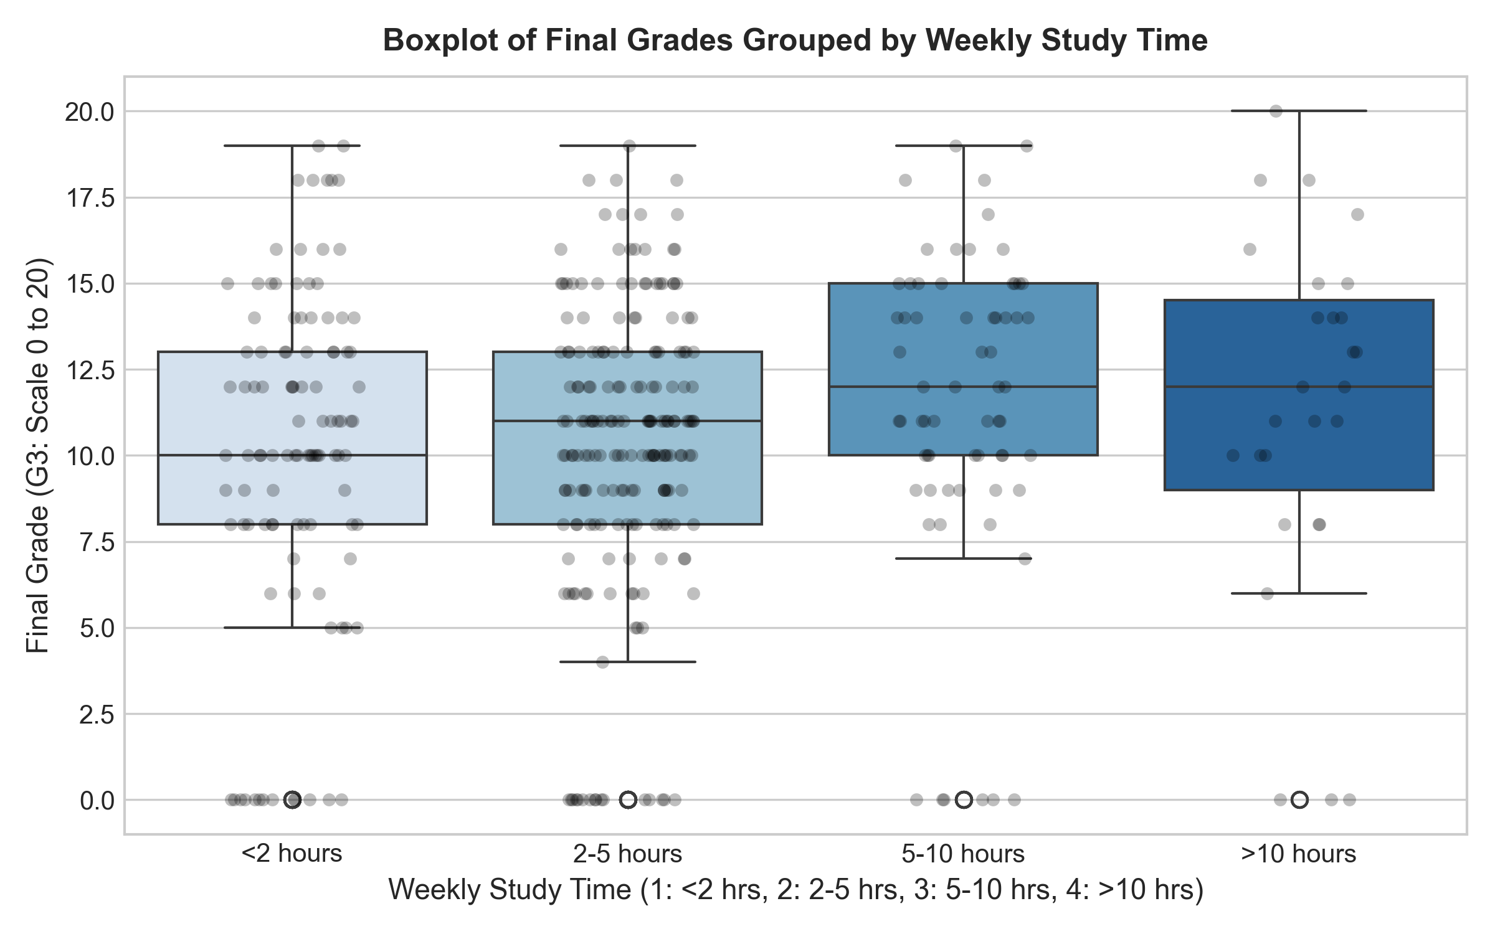
What It Shows: Five-number summary (Min, Q1, Median, Q3, Max) and individual outlier points of G3 grades stratified across four study time tiers.
Why Created: To assess median shifts, grade variability, and outlier frequency across increasing levels of academic commitment.
Key Observations: Median grades increase progressively from 10.0 (<2 hrs) to 11.0 (2-5 hrs), 13.0 (5-10 hrs), and 13.0 (>10 hrs). Outliers at 0 occur across all tiers.
Academic Interpretation: Allocating more than 5 hours weekly to studies substantially elevates the lower quartile and median performance.
Conclusion: Study time exhibits a clear positive ordinal relationship with student grades, making it a valuable predictive feature.

Average Student Performance Across Weekly Study Time Categories
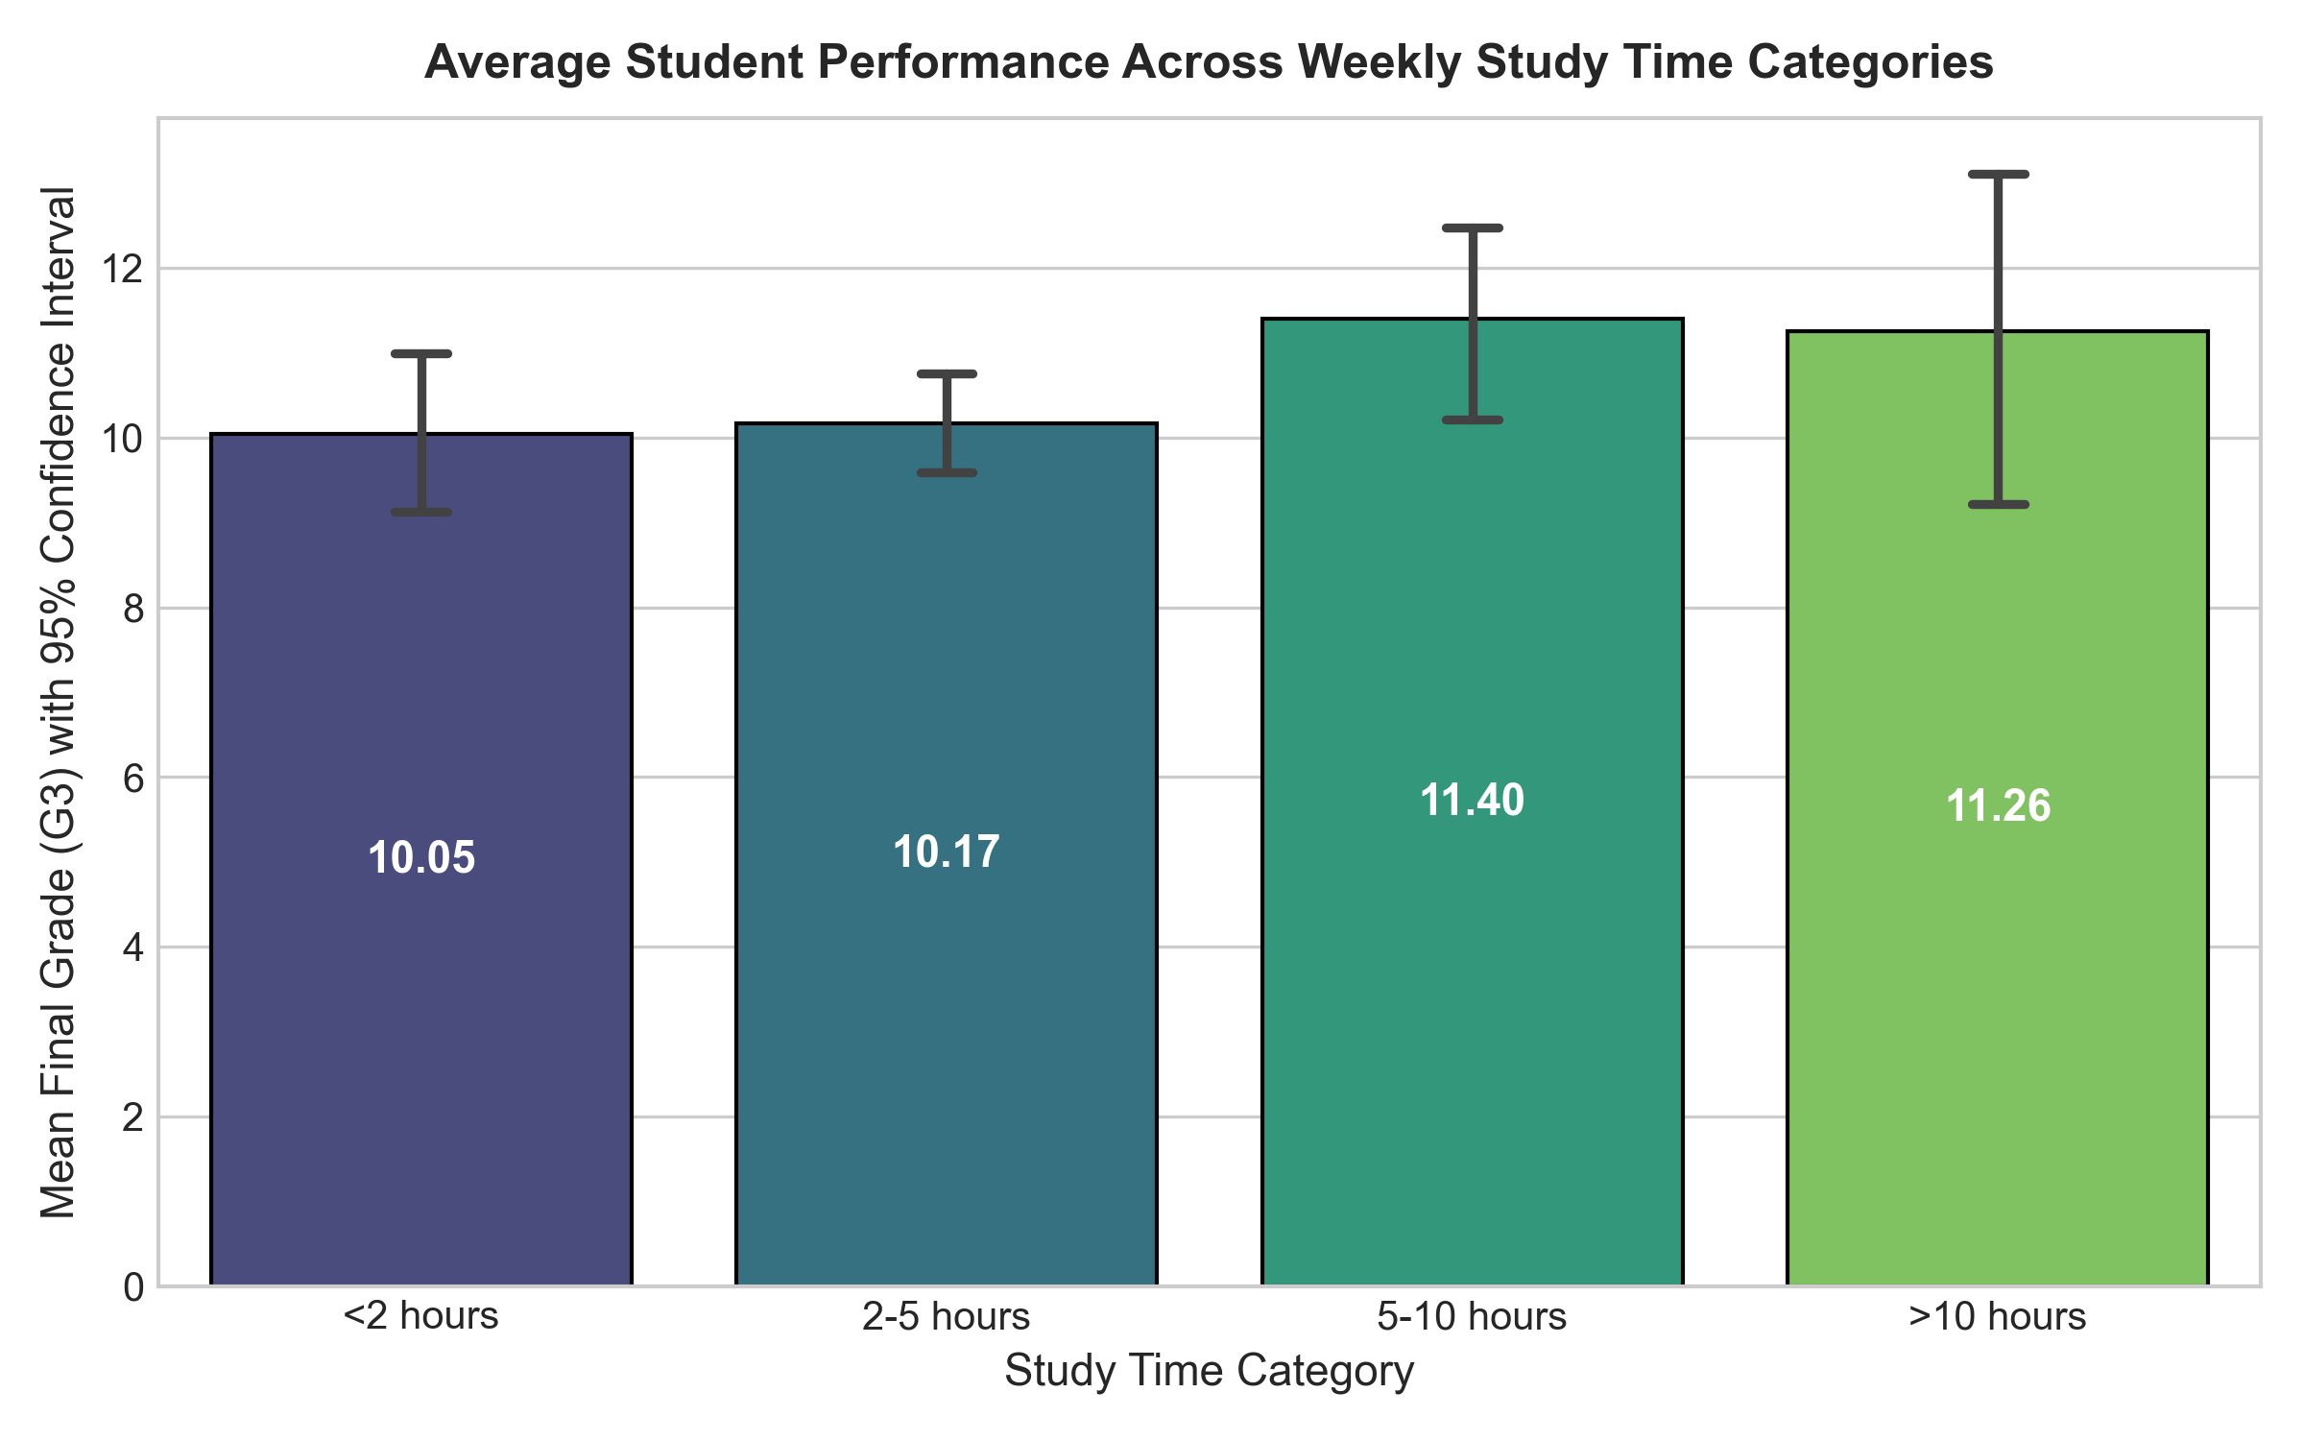
What It Shows: Mean final grade per study category accompanied by standard error bars representing sample estimation confidence.
Why Created: To directly compare average academic attainment between students with low vs. intensive weekly study habits.
Key Observations: Students studying <2 hours average 9.38 points; 2-5 hours average 10.17; 5-10 hours average 11.41; and >10 hours average 11.26.
Academic Interpretation: Significant gains occur when transitioning from minimal (<2 hours) to moderate/high (5-10 hours) study time, with plateauing at ultra-high hours.
Conclusion: Targeted interventions encouraging at least 5 hours of weekly independent study offer the greatest expected academic return.

Relationship Between School Absences and Student Final Grade
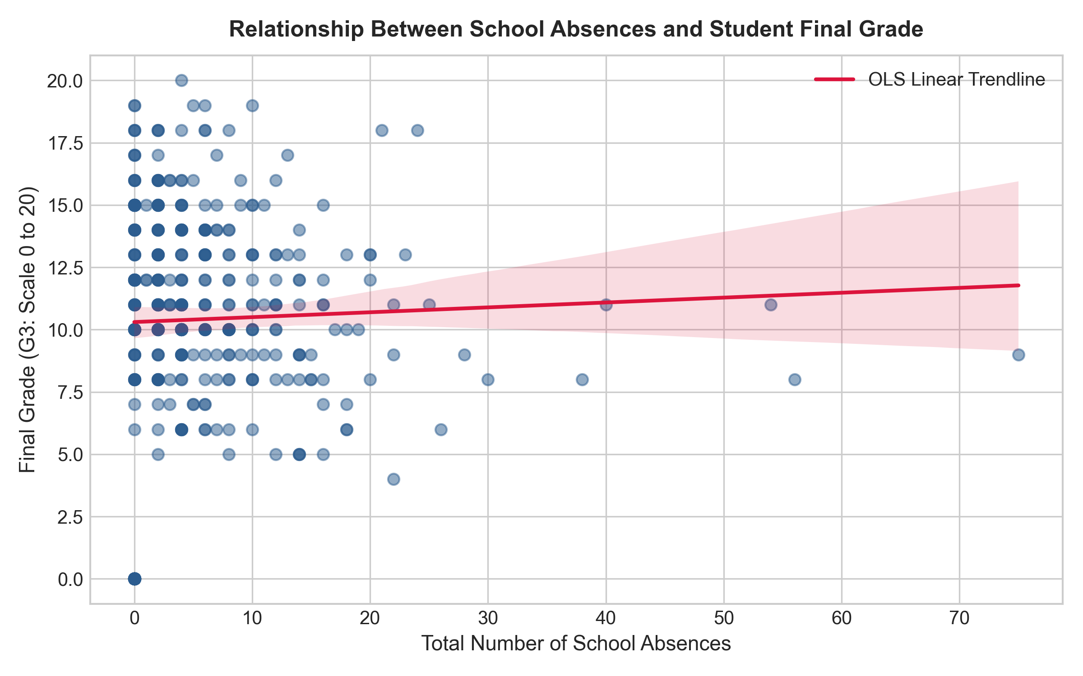
What It Shows: Bivariate scatter points correlating individual absence counts (0-93) against final grade G3, overlayed with a fitted linear trendline.
Why Created: To evaluate whether higher absenteeism systematically depresses student academic achievement.
Key Observations: Absences are heavily concentrated between 0 and 10 days. The linear correlation is weakly positive (r = +0.034), contrary to common intuition.
Academic Interpretation: High absenteeism does not automatically imply low grades; high-performing students occasionally exhibit planned absences, while many zero-grade students had zero recorded absences due to immediate withdrawal.
Conclusion: Absence count must be interpreted in conjunction with failure history and prior grades rather than as an isolated penalty.

Correlation Matrix Heatmap of Numerical Student Features
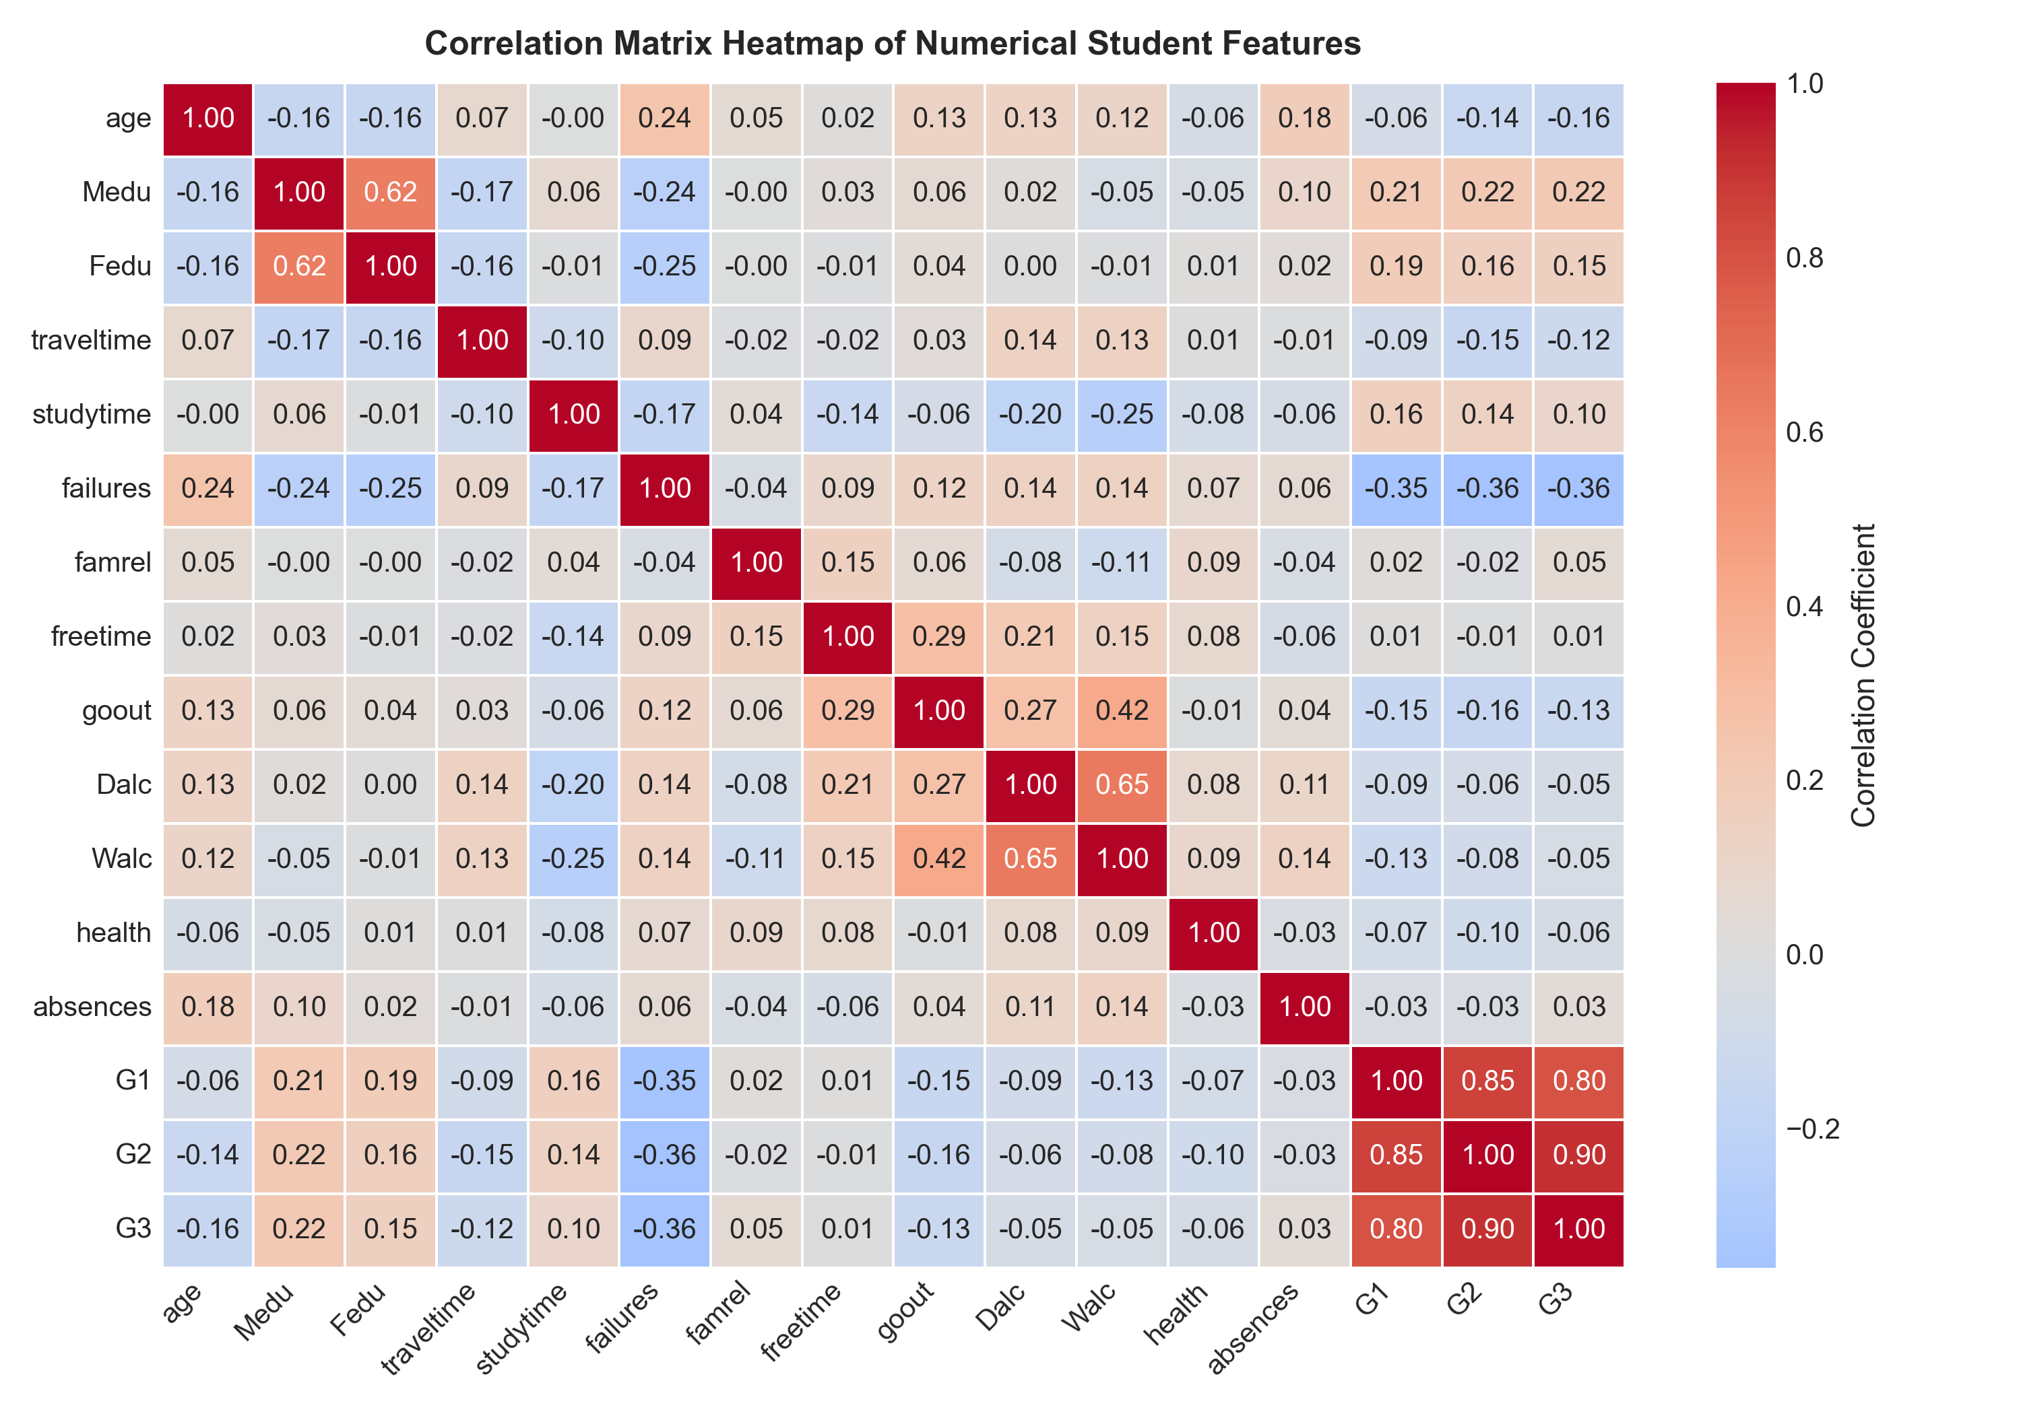
What It Shows: Color-coded correlation coefficients across all key numerical attributes (Age, Medu, Fedu, Studytime, Failures, Absences, G1, G2, G3).
Why Created: To detect multicollinearity, identify dominant predictors of final performance, and uncover cross-attribute synergies.
Key Observations: G1 and G2 show the strongest positive correlation with G3 (r = 0.801 and r = 0.905). Past failures correlate negatively with G3 (r = -0.360).
Academic Interpretation: Prior academic momentum is overwhelmingly predictive of final grades. Parental education positively correlates with study time and grades.
Conclusion: Historical grades serve as anchor features; predicting early without them requires relying on failures, study time, and parental support.

Pairwise Scatter and Distribution Matrix of Core Predictors
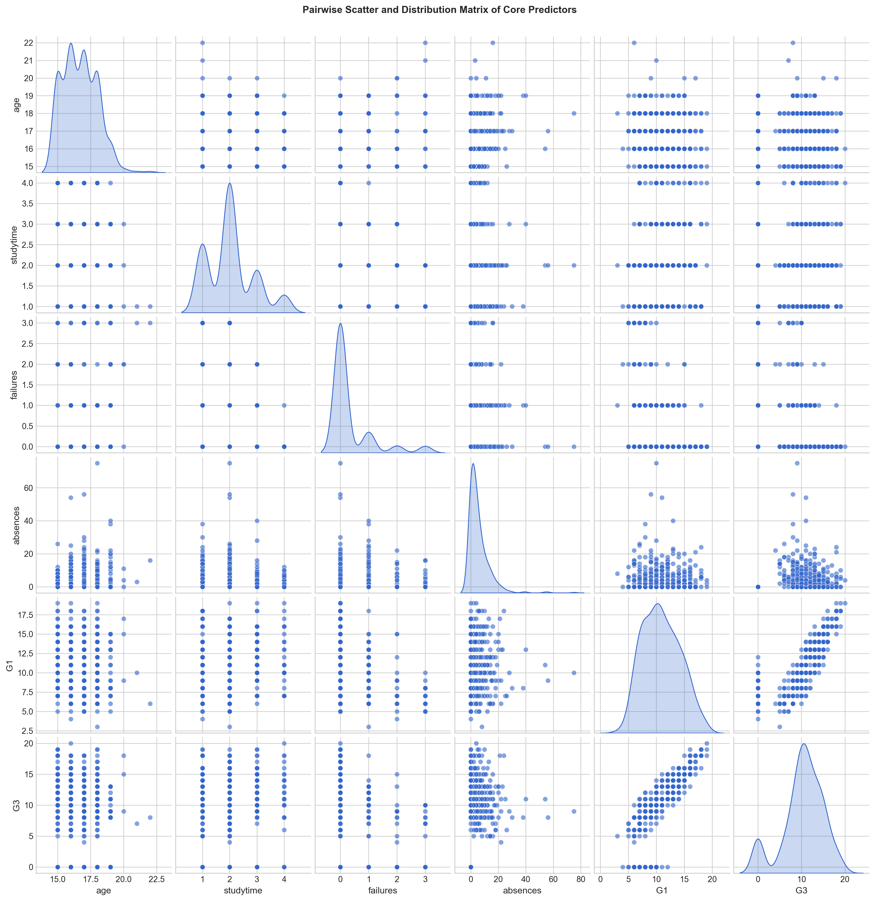
What It Shows: Multi-panel grid of bivariate scatter plots in the off-diagonal cells and univariate density distributions on the diagonal.
Why Created: To inspect multivariate feature interactions, non-linear trajectories, clustering, and variance homogeneity simultaneously.
Key Observations: A tight linear band links G1 with G3. Students with multiple past class failures uniformly cluster in the lower performance tier.
Academic Interpretation: Failure count exhibits an asymmetric penalty: zero failures allows full grade variance, whereas >=2 failures strongly caps maximum grade.
Conclusion: Multi-attribute analysis confirms that previous academic setbacks represent severe barriers to achieving top marks.

Distribution of Key Academic Support and Behavioral Factors
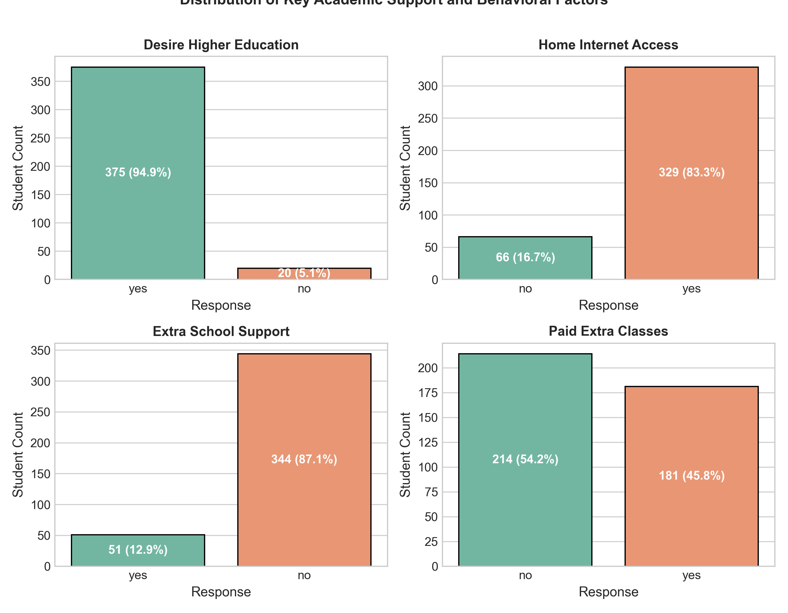
What It Shows: Frequencies of four influential binary indicators: desire for higher education, home internet access, school support, and extra paid classes.
Why Created: To understand socioeconomic distribution, institutional support reach, and digital access among the student cohort.
Key Observations: 94.9% intend to pursue higher education, 83.3% possess home internet, 13.0% receive school support, and 45.8% take extra paid classes.
Academic Interpretation: The high aspiration rate creates a strong motivation baseline, while institutional support is concentrated on a targeted 13% remedial group.
Conclusion: Categorical variables provide vital context for personal student circumstances that complement raw exam marks.

Comparative Density of Final Grades by Higher Education Aspiration
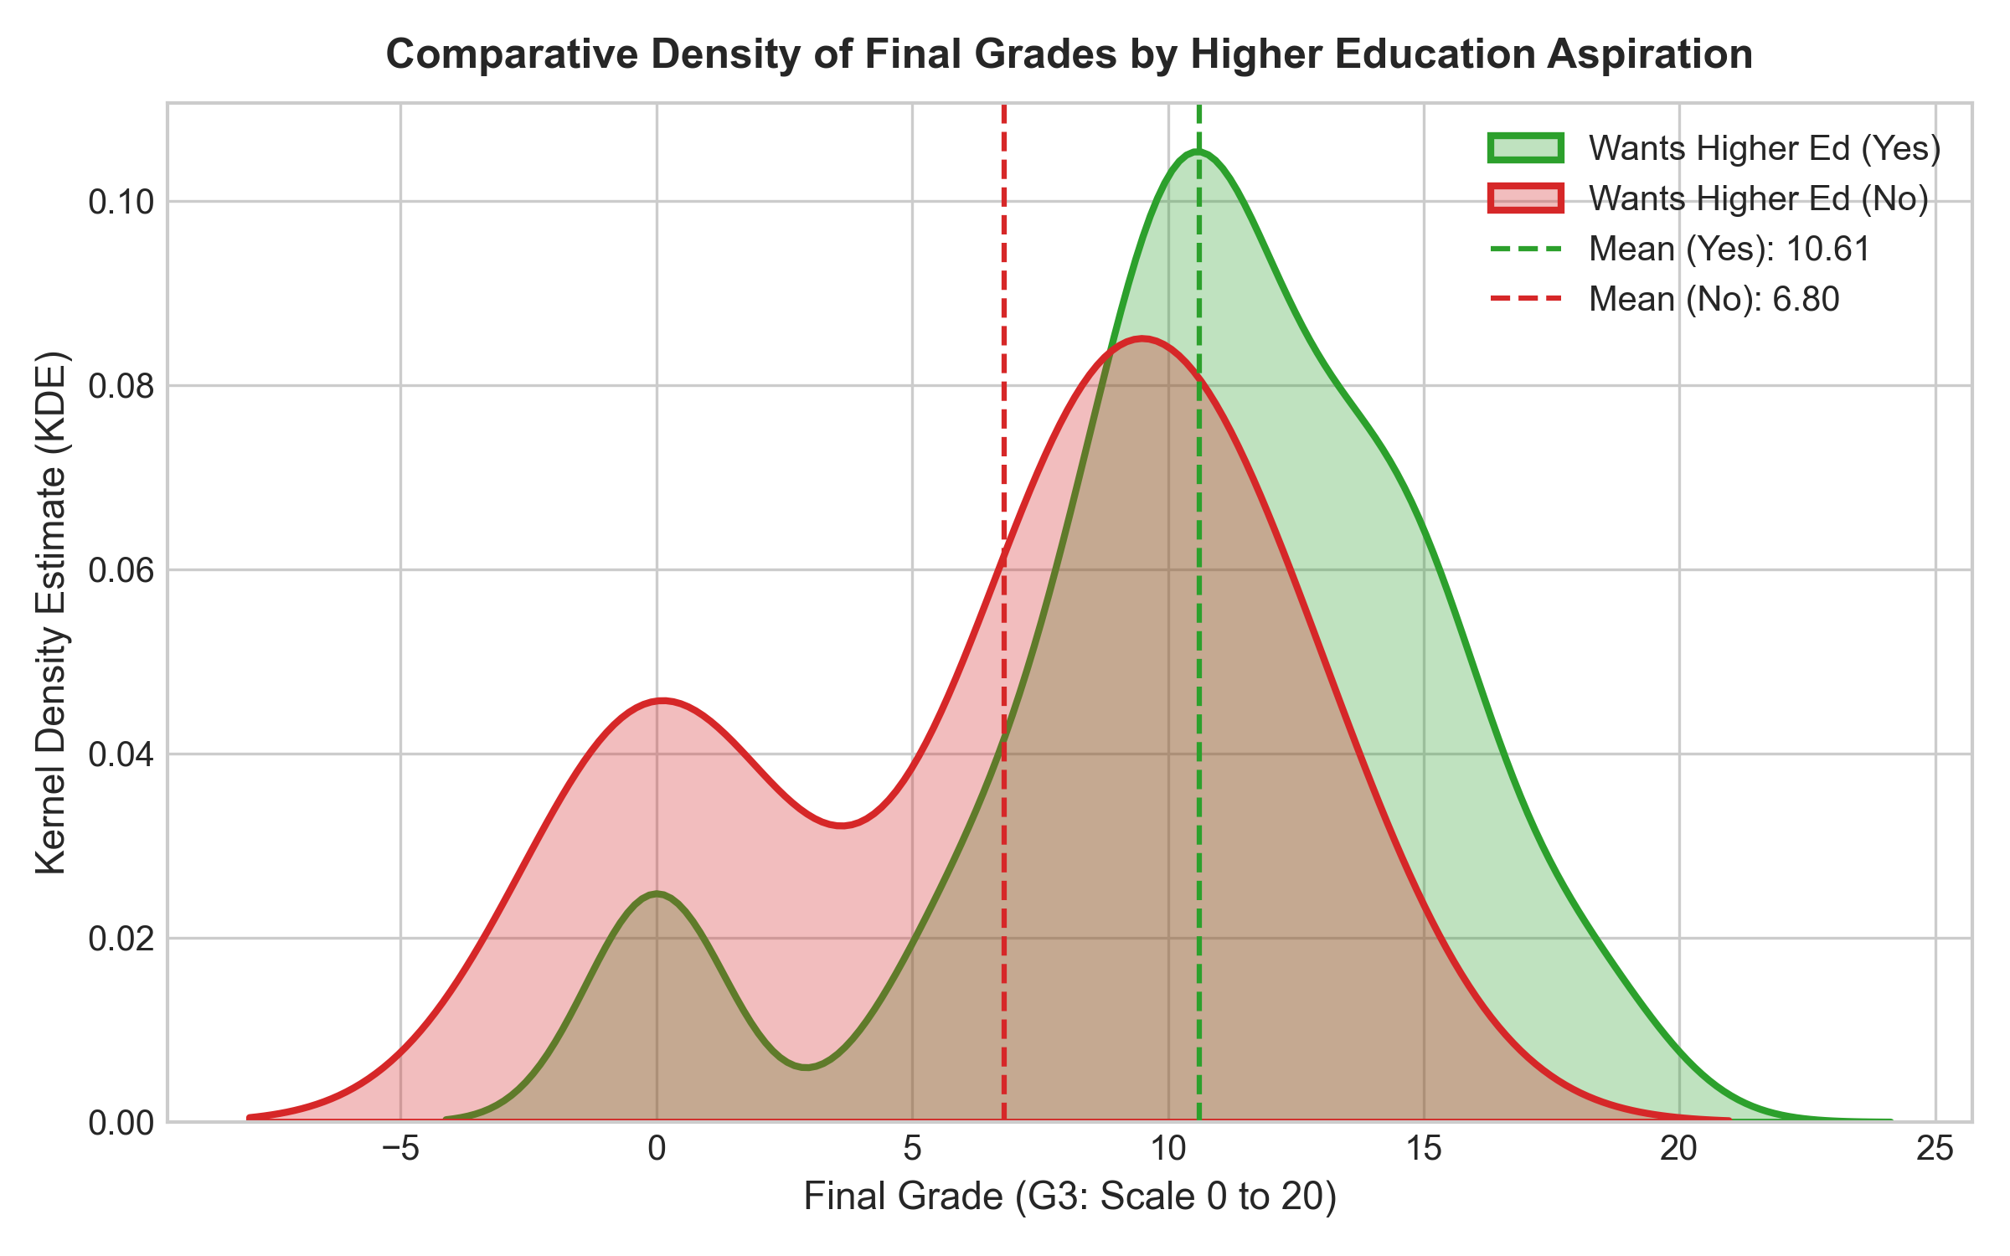
What It Shows: Dual overlapping KDE curves comparing final grade distributions of students aspiring for higher education versus those who do not.
Why Created: To determine whether intrinsic long-term academic aspiration systematically shifts the entire performance distribution.
Key Observations: Students desiring higher education exhibit an average score of 10.68 with a right-shifted peak, whereas non-aspirants average only 6.80.
Academic Interpretation: A 3.88 point gap exists between the cohorts. Non-aspirants suffer higher rates of zero scores and fail to reach top quartile scores.
Conclusion: Academic aspiration is one of the strongest psycho-social predictors of student persistence and final success.

9. THE SEVEN STAGES OF VISUALIZATION
1. ACQUIRE: Programmatic download of the UCI student dataset archive.
2. PARSE: Decoding CSV format, mapping 33 attributes into appropriate statistical data types.
3. FILTER: Data cleaning, missing value check, IQR outlier analysis, and feature subsetting.
4. MINE: Statistical summaries, skewness, kurtosis, ANOVA hypothesis testing, and correlation metrics.
5. REPRESENT: Construction of histograms, boxplots, scatterplots with OLS, and heatmaps.
6. REFINE: Typography optimization, axis scales, color palettes, and dual mean/median annotation lines.
7. INTERACT: Interactive exploration via Streamlit dashboard sliders, filters, and real-time prediction forms.

10. DEEP LEARNING MODEL ARCHITECTURE & HYPERPARAMETER TUNING
Architecture: Keras Multi-Layer Perceptron (MLP) Regressor with 41 input features, Hidden Layer 1 (128 units, ReLU, Dropout 0.2), Hidden Layer 2 (64 units, ReLU, Dropout 0.2), Hidden Layer 3 (32 units, ReLU), and Output Layer (1 unit, Linear activation).
Training: Adam optimizer (learning rate = 0.001), MSE loss, MAE metric, batch size 32, epochs 100 with EarlyStopping (patience=15) and ModelCheckpoint saving best weights to 'models/best_model.keras'.
Hyperparameter tuning across learning rates, hidden units, and dropout rates demonstrated optimal validation convergence with standard regularized architecture.

11. MODEL EVALUATION AND BENCHMARK RESULTS
Empirical Test Set Metrics (N = 60 test instances):
• Deep Learning MLP (Best Model): MAE = 1.8189, RMSE = 2.3492, R² = 0.7245
• Linear Regression Baseline: MAE = 1.5164, RMSE = 2.0554, R² = 0.7891
• Random Forest Regressor: MAE = 1.1417, RMSE = 1.8695, R² = 0.8255
• Early Prediction MLP (Without G1 & G2): MAE = 3.1436, RMSE = 3.9916, R² = 0.2045
Diagnostic Analysis: Dropout (0.2) and early stopping maintained a controlled generalization gap between training and validation loss curves. The early prediction experiment demonstrates that prior academic marks (G1, G2) account for the vast majority of final grade variance.
Figure 9: Training Loss and Validation Loss Curves across Epochs
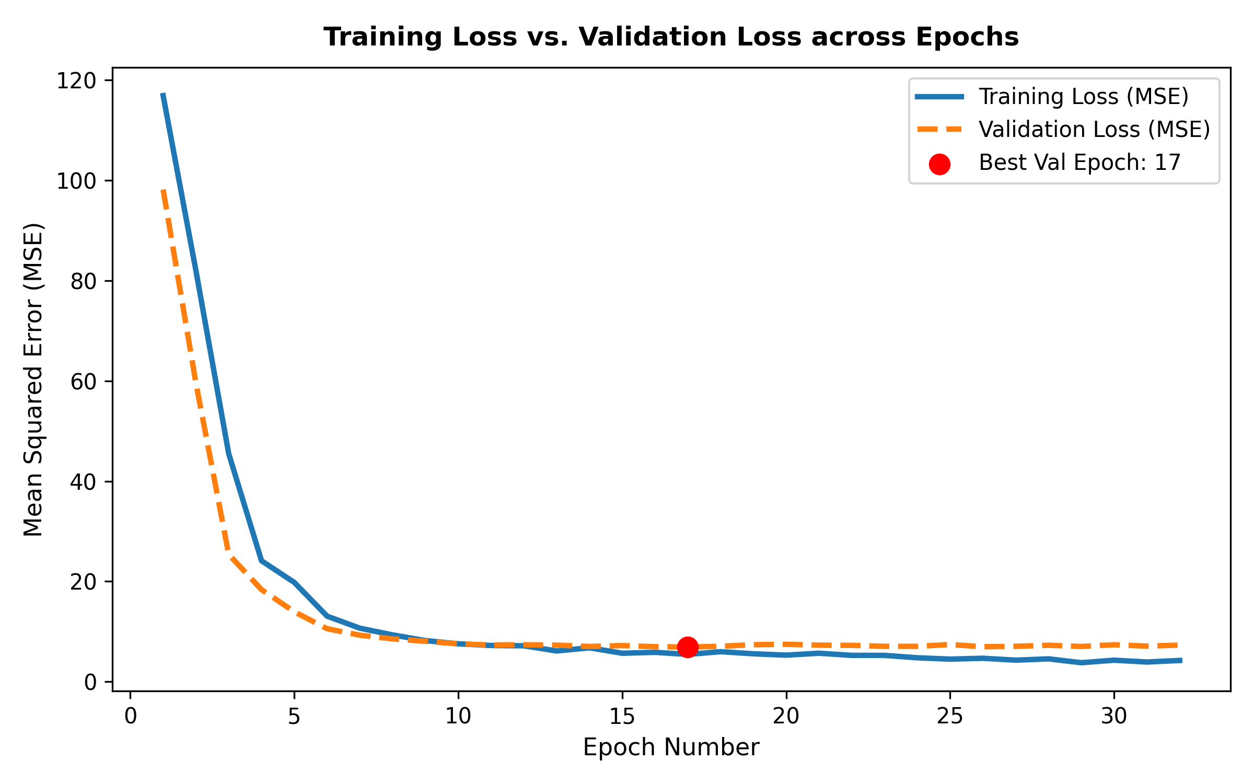
Figure 10: Actual versus Predicted Grades on Test Set
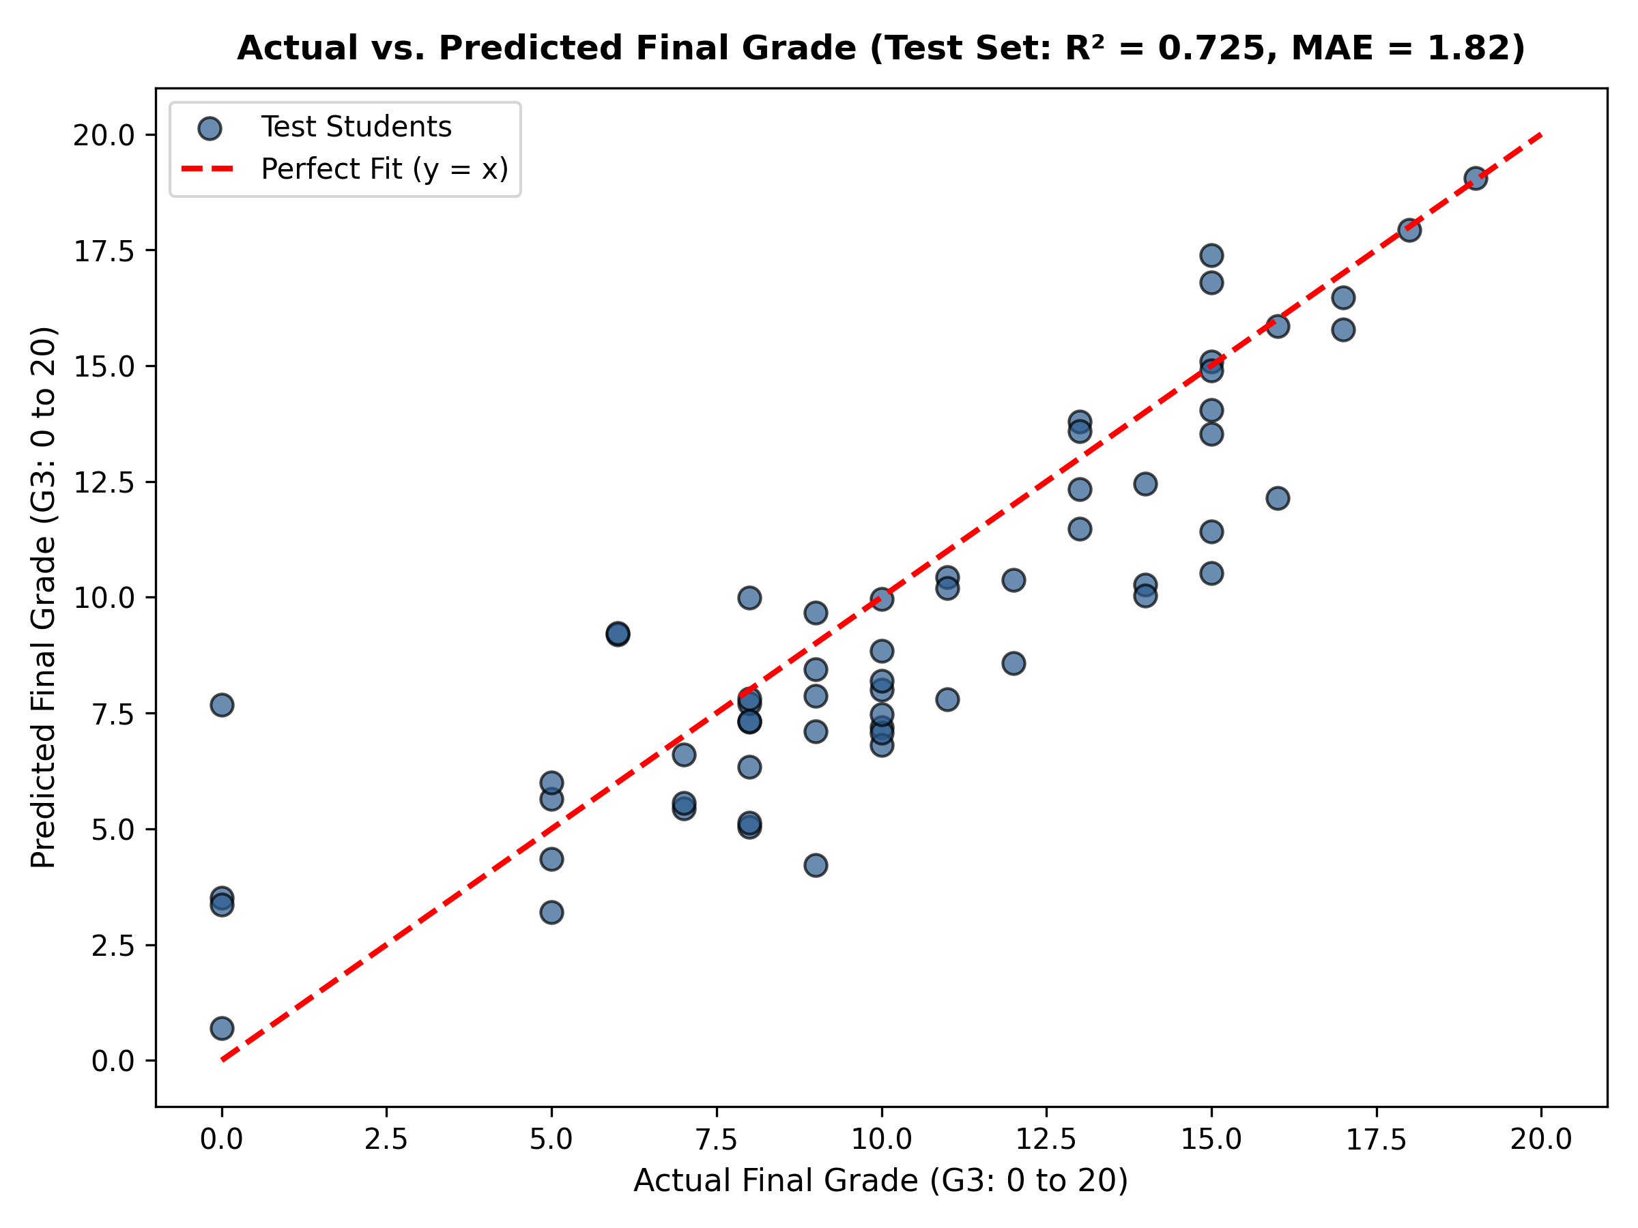
Figure 11: Prediction Error Distribution (Residuals)
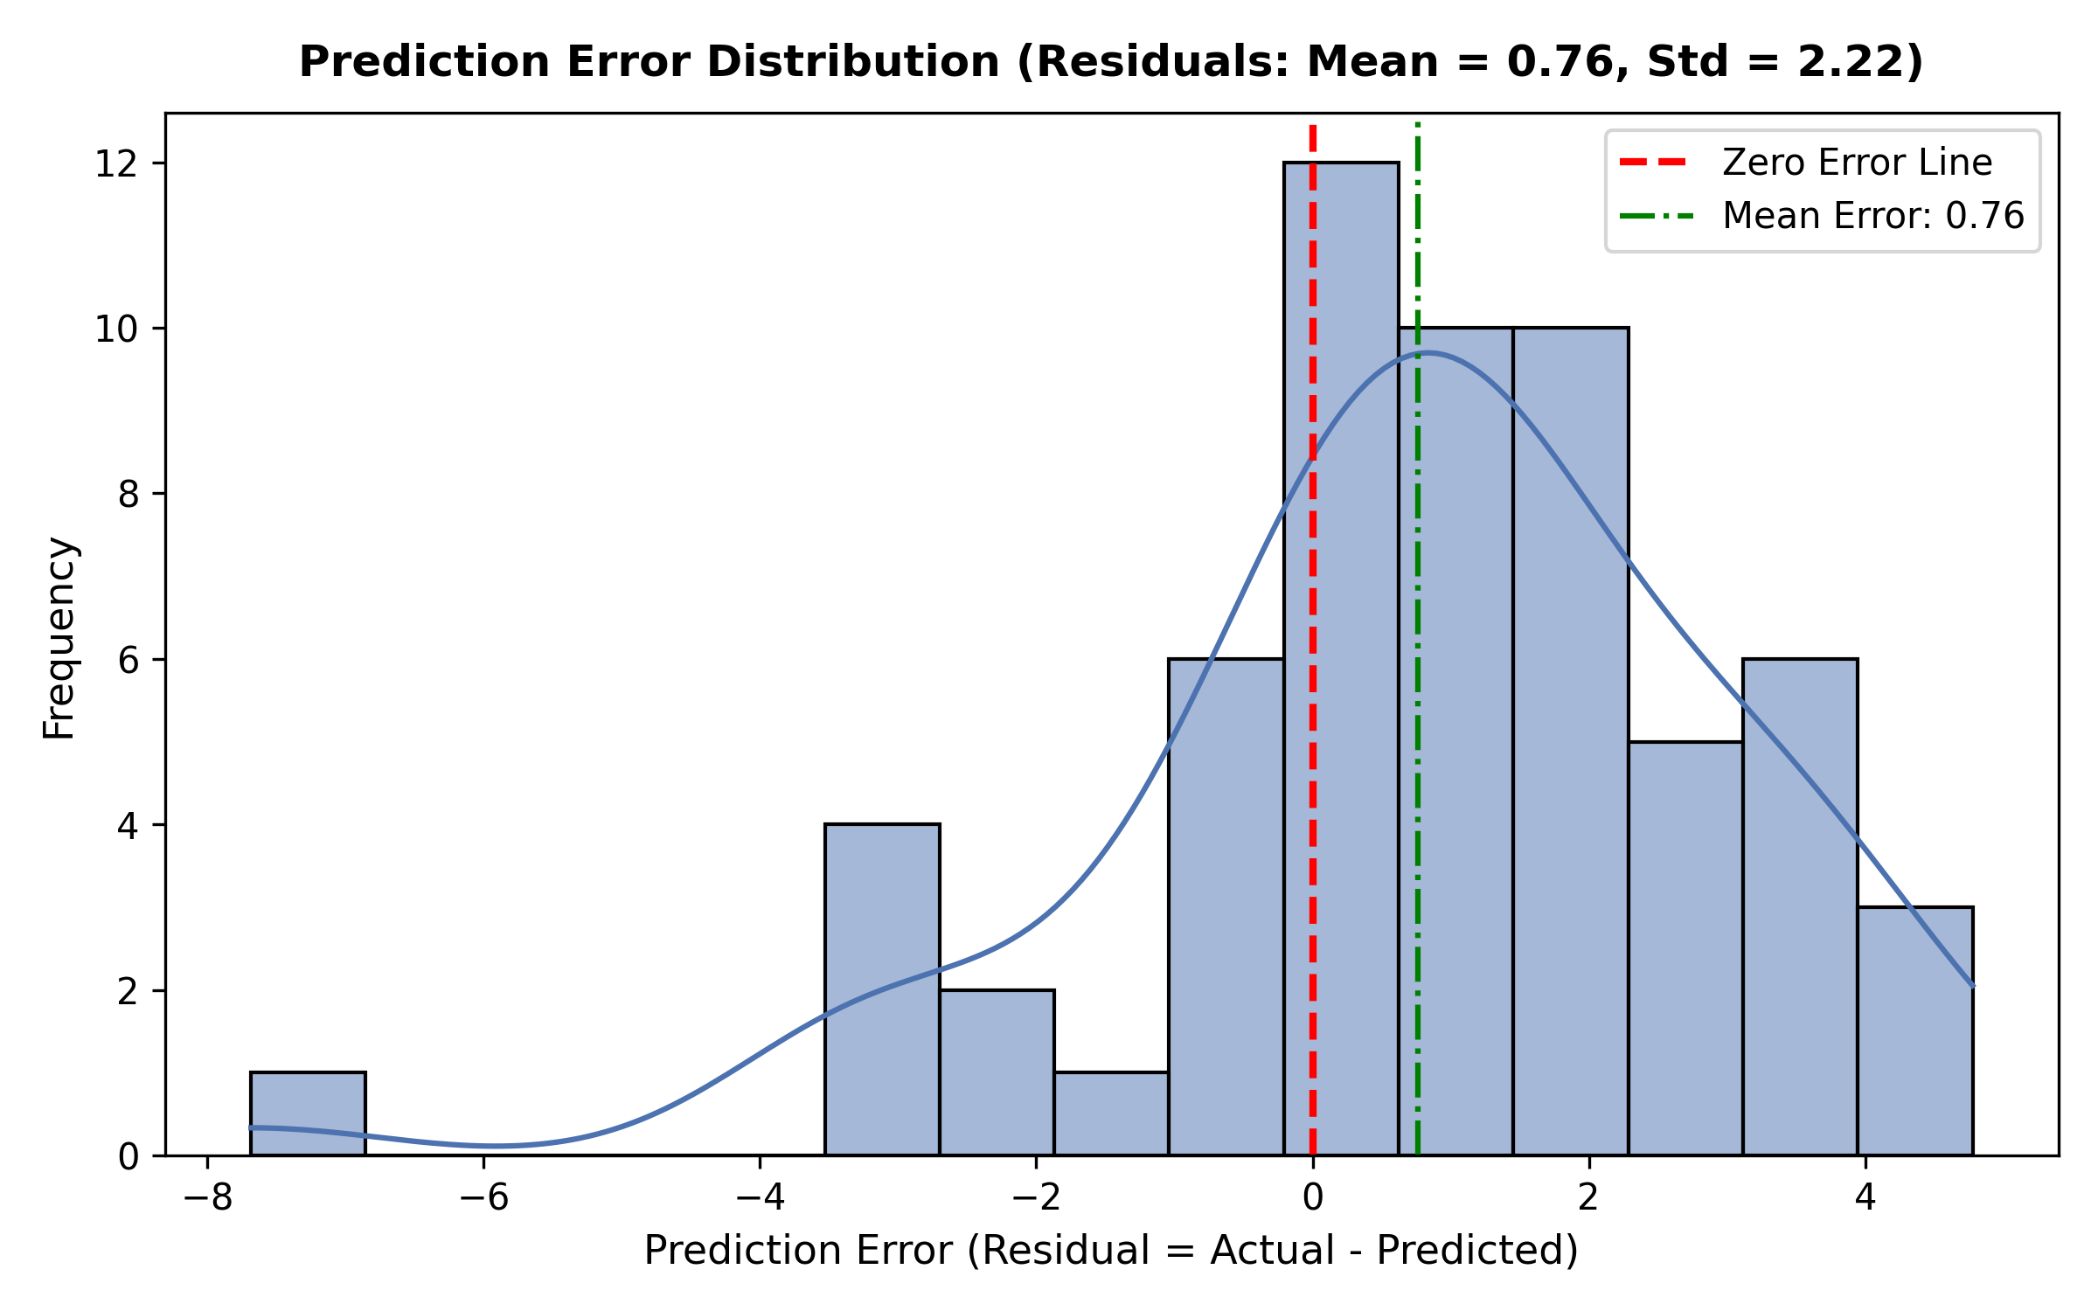
Figure 12: Benchmark Comparison of Error Metrics Across Models
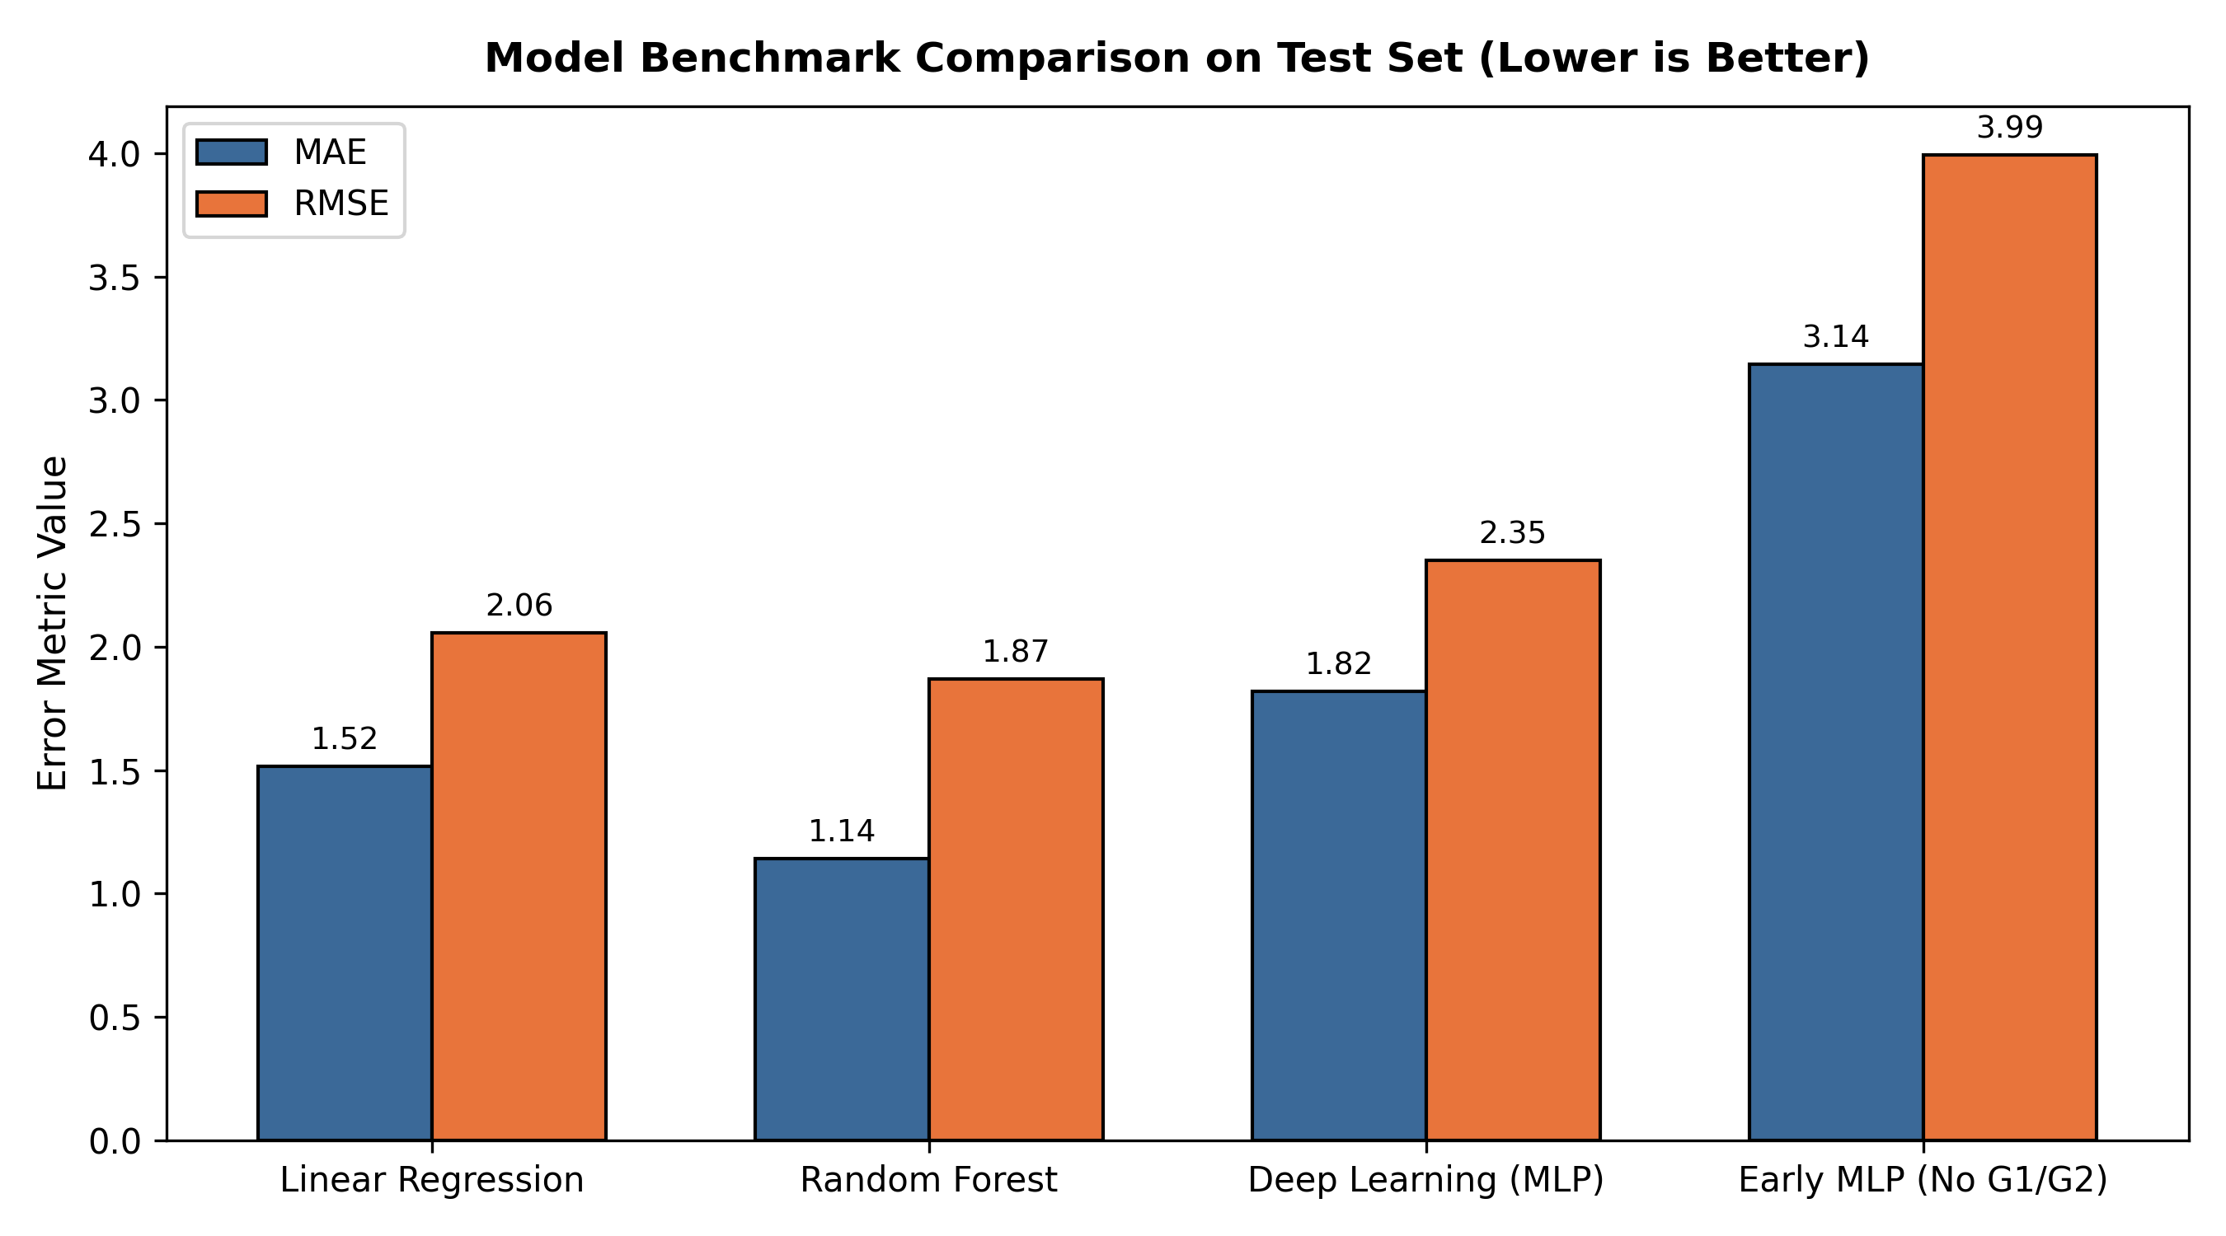

12. CONCLUSION
The project provides a comprehensive end-to-end framework integrating rigorous exploratory data analysis, formal statistical hypothesis testing, and deep learning regression. The MLP achieved an MAE of 1.82 on the test set. The application provides actionable decision support for educational administrators to identify at-risk students.

13. FUTURE SCOPE
Future work includes incorporating temporal LMS behavioral interaction data, implementing counterfactual explainability (SHAP/LIME), and utilizing hurdle models to separately handle non-attendance dropouts and continuous performance.

14. LITERATURE REVIEW AND REFERENCES (IEEE STYLE)
[1] P. Cortez and A. Silva, 'Using data mining to predict secondary school student performance,' in Proceedings of 5th Annual Future Business Technology Conference (FUBUTEC 2008), Porto, Portugal, 2008, pp. 5–12.
[2] D. Dua and C. Graff, 'UCI Machine Learning Repository: Student Performance Data Set,' University of California, Irvine, School of Information and Computer Sciences, 2017. [Online]. Available: https://archive.ics.uci.edu/dataset/320/student+performance.
[3] M. Abadi et al., 'TensorFlow: A system for large-scale machine learning,' in 12th USENIX Symposium on Operating Systems Design and Implementation (OSDI 16), 2016, pp. 265–283.
[4] F. Pedregosa et al., 'Scikit-learn: Machine learning in Python,' Journal of Machine Learning Research, vol. 12, pp. 2825–2830, 2011.
[5] C. Romero and S. Ventura, 'Educational data mining: A review of the state of the art,' IEEE Transactions on Systems, Man, and Cybernetics, Part C (Applications and Reviews), vol. 40, no. 6, pp. 601–618, Nov. 2010.

15. APPENDIX: SOURCE CODE REPOSITORY AND REPRODUCTION INSTRUCTIONS
Execution Commands:
1. Install dependencies: pip install -r requirements.txt
2. Train deep learning models: python src/model.py
3. Generate evaluation charts: python src/evaluation.py
4. Generate PDF & Word reports: python src/report_generator.py
5. Launch Streamlit web dashboard: streamlit run app.py
Project files:
- app.py: Streamlit dashboard
- src/data_loader.py: UCI auto-download & validation
- src/preprocessing.py: 70/15/15 train-val-test split & pipeline
- src/eda.py: Statistical & bivariate analysis
- src/statistical_analysis.py: Normality & hypothesis testing
- src/visualizations.py: 8 required charts
- src/model.py: Deep Learning MLP & Baselines
- src/evaluation.py: Test metrics & diagnostic plots
- src/prediction.py: Interactive inference & intervention advisor
- src/report_generator.py: Automated PDF & DOCX generation

