TamilNadu’s Health Centers Report

(For Covid-19)

Done by: Shreebuvan V

**Introduction:**

The present scenario of the outbreak of the COIVD-19 has led to a pandemic which none of us have never even imagined off. This situation has made it really hard for even many of the developed countries like US. It has also made a wild swipe in India as well with almost 10 lakhs+ cases at present and still counting. Tamilnadu has become the one of the most affected states in India with almost 150k+ cases. Although Tamilnadu govt. have taken many steps to bring this pandemic to a control, the population density has always been an alarming problem. Therefore, there is always a huge problem in bringing forth the isolation centers in the state and making this accessible to the masses is also a rising problem. The issues to be kept in mind for this is as follows:

* Centralized centers alone cannot do any good to the people as people from the other parts of the state will not be able to get in access to the facilities
* When the infected are to be taken to the hospitals there are chances that the attendees may get affected and the social distancing fact is taken for granted in a state like Tamilnadu.

So decentralized testing and isolation wards can be very useful for the govt. to both keep the pandemic under control as well as treat the infected with the best facilities available and this work would of great help to them.

**Data:**

I have surfed through the Internet and found out NRIOL website where anyone can get the split-up of the population and the area (in sq. km) of a given state, district-wise. The most important feature is that we get all the details in tabular for with the .asp file extension which is easier to play around with. The information in the website is as shown in the image below:

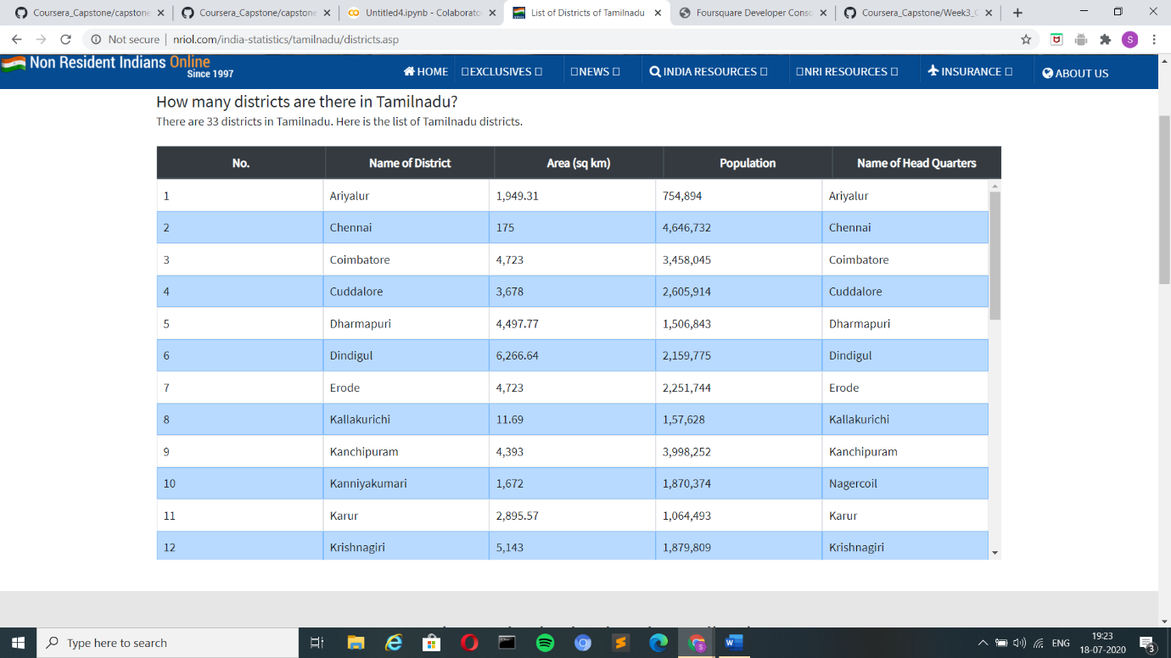

I have done the web-scrapping using the BeautifulSoup available as a part of the bs4 library in python. This information is then compiled and made into a dataframe and the latitude and longitude values where extracted using the Nominatim function in Geopy Library with the names of the districts which where web-scrapped from the NRIOL website. Now this information together makes the dataframe ready to play with and get the needed insights from it. The final dataframe with all the data values looks like the image below.

