**Short Answer Question:**

[After ***scrutinising*** the question – highlight the **key words** in the question]

Q1. Explain what is meant by a production possibility curve and use a production possibility curve diagram to explain the concepts of scarcity, choice and opportunity cost. [10m]

M08/HP2/Q1

Scarcity refers to the insufficiency of amount or supply of existing human resources.

Choice refers to when a person is faced with two or more alternative uses of a resource and must make a decision to utilize only one alternative

Opportunity cost refers to the measure of the cost of any choice in terms of the next best alternative forgone

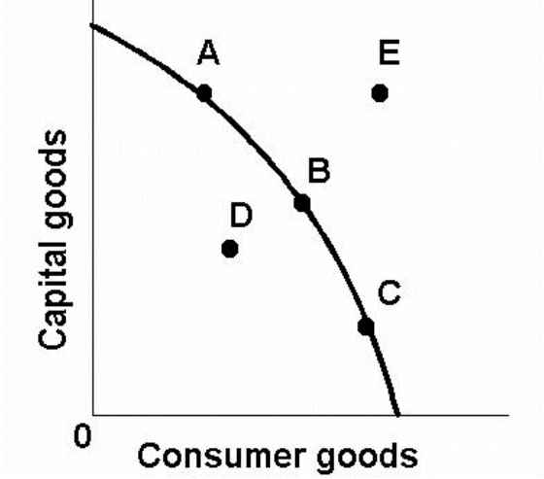

The (((diagram W))) illustrates the concept of the PPC.

Scarcity is the insufficiency of amount or supply of existing human resources. It is shown in the PPC by the fact that you cannot produce at any point beyond the PPC which means you are confined to your productive capacity. Scarcity is therefore represented on the PPC by the point E.

For example, land is a scarcity in Singapore. There are insufficient land resources to meet the housing demand, and therefore production of housing is limited by scarcity of land available.

Choice arises when a person is faced with two or more alternative uses of a resource and must make a decision to utilize only one alternative. It is shown in the PPC by the points A, B and C on the curve where you have the alternatives of utilizing resources in 3 different ways.

For example, land is a limited resource in Singapore, therefore the government has to choose how they want to utilize the land, such as for housing or for industry.

Opportunity cost measures the cost of any choice in terms of the next best alternative forgone. Opportunity cost is measured by the gradient of the PPC, where it slopes downwards towards the right, showing the increasing output of consumer goods at the expense of capital goods. An increase in consumer goods requires a decrease in capital goods. The gradient of the curve at B is greater than the gradient of the curve at A, thus there is higher opportunity cost in choosing A than in choosing B.

For example, in a certain amount of land, the government has the choice of building either a school or a HDB Estate. If the government choose to build the school, the HDB Estate will be its opportunity cost.