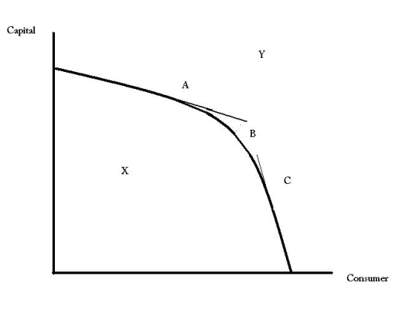**Assignment: 3**

(3) points

Product A

The (((diagram W))) illustrates the concept of the PPC

Product B

**Production Possibility Curve:**

[Production possibilities](javascript:pop_dsp('pop_gls.pl?k=Production%20possibilities',500,400)) is a study the production of alternative goods and services produced with the equal quantity of input within the given time limit and represented by a graph.

.**Scarcity:**

Human suffers the limitation in his life, this limitation does not mean that things or circumstances around him is limited, but his wants never let him to have unlimited resources, this situation is known as scarcity. The curve line in the production Possibility is because of scarcity.

**Choice: (4)**

In the production Possibility curve, the convex line on the graph shows the restriction in the way of production. This line says that if economy has to increase the quantity of one product (consumer goods) then economy has to decrease the quantity of other product (capital good), at this point economy choose that what he has to produce, and what quantity, and who are demanding the particular goods which economy is supposed to increase the quantity. This situation is known as Choice.

**Opportunity Cost**:

Opportunity cost is the worth of an activity which you do on alternative basis, in which you have to have one thing by leaving the other one. It is said that there is nothing like “Free lunch” in the economy, everything which you do has price. And that price which you pay to get the other one is known as opportunity cost.

In this diagram, the quantity obtained of product B at point C having the opportunity cost which is the amount we forgo from the Product A.