**(3 marks)**

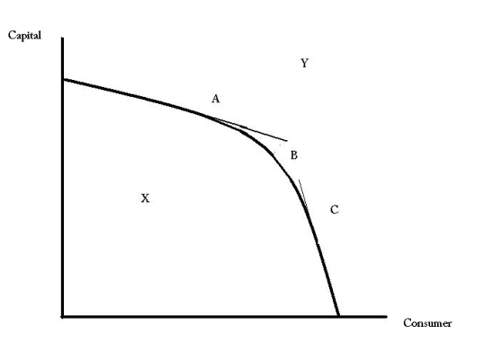**Assignment: 5**

Product A

The (((diagram W))) illustrates the concept of the PPC

Product B

**Production Possibility Curve:**

Production Possibility Curve or PPC graph is an analytical study of the combination of two products, produced at the same time with different alternatives of resources are being applied for production to get the maximum output.

In the graph every point (X,Y,A,B,C) has the economic philosophy. Lets study each point and find out the economic philosophy.

**Point X in the graph**:

Point X exists below the curve, this shows that economy has resources but these resources are not being utilized efficiently that is why the combination of two goods are being produced but resourced those are consumed in the production are to as efficient as they should be. The economy is running below the strength that it has. This may happen because of poor planning, wrong decision making, and external disturbance (natural disasters, civilian anarchy, and political disorder).

**Point Y in the graph:**

Point Y is above the curve in the graph. This is the desired point for an economy, when the production of both goods increases at the same time. This is only happening when resources are advanced by technological increment and efficient resources. This point represents the concept of scarcity,

**Point B in the graph:**

Point B is on the curve in the graph which shows the maximum production (quantity) from the combination of two goods and services. This point tells us that economy is not in the situation to take the decision regarding alternative quantity for production.

**Point A and C in the graph:**

The point A and C represents the alternative way of production. The point A and Point C represents the concept of choice and if we measure the cost of choice taken, that will represent the concept of opportunity cost.

**Scarcity:**

Above-mentioned graph take a picture of scarcity, the question arises in the graph that why curvy line occurred? The answer of this question is scarcity. We lack the quantity of resources which can meet the quantity we demand for goods and services.

**Choice: (5)**

In the graph, Point A and C shows that economy leaves some quantity of production from the point C and moves to the point A and vice-versa . We know resources do not allow us to move to the point Y, because we have limited resources and increase the production of two products at the same time under the umbrella of same inputs (resources). The shifting of the quantities in the production, from point C to A or A to C because of the concept of Choice.

**Opportunity Cost**:

In the above graph, the activities happen on the point A and C. If we measure the activity’s value, we have to follow the concept of opportunity cost. Opportunity cost can be defined as, the highest-valued forgone, to get the other thing. (3)