LP201 Practicum for Innovative Engineering
Design Presentation Report
SMART LUME
Team Number: 10

S.No  . | Student Name | Roll No. | Year of Study | Department
1 | Kavin Prasanna K | 411723205023 | 3rd Year | IT
2 | Kaviya K | 411723205024 | 3rd Year | IT
3 | Anusha M | 411723205005 | 3rd Year | IT
4 | Viveka M | 411723106089 | 3rd Year | ECE
5 | Shreedhar G | 411723106078 | 3rd Year | ECE

Faculty Mentors:

S.No. | Faculty Name | Department
1 | Ms.D.Little Femilin Jana | S & H
2 | Dr.X.Mercilin Raajini | ECE

PRINCE SHRI VENKATESHWARA PADMAVATHY ENGINEERING COLLEGE
Date of Submission: May 2026

Abstract
Traditional street lighting systems consume a significant amount of electrical energy as they operate continuously at full intensity, regardless of environmental conditions or human presence. This leads to unnecessary energy wastage, increased operational costs, and reduced system efficiency. To address these challenges, this project proposes a Smart Street Light System that automatically controls street lighting based on ambient light intensity and motion detection.

The system uses an LDR (Light Dependent Resistor) to sense surrounding light levels and a PIR (Passive Infrared) sensor to detect the presence of pedestrians or vehicles. A microcontroller such as ESP32 or Arduino processes the sensor data and adjusts the brightness of LED street lights accordingly. The system can also be integrated with IoT technology to enable remote monitoring, real-time data analysis, and control through a cloud platform or mobile application.

This smart solution significantly reduces energy consumption by ensuring that lights operate only when required and at optimal brightness levels. Additionally, it improves safety by increasing illumination when motion is detected. The system is scalable, cost-effective, and environmentally friendly, making it suitable for modern smart city infrastructure. Overall, the proposed design enhances energy efficiency, reduces maintenance costs, and contributes to sustainable urban development.

Table of Contents
- Problem Statement and Product 3
- Disciplines Involved 3
- Design Option Comparison 4
- Design Evaluation – Weighted Rating 5
- Selected Design 6
- Block Diagram 7
- Projection Views & Pseudocode 8
- Bill of Material and Cost Estimate 9
- Gantt Chart – Project Plan 10
- Open Issues 11
- References 12

Problem Statement and Product

Problem Statement:

Traditional street lighting systems operate continuously at full brightness, resulting in excessive energy consumption and higher maintenance costs. These systems lack adaptability to environmental conditions, often remaining switched ON during daylight hours or operating at full intensity even when no pedestrians or vehicles are present.

This inefficiency leads to unnecessary energy wastage and increased operational expenses.

Project / Product:
The proposed system is a Smart Street Light System that automatically adjusts lighting intensity based on ambient light conditions and motion detection.
The system ensures that street lights operate only when required, thereby improving energy efficiency while maintaining safety and visibility.

Disciplines Involved
The development of this project involves multiple engineering disciplines:
- Electrical Engineering – Power supply design, energy distribution, load management, and efficient utilization of electrical energy.
- Electronics Engineering – Integration of sensors such as LDR and PIR, circuit design, signal processing, and interfacing components with the microcontroller.
- Computer Science / IoT – Programming the microcontroller, implementing automation logic, enabling wireless communication, cloud connectivity, and remote monitoring systems.
- Mechanical Engineering – Design and fabrication of the street light structure, enclosure design for protection of components, and durability under environmental conditions.
- Civil Engineering – Planning and installation of street light poles, foundation design, and integration with urban infrastructure.
- Environmental Science – Ensuring energy efficiency, reducing carbon footprint, promoting sustainable energy usage, and minimizing environmental impact.

Design Option Comparison:

Design Option 1 – Basic Sensor-Based System:

This system uses an LDR (Light Dependent Resistor) to detect ambient light levels and a PIR (Passive Infrared) sensor to detect the presence of pedestrians or vehicles. A simple microcontroller (such as Arduino) processes the sensor inputs and controls the street light accordingly.

When the surrounding light intensity is low or motion is detected, the street light is turned ON; otherwise, it remains OFF. This design is simple, cost-effective, and easy to implement. However, it has limitations such as lack of remote monitoring, limited scalability, and no data tracking capabilities.

Design Option 2 – IoT-Based Smart System:
This system enhances the basic design by integrating IoT technology. It uses LDR and PIR sensors along with a microcontroller such as ESP32 or NodeMCU, which provides built-in Wi-Fi connectivity.
The system can monitor and control street lights remotely through a cloud platform or mobile application. It enables real-time data analysis, remote access, and better system control. This design is scalable and suitable for large-scale smart city applications. However, it has a slightly higher cost compared to the basic system.

Feature | Basic System | IoT System
Cost | Low | Moderate
Complexity | Simple | Moderate
Monitoring | No | Yes
Scalability | Limited | High
Efficiency | Moderate | High

Design Evaluation – Weighted Rating Method
To select the most suitable design, both proposed systems were evaluated using a weighted rating method. Different criteria were assigned weights based on their importance to the project objectives. Each design option was then scored on a scale of 1 to 5, and the weighted scores were calculated.

Criteria | Weight | Design A: Basic Method | Design B: IoT System
Scalability | 20% | 2 (0.4) | 5 (1.0)
Development Cost | 25% | 5 (1.25) | 3 (0.75)
User Experience | 20% | 2 (0.4) | 4 (0.8)
Efficiency | 20% | 3 (0.6) | 5 (1.0)
Integration | 15% | 2 (0.3) | 4 (0.6)
TOTAL SCORE | 100% | 2.95 | 4.15

IoT System:

From the evaluation, the IoT-Based Smart Street Light System achieved a higher total score compared to the basic system. It performs better in terms of scalability, efficiency, user experience, and system integration. Although the cost is slightly higher, the long-term benefits outweigh the initial investment.
Therefore, the IoT-based design is selected as the final and optimal solution for this project.

Selected Design Option
Based on the design evaluation using the weighted rating method, the IoT-Based Smart Street Light System is selected as the optimal solution. This design provides better performance in terms of efficiency, scalability, automation, and user experience compared to the basic sensor-based system.

Objective:

The main objective of the selected design is to develop an intelligent street lighting system that automatically adjusts its operation based on environmental conditions and human presence, thereby reducing energy consumption while ensuring safety and visibility.

Power Source:
Operates on solar energy with optional battery backup, enabling eco-friendly and continuous operation.

Working Principle:
The system uses an LDR (Light Dependent Resistor) to detect ambient light intensity. During daytime, when sufficient natural light is available, the street lights remain OFF. During nighttime or low light conditions, the system activates the street lights.
A PIR (Passive Infrared) sensor is used to detect motion such as pedestrians or vehicles. When motion is detected, the brightness of the LED street light increases to provide better visibility. In the absence of motion, the light operates at reduced intensity to conserve energy.
The entire system is controlled by a microcontroller (ESP32 or Arduino), which processes the sensor inputs and controls the output accordingly.

Key Features:
- Automatic ON/OFF control using LDR.
- Motion-based brightness adjustment using PIR sensor.
- Microcontroller-based automation.
- Energy-efficient LED lighting.
- IoT-based remote monitoring and control.
- Optional solar panel integration for renewable energy.

Advantages:
- Reduces energy consumption significantly.
- Enhances safety through intelligent lighting.
- Supports remote monitoring and control.
- Scalable for large-scale implementation.
- Minimizes maintenance and operational costs.
- Environment-friendly and sustainable solution.

Block Diagram
The block diagram below illustrates the major subsystems of the Ocean Guardian and their interconnections. The Main Control Unit (MCU/Arduino) is the central processing hub that receives data from all sensors and drives the propulsion system and skimmer mechanism accordingly.

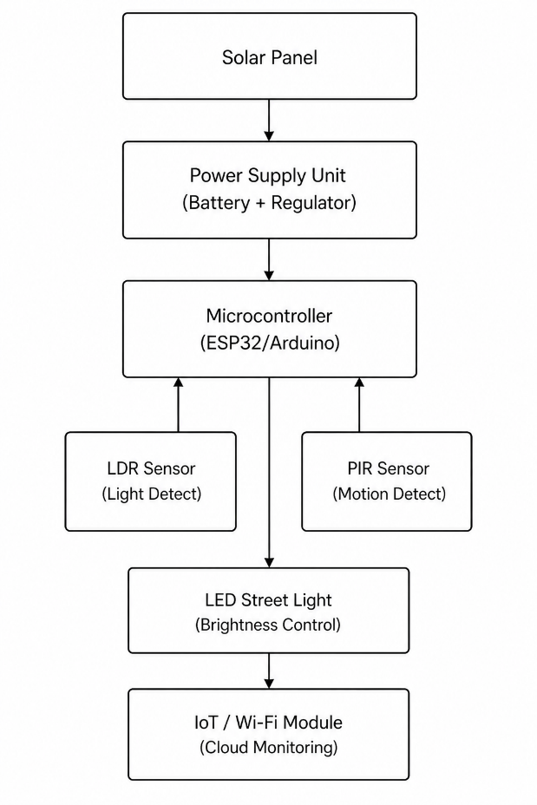

Block Diagram Component Descriptions:
- The block diagram represents the working of the IoT-based Smart Street Light System with all major components. The system is powered by a solar panel and battery unit, which provides a continuous and energy-efficient power supply.
- The LDR (Light Dependent Resistor) senses ambient light intensity to determine day and night conditions, while the PIR (Passive Infrared) sensor detects the presence of pedestrians or vehicles. These sensor inputs are given to the microcontroller (ESP32/Arduino), which acts as the central processing unit.
- Based on the sensor data, the microcontroller controls the LED street light, automatically switching it ON during low light conditions and adjusting brightness when motion is detected to conserve energy.
- Additionally, the system can be integrated with an IoT module for remote monitoring and control, improving efficiency and enabling smart city applications.

Projection Views of the Proposed Design

Pseudocode:
START //start
Init LDR,PIR,LED //setup
WHILE ON //loop
Read LDR,PIR //input
IF LDR<500 //dark
IF PIR=1 LED=HIGH //motion
ELSE LED=DIM //no motion
ENDIF
ELSE LED=OFF //day
ENDIF
Delay //wait
END WHILE
END //stop

Arduino Simulation Code:

int ldrPin = A0; // LDR connected to Analog pin A0
int pirPin = 2; // PIR sensor connected to digital pin 2
int lightPin = 13; // LED light connected to digital pin 13
void setup() {
pinMode(lightPin, OUTPUT);
pinMode(pirPin, INPUT);
Serial.begin(9600);
}
void loop() {
int lightLevel = analogRead(ldrPin);
int motion = digitalRead(pirPin);
if (lightLevel < 500 || motion == HIGH) {
digitalWrite(lightPin, HIGH); // Turn ON light
} else {
digitalWrite(lightPin, LOW); // Turn OFF light }
Serial.print("LDR: ");
Serial.print(lightLevel);
Serial.print(" PIR: ");
Serial.println(motion);
delay(1000);}

Bill of Material (BOM) and Cost Estimate
The following table lists all components required for the Ocean Guardian prototype, with sources and estimated costs:

S.No | Component Name | Quantity | Unit Cost (INR) | Total Cost (INR) | Description | Notes
1 | LDR Sensor | 1 | 50 | 50 | Detects light intensity
2 | PIR Sensor | 1 | 120 | 120 | Detects motion
3 | ESP32 / Arduino | 1 | 300 | 300 | Microcontroller
4 | LED Street Light | 1 | 200 | 200 | Lighting output
5 | Battery | 1 | 500 | 500 | Power supply
6 | Solar Panel (Optional) | 1 | 800 | 800 | Renewable energy source
7 | Resistors & Wiring | 2 | 150 | 300 | Circuit connections
8 | Enclosure / Frame | 1 | 300 | 300 | Protection and mounting
TOTAL ESTIMATED COST |  |  |  |  | INR 2,570

All component costs are approximate and based on Indian retail/online market prices as of mid-2024. The total estimated prototype cost for the Smart Street Light System is INR 2,720, including all major hardware components, supporting materials, wiring, enclosure, and other miscellaneous expenses required for the complete development and implementation of the system.

Gantt Chart – Project Plan
The project is planned over a nine-week period (Week 3 to Week 11). Shaded cells indicate the weeks during which each activity is scheduled to be active:

Task / Activity | Wk3 | Wk4 | Wk5 | Wk6 | Wk7 | Wk8 | Wk9 | Wk10
List 3 design alternatives
Freeze on one design
Design Presentation / Review
Detailed design, BOM, place orders
Implementation and Testing
Demo, Open house preparation
Open house
Closure / Project Report

The project plan ensures systematic progression from design exploration through implementation, testing, and final presentation. Key milestones include design freeze (Week 4–5), implementation and testing (Week 7–9), and open house demonstration (Week 10).

Open Issues
The following challenges are identified as open issues that require further development and testing:

Sensor Accuracy in Outdoor Conditions
LDR and PIR sensors may show variation in performance due to weather conditions like rain, fog, and dust.

Power Supply Reliability
Ensuring continuous operation during low sunlight periods when using solar power and battery backup.

Energy Optimization Threshold Tuning
Fine-tuning light intensity and motion detection thresholds for optimal switching without false triggering.

Real-Time Communication (Optional Upgrade)
Adding IoT cloud monitoring for remote control and status tracking may require additional modules and configuration.

References
- “IoT-based Smart Street Lighting System using Arduino and Sensors,” IEEE Research Papers (Smart City Applications), Available: https://ieeexplore.ieee.org
[2] “Smart Street Light System using IoT and ESP32,” International Journal of Engineering Research & Technology (IJERT), Available: https://www.ijert.org
[3] Arduino Uno Documentation. Available: https://www.arduino.cc
[4] ESP32 Development Board Technical Details. Available: https://www.espressif.com
[5] PIR Motion Sensor (HC-SR501) Datasheet. Available: https://amzn.to/3T5sh6M
[6] LDR Sensor Working and Applications. Available: https://www.electronics-tutorials.ws
[7] Solar Panel (12V) Specifications. Available: https://amzn.to/3HPCzN1
[8] Smart Lighting Systems for Smart Cities. Available: https://smartcities.gov.in

