Objective 2: The Value Proposition (Average Price vs. Player Satisfaction)

Python Code Used for Analysis
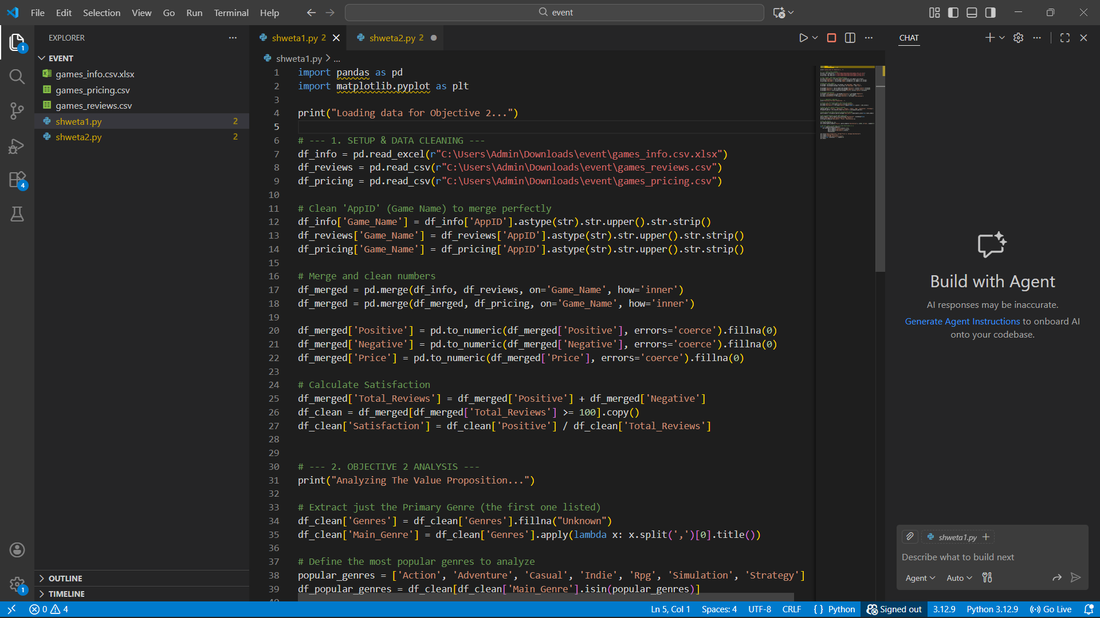
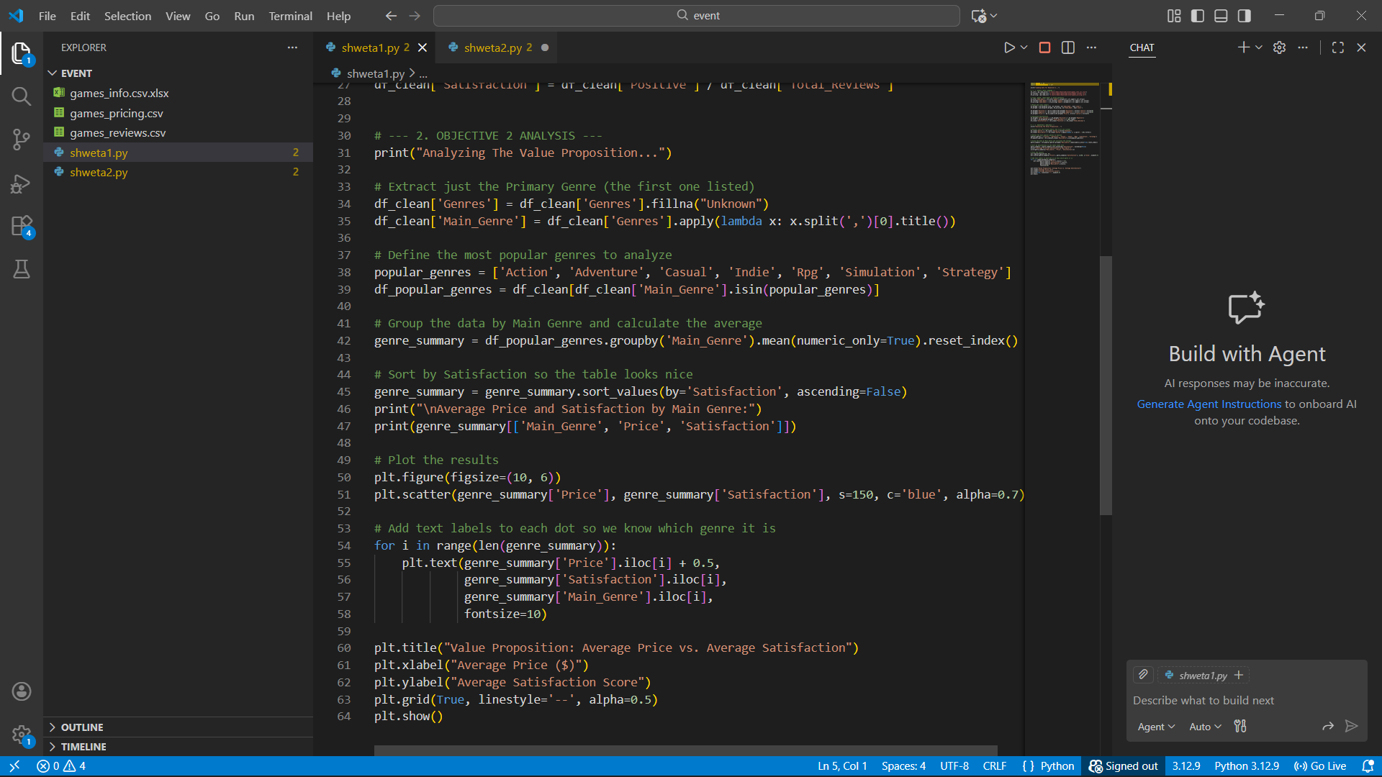

Program Output (Calculated Results)
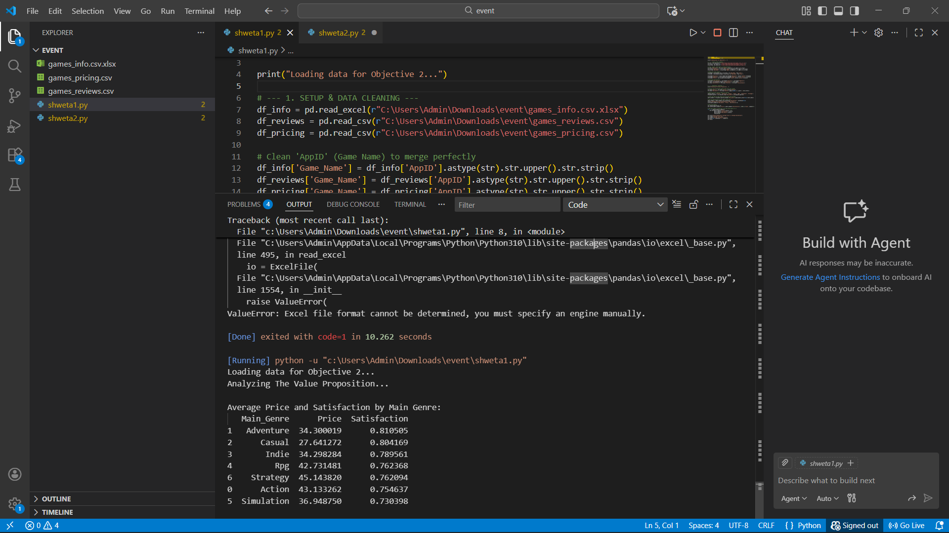

Visualization Result
