Create a simple script file , with some data present it and push it to repo. Now Create a project in Jenkins connected to your GitHub repository. When a commit is made to your repo, automatically build must get triggered from Jenkins and the output must be shared to me via email

* Github Repo link : <https://github.com/shreegs123/Jenkins-email-config-project.git>
* Jenkins pipeline project connected to github and dockerhub

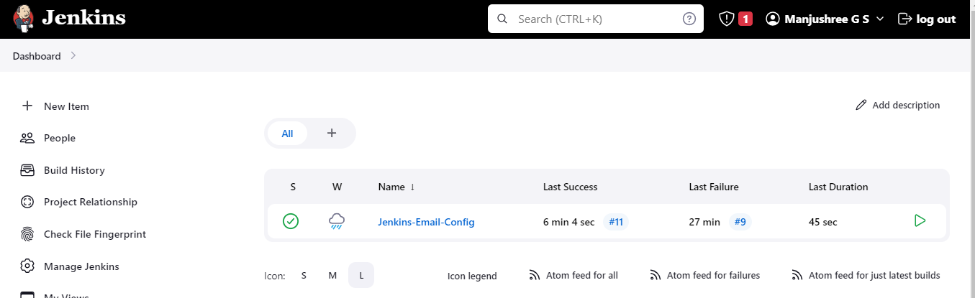

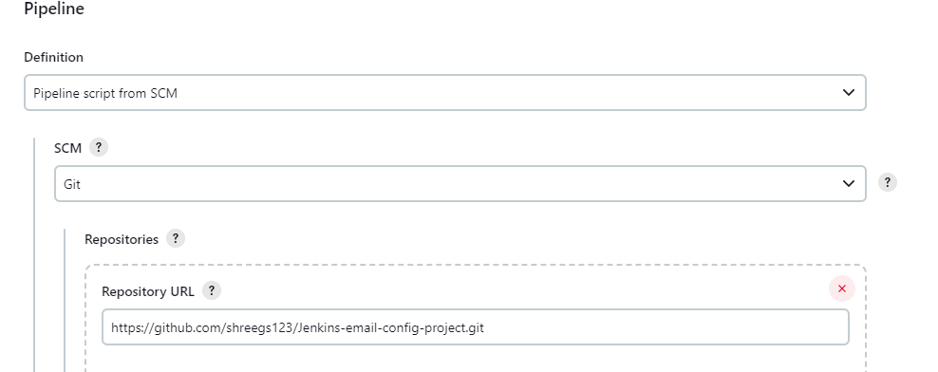

* Email configuration

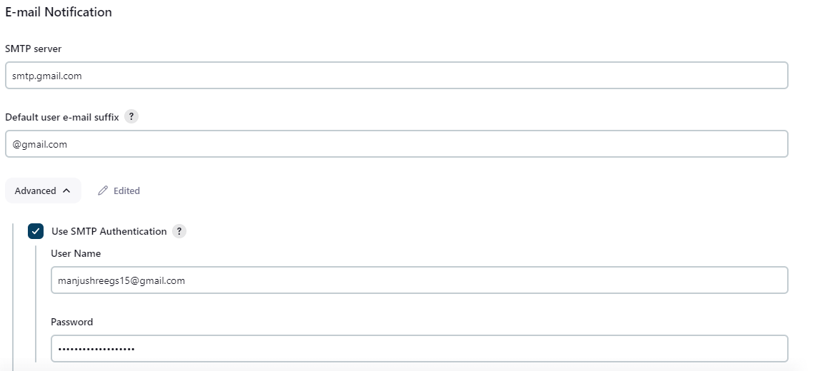

* Test configuration

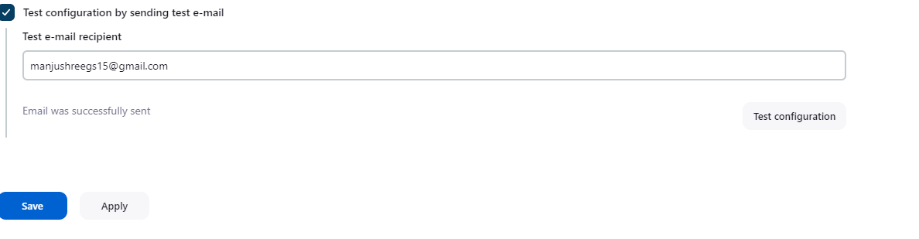

* Build Success

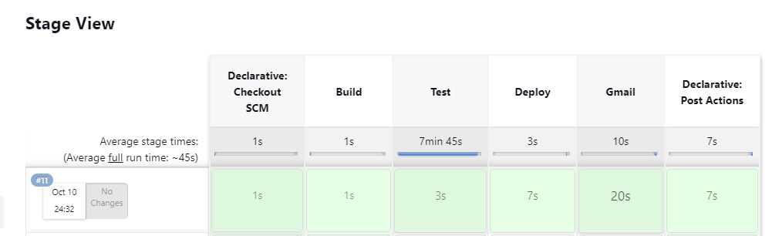

* Email Triggred

